Course: Earth Observation

Group: Philip Liehr, Clemens Lang, Janis Klug, Shawn Schneidereit

Date: 25-06-2021

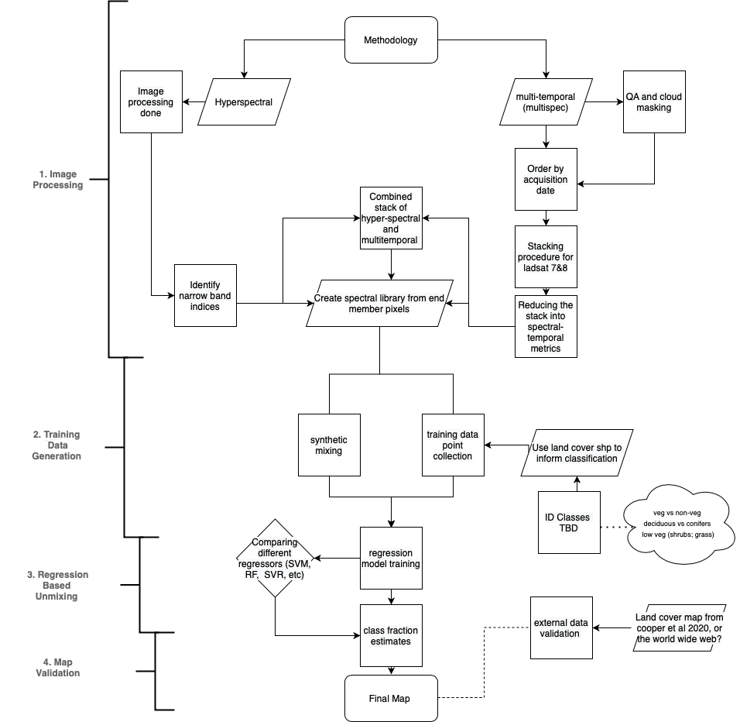

**Fig. 1:** Workflow proposal for the hyperspectral study