|  |
| --- |
| Fontys ICT |
| State pattern |
| Design patterns |

|  |
| --- |
| Jan-Niklas Schneider, Georgiana Manolache  10-4-2016 |

Contents

1 Introduction 3

2 Iterator pattern 3

3 Implementation 4

3.1 Explanation of classes 4

3.2 Features 5

4 Design choices 5

5 Graphical User Interface 6

6 Unit tests 7

7 References 7

# Introduction

The goal of this document is to give an overview of the state pattern by giving an example implementation which features a simplified industrial 3D print process. Furthermore, reusability, extensibility, and maintainability of this pattern are elaborated. Also, the implementation, its unit test and graphical user interface (GUI) are reviewed.

# State pattern

The state pattern is a software design pattern which describes an object-oriented state machine. The pattern has two application areas. Firstly, an object which must change its behavior at run-time depending on a state. Secondly, the pattern is utilized in applications that uses a significant amount of case statements that vector flow based the applications state (SourceMaking, 2016).

The figure below depicts an UML diagram of the state pattern.

Initially, a *Context* class is created which is a single point of entry. *Context* holds a *State* and is able to either set or get a state.

Secondly, an *State* interface is defined which sets the actions of its derived classes.

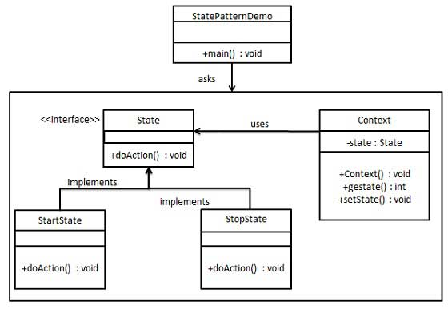

Figure 2‑1: UML diagram of state pattern (TutorialsPoint, 2016)

# Implementation

Figure 3‑1: UML diagram of the state pattern

## Explanation of classes

1. *IState* is an interface with two methods *GetState()* and *Pull()*. These methods define the iterator protocol for all derived classes.

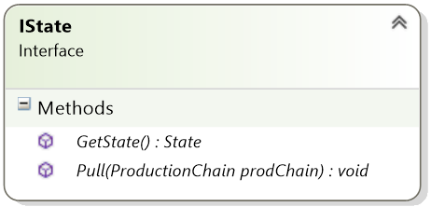

1. *State* is an abstract class which inherits from *IState*, hence, it implements the interfaces methods, namely *GetState()* and *Pull()*. Additonally, it holds a string *Action.*

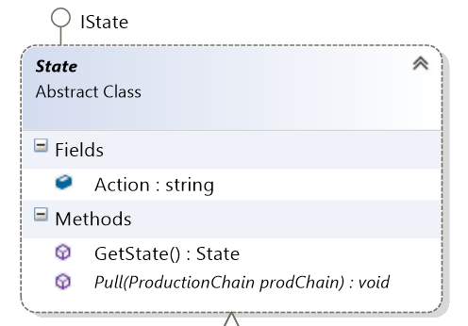

1. The classes depicted below inherit from *State* and describe concrete states of the state pattern.

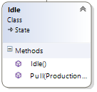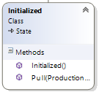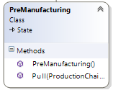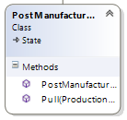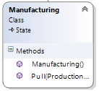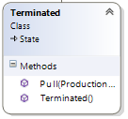

1. *ProductionChain* is the context class of the state pattern. It holds the *currentState* and has three methods *GetState(), NextState(),* and *Pull().*

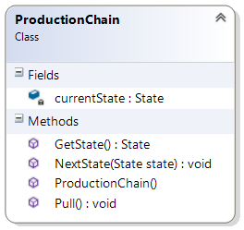

## Features

The application has a simple and straightforward user interface. Users are presented a simplified, fully automated industrial 3D printer which demonstrates the state pattern by showing a print process. The print begins with initializing the machine, followed by premanufacturing, manufacturing, and postmanufacturing. Then the machine terminates itself. During the print the machine can be emergency stopped.

# Design choices

The implementation of the state pattern has been done with regard to reusability, extensibility, and maintainability.

The **reusability** of the pattern is decent. While the context and interface are mostly reusable for other applications, the concrete states are very dependent on the application’s use case, therefore, won’t be reusable in another context.

In terms of **maintainability** the pattern is difficult to maintain. The classes derived from *State* are tightly coupled to its neighbors which results in dependencies between the sub classes.

The state pattern shows low **extensibility**.

While the iterator protocol can be easily extended and modified, they can be also added by implementing *IIterator.* Additionally, *IContainer* can offer multiple methods which describe different iterator protocols.

Something MVVM

# Graphical User Interface

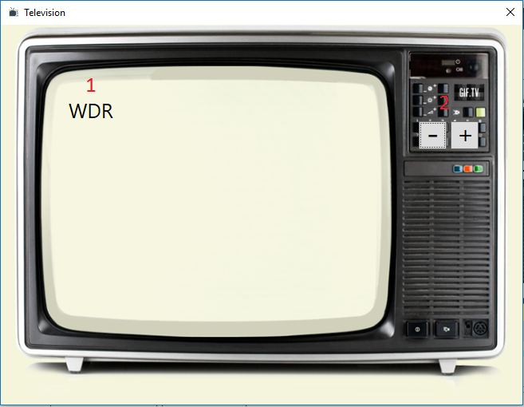

Figure 5‑1: Graphical user interface

The figure above depicts the user interface where red numbers indicate functionality or controls. More precisely these are:

1. A TextBlock which displays the name of the current TV channel.
2. Two buttons which allow changing channels. “+” is channel up, “-” is channel down.

# Unit tests

To assert correct behavior of the iteration protocol one unit test has been created, namely *IteratorValuesValid_Test.* The test cycles through all channels from first to last and back to the first.Subsequently, the test ran successful.



Figure ‑: Unit test result

# References

SourceMaking. (2016, September). *Iterator*. Retrieved from SourceMaking.com: https://sourcemaking.com/design_patterns/iterator

Tutorialspoint. (2016, September). *Design Patterns - Iterator Pattern*. Retrieved from Tutorialspoint.com: https://www.tutorialspoint.com/design_pattern/iterator_pattern.htm