

Figure 1: Request and response package

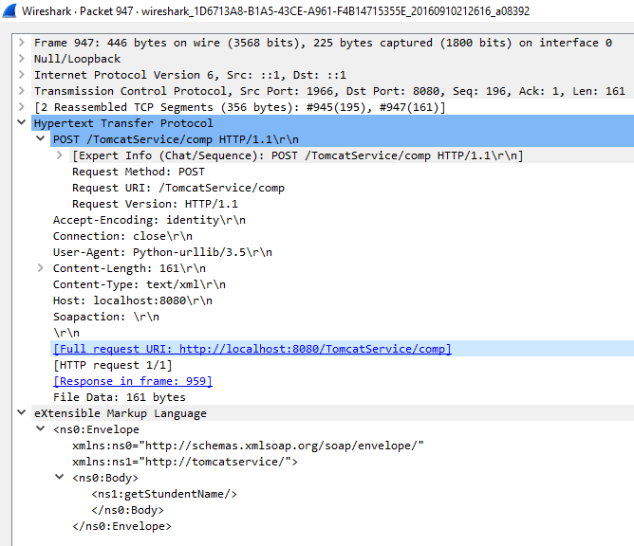

Figure 2: Request

The figure above shows the request when python script calls the method client.service.getStundentName() on the service. Header of the xml contains the service at ns1, the body contains the method call ns1:getstudentName

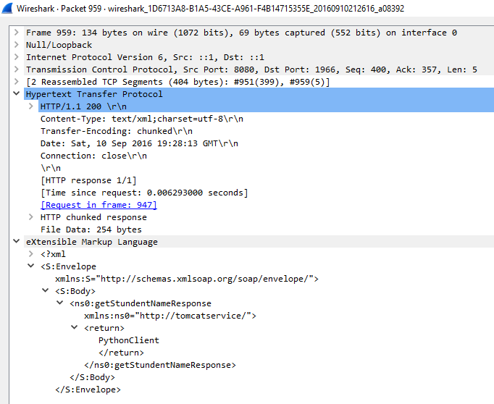

Figure 3: Response

Response to the request above. The string PythonClient is return using getStudentNameResponse