ClickBake

Nithin Perumal

Daniel Schnipke

Daniel McGarry

Jason Lane

Introduction

ClickBake is the great new way to combine the creativity of cooking and recipe websites as well as the convenience of Amazon Fresh by allowing users to click a browser extension that allows them to purchase all the necessary ingredients to a variety of existing recipe websites and then be able to click once more to have them shipped directly to their home. The extension lets users refrain from wasting valuable time by simply buying ingredients from the comfort of their own homes.

StakeHolders

|  |  |
| --- | --- |
| Stakeholders | Concerns/Interest ClickBake |
| Developers | We have an obvious interest in ClickBake as we hope to turn it into a profitable business and it must therefore be a great product. |
| Amazon | They would see a larger volume of orders as more people use Amazon Fresh even if they don’t explicitly go to the website to use it. |
| Delivery Services | Similar to amazon, delivery services would also see a higher volume of deliveries due to more orders being made on amazon fresh. |
| Disabled, Elderly, Lazy People | The disabled and elderly would be interested as they would no longer need to struggle to go out to shop for groceries to make their daily meals. This would also profit lazy people for similar reasons. |
| Busy People | Busy people would find interest in this product as they often need to buy groceries but don’t have the time to do so. With Amazon Fresh, this can be done very quickly. |

Affinity Diagram - Dan

|  |  |  |  |  |  |
| --- | --- | --- | --- | --- | --- |
| **Older age makes trips difficult** | **Being busy leaves little time for shopping** | **Why go anywhere at all?** | **Physically can’t go to store** | **Connectivity with Amazon Fresh** | **Shopping is Routine** |
| Lack of transportation do to health issues | Expect someone else to do the cooking or shopping | Going to the store takes effort | Often too painful to go to the store | No service in many places | Look forward to shopping at a normal time/place |
| Lack of Physical endurance | When there is time, they generally feel too drained to actually shop/cook | Finding all the separate ingredients in an online recipe takes time | Not enough people to help get what they need | No API | Know where everything is |
| General lack of computer skills |  | After going to the store, you no longer want to cook |  | Some people don’t like using Amazon at all | Change in scenery of everyday life |
|  |  |  |  |  | Know the quality of the ingredients they’re buying |

Epic Level User Stories - Nithin

Title: Click and Bake

Category: Epic

As a fellow lazy person, I want to use minimal effort to acquire the ingredients to cook my favorite meals.

-Order is confirmed and correct

-Order is correctly shipped

-Process requires very few clicks as I am lazy

-I don’t care much for time restrictions as I eat any time.

Tracing to category in affinity diagram: **Why go anywhere at all?**

Title: No Drive to Bake

Category: Epic

As an elderly person, I want to easily get food without having to drive to the nearby supermarket to get ingredients.

-Order is confirmed and correct

-Order is correctly shipped and arrives in a timely fashion

-Process requires very few clicks

-I am not required to travel

Tracing to category in affinity diagram: **Older age makes trips difficult**

Title: Can’t Drive to Bake

Category: Epic

As an elderly person, I’d like to be able to get food without having to talk to the supermarket. Both my husband and I can’t drive due to our poor vision and the task of going to the supermarket is just so taxing - especially during winter and summer.

-Order is valid and confirmed

-Order is shipped to the right address and arrives in a timely fashion.

-Simple ordering process with reliable delivery

-I am not required to travel.

Tracing to category in affinity diagram: **Older age makes trips difficult, Physically can’t go to store**

Title: Working and Cooking

Category: Epic

I am a busy person and I would like to cook my own special meals more often as I have grown tired of ordering in. Currently, I only have the time to either cook a special meal OR go out and purchase groceries. I would really like a way to get groceries delivered to my home so I can cook my own special meals.

-Order is valid and confirmed

-Timely delivery

-Order is shipped correctly and arrives in targeted time frame as I don’t have much time outside of work nor are my hours flexible.

Tracing to category in affinity diagram: **Being busy leaves little time for shopping**

Title: Disabled and Cooking

Category: Epic

As a disabled person, I would like a way to procure groceries to cook my own meals as I often struggle to make it to the supermarket and purchase the goods I need on my own.

-Order is valid and confirmed

-Delivery is timely

-Order is correctly shipped and arrives in the given amount of time

-I’m not required to travel to pick up my goods

Tracing to category in affinity diagram: **Physically can’t go to store**

Feature Level User Stories - Jason

Title: Extension button

Category: Feature

As a user, I want to press a chrome extension button and a new tab will open with appropriate information regarding buying the recipes so that I can say "Yes, buy me food."

-New tab opens when user presses chrome extension

-New tab knows the information from the recipe page that was open

Title: Address information

Category: Feature

As a user, I want ClickBake to be able to store my address securely so that I do not have to retype it every single time that I want food.

-User can enter address information

-Address information can be stored

Title: Multiple locations  
Category: Feature  
As a busy person, I want to be able to select from multiple locations for ClickBake to deliver to, so that I can get ingredients wherever I am without having to retype addresses.

-Multiple addresses can be stored

-User can select address for delivery

Title: Delivery  
Category: Feature  
As a user, I want the food I buy through ClickBake to be somehow delivered to my door so that I can get ingredients without having to go out.

-ClickBake places Amazon Fresh order

-Amazon Fresh supplies their services

Title: Credit card information

Category: Feature

As a user, I want ClickBake to store my credit card information securely so that I do not have to enter it every single time that I want food.

-User can enter credit card information

-Credit card information is stored securely

Title: Brand information

Category: Feature

As a user, I want ClickBake to store my favorite brands so that I do not have to enter them every single time that I want food.

-User can enter favorite brands

-Brand information is stored for future use

Title: Pricing review

Category: Feature

As a consumer, I want to be able to review how much I’m spending on an order so that I can keep track of my budget.

-ClickBake reports pricing of each item

-ClickBake totals the contents of my shopping cart

Title: Correct shopping  
Category: Feature  
As a shopper, I want ClickBake to order the correct food for the recipe I’m looking at, so that I don’t waste money on ingredients I don’t want.

-ClickBake properly finds ingredients using information from the recipe page

-ClickBake adds these ingredients to my shopping cart

Storyboards - Schnips

Ordering/Primary Usage

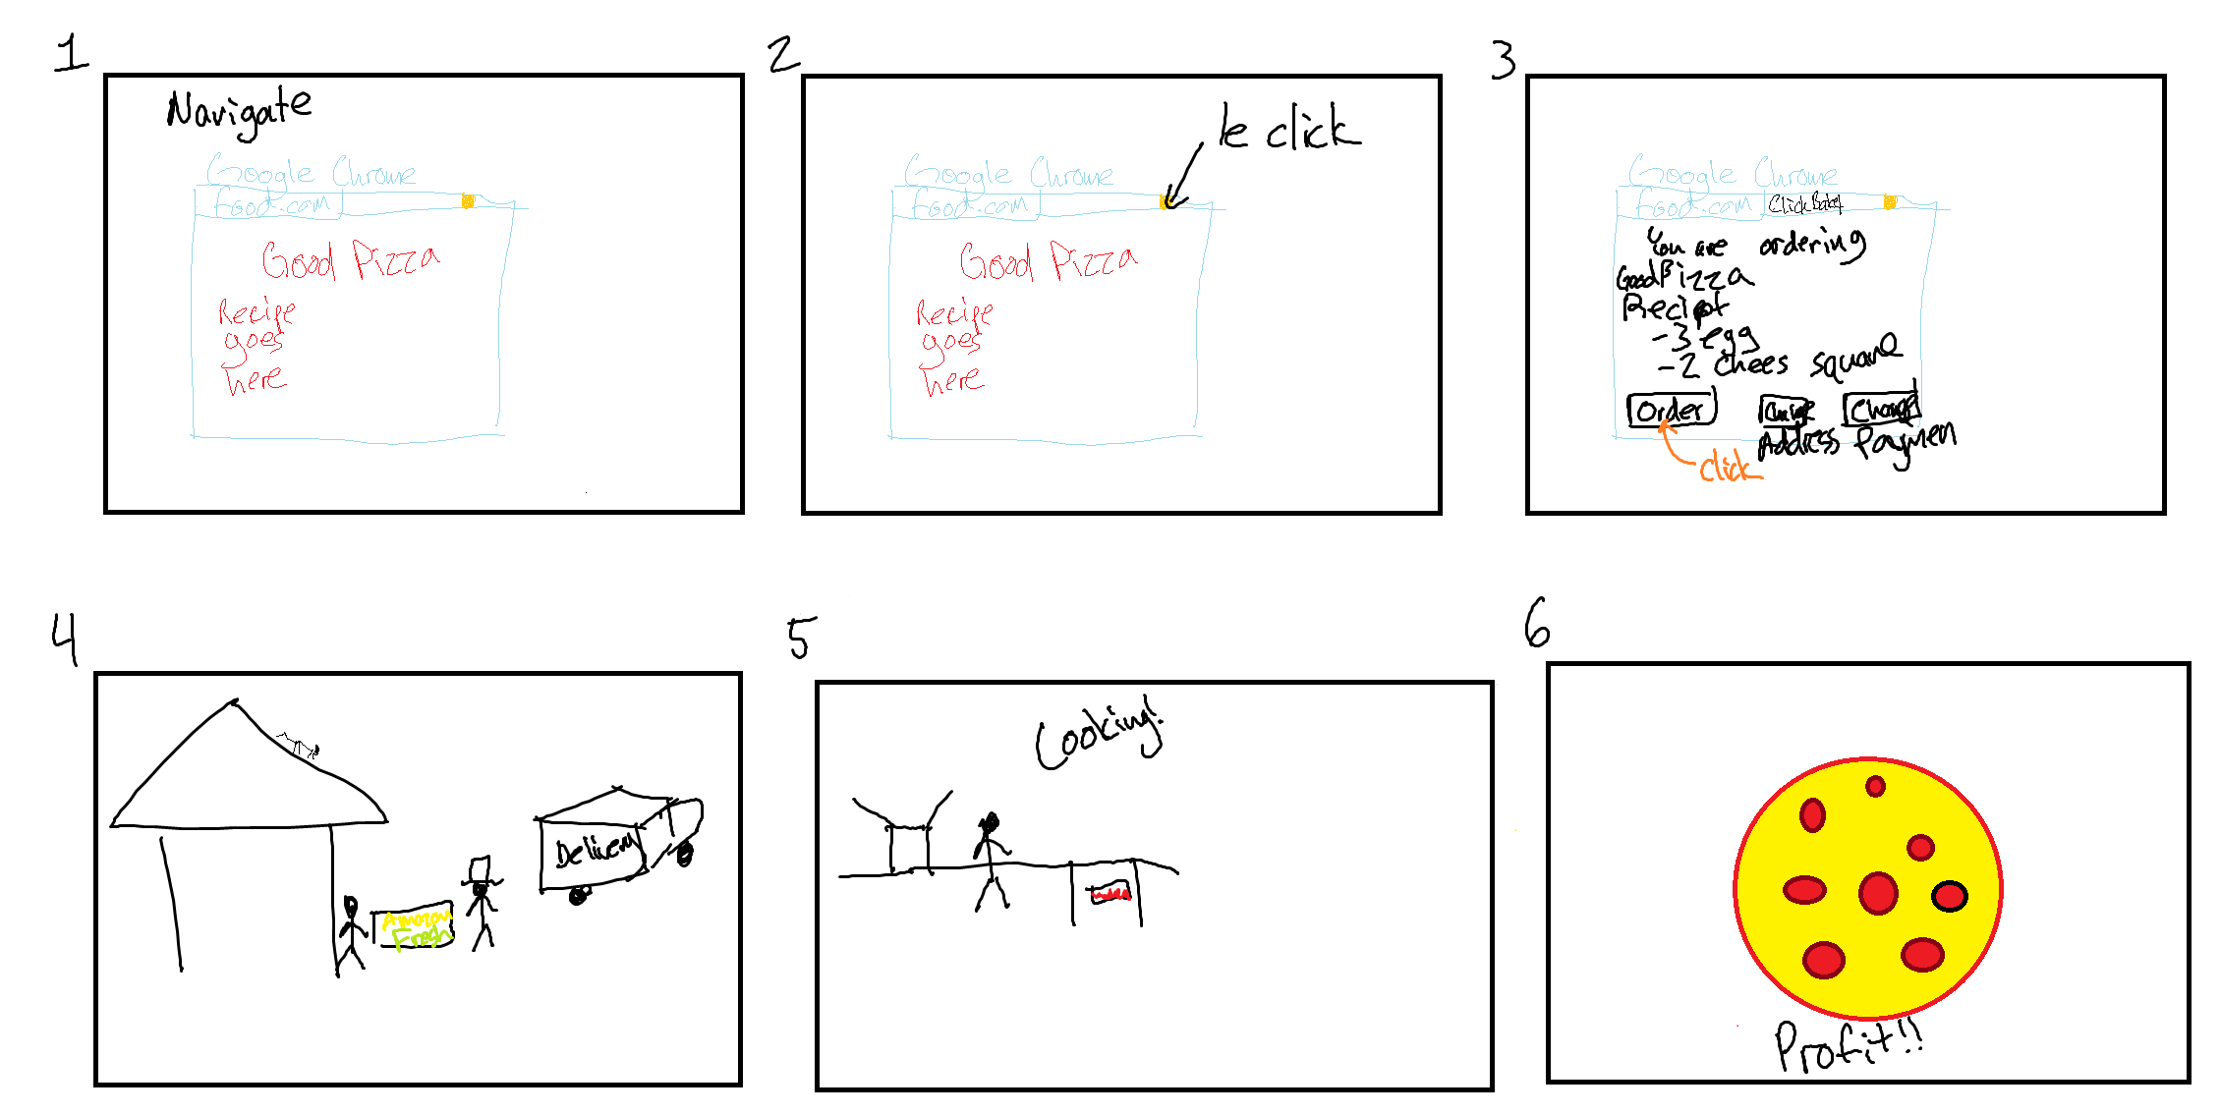

Setting Preferences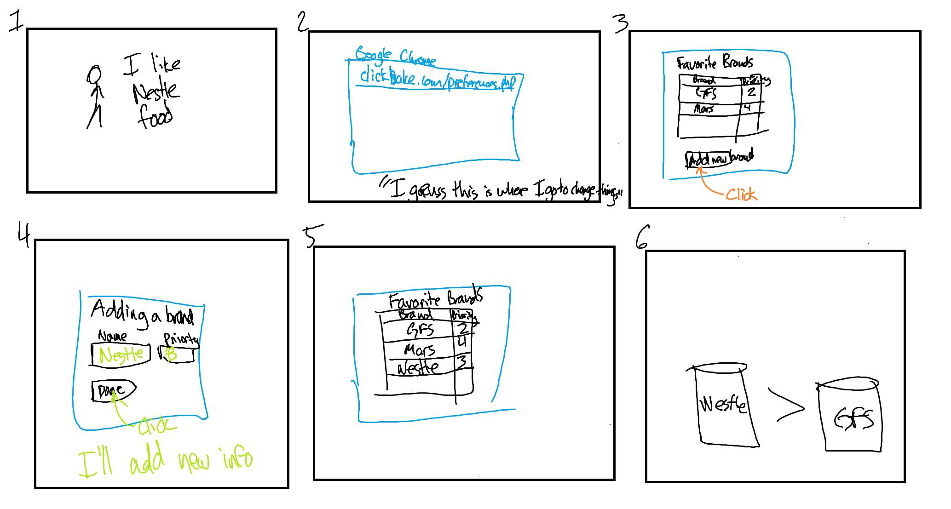

Saved Preferences being used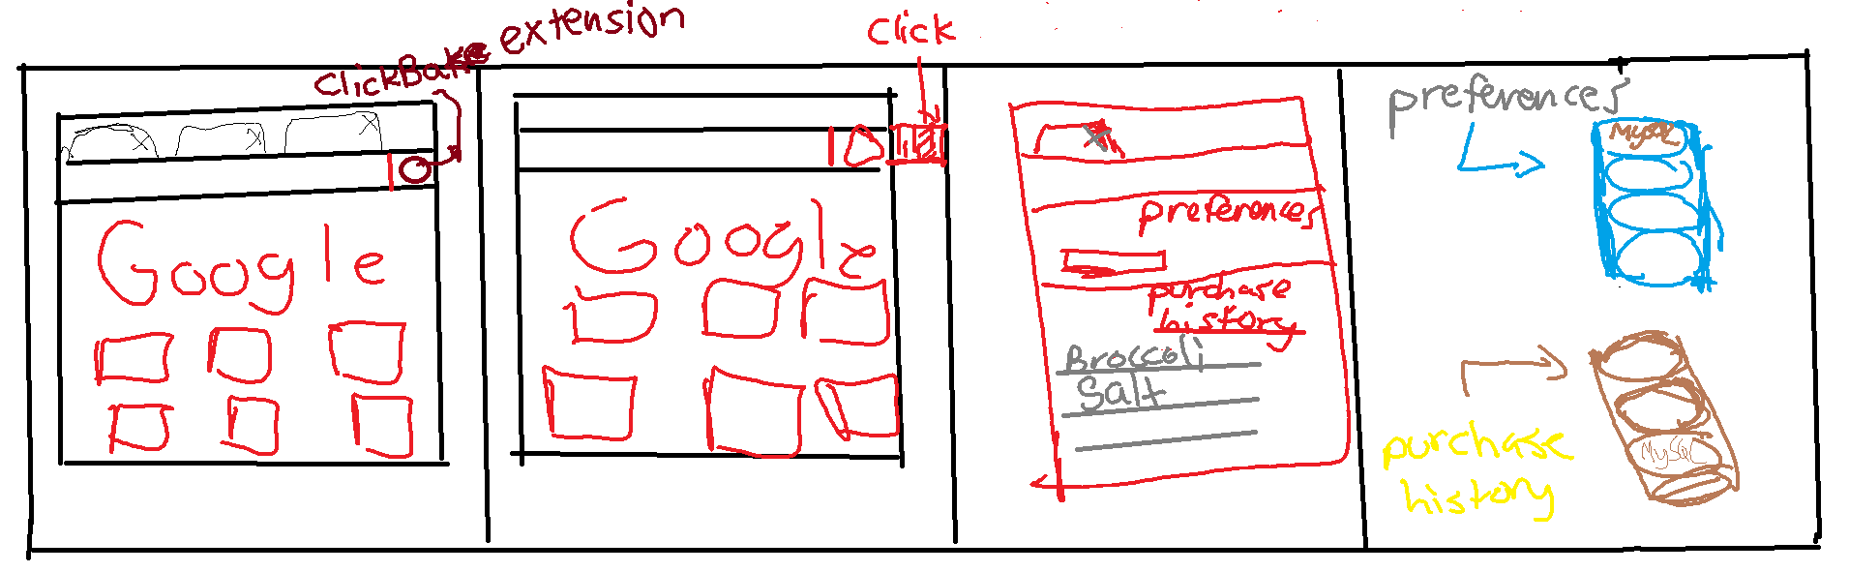

Credit Card information being securely stored

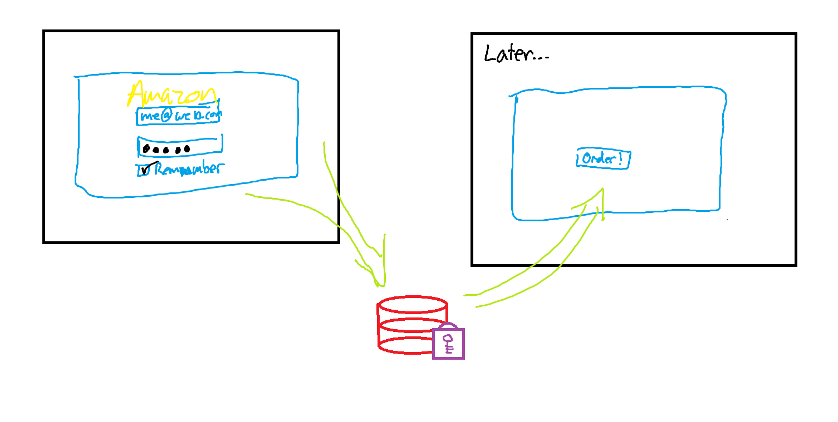

Appendix I: Interview Notes - Questionnaire Answers Summarized

Elderly Person - Grandma

Is getting older each day and therefore finds it increasingly difficult to purchase ingredients for daily cooking on a regular basis. Would use this product if it were reliable as it would cut down on travel time. Cannot drive – hence walking to buy ingredients is usually the only option. Might be a little hard to convince her to use it since she tends to stick to old habits and uses books to find new recipes. She is also unsure of the availability of some special ingredients used in foreign cuisines. But she did state that she would use it once in awhile if amazonfresh proves to be reliable.

Lazy College Student:

Karan is my apartment mate and enjoys cooking his own food as he has grown a little tired of food from the ARA. Often has no time or desire to purchase ingredients. Also has no car to go buy things on his own and must rely on others to drive him. Would use this extension if it came along as procuring ingredients would be easy.

Must be cost efficient though and not excessively expensive.

Elderly Person - Grandma

Recipes were usually from friends or from old cookbook. Internet was a last resort for recipes unless they were ones that friends had shared on facebook. Driving to the store is a lot of work for her, and so she would prefer not to. She very much was open to the idea of having the raw ingredients of food brought to her.

Disabled Person

This individual was unable to drive due to leg injuries they had in the past. They liked the idea of amazon fresh and especially receiving the ingredients. They noted that there are many ways to get food at home, but most often they are not healthy at all, such as pizza and Chinese takeout. They likely the idea of not having to rely on or burden friends and family to get fresh ingredients to make healthy food.

Busy Person - My Parents

Said they would consider using amazon fresh if it proved reliable as Amazonfresh does deliver in the area they live in. Their main concern was a lack of special ingredients used in foreign cuisines as that is generally what my mother cooks. Right now they go to the supermarket about once a week and take a couple hours to buy everything they need. As busy people, they said this would be great to implement on those busy weekdays when they don’t have the time to prepare anything else.

Busy Person - Family Friends

Said they would consider using amazon fresh if it proved reliable as Amazonfresh does delivers in the area they live in. Right now they go to the supermarket about once a week and take a couple hours to buy everything they need. As busy people, they said this would be awesome on weekdays when they don’t have much time to buy ingredients and cook. But they do hope that the food has at least equal quality to ingredients they normally purchase at supermarket.

Lazy College Student

She has heard of Amazonfresh and is quite sure they deliver to her area. Her main contingency on using ClickBake is the cost of ordering vs the cost of actually buying things from amazon fresh. She is not too concerned about cuisine and is sure she could find the required ingredients on Amazonfresh. She also says she would continue using the extension if the delivery is fresh and timely.