Computer Graphics

Course final project

Oeuvre
(A collection of works)

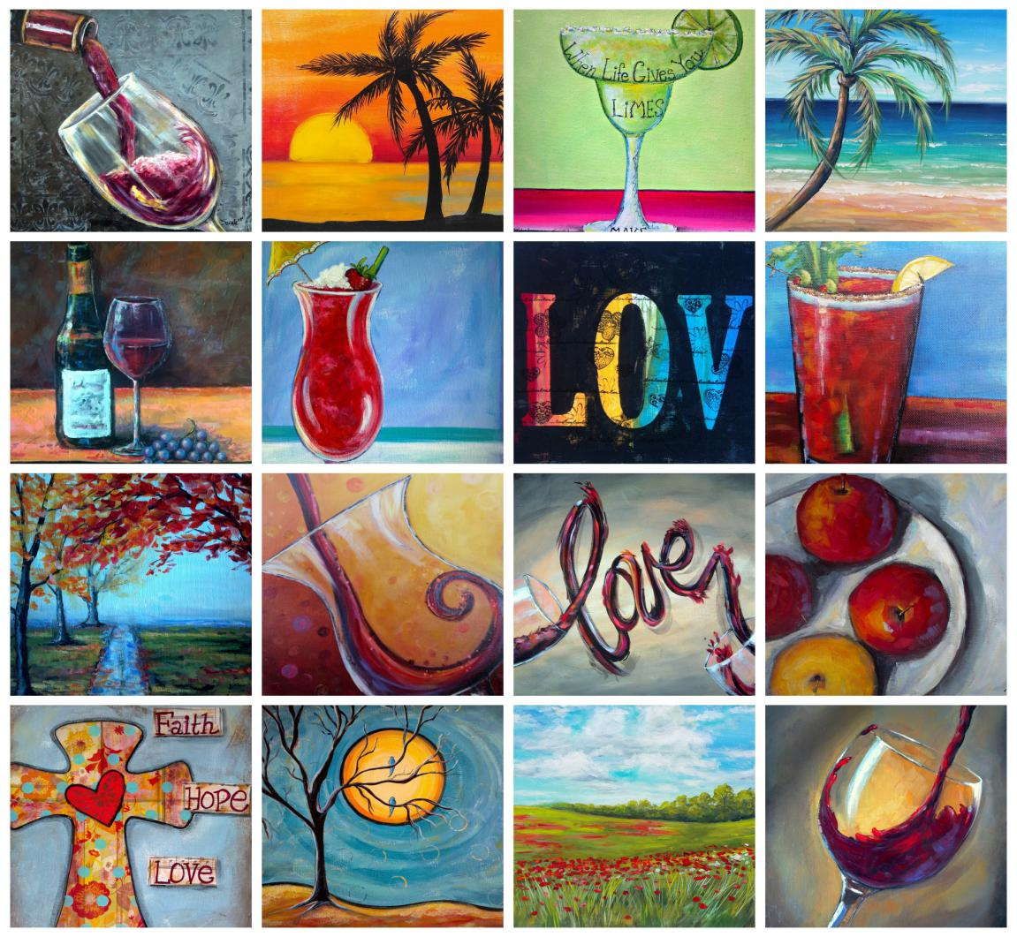

Submitted by:-
Noel Joe
SE-Comps
Roll no-38

1.Fractal Tree

First we will be looking at fractals.
Fractal is a self-similar subset of Euclidean space whose fractal dimension exceeds the Topological dimension.
We have seen Koch curve and the Mandelbrot set in syllabus.
Fractals exhibit similar patterns at increasingly small scales called self-similarity,also known as expanding symmetric or unfolding symmetry.
Fractal geometry lies within the mathematical branch of measure theory.
Starting with the notions of recursion,fractals have undergone rigorous mathematical treatment by the likes of mathematicians like Bernard Bolzano,Bernard Riemann and Karl Weiestrass.
A binary fractal tree is defined recursively by symmetric binary branching. The trunk of length 1 splits into two branches of length r, each making an angle θ with the direction of the trunk. Both of these branches divides into two branches of length r², each making an angle θ with the direction of its parent branch. Continuing in this way for infinitely many branchings, the tree is the set of branches, together with their limit points, called branch tips.
In the obvious way, each branch is determined by a string of symbols L and R specifying the choice of direction taken along the tree to reach the branch. A branch determined by a string of n symbols has length r^{n}; a branch tip is determined by an infinite string of symbols. Most of the analysis in results from converting eventually periodic symbol strings of branch tips into geometric series for the x and y coordinates of the branch tips, and making appropriate interpretations.
For example, in the tree on this page the branch tip marked * can be reached in two ways
LRRRRLRLRLRLRLR...
and
RLLLLRLRLRLRLRL...

Here I have demonstrated Fractal trees by simple recursion method.

Code:-
HTML FILE
<!DOCTYPE html>
<html>

<head>
<meta charset="UTF-8">

<title>Fractal Tree</title>

<script language="javascript" type="text/javascript" src="https://cdn.jsdelivr.net/npm/p5@1.0.0/lib/p5.min.js"></script>

<script language="javascript" type="text/javascript" src="/Users/Noel Joe/Desktop/p5/p5/empty-example/sketch.js"></script>
<style>
body {
padding: 0;
margin: 0;
}
</style>

</head>
<body>
</body>
</html>

JavaScript File

var angle = 0;
var slider;

function setup()
{
createCanvas(600,600);
slider = createSlider(0, TWO_PI,PI / 4,0.01);
}
function draw()
{

background(51);
angle = slider.value();
stroke(255);
translate(200,height);
branch(100);
}

function branch(len)
{
line(0, 0, 0, -len);
translate(0, -len);
if (len > 4)
{
push();
rotate(angle);
branch(len*0.67);
pop();
push();
rotate(-angle);
branch(len * 0.67);
pop();
}

}

OUTPUT SNAPSHOTS

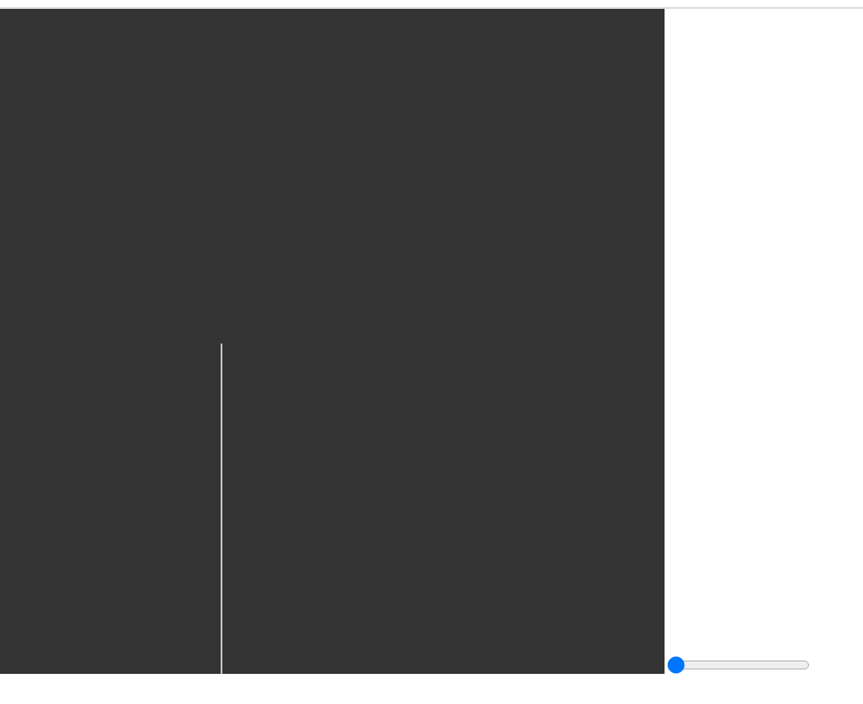

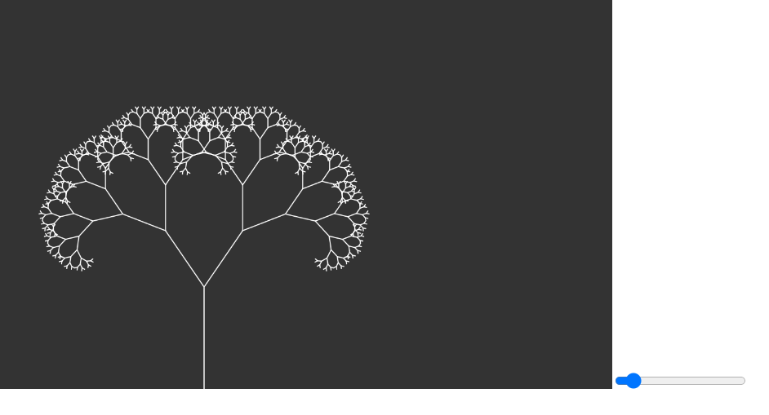
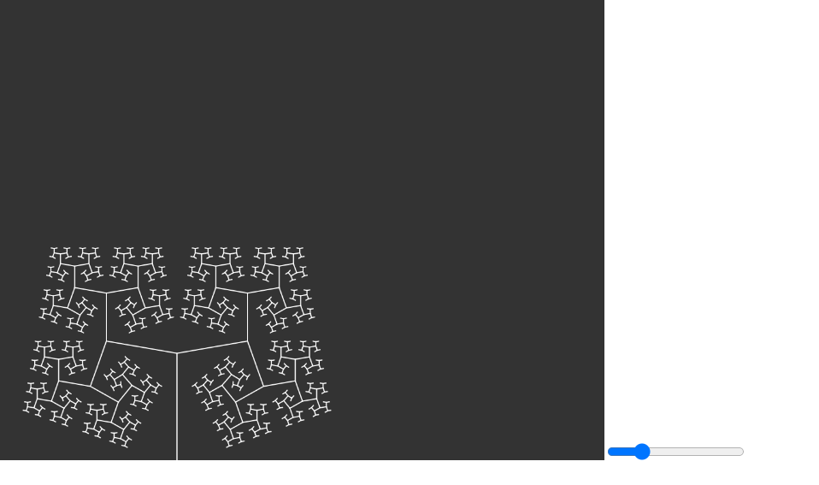

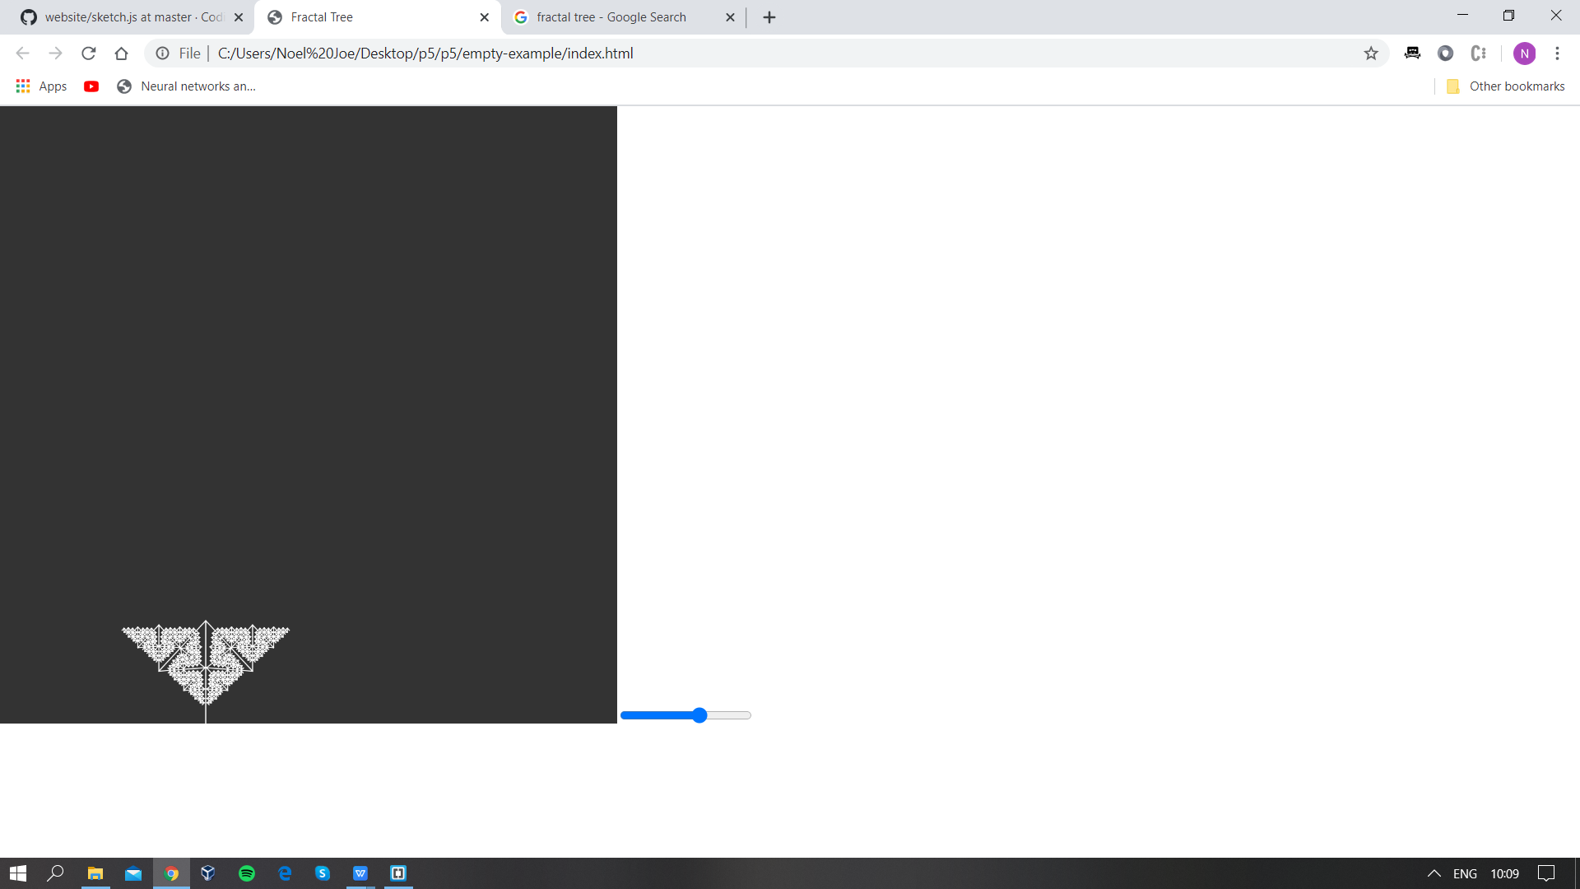

2 .Fourier Transform

In this part we dive into Mathematics further.
Maths can be fun too! Here I have considered something like the Fourier transform which is at one of the foundations of a lot of sub-branches of mathematics.
The Fourier transform decomposes a signal into its constituent frequencies.We apply it both in the frequency and time domain.
In this example I have considered the Discrete Fourier Transform which is the computational form of the Fourier transform.
The founding equation of DFT

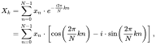

is derived from these equations.

In this example I have used the DFT algorithm to recreate some fond memories of train.
I have used a series of values inside an array to
trace this drawing.
You can also call this as a DFT drawing machine.
We can use these epicycles to create any kind of wave.

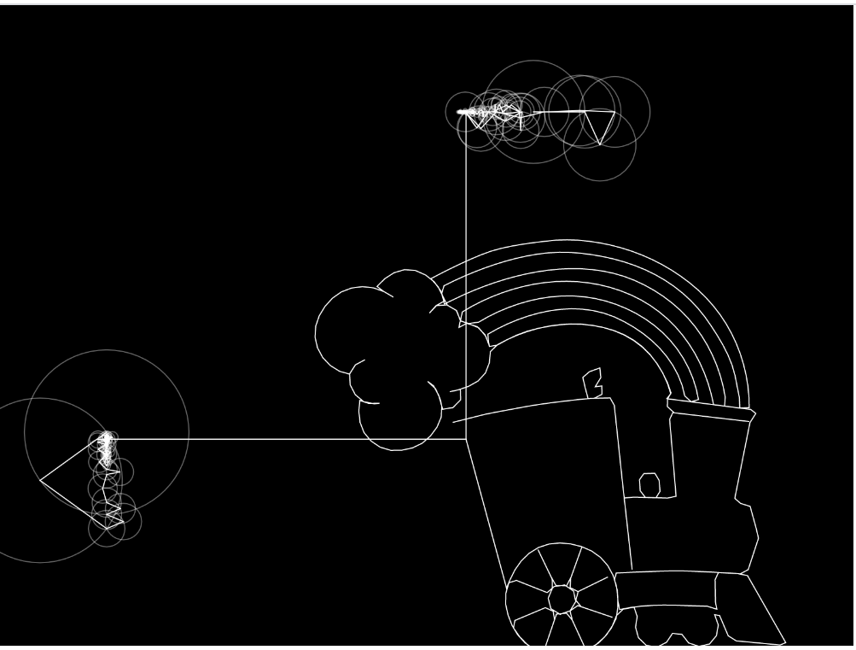

CODE

HTML FILE

<!DOCTYPE html>
<html>

<head>
<meta charset="UTF-8">
<title>Fourier Series Representation </title>

<script language ="javascript" type ="text/javascript" src="https://cdn.jsdelivr.net/npm/p5@1.0.0/lib/p5.min.js"></script>

<script language ="javascript" type = "text/javascript" src ="C:/Users/Noel Joe/Desktop/p5/p5/empty-example/sketch.js"></script>

<script language ="javascript" type = "text/javascript" src = "C:/Users/Noel Joe/Desktop/p5/p5/empty-example/fourier.js"></script>
<script language ="javascript" type="text/javascript" src ="C:/Users/Noel Joe/Desktop/p5/p5/empty-example/data.js"></script>
<style>
body{
padding :0;
margin: 0;
}

</style>

</head>
<body>
</body>
</html>

JAVASCRIPT FILES
Sketch.js

let x = [];
let y = [];
let fourierX;
let fourierY;
let time = 0;
let path = [];

function setup()
{

createCanvas(800, 600);
const skip = 8;
for (let i =0; i < drawing.length; i+= skip)
{
x.push(drawing[i].x);
y.push(drawing[i].y);
}
fourierX = dft(x);
fourierY = dft(y);

fourierX.sort((a,b) => b.amp - a.amp);
fourierY.sort((a,b) => b.amp - a.amp);

}

function epiCycles(x,y,rotation,fourier)
{
for (let i = 0; i < fourier.length; i++)
{
let prevx = x;
let prevy = y;
let freq = fourier[i].freq;
let radius = fourier[i].amp;
let phase = fourier[i].phase;
x += radius * cos(freq * time + phase + rotation);
y += radius * sin(freq * time + phase +rotation);

stroke(255, 100);
noFill();
ellipse(prevx, prevy, radius * 2);
stroke(255);
line(prevx, prevy, x, y);
}

return createVector(x, y);
}

function draw() {

background(0);

let vx =epiCycles(width / 2 +100, 100, 0 ,fourierX);
let vy = epiCycles(100, height / 2 + 100, HALF_PI, fourierY);
let v = createVector(vx.x, vy.y);
path.unshift(v);
line(vx.x, vx.y, v.x, v.y);
line(vy.x, vy.y, v.x ,v.y);
beginShape();
noFill();
for (let i=0; i < path.length; i++)
{
vertex(path[i].x, path[i].y);
}
endShape();
const dt =TWO_PI / fourierY.length;
time += dt;

if(time >TWO_PI)
{
time =0;
path=[];
}
}

Fourier.js
function dft(x)
{
const X = [];
const N = x.length;
for(let k =0; k< N; k++)
{
let re = 0;
let im = 0;
for (let n =0; n< N; n++)
{
const phi = (TWO_PI * k *n) / N;
re += x[n] * cos(phi);
im -= x[n] * sin(phi);
}
re = re / N;
im = im / N;let freq = k;
\let amp = sqrt(re * re + im * im);
let phase = atan2(im, re);
X[k] ={re ,im,freq, amp,phase } }return X; }
- Dithering
Dithering is used in computer graphics to create the illusion of color depth in images on systems with a limited color palette.
In a dithered image, colors that are not available in the palette are approximated by a diffusion of colored pixels from within the available palette. The human eye perceives the diffusion as a mixture of the colors within it (see color vision).

Dithered images, particularly those using palettes with relatively few colors, can often be distinguished by a characteristic graininess or speckled appearance.

In this example I took inspiration from one of our Graphics lessons.Where we were looking at Dithering,Toning, and more concepts related to image processing.

I have used the Floyd-Steinberg algorithm for processing my images.

The Floyd-Steinberg was published in 1976 by Robert Floyd and Louis Steinberg.

It is most commonly used when an image is converted into GIF format that is restricted to a maximum of 256 colors.

This algorithm achieves dithering using error diffusion,it pushes the residual quantization error,
of a pixel onto its neighbouring pixels.

Algorithm

for each y from top to bottom do
for each x from left to right do
oldpixel := pixel[x][y]
newpixel := find_closest_palette_color(oldpixel)
pixel[x][y] := newpixel
quant_error := oldpixel - newpixel
pixel[x + 1][y ] := pixel[x + 1][y ] + quant_error × 7 / 16
pixel[x - 1][y + 1] := pixel[x - 1][y + 1] + quant_error × 3 / 16
pixel[x ][y + 1] := pixel[x ][y + 1] + quant_error × 5 / 16
pixel[x + 1][y + 1] := pixel[x + 1][y + 1] + quant_error × 1 / 16

OUTPUT SNAPSHOTS

London City Skyline
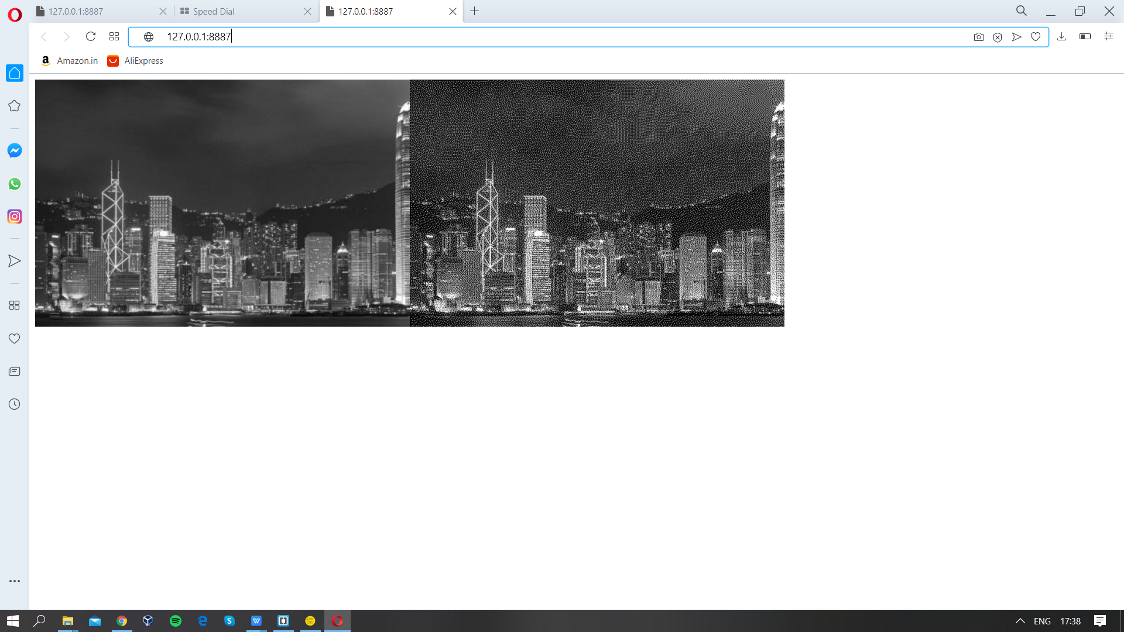

Alan Turing-(The Father of Computer Science)

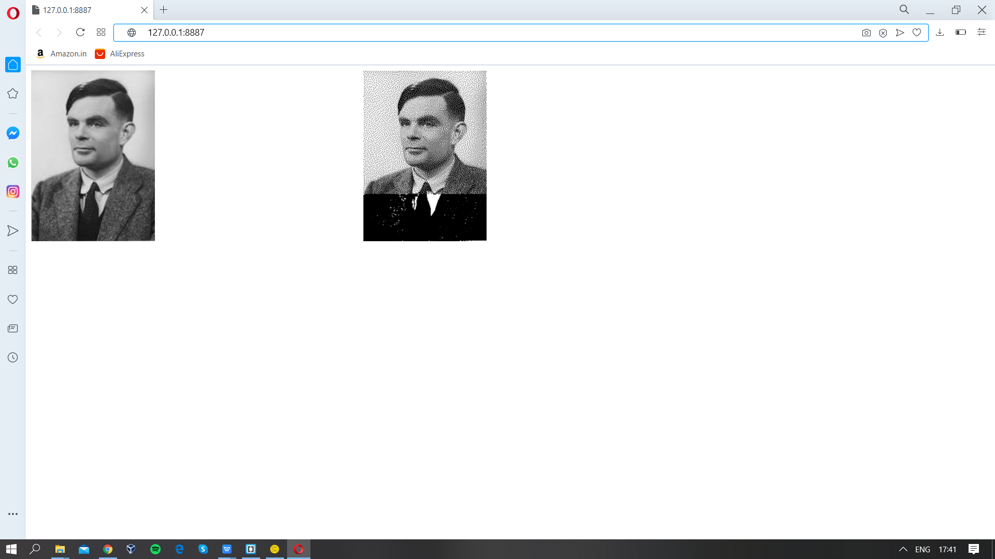

CODE
HTML FILE
<!DOCTYPE html>
<html>

<head>

<script type ="text/javascript" src="https://cdn.jsdelivr.net/npm/p5@1.0.0/lib/p5.min.js"></script>
<script type ="text/javascript" src="https://cdn.jsdelivr.net/npm/p5@1.0.0/lib/addons/p5.sound.min.js"></script>

<script type = "text/javascript" src="sketch.js"></script>

</head>
<body>
</body>
</html>

JAVASCRIPT FILE
let alan;

function preload() {
alan = loadImage('alan.jpg');
}
function setup()
{

createCanvas(1024,512);

image(alan,0,0);
makeDithered(alan,1);
image(alan,512,0);
filter(GRAY);
}
function imageIndex(img,x,y)
{
return 4*(x+y*img.width);
}
function getColorAtIndex(img,x,y)
{
let idx= imageIndex(img,x,y);
let pix = img.pixels;
let red = pix[idx];
let green = pix[idx+ 1];
let blue = pix[idx+ 2];
let alpha = pix[idx+ 3];
return color(red,green,blue,alpha);

}
function setColorAtIndex(img,x,y,clr)
{
let idx = imageIndex(img,x,y);
let pix = img.pixels;
pix[idx] = red(clr);
pix[idx + 1] = green(clr);
pix[idx + 2] = blue(clr);
pix[idx + 3] = alpha(clr);
}
function closestStep(max,steps,value)
{
return round((steps * value) /255) * floor(255/ steps);
}
function makeDithered(img,steps)
{

img.loadPixels();
for (let y=0; y<img.height;y++)
{
for(let x=0; x <img.width; x++)
{
let clr =getColorAtIndex(img,x,y);
let oldR= red(clr);
let oldG= green(clr);
let oldB = blue(clr);
let newR = closestStep(255,steps,oldR);
let newG = closestStep(255,steps,oldG);
let newB = closestStep(255,steps,oldB);

let newClr = color(newR,newG,newB)
setColorAtIndex(img,x,y,newClr);

let errR =oldR-newR;
let errG =oldG-newG;
let errB =oldB-newB;

distributeError(img, x, y,errR,errG,errB);

}
}
img.updatePixels();
}
function distributeError(img,x,y,errR,errG,errB)
{
addError(img,7/16.0,x+1,y,errR,errG,errB);
addError(img,3/16.0,x-1,y+1,errR,errG,errB);
addError(img,5/16.0,x,y+1,errR,errG,errB);
addError(img,1/16.0,x+1,y+1,errR,errG,errB);
}
function addError(img,factor,x,y,errR,errG,errB)
{
if(x<0 || x>=img.width || y<0 || y>=img.width)
return;
let clr = getColorAtIndex(img,x,y);
let r= red(clr);
let g =green(clr);
let b = blue(clr);
clr.setRed(r+ errR*factor);
clr.setGreen(g+errG*factor);
clr.setBlue(b+errB*factor);

setColorAtIndex(img,x,y,clr);
}

I used Chrome Webserver for this project
and brackets as an IDE for connecting both the server and p5.js and other components.

References:-The Coding Train/Dan Shiffman.

