Flutter Banking Capstone
10 Project Problem Statements
Features, non-functional requirements, API contracts and architecture — aligned to the 60-hour Flutter track

Track: Flutter cross-platform development · Modules 1–7
Projects: PayLite · CardVault · LoanEase · SaveSmart · SpendWise · BillBuddy · BranchQ · OpenAccount · InvestLite · FraudShield
Each includes: Problem statement · personas · prioritised features · acceptance criteria · screens · data model · API contract · NFRs · architecture diagram · edge cases · stretch goals
Reference build: BankEase (Modules 1–6) is the worked example every project follows
Author: Nawaz Bagwan · Illuminate Skills
Contents

Word asks to update fields when the file opens: choose Yes to fill this table.

How to use this document
Each project is a realistic banking product brief, written the way a product owner would hand it to a mobile team. Every project is sized for the capstone (Module 7) and deliberately exercises every module of the track: the same concepts learners practised on BankEase, applied to a new domain without step-by-step code.
Reader | How to use it
Trainer | Assign one project per team of 2–3 (or let teams choose from the selection matrix). Use the rubric at the end of Part A for evaluation. Each project names its "hard part" so reviews can focus there.
Participants | Read Part A first: it contains the requirements that apply to every project. Then read your project in full before writing any code. Build in the order of the milestones.
Scope | Must features are required to pass. Should features separate good from excellent. Could features and stretch goals are for teams that finish early.

Note: Every project reuses the BankEase architecture: feature folders, Riverpod, repositories, a sealed error type, Dio with interceptors, secure storage and biometrics. Nothing here requires a library the course did not teach, apart from those named in a project (for example a charting or camera package).

Project selection matrix
# | Project | Theme | Level | The hard part
P01 | PayLite — UPI-style person-to-person payments with QR scan-and-pay | Payments | Advanced | Payment status is not binary
P02 | CardVault — Debit and credit card control centre | Cards | Intermediate | Optimistic UI done right
P03 | LoanEase — Personal loan application and EMI tracker | Lending | Advanced | A long, interruptible workflow
P04 | SaveSmart — Goal-based savings, recurring and fixed deposits | Savings | Intermediate | Financial maths that must be exactly right, plus motion that motivates without getting in the way
P05 | SpendWise — Expense analytics and monthly budgets | Personal finance | Intermediate | Fast aggregation and charts over large data, and a recategorisation flow that feels instant yet stays consistent
P06 | BillBuddy — Bill payments, recharges and autopay | Payments | Intermediate | Server-driven dynamic forms, and many independent external systems that can each fail on their own
P07 | BranchQ — Branch appointments and live queue tokens | Branch services | Beginner–Intermediate | Time-based, contended resources (slots and queues) with honest real-time updates that do not drain the battery
P08 | OpenAccount — Digital savings account opening with KYC | Onboarding | Advanced | A long, regulated, interruptible state machine with sensitive data at every step
P09 | InvestLite — Mutual funds and SIP tracker | Wealth | Advanced | Heavy charts and numeric correctness (XIRR, units, cut-offs), kept fast and honest
P10 | FraudShield — Real-time transaction alerts and dispute management | Risk & servicing | Advanced | Real-time streams, safety-critical actions that must be instant and idempotent, and a branching dispute flow with an auditable trail

Device capabilities per project
Project | Device features used
P01 PayLite | Camera · Biometrics · Contacts · Push notifications
P02 CardVault | Biometrics · Secure screen · Push notifications
P03 LoanEase | Camera · File picker · Biometrics
P04 SaveSmart | Local notifications · Biometrics
P05 SpendWise | Notifications · Share sheet
P06 BillBuddy | Notifications · Contacts (recharge) · Share sheet
P07 BranchQ | GPS · Maps · Notifications
P08 OpenAccount | Camera · SMS retriever (OTP) · Biometrics
P09 InvestLite | Biometrics · Notifications
P10 FraudShield | Push notifications · Biometrics · File picker

What every project must demonstrate
The capstone is assessed against the course, not just the feature list. Each module maps to concrete evidence in the project:
Module | Required evidence
M1 · Dart & Flutter basics | Null-safe models; money as int paise; no dynamic outside fromJson; const constructors.
M2 · UI & navigation | Responsive layouts without overflow at 200% text scale; forms with validators; go_router with nested routes, path/query parameters and results returned via pop.
M3 · State management | Riverpod throughout; ref.watch in build and ref.read in handlers; immutable state; a router guard driven by session state.
M4 · API integration | One repository per domain; Dio with auth and 401 interceptors; one sealed error type; AsyncValue.when with loading, error and data on every screen; idempotent money movements.
M5 · Performance, motion, security | Profiled in profile mode with before/after numbers; skeletons; at least two purposeful animations honouring reduce motion; token in secure storage; biometric lock; FLAG_SECURE on sensitive screens; no secrets in logs.
M6 · Testing & CI/CD | Unit tests for business rules, widget tests for key screens, one integration test for the main journey; ≥ 70% coverage; GitHub Actions running format, analyze and tests on every pull request.
M7 · Capstone | Working product demo, architecture walkthrough, and a short retrospective.

Baseline functional requirements (all projects)
These are not repeated inside each project, but they are part of every project's Must scope.
# | Requirement | Detail
B1 | Authentication | Login (or onboarding), session restored from secure storage, logout from the profile screen.
B2 | App lock | Lock on background; biometric unlock with device-PIN fallback; "Log out instead" option.
B3 | Route guard | Deep links while logged out land on login; logout needs no navigation code.
B4 | Three states everywhere | Every network-backed screen has designed loading (skeleton), error (with retry) and empty states.
B5 | Refresh | Pull-to-refresh on every list; data invalidated after any mutation that changes it.
B6 | Idempotency | Every call that moves money or creates a record sends an Idempotency-Key created once per confirmation screen.
B7 | Errors in plain language | No stack traces, HTML or raw codes on screen; server messages shown when they exist.
B8 | Accessibility | Tooltips on icon buttons; text alternatives for colour; usable at 200% font scale; reduce motion honoured.
B9 | Environments | --dart-define for dev/staging/prod API URLs; no URL hard-coded in screens.

Baseline non-functional requirements
Quality | Requirement | How it is verified
Performance | Scrolling lists at 60 fps in profile mode on a mid-range Android device; no frame over 32 ms during normal use. | DevTools screenshots in the PR
Start-up | Cold start to first meaningful screen under 2.5 s (release build). | Stopwatch + DevTools timeline
Security | Tokens only in Keychain/Keystore; FLAG_SECURE on money and identity screens; release build obfuscated; no tokens, PINs or account numbers in logs. | Code review + log inspection
Reliability | No duplicate money movement under retry; graceful behaviour with no network, slow network and server errors. | Chaos switches on the mock API
Accessibility | WCAG-inspired checks: labels, contrast, text scale, reduce motion. | Manual checklist
Maintainability | Feature-first folders; no widget imports Dio; flutter analyze clean; formatted. | CI
Testability | ≥ 70% line coverage; business rules fully unit-tested; one integration test. | CI coverage gate
Observability | Server traceId surfaced in debug logs; errors categorised by BankError type. | Code review

Reference architecture
Every project uses the same four client layers. Only the contents change.
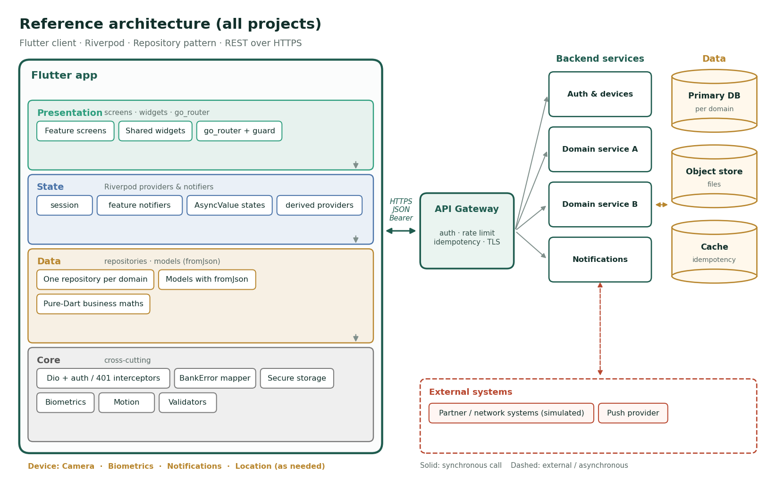
Figure A · Reference architecture shared by all ten projects
Layer | Responsibility
Presentation | Screens and widgets; routing with go_router and a session-driven guard. Knows nothing about HTTP.
State | Riverpod providers and notifiers holding AsyncValues. Screens watch; handlers read.
Data | One repository per backend domain. Converts JSON to models at the border and DioException to BankError. Pure-Dart business maths lives here and is unit-tested.
Core | Shared, feature-agnostic code: the Dio client and interceptors, the error mapper, secure storage, biometrics, motion, validators.
API gateway | Authentication, rate limiting, idempotency and TLS termination. In class, the provided mock server plays this role.
Services & data | Simulated by the mock backend. The app must not assume anything about them beyond the API contract.

Folder structure template
lib/
├── main.dart ProviderScope, session restore
├── app/ app.dart · router.dart · routes.dart · theme.dart
├── core/
│ ├── errors/ bank_error.dart
│ ├── network/ api_config.dart · api_client.dart · error_mapper.dart
│ ├── security/ secure_session_store.dart · biometric_service.dart · app_lock.dart
│ ├── motion/ motion.dart · …
│ ├── utils/ money.dart · date_format.dart · validators.dart
│ └── widgets/ async_error_view.dart · skeleton.dart · …
└── features/
└── <feature>/
├── domain/ models (fromJson)
├── data/ <feature>_repository.dart
├── state/ <feature>_provider.dart
├── presentation/ screens
└── widgets/ feature-only widgets
test/ unit/ · widget/ · helpers/ (fake API, test app, flows)
integration_test/

API conventions (all projects)
Topic | Convention
Money | Integer paise in JSON ("amountPaise": 50000). Never floats, never formatted strings.
Dates | ISO-8601 UTC strings; the app converts to local time once, in the model.
Errors | { "error": { "code", "message", "details", "traceId" } } with 400/401/403/404/409/422/5xx semantics as taught in Module 4.
Idempotency | Idempotency-Key header on every mutating call that moves money or creates a record; same key → same response.
Paging | Cursor paging (?cursor=&limit=) returning { items, nextCursor }.
Auth | Authorization: Bearer <token>; 401 means sign in again.

Backend options
Option | When to use it
A · Mock Node API (recommended) | Extend the BankEase API: in-memory data, the error shape, idempotency and the chaos switches already exist. Fastest path and fully controllable in class.
B · Firebase | Firebase Auth for identity, Firestore for data with owner-scoped read rules, and a small trusted server (or Cloud Functions) for every money movement — the pattern from the BankEase Firebase edition.
C · json-server | Quick start for UI-heavy projects (BranchQ, SpendWise). Idempotency and error shapes must then be simulated in a fake adapter for tests.

Milestones, deliverables and evaluation
Milestone | Deliverables | Modules
1 · Foundations | Folder structure, theme, router with guard, login, models with fromJson + unit tests | M1–M3
2 · Data | Repositories, error mapping, all read screens with loading/error/empty states | M4
3 · Money & forms | All Must write flows with validation and idempotency | M2–M4
4 · Quality | Profiling numbers, skeletons, motion, secure storage, biometric lock, FLAG_SECURE | M5
5 · Ship | Tests to ≥ 70%, CI green, signed release build, demo and retrospective | M6–M7

Submission checklist
- Git repository with a protected main, pull-request history, and CI badges green.
- README: setup, how to run the mock API, environment variables, architecture diagram, and known limitations.
- A 5-minute demo video of the main journey, including one failure path (no network or server error).
- Profiling evidence: before/after worst-frame numbers for one list screen.
- Signed release build (APK or AAB) with symbols kept.

Evaluation rubric (100 points)
Area | What earns the points | Points
Functional completeness | All Must features working; Should features attempted | 25
Architecture & code quality | Layers respected; no Dio in widgets; readable, formatted, analyzer-clean | 15
State management | Correct watch/read; immutable state; no stale data after mutations | 10
API & error handling | Repositories, BankError, three states per screen, idempotency | 15
Performance & motion | Measured improvements; purposeful animations; reduce motion | 10
Security | Secure storage, biometric lock, FLAG_SECURE, clean logs, obfuscated release | 10
Testing & CI/CD | Coverage, meaningful tests, pipeline, protected main | 10
Demo & communication | Clear demo, honest retrospective, architecture explained | 5

P01 · PayLite
UPI-style person-to-person payments with QR scan-and-pay
Theme | Payments
Level | Advanced
Device features | Camera · Biometrics · Contacts · Push notifications
The hard part | Payment status is not binary. The hard part is modelling SUCCESS / PENDING / FAILED honestly, polling without leaking timers, and making retries safe.

1. Problem statement
Context. Digital payments in India are dominated by UPI: a customer pays another person or a shop by scanning a QR code or entering a UPI ID (VPA), and the money moves instantly. A mid-sized bank wants its own lightweight payments app so customers stop leaving for third-party wallets.
Problem. Customers today must open the full net-banking app, add a beneficiary and wait for activation before paying someone new. Small payments — splitting a dinner bill, paying a vegetable seller — are too slow, and failed or duplicate payments generate a high volume of support calls.
Goal. Build PayLite, a Flutter app that lets a signed-in customer pay any VPA or QR code in under ten seconds, request money from others, split a bill between friends, and see every payment's status in real time — without ever charging twice.

2. Users
Persona | Situation | What they need
Priya, 24, software engineer | Splits rent and dinners with flatmates weekly | Fast payments and one-tap requests
Ramesh, 48, vegetable vendor | Receives dozens of small payments daily | A clear "received" confirmation he can trust
Asha, 62, retired teacher | Pays occasionally, anxious about mistakes | Large text, a confirm step, and a visible PIN step

3. Features
10 features: 7 Must · 2 Should · 1 Could — in addition to baseline requirements B1–B9.
ID | Feature | Description | Modules | Priority
F1 | Sign in and device binding | Login with customer ID + PIN; the device is bound on first login and the session is restored from secure storage with biometric unlock. | M4, M5 | Must
F2 | Home and balance | Primary account balance (hidden by default), recent payments, and quick actions: Scan, Pay, Request, Split. | M2, M3 | Must
F3 | Scan and pay | Scan a UPI QR code with the camera, parse payee name, VPA and optional amount, then go to the pay screen pre-filled. | M2, M5 | Must
F4 | Pay to VPA | Enter a VPA, verify it with the server (shows the registered name), enter amount and note, review, and confirm with the UPI PIN. | M2, M4 | Must
F5 | Idempotent payment | Every payment attempt carries an Idempotency-Key created once per review screen; a timeout followed by retry never debits twice. | M4, M6 | Must
F6 | Payment status | Payments can be SUCCESS, PENDING or FAILED; pending payments are polled every 5 s for up to 2 minutes, then shown as "Pending — we will notify you". | M3, M4 | Must
F7 | Request money | Send a collect request to a VPA; the receiver sees it in "Requests" and can pay or decline. | M3, M4 | Should
F8 | Split bill | Pick 2–10 contacts, split equally or by custom amounts that must add up to the total, and send one collect request each. | M2, M3 | Should
F9 | History and search | Infinite-scroll payment history with filters (sent, received, failed) and search by name or VPA. | M2, M4, M5 | Must
F10 | Receipt and share | A receipt screen with reference number, time and status, shareable as text. | M2 | Could

4. Acceptance criteria
F1 · Sign in and device binding (Must)
- A second device cannot use a session token issued to the first
- Reopening the app requires biometrics before any balance is shown
F2 · Home and balance (Must)
- Balance is hidden until the eye is tapped
- Pull to refresh re-fetches balance and recent payments
F3 · Scan and pay (Must)
- A malformed QR shows "This is not a valid payment QR" and never navigates
- A QR with a fixed amount locks the amount field
F4 · Pay to VPA (Must)
- Unknown VPAs show "No account found for this UPI ID" before the amount step
- Amounts above ₹1,00,000 are blocked with the limit message
F5 · Idempotent payment (Must)
- A retry after a 30-second timeout returns the original receipt
- A unit test proves one key produces exactly one debit
F6 · Payment status (Must)
- A pending payment turns into success on screen without the user refreshing
- Polling stops when the screen is closed
F7 · Request money (Should)
- A declined request shows "Declined" on the requester's side within one refresh
- Expired requests (48 h) cannot be paid
F8 · Split bill (Should)
- Custom amounts that do not add up disable Send and show the difference
- Each participant's status (paid/pending) is visible
F9 · History and search (Must)
- 500+ rows scroll at 60 fps in profile mode
- Filters and search combine
F10 · Receipt and share (Could)
- The UPI reference number is copyable with one tap

5. Screens and navigation
Screen | Route | Purpose
Login | /login | Customer ID + PIN, then device binding
Lock | overlay | Biometric unlock on resume
Home | /home | Balance, quick actions, recent payments
Scan | /scan | Camera QR scanner
Pay | /pay?vpa=… | VPA, verified name, amount, note
Review | /pay/review | Summary and confirm
UPI PIN | /pay/pin | 4–6 digit PIN pad
Status | /pay/status/:id | Success / pending / failed
Requests | /requests | Incoming and outgoing collect requests
Split | /split | Participants and amounts
History | /history | Filters, search, infinite scroll
Receipt | /history/:id | Shareable receipt

6. Data model
Entity | Fields
Account | id, maskedNumber, balancePaise, primaryVpa
Vpa | address, verifiedName, bankName
Payment | id, direction, counterparty, amountPaise, note, status, upiRef, createdAt
CollectRequest | id, from, to, amountPaise, status, expiresAt
SplitGroup | id, totalPaise, participants[]

All money fields are integer paise; all timestamps are ISO-8601 UTC.

7. API contract
Method | Path | Purpose | Notable errors
POST | /auth/login | Customer ID + PIN → token + device id | 401, 423 locked
GET | /accounts/primary | Balance and primary VPA | 401
GET | /vpa/{address} | Verify a VPA, return the registered name | 404 VPA_NOT_FOUND
POST | /payments | Pay (Idempotency-Key header, UPI PIN hash) | 422 INSUFFICIENT_FUNDS, 422 LIMIT_EXCEEDED, 409 KEY_REUSED
GET | /payments/{id} | Poll a payment status | 404
GET | /payments?cursor=&filter=&q= | History with cursor paging | —
POST | /collect-requests | Request money | 404, 422
POST | /collect-requests/{id}/pay | /decline | Act on a request | 410 EXPIRED

8. Non-functional requirements
Quality | Requirement (in addition to the baseline)
Performance | Pay flow from Scan to Status in under 10 s on a mid-range phone; history scrolls at 60 fps with 500 rows (profile mode)
Reliability | Zero duplicate debits under retry; pending payments resolve or are reported within 2 minutes
Security | Token and device id in Keychain/Keystore; UPI PIN never stored or logged, sent only as a hash; FLAG_SECURE on pay and PIN screens
Availability | If the server is down, the app shows a clear status and never shows a stale balance as current
Accessibility | PIN pad and amounts readable at 200% font scale; every icon button has a tooltip; reduce motion honoured
Usability | A first-time user can pay a QR in 3 taps after scanning
Testability | ≥ 70% line coverage; idempotency and status polling covered by unit tests; one integration test from scan to status
Observability | Every error carries the server traceId in debug logs; no personal data in logs

9. Architecture
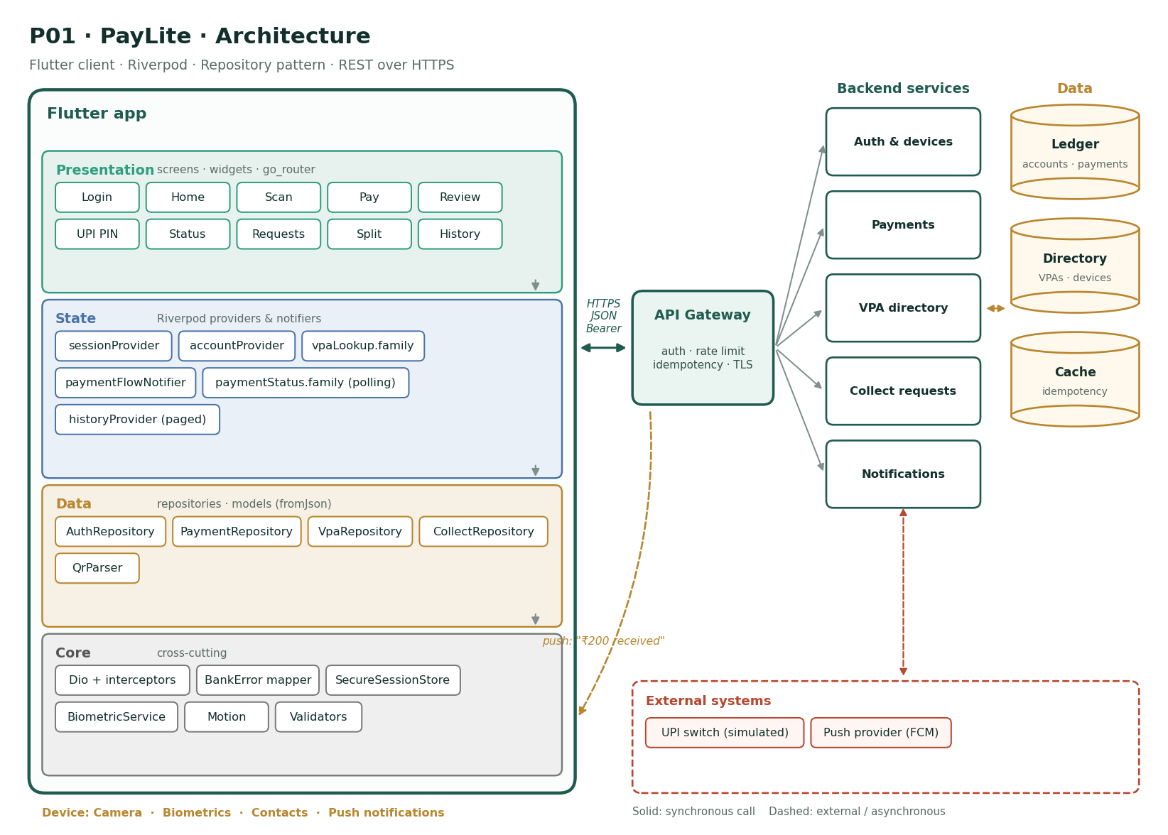
Figure P01 · PayLite architecture
- Presentation: 10 screens (Login, Home, Scan, Pay, Review, UPI PIN, Status, Requests, Split, History), all routed through go_router with the session guard.
- State: sessionProvider, accountProvider, vpaLookup.family, paymentFlowNotifier, paymentStatus.family (polling), historyProvider (paged). Screens watch these; buttons read their notifiers.
- Data: AuthRepository, PaymentRepository, VpaRepository, CollectRepository, QrParser — each repository owns one backend domain and throws only BankError.
- Core: Dio + interceptors, BankError mapper, SecureSessionStore, BiometricService, Motion, Validators.
- Backend (simulated): Auth & devices, Payments, VPA directory, Collect requests, Notifications, over Ledger, Directory, Cache.
- External systems (simulated): UPI switch (simulated), Push provider (FCM). Treat them as unreliable: they can be slow, down, or return partial results.
- Push: push: "₹200 received" — the notification opens the related screen through a deep link.

10. Edge cases the solution must handle
- The camera permission is denied: show why it is needed and a button to open settings
- A QR encodes a VPA with a trailing space or lowercase letters: normalise before verifying
- The network drops after the PIN is entered: show Pending, never "Failed", until the server confirms
- The user double-taps Confirm: only one request leaves the device
- A collect request expires while the user is on its screen: disable Pay and explain
- Split amounts in paise do not divide evenly (₹100 / 3): assign the extra paise to the first participant

11. Stretch goals
- Offline QR "pay later" queue that sends when back online, with the same idempotency key
- Home-screen widget showing the last 3 payments
- Merchant mode with a static QR and a daily collection summary

12. Definition of done
Area | Done when…
Features | All Must features and baseline B1–B9 working against the mock API
The hard part | Payment status is not binary. The hard part is modelling SUCCESS / PENDING / FAILED honestly, polling without leaking timers, and making retries safe.
Tests | Business rules unit-tested; widget tests for every Must screen; one integration test for the main journey; ≥ 70% coverage
Quality | Profiling numbers in the PR; skeletons; reduce motion; FLAG_SECURE where money or identity is shown
Delivery | CI green on protected main; signed, obfuscated release build; README with setup and this architecture

P02 · CardVault
Debit and credit card control centre
Theme | Cards
Level | Intermediate
Device features | Biometrics · Secure screen · Push notifications
The hard part | Optimistic UI done right: instant toggles that stay truthful when the network fails, plus a reveal screen that is genuinely secure.

1. Problem statement
Context. Card fraud and lost cards are the most common reasons customers call a bank. Today, freezing a card or changing its limits means a phone call and a 20-minute wait.
Problem. Customers cannot see all their cards in one place, cannot temporarily freeze a card they have misplaced, and cannot turn off international or online use when they do not need it. Every change is a support ticket.
Goal. Build CardVault, a Flutter app where customers see all their debit and credit cards, freeze and unfreeze them instantly, set spending limits and channel controls, view credit card statements and dues, and reveal card details securely.

2. Users
Persona | Situation | What they need
Kiran, 31, frequent traveller | Uses cards abroad a few times a year | Turn international use on only when travelling
Meena, 40, small-business owner | Holds three credit cards | Track dues and avoid late fees
Arjun, 22, student | First debit card, often misplaces it | Freeze first, search the bag later

3. Features
10 features: 7 Must · 2 Should · 1 Could — in addition to baseline requirements B1–B9.
ID | Feature | Description | Modules | Priority
F1 | Card wallet | All cards as a horizontal carousel of card visuals (network, masked number, expiry, status badge). | M2, M5 | Must
F2 | Freeze / unfreeze | Instantly freeze or unfreeze a card with a confirmation sheet; the change is optimistic and rolls back on failure. | M3, M4 | Must
F3 | Channel controls | Toggle online, contactless, ATM and international usage per card. | M2, M3, M4 | Must
F4 | Spending limits | Set daily limits per channel with a slider and a text field; limits cannot exceed the bank maximum. | M2, M3 | Must
F5 | Reveal card details | Show full number, expiry and CVV for 30 seconds after biometric check, with copy buttons, then auto-hide. | M5 | Must
F6 | Credit card summary | Credit limit, available limit, current outstanding, minimum due and due date, with a progress ring. | M2, M4 | Must
F7 | Statements | Monthly statements list, statement detail with transactions grouped by date, and category totals. | M2, M4, M5 | Should
F8 | Pay credit card bill | Pay minimum, total or custom amount from a savings account (idempotent). | M4 | Should
F9 | Report lost / stolen | Permanently block a card with a reason and request a replacement; irreversible, with a typed confirmation. | M2, M4 | Must
F10 | Transaction alerts | A notifications list of recent card transactions with merchant and location. | M3, M4 | Could

4. Acceptance criteria
F1 · Card wallet (Must)
- Frozen cards show a frost overlay and a "Frozen" badge
- The carousel animates between cards with page snapping
F2 · Freeze / unfreeze (Must)
- The toggle updates immediately and reverts with an error message if the server rejects it
- Freezing requires biometric confirmation
F3 · Channel controls (Must)
- Each toggle saves independently; a failed save reverts only that toggle
- International can be enabled with an end date (auto-off)
F4 · Spending limits (Must)
- The slider and text field stay in sync
- Values above the maximum are clamped with a message
F5 · Reveal card details (Must)
- Details auto-hide after 30 s or when the app goes to background
- Screenshots are blocked on this screen
F6 · Credit card summary (Must)
- Due within 3 days shows a warning banner
- Amounts are formatted in Indian grouping
F7 · Statements (Should)
- Switching months keeps scroll position per month
- Large statements stay at 60 fps
F8 · Pay credit card bill (Should)
- Paying twice with the same key debits once
F9 · Report lost / stolen (Must)
- The user must type BLOCK to confirm
- A blocked card cannot be unfrozen
F10 · Transaction alerts (Could)
- Tapping an alert opens the transaction detail

5. Screens and navigation
Screen | Route | Purpose
Login | /login | Sign in
Wallet | /cards | Card carousel and quick controls
Card detail | /cards/:id | Controls, limits, recent transactions
Limits | /cards/:id/limits | Per-channel sliders
Reveal | /cards/:id/reveal | Secure details (30 s)
Credit summary | /cards/:id/credit | Dues and ring
Statements | /cards/:id/statements | Month list
Statement | /cards/:id/statements/:month | Transactions by date
Pay bill | /cards/:id/pay | Amount options
Block | /cards/:id/block | Lost / stolen flow

6. Data model
Entity | Fields
Card | id, type, network, maskedNumber, expiry, status (ACTIVE/FROZEN/BLOCKED)
Controls | online, contactless, atm, international, internationalUntil
Limits | atmDailyPaise, posDailyPaise, onlineDailyPaise, maxPaise
CreditSummary | limitPaise, availablePaise, outstandingPaise, minDuePaise, dueDate
Statement | month, openingPaise, closingPaise, transactions[]

All money fields are integer paise; all timestamps are ISO-8601 UTC.

7. API contract
Method | Path | Purpose | Notable errors
GET | /cards | All cards | 401
PATCH | /cards/{id}/status | FREEZE / UNFREEZE | 409 BLOCKED
PUT | /cards/{id}/controls | Channel toggles | 422
PUT | /cards/{id}/limits | Daily limits | 422 ABOVE_MAX
POST | /cards/{id}/reveal | One-time sensitive details (short-lived token) | 403
GET | /cards/{id}/credit-summary | Dues | —
GET | /cards/{id}/statements | Months | —
GET | /cards/{id}/statements/{month} | Transactions | 404
POST | /cards/{id}/payments | Pay bill (Idempotency-Key) | 422
POST | /cards/{id}/block | Permanent block | 409

8. Non-functional requirements
Quality | Requirement (in addition to the baseline)
Performance | Freeze toggle feels instant (optimistic UI, < 100 ms visual response); carousel at 60 fps
Security | Card number, expiry and CVV never stored on the device, never logged, never in a screenshot; revealed data cleared from memory on hide
Consistency | Optimistic updates always reconcile with the server; a failed save reverts and explains
Accessibility | Card visuals have semantic labels ("Visa debit ending 4417, frozen"); toggles announce state
Usability | Freeze reachable in at most 2 taps from launch
Testability | Optimistic rollback covered by unit tests; widget tests for every control; ≥ 70% coverage
Reliability | Duplicate bill payments impossible (idempotency)
Compliance | Show last 4 digits only, everywhere except the reveal screen (PCI DSS display rule)

9. Architecture
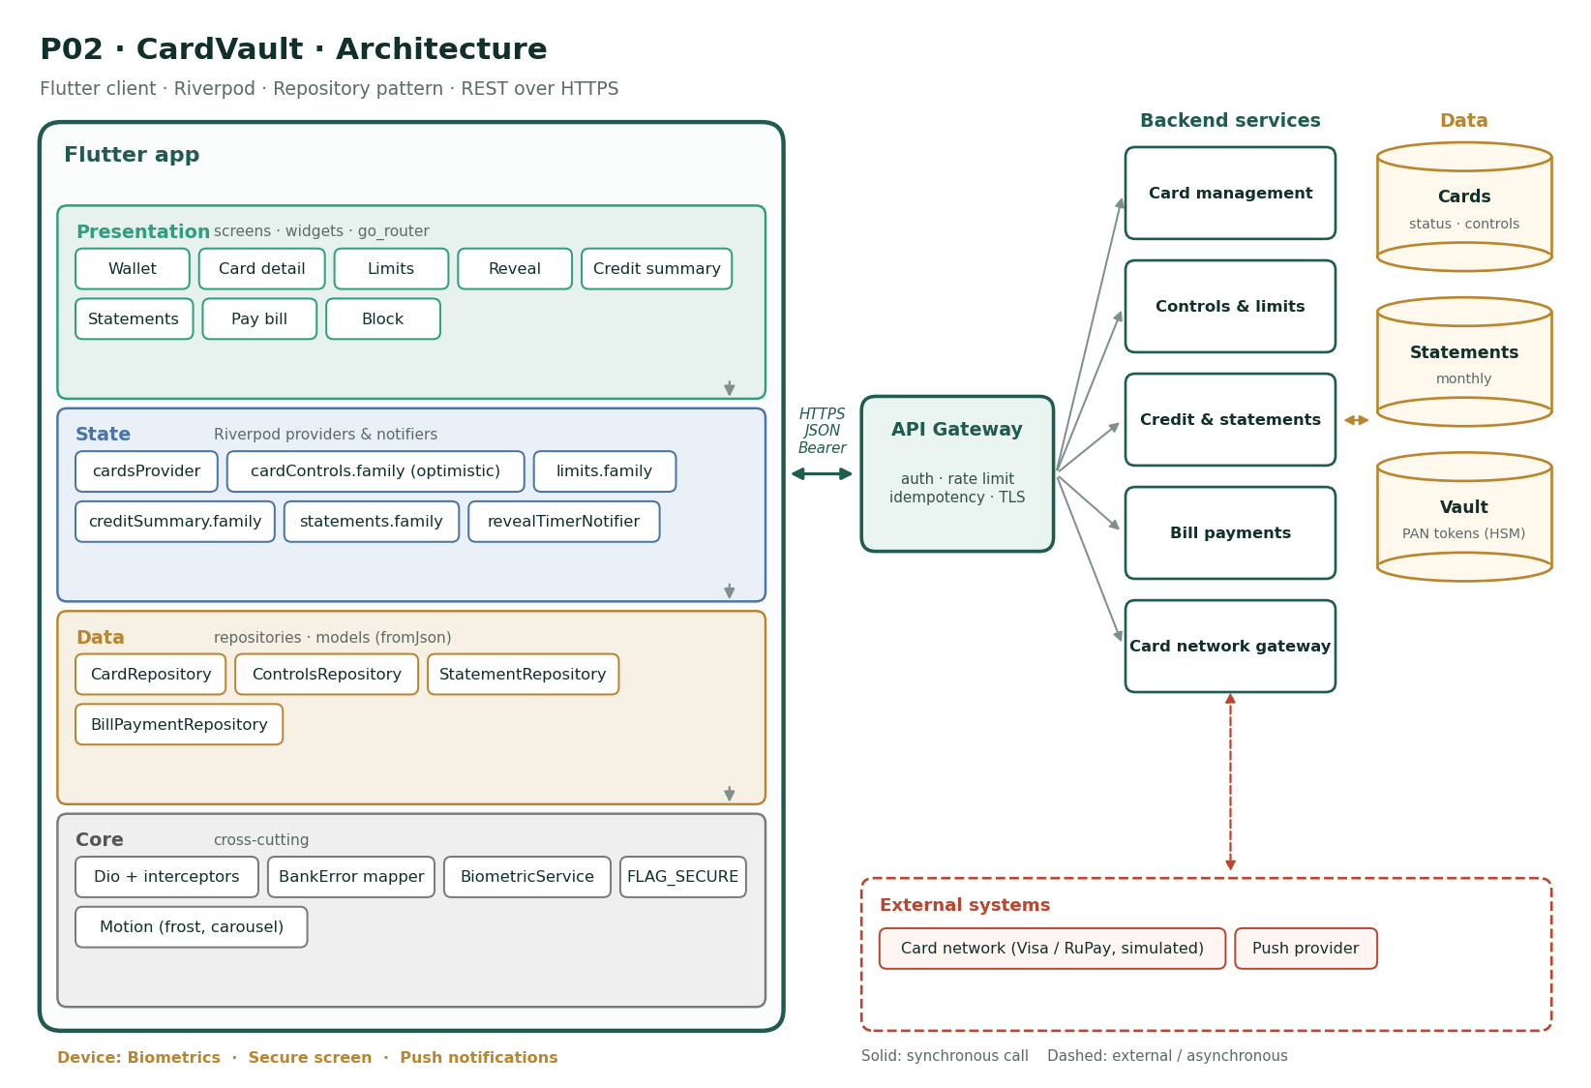
Figure P02 · CardVault architecture
- Presentation: 8 screens (Wallet, Card detail, Limits, Reveal, Credit summary, Statements, Pay bill, Block), all routed through go_router with the session guard.
- State: cardsProvider, cardControls.family (optimistic), limits.family, creditSummary.family, statements.family, revealTimerNotifier. Screens watch these; buttons read their notifiers.
- Data: CardRepository, ControlsRepository, StatementRepository, BillPaymentRepository — each repository owns one backend domain and throws only BankError.
- Core: Dio + interceptors, BankError mapper, BiometricService, FLAG_SECURE, Motion (frost, carousel).
- Backend (simulated): Card management, Controls & limits, Credit & statements, Bill payments, Card network gateway, over Cards, Statements, Vault.
- External systems (simulated): Card network (Visa / RuPay, simulated), Push provider. Treat them as unreliable: they can be slow, down, or return partial results.

10. Edge cases the solution must handle
- Freeze succeeds on the server but the response is lost: the next refresh must show the true state
- Two quick taps on the same toggle: the last intent wins, and only one request per toggle is in flight
- The reveal timer is running when a phone call arrives: details are hidden immediately
- International auto-off date is in the past: reject with a clear message
- A blocked card appears in the wallet: controls are hidden, only "Replacement status" is shown
- Statement for a month with no transactions: show an empty state, not an error

11. Stretch goals
- Virtual card generation for one-time online use
- Merchant category blocking (gambling, crypto)
- Card-level spend analytics chart

12. Definition of done
Area | Done when…
Features | All Must features and baseline B1–B9 working against the mock API
The hard part | Optimistic UI done right: instant toggles that stay truthful when the network fails, plus a reveal screen that is genuinely secure.
Tests | Business rules unit-tested; widget tests for every Must screen; one integration test for the main journey; ≥ 70% coverage
Quality | Profiling numbers in the PR; skeletons; reduce motion; FLAG_SECURE where money or identity is shown
Delivery | CI green on protected main; signed, obfuscated release build; README with setup and this architecture

P03 · LoanEase
Personal loan application and EMI tracker
Theme | Lending
Level | Advanced
Device features | Camera · File picker · Biometrics
The hard part | A long, interruptible workflow: resumable drafts, reliable uploads with progress, and money maths that are provably correct.

1. Problem statement
Context. Personal loan applications still involve paper forms, branch visits and a week of back-and-forth for missing documents. Most drop-offs happen at the documents step.
Problem. Applicants do not know whether they are eligible until after applying, cannot see where their application is stuck, and existing borrowers have no clear view of their EMI schedule or the effect of a prepayment.
Goal. Build LoanEase: an eligibility checker, a multi-step application with document upload and resumable drafts, live application tracking, and an EMI dashboard with a prepayment simulator.

2. Users
Persona | Situation | What they need
Sunil, 29, salaried | Needs ₹3 lakh for a wedding | Know eligibility and EMI before applying
Farah, 35, self-employed | Irregular income, many documents | Save progress and finish later
Vikram, 45, existing borrower | Paying an EMI for 2 years | See how a prepayment shortens the loan

3. Features
10 features: 7 Must · 2 Should · 1 Could — in addition to baseline requirements B1–B9.
ID | Feature | Description | Modules | Priority
F1 | EMI calculator | Amount, tenure and rate sliders with live EMI, total interest and a principal/interest chart. | M2, M3 | Must
F2 | Eligibility check | Income, obligations and employment type → server returns eligible amount and indicative rate. | M2, M4 | Must
F3 | Multi-step application | 5 steps: personal, employment, loan details, documents, review — with a progress stepper and per-step validation. | M2, M3 | Must
F4 | Resumable draft | Each step is saved as a server draft; reopening the app resumes at the last incomplete step. | M3, M4 | Must
F5 | Document upload | Capture or pick PAN, Aadhaar (masked), salary slips and bank statement; show upload progress, retry and replace. | M4, M5 | Must
F6 | Submit and consent | Review screen with all details, explicit consent checkboxes and a final submit (idempotent). | M2, M4 | Must
F7 | Application tracker | Timeline: Submitted → Documents verified → Credit check → Approved/Rejected → Disbursed, with timestamps. | M2, M3, M4 | Must
F8 | Loan dashboard | Active loans with outstanding principal, next EMI date and a paid/remaining progress bar. | M2, M4 | Should
F9 | EMI schedule | Full amortisation table (month, EMI, principal, interest, balance) with infinite scroll. | M2, M5 | Should
F10 | Prepayment simulator | Enter a prepayment → compare "reduce tenure" vs "reduce EMI" side by side, with interest saved. | M3 | Could

4. Acceptance criteria
F1 · EMI calculator (Must)
- EMI matches the standard formula to the paise (unit-tested)
- Changing any slider updates results within one frame
F2 · Eligibility check (Must)
- Soft check: no credit-score impact message shown
- Ineligible users see the reason and a smaller suggested amount
F3 · Multi-step application (Must)
- The Next button is disabled until the step is valid
- Back never loses entered data
F4 · Resumable draft (Must)
- Killing the app on step 3 and reopening resumes on step 3 with data
- Drafts expire after 30 days with a warning
F5 · Document upload (Must)
- Files over 5 MB are compressed or rejected with a message
- A failed upload can be retried without re-selecting the file
F6 · Submit and consent (Must)
- Submit is disabled until both consents are ticked
- Double submit creates one application
F7 · Application tracker (Must)
- Status refreshes on pull and on resume
- Rejected shows the reason category
F8 · Loan dashboard (Should)
- Overdue EMIs show a red banner with the amount due
F9 · EMI schedule (Should)
- 360-row schedules scroll smoothly
F10 · Prepayment simulator (Could)
- Results computed locally and match the server within ₹1

5. Screens and navigation
Screen | Route | Purpose
Home | /home | Offers and active loans
Calculator | /calculator | Sliders and chart
Eligibility | /eligibility | Soft check
Apply (stepper) | /apply/:step | 5 steps
Documents | /apply/documents | Upload list
Review & consent | /apply/review | Submit
Tracker | /applications/:id | Timeline
Loan | /loans/:id | Dashboard
Schedule | /loans/:id/schedule | Amortisation
Prepay | /loans/:id/prepay | Simulator

6. Data model
Entity | Fields
Application | id, status, currentStep, draft{…}, createdAt, updatedAt
Document | id, type, fileName, sizeBytes, status (UPLOADING/UPLOADED/REJECTED)
StatusEvent | status, at, note
Loan | id, principalPaise, ratePct, tenureMonths, outstandingPaise, nextEmiDate
Installment | n, dueDate, emiPaise, principalPaise, interestPaise, balancePaise, paid

All money fields are integer paise; all timestamps are ISO-8601 UTC.

7. API contract
Method | Path | Purpose | Notable errors
POST | /eligibility | Soft eligibility check | 422
POST | /applications | Create draft | —
PATCH | /applications/{id} | Save a step | 422 field errors
POST | /applications/{id}/documents | Multipart upload with progress | 413 TOO_LARGE, 415 TYPE
POST | /applications/{id}/submit | Submit (Idempotency-Key) | 409, 422 INCOMPLETE
GET | /applications/{id} | Status + timeline | 404
GET | /loans | Active loans | —
GET | /loans/{id}/schedule | Amortisation | —
POST | /loans/{id}/prepayment-quote | Server quote | 422

8. Non-functional requirements
Quality | Requirement (in addition to the baseline)
Correctness | EMI and amortisation match the standard reducing-balance formula; money in paise, rounding rules documented and tested
Resilience | No data lost if the app is killed mid-application; uploads resume or retry cleanly
Performance | Calculator updates within one frame; 360-row schedule at 60 fps
Security | Documents never cached in shared storage; Aadhaar shown masked (XXXX XXXX 1234); consent timestamps recorded server-side
Accessibility | Stepper announces "Step 2 of 5"; sliders have text-field alternatives
Usability | Application completable in under 8 minutes with documents at hand
Testability | Unit tests for EMI maths and step validation; widget test for the full stepper; ≥ 75% coverage
Data minimisation | Only fields required for the loan type are collected

9. Architecture
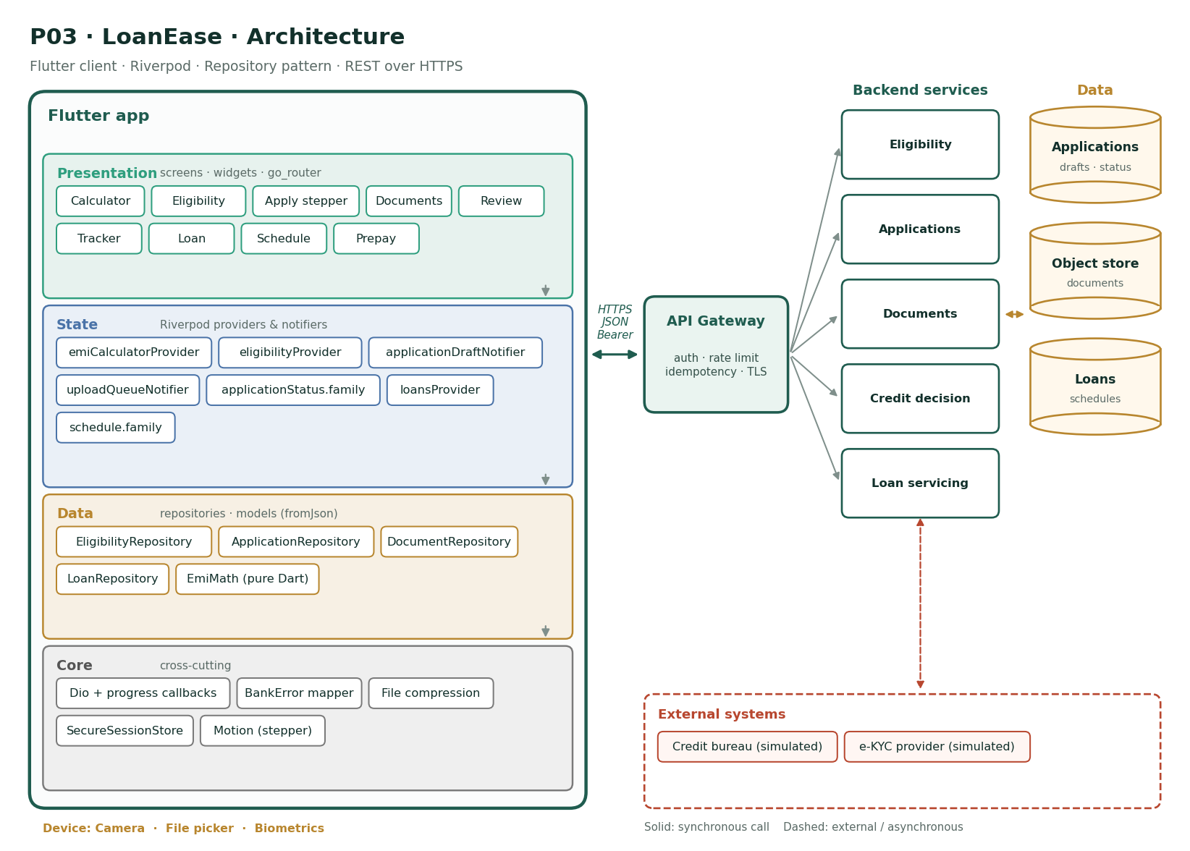
Figure P03 · LoanEase architecture
- Presentation: 9 screens (Calculator, Eligibility, Apply stepper, Documents, Review, Tracker, Loan, Schedule, Prepay), all routed through go_router with the session guard.
- State: emiCalculatorProvider, eligibilityProvider, applicationDraftNotifier, uploadQueueNotifier, applicationStatus.family, loansProvider, schedule.family. Screens watch these; buttons read their notifiers.
- Data: EligibilityRepository, ApplicationRepository, DocumentRepository, LoanRepository, EmiMath (pure Dart) — each repository owns one backend domain and throws only BankError.
- Core: Dio + progress callbacks, BankError mapper, File compression, SecureSessionStore, Motion (stepper).
- Backend (simulated): Eligibility, Applications, Documents, Credit decision, Loan servicing, over Applications, Object store, Loans.
- External systems (simulated): Credit bureau (simulated), e-KYC provider (simulated). Treat them as unreliable: they can be slow, down, or return partial results.

10. Edge cases the solution must handle
- Upload succeeds but the app is killed before the response: the document list must reconcile on resume
- Two devices edit the same draft: last save wins with a "changed elsewhere" notice
- Rate changes between calculator and submit: the review screen shows the final rate prominently
- A rejected document (blurry): show which one and allow replacing only that file
- Tenure slider at maximum with tiny amount: EMI rounding must never produce negative interest
- Consent withdrawn before decision: application moves to Withdrawn

11. Stretch goals
- Auto-fill from a salary slip photo (OCR)
- Push notifications on every status change
- Pre-approved offers for existing customers

12. Definition of done
Area | Done when…
Features | All Must features and baseline B1–B9 working against the mock API
The hard part | A long, interruptible workflow: resumable drafts, reliable uploads with progress, and money maths that are provably correct.
Tests | Business rules unit-tested; widget tests for every Must screen; one integration test for the main journey; ≥ 70% coverage
Quality | Profiling numbers in the PR; skeletons; reduce motion; FLAG_SECURE where money or identity is shown
Delivery | CI green on protected main; signed, obfuscated release build; README with setup and this architecture

P04 · SaveSmart
Goal-based savings, recurring and fixed deposits
Theme | Savings
Level | Intermediate
Device features | Local notifications · Biometrics
The hard part | Financial maths that must be exactly right, plus motion that motivates without getting in the way.

1. Problem statement
Context. Customers keep large idle balances in savings accounts earning very little, while saying they want to save for goals such as a bike, a trip or an emergency fund.
Problem. Opening an FD or RD requires a branch visit or a hard-to-find menu, customers cannot compare maturity amounts, and nothing links a deposit to a goal they care about.
Goal. Build SaveSmart: goal creation with progress, automatic round-up and scheduled savings, FD and RD booking with maturity calculators, and a clear view of every deposit.

2. Users
Persona | Situation | What they need
Neha, 27, first job | Saving for a two-wheeler in 10 months | See progress and stay motivated
Rao, 55, pre-retiree | Moves money into FDs regularly | Compare tenures and book in one minute
Imran, 33, family man | Wants an emergency fund | Automatic monthly saving he can forget about

3. Features
10 features: 5 Must · 3 Should · 2 Could — in addition to baseline requirements B1–B9.
ID | Feature | Description | Modules | Priority
F1 | Goals | Create a goal with name, target amount, target date and an icon; see a progress ring and required monthly saving. | M2, M3 | Must
F2 | Add money to a goal | One-off transfer from savings into a goal (idempotent) with a celebratory animation at milestones. | M4, M5 | Must
F3 | Auto-save rules | Round-up spare change, fixed weekly/monthly amount, or salary-day percentage; pause and resume. | M3, M4 | Should
F4 | FD calculator | Principal, tenure (7 days–10 years), payout type → maturity amount, interest and effective yield. | M2, M3 | Must
F5 | Book an FD | Choose account, amount, tenure, nominee and renewal instruction; review and confirm. | M2, M4 | Must
F6 | RD booking | Monthly instalment, tenure, debit date; shows the instalment schedule. | M2, M4 | Should
F7 | Deposits portfolio | All FDs and RDs with principal, rate, maturity date and a days-to-maturity bar; sort and filter. | M2, M4, M5 | Must
F8 | Premature withdrawal quote | Shows penalty-adjusted amount before breaking an FD; confirm with biometrics. | M4, M5 | Should
F9 | Nominee management | Add or change a nominee with relationship and share percentage totalling 100%. | M2 | Could
F10 | Maturity reminders | Local notification 7 days before maturity with a deep link. | M5 | Could

4. Acceptance criteria
F1 · Goals (Must)
- Target dates in the past are rejected
- Required monthly amount recalculates when target or date changes
F2 · Add money to a goal (Must)
- Milestone animation at 25/50/75/100%, skipped with reduce motion
- A retry never moves money twice
F3 · Auto-save rules (Should)
- Paused rules show "Paused since …"
- Rules cannot exceed 3 per goal
F4 · FD calculator (Must)
- Matches the quarterly compounding formula (unit-tested)
- Senior citizen toggle adds 0.5%
F5 · Book an FD (Must)
- Minimum ₹1,000 enforced
- Booking is idempotent
F6 · RD booking (Should)
- Debit date limited to 1–28
F7 · Deposits portfolio (Must)
- Sorting keeps the list at 60 fps with 200 deposits
F8 · Premature withdrawal quote (Should)
- The quote expires after 10 minutes
F9 · Nominee management (Could)
- Shares must add to 100%
F10 · Maturity reminders (Could)
- Tapping the notification opens that deposit

5. Screens and navigation
Screen | Route | Purpose
Home | /home | Goals and deposits summary
Goals | /goals | Goal cards
New goal | /goals/new | Form
Goal | /goals/:id | Progress, rules, history
Auto-save | /goals/:id/rules | Rules
FD calculator | /fd/calculator | Maturity maths
Book FD | /fd/new | Booking flow
RD | /rd/new | RD flow
Deposits | /deposits | Portfolio
Deposit | /deposits/:id | Detail and withdrawal quote

6. Data model
Entity | Fields
Goal | id, name, icon, targetPaise, savedPaise, targetDate, status
AutoSaveRule | id, goalId, type, amountPaise|percent, schedule, paused
Deposit | id, kind (FD/RD), principalPaise, ratePct, startDate, maturityDate, maturityPaise, payout, renewal
Nominee | name, relation, sharePct

All money fields are integer paise; all timestamps are ISO-8601 UTC.

7. API contract
Method | Path | Purpose | Notable errors
GET/POST | /goals | List / create | 422
POST | /goals/{id}/contributions | Add money (Idempotency-Key) | 422 INSUFFICIENT_FUNDS
PUT | /goals/{id}/rules | Auto-save rules | 422
GET | /deposits/rates | Rate card by tenure | —
POST | /deposits | Book FD/RD (Idempotency-Key) | 422
GET | /deposits | Portfolio | —
POST | /deposits/{id}/withdrawal-quote | Premature quote | 409
POST | /deposits/{id}/withdraw | Confirm with quote id | 410 QUOTE_EXPIRED

8. Non-functional requirements
Quality | Requirement (in addition to the baseline)
Correctness | Maturity maths match published bank formulas to the rupee; rates always from the server, never hard-coded
Performance | Portfolio of 200 deposits sorts and scrolls at 60 fps
Security | Withdrawal requires biometric confirmation; FLAG_SECURE on booking review
Delight | Milestone animations under 1.2 s and never blocking; reduce motion disables them
Accessibility | Progress rings expose percentage as text
Reliability | All money-moving calls idempotent
Testability | Calculator maths 100% unit-covered; ≥ 70% overall
Offline | Goals and portfolio readable offline from the last sync, clearly labelled

9. Architecture
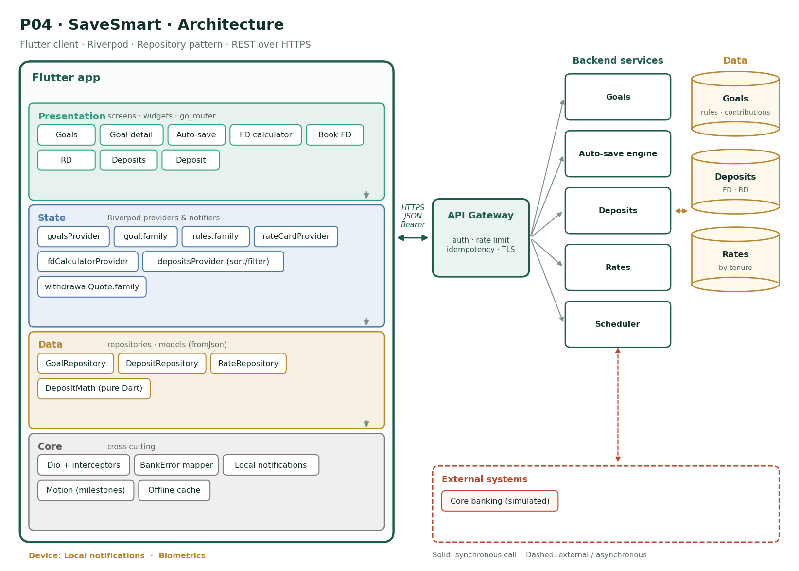
Figure P04 · SaveSmart architecture
- Presentation: 8 screens (Goals, Goal detail, Auto-save, FD calculator, Book FD, RD, Deposits, Deposit), all routed through go_router with the session guard.
- State: goalsProvider, goal.family, rules.family, rateCardProvider, fdCalculatorProvider, depositsProvider (sort/filter), withdrawalQuote.family. Screens watch these; buttons read their notifiers.
- Data: GoalRepository, DepositRepository, RateRepository, DepositMath (pure Dart) — each repository owns one backend domain and throws only BankError.
- Core: Dio + interceptors, BankError mapper, Local notifications, Motion (milestones), Offline cache.
- Backend (simulated): Goals, Auto-save engine, Deposits, Rates, Scheduler, over Goals, Deposits, Rates.
- External systems (simulated): Core banking (simulated). Treat them as unreliable: they can be slow, down, or return partial results.

10. Edge cases the solution must handle
- Rate card changes while the booking screen is open: re-quote before confirm
- Goal reached exactly: 100% animation once, then offer to create the next goal
- Round-up rule on a ₹0.00 fractional transaction: no contribution
- Withdrawal quote expired: fetch a new one, never use the old amount
- RD debit date on the 29th–31st: disallowed
- Offline with a stale portfolio: show "Last updated 2 h ago"

11. Stretch goals
- Shared family goals
- Tax-saver FD with 80C summary
- Charts of savings over time

12. Definition of done
Area | Done when…
Features | All Must features and baseline B1–B9 working against the mock API
The hard part | Financial maths that must be exactly right, plus motion that motivates without getting in the way.
Tests | Business rules unit-tested; widget tests for every Must screen; one integration test for the main journey; ≥ 70% coverage
Quality | Profiling numbers in the PR; skeletons; reduce motion; FLAG_SECURE where money or identity is shown
Delivery | CI green on protected main; signed, obfuscated release build; README with setup and this architecture

P05 · SpendWise
Expense analytics and monthly budgets
Theme | Personal finance
Level | Intermediate
Device features | Notifications · Share sheet
The hard part | Fast aggregation and charts over large data, and a recategorisation flow that feels instant yet stays consistent.

1. Problem statement
Context. Most customers have no idea where their money goes each month. Transactions are a long list of cryptic merchant strings.
Problem. Raw statements are unreadable, categories are missing, and there is no warning before a budget is exceeded.
Goal. Build SpendWise: auto-categorised transactions, monthly and category charts, budgets with alerts, merchant insights, and a way to fix wrong categories that the app remembers.

2. Users
Persona | Situation | What they need
Ananya, 26, spends mostly online | Wants to cut food delivery | See category totals and trends
Deepak, 38, household budget owner | Manages family expenses | Budgets per category with early warnings
Sara, 30, freelancer | Irregular income | Month-over-month comparison

3. Features
10 features: 5 Must · 3 Should · 2 Could — in addition to baseline requirements B1–B9.
ID | Feature | Description | Modules | Priority
F1 | Categorised feed | Transactions with category icon, cleaned merchant name and amount, grouped by day. | M2, M4, M5 | Must
F2 | Recategorise and learn | Change a transaction's category; optionally apply to all from that merchant. | M3, M4 | Must
F3 | Monthly overview | Total spent vs last month, top categories donut chart, daily spend line chart. | M2, M5 | Must
F4 | Budgets | Monthly budget per category with progress bars coloured by risk. | M2, M3, M4 | Must
F5 | Budget alerts | Notification when a transaction pushes a category over 80% or 100%. | M4, M5 | Should
F6 | Merchant insights | Per-merchant totals, visit count and average spend. | M2, M4 | Should
F7 | Search and filters | Search merchants; filter by category, amount range and date range. | M2, M3 | Must
F8 | Month switcher | Swipe between months with cached data. | M3, M5 | Should
F9 | Export | Export a month as CSV via the share sheet. | M4 | Could
F10 | Insights cards | "You spent 32% more on food this month" style cards generated by the server. | M4 | Could

4. Acceptance criteria
F1 · Categorised feed (Must)
- 1,000 transactions scroll at 60 fps
- Day headers stay sticky
F2 · Recategorise and learn (Must)
- "Apply to all" updates past and future matches
- Undo within 5 s
F3 · Monthly overview (Must)
- Charts render in under 300 ms for a month of data
- Tapping a slice filters the feed
F4 · Budgets (Must)
- At 80% the bar turns amber, at 100% red
- Budgets roll over monthly
F5 · Budget alerts (Should)
- At most one alert per category per threshold per month
F6 · Merchant insights (Should)
- Sorted by total by default
F7 · Search and filters (Must)
- Filters combine and survive navigating away and back
F8 · Month switcher (Should)
- Previously viewed months load instantly from cache
F9 · Export (Could)
- CSV has a header row and ISO dates
F10 · Insights cards (Could)
- Cards are dismissible

5. Screens and navigation
Screen | Route | Purpose
Overview | /overview | Charts and totals
Feed | /transactions | Categorised list
Transaction | /transactions/:id | Detail and recategorise
Budgets | /budgets | Progress bars
Budget edit | /budgets/:category | Set amount
Merchants | /merchants | Insights
Merchant | /merchants/:id | History
Filters | sheet | Filter sheet

6. Data model
Entity | Fields
Transaction | id, merchantRaw, merchantName, category, amountPaise, at, mode
Category | id, name, icon, color
Budget | category, month, limitPaise, spentPaise
MerchantRule | merchantKey, category
MonthSummary | month, totalPaise, byCategory{}, byDay[]

All money fields are integer paise; all timestamps are ISO-8601 UTC.

7. API contract
Method | Path | Purpose | Notable errors
GET | /transactions?month=&category=&q=&cursor= | Feed | —
PATCH | /transactions/{id} | Change category (+applyToMerchant) | 422
GET | /summary?month= | Month summary | —
GET/PUT | /budgets?month= | Budgets | 422
GET | /merchants?month= | Merchant insights | —
GET | /insights | Insight cards | —

8. Non-functional requirements
Quality | Requirement (in addition to the baseline)
Performance | Feed of 1,000 rows at 60 fps; month switch < 200 ms when cached; chart build off the UI thread when the month is large
Accuracy | Category totals equal the sum of their transactions to the paise
Privacy | Analytics computed per user; exports never leave the device except through the user's share action
Accessibility | Charts have a table alternative; colour is never the only signal
Usability | Recategorising takes at most 2 taps
Testability | Aggregation logic unit-tested; golden test for the donut; ≥ 70% coverage
Offline | Last three months viewable offline

9. Architecture
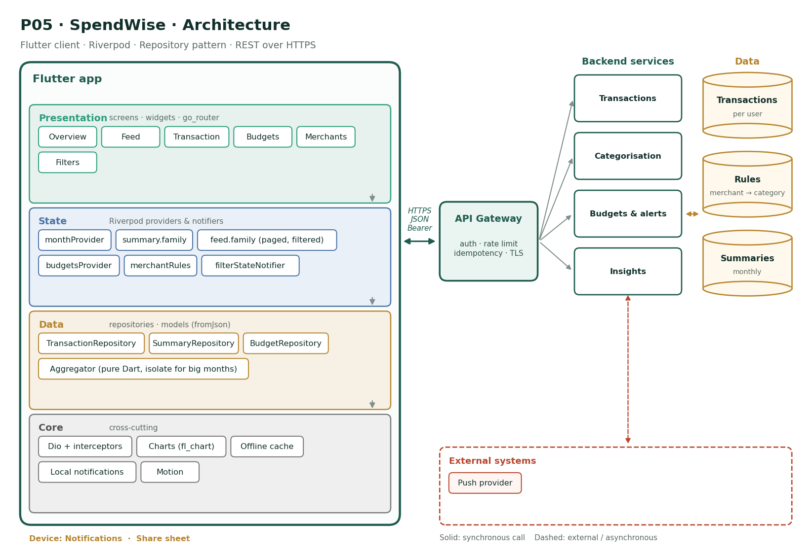
Figure P05 · SpendWise architecture
- Presentation: 6 screens (Overview, Feed, Transaction, Budgets, Merchants, Filters), all routed through go_router with the session guard.
- State: monthProvider, summary.family, feed.family (paged, filtered), budgetsProvider, merchantRules, filterStateNotifier. Screens watch these; buttons read their notifiers.
- Data: TransactionRepository, SummaryRepository, BudgetRepository, Aggregator (pure Dart, isolate for big months) — each repository owns one backend domain and throws only BankError.
- Core: Dio + interceptors, Charts (fl_chart), Offline cache, Local notifications, Motion.
- Backend (simulated): Transactions, Categorisation, Budgets & alerts, Insights, over Transactions, Rules, Summaries.
- External systems (simulated): Push provider. Treat them as unreliable: they can be slow, down, or return partial results.

10. Edge cases the solution must handle
- A refund (positive amount) in a spend category reduces that category's total
- A merchant string that changes slightly ("SWIGGY*1234"): normalise before matching rules
- Budget set mid-month: progress counts the whole month
- Zero transactions in a month: charts show an empty state, not a crash
- Undo after "apply to all": restores every changed transaction
- Very large month (5,000 rows): aggregation moves to an isolate

11. Stretch goals
- Receipt photo attached to a transaction
- Shared household budgets
- Predictive month-end spend

12. Definition of done
Area | Done when…
Features | All Must features and baseline B1–B9 working against the mock API
The hard part | Fast aggregation and charts over large data, and a recategorisation flow that feels instant yet stays consistent.
Tests | Business rules unit-tested; widget tests for every Must screen; one integration test for the main journey; ≥ 70% coverage
Quality | Profiling numbers in the PR; skeletons; reduce motion; FLAG_SECURE where money or identity is shown
Delivery | CI green on protected main; signed, obfuscated release build; README with setup and this architecture

P06 · BillBuddy
Bill payments, recharges and autopay
Theme | Payments
Level | Intermediate
Device features | Notifications · Contacts (recharge) · Share sheet
The hard part | Server-driven dynamic forms, and many independent external systems that can each fail on their own.

1. Problem statement
Context. Electricity, water, broadband, mobile and credit card bills arrive on different dates through different channels. Late fees are common, and customers pay the same bills manually every month.
Problem. There is no single place to see what is due, reminders are unreliable, and setting up autopay means paperwork. Customers also cannot prove a payment when a biller claims it was not received.
Goal. Build BillBuddy: biller discovery, saved billers with fetched due amounts, one-tap payment, autopay with limits, reminders, and downloadable receipts.

2. Users
Persona | Situation | What they need
Lakshmi, 45, runs the household | Pays 7 bills a month | One list of what is due
Rohan, 29, forgetful | Paid 3 late fees last year | Autopay with a safety limit
Mr. Iyer, 67 | Needs proof of payment | Receipts he can show the biller

3. Features
10 features: 7 Must · 3 Should · 0 Could — in addition to baseline requirements B1–B9.
ID | Feature | Description | Modules | Priority
F1 | Biller directory | Browse by category (electricity, water, gas, broadband, mobile, DTH, credit card) and search by name and state. | M2, M4 | Must
F2 | Add a biller | Dynamic form per biller: consumer number, account ID, etc., validated by the biller's regex from the server. | M2, M3 | Must
F3 | Fetch bill | Fetch the current due amount, due date and bill period for a saved biller. | M4 | Must
F4 | Upcoming bills | Home list of saved billers sorted by due date with overdue/due-soon badges. | M2, M3 | Must
F5 | Pay bill | Pay exact or partial (if allowed) amount from a chosen account; idempotent; status success/pending/failed. | M4 | Must
F6 | Mobile recharge | Operator and circle auto-detected from number; plan browser with filters. | M2, M4, M5 | Should
F7 | Autopay | Enable autopay per biller with a maximum amount; payments above it require manual approval. | M3, M4 | Should
F8 | Reminders | Local reminders 3 days before due for billers without autopay. | M5 | Should
F9 | Receipts | Receipt with biller reference and bank reference; share as text or PDF. | M2, M4 | Must
F10 | Payment history | History per biller and overall with status filters. | M2, M4 | Must

4. Acceptance criteria
F1 · Biller directory (Must)
- Search is debounced (300 ms)
- Categories load from the server, not hard-coded
F2 · Add a biller (Must)
- Fields and validations come from the biller definition
- A nickname is required
F3 · Fetch bill (Must)
- "No bill due" is a normal state, not an error
- Fetch failures offer retry
F4 · Upcoming bills (Must)
- Overdue first, then due within 3 days
F5 · Pay bill (Must)
- Partial payment is only offered for billers that allow it
- Retry never pays twice
F6 · Mobile recharge (Should)
- Plan list of 300 items scrolls smoothly
- Detected operator can be changed
F7 · Autopay (Should)
- Autopay can be paused
- Bills above the limit notify instead of paying
F8 · Reminders (Should)
- Reminders cancel when the bill is paid
F9 · Receipts (Must)
- Receipt available from history for 12 months
F10 · Payment history (Must)
- Pending payments update when refreshed

5. Screens and navigation
Screen | Route | Purpose
Home | /home | Upcoming bills
Categories | /billers | Browse
Search | /billers/search | Search
Add biller | /billers/:id/add | Dynamic form
Bill | /my-billers/:id | Fetched bill
Pay | /my-billers/:id/pay | Amount and account
Status | /payments/:id | Result
Recharge | /recharge | Number and plans
Autopay | /my-billers/:id/autopay | Settings
History | /history | Payments

6. Data model
Entity | Fields
Biller | id, name, category, state, fields[{key,label,regex}], allowsPartial
SavedBiller | id, billerId, nickname, params{}, autopay{enabled,maxPaise}
Bill | billerRef, amountPaise, dueDate, period, status
BillPayment | id, savedBillerId, amountPaise, status, bankRef, billerRef, at
Plan | id, operator, circle, pricePaise, validityDays, benefits

All money fields are integer paise; all timestamps are ISO-8601 UTC.

7. API contract
Method | Path | Purpose | Notable errors
GET | /biller-categories | Categories | —
GET | /billers?category=&q=&state= | Directory | —
POST | /my-billers | Save biller (server validates params) | 422
GET | /my-billers/{id}/bill | Fetch current bill | 404 NO_BILL, 502 BILLER_DOWN
POST | /bill-payments | Pay (Idempotency-Key) | 422
PUT | /my-billers/{id}/autopay | Autopay settings | 422
GET | /recharge/detect?number= | Operator and circle | —
GET | /recharge/plans?operator=&circle= | Plans | —

8. Non-functional requirements
Quality | Requirement (in addition to the baseline)
Reliability | Biller outages (502) degrade gracefully per biller, never for the whole app
Correctness | Amounts in paise; partial payment rules enforced client and server
Performance | Directory search results within 500 ms of typing stopping; plan list at 60 fps
Security | FLAG_SECURE on pay review; tokens in Keychain/Keystore
Usability | Pay a saved bill in 3 taps from home
Accessibility | Due badges have text, not just colour
Testability | Dynamic form validation unit-tested per field type; ≥ 70% coverage

9. Architecture
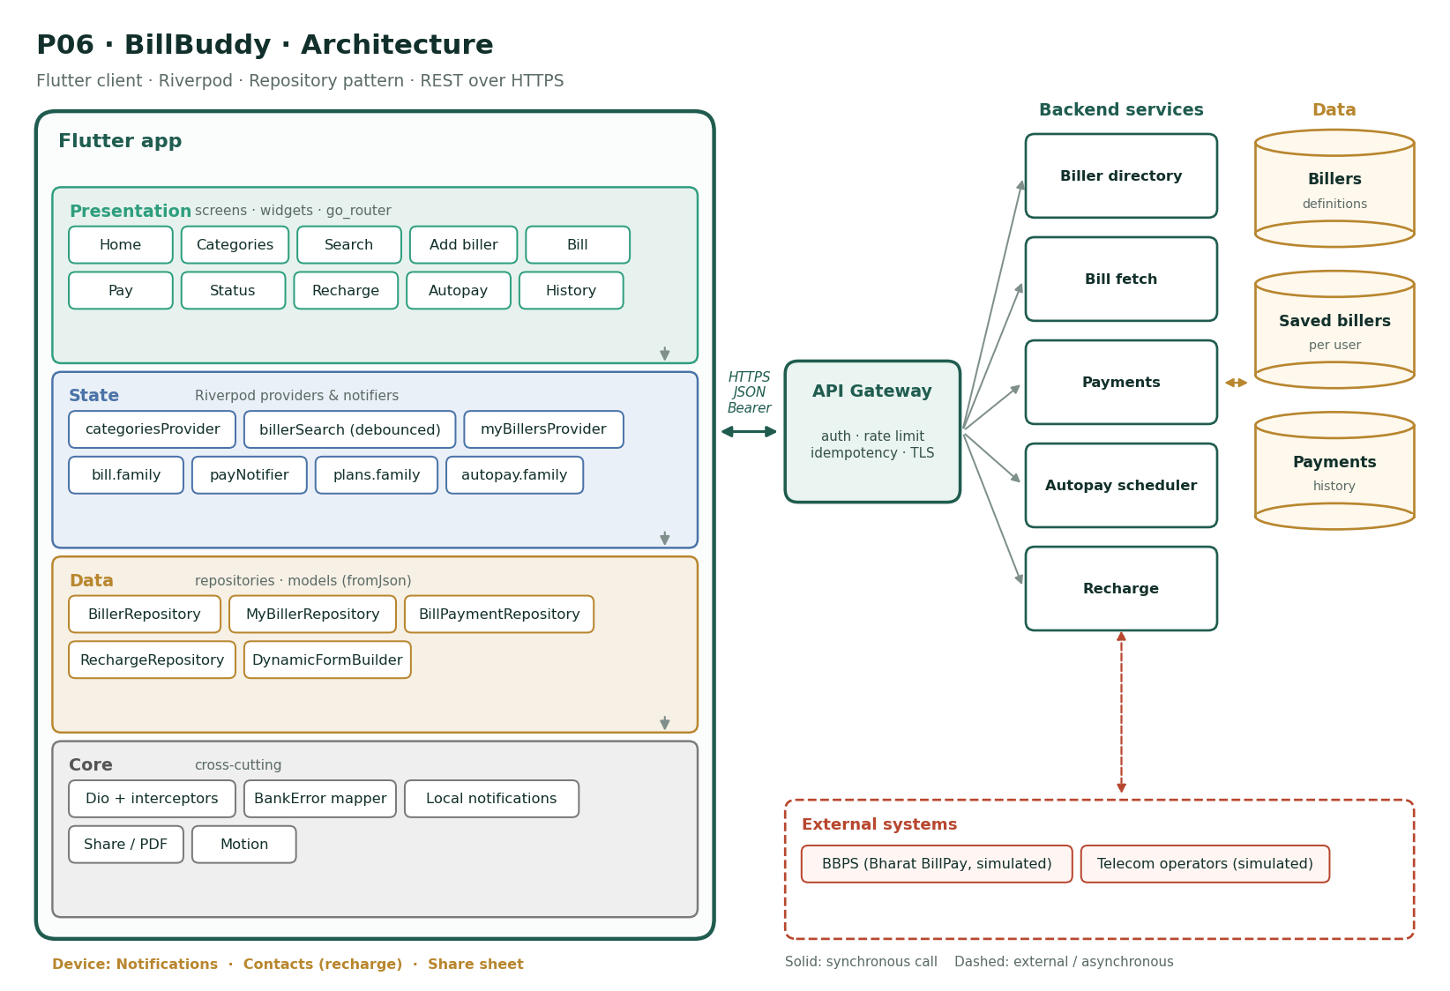
Figure P06 · BillBuddy architecture
- Presentation: 10 screens (Home, Categories, Search, Add biller, Bill, Pay, Status, Recharge, Autopay, History), all routed through go_router with the session guard.
- State: categoriesProvider, billerSearch (debounced), myBillersProvider, bill.family, payNotifier, plans.family, autopay.family. Screens watch these; buttons read their notifiers.
- Data: BillerRepository, MyBillerRepository, BillPaymentRepository, RechargeRepository, DynamicFormBuilder — each repository owns one backend domain and throws only BankError.
- Core: Dio + interceptors, BankError mapper, Local notifications, Share / PDF, Motion.
- Backend (simulated): Biller directory, Bill fetch, Payments, Autopay scheduler, Recharge, over Billers, Saved billers, Payments.
- External systems (simulated): BBPS (Bharat BillPay, simulated), Telecom operators (simulated). Treat them as unreliable: they can be slow, down, or return partial results.

10. Edge cases the solution must handle
- Biller returns a due amount of ₹0: show "No bill due"
- Consumer number valid by regex but unknown to the biller: server 422 shown on the field
- Bill fetched yesterday, paid elsewhere today: re-fetch before pay
- Autopay limit lower than the bill: notify, do not pay
- Recharge number is a landline: operator detection fails with a manual choice
- Pending payment older than 24 h: mark as "Under review" with support info

11. Stretch goals
- Pay multiple bills in one checkout
- Bill amount trend chart per biller
- Scan the bill's QR to add a biller

12. Definition of done
Area | Done when…
Features | All Must features and baseline B1–B9 working against the mock API
The hard part | Server-driven dynamic forms, and many independent external systems that can each fail on their own.
Tests | Business rules unit-tested; widget tests for every Must screen; one integration test for the main journey; ≥ 70% coverage
Quality | Profiling numbers in the PR; skeletons; reduce motion; FLAG_SECURE where money or identity is shown
Delivery | CI green on protected main; signed, obfuscated release build; README with setup and this architecture

P07 · BranchQ
Branch appointments and live queue tokens
Theme | Branch services
Level | Beginner–Intermediate
Device features | GPS · Maps · Notifications
The hard part | Time-based, contended resources (slots and queues) with honest real-time updates that do not drain the battery.

1. Problem statement
Context. Branch visits are still needed for lockers, demand drafts, KYC updates and loan discussions. Customers wait an hour without knowing whether the branch is even open.
Problem. There is no way to find the right branch, see how busy it is, book a slot, or get a queue token before arriving.
Goal. Build BranchQ: find branches on a map, see services and live crowd levels, book an appointment slot, get a digital token with live position, and receive a "you are next" alert.

2. Users
Persona | Situation | What they need
Geeta, 58 | Needs a locker visit | Book a slot and avoid the crowd
Ajay, 34, office worker | Lunch-break visits only | Know the wait before leaving the office
Branch manager | Runs 3 counters | Balanced load across the day

3. Features
9 features: 6 Must · 2 Should · 1 Could — in addition to baseline requirements B1–B9.
ID | Feature | Description | Modules | Priority
F1 | Branch finder | List and map of nearby branches with distance, open/closed status and today's hours. | M2, M4 | Must
F2 | Branch detail | Address, hours, services, facilities and a live crowd indicator. | M2, M4 | Must
F3 | Service selection | Choose a service; each shows required documents and estimated time. | M2 | Must
F4 | Slot booking | Calendar of the next 7 days with 15-minute slots and remaining capacity. | M2, M3, M4 | Must
F5 | My appointments | Upcoming and past appointments; reschedule and cancel. | M2, M4 | Must
F6 | Walk-in token | Get a token for a service when at the branch (geofenced within 200 m). | M4, M5 | Should
F7 | Live queue | Token number, position, estimated wait and counter; refreshes every 20 s. | M3, M4 | Must
F8 | You-are-next alert | Notification when 2 tokens away and when called. | M5 | Should
F9 | Feedback | Rate the visit after completion. | M2, M4 | Could

4. Acceptance criteria
F1 · Branch finder (Must)
- Location permission denied: search by city or PIN code
- Closed branches are clearly labelled
F2 · Branch detail (Must)
- Crowd level shown as text and colour
F3 · Service selection (Must)
- Required documents shown before booking
F4 · Slot booking (Must)
- Full slots are disabled
- Booking the last slot at the same moment as someone else returns a clear conflict (409)
F5 · My appointments (Must)
- Cancel up to 1 hour before
F6 · Walk-in token (Should)
- Outside 200 m: "You need to be at the branch"
F7 · Live queue (Must)
- Position updates without user action
- Stops polling when the screen is not visible
F8 · You-are-next alert (Should)
- Tapping opens the live queue
F9 · Feedback (Could)
- One rating per appointment

5. Screens and navigation
Screen | Route | Purpose
Finder | /branches | List and map
Branch | /branches/:id | Detail and crowd
Services | /branches/:id/services | Choose service
Slots | /branches/:id/book | Date and slot
Confirm | /bookings/confirm | Summary
My visits | /appointments | Upcoming and past
Token | /tokens/:id | Live queue
Feedback | /appointments/:id/feedback | Rating

6. Data model
Entity | Fields
Branch | id, name, address, lat, lng, hours[], services[], crowdLevel
Service | id, name, documents[], avgMinutes
Slot | start, capacity, remaining
Appointment | id, branchId, serviceId, slotStart, status
Token | id, number, position, etaMinutes, counter, status

All money fields are integer paise; all timestamps are ISO-8601 UTC.

7. API contract
Method | Path | Purpose | Notable errors
GET | /branches?lat=&lng=&q= | Nearby / search | —
GET | /branches/{id} | Detail | 404
GET | /branches/{id}/slots?serviceId=&date= | Availability | —
POST | /appointments | Book (Idempotency-Key) | 409 SLOT_FULL
PATCH | /appointments/{id} | Reschedule / cancel | 409, 422
POST | /tokens | Walk-in token (lat/lng) | 403 NOT_AT_BRANCH
GET | /tokens/{id} | Live position | —
POST | /appointments/{id}/feedback | Rating | 409

8. Non-functional requirements
Quality | Requirement (in addition to the baseline)
Timeliness | Queue position at most 30 s stale while the token screen is open
Battery | No polling or location use in the background; polling pauses when the screen is hidden
Privacy | Location used only on the finder and token screens, with a clear reason
Performance | Map with 200 branch markers pans smoothly
Accessibility | Token number displayed very large; crowd level never colour-only
Testability | Slot conflict and polling lifecycle unit-tested
Offline | Upcoming appointments viewable offline

9. Architecture
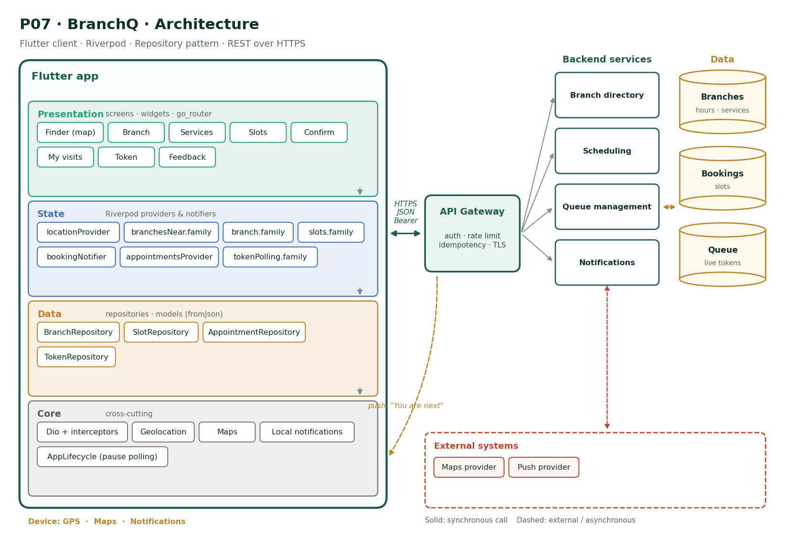
Figure P07 · BranchQ architecture
- Presentation: 8 screens (Finder (map), Branch, Services, Slots, Confirm, My visits, Token, Feedback), all routed through go_router with the session guard.
- State: locationProvider, branchesNear.family, branch.family, slots.family, bookingNotifier, appointmentsProvider, tokenPolling.family. Screens watch these; buttons read their notifiers.
- Data: BranchRepository, SlotRepository, AppointmentRepository, TokenRepository — each repository owns one backend domain and throws only BankError.
- Core: Dio + interceptors, Geolocation, Maps, Local notifications, AppLifecycle (pause polling).
- Backend (simulated): Branch directory, Scheduling, Queue management, Notifications, over Branches, Bookings, Queue.
- External systems (simulated): Maps provider, Push provider. Treat them as unreliable: they can be slow, down, or return partial results.
- Push: push: "You are next" — the notification opens the related screen through a deep link.

10. Edge cases the solution must handle
- Two users book the last slot simultaneously: one gets 409 and a refreshed slot list
- Branch closes early (holiday): appointments are cancelled with a notification
- User arrives late and the token was skipped: show "Missed — rejoin queue"
- Location is inaccurate indoors: allow a manual "I am at the branch" with a branch QR
- Daylight/time-zone edge: all slot times from the server in IST, displayed as local
- No branches within 50 km: widen search and show the nearest 5

11. Stretch goals
- Branch manager dashboard (web)
- Video appointment for loan discussions
- Accessibility services flag (wheelchair, assistance)

12. Definition of done
Area | Done when…
Features | All Must features and baseline B1–B9 working against the mock API
The hard part | Time-based, contended resources (slots and queues) with honest real-time updates that do not drain the battery.
Tests | Business rules unit-tested; widget tests for every Must screen; one integration test for the main journey; ≥ 70% coverage
Quality | Profiling numbers in the PR; skeletons; reduce motion; FLAG_SECURE where money or identity is shown
Delivery | CI green on protected main; signed, obfuscated release build; README with setup and this architecture

P08 · OpenAccount
Digital savings account opening with KYC
Theme | Onboarding
Level | Advanced
Device features | Camera · SMS retriever (OTP) · Biometrics
The hard part | A long, regulated, interruptible state machine with sensitive data at every step.

1. Problem statement
Context. Opening a savings account still takes a branch visit and a stack of photocopies. Competing digital banks open accounts in 10 minutes.
Problem. Customers abandon the process at document collection, cannot tell what is pending, and data entered is re-typed by staff with errors.
Goal. Build OpenAccount: a guided onboarding flow with mobile OTP verification, PAN and Aadhaar-based KYC (simulated), selfie and signature capture, video-KYC scheduling, and a live status tracker ending in account activation.

2. Users
Persona | Situation | What they need
Tanvi, 21, first account | Joining college | Open an account from her phone
Harish, 39, switching banks | Busy, impatient | Finish in one sitting
Bank operations officer | Verifies applications | Clear, complete, legible data

3. Features
10 features: 8 Must · 2 Should · 0 Could — in addition to baseline requirements B1–B9.
ID | Feature | Description | Modules | Priority
F1 | Mobile OTP | Enter mobile number, receive a 6-digit OTP (auto-read on Android), verify with retry limits. | M2, M4 | Must
F2 | PAN verification | Enter PAN; server returns the name on record for confirmation. | M2, M4 | Must
F3 | Aadhaar e-KYC (simulated) | Consent screen, Aadhaar number (masked as typed), OTP, then pre-filled name, DOB, address. | M2, M4 | Must
F4 | Personal details | Occupation, income band, nominee, communication address (same/different). | M2, M3 | Must
F5 | Selfie capture | Front camera with a face-oval guide; retake; liveness hint (blink) simulated. | M5 | Must
F6 | Signature capture | Draw a signature on a canvas; clear and redo; saved as PNG. | M2, M5 | Should
F7 | Account type and preferences | Choose account variant, debit card type, cheque book. | M2 | Must
F8 | Video-KYC slot | Book a video-KYC slot (date/time) or join now if an agent is available. | M4 | Should
F9 | Status tracker | Steps with states: Mobile ✓, PAN ✓, e-KYC ✓, Documents ✓, Video KYC ⏳, Account active. | M2, M3, M4 | Must
F10 | Activation | Account number, IFSC, virtual debit card preview and set-MPIN. | M4, M5 | Must

4. Acceptance criteria
F1 · Mobile OTP (Must)
- Resend enabled after 30 s
- 5 wrong attempts lock for 15 minutes
F2 · PAN verification (Must)
- PAN format validated before calling
- Name mismatch requires explicit confirmation
F3 · Aadhaar e-KYC (simulated) (Must)
- Aadhaar shown as XXXX XXXX 1234 after entry
- Pre-filled fields are read-only
F4 · Personal details (Must)
- Different address reveals a second address form
F5 · Selfie capture (Must)
- Image compressed below 500 KB
- Retake keeps the flow position
F6 · Signature capture (Should)
- Empty signature cannot be submitted
F7 · Account type and preferences (Must)
- Minimum balance shown per variant
F8 · Video-KYC slot (Should)
- Slots in the next 3 days only
F9 · Status tracker (Must)
- Resumable from any step after app restart
F10 · Activation (Must)
- MPIN never stored on the device

5. Screens and navigation
Screen | Route | Purpose
Welcome | / | Start or resume
Mobile | /onboard/mobile | Number
OTP | /onboard/otp | Verify
PAN | /onboard/pan | PAN
e-KYC | /onboard/kyc | Consent and OTP
Details | /onboard/details | Personal
Selfie | /onboard/selfie | Camera
Signature | /onboard/signature | Canvas
Account type | /onboard/variant | Choice
Video KYC | /onboard/vkyc | Slot
Status | /onboard/status | Tracker
Activated | /onboard/done | Welcome kit

6. Data model
Entity | Fields
OnboardingSession | id, step, mobile, panVerified, kycVerified, status
Applicant | name, dob, gender, address, occupation, incomeBand
Artifact | type (SELFIE/SIGNATURE), url, sizeBytes, status
VideoKycSlot | start, agentId
AccountResult | accountNumber, ifsc, cardPreview

All money fields are integer paise; all timestamps are ISO-8601 UTC.

7. API contract
Method | Path | Purpose | Notable errors
POST | /onboarding/otp | Send OTP | 429 TOO_MANY
POST | /onboarding/otp/verify | Verify → session token | 401, 423 LOCKED
POST | /onboarding/pan | Verify PAN | 404, 422
POST | /onboarding/ekyc/otp | /verify | Aadhaar e-KYC (simulated) | 401, 422
PATCH | /onboarding/details | Save details | 422
POST | /onboarding/artifacts | Upload selfie / signature | 413, 415
GET | /onboarding/vkyc/slots | Slots | —
POST | /onboarding/submit | Submit (Idempotency-Key) | 422 INCOMPLETE
GET | /onboarding/status | Tracker | —

8. Non-functional requirements
Quality | Requirement (in addition to the baseline)
Completion | Median completion under 10 minutes; resumable at every step
Security & privacy | Aadhaar never stored on device; masked in UI; images uploaded then deleted locally; FLAG_SECURE on all KYC screens
Compliance | Consent captured with timestamp and text version (server-side audit)
Reliability | OTP and uploads handle poor networks with retry and clear states
Accessibility | Camera screens have text instructions and large capture buttons
Performance | Selfie compressed on-device in < 1 s
Testability | Step machine unit-tested; integration test through the full happy path with fakes

9. Architecture
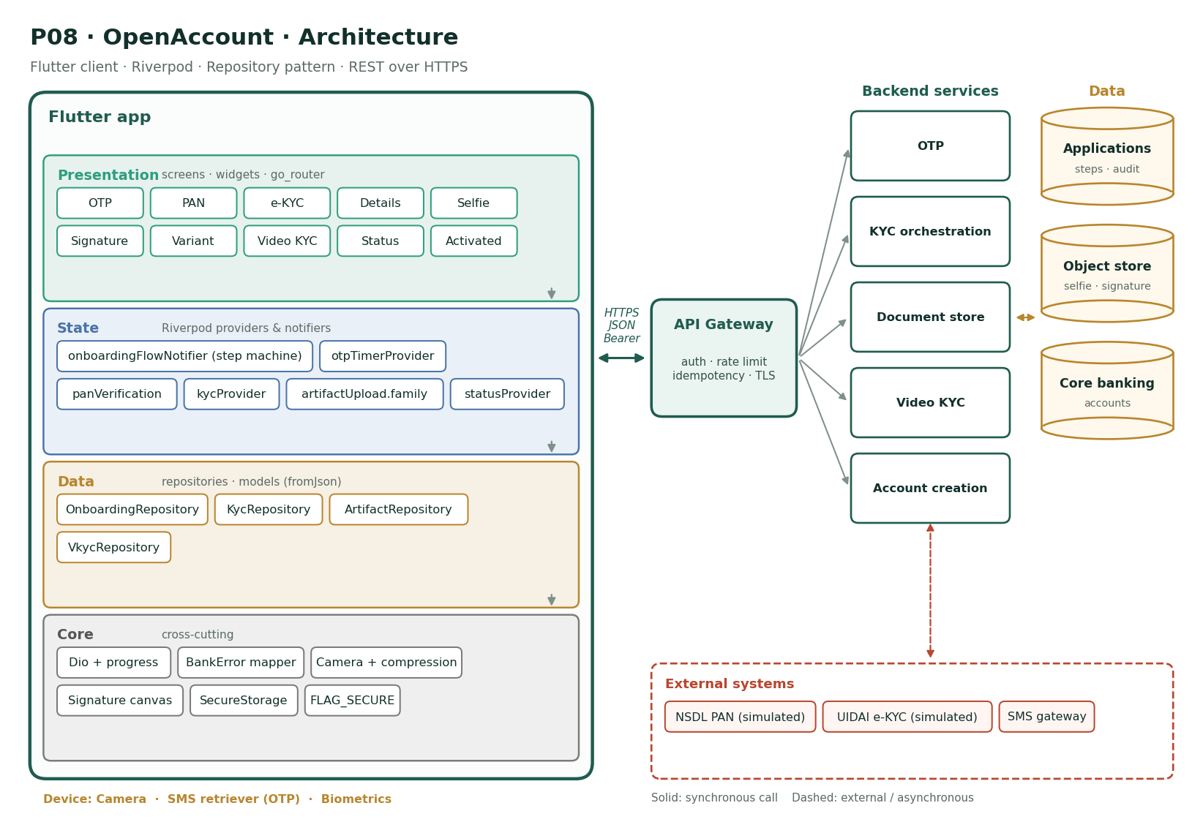
Figure P08 · OpenAccount architecture
- Presentation: 10 screens (OTP, PAN, e-KYC, Details, Selfie, Signature, Variant, Video KYC, Status, Activated), all routed through go_router with the session guard.
- State: onboardingFlowNotifier (step machine), otpTimerProvider, panVerification, kycProvider, artifactUpload.family, statusProvider. Screens watch these; buttons read their notifiers.
- Data: OnboardingRepository, KycRepository, ArtifactRepository, VkycRepository — each repository owns one backend domain and throws only BankError.
- Core: Dio + progress, BankError mapper, Camera + compression, Signature canvas, SecureStorage, FLAG_SECURE.
- Backend (simulated): OTP, KYC orchestration, Document store, Video KYC, Account creation, over Applications, Object store, Core banking.
- External systems (simulated): NSDL PAN (simulated), UIDAI e-KYC (simulated), SMS gateway. Treat them as unreliable: they can be slow, down, or return partial results.

10. Edge cases the solution must handle
- OTP auto-read fills the wrong field: always allow manual entry
- App killed during selfie upload: status shows the selfie as pending and allows retake
- PAN name differs slightly from Aadhaar name ("Kumar S" vs "S Kumar"): flag for review, do not block
- Video-KYC agent unavailable at slot time: automatic reschedule offer
- User under 18 by Aadhaar DOB: stop with a minor-account message
- Session expires mid-flow: re-verify mobile OTP and resume at the saved step

11. Stretch goals
- NFC reading of passport chip
- Instant virtual card usable for UPI immediately
- Referral codes

12. Definition of done
Area | Done when…
Features | All Must features and baseline B1–B9 working against the mock API
The hard part | A long, regulated, interruptible state machine with sensitive data at every step.
Tests | Business rules unit-tested; widget tests for every Must screen; one integration test for the main journey; ≥ 70% coverage
Quality | Profiling numbers in the PR; skeletons; reduce motion; FLAG_SECURE where money or identity is shown
Delivery | CI green on protected main; signed, obfuscated release build; README with setup and this architecture

P09 · InvestLite
Mutual funds and SIP tracker
Theme | Wealth
Level | Advanced
Device features | Biometrics · Notifications
The hard part | Heavy charts and numeric correctness (XIRR, units, cut-offs), kept fast and honest.

1. Problem statement
Context. Retail investors hold mutual funds across several platforms and cannot see a single view of their portfolio or whether their SIPs are working.
Problem. Portfolio value, returns and allocation are scattered; starting or pausing a SIP is confusing; and NAV charts are slow and cluttered.
Goal. Build InvestLite: a unified portfolio with XIRR returns, fund discovery with filters, fund detail with fast NAV charts, lump-sum and SIP orders, SIP management, and a watchlist.

2. Users
Persona | Situation | What they need
Varun, 28, new investor | Starting a first SIP | Understand a fund before investing
Pooja, 41, experienced | 8 funds, 4 SIPs | One view of allocation and returns
Mr. Menon, 60 | Conservative | Clear risk labels

3. Features
10 features: 6 Must · 3 Should · 1 Could — in addition to baseline requirements B1–B9.
ID | Feature | Description | Modules | Priority
F1 | Portfolio overview | Current value, invested amount, absolute and XIRR returns, allocation donut by category. | M2, M4 | Must
F2 | Holdings list | Per-fund units, NAV, value and return, sortable. | M2, M3, M5 | Must
F3 | Fund discovery | Browse by category (equity, debt, hybrid), risk level and rating; search by name. | M2, M4 | Must
F4 | Fund detail | NAV chart with 1M/6M/1Y/3Y/5Y ranges, returns table, risk-o-meter, expense ratio, holdings. | M2, M4, M5 | Must
F5 | Invest lump sum | Amount (min per fund), account, review, confirm (idempotent); order status. | M4 | Must
F6 | Start SIP | Amount, date (1–28), start month, optional step-up; mandate confirmation. | M2, M4 | Must
F7 | Manage SIPs | Pause (1–6 months), resume, modify amount, cancel with reason. | M3, M4 | Should
F8 | Watchlist | Add or remove funds; list with 1-day NAV change. | M3, M4 | Should
F9 | Redeem | Redeem by amount or all units; shows exit load and tax hint. | M4 | Should
F10 | Goal mapping | Tag holdings to goals and view progress. | M3 | Could

4. Acceptance criteria
F1 · Portfolio overview (Must)
- XIRR matches a reference implementation within 0.01%
- Values refresh on pull
F2 · Holdings list (Must)
- Sort by value, return or name
F3 · Fund discovery (Must)
- Filters combine; results paged
F4 · Fund detail (Must)
- Range switch redraws in < 200 ms
- Chart downsamples data for long ranges
F5 · Invest lump sum (Must)
- Orders after the 3 pm cut-off show the next NAV date
F6 · Start SIP (Must)
- Minimum SIP per fund enforced
F7 · Manage SIPs (Should)
- Paused SIP shows its resume date
F8 · Watchlist (Should)
- Optimistic add/remove with rollback
F9 · Redeem (Should)
- Cannot exceed redeemable units
F10 · Goal mapping (Could)
- A holding can map to one goal

5. Screens and navigation
Screen | Route | Purpose
Portfolio | /portfolio | Overview
Holdings | /portfolio/holdings | List
Explore | /funds | Discovery
Fund | /funds/:id | Chart and details
Invest | /funds/:id/invest | Lump sum
SIP | /funds/:id/sip | Start SIP
My SIPs | /sips | Manage
Orders | /orders | Status
Watchlist | /watchlist | Saved funds
Redeem | /holdings/:id/redeem | Redeem

6. Data model
Entity | Fields
Fund | id, name, amc, category, risk, expenseRatio, minLumpPaise, minSipPaise
NavPoint | date, nav
Holding | fundId, units, investedPaise, currentPaise
Order | id, type (BUY/SELL), amountPaise, units, status, navDate
Sip | id, fundId, amountPaise, day, status, nextDate, stepUpPct

All money fields are integer paise; all timestamps are ISO-8601 UTC.

7. API contract
Method | Path | Purpose | Notable errors
GET | /portfolio | Summary + holdings | —
GET | /funds?category=&risk=&q=&cursor= | Discovery | —
GET | /funds/{id} | Detail | 404
GET | /funds/{id}/nav?range= | NAV series (downsampled) | —
POST | /orders | Buy / redeem (Idempotency-Key) | 422 BELOW_MIN, 422 INSUFFICIENT_UNITS
POST | /sips | Create SIP | 422
PATCH | /sips/{id} | Pause / resume / modify | 409
DELETE | /sips/{id} | Cancel | 409
GET/PUT | /watchlist | Watchlist | —

8. Non-functional requirements
Quality | Requirement (in addition to the baseline)
Performance | NAV chart with 5 years of daily data renders in < 200 ms; downsampling to ≤ 500 points; parsing large series in an isolate
Correctness | XIRR and returns unit-tested against known cases; money in paise, units with 3–4 decimal precision (never double for money)
Transparency | Every order shows the NAV date and cut-off rule
Security | Orders confirmed with biometrics; FLAG_SECURE on order review
Accessibility | Charts expose a summary ("up 12.4% over 1 year"); risk labels in text
Testability | ≥ 75% coverage; golden tests for the chart widget

9. Architecture
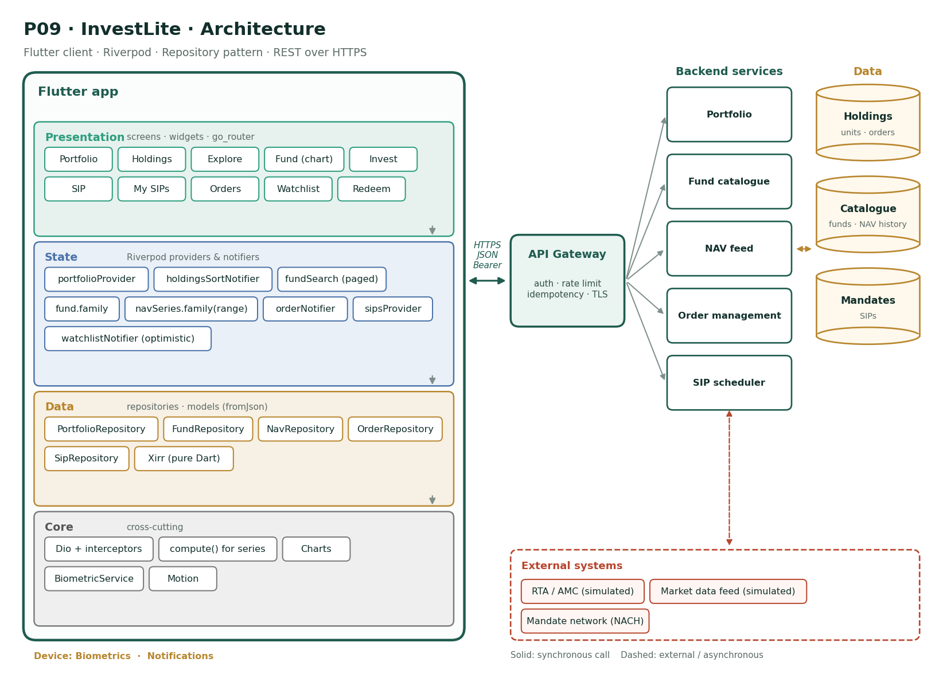
Figure P09 · InvestLite architecture
- Presentation: 10 screens (Portfolio, Holdings, Explore, Fund (chart), Invest, SIP, My SIPs, Orders, Watchlist, Redeem), all routed through go_router with the session guard.
- State: portfolioProvider, holdingsSortNotifier, fundSearch (paged), fund.family, navSeries.family(range), orderNotifier, sipsProvider, watchlistNotifier (optimistic). Screens watch these; buttons read their notifiers.
- Data: PortfolioRepository, FundRepository, NavRepository, OrderRepository, SipRepository, Xirr (pure Dart) — each repository owns one backend domain and throws only BankError.
- Core: Dio + interceptors, compute() for series, Charts, BiometricService, Motion.
- Backend (simulated): Portfolio, Fund catalogue, NAV feed, Order management, SIP scheduler, over Holdings, Catalogue, Mandates.
- External systems (simulated): RTA / AMC (simulated), Market data feed (simulated), Mandate network (NACH). Treat them as unreliable: they can be slow, down, or return partial results.

10. Edge cases the solution must handle
- Order placed at 2:59 pm, confirmed at 3:01 pm: server decides the NAV date and the app shows it
- Fund merged or closed: holdings show "Fund merged into …"
- SIP date falls on a holiday: next business day shown
- Units with 4 decimals: display rounding never changes redeemable totals
- Portfolio with zero holdings: onboarding empty state
- NAV missing for a day: chart connects points without inventing values

11. Stretch goals
- Tax-harvesting suggestions
- Compare two funds side by side
- Portfolio rebalancing hints

12. Definition of done
Area | Done when…
Features | All Must features and baseline B1–B9 working against the mock API
The hard part | Heavy charts and numeric correctness (XIRR, units, cut-offs), kept fast and honest.
Tests | Business rules unit-tested; widget tests for every Must screen; one integration test for the main journey; ≥ 70% coverage
Quality | Profiling numbers in the PR; skeletons; reduce motion; FLAG_SECURE where money or identity is shown
Delivery | CI green on protected main; signed, obfuscated release build; README with setup and this architecture

P10 · FraudShield
Real-time transaction alerts and dispute management
Theme | Risk & servicing
Level | Advanced
Device features | Push notifications · Biometrics · File picker
The hard part | Real-time streams, safety-critical actions that must be instant and idempotent, and a branching dispute flow with an auditable trail.

1. Problem statement
Context. Card and UPI fraud reports take days to resolve because customers call support, explain the transaction verbally, and the bank opens a case manually.
Problem. Customers learn about suspicious transactions late, cannot act immediately, and have no visibility into dispute progress, which drives repeated calls and complaints to the ombudsman.
Goal. Build FraudShield: real-time alerts for suspicious transactions with "Yes, it was me / No, block it" actions, instant card and UPI blocking, a guided dispute flow with evidence upload, and a case tracker with SLA timers.

2. Users
Persona | Situation | What they need
Nisha, 33 | Gets an alert for a transaction she did not make | Stop it in one tap
Rahul, 26 | Online purchase never delivered | Raise a dispute with proof
Support agent | Handles disputes | Complete, structured cases

3. Features
9 features: 5 Must · 3 Should · 1 Could — in addition to baseline requirements B1–B9.
ID | Feature | Description | Modules | Priority
F1 | Alert inbox | Real-time alerts (push + in-app list) for transactions flagged as unusual, with merchant, amount, location and time. | M3, M4, M5 | Must
F2 | Confirm or deny | "Yes, it was me" clears the alert; "No, it wasn't me" blocks the instrument and starts a dispute. | M2, M3, M4 | Must
F3 | Instant block | Block a card, UPI or net banking access with a reason; show which instruments are blocked. | M4, M5 | Must
F4 | Raise a dispute | Guided flow: pick transaction → reason (unauthorised, not received, duplicate, wrong amount) → questions per reason → evidence → review. | M2, M3 | Must
F5 | Evidence upload | Attach screenshots, invoices, chats (images/PDF) with progress and retry. | M4, M5 | Should
F6 | Case tracker | Case number, status timeline, SLA countdown (e.g., 10 days for provisional credit), and messages from the bank. | M2, M3, M4 | Must
F7 | Provisional credit | When granted, show the credit and conditions on the case. | M4 | Should
F8 | Secure messages | Two-way messages on a case (text + attachments). | M3, M4 | Could
F9 | Security centre | Login history, active devices, sign out other devices. | M4, M5 | Should

4. Acceptance criteria
F1 · Alert inbox (Must)
- New alerts appear without refresh while the app is open
- Unread count on the tab
F2 · Confirm or deny (Must)
- Deny requires biometric confirmation
- Deny completes in under 2 s end to end
F3 · Instant block (Must)
- Block is idempotent
- Blocked state visible on the home screen
F4 · Raise a dispute (Must)
- Questions change by reason
- Evidence optional for "unauthorised", required for "not received"
F5 · Evidence upload (Should)
- Max 5 files, 5 MB each
F6 · Case tracker (Must)
- SLA timer shows days remaining and turns amber in the last 2 days
F7 · Provisional credit (Should)
- Credit amount matches the disputed amount or shows the difference
F8 · Secure messages (Could)
- Messages paginate; newest at bottom
F9 · Security centre (Should)
- Current device cannot be removed from itself

5. Screens and navigation
Screen | Route | Purpose
Home | /home | Alerts summary and blocked instruments
Alerts | /alerts | Inbox
Alert | /alerts/:id | Confirm / deny
Block | /block | Instruments
Dispute | /disputes/new/:txnId | Guided flow
Evidence | /disputes/new/evidence | Upload
Cases | /cases | List
Case | /cases/:id | Timeline, SLA, messages
Security | /security | Devices and logins

6. Data model
Entity | Fields
Alert | id, txnId, merchant, amountPaise, location, at, riskReason, status
Instrument | id, type (CARD/UPI/NETBANKING), masked, blocked
Dispute | id, txnId, reason, answers{}, evidence[], status
Case | id, disputeId, status, timeline[], slaDueAt, provisionalCreditPaise
Device | id, name, lastSeen, current

All money fields are integer paise; all timestamps are ISO-8601 UTC.

7. API contract
Method | Path | Purpose | Notable errors
GET | /alerts?status= | Inbox | —
POST | /alerts/{id}/confirm | It was me | 409
POST | /alerts/{id}/deny | Not me → block + dispute (Idempotency-Key) | 409
POST | /instruments/{id}/block | Block | 409
POST | /disputes | Create | 422 by reason
POST | /disputes/{id}/evidence | Upload | 413
GET | /cases/{id} | Case with timeline | 404
GET/POST | /cases/{id}/messages | Messages | —
GET | /devices | Devices | —
DELETE | /devices/{id} | Sign out a device | 409 CURRENT

8. Non-functional requirements
Quality | Requirement (in addition to the baseline)
Latency | Alert visible within 5 s of the server flagging it (push or in-app stream); deny-and-block under 2 s
Security | Deny, block and device removal require biometrics; FLAG_SECURE on all screens; no transaction details in notification previews when the device is locked
Reliability | Block and deny are idempotent and safe to retry on flaky networks
Auditability | Every action carries a client timestamp and device id; server keeps an immutable log
Accessibility | Alert actions are large, clearly labelled buttons; colour plus icon plus text for risk
Testability | Dispute question logic unit-tested per reason; integration test for deny → block → case created

9. Architecture
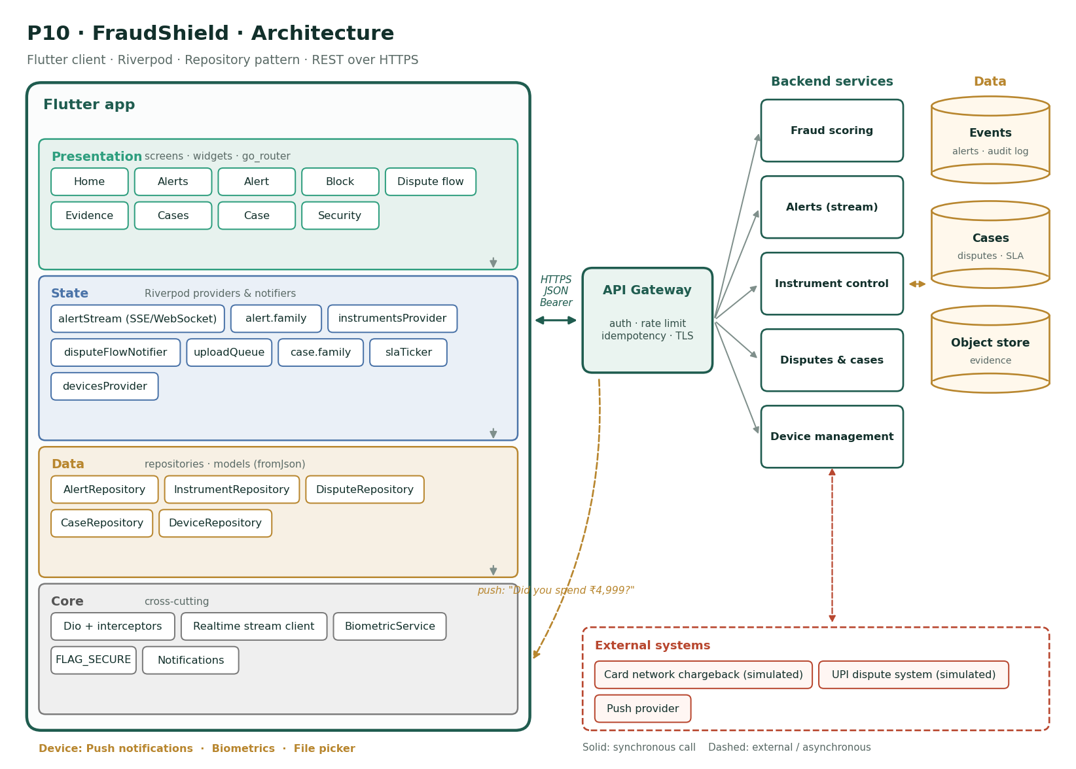
Figure P10 · FraudShield architecture
- Presentation: 9 screens (Home, Alerts, Alert, Block, Dispute flow, Evidence, Cases, Case, Security), all routed through go_router with the session guard.
- State: alertStream (SSE/WebSocket), alert.family, instrumentsProvider, disputeFlowNotifier, uploadQueue, case.family, slaTicker, devicesProvider. Screens watch these; buttons read their notifiers.
- Data: AlertRepository, InstrumentRepository, DisputeRepository, CaseRepository, DeviceRepository — each repository owns one backend domain and throws only BankError.
- Core: Dio + interceptors, Realtime stream client, BiometricService, FLAG_SECURE, Notifications.
- Backend (simulated): Fraud scoring, Alerts (stream), Instrument control, Disputes & cases, Device management, over Events, Cases, Object store.
- External systems (simulated): Card network chargeback (simulated), UPI dispute system (simulated), Push provider. Treat them as unreliable: they can be slow, down, or return partial results.
- Push: push: "Did you spend ₹4,999?" — the notification opens the related screen through a deep link.

10. Edge cases the solution must handle
- Deny tapped twice on a slow network: one block, one case
- Alert arrives for an already-blocked card: show it as "Blocked — no action needed"
- The stream disconnects: reconnect with backoff and fetch missed alerts since the last id
- Dispute for a transaction older than 90 days: explain the window and offer support contact
- Evidence upload fails at 90%: retry that file only
- SLA breached: case highlights it and shows the escalation path

11. Stretch goals
- On-device risk hints (unusual location vs last login)
- Chatbot triage before the dispute form
- Temporary card unblock for a single merchant

12. Definition of done
Area | Done when…
Features | All Must features and baseline B1–B9 working against the mock API
The hard part | Real-time streams, safety-critical actions that must be instant and idempotent, and a branching dispute flow with an auditable trail.
Tests | Business rules unit-tested; widget tests for every Must screen; one integration test for the main journey; ≥ 70% coverage
Quality | Profiling numbers in the PR; skeletons; reduce motion; FLAG_SECURE where money or identity is shown
Delivery | CI green on protected main; signed, obfuscated release build; README with setup and this architecture

Appendix · Writing acceptance tests from these criteria
Each acceptance criterion is written to become a test. The pattern learners used in Module 6 applies directly:
// Criterion (PayLite F5): "A retry after a 30-second timeout returns the original receipt"
test('retry with the same idempotency key returns the original receipt', () async {
// Arrange: fake API that times out on the first call, succeeds on the second
// Act: pay twice with one key
// Assert: same reference id, balance debited once
});
If the criterion is about… | Write a…
A pure rule (maths, validation) | Unit test, no Flutter
A repository or notifier behaviour | Unit test with a fake adapter and ProviderContainer
What the user sees on one screen | Widget test with testApp(...)
A journey across screens | Widget flow test, then one integration test on a device

