**TEST CONNECTION TO THE AWS MACHINES**

**Pre-requisites:**

Default.ppk file needed for windows users

Default.pem file needed for Mac/Linux users

<IP>: IP address provided for testing by ASPE

**Instructions to connect for Mac/Linux users**

1. Open the Linux terminal.
2. “cd” to the folder that has the file “Default.pem”
3. Run below commands.

**$ chmod 400 Default.pem**

**$ ssh -i "Default.pem" ubuntu@IP**

**\*\* Replace IP with the IP address provided for testing**

It will ask you to add the SSH key value to cache, click “**yes**”.

If you get no errors, you are in the AWS system.

In the AWS machine, type the below command to check if Docker is installed and working.

**$ sudo apt-get install -y git**

If this command runs, you are all set

** Note that – no other “kubectl” command will run as of now, because setting Kubernetes master is included as a part of exercise 2.1

**Instructions to connect for Windows users**

1. Install Putty
2. On the left side menu, go to “connection” --> “SSH” --> “Auth”. Give the path of the file “Default.ppk” from your local computer, as shown below.

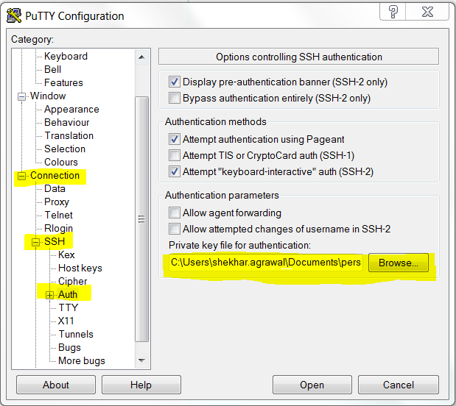

1. On the left side menu, go to the top and write **ubuntu@IP** in the hostname as shown below.

**\*\* Replace IP with the IP address provided for testing**

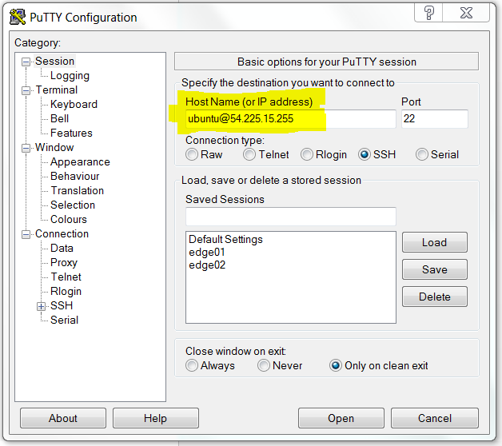

1. Click ‘open’

If you are logging to a new machine, it will ask you to add the SSH key value to cache, click “yes”.

If you get no errors, you are in the AWS system.

In the AWS machine, type the below command to check if Docker is installed and working.

**$ sudo apt-get install -y git**

If this command runs, you are all set

** Note that – no other “kubectl” command will run as of now, because setting Kubernetes master is included as a part of exercise 2.1