SDQ draft

—

tým Schola Empirica

kontakt: Jaromír Mazák, [mazak@scholaempirica.org](mailto:mazak@scholaempirica.org)

19. květen 2020

Lorem ipsum abstract

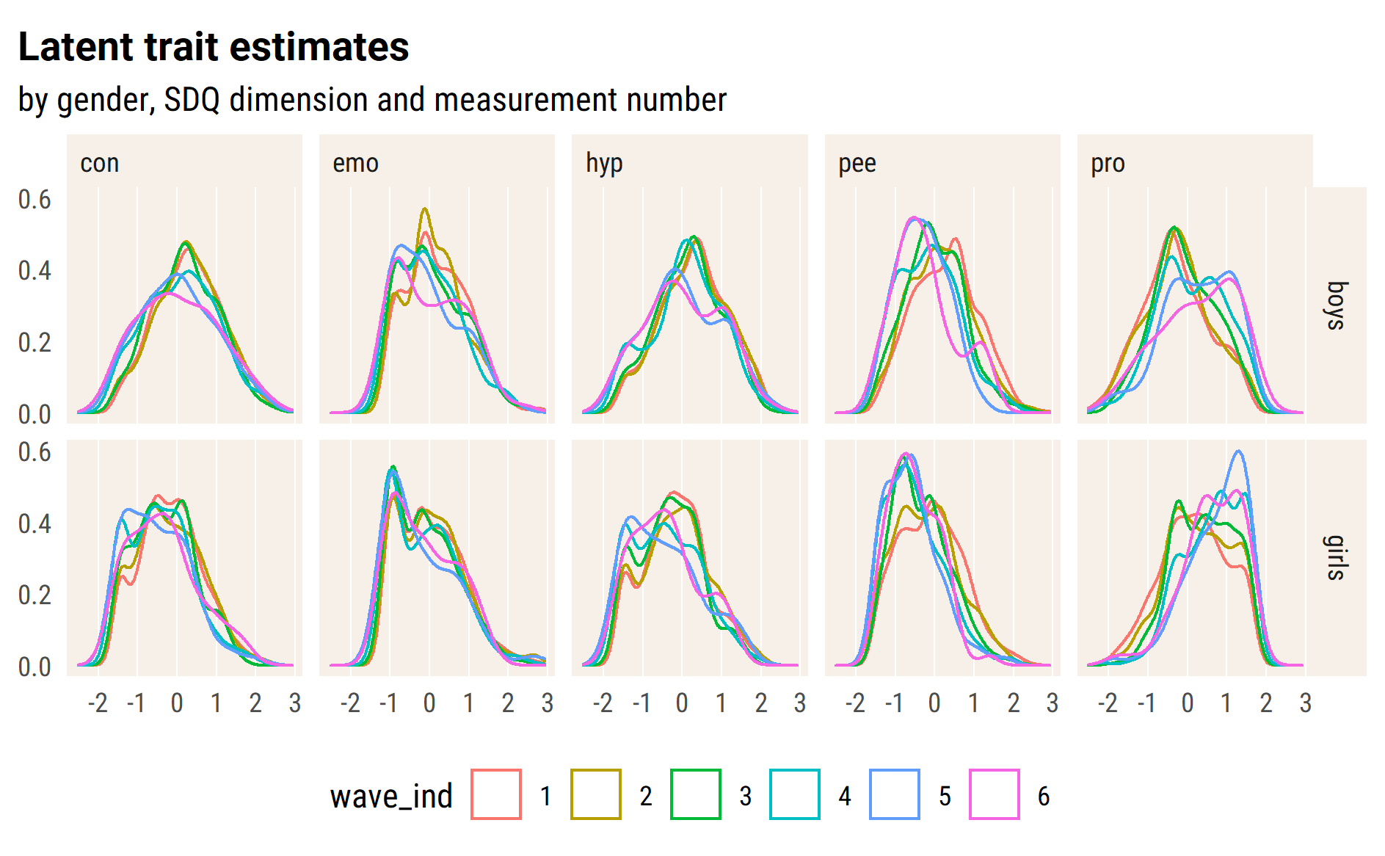

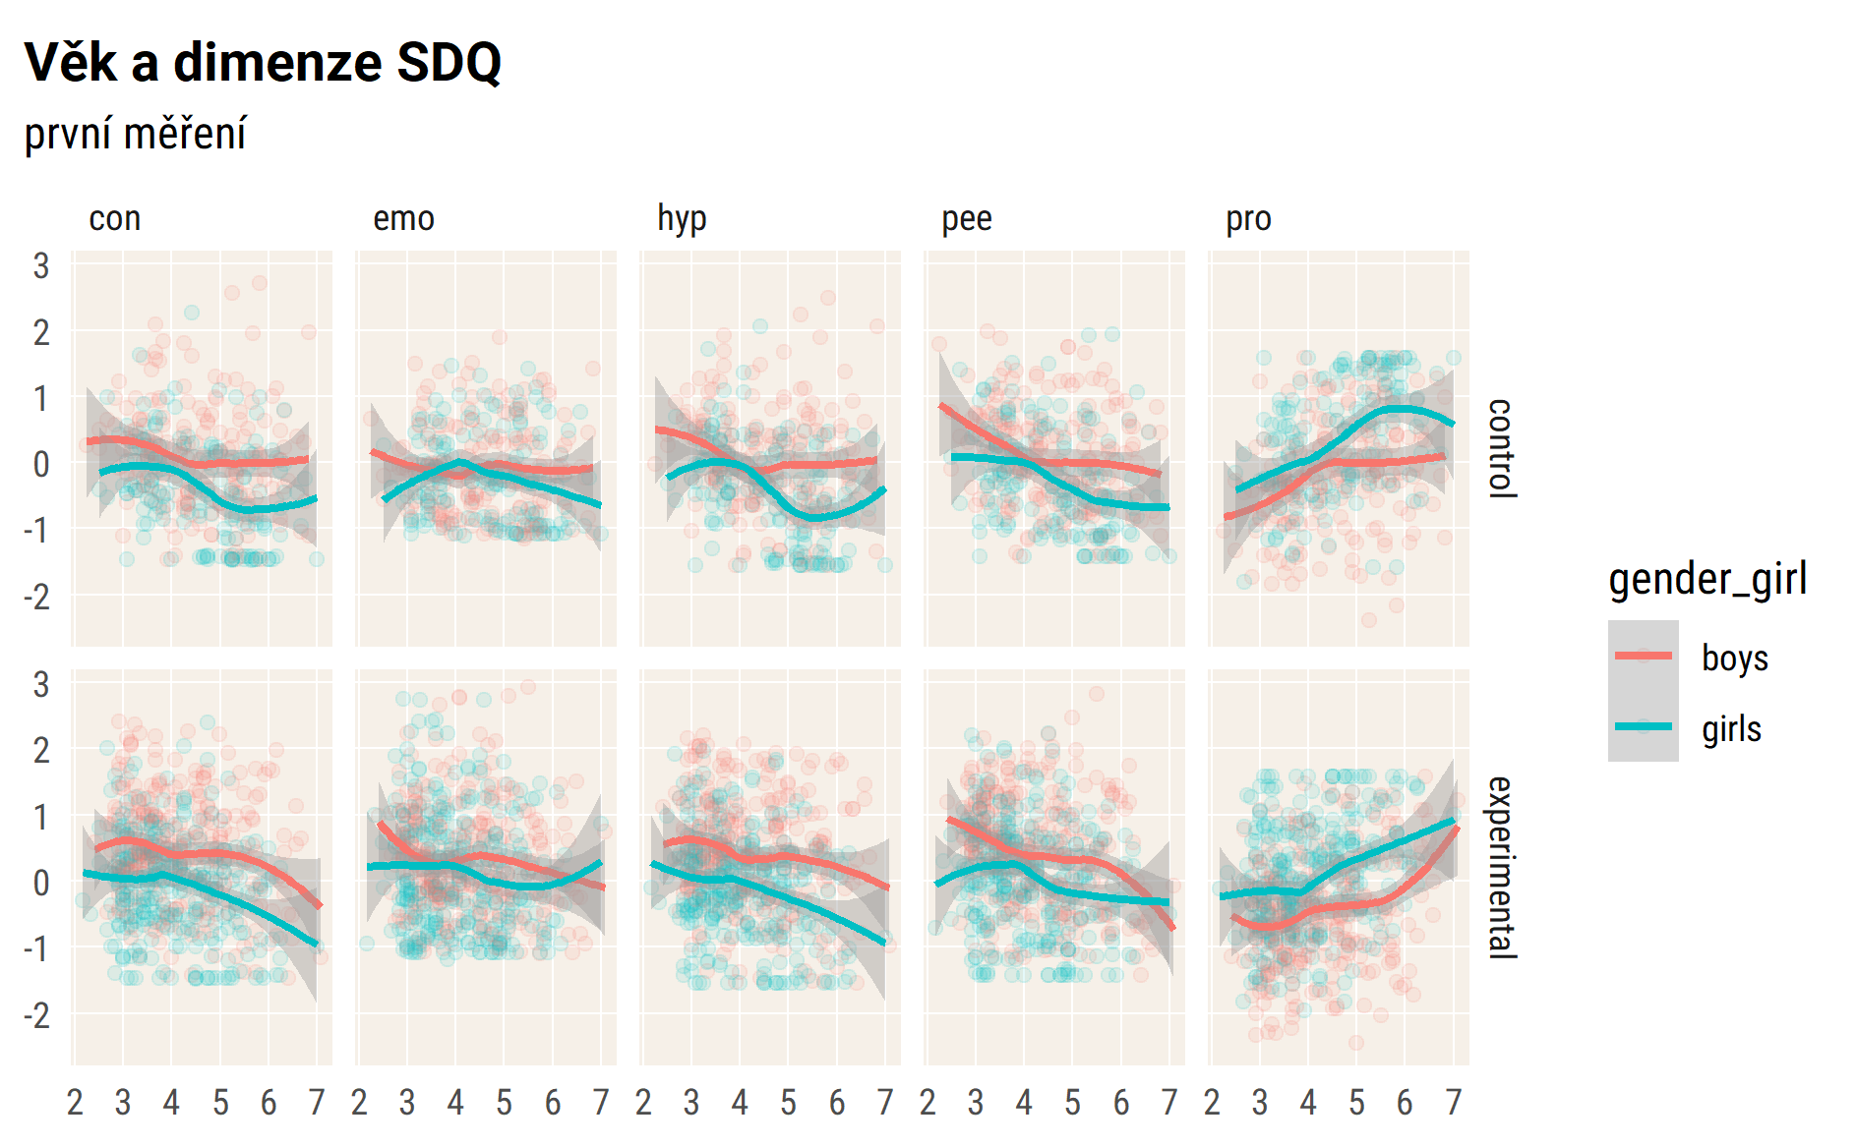

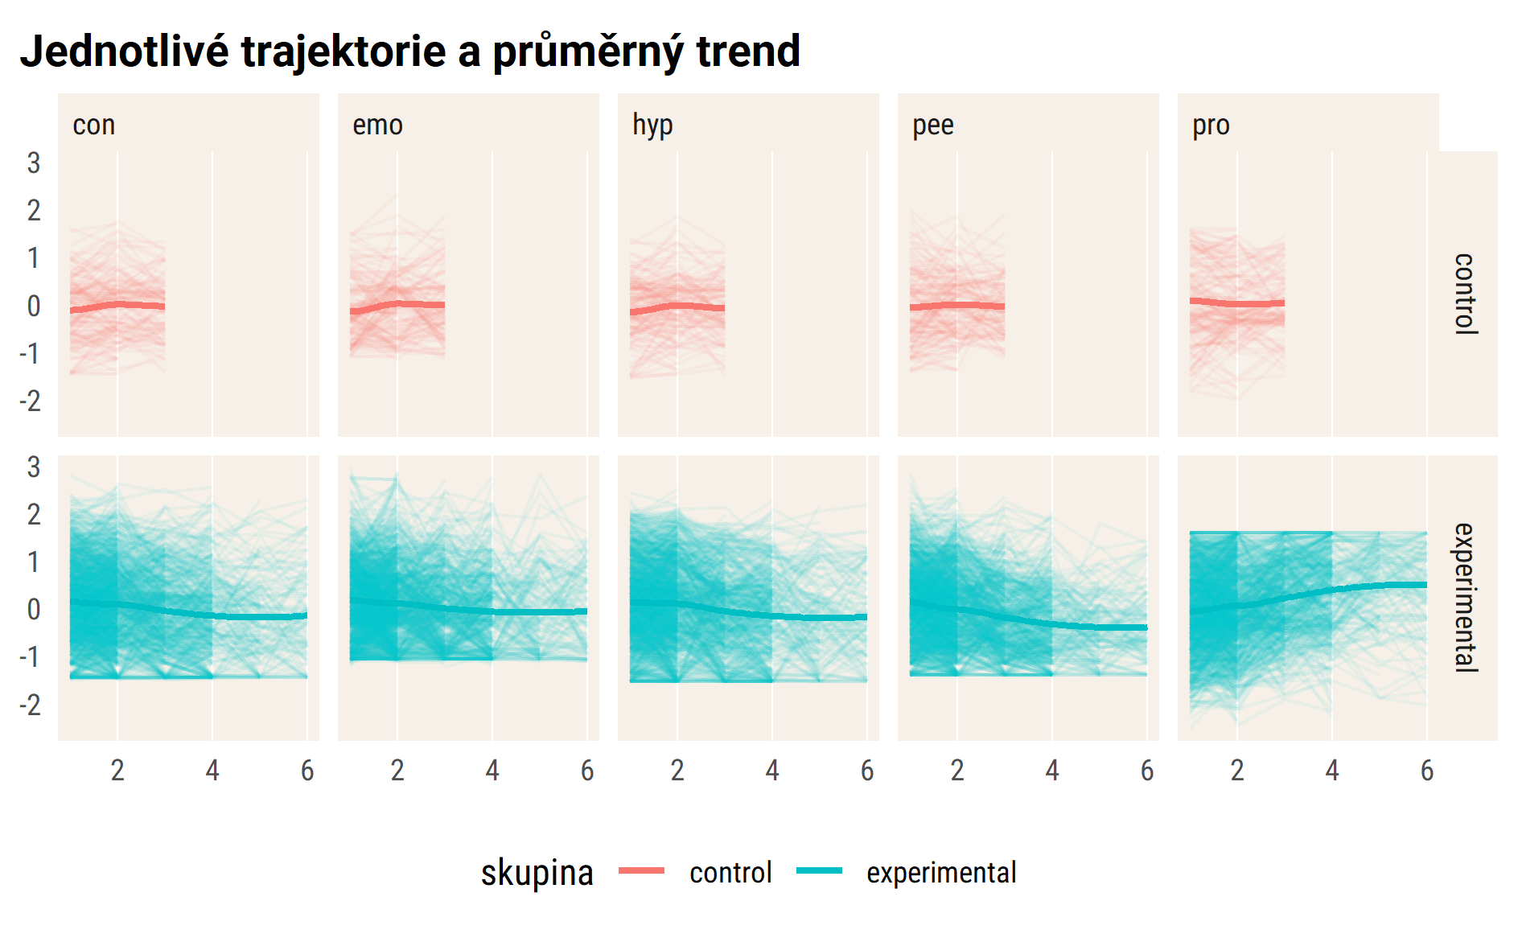

*Test* tabulek – time dependency

| rowname | pro_1 | pro_2 | pro_3 | pro_4 | pro_5 | pro_6 |
| --- | --- | --- | --- | --- | --- | --- |
| pro_1 |  | .66 | .48 | .48 | .42 | .46 |
| pro_2 |  |  | .55 | .53 | .56 | .49 |
| pro_3 |  |  |  | .68 | .50 | .46 |
| pro_4 |  |  |  |  | .57 | .51 |
| pro_5 |  |  |  |  |  | .67 |
| pro_6 |  |  |  |  |  |  |

#> [[1]]  
#>   
#> [[2]]  
#>   
#> [[3]]  
#>   
#> [[4]]  
#>   
#> [[5]]

## Null model

#> Linear mixed model fit by REML. t-tests use Satterthwaite's method [  
#> lmerModLmerTest]  
#> Formula: emo ~ (1 | id_pupil)  
#> Data: df_long_zero  
#>   
#> REML criterion at convergence: 11620.1  
#>   
#> Scaled residuals:   
#> Min 1Q Median 3Q Max   
#> -3.3362 -0.6135 -0.0508 0.5567 3.3581   
#>   
#> Random effects:  
#> Groups Name Variance Std.Dev.  
#> id_pupil (Intercept) 0.3078 0.5548   
#> Residual 0.3603 0.6003   
#> Number of obs: 5171, groups: id_pupil, 2045  
#>   
#> Fixed effects:  
#> Estimate Std. Error df t value Pr(>|t|)   
#> (Intercept) 0.05184 0.01533 1930.25353 3.382 0.000733 ***  
#> ---  
#> Signif. codes: 0 '***' 0.001 '**' 0.01 '*' 0.05 '.' 0.1 ' ' 1

## random intercept + slope

pupils are not yet nested within classes, model fails to converge

TODO: check id_class

#> Linear mixed model fit by REML. t-tests use Satterthwaite's method [  
#> lmerModLmerTest]  
#> Formula:   
#> pro ~ wave_ind * is_intervention2 + age_fst_measur + gender_girl +   
#> (wave_ind | id_pupil)  
#> Data: df_long_zero  
#>   
#> REML criterion at convergence: 9638.4  
#>   
#> Scaled residuals:   
#> Min 1Q Median 3Q Max   
#> -3.3437 -0.5035 0.0191 0.5253 3.3180   
#>   
#> Random effects:  
#> Groups Name Variance Std.Dev. Corr   
#> id_pupil (Intercept) 0.3873 0.6223   
#> wave_ind 0.0214 0.1463 -0.34  
#> Residual 0.2592 0.5092   
#> Number of obs: 4562, groups: id_pupil, 1738  
#>   
#> Fixed effects:  
#> Estimate Std. Error df  
#> (Intercept) -1.13538 0.08865 1884.41211  
#> wave_ind 0.02615 0.03203 3040.12238  
#> is_intervention2experimental -0.14925 0.04700 1898.60217  
#> age_fst_measur 0.20574 0.01656 1752.12434  
#> gender_girlgirls 0.52653 0.03329 1663.88095  
#> wave_ind:is_intervention2experimental 0.14399 0.03327 2838.77281  
#> t value Pr(>|t|)   
#> (Intercept) -12.807 < 2e-16 ***  
#> wave_ind 0.816 0.41430   
#> is_intervention2experimental -3.175 0.00152 **   
#> age_fst_measur 12.425 < 2e-16 ***  
#> gender_girlgirls 15.814 < 2e-16 ***  
#> wave_ind:is_intervention2experimental 4.328 0.0000156 ***  
#> ---  
#> Signif. codes: 0 '***' 0.001 '**' 0.01 '*' 0.05 '.' 0.1 ' ' 1  
#>   
#> Correlation of Fixed Effects:  
#> (Intr) wav_nd is_nt2 ag_fs_ gndr_g  
#> wave_ind -0.240   
#> is_ntrvntn2 -0.522 0.342   
#> age_fst_msr -0.864 0.079 0.121   
#> gndr_grlgrl -0.206 -0.023 -0.021 0.034   
#> wv_nd:s_nt2 0.219 -0.962 -0.380 -0.062 0.023

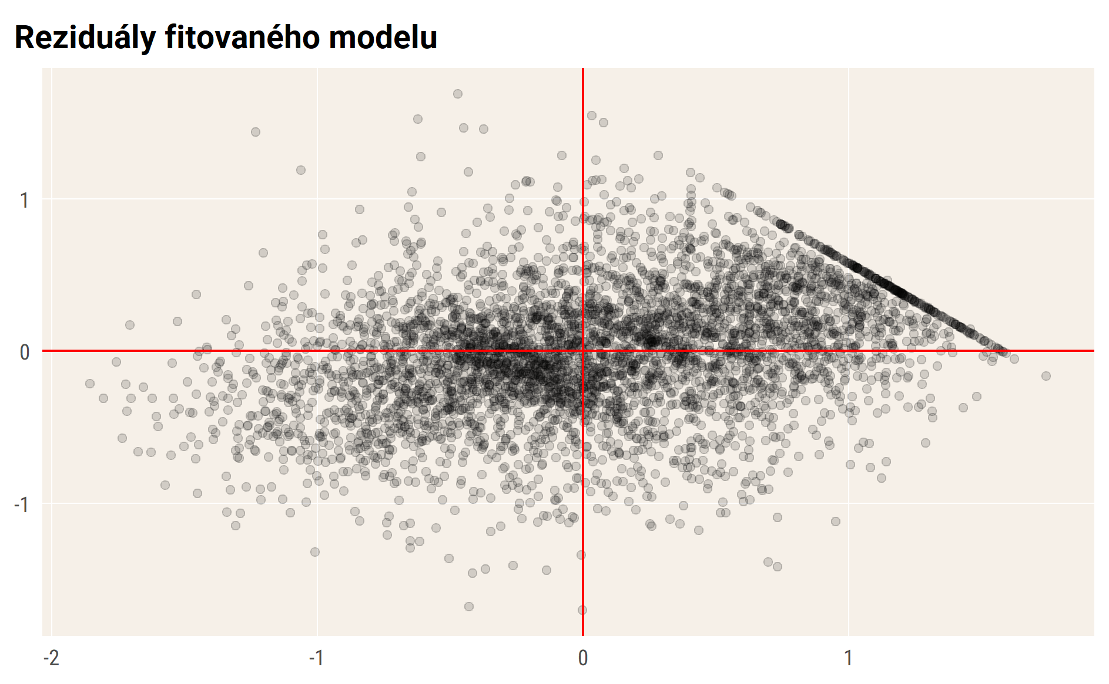

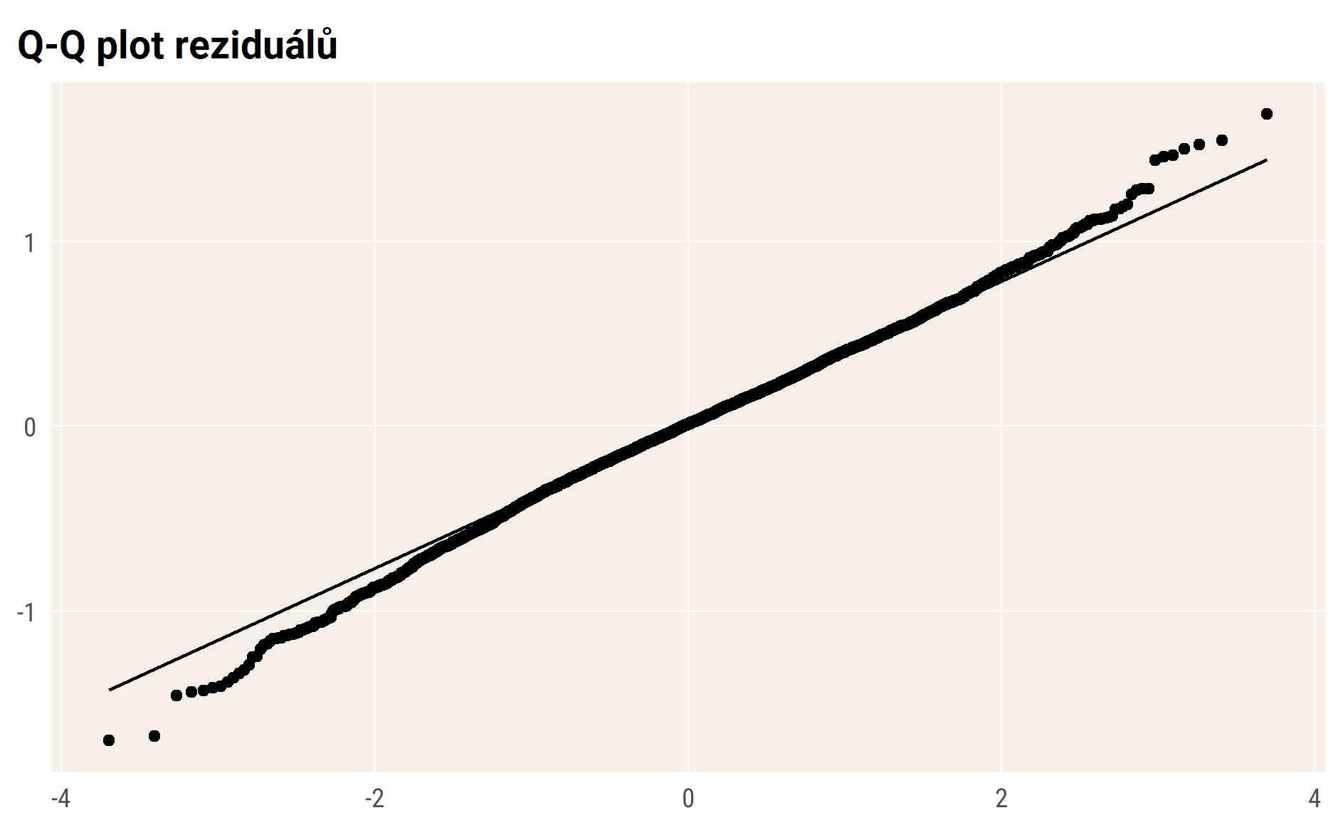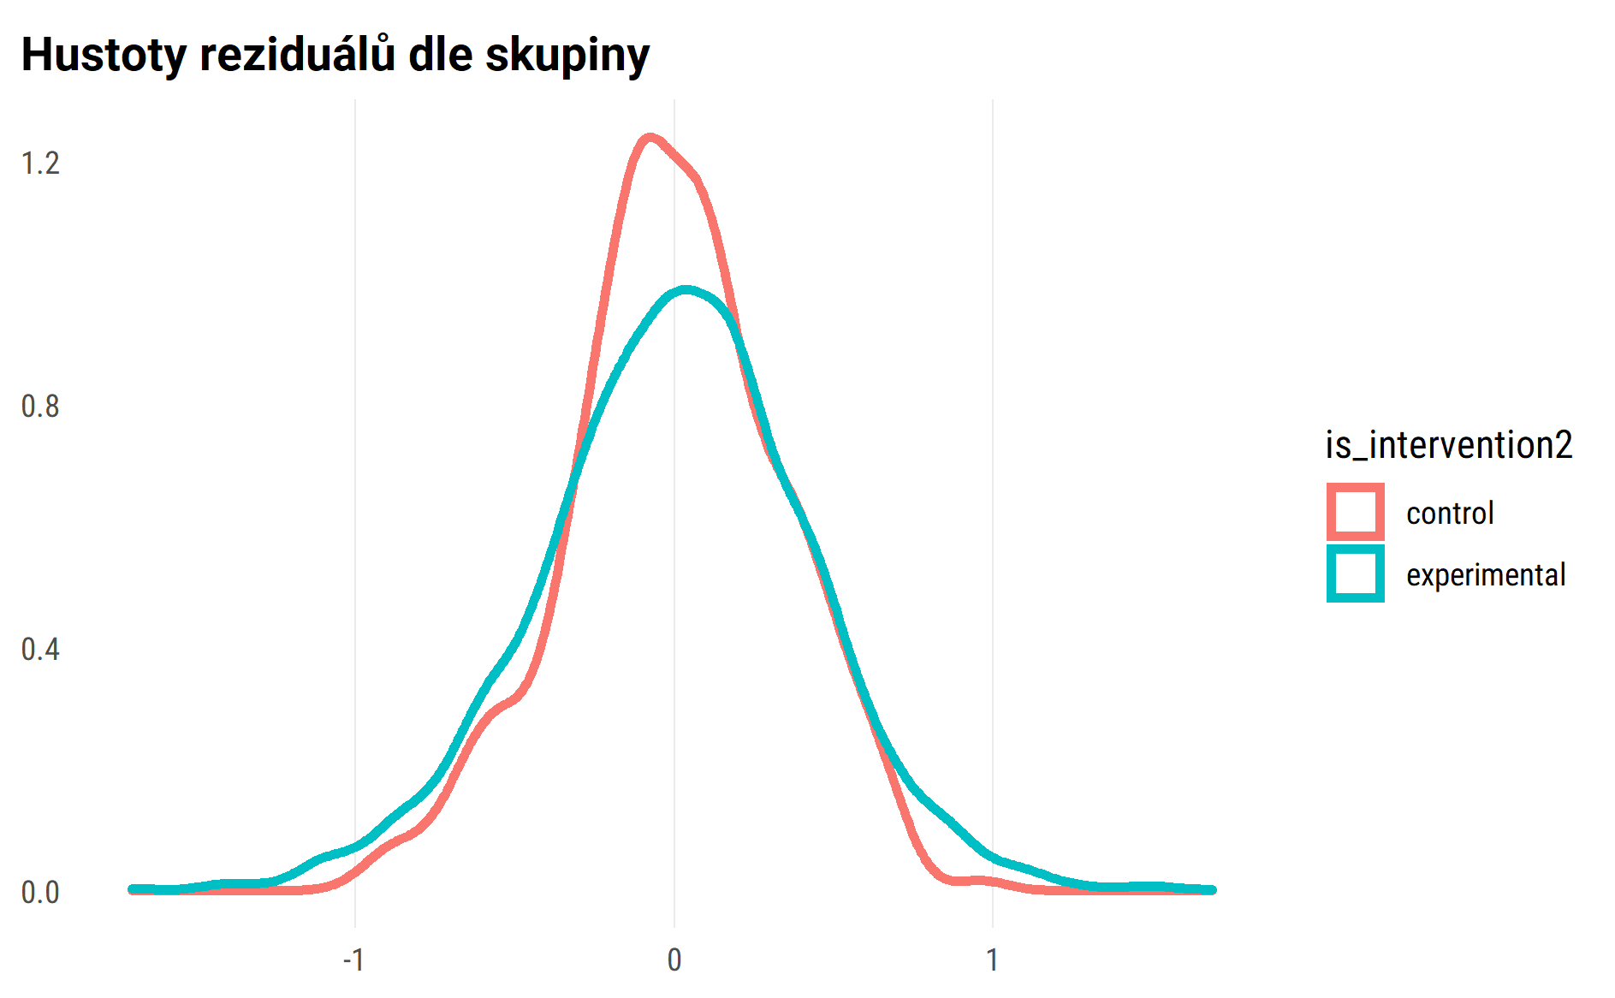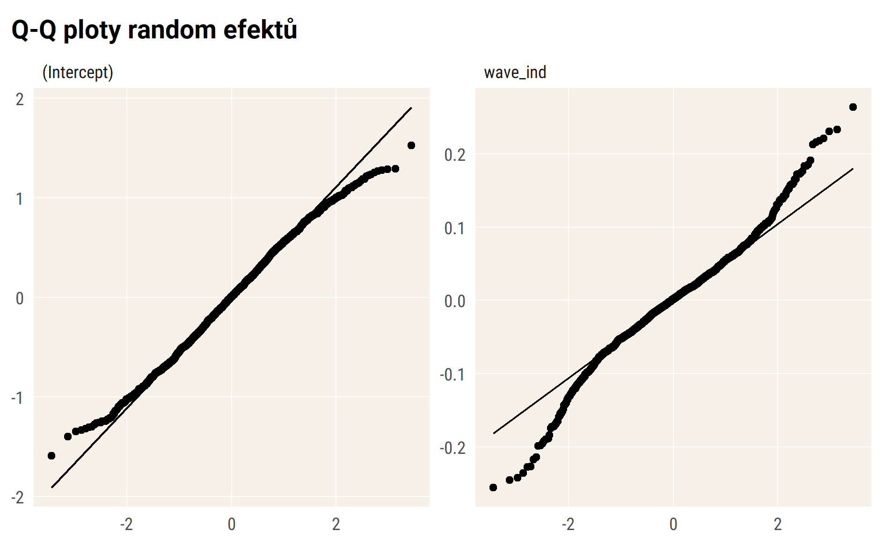

## Vizualizace modelu – průměry

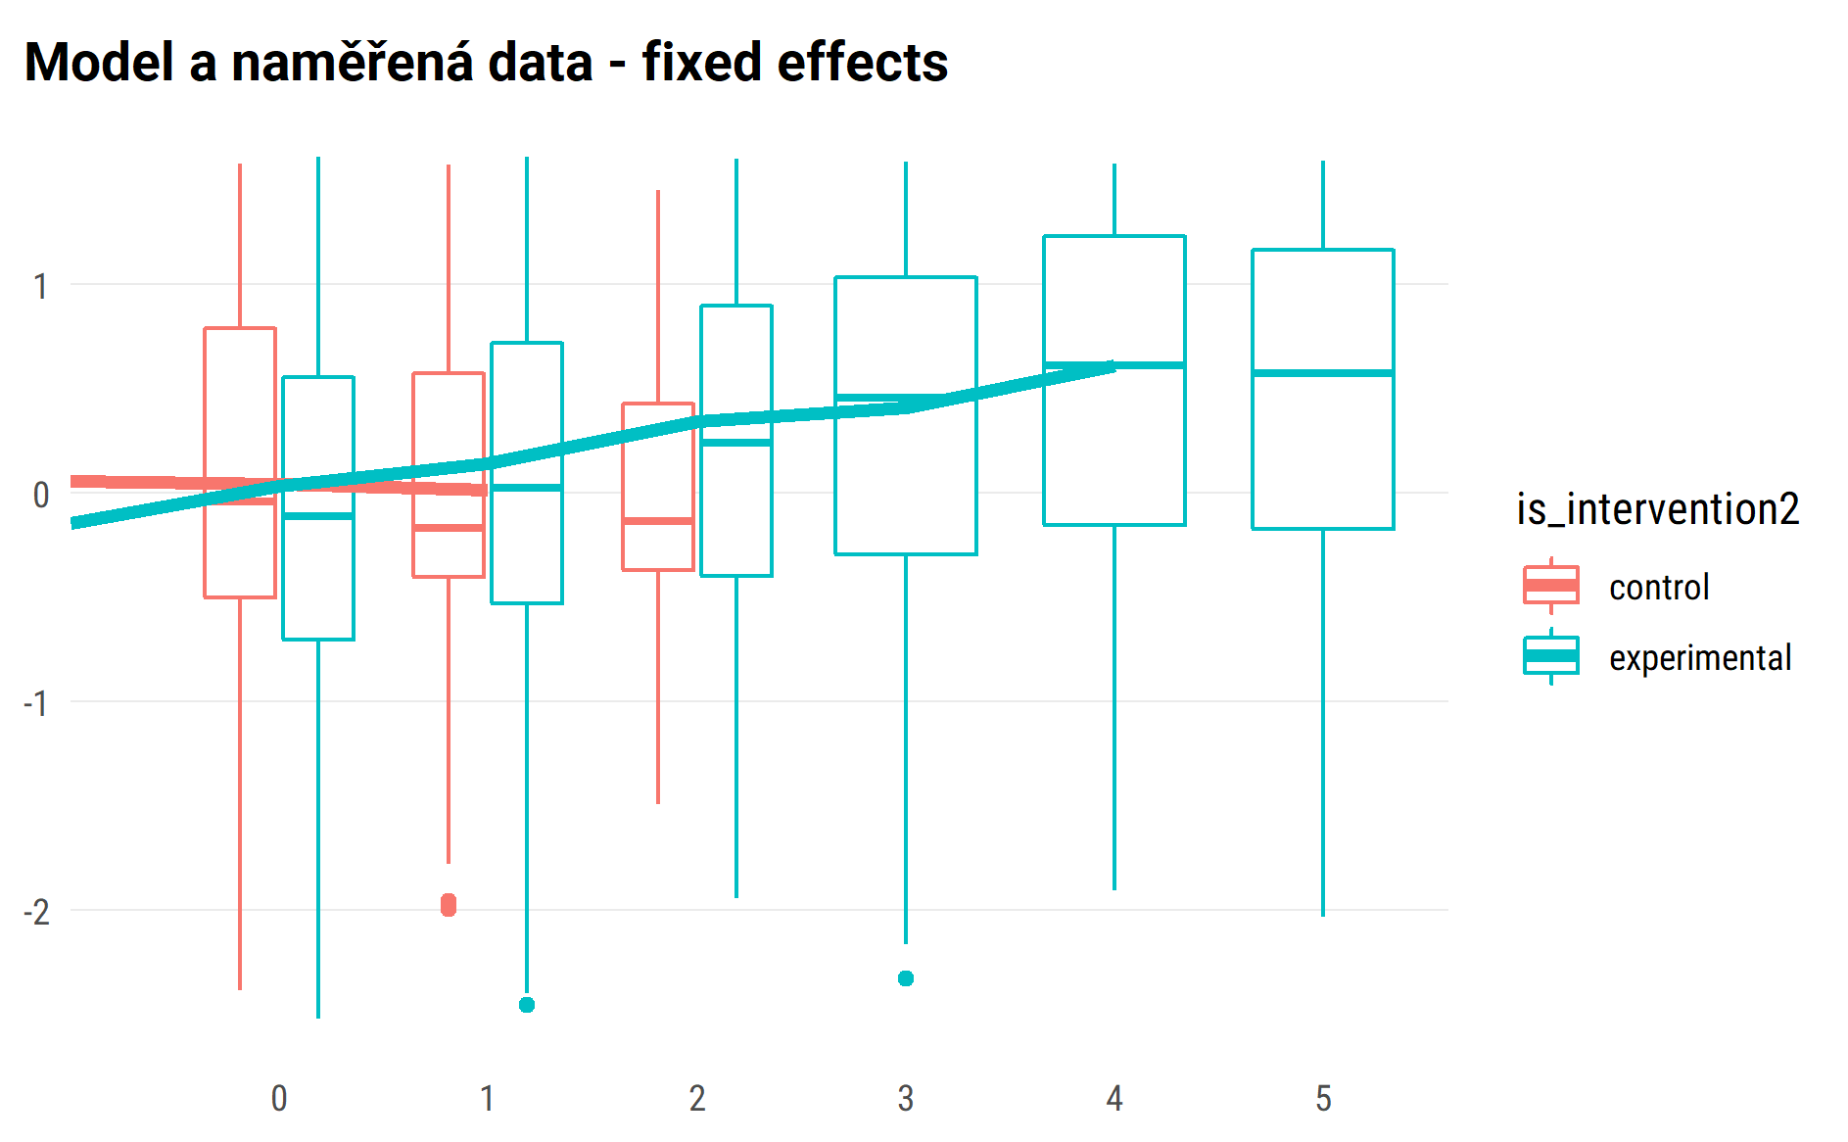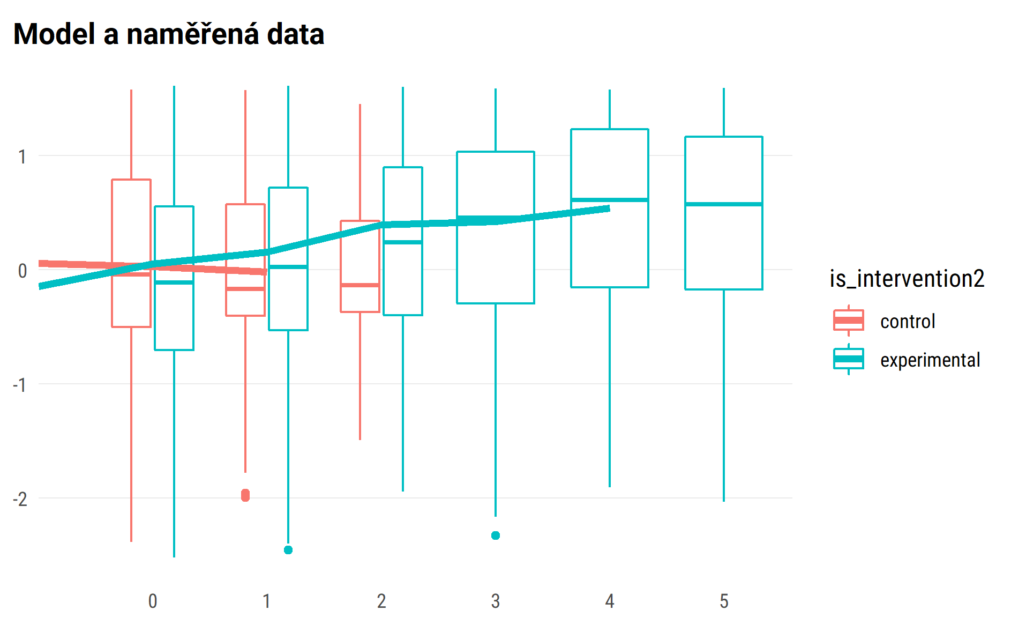

## random effect for sample of 50 pupils

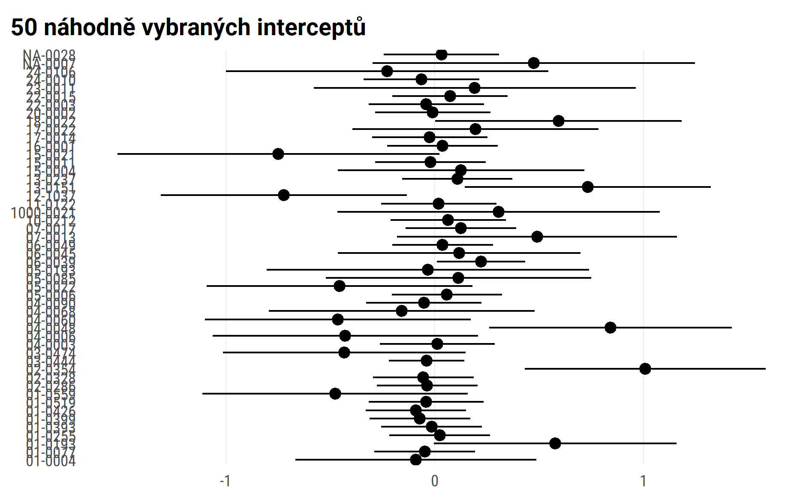

#> $wave_ind  
#>   
#> # Predicted values of pro  
#> # x = wave_ind  
#>   
#> x | Predicted | SE | 95% CI  
#> -------------------------------------  
#> 0 | -0.28 | 0.05 | [-0.36, -0.19]  
#> 1 | -0.25 | 0.05 | [-0.34, -0.16]  
#> 2 | -0.22 | 0.06 | [-0.35, -0.10]  
#> 3 | -0.20 | 0.09 | [-0.38, -0.02]  
#> 4 | -0.17 | 0.12 | [-0.41, 0.06]  
#> 5 | -0.15 | 0.15 | [-0.44, 0.15]  
#>   
#> Adjusted for:  
#> * is_intervention2 = control  
#> * age_fst_measur = 4.18  
#> * gender_girl = boys  
#> * id_pupil = 0 (population-level)  
#>   
#>   
#> $is_intervention2  
#>   
#> # Predicted values of pro  
#> # x = is_intervention2  
#>   
#> x | Predicted | SE | 95% CI  
#> ------------------------------------------------  
#> control | -0.24 | 0.05 | [-0.34, -0.15]  
#> experimental | -0.22 | 0.03 | [-0.27, -0.17]  
#>   
#> Adjusted for:  
#> * wave_ind = 1.23  
#> * age_fst_measur = 4.18  
#> * gender_girl = boys  
#> * id_pupil = 0 (population-level)  
#>   
#>   
#> $age_fst_measur  
#>   
#> # Predicted values of pro  
#> # x = age_fst_measur  
#>   
#> x | Predicted | SE | 95% CI  
#> -------------------------------------  
#> 2 | -0.69 | 0.06 | [-0.82, -0.57]  
#> 3 | -0.49 | 0.05 | [-0.59, -0.38]  
#> 4 | -0.28 | 0.05 | [-0.38, -0.18]  
#> 5 | -0.07 | 0.05 | [-0.17, 0.02]  
#> 6 | 0.13 | 0.05 | [ 0.02, 0.24]  
#> 7 | 0.34 | 0.06 | [ 0.21, 0.46]  
#> 8 | 0.54 | 0.08 | [ 0.39, 0.69]  
#>   
#> Adjusted for:  
#> * wave_ind = 1.23  
#> * is_intervention2 = control  
#> * gender_girl = boys  
#> * id_pupil = 0 (population-level)  
#>   
#>   
#> $gender_girl  
#>   
#> # Predicted values of pro  
#> # x = gender_girl  
#>   
#> x | Predicted | SE | 95% CI  
#> -----------------------------------------  
#> boys | -0.24 | 0.05 | [-0.34, -0.15]  
#> girls | 0.28 | 0.05 | [ 0.19, 0.38]  
#>   
#> Adjusted for:  
#> * wave_ind = 1.23  
#> * is_intervention2 = control  
#> * age_fst_measur = 4.18  
#> * id_pupil = 0 (population-level)  
#>   
#>   
#> attr(,"class")  
#> [1] "ggalleffects" "list"   
#> attr(,"model.name")  
#> [1] "."

marginal plots draft

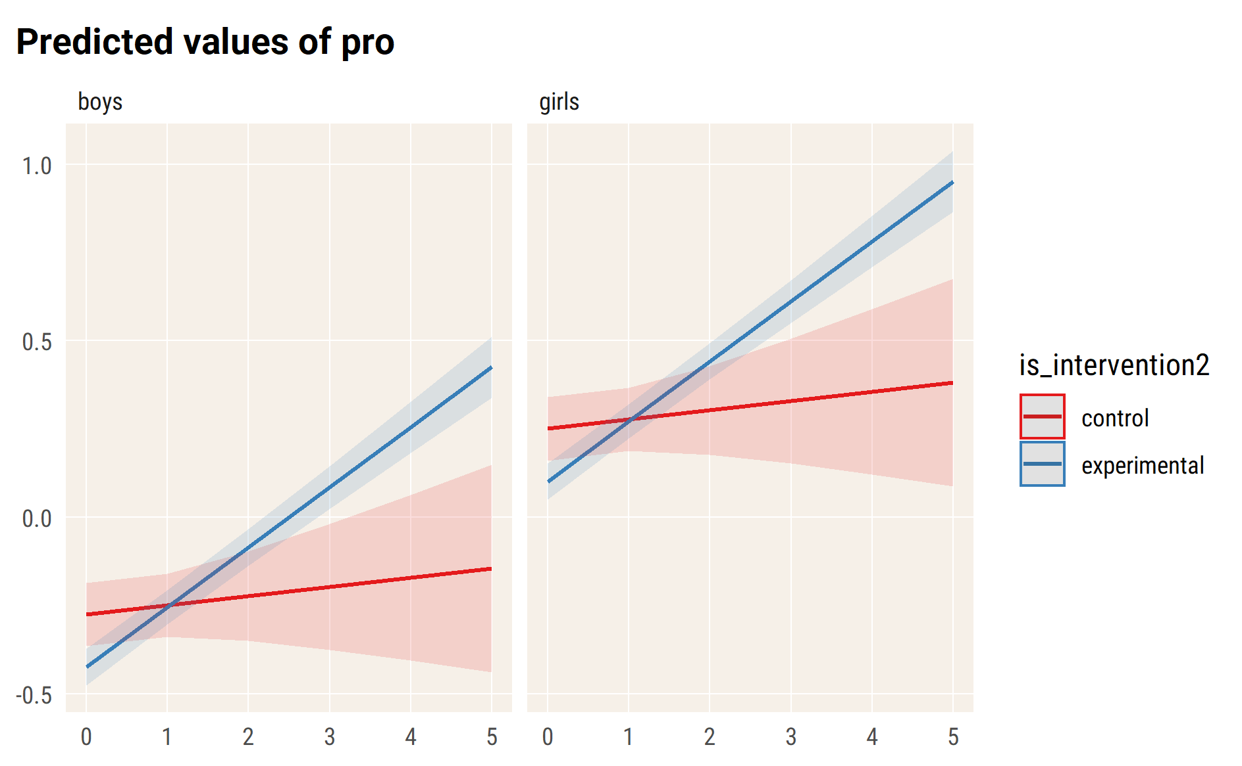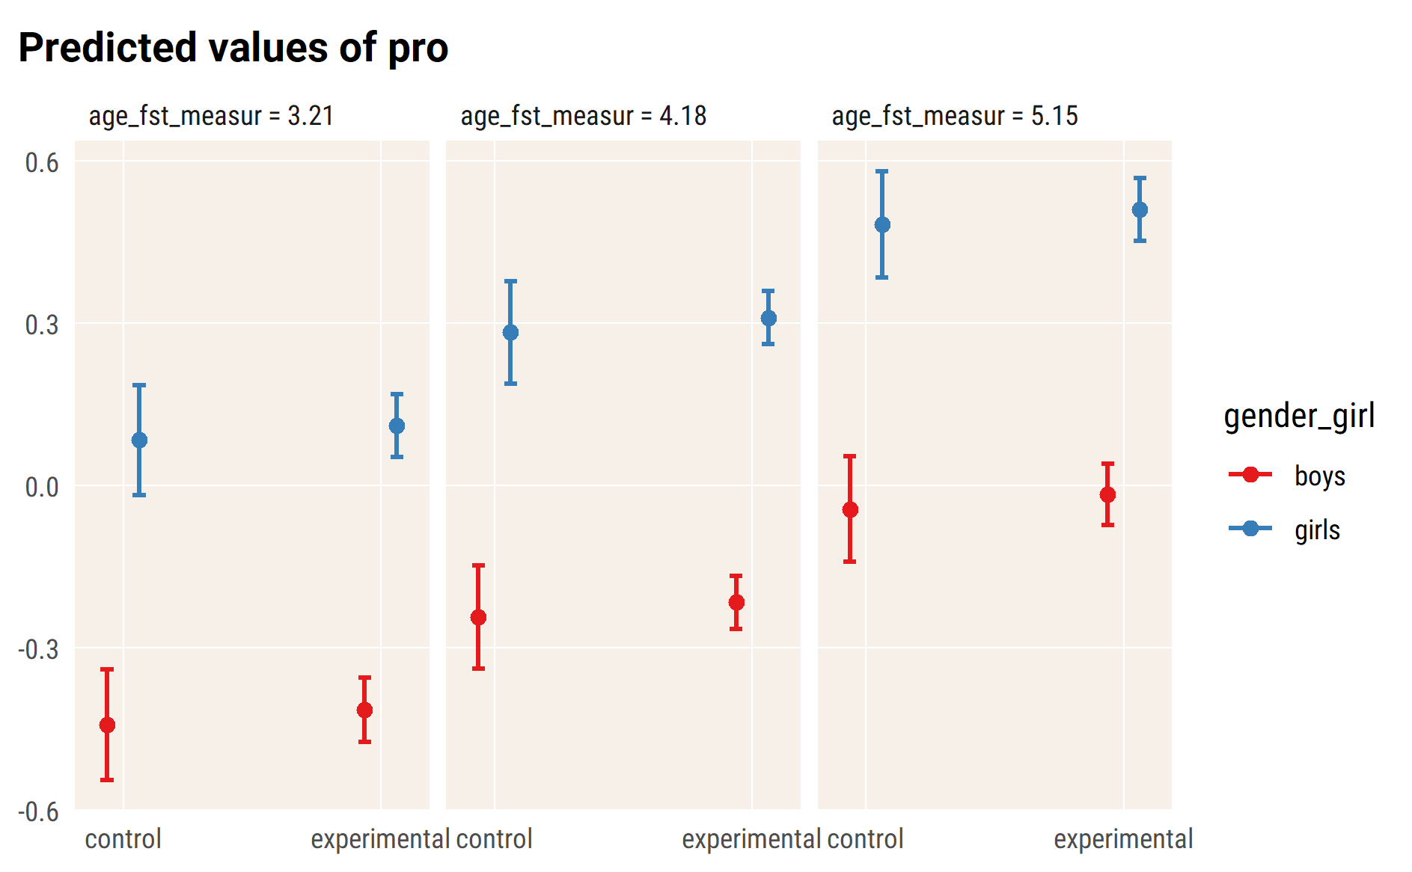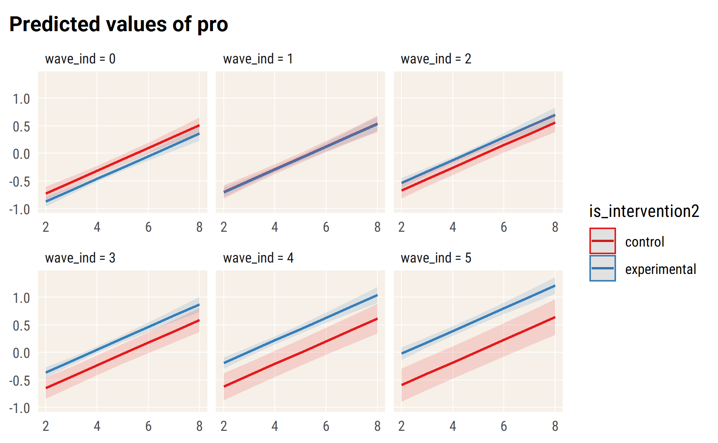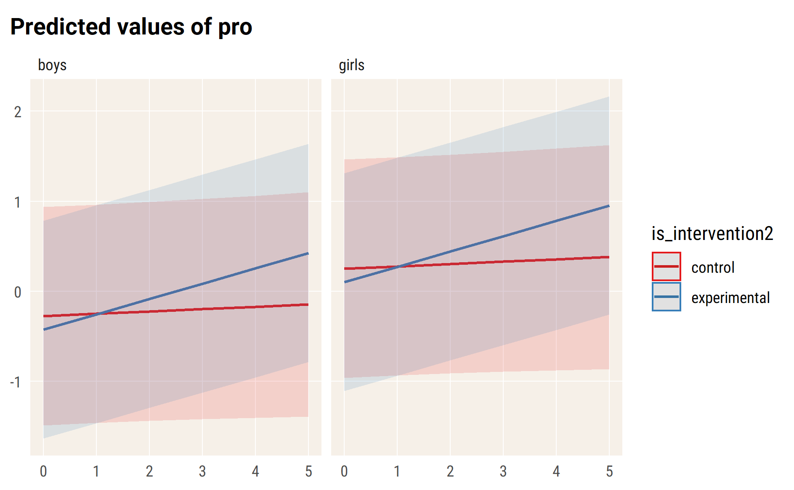

# emo

#> Linear mixed model fit by REML. t-tests use Satterthwaite's method [  
#> lmerModLmerTest]  
#> Formula:   
#> emo ~ wave_ind * is_intervention2 + age_fst_measur + gender_girl +   
#> (wave_ind | id_pupil)  
#> Data: df_long_zero  
#>   
#> REML criterion at convergence: 10023.8  
#>   
#> Scaled residuals:   
#> Min 1Q Median 3Q Max   
#> -3.3040 -0.5813 -0.0653 0.5230 3.5151   
#>   
#> Random effects:  
#> Groups Name Variance Std.Dev. Corr   
#> id_pupil (Intercept) 0.33129 0.5756   
#> wave_ind 0.01434 0.1197 -0.27  
#> Residual 0.31666 0.5627   
#> Number of obs: 4562, groups: id_pupil, 1738  
#>   
#> Fixed effects:  
#> Estimate Std. Error df  
#> (Intercept) 0.26291 0.08749 1909.59891  
#> wave_ind 0.05135 0.03408 3177.75351  
#> is_intervention2experimental 0.29496 0.04678 1973.65201  
#> age_fst_measur -0.07385 0.01629 1755.10645  
#> gender_girlgirls -0.15659 0.03270 1651.44995  
#> wave_ind:is_intervention2experimental -0.13119 0.03524 3030.72550  
#> t value Pr(>|t|)   
#> (Intercept) 3.005 0.002691 **   
#> wave_ind 1.507 0.131977   
#> is_intervention2experimental 6.306 0.000000000353 ***  
#> age_fst_measur -4.532 0.000006224764 ***  
#> gender_girlgirls -4.788 0.000001831639 ***  
#> wave_ind:is_intervention2experimental -3.722 0.000201 ***  
#> ---  
#> Signif. codes: 0 '***' 0.001 '**' 0.01 '*' 0.05 '.' 0.1 ' ' 1  
#>   
#> Correlation of Fixed Effects:  
#> (Intr) wav_nd is_nt2 ag_fs_ gndr_g  
#> wave_ind -0.253   
#> is_ntrvntn2 -0.525 0.360   
#> age_fst_msr -0.861 0.082 0.119   
#> gndr_grlgrl -0.205 -0.024 -0.021 0.034   
#> wv_nd:s_nt2 0.232 -0.966 -0.397 -0.065 0.023

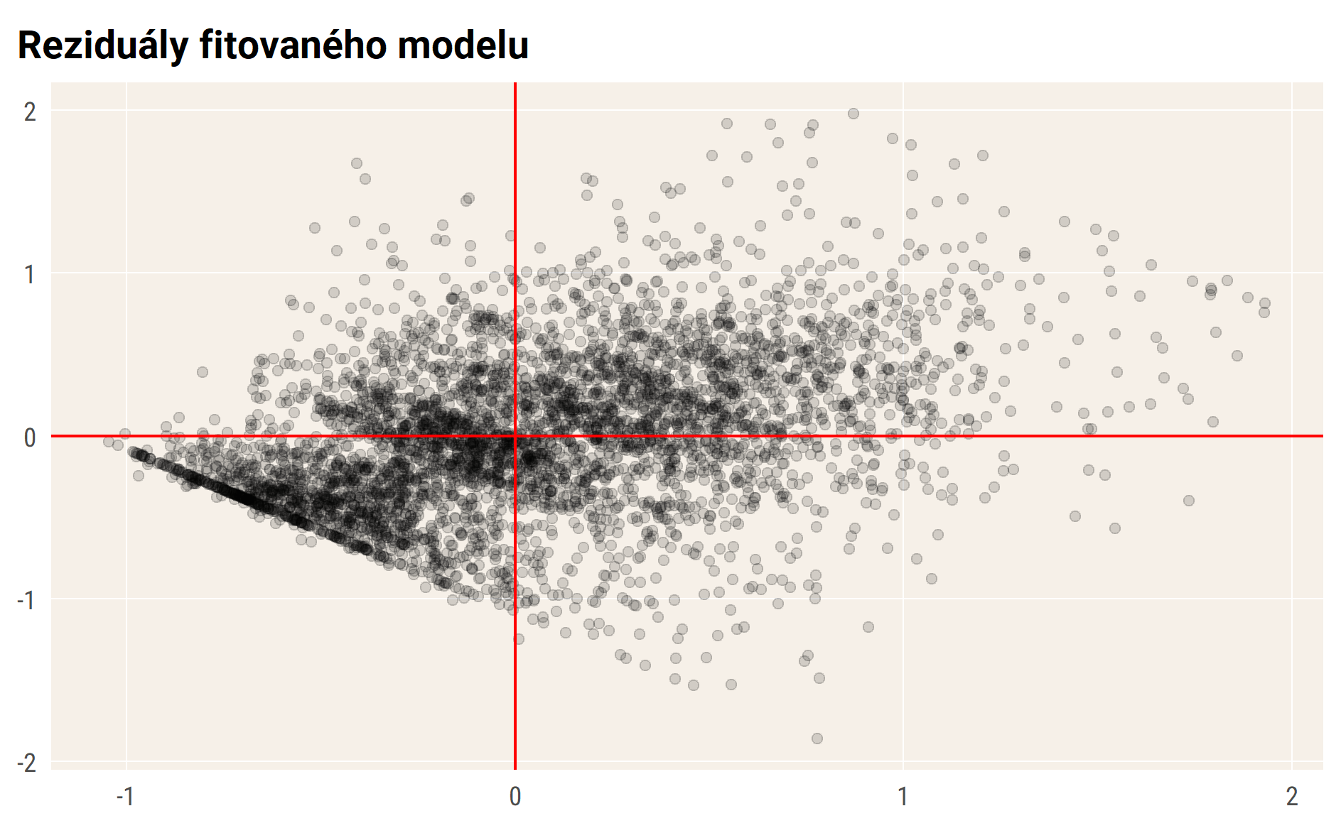

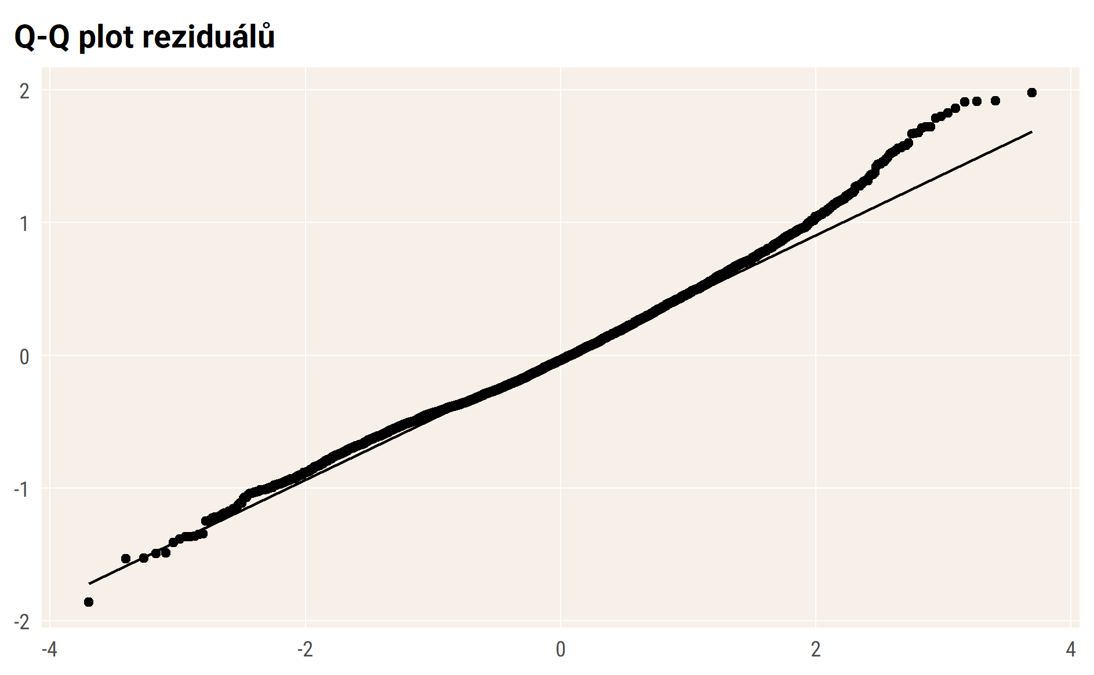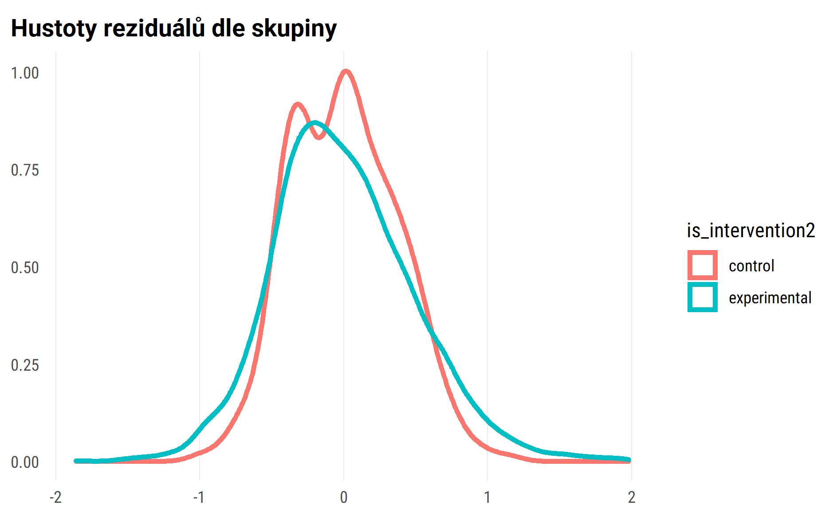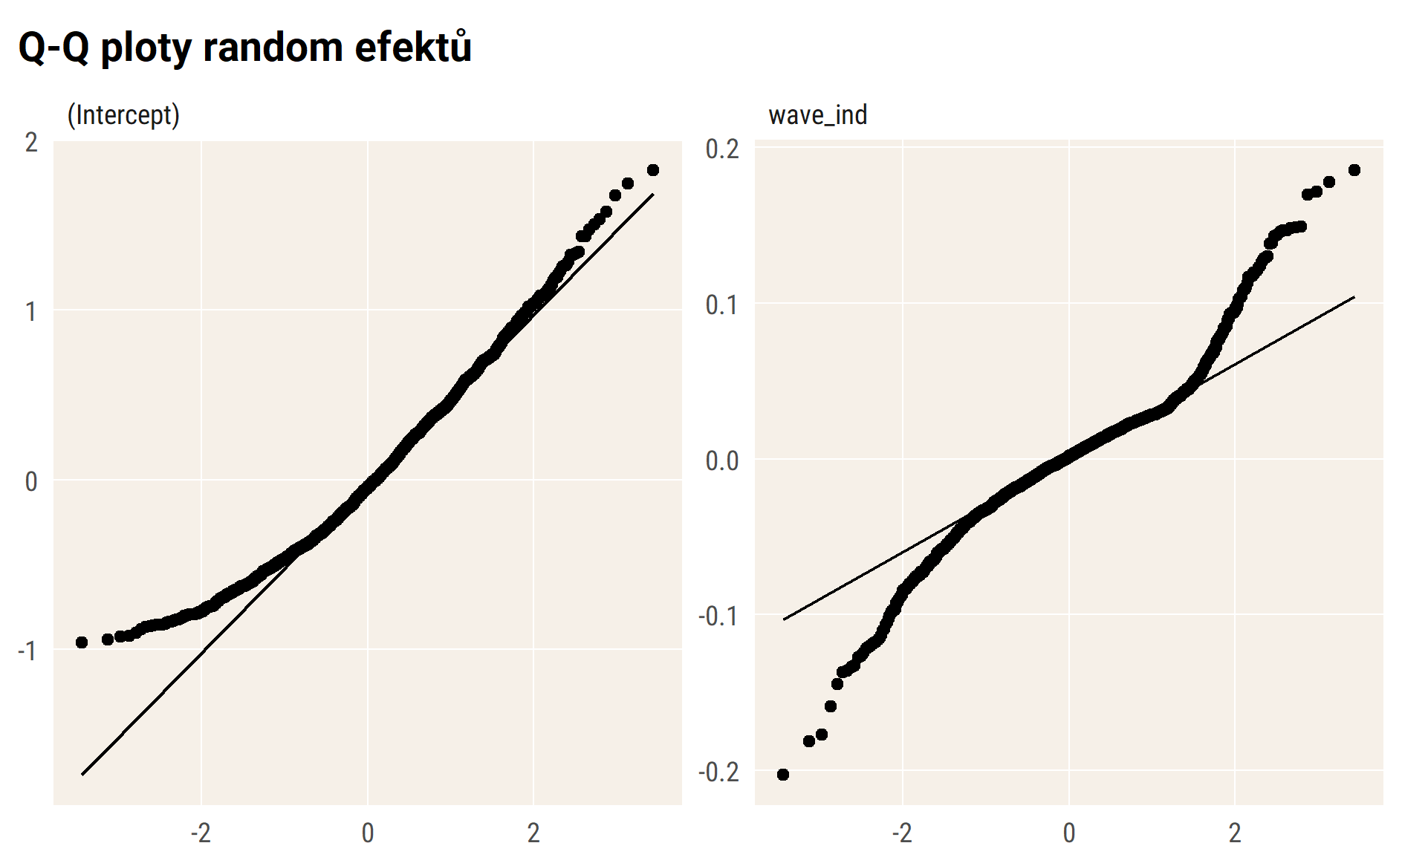

## Vizualizace modelu – průměry

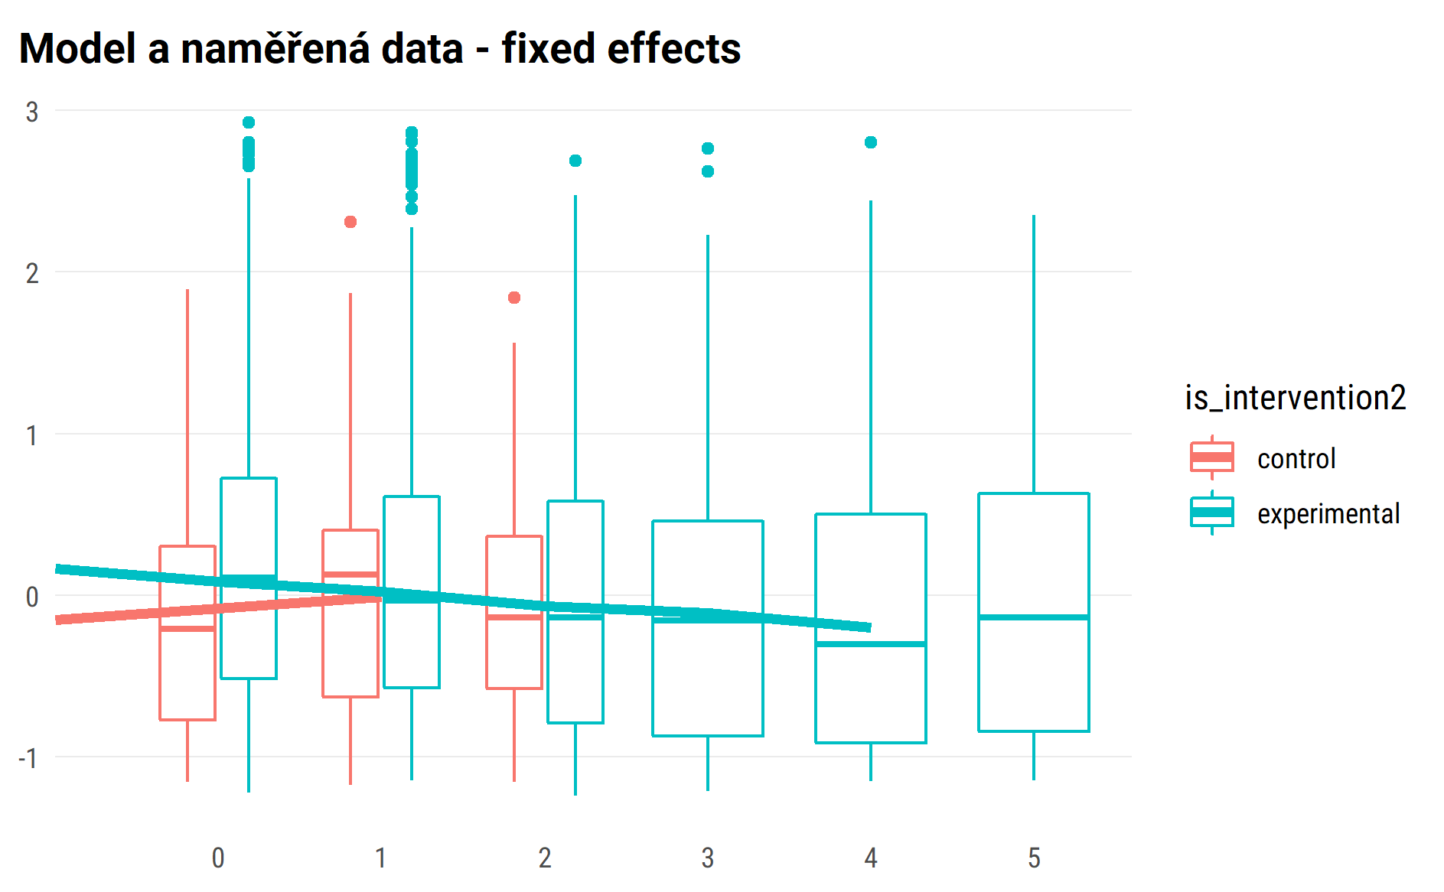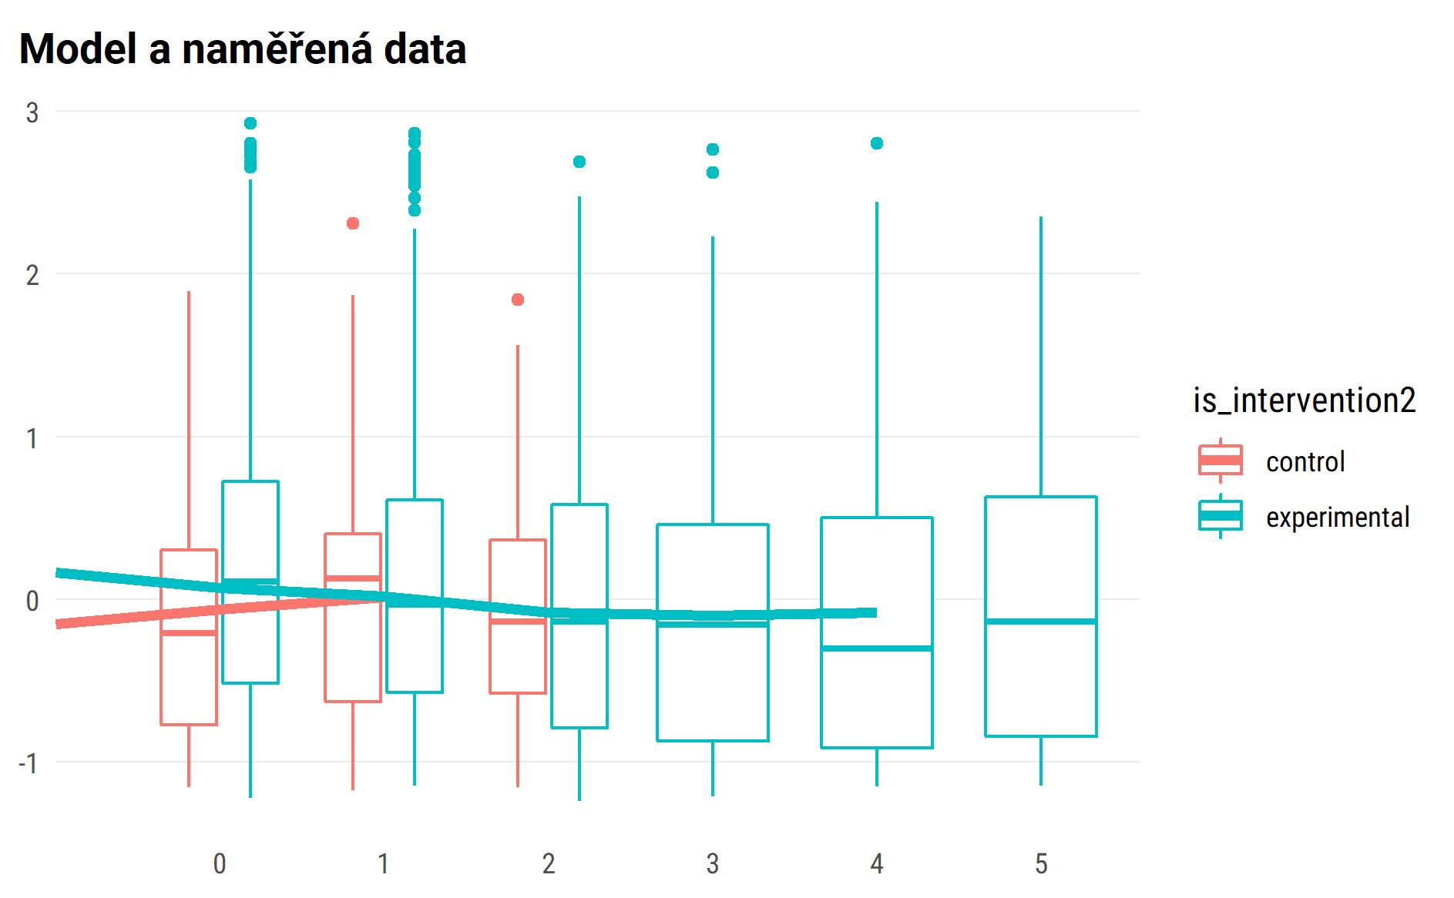

## random effect for sample of 50 pupils

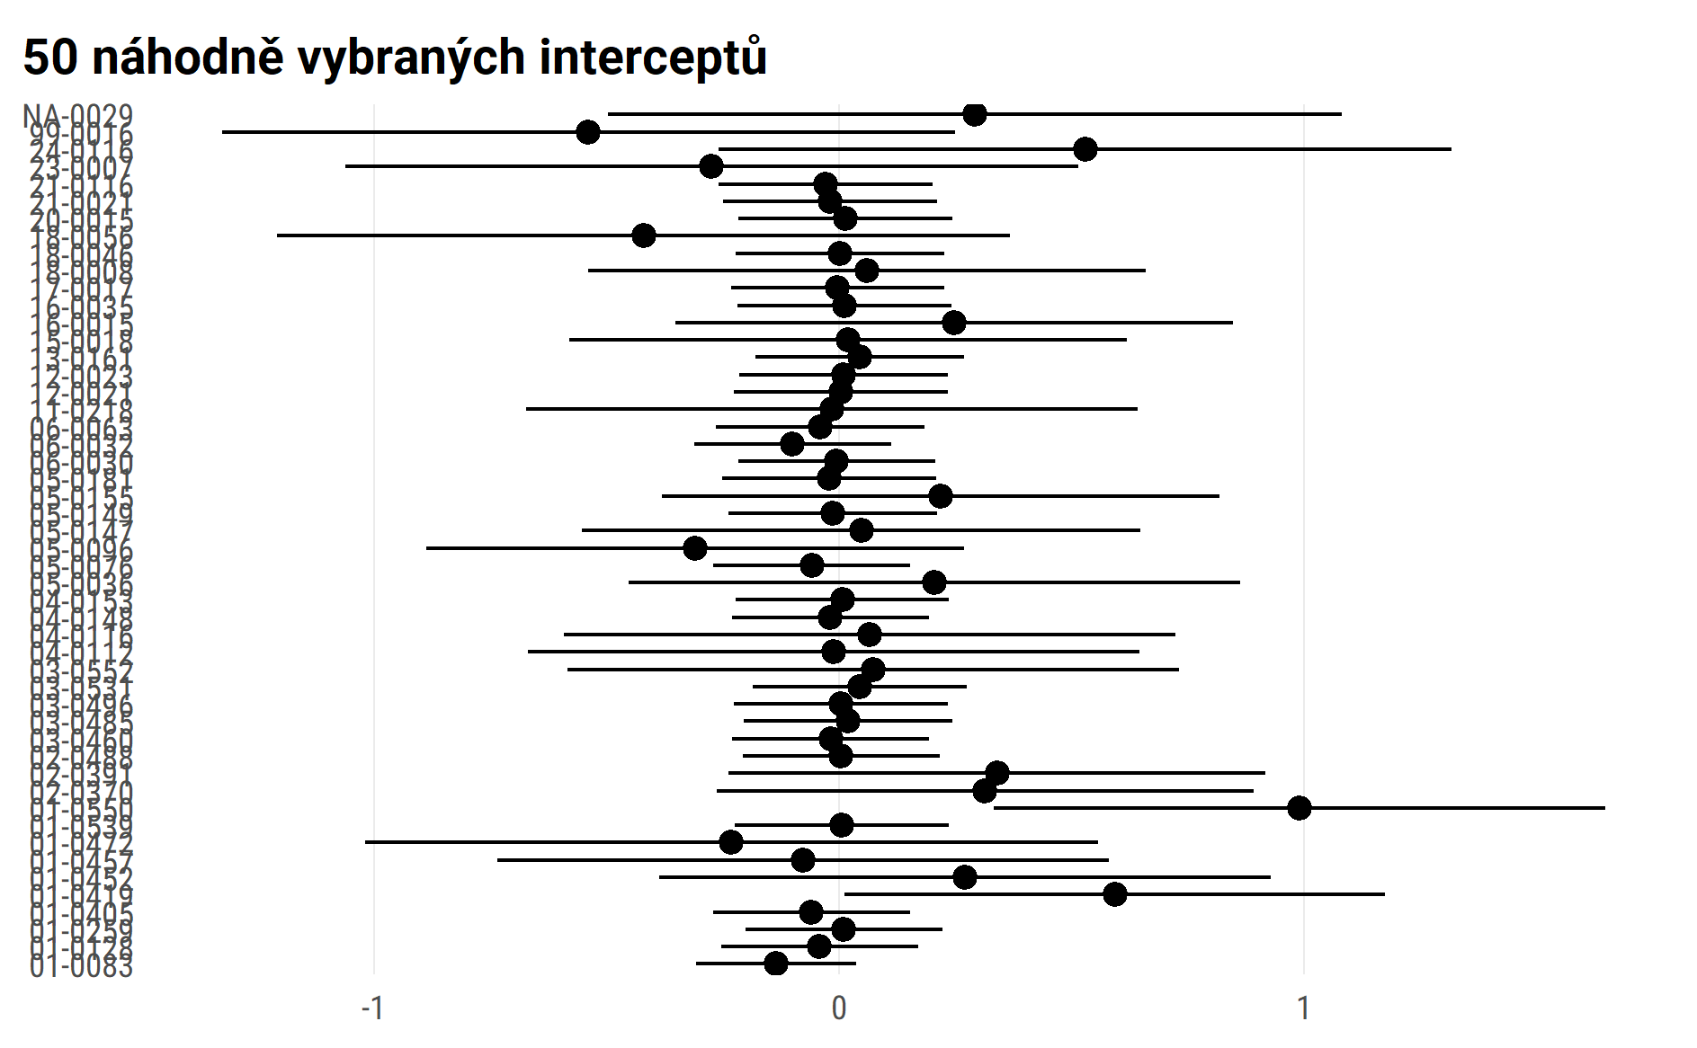

#> $wave_ind  
#>   
#> # Predicted values of emo  
#> # x = wave_ind  
#>   
#> x | Predicted | SE | 95% CI  
#> ------------------------------------  
#> 0 | -0.05 | 0.05 | [-0.13, 0.04]  
#> 1 | 0.01 | 0.05 | [-0.08, 0.09]  
#> 2 | 0.06 | 0.07 | [-0.07, 0.19]  
#> 3 | 0.11 | 0.10 | [-0.08, 0.30]  
#> 4 | 0.16 | 0.13 | [-0.09, 0.41]  
#> 5 | 0.21 | 0.16 | [-0.10, 0.52]  
#>   
#> Adjusted for:  
#> * is_intervention2 = control  
#> * age_fst_measur = 4.18  
#> * gender_girl = boys  
#> * id_pupil = 0 (population-level)  
#>   
#>   
#> $is_intervention2  
#>   
#> # Predicted values of emo  
#> # x = is_intervention2  
#>   
#> x | Predicted | SE | 95% CI  
#> -----------------------------------------------  
#> control | 0.02 | 0.05 | [-0.08, 0.11]  
#> experimental | 0.15 | 0.02 | [ 0.10, 0.20]  
#>   
#> Adjusted for:  
#> * wave_ind = 1.23  
#> * age_fst_measur = 4.18  
#> * gender_girl = boys  
#> * id_pupil = 0 (population-level)  
#>   
#>   
#> $age_fst_measur  
#>   
#> # Predicted values of emo  
#> # x = age_fst_measur  
#>   
#> x | Predicted | SE | 95% CI  
#> -------------------------------------  
#> 2 | 0.18 | 0.06 | [ 0.06, 0.30]  
#> 3 | 0.10 | 0.05 | [ 0.00, 0.21]  
#> 4 | 0.03 | 0.05 | [-0.07, 0.13]  
#> 5 | -0.04 | 0.05 | [-0.14, 0.05]  
#> 6 | -0.12 | 0.06 | [-0.23, -0.01]  
#> 7 | -0.19 | 0.06 | [-0.32, -0.06]  
#> 8 | -0.26 | 0.08 | [-0.41, -0.12]  
#>   
#> Adjusted for:  
#> * wave_ind = 1.23  
#> * is_intervention2 = control  
#> * gender_girl = boys  
#> * id_pupil = 0 (population-level)  
#>   
#>   
#> $gender_girl  
#>   
#> # Predicted values of emo  
#> # x = gender_girl  
#>   
#> x | Predicted | SE | 95% CI  
#> -----------------------------------------  
#> boys | 0.02 | 0.05 | [-0.08, 0.11]  
#> girls | -0.14 | 0.05 | [-0.23, -0.04]  
#>   
#> Adjusted for:  
#> * wave_ind = 1.23  
#> * is_intervention2 = control  
#> * age_fst_measur = 4.18  
#> * id_pupil = 0 (population-level)  
#>   
#>   
#> attr(,"class")  
#> [1] "ggalleffects" "list"   
#> attr(,"model.name")  
#> [1] "."

marginal plots draft

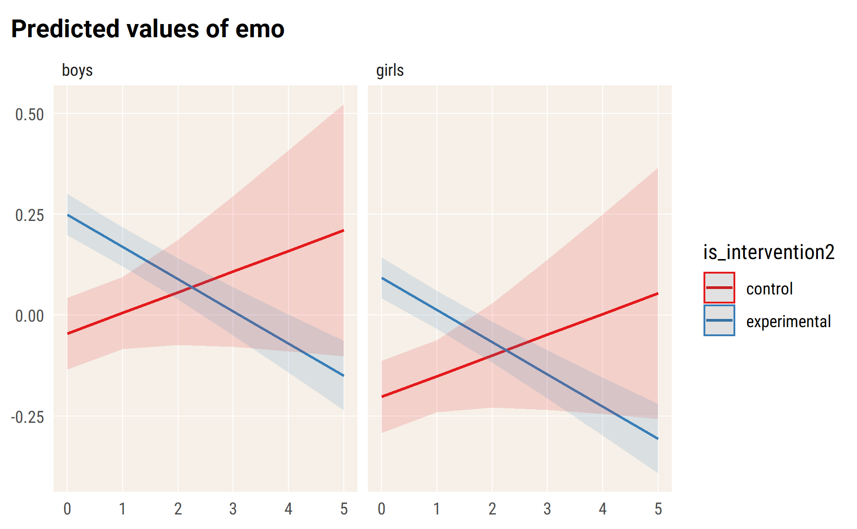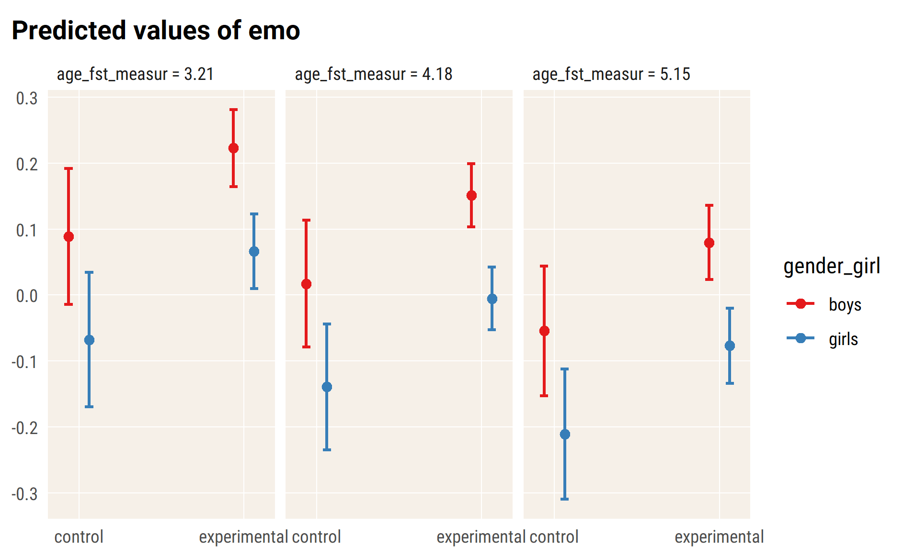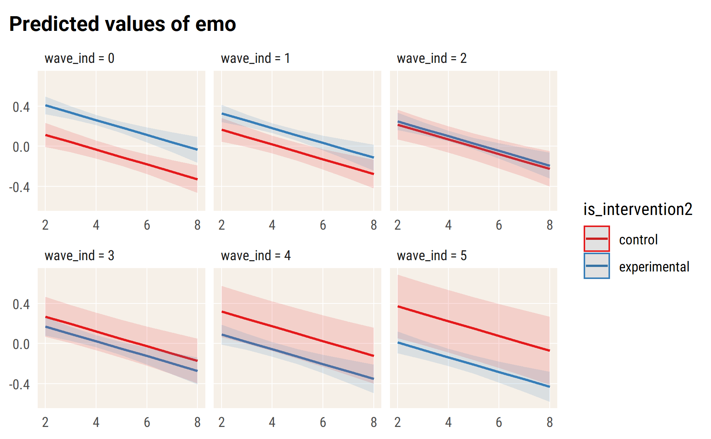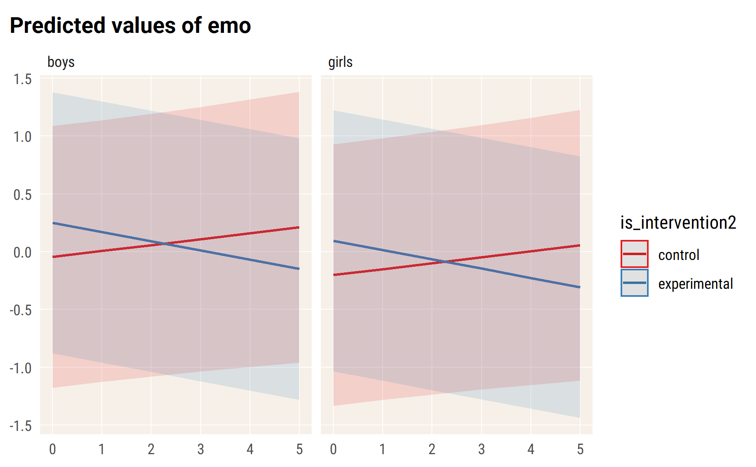

# con

#> Linear mixed model fit by REML. t-tests use Satterthwaite's method [  
#> lmerModLmerTest]  
#> Formula:   
#> con ~ wave_ind * is_intervention2 + age_fst_measur + gender_girl +   
#> (wave_ind | id_pupil)  
#> Data: df_long_zero  
#>   
#> REML criterion at convergence: 9371.4  
#>   
#> Scaled residuals:   
#> Min 1Q Median 3Q Max   
#> -3.5873 -0.5189 -0.0342 0.4973 3.1481   
#>   
#> Random effects:  
#> Groups Name Variance Std.Dev. Corr   
#> id_pupil (Intercept) 0.40587 0.6371   
#> wave_ind 0.01547 0.1244 -0.12  
#> Residual 0.23020 0.4798   
#> Number of obs: 4562, groups: id_pupil, 1738  
#>   
#> Fixed effects:  
#> Estimate Std. Error df  
#> (Intercept) 0.75876 0.09075 1837.94628  
#> wave_ind 0.01624 0.03061 2916.86556  
#> is_intervention2experimental 0.25691 0.04675 1908.01245  
#> age_fst_measur -0.13790 0.01709 1750.42374  
#> gender_girlgirls -0.52093 0.03458 1707.08853  
#> wave_ind:is_intervention2experimental -0.12578 0.03175 2728.55751  
#> t value Pr(>|t|)   
#> (Intercept) 8.361 < 2e-16 ***  
#> wave_ind 0.531 0.596   
#> is_intervention2experimental 5.495 0.0000000442967787 ***  
#> age_fst_measur -8.069 0.0000000000000013 ***  
#> gender_girlgirls -15.065 < 2e-16 ***  
#> wave_ind:is_intervention2experimental -3.961 0.0000764426849123 ***  
#> ---  
#> Signif. codes: 0 '***' 0.001 '**' 0.01 '*' 0.05 '.' 0.1 ' ' 1  
#>   
#> Correlation of Fixed Effects:  
#> (Intr) wav_nd is_nt2 ag_fs_ gndr_g  
#> wave_ind -0.195   
#> is_ntrvntn2 -0.514 0.283   
#> age_fst_msr -0.871 0.066 0.127   
#> gndr_grlgrl -0.209 -0.020 -0.022 0.035   
#> wv_nd:s_nt2 0.180 -0.964 -0.312 -0.054 0.019

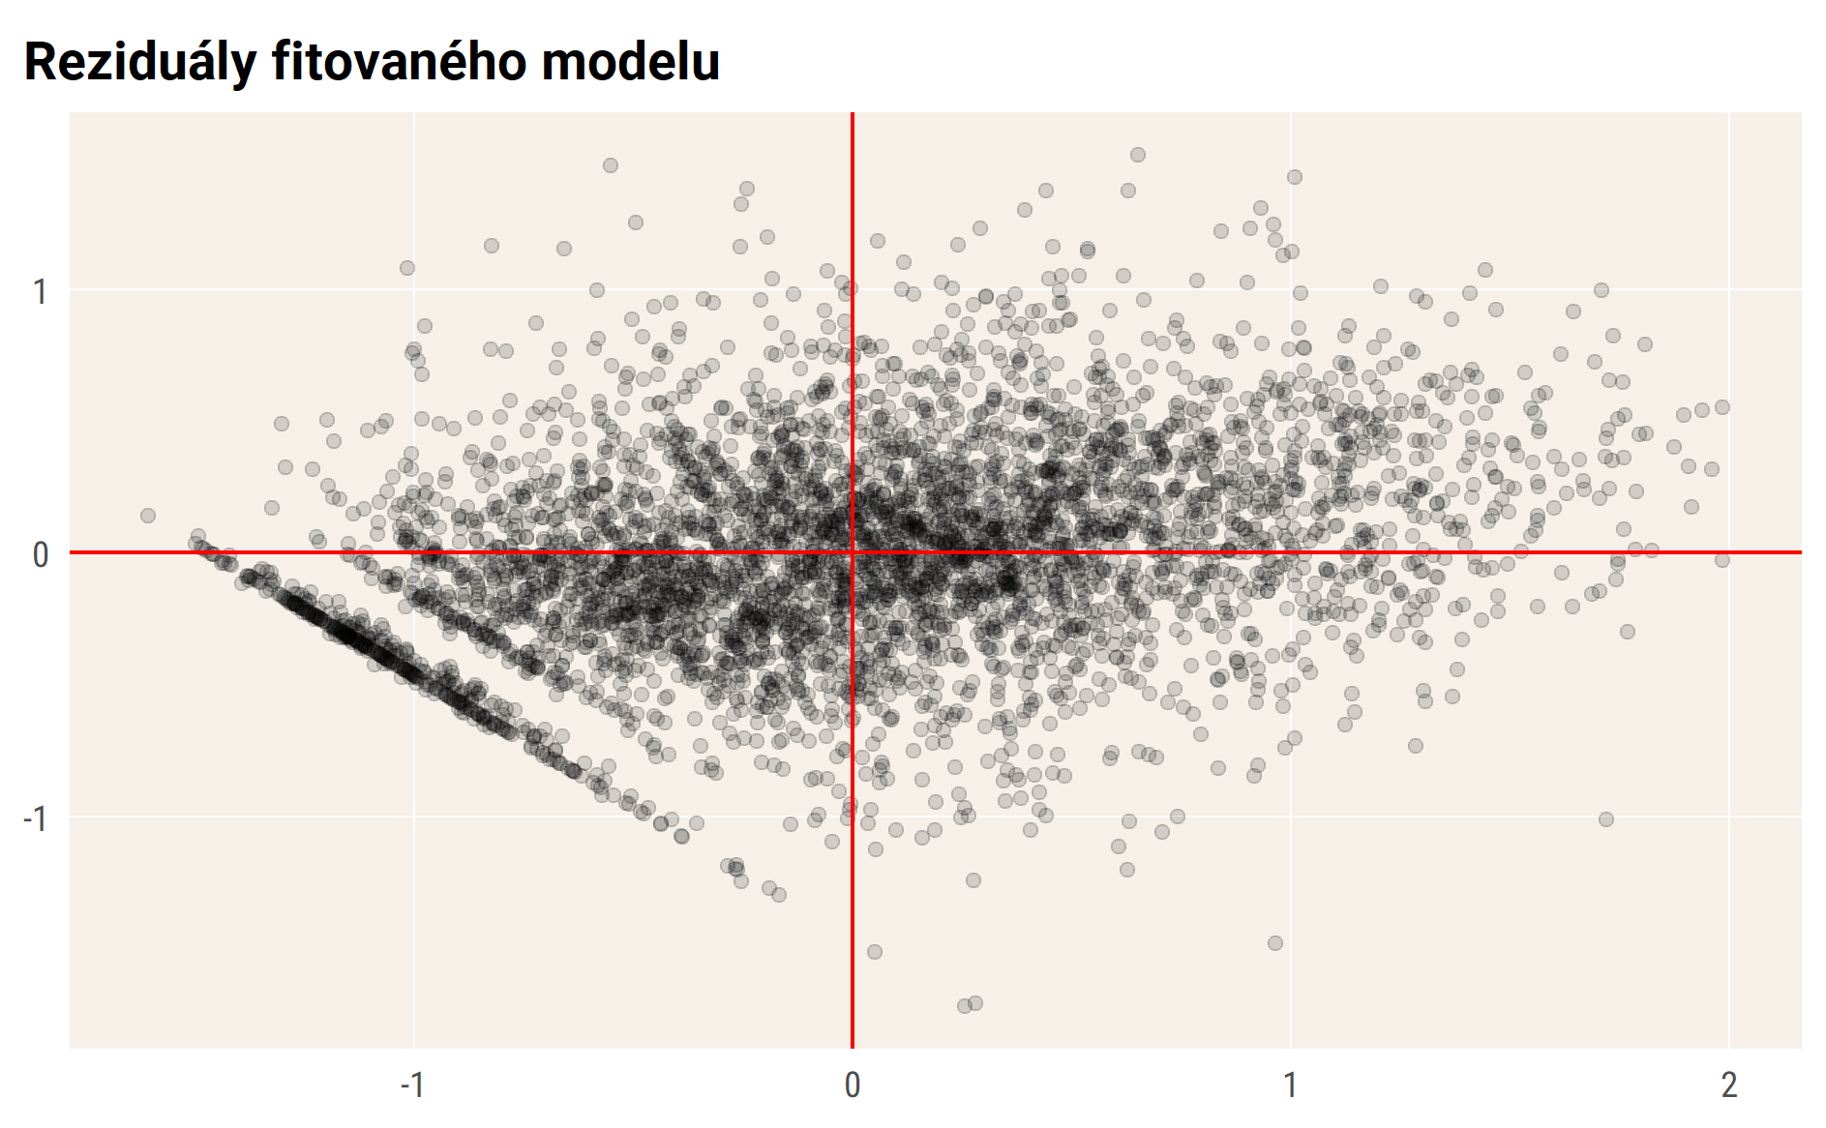

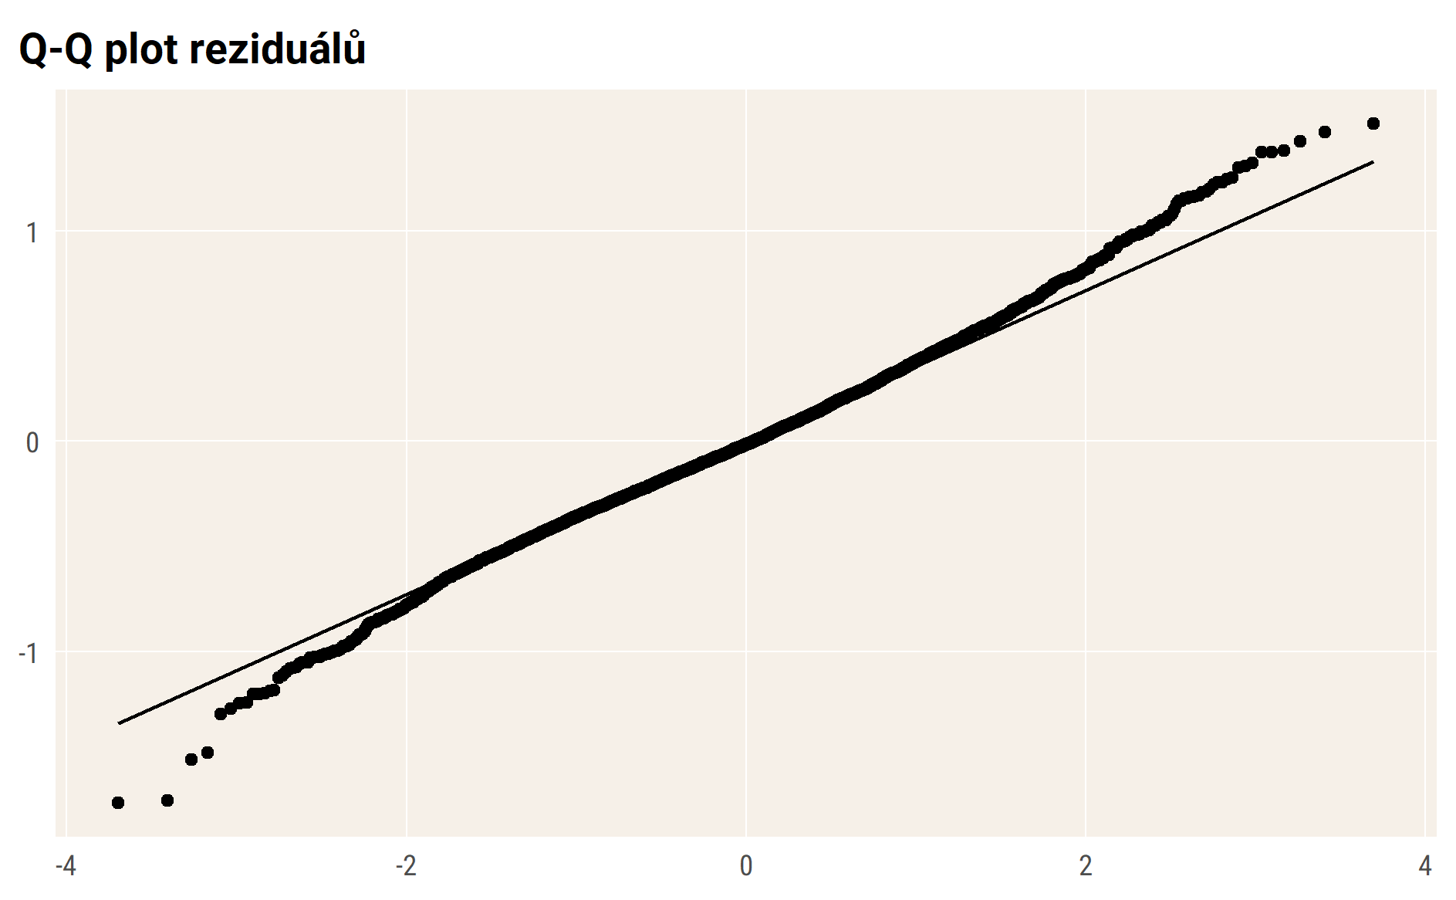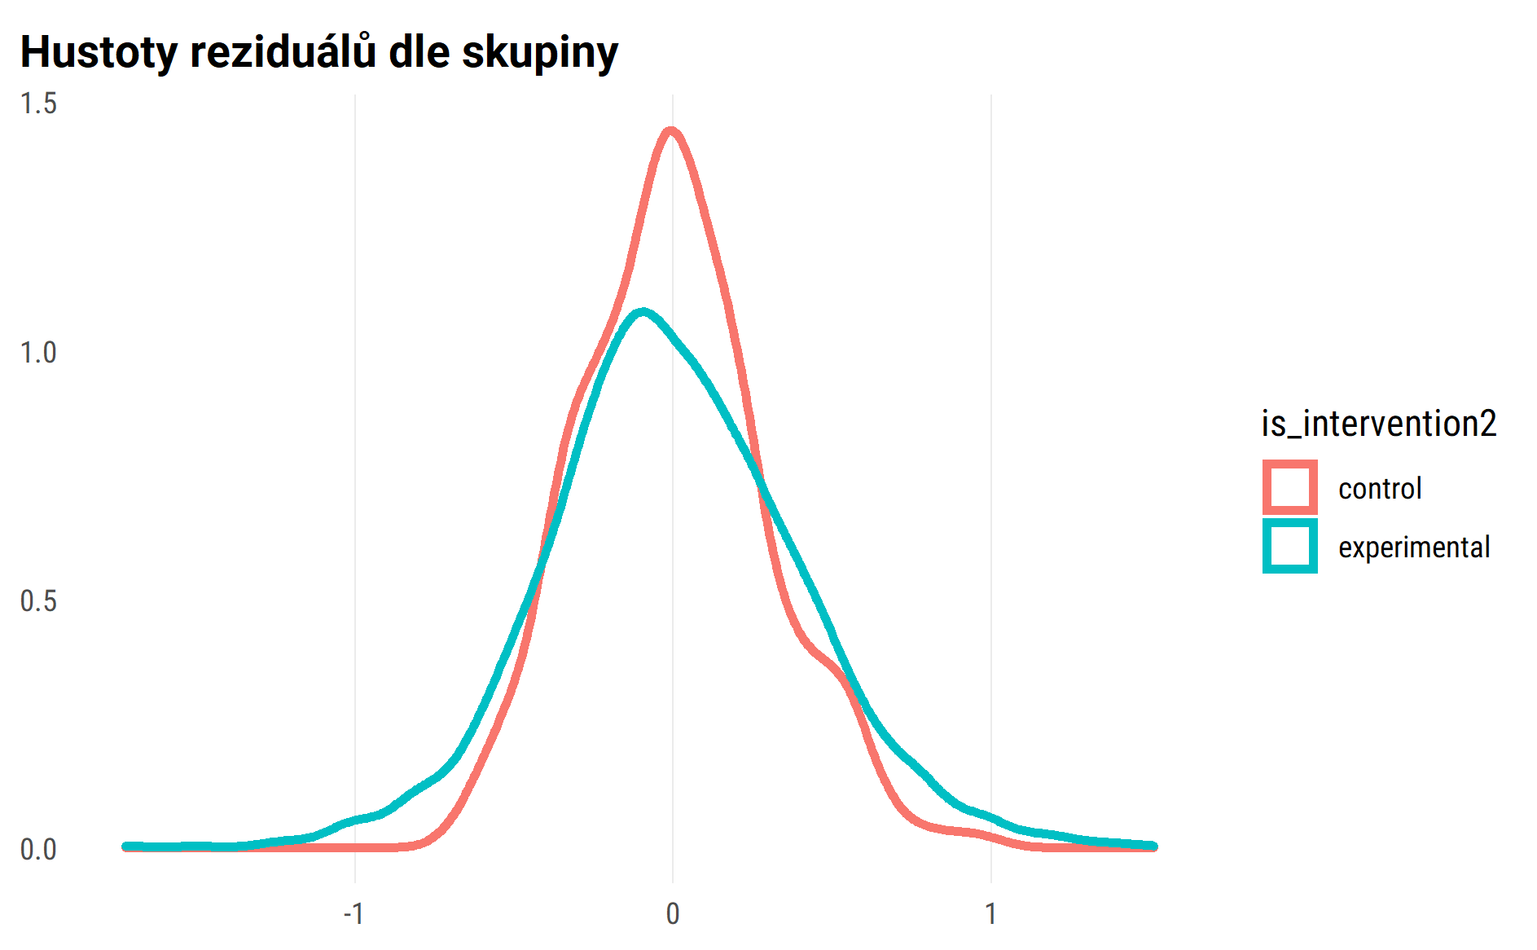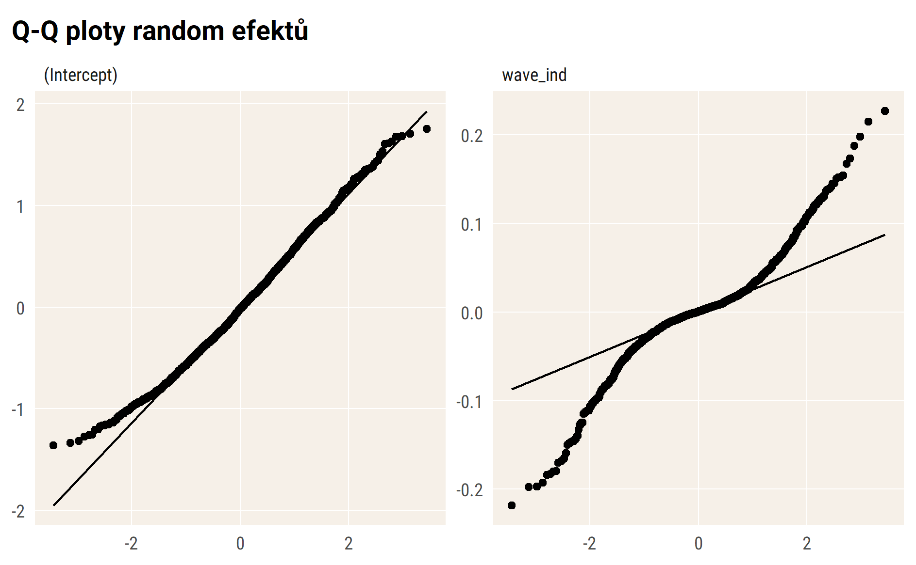

## Vizualizace modelu – průměry

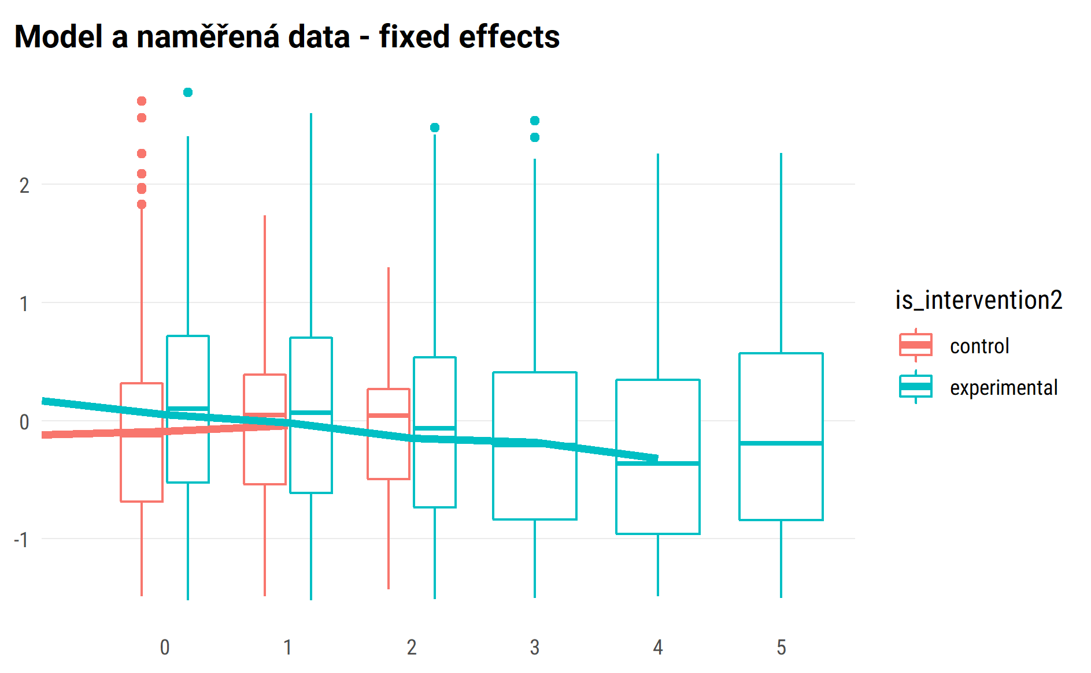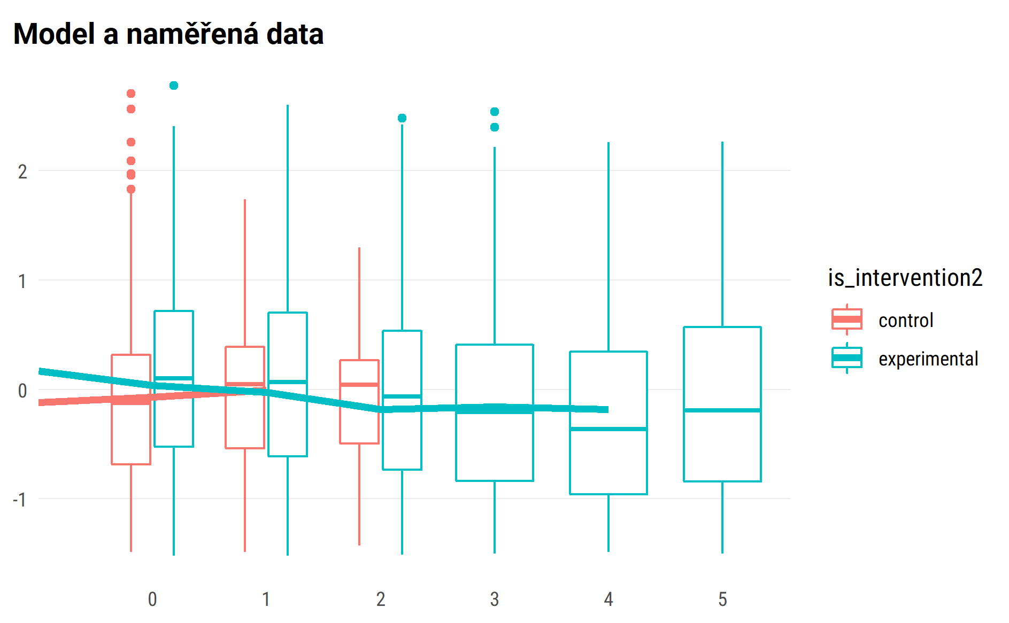

## random effect for sample of 50 pupils

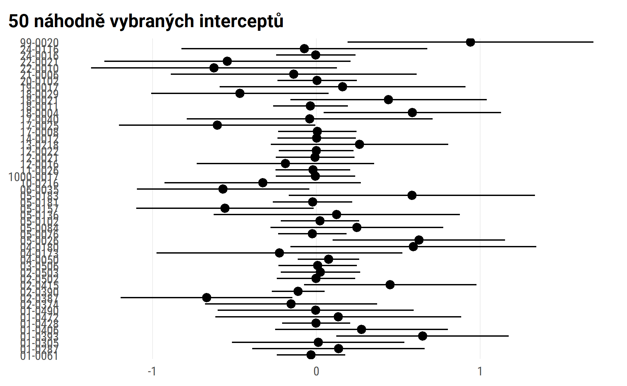

#> $wave_ind  
#>   
#> # Predicted values of con  
#> # x = wave_ind  
#>   
#> x | Predicted | SE | 95% CI  
#> ------------------------------------  
#> 0 | 0.18 | 0.05 | [ 0.09, 0.27]  
#> 1 | 0.20 | 0.05 | [ 0.11, 0.29]  
#> 2 | 0.22 | 0.06 | [ 0.09, 0.34]  
#> 3 | 0.23 | 0.09 | [ 0.05, 0.41]  
#> 4 | 0.25 | 0.12 | [ 0.02, 0.48]  
#> 5 | 0.26 | 0.15 | [-0.02, 0.55]  
#>   
#> Adjusted for:  
#> * is_intervention2 = control  
#> * age_fst_measur = 4.18  
#> * gender_girl = boys  
#> * id_pupil = 0 (population-level)  
#>   
#>   
#> $is_intervention2  
#>   
#> # Predicted values of con  
#> # x = is_intervention2  
#>   
#> x | Predicted | SE | 95% CI  
#> ----------------------------------------------  
#> control | 0.20 | 0.05 | [0.10, 0.30]  
#> experimental | 0.31 | 0.03 | [0.25, 0.36]  
#>   
#> Adjusted for:  
#> * wave_ind = 1.23  
#> * age_fst_measur = 4.18  
#> * gender_girl = boys  
#> * id_pupil = 0 (population-level)  
#>   
#>   
#> $age_fst_measur  
#>   
#> # Predicted values of con  
#> # x = age_fst_measur  
#>   
#> x | Predicted | SE | 95% CI  
#> -------------------------------------  
#> 2 | 0.50 | 0.07 | [ 0.38, 0.63]  
#> 3 | 0.36 | 0.06 | [ 0.26, 0.47]  
#> 4 | 0.23 | 0.05 | [ 0.13, 0.33]  
#> 5 | 0.09 | 0.05 | [-0.01, 0.19]  
#> 6 | -0.05 | 0.06 | [-0.16, 0.06]  
#> 7 | -0.19 | 0.07 | [-0.32, -0.06]  
#> 8 | -0.32 | 0.08 | [-0.48, -0.17]  
#>   
#> Adjusted for:  
#> * wave_ind = 1.23  
#> * is_intervention2 = control  
#> * gender_girl = boys  
#> * id_pupil = 0 (population-level)  
#>   
#>   
#> $gender_girl  
#>   
#> # Predicted values of con  
#> # x = gender_girl  
#>   
#> x | Predicted | SE | 95% CI  
#> -----------------------------------------  
#> boys | 0.20 | 0.05 | [ 0.10, 0.30]  
#> girls | -0.32 | 0.05 | [-0.42, -0.22]  
#>   
#> Adjusted for:  
#> * wave_ind = 1.23  
#> * is_intervention2 = control  
#> * age_fst_measur = 4.18  
#> * id_pupil = 0 (population-level)  
#>   
#>   
#> attr(,"class")  
#> [1] "ggalleffects" "list"   
#> attr(,"model.name")  
#> [1] "."

marginal plots draft

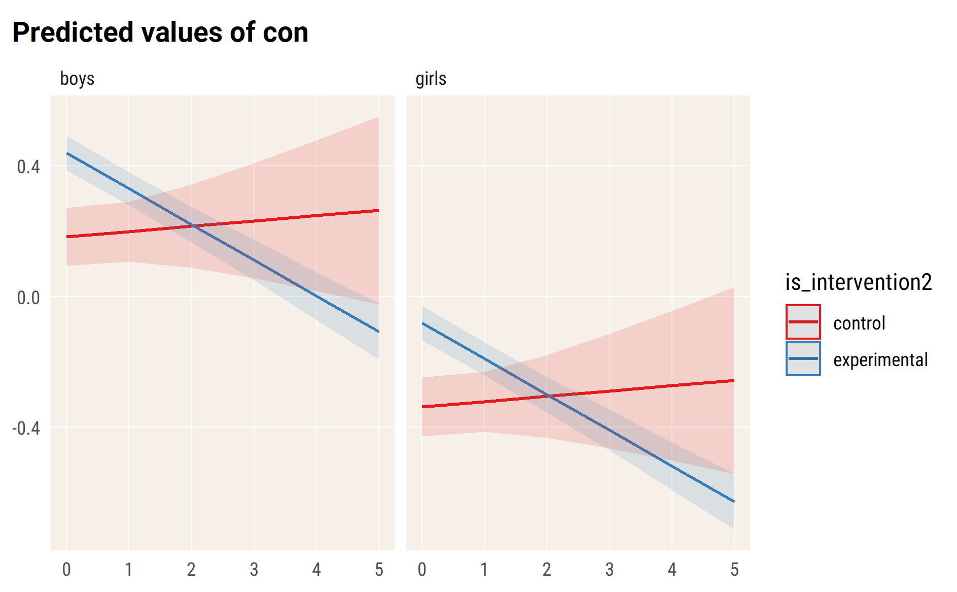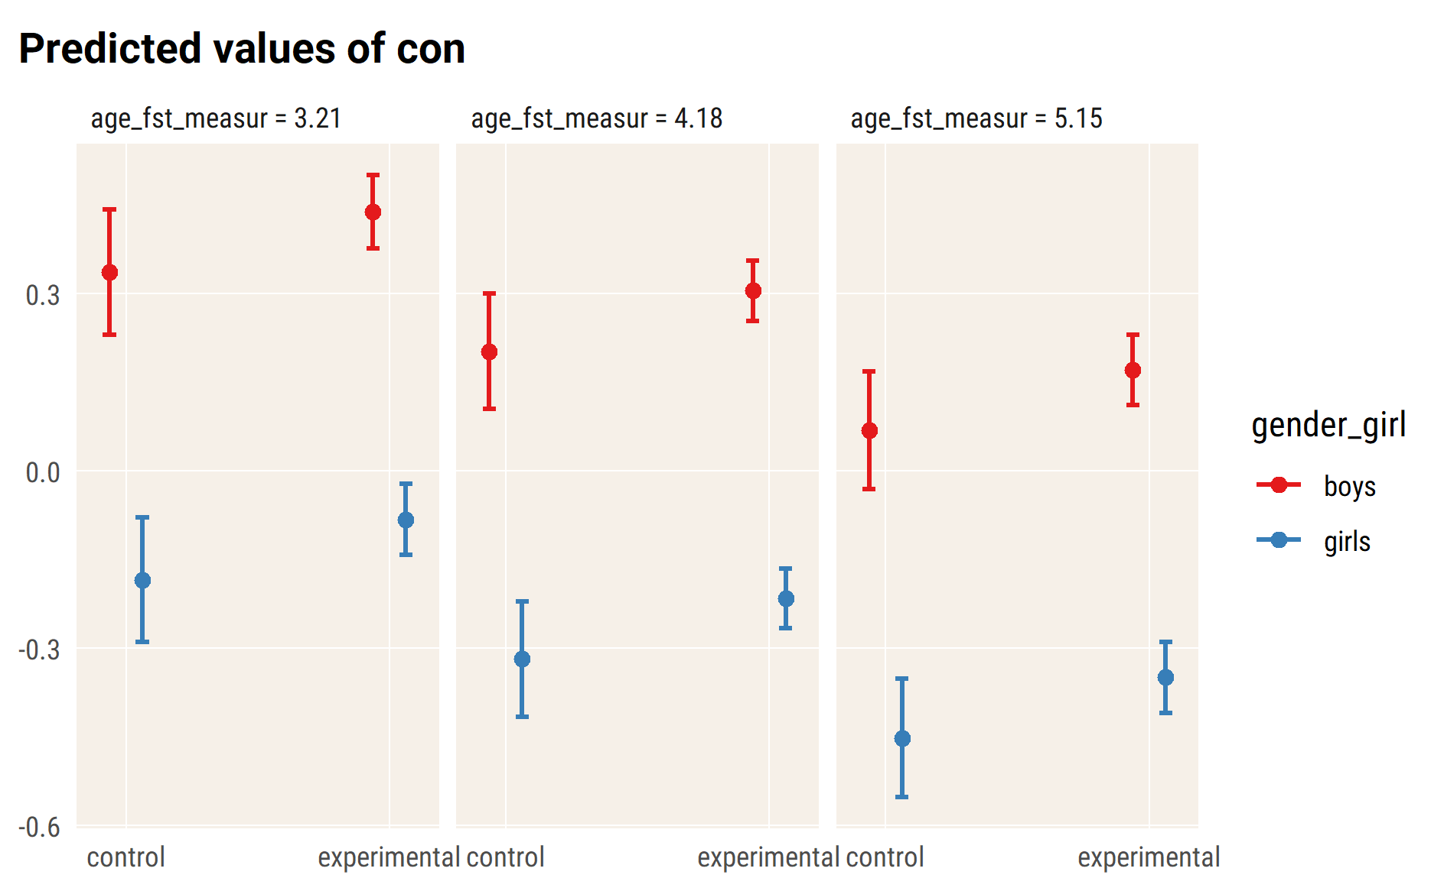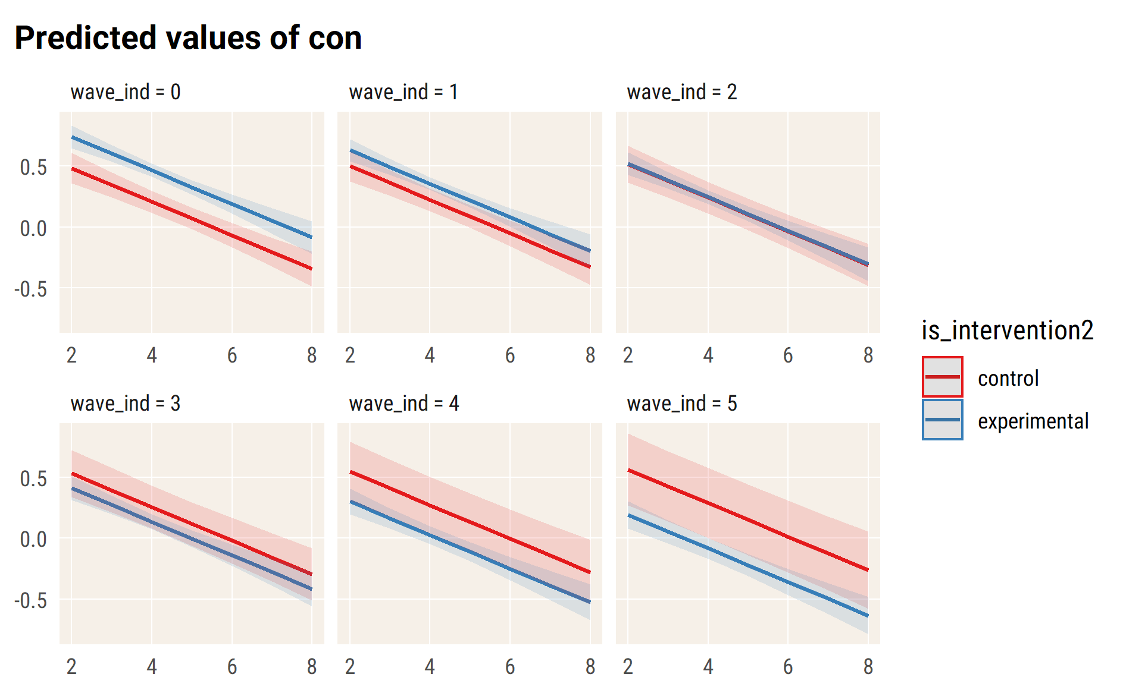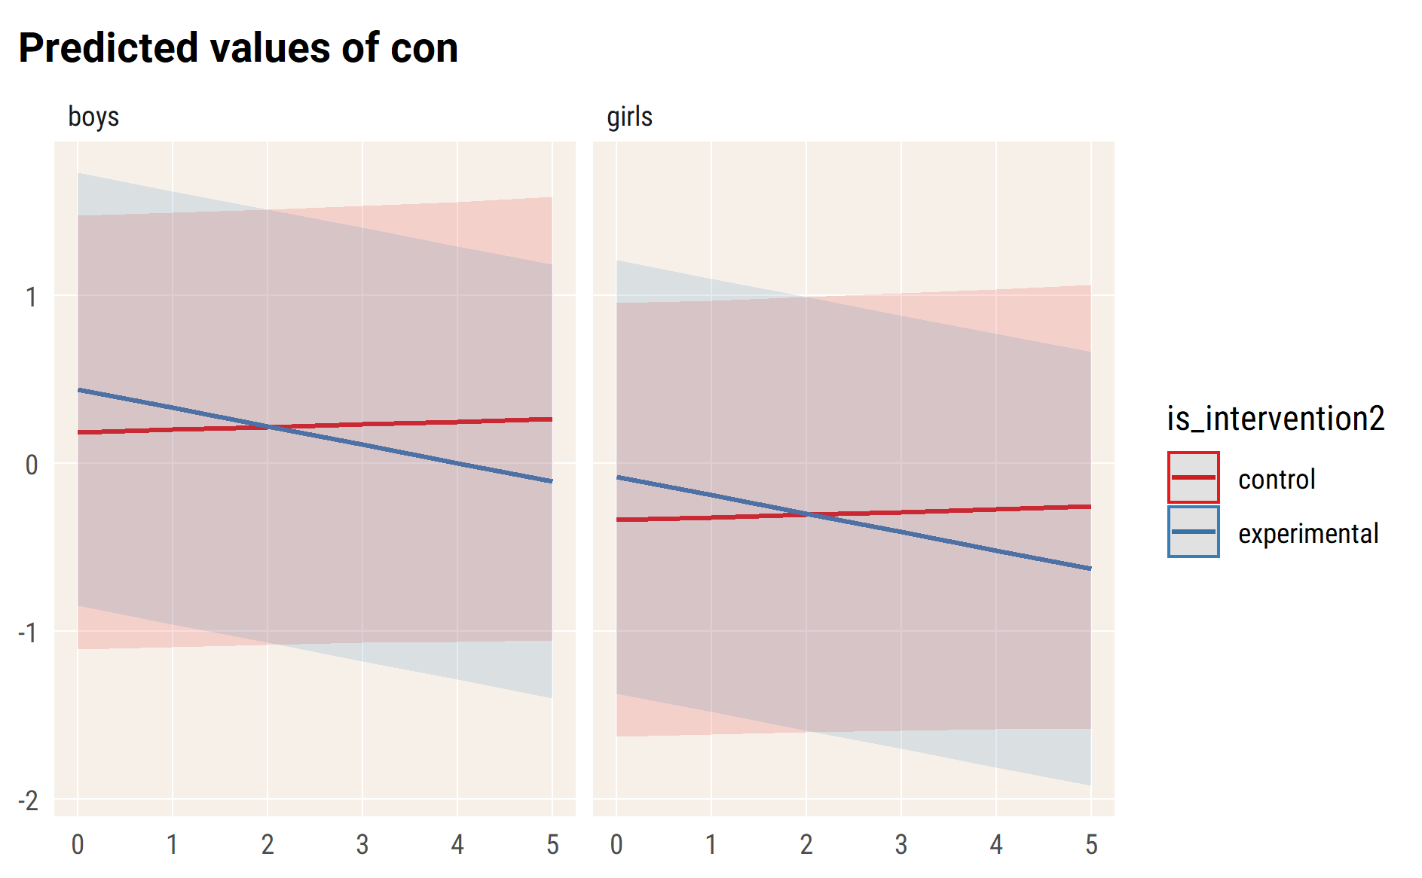

# hyp

#> Linear mixed model fit by REML. t-tests use Satterthwaite's method [  
#> lmerModLmerTest]  
#> Formula:   
#> hyp ~ wave_ind * is_intervention2 + age_fst_measur + gender_girl +   
#> (wave_ind | id_pupil)  
#> Data: df_long_zero  
#>   
#> REML criterion at convergence: 9524.9  
#>   
#> Scaled residuals:   
#> Min 1Q Median 3Q Max   
#> -3.6163 -0.5106 -0.0208 0.4919 3.3486   
#>   
#> Random effects:  
#> Groups Name Variance Std.Dev. Corr   
#> id_pupil (Intercept) 0.4222 0.6498   
#> wave_ind 0.0203 0.1425 -0.23  
#> Residual 0.2364 0.4862   
#> Number of obs: 4562, groups: id_pupil, 1738  
#>   
#> Fixed effects:  
#> Estimate Std. Error df  
#> (Intercept) 0.812072 0.091558 1859.787339  
#> wave_ind -0.001427 0.031233 2913.960506  
#> is_intervention2experimental 0.285735 0.047580 1912.245773  
#> age_fst_measur -0.159383 0.017202 1763.744759  
#> gender_girlgirls -0.502990 0.034742 1712.265245  
#> wave_ind:is_intervention2experimental -0.125897 0.032458 2714.238888  
#> t value Pr(>|t|)   
#> (Intercept) 8.869 < 2e-16 ***  
#> wave_ind -0.046 0.963551   
#> is_intervention2experimental 6.005 0.00000000228 ***  
#> age_fst_measur -9.266 < 2e-16 ***  
#> gender_girlgirls -14.478 < 2e-16 ***  
#> wave_ind:is_intervention2experimental -3.879 0.000107 ***  
#> ---  
#> Signif. codes: 0 '***' 0.001 '**' 0.01 '*' 0.05 '.' 0.1 ' ' 1  
#>   
#> Correlation of Fixed Effects:  
#> (Intr) wav_nd is_nt2 ag_fs_ gndr_g  
#> wave_ind -0.209   
#> is_ntrvntn2 -0.516 0.302   
#> age_fst_msr -0.869 0.070 0.125   
#> gndr_grlgrl -0.208 -0.021 -0.022 0.035   
#> wv_nd:s_nt2 0.192 -0.962 -0.335 -0.057 0.020

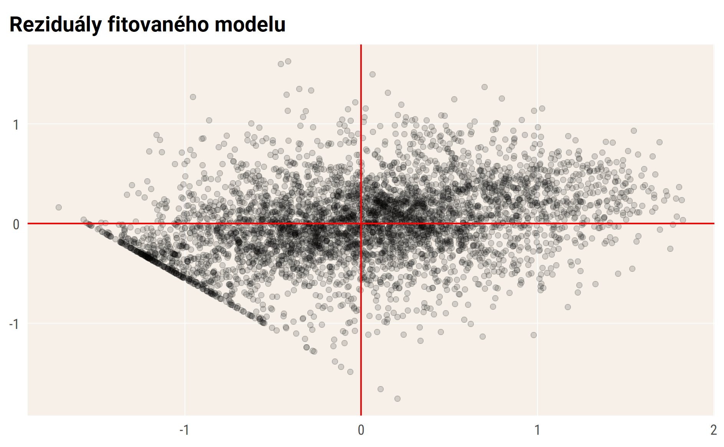

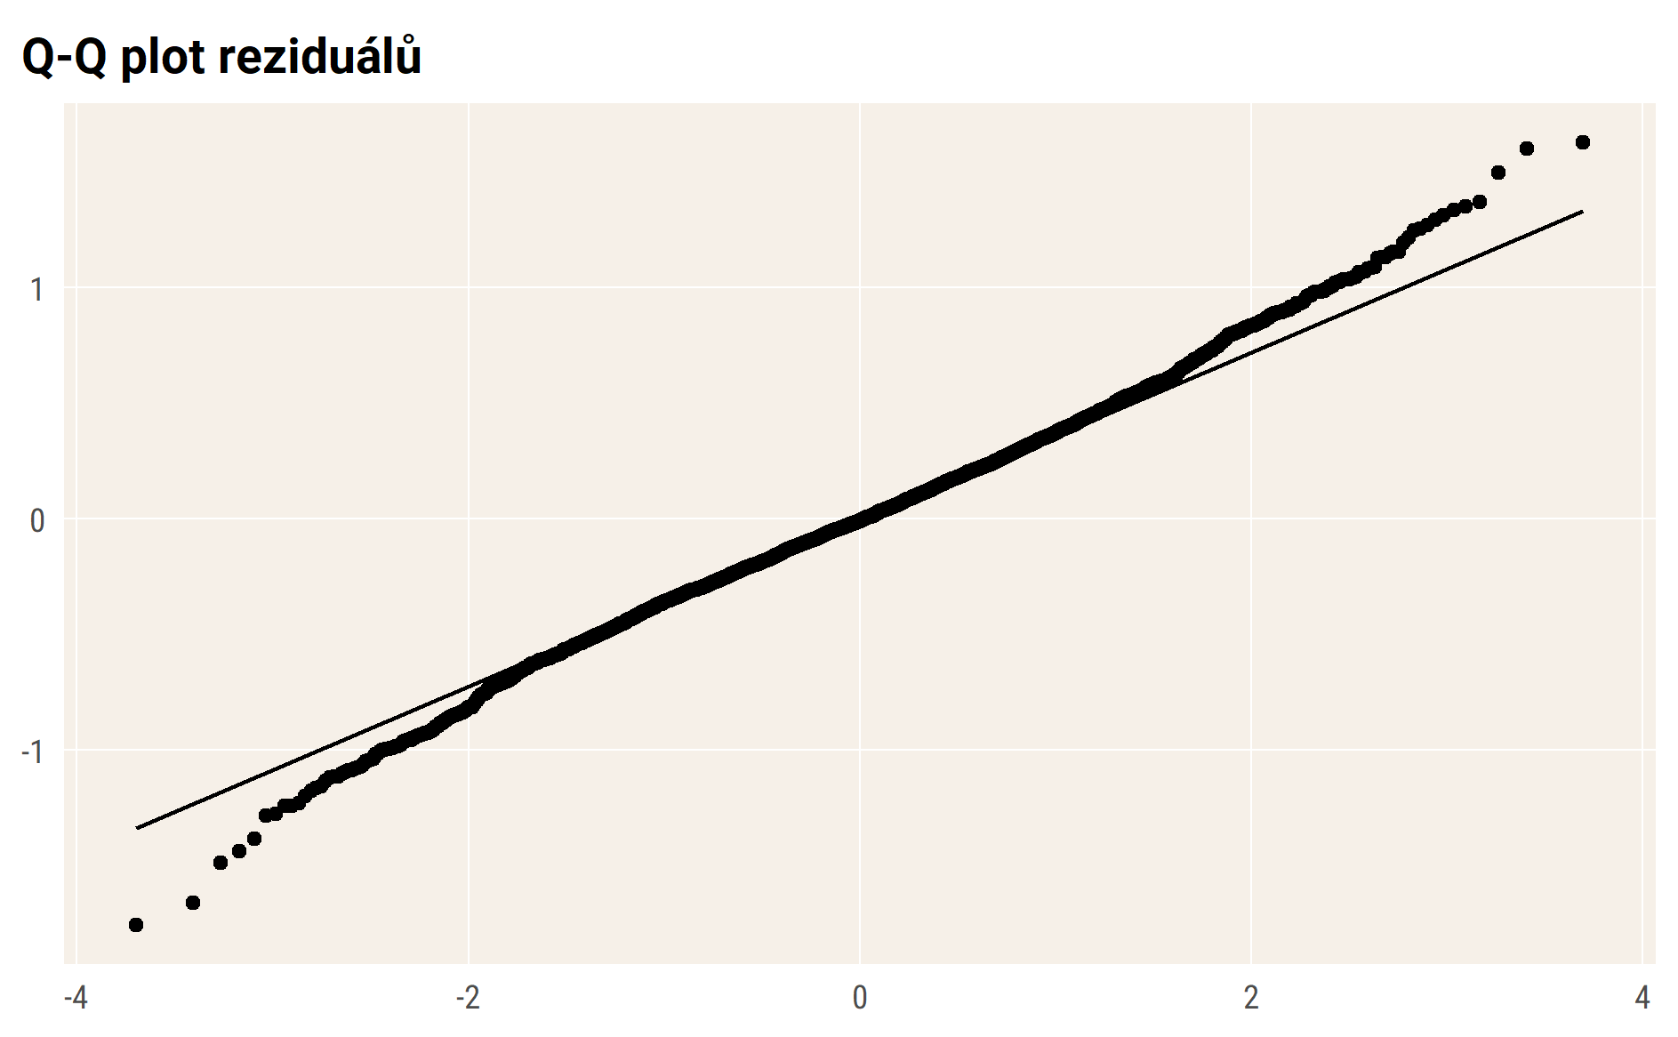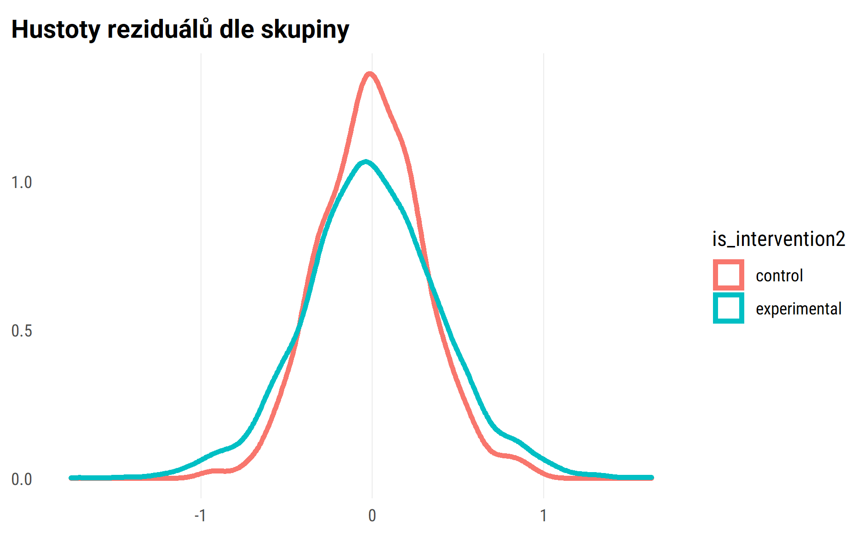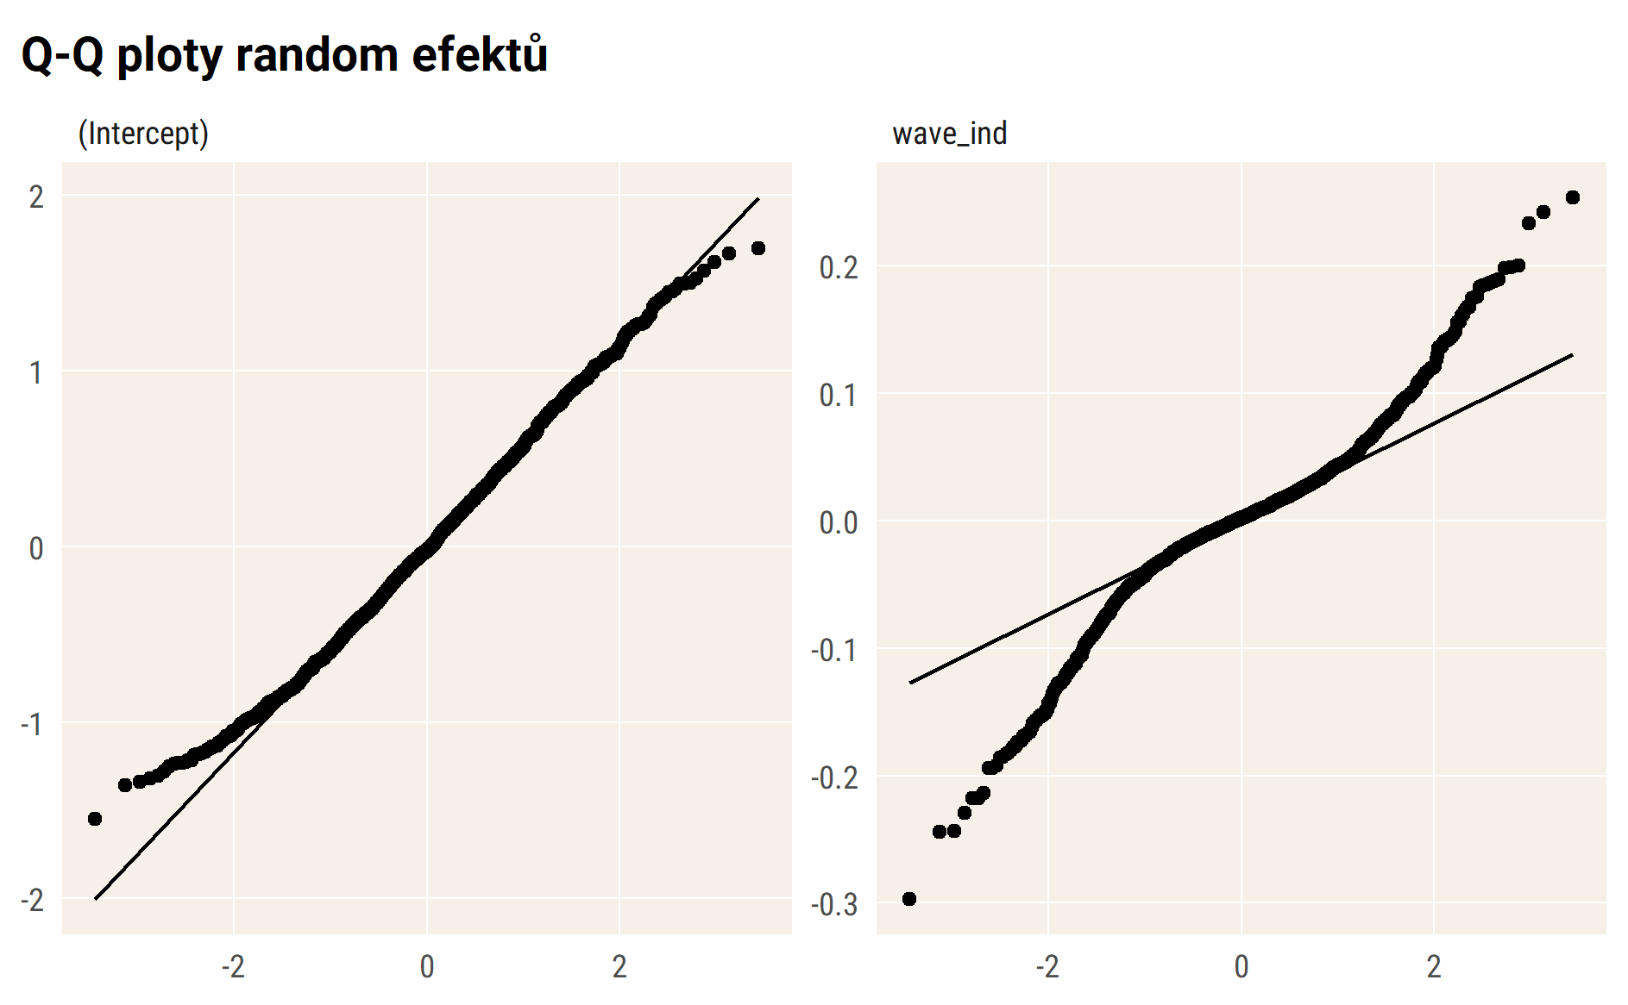

## Vizualizace modelu – průměry

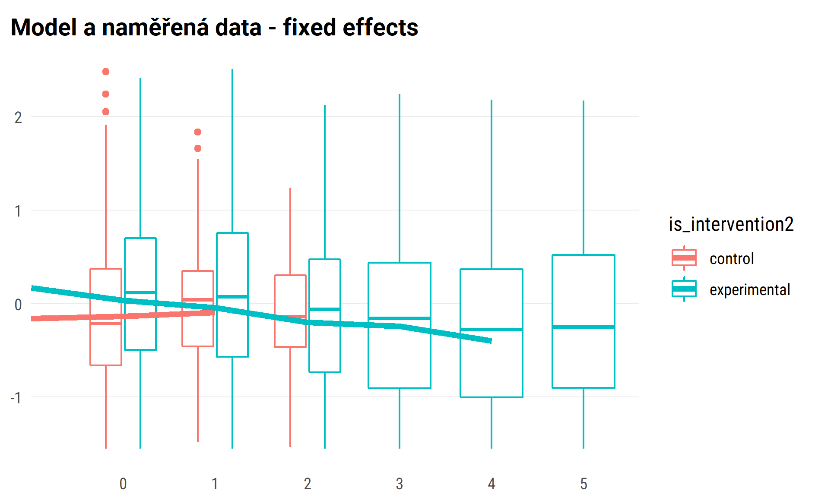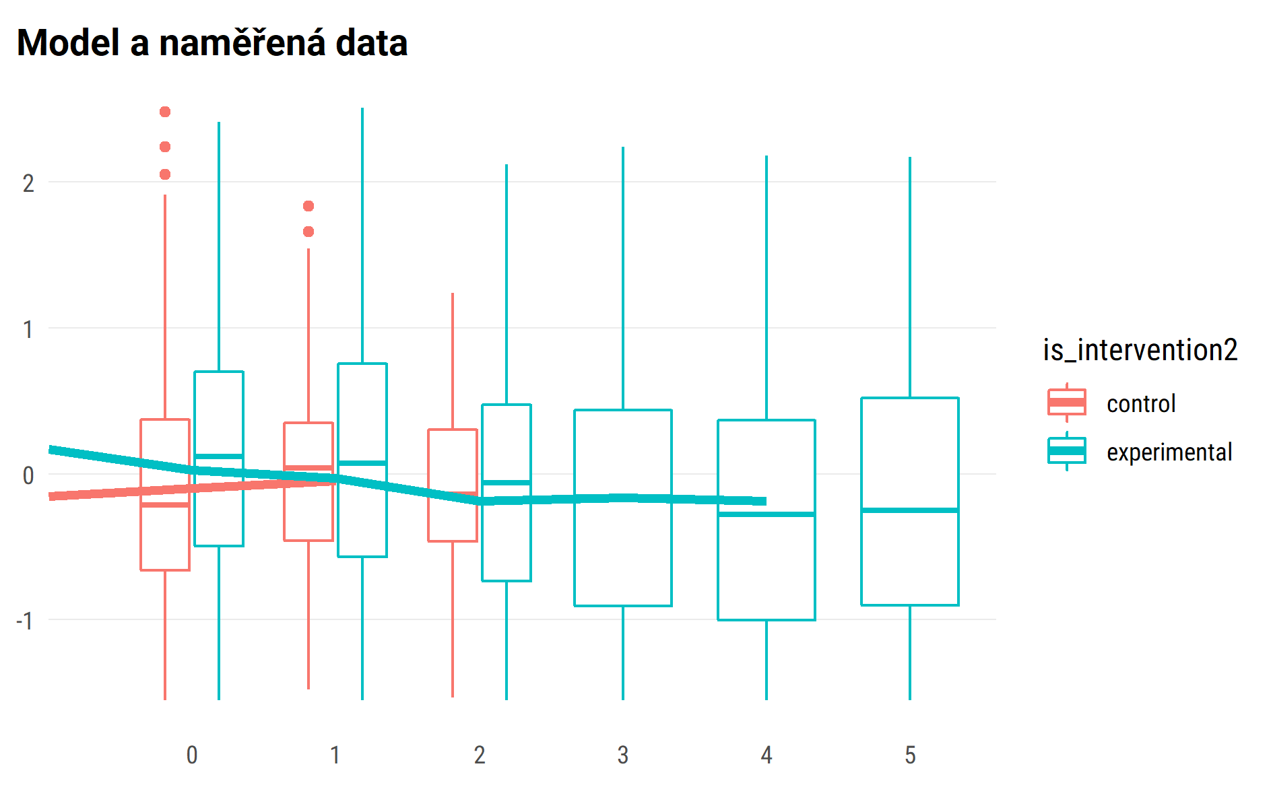

## random effect for sample of 50 pupils

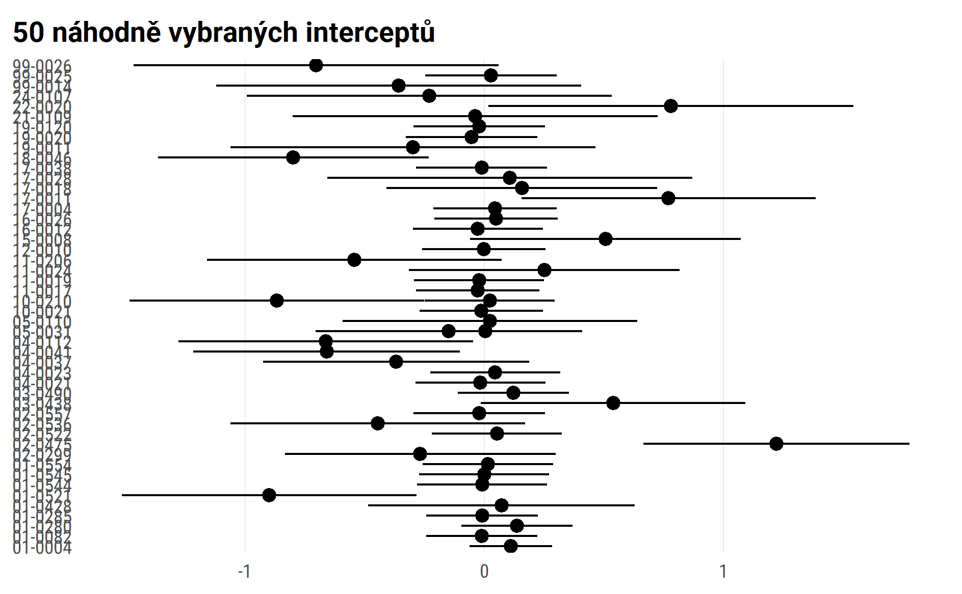

#> $wave_ind  
#>   
#> # Predicted values of hyp  
#> # x = wave_ind  
#>   
#> x | Predicted | SE | 95% CI  
#> ------------------------------------  
#> 0 | 0.15 | 0.05 | [ 0.06, 0.24]  
#> 1 | 0.14 | 0.05 | [ 0.05, 0.24]  
#> 2 | 0.14 | 0.07 | [ 0.02, 0.27]  
#> 3 | 0.14 | 0.09 | [-0.04, 0.32]  
#> 4 | 0.14 | 0.12 | [-0.09, 0.37]  
#> 5 | 0.14 | 0.15 | [-0.15, 0.43]  
#>   
#> Adjusted for:  
#> * is_intervention2 = control  
#> * age_fst_measur = 4.18  
#> * gender_girl = boys  
#> * id_pupil = 0 (population-level)  
#>   
#>   
#> $is_intervention2  
#>   
#> # Predicted values of hyp  
#> # x = is_intervention2  
#>   
#> x | Predicted | SE | 95% CI  
#> ----------------------------------------------  
#> control | 0.14 | 0.05 | [0.05, 0.24]  
#> experimental | 0.28 | 0.03 | [0.22, 0.33]  
#>   
#> Adjusted for:  
#> * wave_ind = 1.23  
#> * age_fst_measur = 4.18  
#> * gender_girl = boys  
#> * id_pupil = 0 (population-level)  
#>   
#>   
#> $age_fst_measur  
#>   
#> # Predicted values of hyp  
#> # x = age_fst_measur  
#>   
#> x | Predicted | SE | 95% CI  
#> -------------------------------------  
#> 2 | 0.49 | 0.07 | [ 0.36, 0.62]  
#> 3 | 0.33 | 0.06 | [ 0.22, 0.44]  
#> 4 | 0.17 | 0.05 | [ 0.07, 0.27]  
#> 5 | 0.01 | 0.05 | [-0.09, 0.11]  
#> 6 | -0.15 | 0.06 | [-0.26, -0.04]  
#> 7 | -0.31 | 0.07 | [-0.44, -0.18]  
#> 8 | -0.46 | 0.08 | [-0.62, -0.31]  
#>   
#> Adjusted for:  
#> * wave_ind = 1.23  
#> * is_intervention2 = control  
#> * gender_girl = boys  
#> * id_pupil = 0 (population-level)  
#>   
#>   
#> $gender_girl  
#>   
#> # Predicted values of hyp  
#> # x = gender_girl  
#>   
#> x | Predicted | SE | 95% CI  
#> -----------------------------------------  
#> boys | 0.14 | 0.05 | [ 0.05, 0.24]  
#> girls | -0.36 | 0.05 | [-0.46, -0.26]  
#>   
#> Adjusted for:  
#> * wave_ind = 1.23  
#> * is_intervention2 = control  
#> * age_fst_measur = 4.18  
#> * id_pupil = 0 (population-level)  
#>   
#>   
#> attr(,"class")  
#> [1] "ggalleffects" "list"   
#> attr(,"model.name")  
#> [1] "."

marginal plots draft

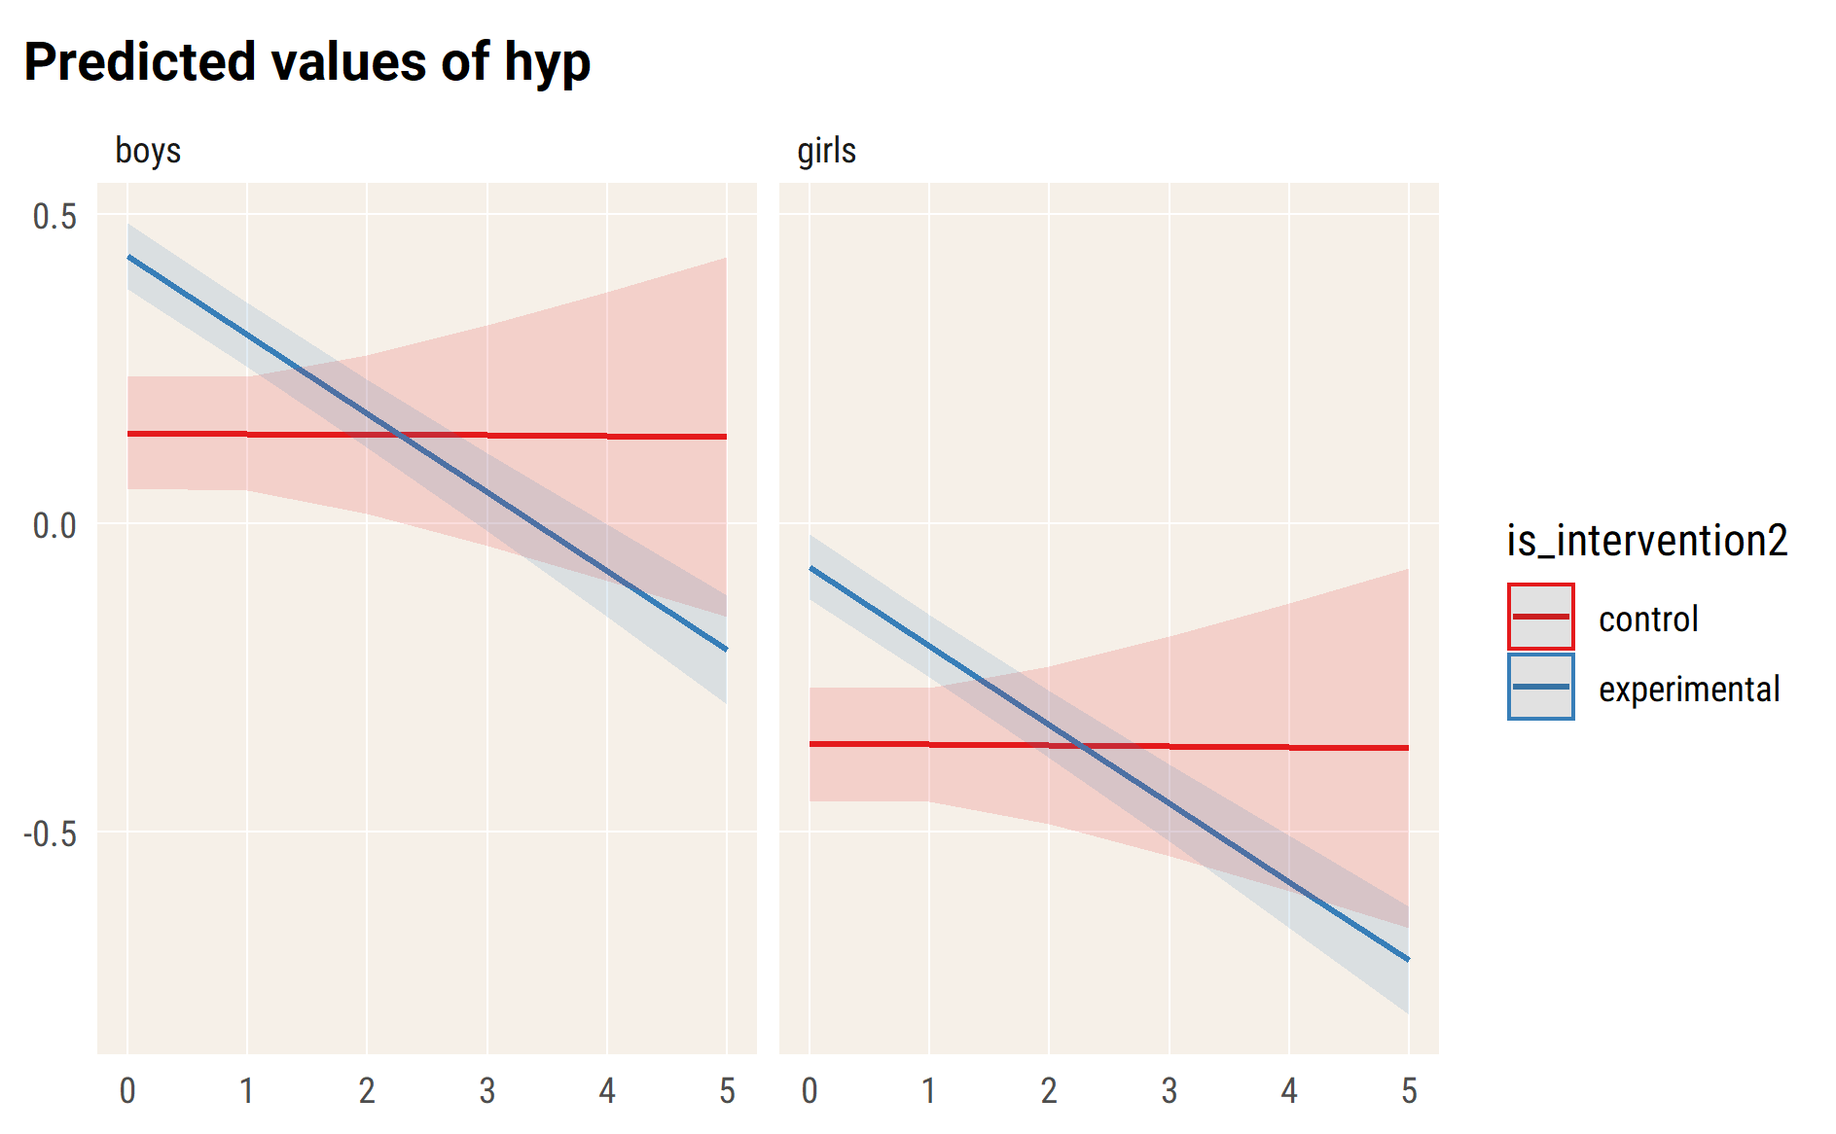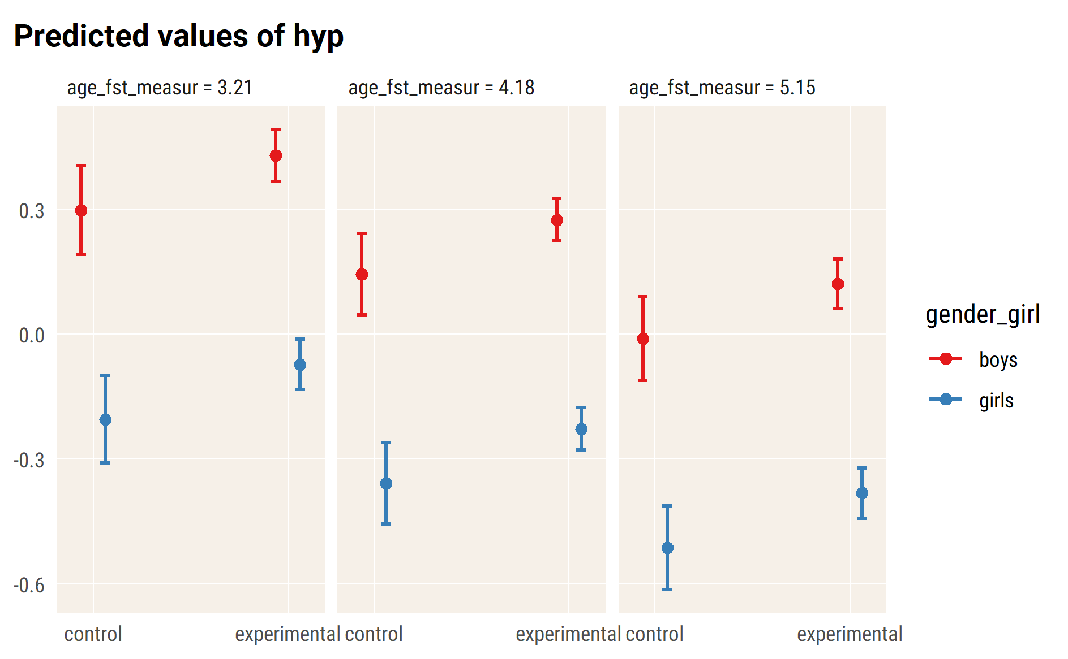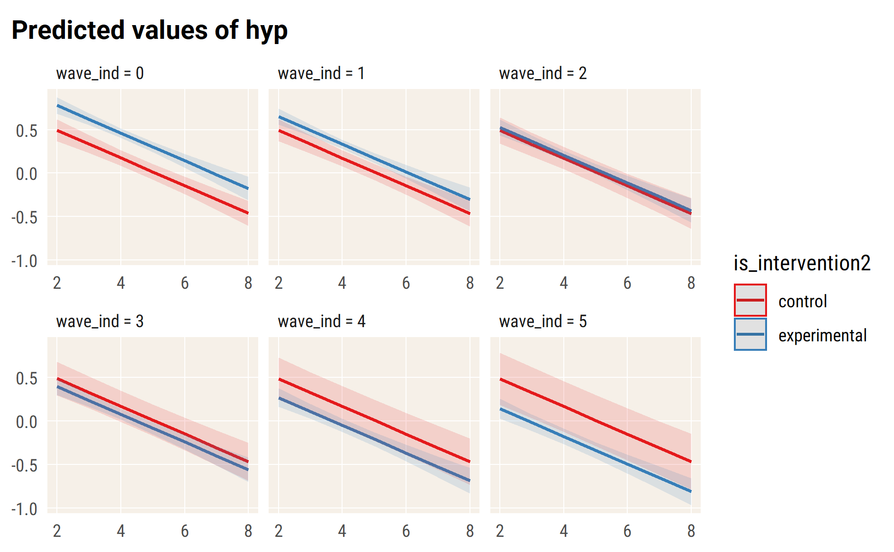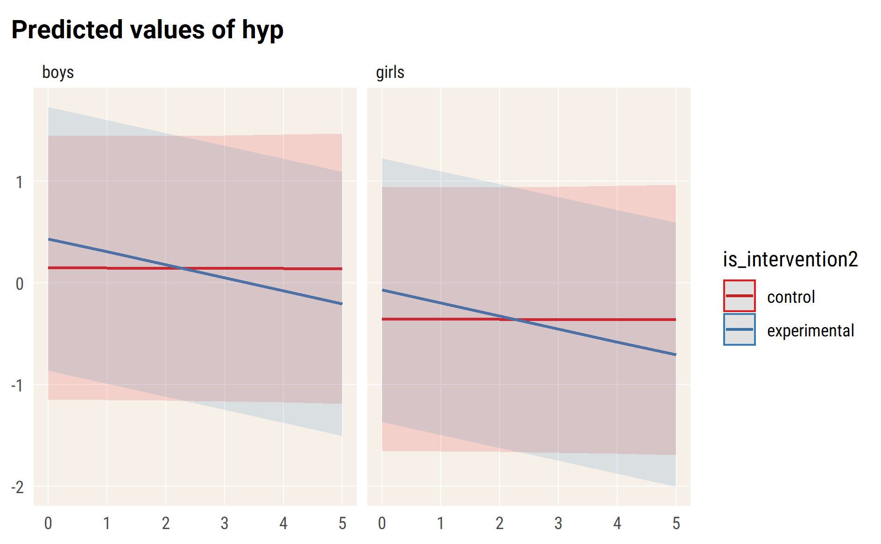

# pee

#> Linear mixed model fit by REML. t-tests use Satterthwaite's method [  
#> lmerModLmerTest]  
#> Formula:   
#> pee ~ wave_ind * is_intervention2 + age_fst_measur + gender_girl +   
#> (wave_ind | id_pupil)  
#> Data: df_long_zero  
#>   
#> REML criterion at convergence: 9310.3  
#>   
#> Scaled residuals:   
#> Min 1Q Median 3Q Max   
#> -3.3695 -0.5512 -0.0415 0.5402 4.1529   
#>   
#> Random effects:  
#> Groups Name Variance Std.Dev. Corr   
#> id_pupil (Intercept) 0.36648 0.6054   
#> wave_ind 0.01437 0.1199 -0.48  
#> Residual 0.25122 0.5012   
#> Number of obs: 4562, groups: id_pupil, 1738  
#>   
#> Fixed effects:  
#> Estimate Std. Error df  
#> (Intercept) 0.87344 0.08529 1918.19458  
#> wave_ind -0.02583 0.03051 3224.21851  
#> is_intervention2experimental 0.15764 0.04588 1922.81660  
#> age_fst_measur -0.16589 0.01586 1766.09825  
#> gender_girlgirls -0.36439 0.03169 1636.79303  
#> wave_ind:is_intervention2experimental -0.12876 0.03157 3052.94138  
#> t value Pr(>|t|)   
#> (Intercept) 10.241 < 2e-16 ***  
#> wave_ind -0.847 0.397230   
#> is_intervention2experimental 3.436 0.000604 ***  
#> age_fst_measur -10.458 < 2e-16 ***  
#> gender_girlgirls -11.499 < 2e-16 ***  
#> wave_ind:is_intervention2experimental -4.079 0.0000464 ***  
#> ---  
#> Signif. codes: 0 '***' 0.001 '**' 0.01 '*' 0.05 '.' 0.1 ' ' 1  
#>   
#> Correlation of Fixed Effects:  
#> (Intr) wav_nd is_nt2 ag_fs_ gndr_g  
#> wave_ind -0.258   
#> is_ntrvntn2 -0.525 0.365   
#> age_fst_msr -0.860 0.084 0.118   
#> gndr_grlgrl -0.203 -0.024 -0.021 0.034   
#> wv_nd:s_nt2 0.235 -0.965 -0.406 -0.064 0.024

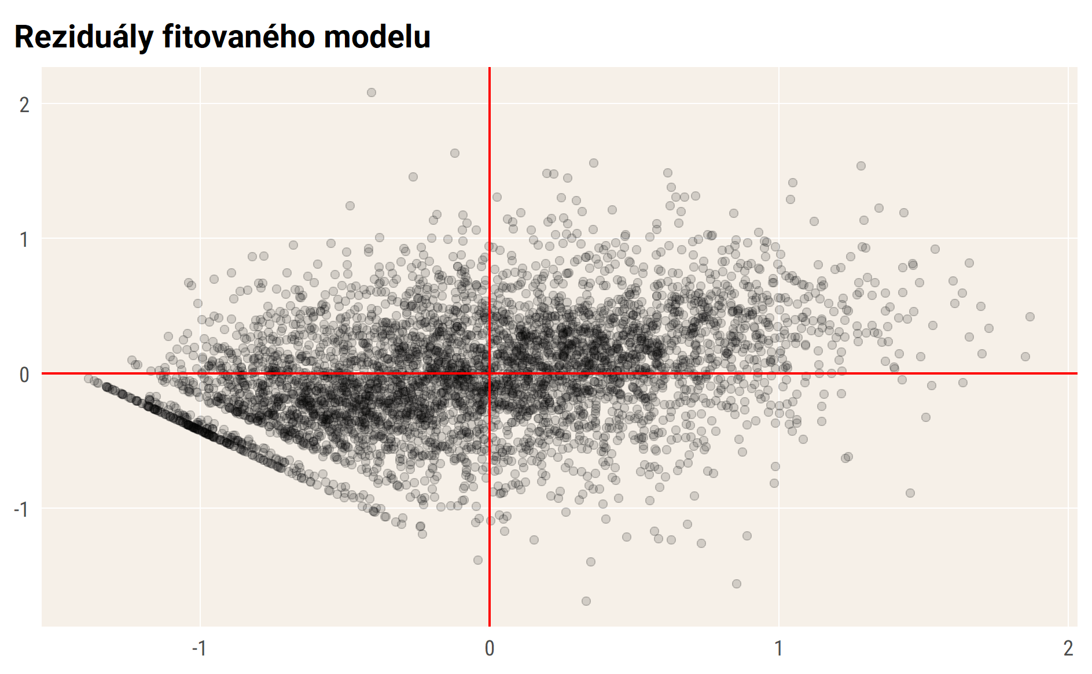

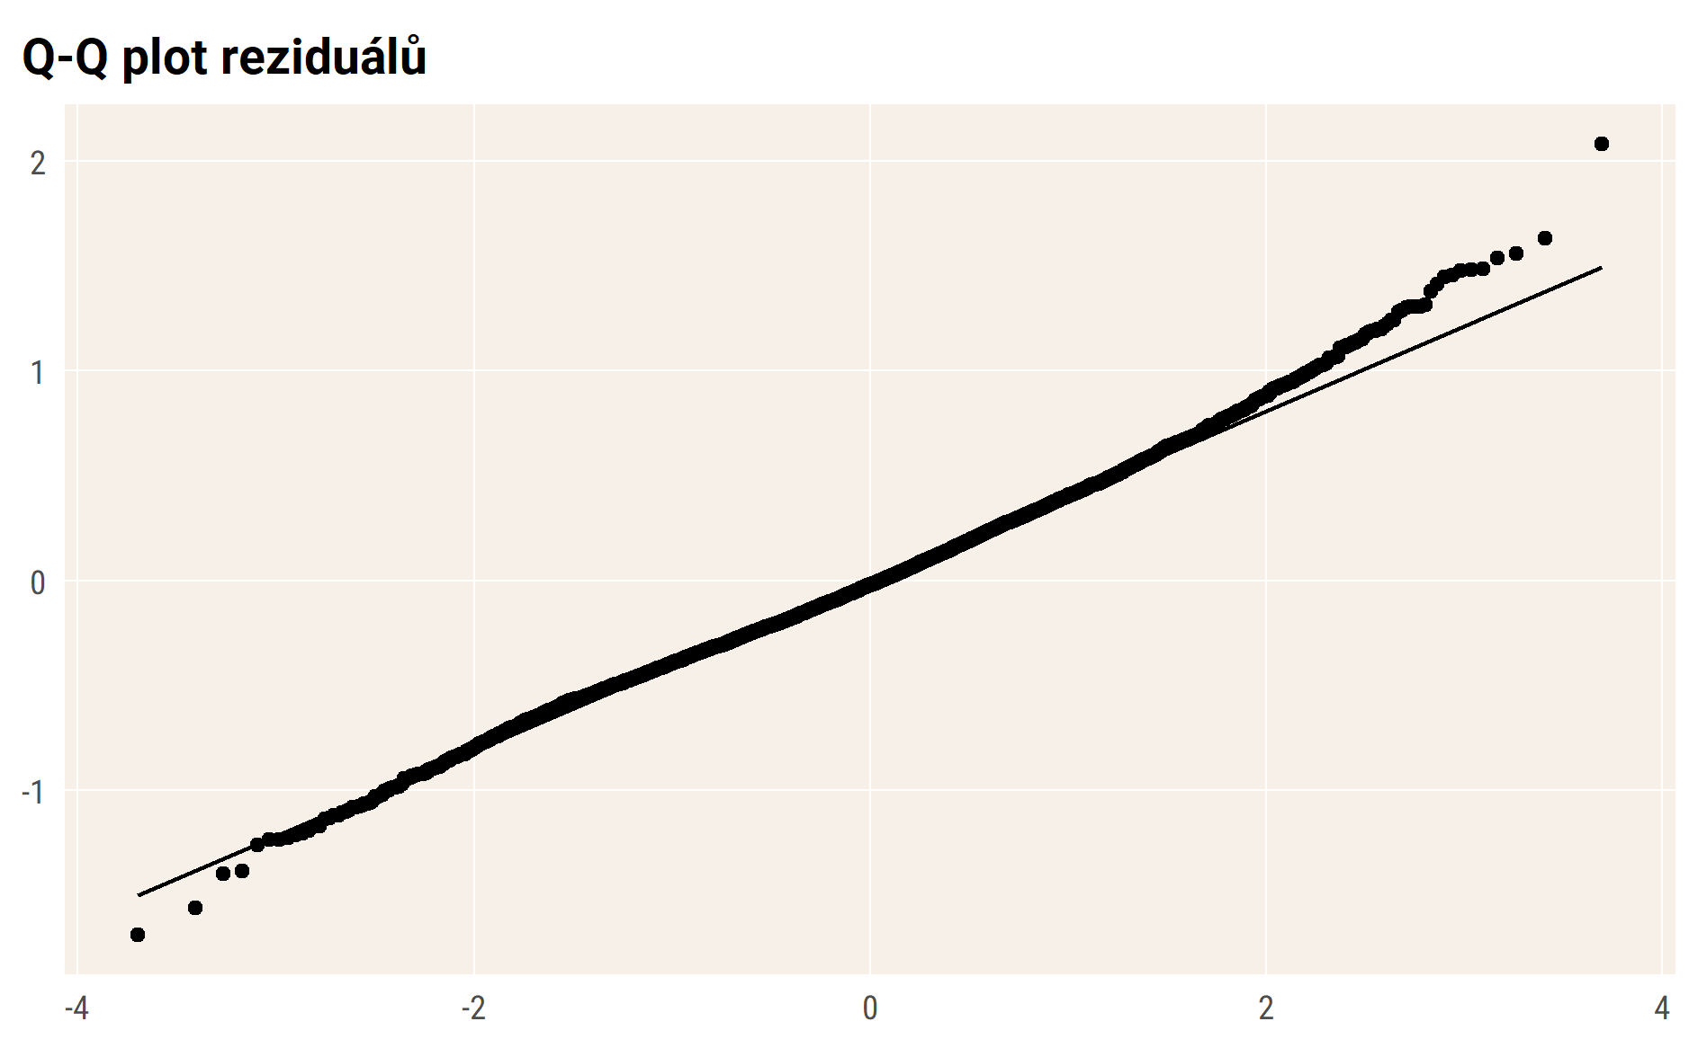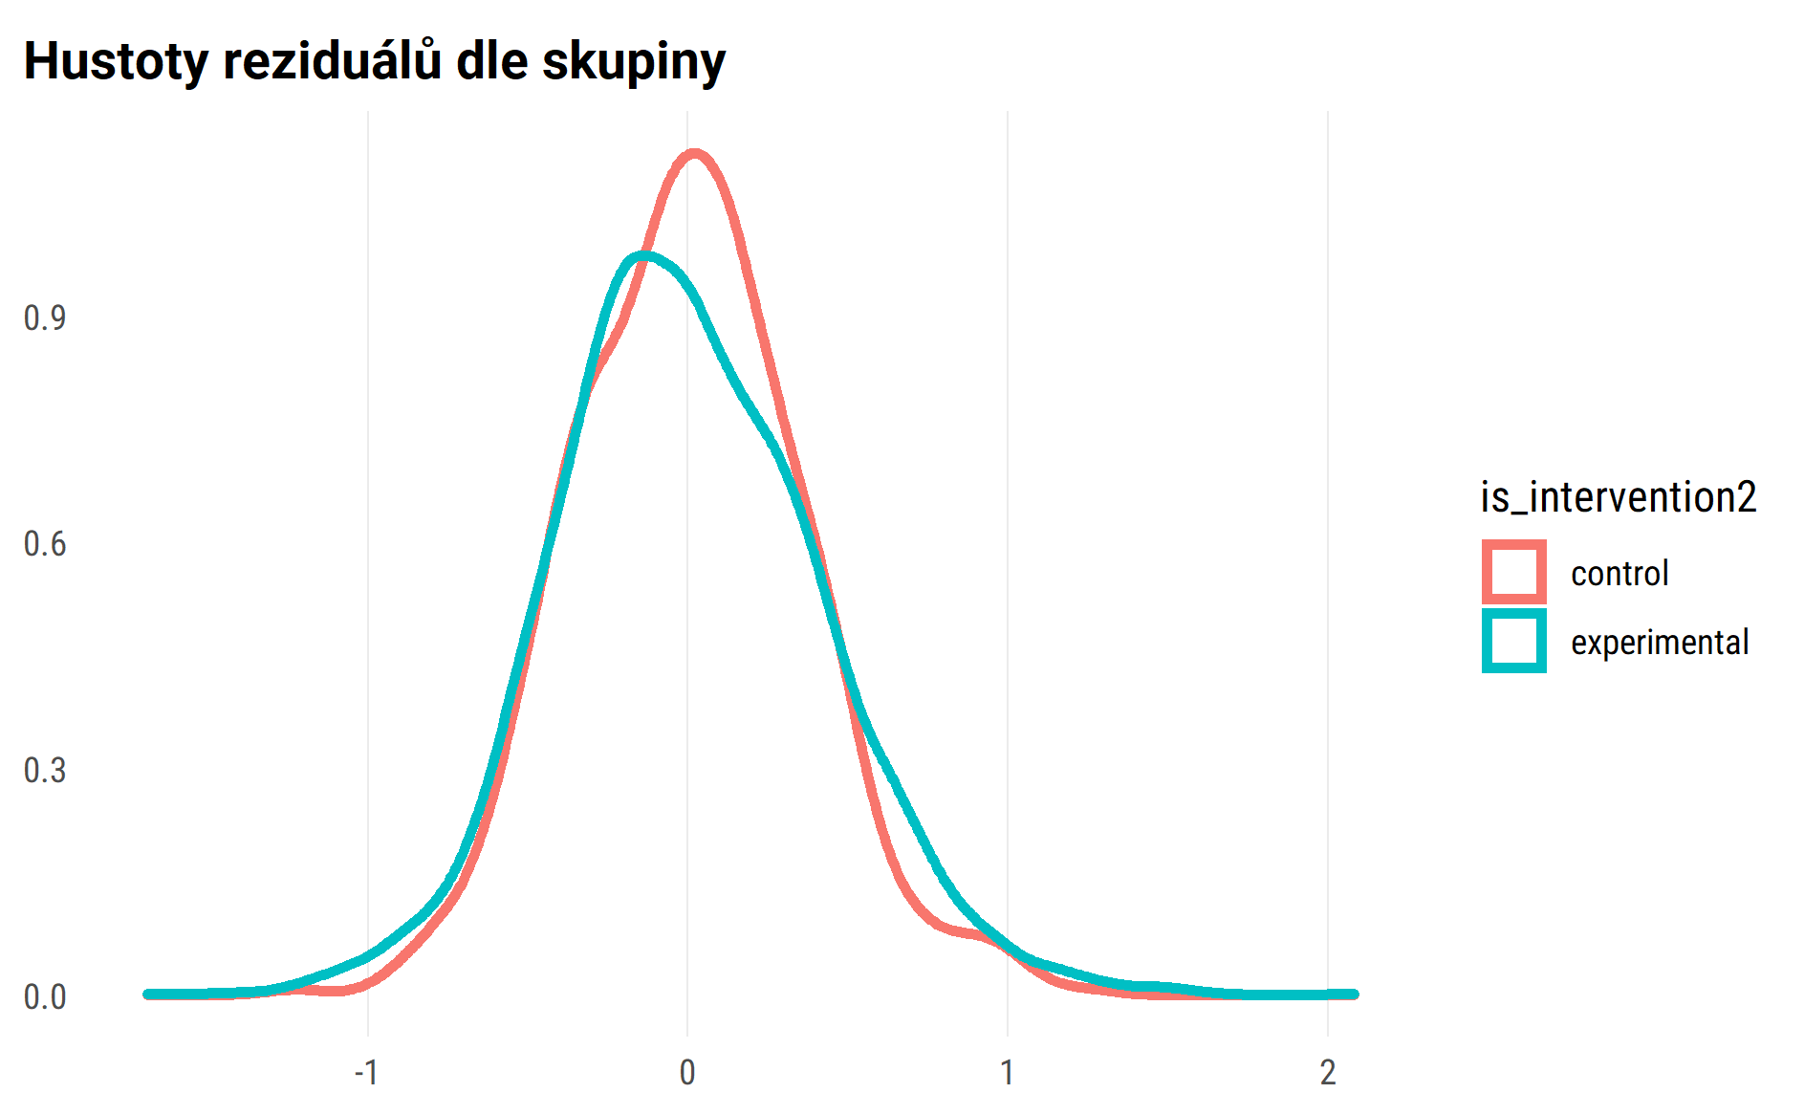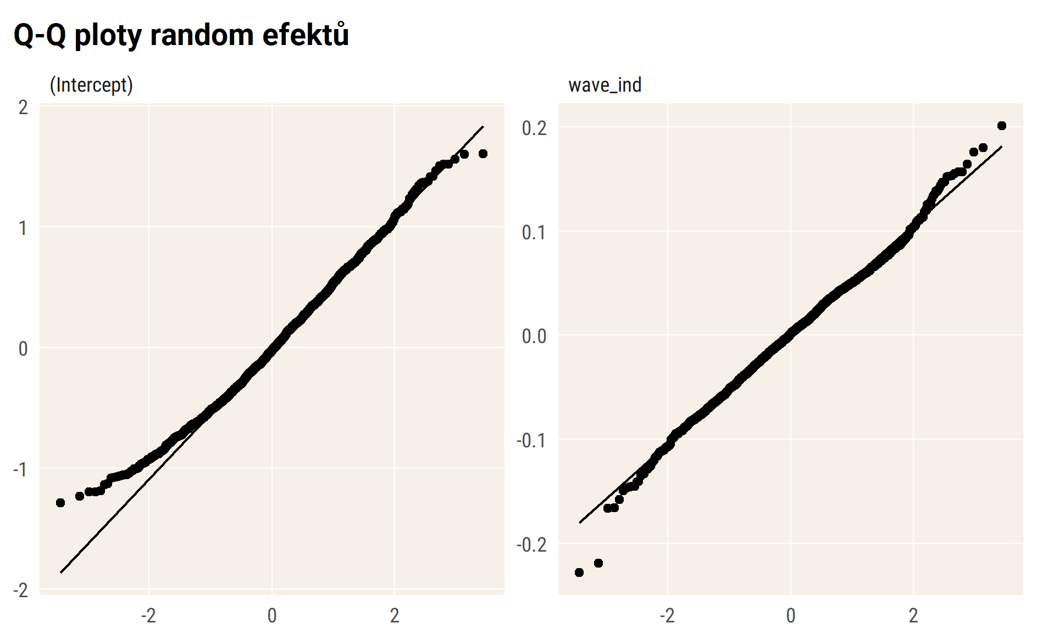

## Vizualizace modelu – průměry

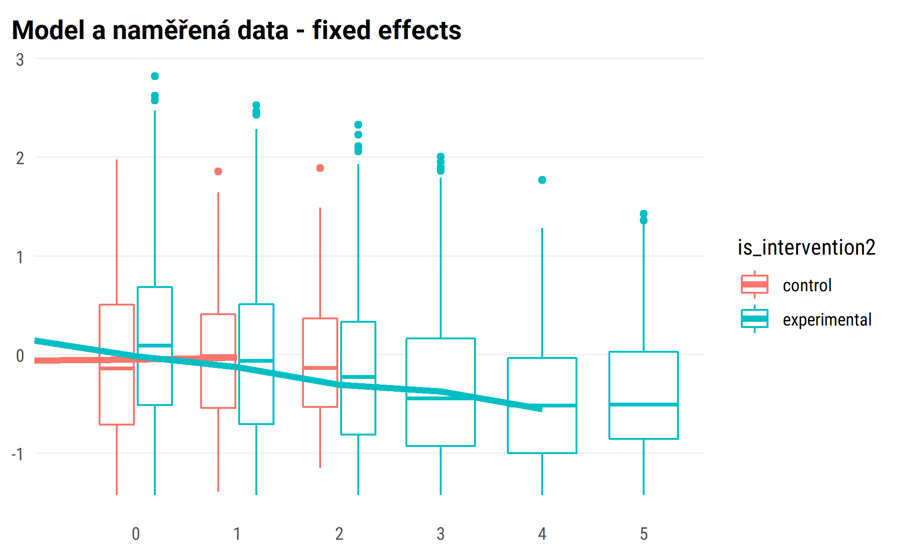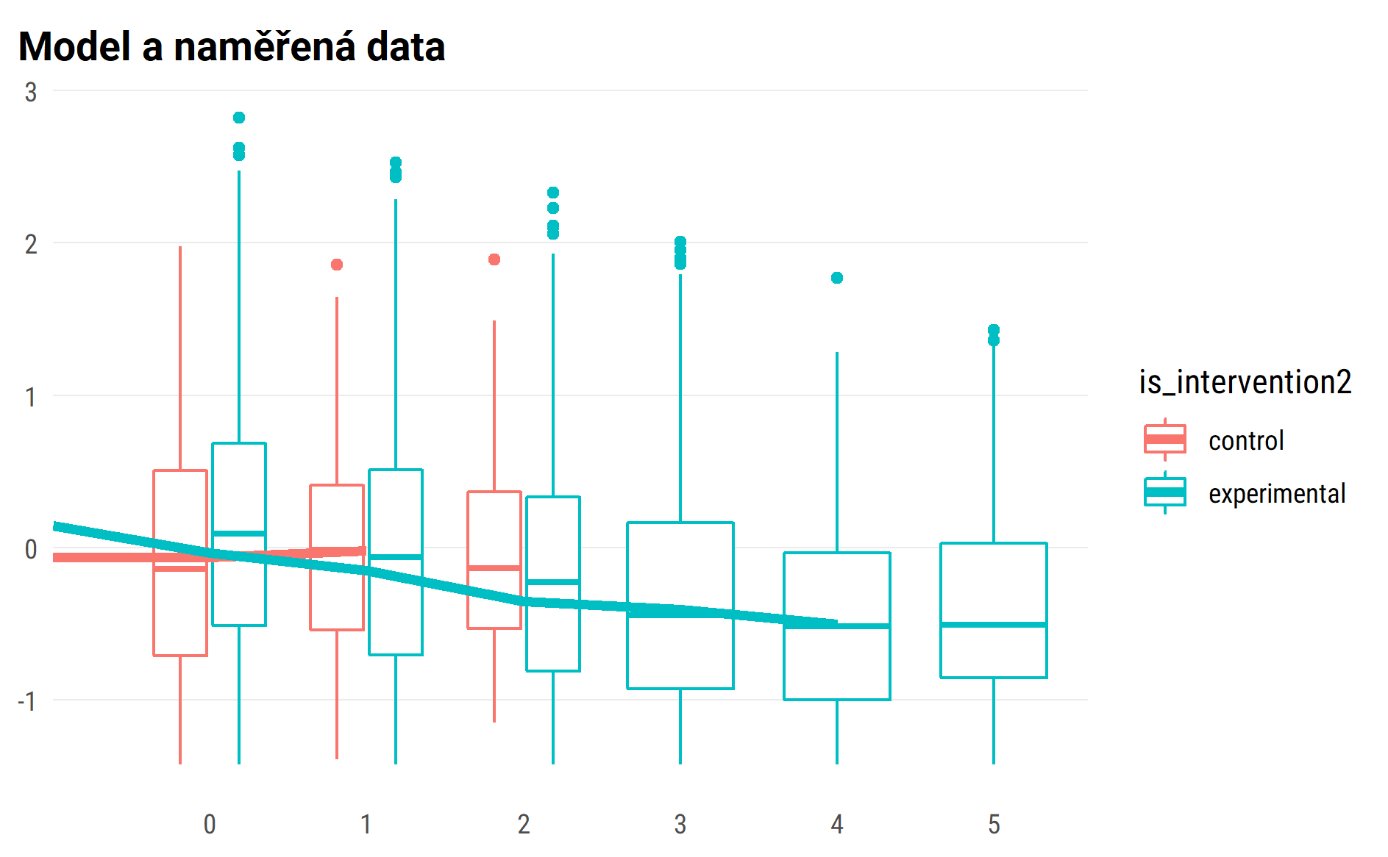

## random effect for sample of 50 pupils

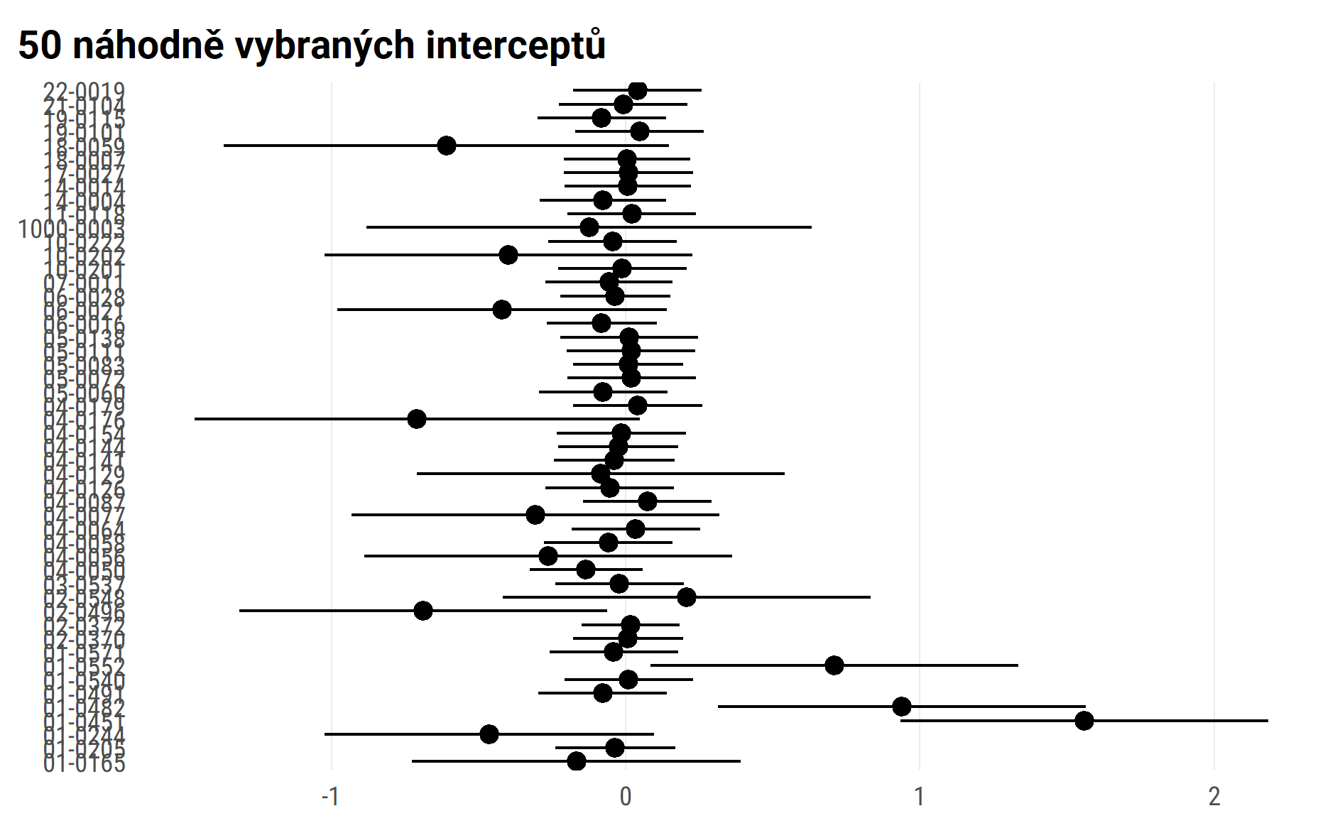

#> $wave_ind  
#>   
#> # Predicted values of pee  
#> # x = wave_ind  
#>   
#> x | Predicted | SE | 95% CI  
#> ------------------------------------  
#> 0 | 0.18 | 0.04 | [ 0.09, 0.27]  
#> 1 | 0.15 | 0.04 | [ 0.07, 0.24]  
#> 2 | 0.13 | 0.06 | [ 0.01, 0.25]  
#> 3 | 0.10 | 0.09 | [-0.06, 0.27]  
#> 4 | 0.08 | 0.11 | [-0.14, 0.30]  
#> 5 | 0.05 | 0.14 | [-0.23, 0.33]  
#>   
#> Adjusted for:  
#> * is_intervention2 = control  
#> * age_fst_measur = 4.18  
#> * gender_girl = boys  
#> * id_pupil = 0 (population-level)  
#>   
#>   
#> $is_intervention2  
#>   
#> # Predicted values of pee  
#> # x = is_intervention2  
#>   
#> x | Predicted | SE | 95% CI  
#> ----------------------------------------------  
#> control | 0.15 | 0.05 | [0.06, 0.24]  
#> experimental | 0.15 | 0.02 | [0.10, 0.19]  
#>   
#> Adjusted for:  
#> * wave_ind = 1.23  
#> * age_fst_measur = 4.18  
#> * gender_girl = boys  
#> * id_pupil = 0 (population-level)  
#>   
#>   
#> $age_fst_measur  
#>   
#> # Predicted values of pee  
#> # x = age_fst_measur  
#>   
#> x | Predicted | SE | 95% CI  
#> -------------------------------------  
#> 2 | 0.51 | 0.06 | [ 0.39, 0.63]  
#> 3 | 0.34 | 0.05 | [ 0.24, 0.44]  
#> 4 | 0.18 | 0.05 | [ 0.09, 0.27]  
#> 5 | 0.01 | 0.05 | [-0.08, 0.10]  
#> 6 | -0.15 | 0.05 | [-0.26, -0.05]  
#> 7 | -0.32 | 0.06 | [-0.44, -0.20]  
#> 8 | -0.49 | 0.07 | [-0.63, -0.34]  
#>   
#> Adjusted for:  
#> * wave_ind = 1.23  
#> * is_intervention2 = control  
#> * gender_girl = boys  
#> * id_pupil = 0 (population-level)  
#>   
#>   
#> $gender_girl  
#>   
#> # Predicted values of pee  
#> # x = gender_girl  
#>   
#> x | Predicted | SE | 95% CI  
#> -----------------------------------------  
#> boys | 0.15 | 0.05 | [ 0.06, 0.24]  
#> girls | -0.22 | 0.05 | [-0.31, -0.13]  
#>   
#> Adjusted for:  
#> * wave_ind = 1.23  
#> * is_intervention2 = control  
#> * age_fst_measur = 4.18  
#> * id_pupil = 0 (population-level)  
#>   
#>   
#> attr(,"class")  
#> [1] "ggalleffects" "list"   
#> attr(,"model.name")  
#> [1] "."

marginal plots draft

