Schola-styled Word document

A great one, too

tým Schola Empirica

kontakt: Jaromír Mazák, [mazak@scholaempirica.org](mailto:mazak@scholaempirica.org)

20. duben 2020

Lorem ipsum abstract

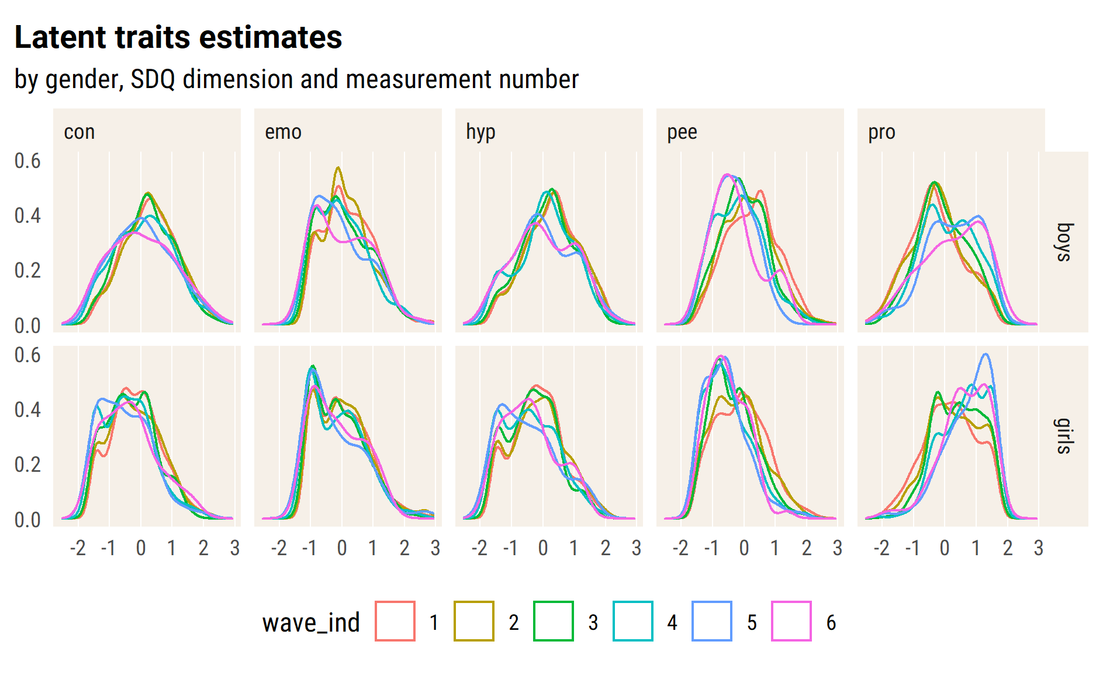

Much better! For now on, we work with *theta* estimates.

CI is off because of dependent data.

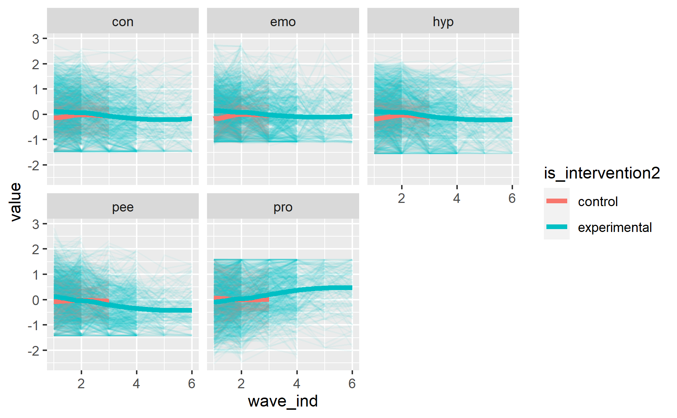

Check measurements dependency

#> [[1]]  
#> rowname emo_1 emo_2 emo_3 emo_4 emo_5 emo_6  
#> 1 emo_1 .52 .42 .46 .25 .36  
#> 2 emo_2 .46 .43 .22 .32  
#> 3 emo_3 .54 .18 .18  
#> 4 emo_4 .30 .44  
#> 5 emo_5 .49  
#> 6 emo_6   
#>   
#> [[2]]  
#> rowname con_1 con_2 con_3 con_4 con_5 con_6  
#> 1 con_1 .68 .56 .57 .60 .61  
#> 2 con_2 .63 .63 .64 .48  
#> 3 con_3 .76 .60 .58  
#> 4 con_4 .62 .57  
#> 5 con_5 .67  
#> 6 con_6   
#>   
#> [[3]]  
#> rowname hyp_1 hyp_2 hyp_3 hyp_4 hyp_5 hyp_6  
#> 1 hyp_1 .68 .58 .56 .52 .55  
#> 2 hyp_2 .61 .61 .59 .49  
#> 3 hyp_3 .76 .54 .55  
#> 4 hyp_4 .60 .54  
#> 5 hyp_5 .69  
#> 6 hyp_6   
#>   
#> [[4]]  
#> rowname pee_1 pee_2 pee_3 pee_4 pee_5 pee_6  
#> 1 pee_1 .58 .47 .53 .27 .44  
#> 2 pee_2 .51 .52 .52 .55  
#> 3 pee_3 .63 .33 .47  
#> 4 pee_4 .45 .54  
#> 5 pee_5 .56  
#> 6 pee_6   
#>   
#> [[5]]  
#> rowname pro_1 pro_2 pro_3 pro_4 pro_5 pro_6  
#> 1 pro_1 .66 .48 .48 .42 .46  
#> 2 pro_2 .55 .53 .56 .49  
#> 3 pro_3 .68 .50 .46  
#> 4 pro_4 .57 .51  
#> 5 pro_5 .67  
#> 6 pro_6

null model

#> Linear mixed model fit by REML. t-tests use Satterthwaite's method ['lmerModLmerTest']  
#> Formula: emo ~ (1 | id_pupil)  
#> Data: df_long_zero  
#>   
#> REML criterion at convergence: 11620.1  
#>   
#> Scaled residuals:   
#> Min 1Q Median 3Q Max   
#> -3.3362 -0.6135 -0.0508 0.5567 3.3581   
#>   
#> Random effects:  
#> Groups Name Variance Std.Dev.  
#> id_pupil (Intercept) 0.3078 0.5548   
#> Residual 0.3603 0.6003   
#> Number of obs: 5171, groups: id_pupil, 2045  
#>   
#> Fixed effects:  
#> Estimate Std. Error df t value Pr(>|t|)   
#> (Intercept) 0.05184 0.01533 1930.25345 3.382 0.000733 ***  
#> ---  
#> Signif. codes: 0 '***' 0.001 '**' 0.01 '*' 0.05 '.' 0.1 ' ' 1

random intercept + slope

pupils are nested within classes

TODO: check id_class

#> Linear mixed model fit by REML. t-tests use Satterthwaite's method ['lmerModLmerTest']  
#> Formula: pro ~ wave_ind * is_intervention2 + age_fst_measur + gender_girl +   
#> (wave_ind | id_pupil)  
#> Data: df_long_zero  
#>   
#> REML criterion at convergence: 9638.4  
#>   
#> Scaled residuals:   
#> Min 1Q Median 3Q Max   
#> -3.3437 -0.5035 0.0191 0.5253 3.3180   
#>   
#> Random effects:  
#> Groups Name Variance Std.Dev. Corr   
#> id_pupil (Intercept) 0.3873 0.6223   
#> wave_ind 0.0214 0.1463 -0.34  
#> Residual 0.2592 0.5092   
#> Number of obs: 4562, groups: id_pupil, 1738  
#>   
#> Fixed effects:  
#> Estimate Std. Error df t value Pr(>|t|)   
#> (Intercept) -1.13538 0.08865 1884.41200 -12.807 < 2e-16 ***  
#> wave_ind 0.02615 0.03203 3040.12239 0.816 0.41430   
#> is_intervention2experimental -0.14925 0.04700 1898.60213 -3.175 0.00152 **   
#> age_fst_measur 0.20574 0.01656 1752.12435 12.425 < 2e-16 ***  
#> gender_girlgirls 0.52653 0.03329 1663.88096 15.814 < 2e-16 ***  
#> wave_ind:is_intervention2experimental 0.14399 0.03327 2838.77281 4.328 0.0000156 ***  
#> ---  
#> Signif. codes: 0 '***' 0.001 '**' 0.01 '*' 0.05 '.' 0.1 ' ' 1  
#>   
#> Correlation of Fixed Effects:  
#> (Intr) wav_nd is_nt2 ag_fs_ gndr_g  
#> wave_ind -0.240   
#> is_ntrvntn2 -0.522 0.342   
#> age_fst_msr -0.864 0.079 0.121   
#> gndr_grlgrl -0.206 -0.023 -0.021 0.034   
#> wv_nd:s_nt2 0.219 -0.962 -0.380 -0.062 0.023

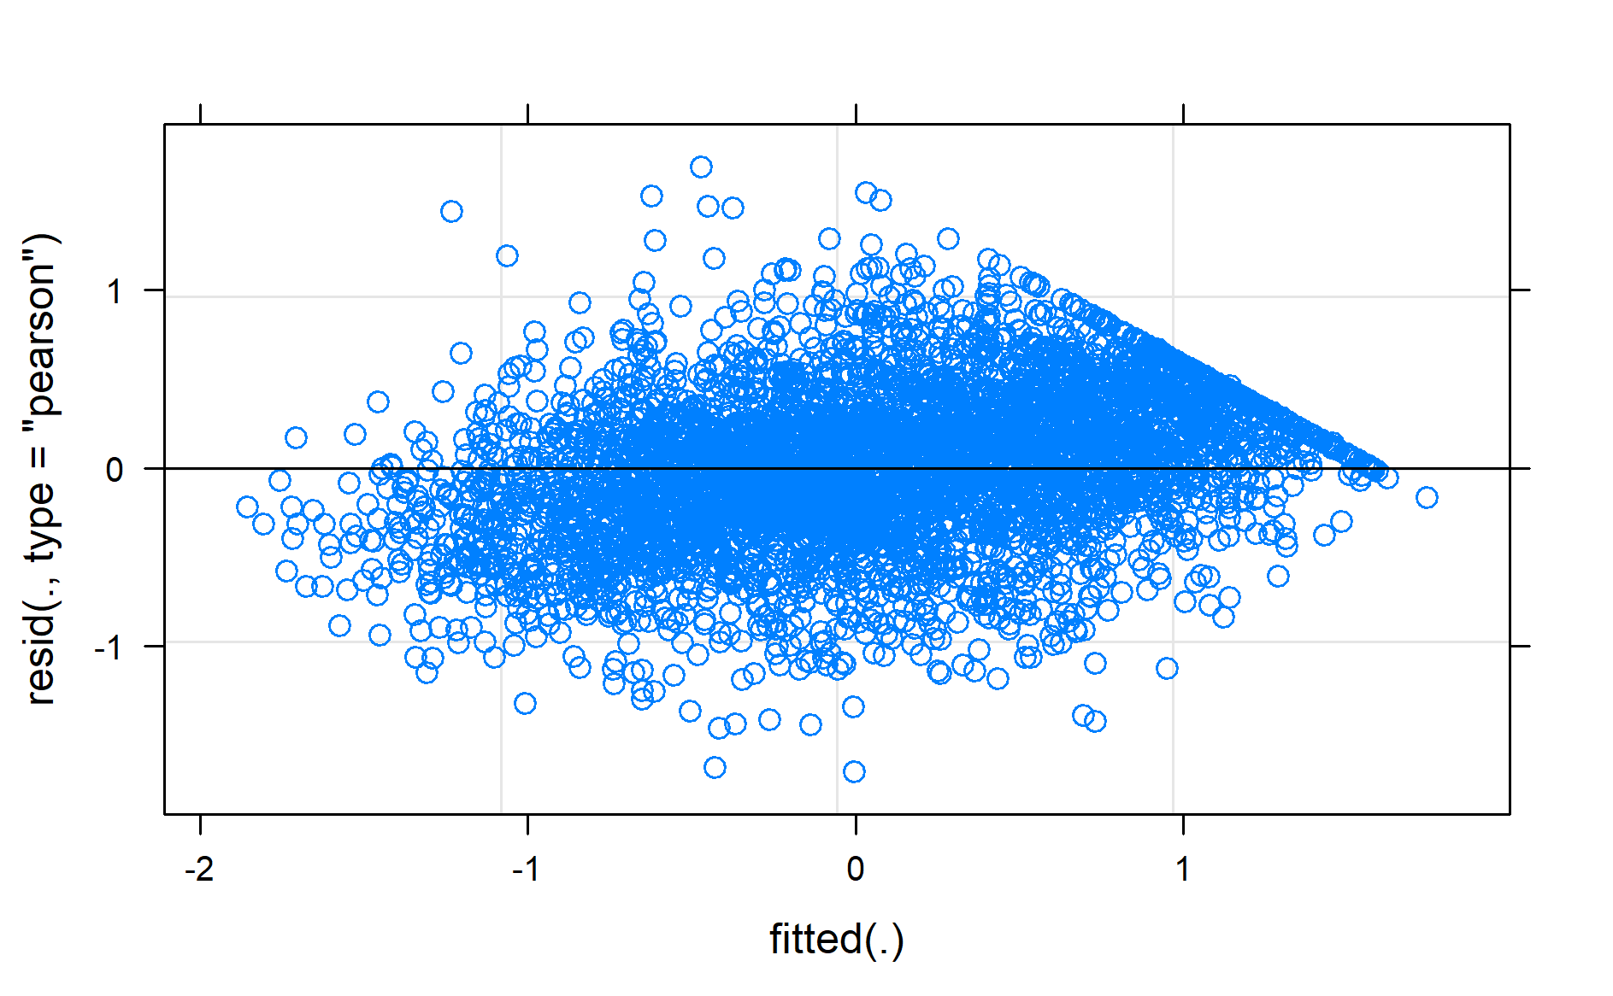

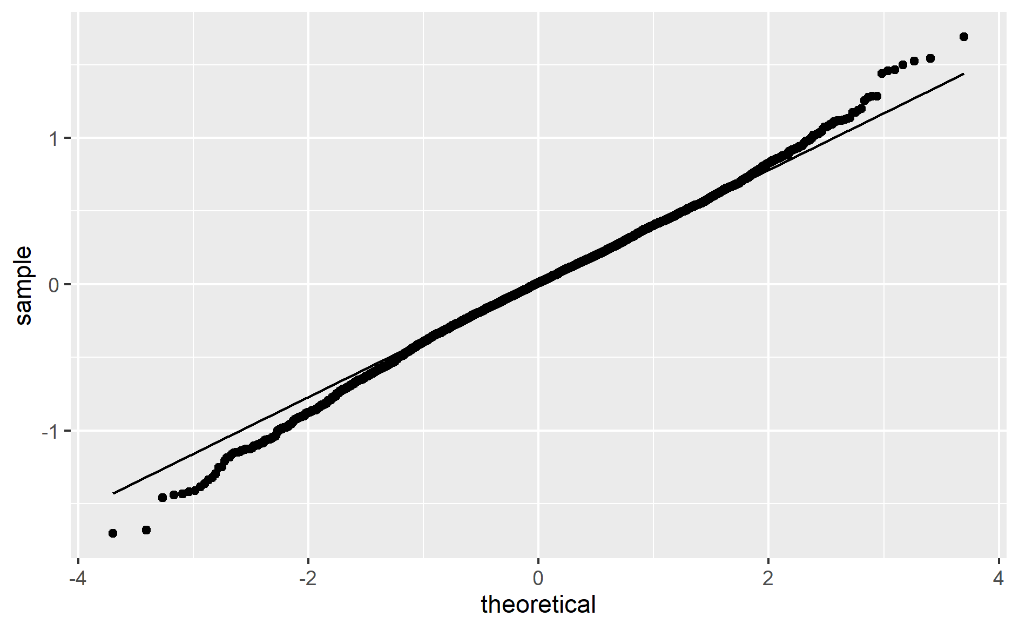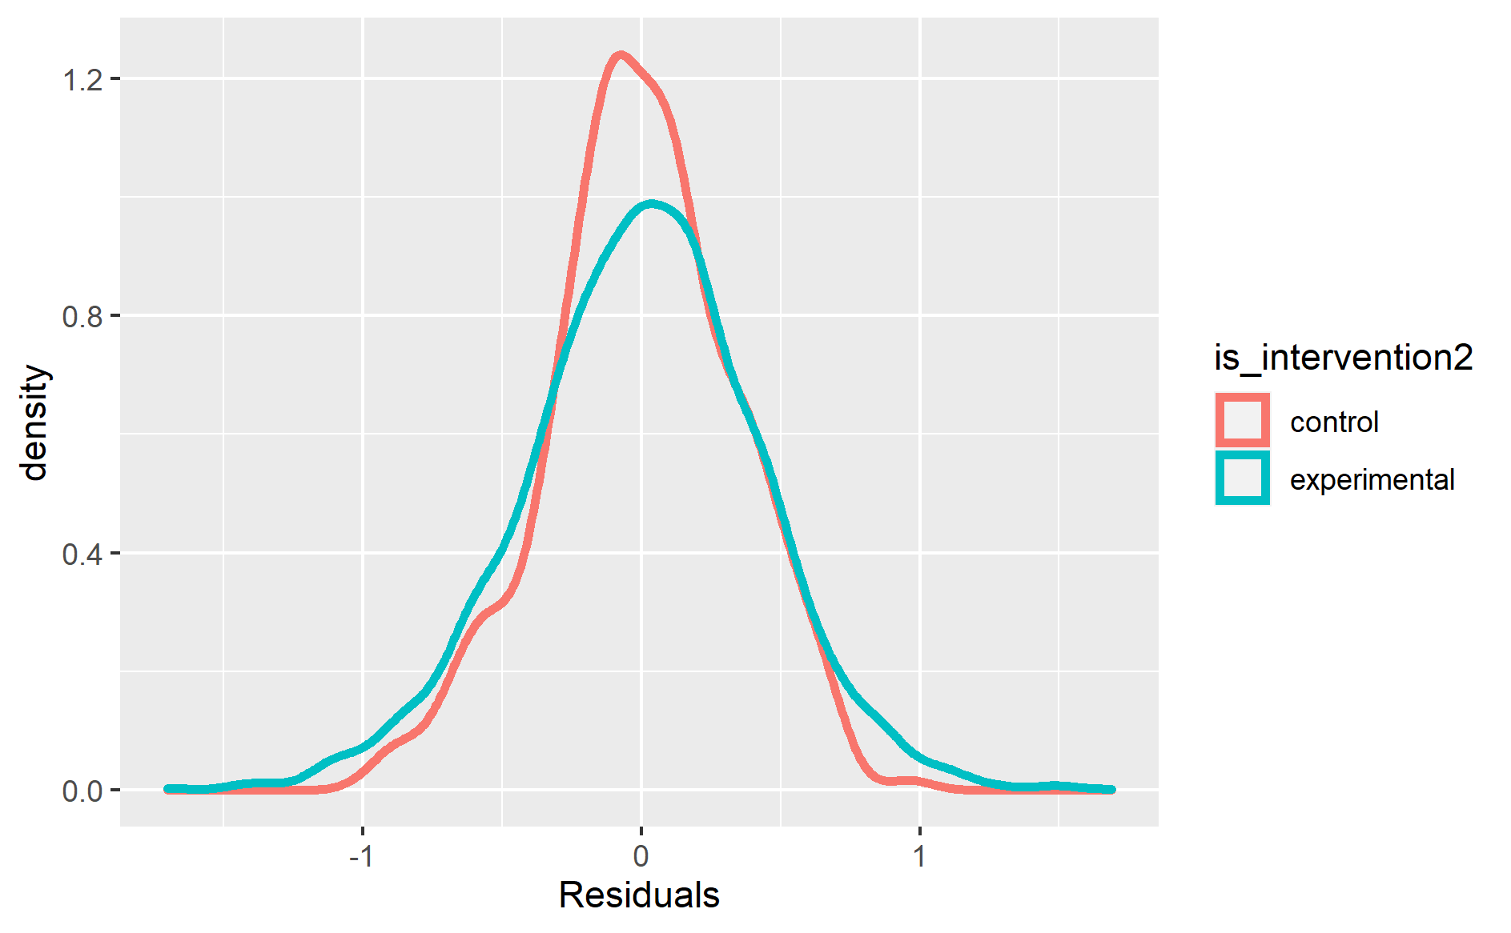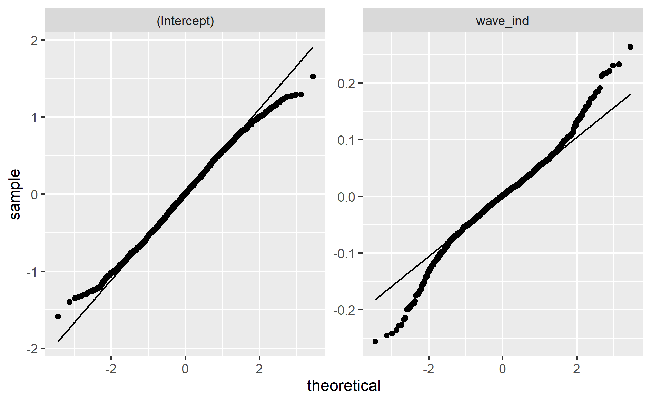

Vizualizace modelu – průměry

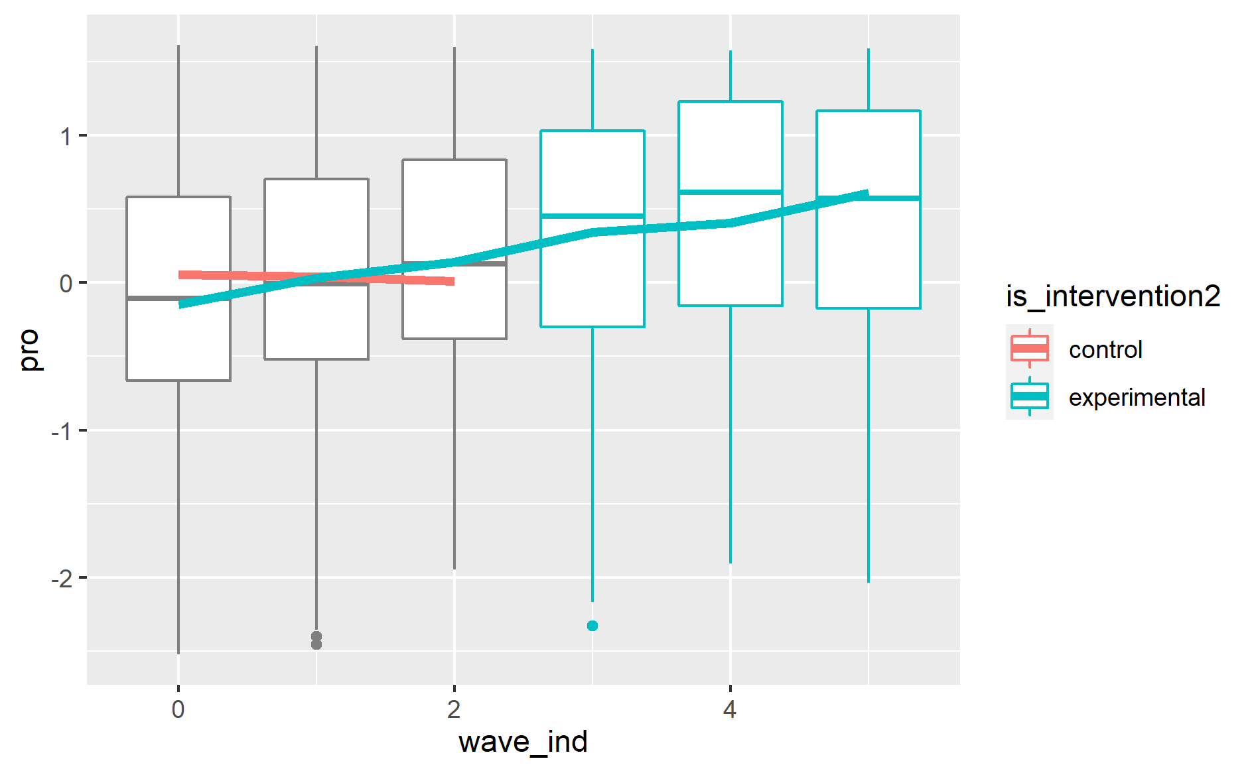 random effect for sample of 50 pupils

