Project proposal

COMP 1682

Contents

1.Introduction 3

2.Aim 4

3.Objecttive 4

3.1 Design Game Concepts 4

3.1.1 Activities 4

3.1.2 Deliverables 4

3.2 Create pixel arts designs for Game Objects 4

3.1.1 Activities 4

3.1.2 Deliverables 5

3.3 Create Animation for Game Objects 5

3.1.1 Activities 5

3.1.2 Deliverables 5

3.4 Program Game Logic and interaction 5

3.1.1 Activities 5

3.1.2 Deliverables 5

3.5 Testing and Debugging 5

3.1.1 Activities 5

3.1.2 Deliverables 6

4. Legal and Ethical issues 6

4.1 Legal issues 6

4.2 Ethical issues 6

5. Plan 7

# 

# 1.Introduction

“Role-Playing Games (RPGs) form one of the primary genres of games, and is possibly one of the most widely varying game forms around. The diverse range of RPGs, which despite a strong variation across and within formats and platforms, share a similar focus on providing the player with a character that grows and develops through play experience as well as on storytelling, provide an immersive and enjoyable experience for the players.” (Drachen, 2009)

The history of RPGs goes back to as far as the late 1970s to 1980s, where games such as Dungeons and Dragons (DnD), Advanced Dungeons and Dragons (ADnD), Run Quests, Call of Cthulhu, etc. made their appearances in the form of board games. These games are well-known and famous for their interesting fantasy elements, deep, rich story-telling and a unique system of freedom, allowing the players to be anyone, do anything, make any decisions, all through a piece of paper, a rolling dice and their imagination. As time goes on, other platforms such as computers and game consoles were introduced, visualizing the imagination of the game creators and players, making RPGs even more popular; the genre extends beyond their formal concepts of world building and characters design, bringing new ideas and playstyles, creating many sub-categories such as *Massively Multiplayer Online Role Playing Game* (MMORPG), *Indie*, *Rouge-Like,* etc. Some of the most well-known RPGs of this decade are the **Final Fantasy** series, the **Persona** series, the **Monster Hunter** series, etc.

The game that will be featured in this project is a RPG that is inspired by the **Zelda series,** which is a game with 2D, pixel graphics, real time combats, a storyline progressed by doing multiple quests, main and optional, given by Non-Player Character (NPC), killing monsters, gathering equipment and many more features. The game is initially planned to be built on a game engine, **Godot,** this is a game engine that is widely known in the Indie games developer community as it was made almost entirely for the makings of 2D games. The design ideas, concepts and character design is initially planned to be created using **Aseprites**, a tool for pixel art designs.

# 2.Aim

The main aim of this project is to create a beta version of the game, the game will then be on sale on **itch.io** as an early access version where it will be open to feedbacks from the community.

# 3.Objecttive

## 3.1 Design Game Concepts

### 3.1.1 Activities

- Choose a theme for the game

- Write a storyline

- create sketches for playable characters

- create sketches for NPCs

- create sketches for monsters

- create sketches for equipment

- Draft out some general mechanics and interactions for playable characters, monsters and NPCs

### 3.1.2 Deliverables

- Sketches and ideas for most game objects that will be included in the final product

- A document for game ideas, including pictures and explanation for the product.

## 3.2 Create pixel arts designs for Game Objects

### 3.1.1 Activities

- Create pixel art designs for playable characters, monsters, NPCs and equipment

- Create pixel art designs for intractable objects

- Create pixel art designs for scenery objects

- Create pixel art designs for background objects

- Create pixel art design for menu type objects

### 3.1.2 Deliverables

- Pixel art designs in .png file format for playable characters, monsters, NPCs and equipment and various types of objects that will be included in the final product.

## 3.3 Create Animation for Game Objects

### 3.1.1 Activities

- Identify different states for playable characters, monsters and NPCs

- Make animation for each states of playable characters, monsters and NPCs

- Make animations for intractable objects.

### 3.1.2 Deliverables

- A document of all the animations for each states of each game objects including a brief description for when an animation should play and the number of frames for that animation.

- A series of frame by frame animation designs in .png format for playable characters, NPCs, monsters and various types of intractable objects that will be included in the final product.

## 3.4 Program Game Logic and interaction

### 3.1.1 Activities

- Program Game Logics for playable characters, NPCs and monsters

- Program Game Interactions for playable characters

### 3.1.2 Deliverables

- The alpha version of the final product for further testing

## 3.5 Testing and Debugging

### 3.1.1 Activities

- Check for animations error

- Check for Game Logic error

- Check for interactions error

- Check for Game Design error

- Fix errors

### 3.1.2 Deliverables

- A document listing all found bugs and errors sorted by categories and their current state, whether fixed or not fixed.

- The beta version of the game.

# 4. Legal and Ethical issues

## 4.1 Legal issues

The legal issues for game developers mostly comes in the form of Copyrights.

“Copyright protects original works of authorship fixed in any tangible medium of expression. These specifically include things like literary works, musical scores, pictures (both static and motion picture), and dramatic works.” (Rosenthal, 2009)

For solo game developers, such as myself, creating sketches and designing game objects takes a lot of time and effort, that’s why we often find shared design ideas and templates online, sometimes even sound and music design. Some of these templates are free to purchase and can be used for any purposes whether it is for personal usage or business, some are also free but cannot be used for business purposes while some are paid to use, the terms of usage for these templates are formed when the seller and the buyer comes in agreement with each other and often listed right under the price, if there is one, of the templates.

To avoid legal issues, it is advised to read these terms of use and services carefully before making any decision.

## 4.2 Ethical issues

The ethical issues of game development often come in the form of the excessive use of violence, nudity, etc. in a game.

The use of action, combat feature in game development is nothing new, it provides a more exciting and engaging experience for the player. However, as games become more and more realistic, so are the actions, some games took this too far and accidentally create more violence than actions. Even though there hasn’t been any official report of how much violence in a game could affect a person in real life situations, the possibility of it could affect cannot be ignored.

To avoid ethical issues, it is advised to manage the “parental guidance” content as much as possible.

# 5. Plan

The project will begin on 2nd November, 2020 and end on 21st March, 2021. Note that this is just the initial plan and could be changed in the future, the detail is as follow:

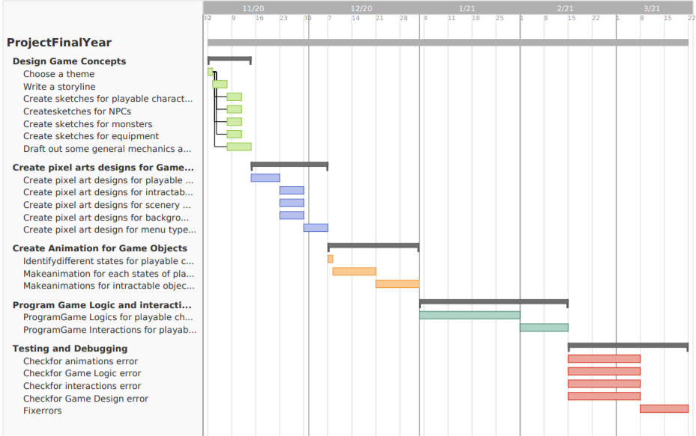

# Bibliography

Drachen, A., 2009. Role-Playing Games: The State of Knowledge.

Rosenthal, D., 2009. *gamedesignconcepts.* [Online]   
Available at: http://gamedesignconcepts.pbworks.com/w/page/11829076/Legal%20Issues%20for%20Game%20Developers