Name intentionally omitted
Professor Chukwuemeka
IT 36311
29 April 2021
Tuscarawas Central Catholic Tuition Calculator
Objective:
The objective of this project is to provide a tuition calculator for Tuscarawas Central Catholic Junior High and High School. Located in New Philadelphia, Ohio, which is in Tuscarawas County, Tuscarawas Central Catholic is a small private Catholic junior high and high school. The tuition rates are cheaper if the students are Catholic because the parish of the student pays for part of the tuition. However, being Catholic is not a requirement for attending the school. Anyone can attend the school. A tuition calculator is needed on the school’s website to make calculating tuition easier for anyone wanting to send their children to this private Catholic school.
Issue:
The issue is that there is no visible calculator to compute tuition on the school’s website. The tuition must be manually calculated with a calculator or by hand. By adding a tuition calculator, the website would be more efficient for those considering sending their children to either the high school and or junior high school. The tuition can be easily calculated by entering data into the tuition calculator about how many students are attending each school and if any students are Catholic. Students who are Catholic have a sliding scale for their tuition; students who are not Catholic have a flat rate. Of course, high school students pay more than junior high school students. Also, students who attend Buckeye Career Center pay a lesser flat rate. International (foreign exchange) high school students pay a higher flat rate than any other student. Tuition for international junior high school students does not exist because junior high school students do not participate in the foreign exchange program (this was verified with Patty Tolotti, who works for the school).
Of course, a main website for Tuscarawas Central Catholic exists on the Internet. Below is the link to the main website.
Tuscarawas Central Catholic JSHS - New Philadelphia, OH (tccsaints.com)
A link for the tuition rates exists on the main website, but for direct access to the page for tuition, the website is -
Tuition Rates - Tuscarawas Central Catholic JSHS - New Philadelphia, OH (tccsaints.com)

Project Description:
To create the tuition calculator, data about the tuition was collected from the school’s website. Below is the data about the tuition:
Participating/Non-participating 7-8
1st Child $3,365/$4,595
2nd Child $2,720/$4,595
3rd Child $2,190/$4,595
Participating/Non-participating 9-12
1st Child $5,560/$6,530
2nd Child $4,490/$6,530
3rd Child $3,635/$6,530
Buckeye Career Center
$1,092 per child (BCC students are not included in 1st child, 2nd child, etc.)
International Student
$7,649 per child

Unfortunately, the website does not really describe the difference between participating and non-participating. In this scenario, participating means the student is Catholic. Non-participating means the student is not Catholic. If a family has multiple students that are Catholic, the first student pays more than the second student, and the second student pays more than the third or more students. Note that the fourth student, fifth student, etc. would pay the same as the third student. The tuition rates are divided between junior high (grades 7 and 8) and high school (grades 9 through 12). High school students pay more than junior high students. Non-Catholic students pay a flat rate, meaning there is no price difference if there are multiple non-Catholic children in junior high or high school. Again, non-Catholic high school students pay more than non-Catholic junior high school students. All high school students who attend Buckeye Career Center (BCC) only pay $1,092. The reason that BCC students pay so little is because they spend most of their day at BCC. All international high school students, which would be foreign exchange students, pay $7,649. Junior high school students do not participate in the foreign exchange student program, so they are not included in the tuition calculator.
Indeed, the proposed tuition calculator, which is shown on the next page, is very easy to use. The user just enters the number of high school students, Buckeye Career Center students, international students, and junior high students. Check boxes can be checked if the high school and or junior high school students are Catholic. If no value is entered into the boxes where numbers should be entered, the default is zero. If the check boxes are not checked, it is assumed that the students are not Catholic, which means non-participating. If the check boxes are checked, the students are considered Catholic and participating.
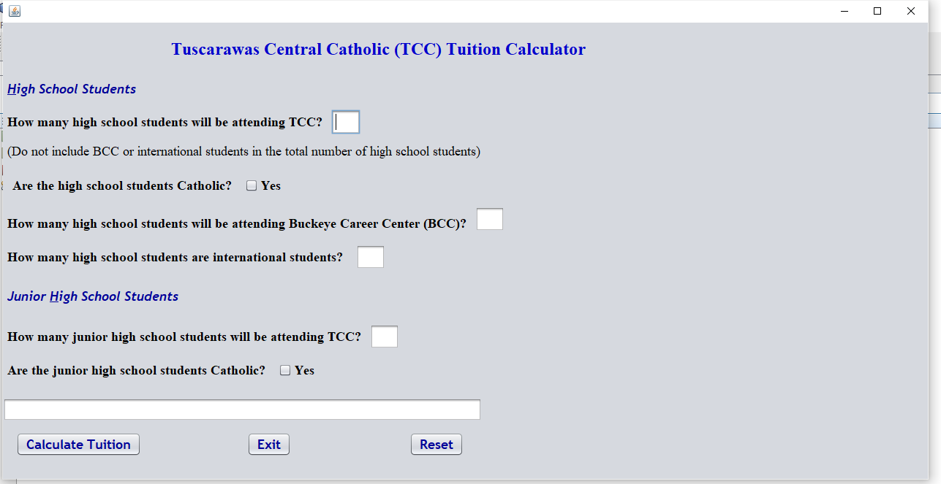
Furthermore, the desktop application for the Tuscarawas Central Catholic Tuition Calculator uses inheritance to calculate the tuition. The main program, TCCTuitionCalculation, retrieves the data from the values entered on the screen. Once all the editing in the program has passed satisfactorily, the values are sent to a parameterized constructor in the following class -TCCCalcTheTuition. The class inherits the values and does the actual calculation. A grand total for the tuition is returned to the main program to display. Then, detailed data regarding the tuition is displayed using HTML code. Below is the screen after a tuition was calculated:
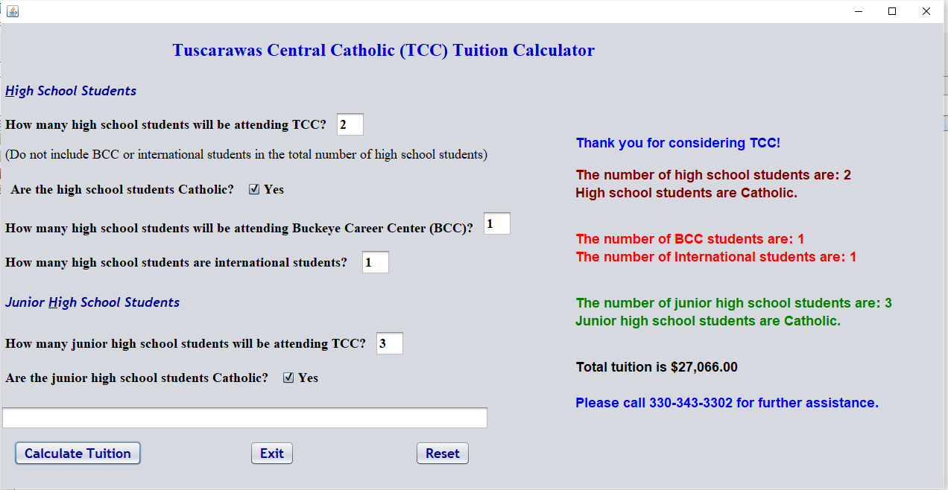
Specifically, the most challenging problem in this project was the sliding scale tuition for Catholic students. To help compute the tuition for Catholic students, arrays were used. For example, if there are 4 high school students, the first student pays $5,560.00. The second student pays $4,490.00. The third student and any other subsequent student pay $3,635.00. The following arrays helped in doing the calculations for the sliding scale:
private double jhsRates[] = {0.00, 3365.00, 2720.00, 2190.00}; (junior high)
private double hsRates[] = {0.00, 5560.00, 4490.00, 3635.00}; (high school)
By using the arrays, it was easy to use indexes for students one, two, three, and beyond. If there are more than 3 high school students, 2 was subtracted from the total number of high school students to get the exact number of students that should be multiplied with the value in the table for index 3. The same process is used for the junior high students. Using the arrays were helpful in calculating the tuition for multiple students.
Class Topics Used in Project
Of course, several Advanced Java class topics were used in this project. One of the most important topics used was inheritance. In Java, inheritance allows an object to acquire all the properties and behaviors of a parent object. New classes can be built upon existing classes. One of the main aspects of inheritance is the reusability of code. When inheriting from an existing class, methods and fields can be reused from the parent class. Inheritance is one of the main concepts for object-oriented programming. When looking at the programming for this project, inheritance was used between the main program and the main class.
Specifically, the application for the Tuscarawas Central Catholic Tuition Calculator is a desktop application. This semester the class learned how to easily create desktop applications using NetBeans IDE (Integrated Development Environment). A form is created and then textboxes, labels, checkboxes, buttons, and other things can be easily dragged and dropped onto the form. The properties, such as font size and color, of each can be changed. By double clicking on the buttons and check boxes on the form, the programmer is taken to the appropriate areas in the source code to create the Java code.
Also, an overloaded constructor was used in the main class. The main program, TCCTuitionCalculation, passes the information to the constructor in the main class, TCCCalcTheTuition, so that the tuition can be calculated. Mutator and Accessor methods are used in the class. Once the tuition is calculated, the main program can use the value in the accessor method getTotalTuition by using the object that was created. The object was tuition, so the code looks like this – tuition.getTotalTuition().
Additionally, another class topic was access methods, which control the access level for constructors, methods, attributes, and classes. Class access modifiers can either be public or default. Public allows a class to be used by another class. For attributes, constructors, and methods, the access modifiers are public, private, default, and protected. Public means the code can be accessed by all classes. Private means the code can only be accessed in the same class. The code can only be accessed in the same package when default is used. Protected is used if the code is to be accessed only in the same package, and, also, the subclasses. Public and private access methods are used throughout the code for the tuition calculator.
Tuition Calculations:
Without doubt, one must manually calculate the tuition to make sure the tuition calculator is working properly. Below are some sample calculations for tuition at Tuscarawas Central Catholic:
- The family has 2 children who will attend junior high and 2 children who will attend high school. All children are Catholic. None are international students. None will attend Buckeye Career Center.

Tuition = ($3365.00 + $2720.00 + $5560.00 + $4490.00)
Tuition = $16,135.00

- The family has 2 high school students. None are Catholic. None are international students. None attend Buckeye Career Center.

Tuition = ($6530.00 * 2)

Tuition = $13,060.00

- The family has 1 international student.

Tuition = $7649.00 * 1
Tuition = $7,649.00

- The family has 3 high school students. One of the students will attend Buckeye Career Center. All are Catholic. None are international students.
Tuition = ($5560.00 + $4490.00 + $1092.00)
Tuition = $11,142.00

- The family has 2 junior high students and 2 high school students. None are Catholic. None will attend Buckeye Career center. None are international students.
Tuition = ($4595.00 * 2) + ($6530.00 * 2)
Tuition = ($9190.00 + $13060.00)
Tuition = $22,250.00

- The family has 2 junior high students and 5 high school students. All are Catholic. None will attend Buckeye Career center. None are international students.
Tuition = $3365.00 + $2720.00 + $5560.00 + $4490.00 + (3 * $3635.00)
Tuition = ($16135.00 + $10905.00)
Tuition = $27,040.00

- The family has 4 junior high students and 1 high school student. All are Catholic. None will attend Buckeye Career center. None are international students.
Tuition = $3365.00 + $2720.00 + (2 * $2190.00) + $5560.00
Tuition = ($11645.00 + $4380.00)
Tuition = $16,025.00

Benefits of the Project:
Chiefly, the main benefit of this project is that tuition can be easily calculated by anyone interested in sending their children to Tuscarawas Central Catholic. Instead of getting out a calculator, or manually calculating the tuition by hand, parents can easily calculate the tuition on the website. For people wondering if they can afford to send their children to a private school, the answer can be quickly found by using the tuition calculator.
Limitations of the Project:
Of course, most everything has limitations. The main limitation in the future for the tuition calculator would be finding someone to change the code when the tuition changes. This person could be a java programmer but could be a very technical person that has had good training on how to change the values in the program. Also, some scholarships are offered at the school for students whose parents are considered poor. The scholarships range from full tuition to partial tuition. Some parents work in the cafeteria or help with janitorial duties to pay for some of the tuition. This project does not address scholarships or parents working to pay for some of the tuition.
Recommendation:
Hence, Tuscarawas Central Catholic should embrace a tuition calculator for their website. This would make calculating tuition for potential students easier for their parents. The desktop calculator would also be very helpful to many people who are math challenged because all they need to do is fill out the information and click a button to get the total tuition.
Conclusion:
The Tuscarawas Central Catholic Tuition Calculator could be adapted for use by any private school. Of course, the name of the school would need to be changed on the form. Also, the way tuition is calculated may need to be changed since many private schools do not calculate tuition in the same manner. However, this tuition calculator is a good base for any private school. Any good Java programmer could copy the code and make the necessary changes
References:
Kent.edu, 2021, learn.kent.edu/webapps/blackboard/content/listContent.jsp?course_id=_326920_1&content_id=_13359987_1&mode=reset.

“Tuscarawas Central Catholic JSHS.” Tuscarawas Central Catholic JSHS, www.tccsaints.com/.
‌

