Midterm Project – Angel L.
Student: Angel L.
Professor: Samuel Chukwuemeka
Project: Web application for Tax rates for 2021 year (filing 2022)
Application Type: Web application using ASP.NET framework.
Application Name: Federal Income Tax Calculator-2022
Website URL: https://federalincometaxcalculator.azurewebsites.net
Source: https://www.debt.org/tax/brackets/
Application URL: https://federalincometaxcalculator.azurewebsites.net

Tax Bracket Table
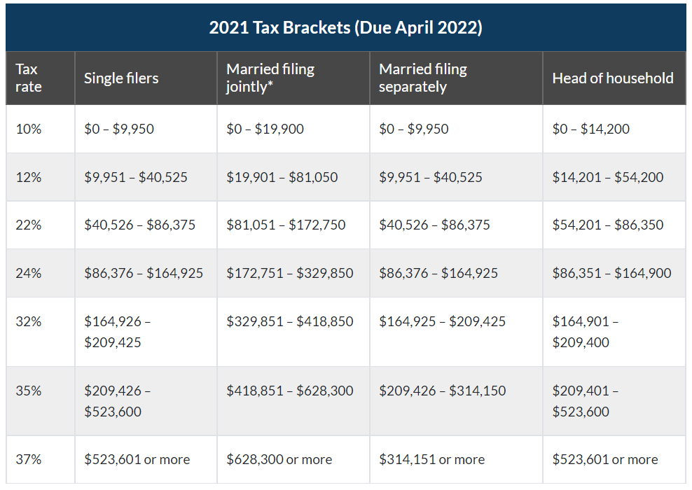
Piecewise Function Math
Let p = taxable income
Let t = income tax
t = f(p)
It can be written as: t(p)

Single filer:
t(p) = $\left\{\begin{matrix}0.1p; & 0≤p≤9950 & & & & \\ 0.12p-199 & 9950<p≤40525 & & & & \\ 0.22p-4251.5; & 40525<p≤86375 & & & & \\ 0.24p-5979; & 86375<p≤164925 & & & & \\ 0.32p-19173; & 164925<p≤209425 & & & & \\ 0.35p-25455.75; & 209425<p≤523600 & & & & \\ 0.37p-35927.75; & p>523600 & & & & \end{matrix}\right.$

First Bracket (10%)
t(p) = 0.10p
Second Bracket (12%)
- Max for 1st bracket: 9950*.10 = 995
- t(p) = 995 + (.12(p – 9950)
t(p) = 995 + .12p – 1194
t(p) = .12p – 199
Third Bracket (22%)
- Max for 1st bracket = 995
- Max for 2nd bracket = ((40525 – 9950) * .12) = 3669
- t(p) = 995 + 3669 + (.22(p – 40525)
t(p) = 4664 + .22p – 8915.5
t(p) = .22p – 4251.50
Fourth Bracket (24%)
- Max for 1st bracket = 995
- Max for 2nd bracket = 3669
- Max for 3rd bracket = ((86375 – 40525) * .22) = 10087
- t(p) = 995 + 3669 + 10087 + (.24(p – 86375)
t(p) = 14751 + .24p – 20730
t(p) = .24p – 5975
Fifth Bracket (32%)
- Max for 1st bracket = 995
- Max for 2nd bracket = 3669
- Max for 3rd bracket = 10087
- Max for 4th bracket = ((164925 – 86375) * .24) = 18852
- t(p) = 995 + 3669 + 10087 + 18852 + (.32(p – 164925)
t(p) = 33603 + .32p – 52776
t(p) = .32p – 19173
Sixth Bracket (35%)
- Max for 1st bracket = 995
- Max for 2nd bracket = 3669
- Max for 3rd bracket = 10087
- Max for 4th bracket = 18852
- Max for 5th bracket = ((209425 – 164925) * .32) = 14240
- t(p) = 995 + 3669 + 10087 + 18852 + 14240 + (.35(p – 209425)
t(p) = 47843 + .35p – 73298.75
t(p) =.35p – 25455.75
Seventh Bracket (37%)
- Max for 1st bracket = 995
- Max for 2nd bracket = 3669
- Max for 3rd bracket = 10087
- Max for 4th bracket = 18852
- Max for 5th bracket = 14240
- Max for 6th bracket = ((523600 – 209425) * .35) = 109961.25
- t(p) = 995 + 3669 + 10087 + 18852 + 14240 + 109961.25 + (.37(p – 523600)
t(p) = 157804.25 + .37p - 193732
t(p) = .37p – 35927.75

Married filing jointly
t(p) = $\left\{\begin{matrix}0.1p; & 0≤p≤19900 & & & & \\ 0.12p-398; & 19900<p≤81050 & & & & \\ 0.22p-8503; & 81050<p≤172750 & & & & \\ 0.24p-11958; & 172750<p≤329850 & & & & \\ 0.32p-38346; & 329850<p≤418850 & & & & \\ 0.35p-50911.50; & 418850<p≤628300 & & & & \\ 0.37p-63477.50; & p>628300 & & & & \end{matrix}\right.$
First Bracket (10%)
t(p) = 0.10p
Second Bracket (12%)
- Max for 1st bracket: (19900 * .10) = 1990
- t(p) = 1990 + (.12(p - 19900))
t(p) = 1990 + .12p – 2388
t(p) = .12p – 398
Third Bracket (22%)
- Max for 1st bracket = 1990
- Max for 2nd bracket = ((81050 – 19900) * .12) = 7338
- t(p) = 1990 + 7338 + (.22(p-81050))
t(p) = 9328 + .22p – 17831
t(p) = .22p – 8503
Fourth Bracket (24%)
- Max for 1st bracket = 1990
- Max for 2nd bracket = 7338
- Max for 3rd bracket = ((172750 – 81050) * .22) = 20174
- t(p) = 1990 + 7338 + 20174 + (.24(p-172750))
t(p) = 29502 + .24p – 41460
t(p) = .24p – 11958
Fifth Bracket (32%)
- Max for 1st bracket = 1990
- Max for 2nd bracket = 7338
- Max for 3rd bracket = 20174
- Max for 4th bracket = ((329850 – 172750) * .24) = 37704
- t(p) = 1990 + 7338 + 20174 + 37704 + (.32(p – 329850))
t(p) = 67206 + .32p – 105552
t(p) =.32p – 38346
Sixth Bracket (35%)
- Max for 1st bracket = 1990
- Max for 2nd bracket = 7338
- Max for 3rd bracket = 20174
- Max for 4th bracket = 37704
- Max for 5th bracket = ((418850 – 329850) * .32) = 28480
- t(p) = 1990 + 7338 + 20174 + 37704 + 28480 + (.35(p – 418850))
t(p) = 95686 + .35p – 146597.50
t(p) =.35p – 50911.50
Seventh Bracket (37%)
- Max for 1st bracket = 1990
- Max for 2nd bracket = 7338
- Max for 3rd bracket = 20174
- Max for 4th bracket = 37704
- Max for 5th bracket = 28480
- Max for 6th bracket = ((628300 – 418850) * .35) = 73307.50
- t(p) = 1990 + 7338 + 20174 + 37704 + 28480 + 73307.50 + (.37(p – 628300))
t(p) = 168993.50 + .37p – 232471
t(p) =.37p – 63477.50

Married filing separately

t(p) = $\left\{\begin{matrix}0.1p; & 0≤p≤9950 & & & & \\ 0.12p-199; & 9950<p≤40525 & & & & \\ 0.22p-4251.5; & 40525<p≤86375 & & & & \\ 0.24p-5979; & 86375<p≤164925 & & & & \\ 0.32p-19173; & 164925<p≤209425 & & & & \\ 0.35p-25455.75; & 209425<p≤314150 & & & & \\ 0.37p-31738.75; & p>314150 & & & & \end{matrix}\right.$

First Bracket (10%)
t(p) = 0.10p
Second Bracket (12%)
- Max for 1st bracket: 9950*.10 = 995
- t(p) = 995 + (.12(p – 9950)
t(p) = 995 + .12p – 1194
t(p) = .12p – 199
Third Bracket (22%)
- Max for 1st bracket = 995
- Max for 2nd bracket = ((40525 – 9950) * .12) = 3669
- t(p) = 995 + 3669 + (.22(p – 40525)
t(p) = 4664 + .22p – 8915.5
t(p) = .22p – 4251.5
Fourth Bracket (24%)
- Max for 1st bracket = 995
- Max for 2nd bracket = 3669
- Max for 3rd bracket = ((86375 – 40525) * .22) = 10087
- t(p) = 995 + 3669 + 10087 + (.24(p – 86375)
t(p) = 14751 + .24p – 20730
t(p) = .24p – 5975
Fifth Bracket (32%)
- Max for 1st bracket = 995
- Max for 2nd bracket = 3669
- Max for 3rd bracket = 10087
- Max for 4th bracket = ((164925 – 86375) * .24) = 18852
- t(p) = 995 + 3669 + 10087 + 18852 + (.32(p – 164925)
t(p) = 33603 + .32p – 52776
t(p) = .32p – 19173
Sixth Bracket (35%)
- Max for 1st bracket = 995
- Max for 2nd bracket = 3669
- Max for 3rd bracket = 10087
- Max for 4th bracket = 18852
- Max for 5th bracket = ((209425 – 164925) * .32) = 14240
- t(p) = 995 + 3669 + 10087 + 18852 + 14240 + (.35(p – 209425)
t(p) = 47843 + .35p – 73298.75
t(p) =.35p – 25455.75
Seventh Bracket (37%)
- Max for 1st bracket = 995
- Max for 2nd bracket = 3669
- Max for 3rd bracket = 10087
- Max for 4th bracket = 18852
- Max for 5th bracket = 14240
- Max for 6th bracket = ((314150 – 209425) * .35) = 36653.75
- t(p) = 995 + 3669 + 10087 + 18852 + 14240 + 36653.75 + (.37(p – 314150)
t(p) = 84496.75 + .37p – 116235.50
t(p) = .37p – 31738.75

Head of Household

t(p) = $\left\{\begin{matrix}0.1p; & 0≤p≤14200 & & & & \\ 0.12p-284; & 14200<p≤54200 & & & & \\ 0.22p-7704; & 54200<p≤86350 & & & & \\ 0.24p-5704; & 86350<p≤164900 & & & & \\ 0.32p-20623; & 164900<p≤209400 & & & & \\ 0.35p-26905; & 209400<p≤523600 & & & & \\ 0.37p-39397; & p>523600 & & & & \end{matrix}\right.$

First Bracket (10%)
t(p) = 0.10p
Second Bracket (12%)
- Max for 1st bracket: 14200*.10 = 1420
- t(p) = 1420+ (.12(p – 14200)
t(p) = 1420+ .12p – 1704
t(p) = .12p – 284
Third Bracket (22%)
- Max for 1st bracket = 1420
- Max for 2nd bracket = ((54200 – 14200) * .12) = 4800
- t(p) = 1420 + 4800 + (.22(p – 54200)
t(p) = 4220 + .22p – 11924
t(p) = .22p – 7704
Fourth Bracket (24%)
- Max for 1st bracket = 1420
- Max for 2nd bracket = 3669
- Max for 3rd bracket = ((86350 – 54200) * .22) = 7073
- t(p) = 1420 + 4800 + 7073 + (.24(p – 86350)
t(p) = 13293 + .24p – 18997
t(p) = .24p – 5704
Fifth Bracket (32%)
- Max for 1st bracket = 1420
- Max for 2nd bracket = 4800
- Max for 3rd bracket = 7073
- Max for 4th bracket = ((164900 – 86350) * .24) = 18852
- t(p) = 1420 + 4800 + 7073 + 18852 + (.32(p – 164900)
t(p) = 32145 + .32p – 52768
t(p) = .32p – 20623
Sixth Bracket (35%)
- Max for 1st bracket = 1420
- Max for 2nd bracket = 4800
- Max for 3rd bracket = 7073
- Max for 4th bracket = 18852
- Max for 5th bracket = ((209400 – 164900) * .32) = 14240
- t(p) = 1420 + 4800 + 7073 + 18852 + 14240 + (.35(p – 209400)
t(p) = 46385 + .35p – 73290
t(p) =.35p – 26905
Seventh Bracket (37%)
- Max for 1st bracket = 1420
- Max for 2nd bracket = 4800
- Max for 3rd bracket = 7073
- Max for 4th bracket = 18852
- Max for 5th bracket = 14240
- Max for 6th bracket = ((523600 – 209400) * .35) = 109970
- t(p) = 1420 + 4800 + 7073 + 18852 + 14240 + 109970 + (.37(p – 523600)
t(p) = 154335 + .37p – 193732
t(p) = .37p – 39397

Test Case for “Married Filing Jointly.”

Notes:
I have selected seven random taxable income amounts.
I worked the math for married filing jointly.
I worked the math for each scenario arithmetically/manually (see below).
I also did the math using the piecewise function (see below).

Random numbers:
- $8000
- $32000
- $101930
- $240690
- $400100
- $490000
- $750930
Calculating random income – Arithmetic
- $8000 – falls within the first bracket (10%)
8000 * .10 = $800.00
- $32000 – falls within the second bracket (12%):
  - first piece: there is $19,900 out of the 32000 taxed at 10%
19,900 * .10 = $1990
  - Second piece: the remaining of the $32000 should be taxed at 12%
32000 – 19900 = $12100
12100 * .12 = $1452
  - So, tax for income of $32000 is:
1990 + 1452 = $3,442.00
- $101930 – falls under the third bracket (22%):
  - First piece: $1990
  - Second piece: calculate the range of income that will be taxed at 12% (anything falls under second bracket)
81050 – 19900 = $61150
61150 * .12 = $7338
  - Third piece: the remaining of the $101930 will be taxed at 22%
101930 – 81050 = $20880
20880 * .22 = $4593.60
  - So, tax for income of $101930 is:
1990 + 7338 + 4593.60 = $13,921.60
- $240690 – Falls under the fourth bracket (24%):
  - First piece: $1990
  - Second piece: $7338
  - Third piece: calculate the range of income that will be taxed at 22% (anything falls under third bracket)
172750 – 81050 = $91700
91700 * .22 = $20174
  - Fourth piece: the remaining of the $240690 will be taxed at 24%
240690 – 172750 = $67940
67940 * .24 = $16,305.60
  - So, tax for income of $240690 is:
1990 + 7338 + 20174 + 16305.60 = $45,807.60
- $400100 - Falls under the Fifth bracket (32%):
  - First piece: $1990
  - Second piece: $7338
  - Third piece: $20174
  - Fourth piece: calculate the range of income that will be taxed at 24% (anything falls under fourth bracket)
329850 – 172750 = $157100
157100 * .24 = $37704
  - Fifth piece: the remaining of the $400100 will be taxed at 32%
400100 – 329850 = $70250
70250 * .32 = $22480
  - So, tax for income of $400100 is:
1990 + 7338 + 20174 + 37704 + 22480 = $89,686.00
- $490000 – Falls under the sixth bracket (35%):
  - First piece: $1990
  - Second piece: $7338
  - Third piece: $20174
  - Fourth piece: $37704
  - fifth piece: calculate the range of income that will be taxed at 32% (anything falls under fifth bracket):
418850 – 329850 = $89000
89000 * .32 = $28480
  - Sixth piece: the remaining of the $490000 will be taxed at 35%
490000 – 418850 = $71150
71150 * .35 = $24902.50
  - So, tax for income of $490000 is:
1990 + 7338 + 20174 + 37704 + 28480 + 24902.50 = $120,588.50
- $750930 – Falls under the seventh bracket (37%):
  - First piece: $1990
  - Second piece: $7338
  - Third piece: $20174
  - Fourth piece: $37704
  - fifth piece: $28480
  - sixth piece: calculate the range of income that will be taxed at 35% (anything falls under sixth bracket):
628300 – 418850 = $209450
209450 * .35 = $73,307.50
  - seventh piece: the remaining of the $750930 will be taxed at 37%
750930 – 628300 = $122630
122630 * .37 = $ 45373.10
  - So, tax for income of $750930 is:
  - 1990 + 7338 + 20174 + 37704 + 28480 + 73307.50 + 45373.10 = $214,366.60
Calculating random income – Piecewise function

- $8000 – falls within the first bracket (10%)
Piecewise function: t(p) = 0.10p
t(8000) = 0.10 * 8000 = $800.00
- $32000 – falls within the second bracket (12%):
Piecewise function: t(p) = .12p – 398
t(32000) = 0.12(32000) – 398
t(32000) = 3840 – 398 = $3,442.00
- $101930 – falls under the third bracket (22%):
Piecewise function: t(p) = .22p – 8503
t(101930) = .22(101930) – 8503
t(101930) = 22424.60 – 8503 = $13,921.60
- $240690 – Falls under the fourth bracket (24%):
Piecewise function: t(p) = .24p – 11958
t(240690) = .24(240690) – 11958
t(240690) = 57765.60 – 11958 = $45,807.60
- $400100 - Falls under the Fifth bracket (32%):
Piecewise function: t(p) = .32p – 38346
t(400100) = .32(400100) – 38346
t(400100) = 128032 – 38346= $89,686.00
- $490000 – Falls under the sixth bracket (35%):
Piecewise function: t(p) = .35p – 50911.50
t(490000) = .35(490000) – 50911.50
t(490000) = 171500 – 50911.50 = $120,588.50
- $750930 – Falls under the seventh bracket (37%):
Piecewise function: t(p) = .37p – 63477.50
t(750930) = .37(750930) – 63477.50
t(750930) = 277,844.10 – 63477.50 = $214,366.60

Reference
2020-2021 Tax Brackets & Rates For Each Income Level. Debt.org. (2021, October 12). Retrieved December 05, 2021, from https://www.debt.org/tax/brackets/#2021-tax-brackets.

Citation Format: APA version7.

