AAll I wanted was to go somewheres@
Stephen Railton

Nineteenth century Americans were a restless people, but few could have traveled further than Sam Clemens, who by age 25 had gone from the middle of the country east to the big cities and then west across the plains and deserts while in between making all those steamboat trips north and south on the Mississippi. As Mark Twain he traveled even further, literally and imaginatively traversing thousands and thousands of miles of space and centuries and centuries in time. As I=m sure we=ll learn this weekend, Twain=s travels had multiples causes and many effects. Part of the baggage that Mark Twain took with him wherever he went was Sam Clemens= temperament, and Sam had very itchy feet. In June 1867, for example, in the east for the second time, now as a traveling correspondent for the Alta California, and while waiting for the Quaker City to sail to Europe and the Holy Land on the trip that would result in his first and best selling travel book, Sam wrote his mother back in the Midwest to complain that "All I do know or feel, is, that I am wild with impatience to moveCmoveCMove! . . . I wish I never had to stop anywhere a month." The desire he expresses here is obviously heartfelt, perhaps even a psychic need that lay beyond his conscious control. But for a traveling correspondent, moving, moving, moving is also a condition of employment. That=s what I=d like to talk about this morning: what travel meant to Mark Twain as a professional writer, the way his need to travel was as much rhetorical as it was temperamental. Travel enabled Twain to be both a humorist and a social critic at a distance, without directly confronting the American audience whose approval was perhaps his greatest need, both professionally and emotionally.

Let me begin by showing you what I mean, with six graphic illustrations about the rhetorical difference that distance can make, especially when it comes to ideologically charged topics like slavery and imperialism. Twain=s first sustained imaginative treatment of slavery is Huckleberry Finn. As the novel=s publisher, Twain himself hired the artist, E. W. Kemble, who drew its 174 illustrations. Here=s one, the novel=s only representation of Jim inside that shed on the Phelps plantation where he is held for days at the end of the narrative:

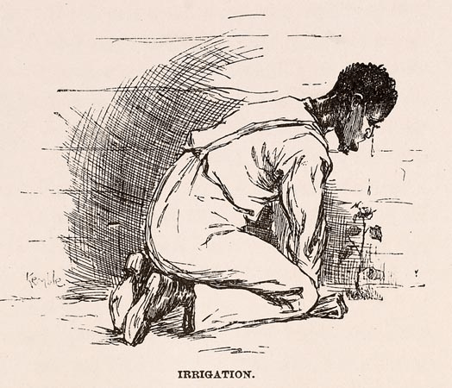

Lest any readers might think he=s crying from anguish over his fate as a recaptured fugitive slave among white strangers, the picture’s caption will set them straight. He=s Airrigating@ the plant that Tom Sawyer declares should be part of the decor of his prison, and his tears will be provoked by the onion that Tom promises to send in to him. Like nearly all of Kemble=s illustrations, especially of Jim and the other black characters in the story, this one is meant to make readers laugh. Giving white audiences ways to laugh at stereotypical blacks, in fact, became Kemble=s specialty as an artist and cartoonist, as the titles of his two books of drawings B Kemble=s Coons and Comical Coons B make sufficiently clear. On the other hand, slavery is no laughing matter in the illustrations Kemble drew five years later for an article in The Century Magazine about the slave trade in the Congo Basin. Here=s one of those, depicting a group of captives in another ASlave Shed@:
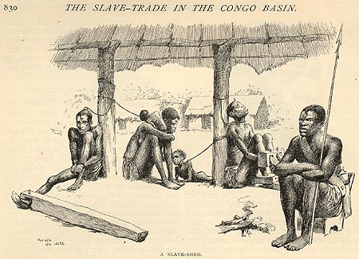
These men, women and children are people, not caricatures, and there is no mistaking their misery B but these slaves are in Africa, not America, and the people who have enslaved them are black, not white. American readers can look on the horrors of slavery from an equally safe distance in the images that the Congo Reform Association included, apparently at Twain=s suggestion, when they published his AKing Leopold=s Soliloquy@ in 1905. Here=s one of those:
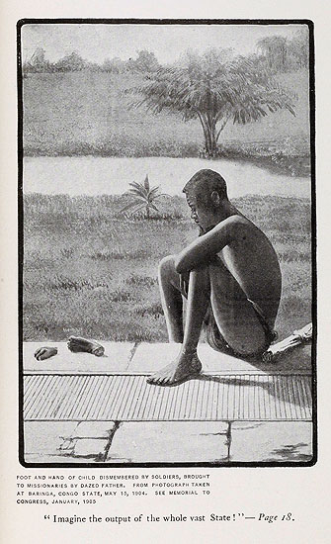
Painful as this picture is to look at, Twain=s countrymen need feel no collective sense of guilt or responsibility for the suffering it depicts, only moral outrage at the villainy of a European monarch.

AKing Leopold=s Soliloquy@ is one of Twain=s angriest denunciations of imperialism. By 1905 the United States had planted the flag of its own imperialist ambitions in the Caribbean and the Philippines, and Twain deserves the credit he has been given for speaking out against those actions in a work like ATo the Person Sitting in Darkness.@ But again, if we look at his books= illustrations, it=s not hard to see how much easier it was for him to condemn the act of dispossessing and exploiting native populations when the imperialists were not members of his American audience. Let me start with a pair of illustrations from one of the two books that Terry Oggel put on our reading list for today, Following the Equator. The first is a very respectful and moving image of the last aboriginal Tasmanian, a people who (Twain tells his reader) were completely exterminated after the English settlers arrived on their island:
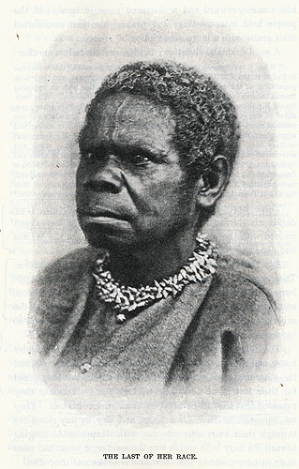
The second is a bitterly ironic depiction of the story that Twain saw being written by the progress of empire at the end of the century across the non-white world:
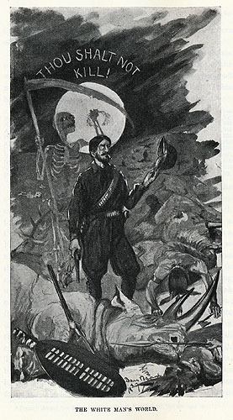
The monocle here is a very strategic detail: there=s no way this Awhite man@ could be American. And you will look in vain for, say, buffaloes B or native Americans B among the corpses this imperialist has made.
The trip around the world that is recounted in Following the Equator is often cited as the source of Twain=s realization of the evils of imperialism. Like this illustration, its text is careful to keep Americans at a distance from those evils. Here=s a passage from a late chapter, summing up human history with the vernacular metaphor of stealing laundry from your neighbor=s clothes-line and also with an inclusiveness that at first seems to leave no way to keep American readers off the hook:

All the territorial possessions of all the political establishments in the earth B including America, of course B consist of pilferings from other people=s wash. No tribe, howsoever insignificant, and no nation, however mighty, occupies a foot of land that was not stolen. When the English, the French, and the Spaniards reached America, the Indian tribes had been raiding each other=s territorial clothes-lines for ages, and every acre of ground in the continent had been stolen and re-stolen 500 times. The English, the French, and the Spaniards went to work and stole it all over again; and when that was satisfactorily accomplished they went to work and stole it from each other. (623)
They went to work B the passage stops just at the point when the United States went from being itself a colonial dependent of a European power to become instead a nation in its own right B and wrongs. It stops, that is, precisely at the point where Twain would have to say to his readers that Awe went to work, and dispossessed and largely exterminated our aboriginal population.@ Despite the obvious chance that Following the Equator provided, Twain never revised the narrative of relations between white and native Americans that we find in places like Tom Sawyer=s Injun Joe or, more unforgettably, the Goshoot Indians he describes in Roughing It. That travel book=s illustration of the Goshoots makes a telling complement to the pictures we=ve just seen from Equator. As American aborigines B in Twain=s facetious terms, Anoble red men@ B the Goshoots are allowed no shred of dignity, and there=s no hint that their homelessness and misery is the result of white colonization of the land that used to be theirs:
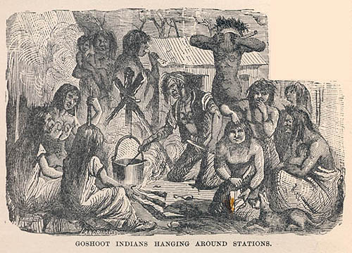

As a humorist, too, Twain quickly learned that audiences are much more willing to laugh at others than at themselves. In Innocents Abroad, for instance, he travels through countries that are almost entirely Catholic and Islamic, but is writing about them for the American public, which is at this time over 90% Protestant. Thus he can be irreverent, even skeptical about what he sees on his travels, about their beliefs and rituals, without disturbing the pieties of what he is careful at one point to call Athe true religion,@ a phrase to which, in order to leave no doubt about what he means, he adds three more words: Athe true religion B which is ours.@ As its title obviously suggests, A Tramp Abroad was partly calculated to appeal to the readers who had loved Innocents Abroad; at the end of the second book, for example, he reprises the comedic assault on the AOld Masters@ of European painting that had been a major feature of the earlier one. But if you listen carefully, you might also hear in the title of A Tramp Abroad the echo of another earlier work: the after-dinner speech Twain gave at the dinner held in honor of John Greenleaf Whittier’s seventieth birthday on December 17th, 1877. The speech repeats a story he claims he heard from an old prospector while making Aan inspection tramp through the southern mines of California.@ The prospector=s tale pokes fun at three of the Old Masters of American literature B Henry Wadsworth Longfellow, Oliver Wendell Holmes and Ralph Waldo Emerson B by putting their words in the mouths of a trio of tramps who pretend to be the poets. This speech was one of Twain’s most dramatic failures. The attacks on it in the American media caused him so much distress that he decided he had better leave the country for a while. The trip to Europe that provides the raw material for A Tramp Abroad was hastily arranged to give his countrymen time to forget his offense, the contract for the book was signed less than three months after the Whittier dinner, and in the book itself Twain is careful to keep his tramps and his irreverent perspective focused entirely Aabroad.”

Perhaps the most efficient way to see the pattern I=m calling Arhetorical@ at work in Twain=s texts is to look at his travel book that stays closest to home, Life on the Mississippi. The germ of this book was the autobiographical narrative he=d written for The Atlantic magazine in the mid-1870s, about his experiences as a cub steamboat pilot learning the river. Interestingly, near the end of this AOld Times on the Mississippi@ series he measures the difference between being a riverboat pilot and the trade he now plies as a writer. The pilot, he says, was free: Athe only unfettered and entirely independent being that lived in the earth.@ He doesn=t quite say that writers are slaves, but comes very close: Awriters of all kinds are manacled servants of the public. We write frankly and fearlessly, but then we >modify= before we print.@ The book he wrote when he traveled back to the river in 1882 for the purpose of writing a book proves his point altogether too conclusively. The manuscript of Life on the Mississippi contains numerous passages, even chapters, that were not published until the mid-20th century. According to Willis Wager, editor of the 1944 Heritage Press edition in which they first appeared, these unpublished segments total about 15,000 words. They are among the earliest examples of what would become a more and more recurrent feature of Twain=s writing life: the first of the many texts he would write but then put aside as too dangerous to publish, too likely to offend his audience. If you want to read the unexpurgated Life on the Mississippi for yourself, the excluded passages are all included in the Viking Penguin edition that James Cox edited in 1984. As you read that version of the book it soon becomes clear that almost all the passages Twain suppressed treat the American culture he is traveling through more critically than the rest of the book. With an irony that I hope was not lost on Twain as he went through the manuscript deciding which parts to leave out, one of the longest excisions concerns a travel book that came out half a century before the one he=s writing: Domestic Manners of the Americans, by Frances Milton Trollope B mother of the famous Victorian novelist, and always referred to as Mrs. Trollope. Always referred to angrily, as Twain would have said if he=d let the chapter about her book stand. As he wrote, but did not print, Mrs. Trollope was Ahandsomely cursed and reviled by this nation@ for Amerely telling the truth@ about what she found during her travels in the U.S. Twain makes her sound a lot like Twain: the Aprejudices@ her American critics accused her of were those Aof a humane spirit against inhumanities; of an honest nature against humbug; . . . of a right heart against unright speech and deed.@ But Twain also makes it clear, both in the chapter and then again in the decision to suppress it, what were the rhetorical risks of trying to tell America these kinds of truths. When you read through the published and unpublished portions of Life on the Mississippi, you can watch him struggling with a different kind of travel: toward and away from telling the American people all that he really thought about them. It is easy to understand why, after his uncomfortable experience in writing about a journey through the heart of America, he would have decided to make his next and last travel book about a trip around the world, and also why Following the Equator sums the first leg of that journey, the twenty-one lecture stops he made from Ohio to Washington State, in one sentence in the book=s third paragraph. AIt was warm work, all the way,@ he writes B but who knows what kind of hot water he might have gotten into if he=d provided more details about the people, aborigines and settlers, that he saw during the American part of his trip?

The conventions of travel writing as a first-person genre had a lot to do with defining the spot Twain was on. Readers identify whatever is said in a travel book with the AI@ of the traveler. As I thought about Twain and travel for this talk, I found myself wondering whether his turn from travel writing, after the great popular success of his first two books, to novel writing was perhaps partly his attempt to get off that spot. What got my thoughts started in that direction was another of the suppressed passages in Life on the Mississippi, a long analysis of the Asolid South@ B that is, the sociological fact that there seems to be no political differences of opinion among post-Reconstruction white southerners. Again the concern is with being Asocially excommunicated@ for expressing an opinion, but in this passage that topic leads Twain to larger generalizations about Athe average Northerner@ and Athe average Southerner,@ and the fact that everywhere in the world Athe average citizen is not brave, he is timid.@ If these unpublished remarks sound familiar, it=s probably because in Chapter 22 of Huckleberry Finn Colonel Sherburn stands in front of a lynch mob and tells them this truth about themselves to their face: ADo I know you?@ he says; AI know you clear through. I was born and raised in the South, and I've lived in the North; so I know the average all around. The average man's a coward.@ Sherburn=s speech was the first episode Twain wrote when he went back to the manuscript of Huck Finn in 1883, immediately after the publication of Life on the Mississippi. In other words, just months after deciding that Mark Twain could not talk to his audience about human cowardice and so cutting those comments from a travel book, he arranged a novelistic scene to give a fictional character the chance to say much the same thing to a fictional audience. We could see Twain himself as one of the cowards here, hiding his own opinions behind the imposing figure of Colonel Sherburn, or instead, more generously, see him using the generic conventions and inherent ambiguities of novelistic narrative as a means of exploring and expressing his ideas more freely. The novel, that is, as a kind of literary territory he could light out to when the rhetorical terms of travel writing came to feel too cramped and smothery.

Certainly the first novel he wrote could be read as a kind of anti-travel narrative. The Gilded Age: A Tale of To-Day, which he co-authored with Charles Dudley Warner, is a tale of here as well as now. While those first two books traveled away from the world Twain=s American audience called home, the novel he and Warner wrote is largely set right where that audience lives. Instead of exotic places and foreign customs, the events of The Gilded Age mirror, with the kind of exaggeration on which satire depends, the stories of political corruption, corporate greed and criminal trials that contemporary readers already knew from the national news in their daily papers. Since the novel was co-written, it=s difficult to assess whose imagination is in charge, but of all Twain=s novels, this first one comes closest to the kind of realist project that Twain=s friend and fellow writer William Dean Howells was calling for. The Gilded Age surprised reviewers who were expecting Twain and Warner to entertain them with humor rather than challenge them with topical satire, but many reviews nevertheless approved of it. The book sold relatively well, too, so it=s also not clear to me why Twain never wrote another novel like it. But he didn=t. Although The Gilded Age gave late 19th century America its nickname, all the rest of Twain=s major fiction transports his audience away from their time and place.
In this respect, Twain=s other novels are also travel books. Beginning with his second novel, The Adventures of Tom Sawyer, the traveling is through time as much as or even more than through space. Rhetorically, time too gives readers a way to keep their distance from whatever happens in a text. Twain depicts the American past in various ways B nostalgically in Tom Sawyer, realistically in Huck Finn, ironically in Pudd=nhead Wilson B but in any case contemporary readers are tourists on that scene, with the tourist=s emotional and moral freedom from all responsibility for what they see, safe in the knowledge that when the trip is over, they have someplace else to go back to. Typically, Twain=s fictions with American settings work hard to establish that chronologically secure perspective, from the adult narrator looking back on childhood in Tom Sawyer to the way Huck Finn announces right on its title page that its ATIME@ is AFORTY TO FIFTY YEARS AGO@ to the first words of AThe Man That Corrupted Hadleyburg,@ his last fictional depiction of American society. There is no way to tell where Hadleyburg the town is, which might make some American readers anxious about how close the story was coming to home, but there is no question about when the story of AHadleyburg@ takes place: its first sentence reads AIt was many years ago.@

Twain=s other major fictions travel through space as well as time. By now I probably don=t need to belabor the way American readers are privileged to look at the historical eras depicted in The Prince and the Pauper or Connecticut Yankee or Joan of Arc from the vantage point of the superior place they occupy in human history as modern Americans. Perhaps we can let those readers speak for themselves here. About The Prince and the Pauper, for example, Howells wrote in his review that Ait is a satire on monarchy; in this sort it is a manual of republicanism which might fairly be introduced in the schools. It breathes throughout the spirit of humanity and the reason of democracy . . .@ Even more complacent is the jingoistic reaction of an anonymous reviewer in the Plumas National (a California paper) to Connecticut Yankee: AMark Twain has come up from the people. He is American to the backbone, and the assumption of natural superiority by titled English aristocrats and the terrible wrongs inflicted on the working people, evidently galled him beyond endurance. He has taken his revenge in this volume, and a thorough going over it is, for he has mercilessly flayed the follies, vices, cruelties and false pretensions of English royalty and aristocracy.@ The consensus among American reviewers of Joan of Arc was that Twain=s modern American sensibility interfered with the narrative=s illusion of historical verisimilitude, but more than one reviewer nonetheless quoted favorably the novel=s condemnation of Joan=s Catholic and monarchical times as the Abrutalest, the wickedest, the rottenest [century] in history since the darkest ages.@ When they read these historical accounts of Old World inequalities and injustices, Twain=s contemporary audience was not only looking back at the past; they were looking down at it too.

There is more to say about the way Twain tended to direct his social criticism away from the American audience he wrote for, but with the little time I have left I=d like to complicate what I=ve been saying by looking at a paradox that students of travel literature know well: that wherever you go, there you are. The promise of a travel book is that it will give readers a window from which to look out on foreign lands, but in fact, what travel writing often reveals most clearly are the preconceptions of the traveler B not the new world around him or her, but the world they carry with them inside their minds. In what travel writers say about exotic places, we see the cultural assumptions and concerns of the society they come from and are writing for.

One of Twain=s most extensively traveled characters, for example, is Hank Morgan, the Connecticut Yankee who gets knocked unconscious in Hartford and wakes up to find that he=s traveled four thousand miles eastward to England and thirteen centuries backward to the age of King Arthur. Hank=s favorite phrase is AGreat Scott!@ B which is Twain=s way of alerting us to the novel=s original goal. Believing, as he said in Life on the Mississippi, that by idealizing the middle ages in romances like Ivanhoe Walter Scott did Amore real and lasting harm, perhaps, than any other individual that ever wrote,@ Twain sends Hank into that world as an unsentimental traveler, a practical realist, someone who could, to paraphrase Hank himself, teach American readers to see how dark the Dark Ages really were. The real Areign of terror,@ Hank says, was not the French Revolution, but the ancien régime it overthrew. On his travels through Arthur=s kingdom Hank emphasizes the plight of the nation=s common people, literally or effectively enslaved by the aristocrats and priests who rule with absolute power. Hank=s own allegiances are to the unmistakably American values of representative government, religious and economic freedom, technological innovation and so on. The contrast the novel sets up between the wicked old world and the enlightened new world point of view from which Hank reports it looks at first like the most obvious instance in Twain=s career of the rhetorical use of distance to flatter his audience. His publishing company boldly advertised the novel as Aa book that will appeal to all true Americans,@ Aa book that every man, woman, and child in this country should read and be proud of.@ And as we have already noted, this tribute to their here-and-now is the book that his grateful American audience bought and read.
But the more Hank tells us about Arthurian England, the more he reveals about himself as a representative American. Convinced that the common people of medieval Britain deserve a Anew deal,@ he decides to bring them the blessings of modern American ideas: public education, telephones and railroads, advertising and dollars. It never occurs to him to doubt whether his changes are really all improvements, whether the best use of the Round Table, for instance, is to transform it into a stock exchange. But to make a long story short, when Lancelot=s stock market manipulations precipitate the civil war that destroys Camelot, and Hank=s technology enables him to destroy 25,000 knights in a battle that leaves Arthurian England looking like a wasteland of decaying corpses, which world is made more problematic here, the European past or the American present? Traveling to 6th century England may be Twain=s way of allowing his own doubts about 19th century America to emerge. I=ve never been able to decide if he was himself conscious of the possibility that Connecticut Yankee might be read as a prequel to The Gilded Age rather than a salute to the red white and blue. And it=s certainly true that on the record we have, no contemporary reader read the novel as at all ironic, a fun-house reflection of their own time and place. But as an example of the way the repressed can always return, Hank=s narrative suggests that Mark Twain=s books of travel may, even in spite of themselves, tell us more about his America than any place else in the world.

