HotPass Encryption

Project Team Members
Andrew Schoonmaker
Reginald Thomas
Landry Baudouin
...

Project Summary
Our project is about trying to implement a device that helps us achieve true randomness in the encryption of passwords. Since computers are discrete machines, there is an inherent pattern to everything that is done, including generating the passwords that are important to securing our data. With the use of a lava lamp and photoresistors, we can use the ever-changing colors of a lava lamp to return values to our Raspberry Pi and seed passwords. All of this is done to help generate passwords that are long and hard to decipher.

Goals and Objectives
The main goal of the project is to generate secure passwords that are long (or depending on user input in which case they can be any size) and hard to decipher. This is a project that is on a small-scale but represents an industry that is much larger and has a much bigger impact on society. Keeping data secured, whether it be bank records or credit card information or private data, is of the utmost importance, and when most information can be found on the internet, and is therefore hackable, finding the most efficient ways to keep our information secure from those who wish to steal it is important! Our project is a taste of how that can be done in the cybersecurity world.

Github Repository
This project's Github repository is located at: <https://github.com/schoobydrew/132LAVA>

Bill of Materials
-Arduino
-Photoresistors that are compatible with Arduino
-Raspberry Pi
-Lava Lamp

GPIO and GUI
We incorporated not only an RPi, but also an Arduino, and the two units have the ability to communicate with eachother. The Arduino takes values from the photoresistors that are focused on the lava lamp, and then it sends those values to the RPi where the code to seed those values in the generation of passwords is carried out. Below is a how the GUI appears.
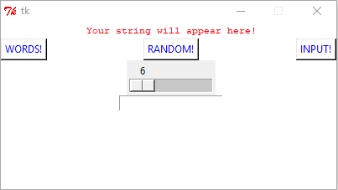

Gantt Chart

We used a lot of our time at the beginning to discuss and figure out how to implement this and then we began by creating our GUI and moving on to the hardware aspect. A lot of the actual implementation of the code can at the very end.

Future Development Plans
For the future, we would for sure add more lava lamps to increase the randomness of values in our seeding. We would also make the GUI on the RPi full screen, touchscreen, and more user-friendly.

Lessons Learned
We all agree, easily, that the GUI was the part where we learned the most. Surprisingly, seeding values for encryption wasn’t that difficult, but the use of the Tkinter library and its window was hard to use and set up.

