**Group Assignment CSC 450 - Computer Networks**

**Distance-vector algorithm**

**Program overview**

This program takes a network topology specified in a csv file and calculates the distance vectors for each node in the specified network. The distance vector estimates are calculated using the Bellman-Ford equation.

**Command Line Input**

python dv_algorithm.py {topology_filepath}

Note: the topology must be a comma separated file with node names on the first row and first column. The cost of links between a row node and a column node are the other cells

Consider the sample format for topology 1:

|  |  |  |  |
| --- | --- | --- | --- |
|  | **X** | **Y** | **Z** |
| **X** | 0 | 2 | 7 |
| **Y** | 2 | 0 | 1 |
| **Z** | 7 | 1 | 0 |

**Outputs**

Below are sample runs of the program for sample topologies:

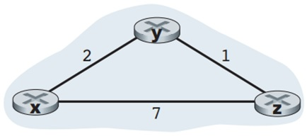 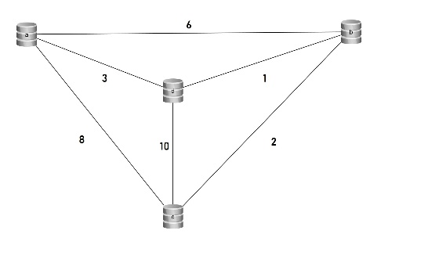

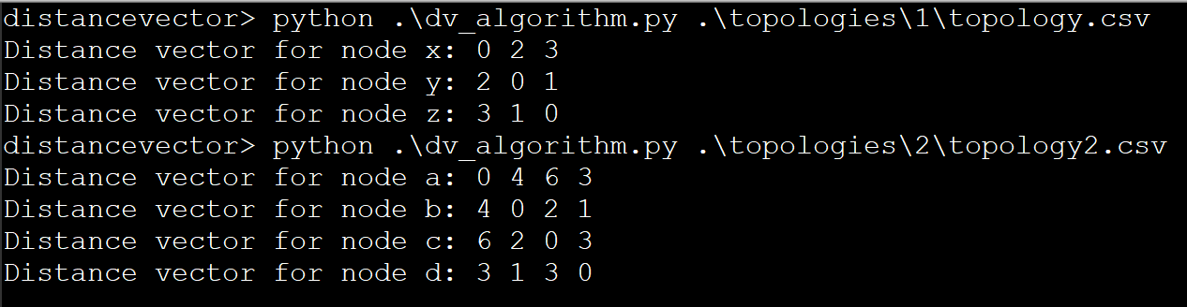

**Python Version**

The program is run using Python 3. Both members used Python 3.6

**Member Responsibilities**

Andre Aguillard formatted the output of the file and created the README. Andrew Schoonmaker implemented the dv algorithm and the load topology functions.

Git commit history can be tracked here: github.com/schoobydrew/distancevector