Security Check – Caught SQL Injection possibility and flagged issue
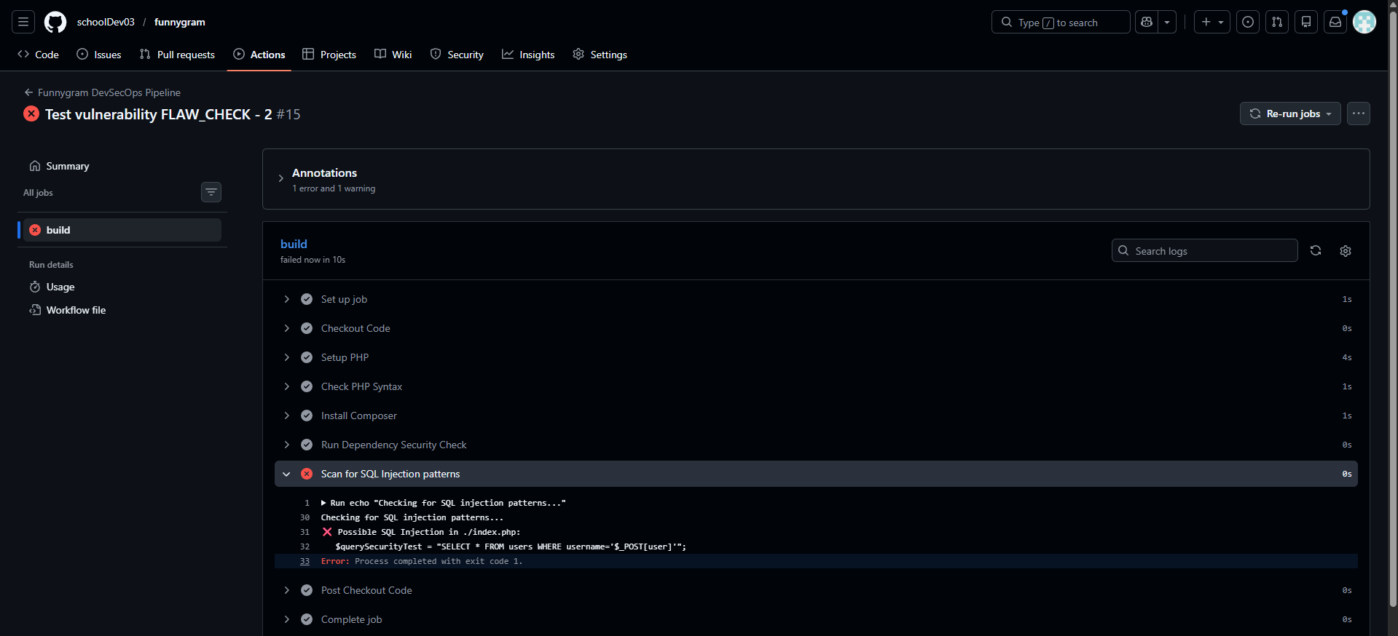

Security Check – SQL Injection had been removed and hence DevOps Security passed successfully
