**College Project**

GitHub URL:

<https://schoolgithubaccounr.github.io/webdesignfundamental/index.html>

Declaration of own work:

I the undersigned declare that the project material, which I now submit, is my own work. This material or project has not previously been submitted for any other assignment. Any assistance received by way of borrowing from previous work, or the work of others has been cited and acknowledged within the work. I make this declaration in the knowledge that a breach of the rules pertaining to project submission may carry serious consequences. We are aware that the project will not be accepted unless this form has been handed in along with the project.

Website Topic: Ancient Greece

Student name: Alexander McCullough Horan

Student number: S00254980

Date: 13/04/2024

**Proposal:**

|  |  |  |  |  |  |
| --- | --- | --- | --- | --- | --- |
| Student Name: | Alexander McCullough Horan | Student Number: | S00254980 | Class Group: | Group C |

## **1. Proposed 4 Page Web Site Topic**

*My goal for the website is to create an informative website that is meant for people interested in history. I will have the topic be about Ancient Greece because I believe it is an interesting topic. My main objective is to create a website that is easy to read and has concise information with links to other more detailed sources for people to explore.*

## **2. Proposed Design**

*I will use the Athen empire flag as it is important to Greek history. The colour scheme will be mainly blue, white and grey. I chose these colours as the blue and white are part of the Greek flag, and the grey will help to balance out the bright colours making the screen easier to look at. I will have a navigation bar at the top of the page for links to different webpages for the website with a link to a reference sheet and more information in the footer of the webpages.*

## **3. Proposed Design of each page content**

*I will have the home page giving a brief but important overview of ancient Greece, where it was what the people did and why it is important to study. The other web pages will be more focused on a specific topic. I will keep the colour scheme, font colour and family the same to add consistency but will edit the layout of the website differently to make each page visually distinctive.*

## **4. Rough Proposed sketch of website home page -**

Below is a rough draft of the home page to give a brief outline of the colour scheme and general layout of the home page

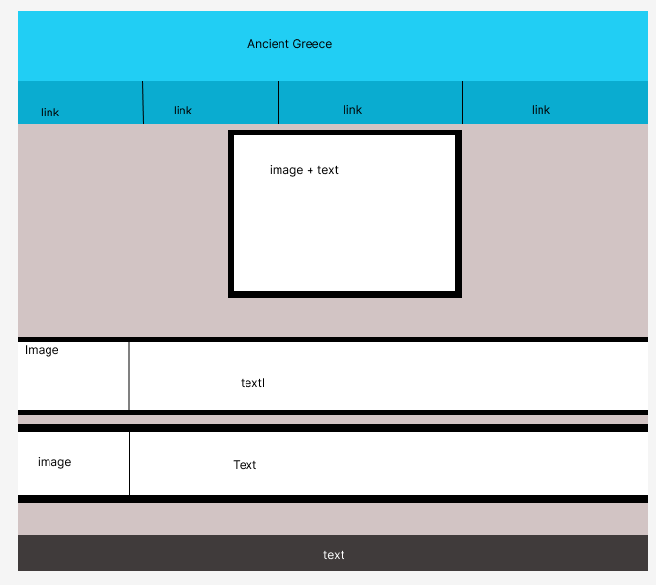

Description of website:

The goal of the website is to provide a brief introduction into ancient Greece. The home page tells the user about Greece its location and the work the people did. The second page is about Greek philosophy and its importance. The third page is about Greek art including statues and pottery. The fourth page is about the city Athens which was the Pride of Greece. There is a last page including references and a place to enter comments and a rating of the page.

References:

<https://www.britishmuseum.org/learn/schools/ages-7-11/ancient-greece>

<https://web.archive.org/web/20060502201333/http://eh.net/encyclopedia/article/engen.greece>

<https://www.worldhistory.org/Greek_Sculpture/>

<https://www.britannica.com/place/ancient-Greece>

<https://iep.utm.edu/ancient-greek-philosophy/>

Checklist

|  |
| --- |
| **R *** GitHub URL Progress upload of web site navigation and 3 pages – Week9** |
| **R Project Report, Upload zipped folders all website files with report, (*place college project on front page, no personal information to be included, public domain images, no images of minors, reference to all content source, individual effort* )** |
| **R Minimum of 4 HTML Page Website** |
| **R HTML5 standards and recommended page layout structure** (header,main,aside,article,section,footer) |
| **R Include Meta data – description, keywords, author - Maximise SEO** |
| **R Include font family for body of page** |
| **R Appropriate use of External Style Sheet – Recommended CSS** |
| **R Appropriate Example using Internal Styling on HTML page** (an example) |
| **R Appropriate Example using use of inline Styling** (an example) |
| **R Home page content aligned to each other and visually attractive** |
| **R Consistency of design on all pages above fold, aligned, use of fonts, colour etc.** |
| **R Appropriate use of Headings (h1, h2, h3, h4)** |
| **R Appropriate use of Colours, easy to read and complimentary colours** |
| **R Include an article or section with css that displays 2 or 3 columns** using CSS Multi-column Properties |
| **R Clear, consistent and align content on page** *(reference all sources)* |
| **R Include public domain images (***with at least on image floated with text or flexbox***)** |
| **R Use of background image** |
| **R Include table of data/information** |
| **R Include and display as lists both ordered and unordered** ( with different shaped bullet points) |
| **R Include favicon and logo on your website** |
| **R Include a contact form Display values entered in form and include red * beside required/mandatory input fields** |
| **☐ Verify data collected on contact form, using get and data attached to URL** (Use the method get to display values entered on form will be appended to URL and passed to server <form <action="http://foo.com" method="get">) |
| **R Include google maps and suitable video** (include reference if YouTube videos are used) |
| **R Footer information include html entity** Copyright© year **and Footer Menu** |
| **R Include Internal Links and External Links – Responsive webpages(70%)** |
| **R Include Appropriate use of both CSS Class and Id selectors** |
| **R Appropriate use content layout using margins, paddings and borders (<br**> only used to split text on separate line eg address or contact form) |
| **R Additional Features : Animation that switches between images** |
| **R W3C HTML (in report)** <https://validator.w3.org/nu/#file> |
| **R Report include Proposal, Declaration of your own work , URL to Github, Rough Sketch of layout design, brief descriptions of the web site its pages and sources for information and Validator results-** |
| **R Website appearance, design and Content** [**https://webdesignledger.com/10-signs-of-a-user-focused-design/**](https://webdesignledger.com/10-signs-of-a-user-focused-design/)[**https://webdesignledger.com/20-dos-and-donts-of-effective-web-design/**](https://webdesignledger.com/20-dos-and-donts-of-effective-web-design/) |

Validator Results:

