Measuring the social inclusion benefits of transit oriented communities

Via mapping data on activity participation in the Toronto region

A core function of urban transportation is to help people take part in everyday life—such as getting to work, school, shopping, or socializing. Yet work in transportation planning, and particularly on assessing impacts of new public transit and transit-oriented development, has mostly focused on metrics like reduction in travel times, congestion, and emissions, as well as financial impacts, among others. While these are important, they often overlook or don't directly answer a key question: do these developments actually help everyone get to where they want to go? If there are limited transportation options, it can cause risks of social exclusion, which can broadly be defined as inability participate in society (link to a couple Steve papers here).
INSERT IMAGE HERE? – SCHEMATIC OF TRANSPORT RELATED SOCIAL EXCLUSION
We wrote a paper a few years ago (https://doi.org/10.1016/j.trd.2019.102212) that explored how increased transit accessibility to destinations improves people’s ability to participate in everyday life in the Greater Toronto and Hamilton Area (GTHA). A core finding of this work is that low-income and car-free households in areas with low transit accessibility were the most affected, lack of quality public transit options were limiting their ability to travel to places and participate in society.
On this page, we update some of this analysis with more recent data and directly look at the social inclusion benefits that specifically living near major rail transit stations can have. This can specifically be measured via activity participation, a metric which refers to how often people can take part in everyday activities, and can be directly quantified from travel survey data by simply counting of how many activities that someone visits per day.

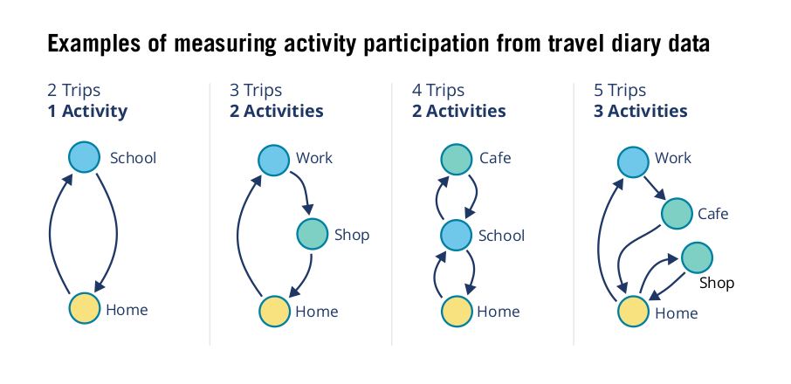

For our analysis, we used the Transportation Tomorrow Survey (TTS) to estimate activity participation for residents Greater Toronto Area. (The survey is a 5% sample of all households). On average, we find that people travel to and partake in 1.15 activities per day.
Of course there will be idiosyncratic variations at an individual level, but by aggregating and looking at averages across different socio-economic groups or between neighbourhoords, it can reveal stark differences. For example, those in households with higher incomes, on average, participate in more activities. This is particularly residents who are low income and also do not have regular access to a car. People who are in households that do not own or lease a car, and are low-income (less than $60k per year), have an average daily activity participation rate 0.89, 22% less than the overall population.
We can also map activity participation by neighbourhood. The map below shows in red areas with very low average activity participation, less than 1 activity per day per person. Certain inner- and outer-suburban areas appear to be the lowest: Scarborough, northern Etobicoke, swaths of Markham, Brampton, and Mississauga. Many of these neighbourhoods are also lower-income and home to recent immigrants.

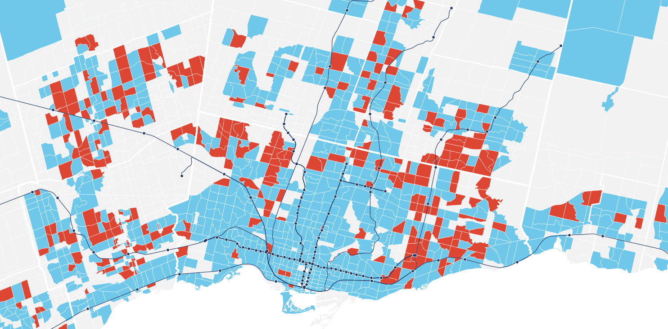
But what role does living near a major transit station play? One notable pattern on the map is that central parts of Toronto have very few low participation neighbourhoods, even though a number of these are also home to many low-income residents who don't own cars. Let's take a deeper look at this, by estimating average participation rates near (within 800m) and not near GO and TTC Subway stations.

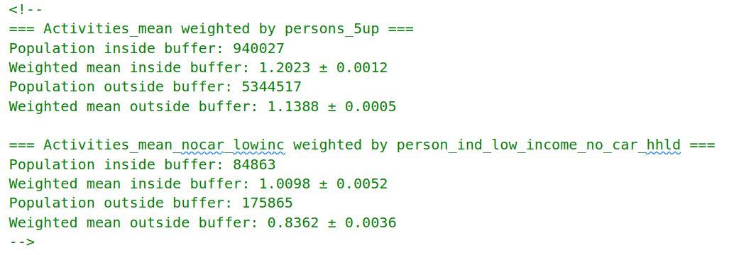
(convert this to chart)

Clearly living near a public transit station has benefits for enabling residents to travel to and participate in daily activities, especially for low-income residents who do not have a car. But what about the characteristics of those stations? Some stations have better connections to other parts of the city. Some stations have better mixed-use development that enables local trips (e.g. shopping) without having to rely on a car.

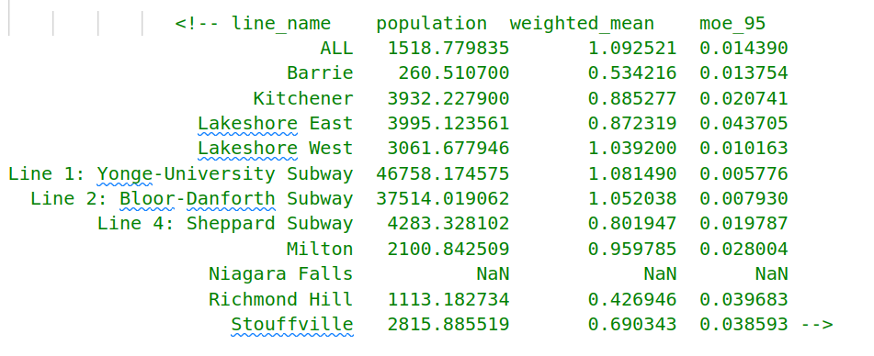
(convert this to chart)
(NOTE: have data for every station as well, but MOE are pretty high for some)

Stations on the TTC Subway lines have higher participation rates than GO Rail stations. This is likely because TTC Subway routes provide connections to many neighbourhoods are much less commuter-focused than GO Rail. As well, many TTC Subway stations are located in walkable neighbourhoods with greater sets of amenities. Conversely, most GO Rail stations were built on historic rail corridors, which have a backdrop of more industrial land-uses, and many are currently surrounded by surface parking lots promoting park-and-ride trips, rather than mixed-use neighbourhoods that would encourage trips by active travel modes.

Visuals to add? Couple photos or land use maps of the top and bottom performing stations?

Wrap up text,
Next steps for analysis?
- correlate station level activity participation with amenity density and/or access to destinations
- multivariate analysis (ind. models) to parse out specific impacts of transit oriented development and communities that enable activity participation.
- analysis in other cities where data is available
- analyze participation in different types of activities

