Design Introduction
There’re 3 projects in this solution: ConferenceTrackManagement,
ConferenceTrackManagementCore and ConferenceTrackManagementTests.
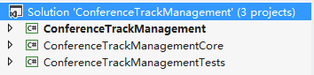

Here’s class diagram of ConferenceTrackManagementCore:
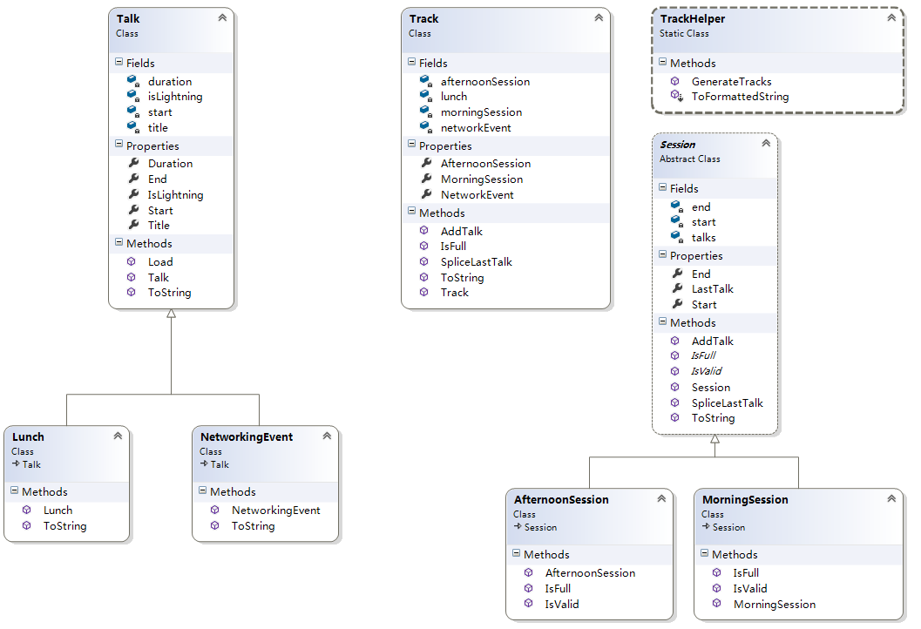

Development Environment
IDE: Visual Studio 2012
OS: Window 8.1

How to Run
This is a console application, after compilation, you will get the following files:

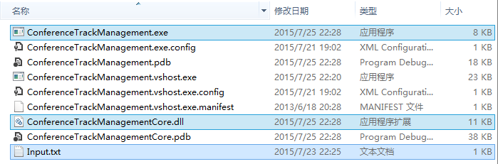

You can run ConferenceTrackManagement.exe directly, Input.txt will be the input by default, you will get this:
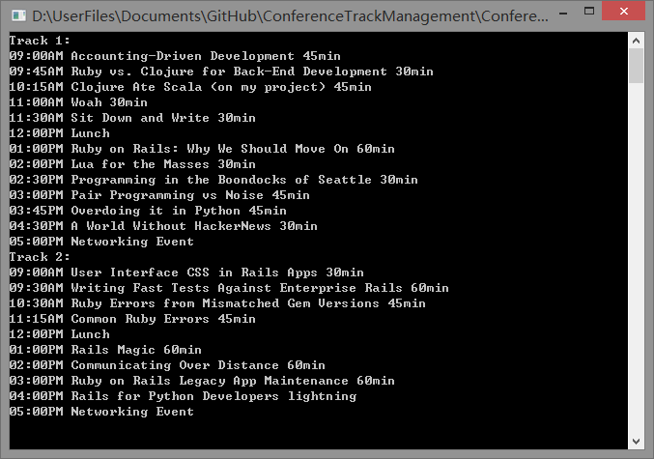

Also you can use your own input file, here’s the usage: ConferenceTrackManagement [FilePath], like the following:

