CIRES

Milestone 3 System Design and Prototype
Team member | Contribution
NKURUNZIZA James | Joint design and prototype preparation
UWASE Phoebe | Joint design and prototype preparation
UNILAK Rwamagana Campus
Software Engineering and User Centred Design
11 November 2026
We designed a demonstration prototype through which a citizen reports an issue, the Cell Executive follows it up, and the Sector Executive handles an overdue escalation. This report brings together our architecture decisions, database model, sequence diagram, wireframes and prototype review.
Our demonstration uses three roles and one escalation level. We selected MySQL in AMPPS for data storage and PHP on Apache for the proposed implementation.

1 Design scope and workflow
A citizen submits a category, cell, location and description. CIRES returns a reference number and a Received status. The Cell Executive reviews reports for the relevant cell, starts work and records a completion note when the issue is resolved. The citizen uses the tracking screen to read progress and the final reply.
An open issue that passes its follow-up deadline becomes eligible for escalation. In our proposed implementation, refreshing a staff queue checks the deadline and records one escalation to the responsible Sector Executive. Escalation changes responsibility while keeping the issue’s work status and earlier history.
Role | Main responsibility
Citizen | Submit a report and follow its progress.
Cell Executive | Review cell reports and record progress or resolution.
Sector Executive | Review overdue escalations and record the action taken.

Design deliverables
The editable Draw.io sources and ADR slide supplied with this report are our updated versions. The diagram previews in this report were generated from those sources. The six SVG wireframes provide editable layouts for Figma, and the shared Figma link provides the connected demonstration.
The prototype uses prepared screen states. Database writes, authentication and deadline checks are implementation decisions represented by the diagrams. The connected screens demonstrate the intended journeys.

2 System architecture
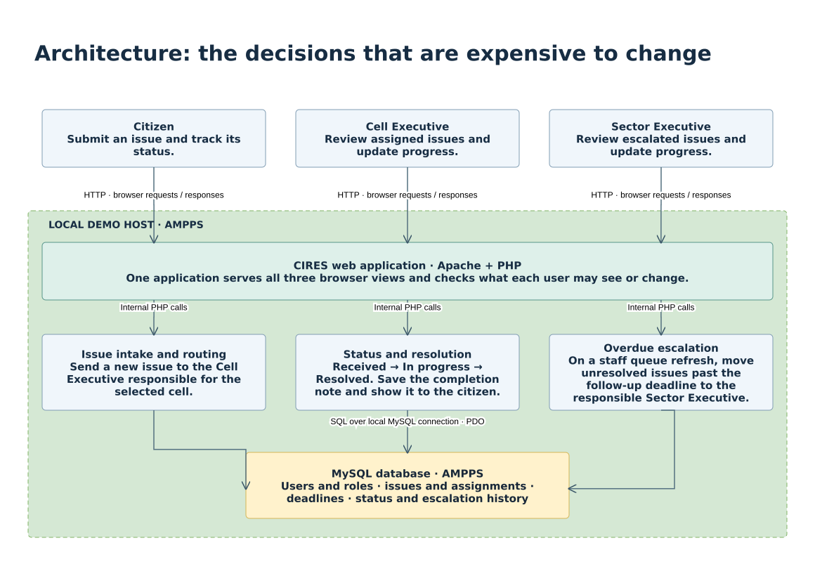
Figure 1 CIRES architecture overview
We chose one web application to serve all three roles. A browser sends requests to Apache, and PHP handles routing, permissions and the issue workflow. The application reads and writes MySQL records through PDO. AMPPS supplies the local demonstration environment.
The issue workflow has three main responsibilities. Intake routes a report to the relevant cell. Status handling records progress and the resolution note. Escalation identifies overdue open reports when a staff member refreshes the queue. Updates and handoffs should be saved consistently so repeated requests preserve one escalation per issue.

3 Architecture decision records

ADR 01 Platform
Citizens and leaders need different views of the same report. We selected one responsive browser application. A native mobile application would require installation. The web application is accessible from a browser when the demonstration host is reachable.

ADR 02 Technology stack
We selected PHP on Apache in AMPPS to keep the local setup manageable. A separate frontend and REST API would introduce additional setup. One application will perform workflow and access checks.

ADR 03 Database
We selected MySQL in AMPPS because reports, users, areas and history have related records. SQLite was an alternative local database. MySQL must run during the demonstration, and related writes can be grouped in transactions.

ADR 04 Authentication
We selected local accounts with hashed passwords and PHP sessions. Each server request will check the user’s role and permitted area. External sign-in would require provider setup. Account and session management will belong to CIRES.

ADR 05 External services
We selected in-application updates and a deadline check on staff queue refresh. SMS and email would require external providers, while a scheduled check would require a background task. Citizens will read updates in CIRES, and overdue escalation will occur when staff refresh the queue.
The accompanying CIRES M3 ADR PowerPoint contains the context, decision, alternatives and consequences in the updated slide format.

4 Database model in third normal form
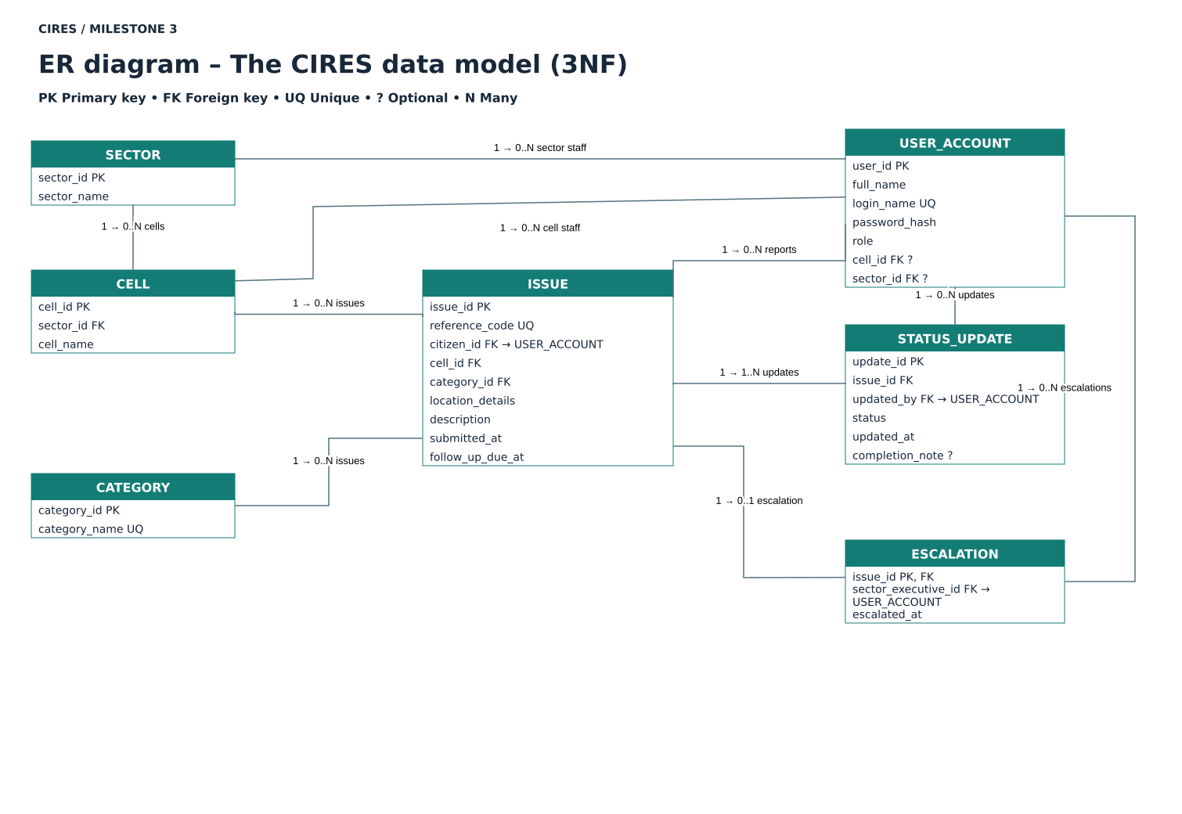
Figure 2 CIRES entity relationship diagram
We separated sectors, cells, categories, accounts, issues, status updates and escalations. Each table has a primary key, and foreign keys identify related records. Category and area names are held in their own tables. An issue’s sector is obtained through its cell, which avoids repeating the sector on every issue.
Each issue has one or more status updates. The latest update determines the current work status, and a Resolved update includes the completion note. The escalation record uses the issue identifier as its primary key, which allows one handoff per issue. Staff permissions must also validate the role and assigned area.

5 Sequence of reporting and escalation
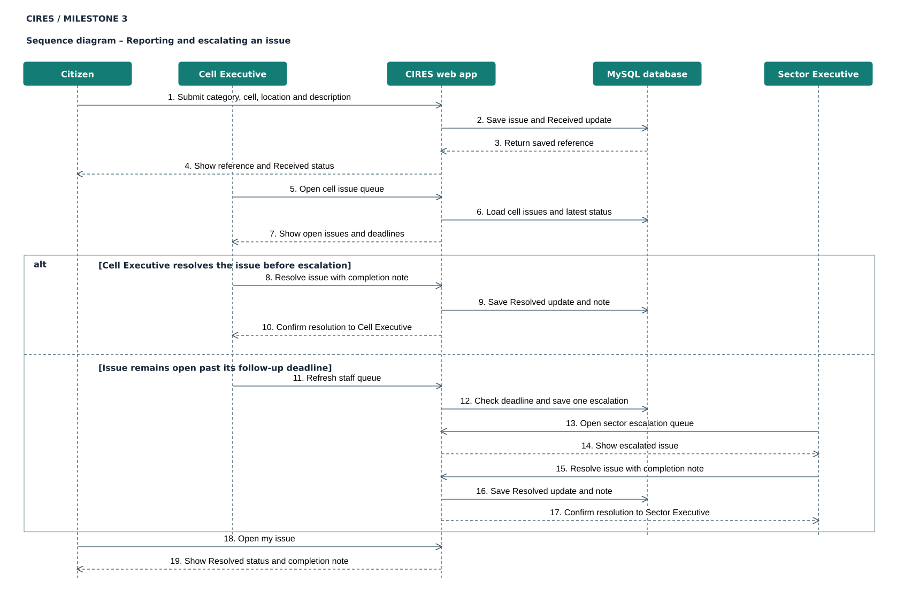
Figure 3 CIRES sequence diagram
The sequence starts when the citizen submits a report and receives its reference. The Cell Executive loads the cell queue. The alternative paths show resolution at cell level or escalation after the follow-up deadline. In the second path, the Sector Executive opens the escalated issue and records its resolution. The citizen then reads the final reply.
The sequence describes proposed application and database behaviour. The Figma prototype illustrates the user-facing steps with prepared content.

6 Citizen submission wireframes
We kept submission fields in a single column and used a clear Submit report button. The confirmation screen repeats the reference and status, giving the citizen a visible receipt and a route to tracking.
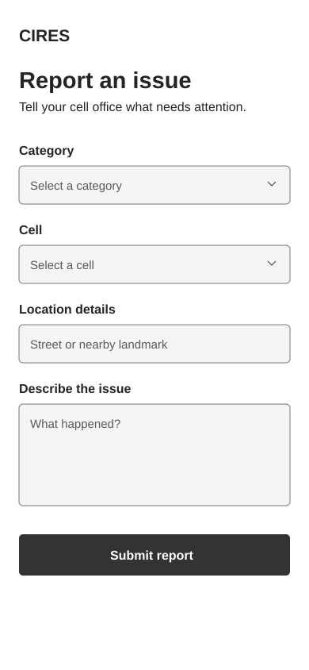  01 Report an issue | 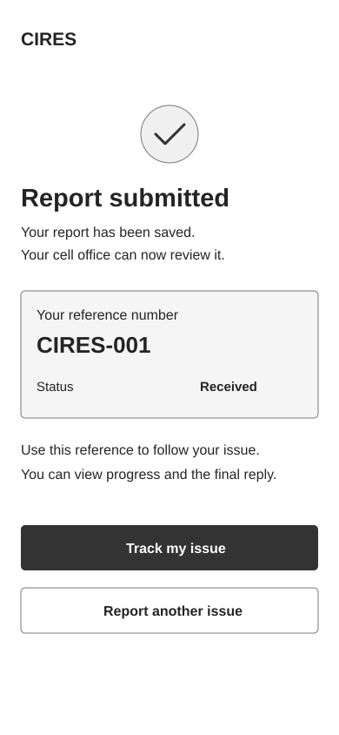  02 Report submitted

7 Tracking and cell follow up wireframes
The tracking screen displays the reference, responsible office and progress history. The Cell Executive screen shows a prepared In progress state and a completion note. Resolving the prepared issue opens the final reply screen.
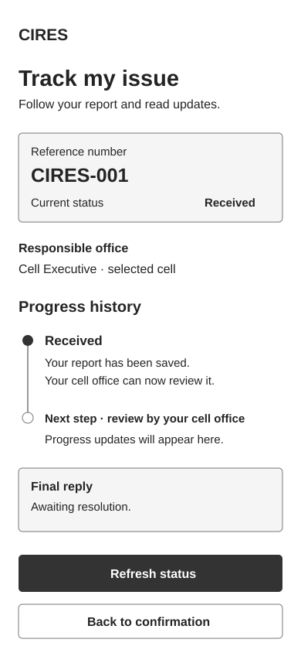  03 Track my issue | 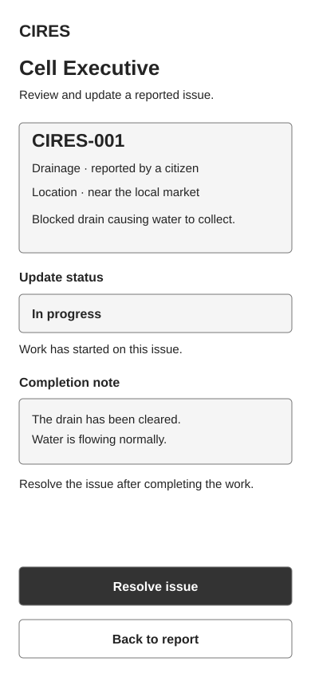  04 Cell Executive

8 Sector follow up and resolution wireframes
The sector screen identifies an overdue issue and records the action taken. The final reply screen displays Resolved status and the completion note. Cell and sector resolution journeys both lead to this prepared citizen view.
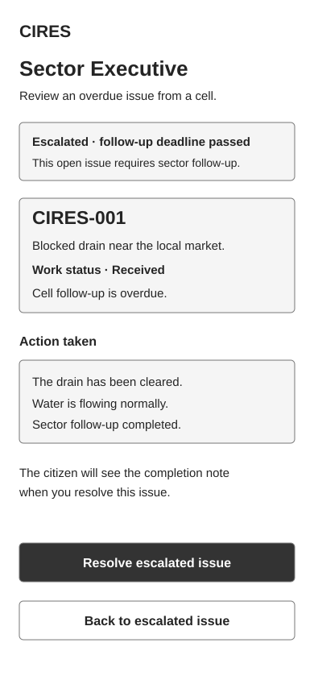  05 Sector Executive | 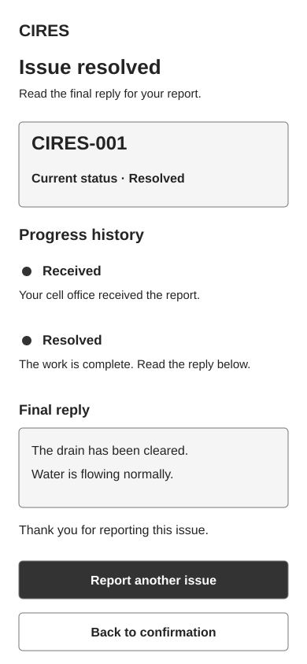  06 Issue resolved

9 Clickable prototype
We imported the editable SVG screens into Figma and connected the main buttons using On click and Navigate to interactions. The citizen journey begins at screen 01. Staff scenarios begin separately at screens 04 and 05, because the prototype demonstrates the three roles through prepared scenarios.
Open the CIRES clickable prototype
Journey | Screen connections
Citizen reporting | 01 Submit report → 02 Track my issue → 03
Cell resolution | 04 Resolve issue → 06
Sector resolution | 05 Resolve escalated issue → 06
Return to confirmation | 03 Back to confirmation → 02
Start another report | 06 Report another issue → 01
Return after resolution | 06 Back to confirmation → 02
We enabled Anyone can view on the design file and opened the prototype link in another Chrome profile. The prototype loaded and navigation worked during that check. The prototype is hosted in Figma, so access uses the shared online link.
The screens use grayscale styling, visible field labels and written status names. These choices help readers identify actions and understand the report’s state. A full accessibility review and external usability sessions remain to be completed.

10 Team review and design improvements
We reviewed the connected screens by following the reporting and resolution journeys. During this work, we identified that the Back to confirmation button on the tracking screen needed a destination. We connected it to screen 02 and successfully tested the return action.
Review item | Before | Change and check
Return from tracking | Back to confirmation had no destination. | Connected screen 03 to screen 02 and confirmed that it opened.
Shared access | The initial sharing view restricted access to the team. | Enabled Anyone can view on the design file and checked navigation in another Chrome profile.
The navigation correction supports user control and freedom because citizens can return to the confirmation screen. The shared-access check confirms that another browser profile could open the demonstration. These are team walkthrough observations, and we have not collected external participant performance or satisfaction results.
The separate External User Testing Form includes task instructions, observation fields and a before-and-after record. It will allow us to document actual sessions and design changes after testing.

Current limitations
The six screens show selected workflow states using prepared issue details. The form fields, progress selection and deadlines do not update a database. Some secondary buttons may still require additional destinations. We will use external sessions to check task understanding, recovery and navigation before drawing conclusions about usability.

