D. Gass
47 School St.
Glace Bay, Nova Scotia
B1A 1J3

The Office of the Police Complaints Commissioner
1690 Hollis Street, 3rd Floor
PO Box 1573
Halifax, Nova Scotia B3J 2Y3
Canada

Attachments

Please find attached a copy of Form 5, CBRPS police report #2018027463 pertaining to the collision, and a copy of a former complaint I had made against the same officer, Sgt. Paul MacDonald, a year prior on July 18th, 2017 (and was subsequently pressured to withdraw.)

Also, please find enclosed a USB memory key containing an audio recording of of a phone conversation I had with Sgt. Paul MacDonald on June 9th, 2018.

This audio file is also available at the following URL in case of difficuly with the memory keys:

https://gass.ca/media

Collision
On Thursday, July 7th, 2018, just before noon, I was cycling West on Reserve Street in Glace Bay. The weather was clear (25 km visibility reported by Environment Canada) and calm.
Cycling is (well, was) my main form of transportation, and I am an extremely cautious and defensive cyclist.
As I passed a side street, Gannon St., I noticed a gold/brown S.U.V. coming down Gannon street towards Reserve, and it appeared not to be slowing down at all for the stop sign on Gannon. I remember my last thought before she struck me as being “damn, she isn't going to stop!” as I hit the brakes and attempted to avoid her. She struck me primarily on my right side, and I tumbled to the pavement, sustaining a fair number of very painful injuries.
Someone got me to stand up and move to the sidewalk from the asphalt roadway. I laid there on my back, with my eyes closed, in incredible pain like I have never known before. Someone took my pulse, I believe it was the motorist who struck me, Cheryl MacDonald.
I distinctly remember two different people saying they had witnessed everything, and that she did not stop at all at the stop sign, consistent with my experience. I was glad to hear that there were witnesses with consistent views to what I experienced, so I assumed there would be no problems regarding the situation and police report, as I could focus upon nothing but the intense pain in my neck, right shoulder, right arm, right knee, right foot—especially the neck and shoulder.
I was told an ambulance was on the way and would be there shortly, and that my bicycle and groceries would be taken to the nearby police station where I could retrieve them later and follow up with the police.
The ambulance took me to Glace Bay hospital, where I was given a shot of morphine for the pain, examined and sent for a large number of x-rays of the head, neck, and shoulder. The x-rays showed no obvious fractures nor bleeding in the brain.
I was told they were transferring me to Sydney Regional hospital for CT scans, but due to the large amount of ionizing radiation from those scans, and the fact I hadn't lost consciousness, they allowed me to decline the scans. I was given a taxi voucher and sent home with 10 Tylenol 3 for the pain.
Later that day I called police dispatch, and Sgt. Paul MacDonald arranged to return my bicycle and groceries. When he did so, I asked about filing a statement and getting a copy of the police report, but he replied “he had all he needed.” This surprised me somewhat, as I hadn't given a statement and was the victim and closest witness to the collision. I figured he meant there was no immediate need for a statement, and I could deal with it after tending to my intense injuries, to which he seemed sympathetic, and indicated that I would even feel “much worse” the following day.
He was correct, and even later that day (Thursday, June 7th), the pain was unbearable, and there were a lot of popping and grinding sounds in my neck and chest, so by early evening I returned to Glace Bay Hospital emergency department, to find it had an unannounced temporary closure. I continued on to Sydney Regional Emergency department in the early evening.
After waiting two hours without one of the dozens of people ahead of me being called in, I couldn't bear the pain of sitting in the waiting room any longer, and figured it would be faster to try Glace Bay Emergency again the following morning, Friday, June 8th, which I did as early as possible (I was the first emergency patient taken in upon their re-opening.)
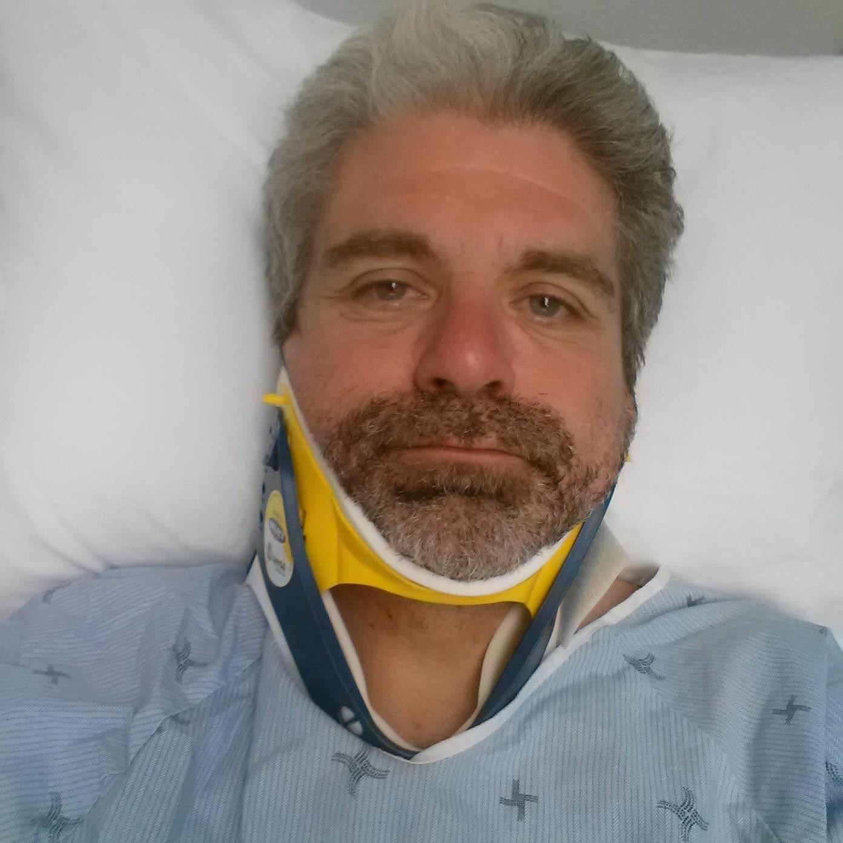
Given the level of intense pain and associated headaches, they again recommended, and I agreed, to be transferred to Sydney Regional Hospital for CT scans of the head and shoulder. (It turns out they did a full body CT scan, more radiation that I would have liked, but given the level of pain I was experiencing, it seemed appropriate.)
With the potential seriousness of the neck injury, and the grinding sounds when I moved my head, they kept me in a neck brace for the transfer, scans, and return to Glace Bay, which took most of the Friday.
The CT scan did not indicate any broken bones, fractures, nor bleeding in the head, so around supper time I was given a meal and again discharged, with Tylenol 3 to manage the pain until I could see my Family Dr. on the following Monday, June 11th to follow up on the pain, injuries, and treatment.
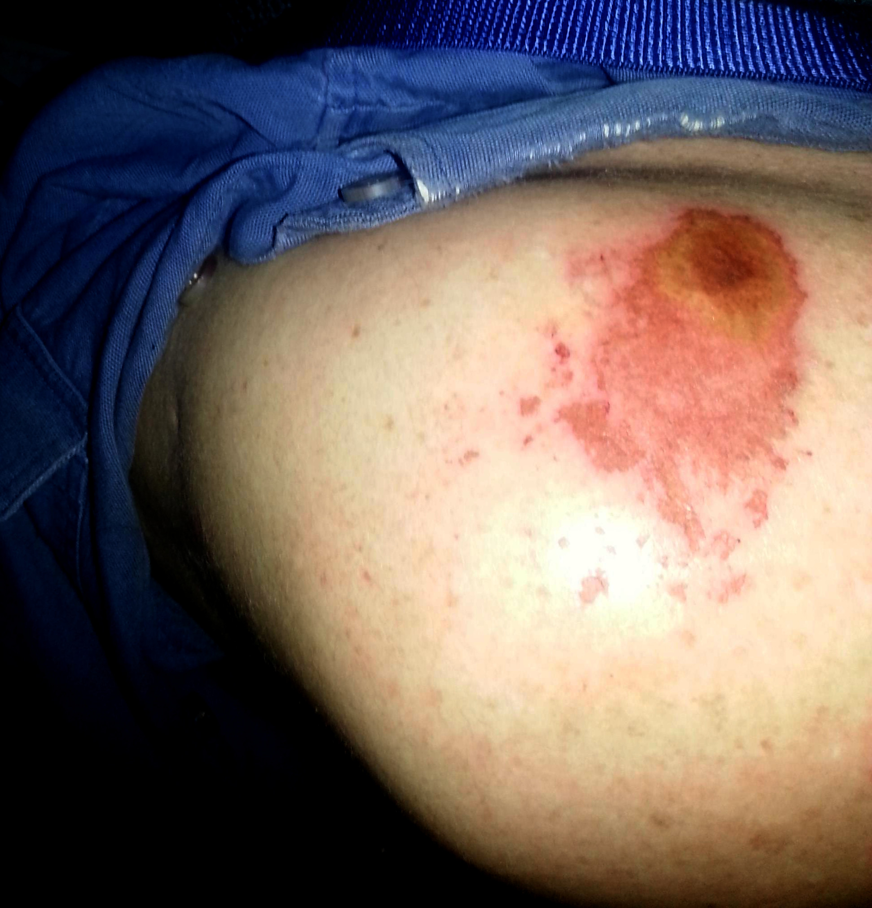
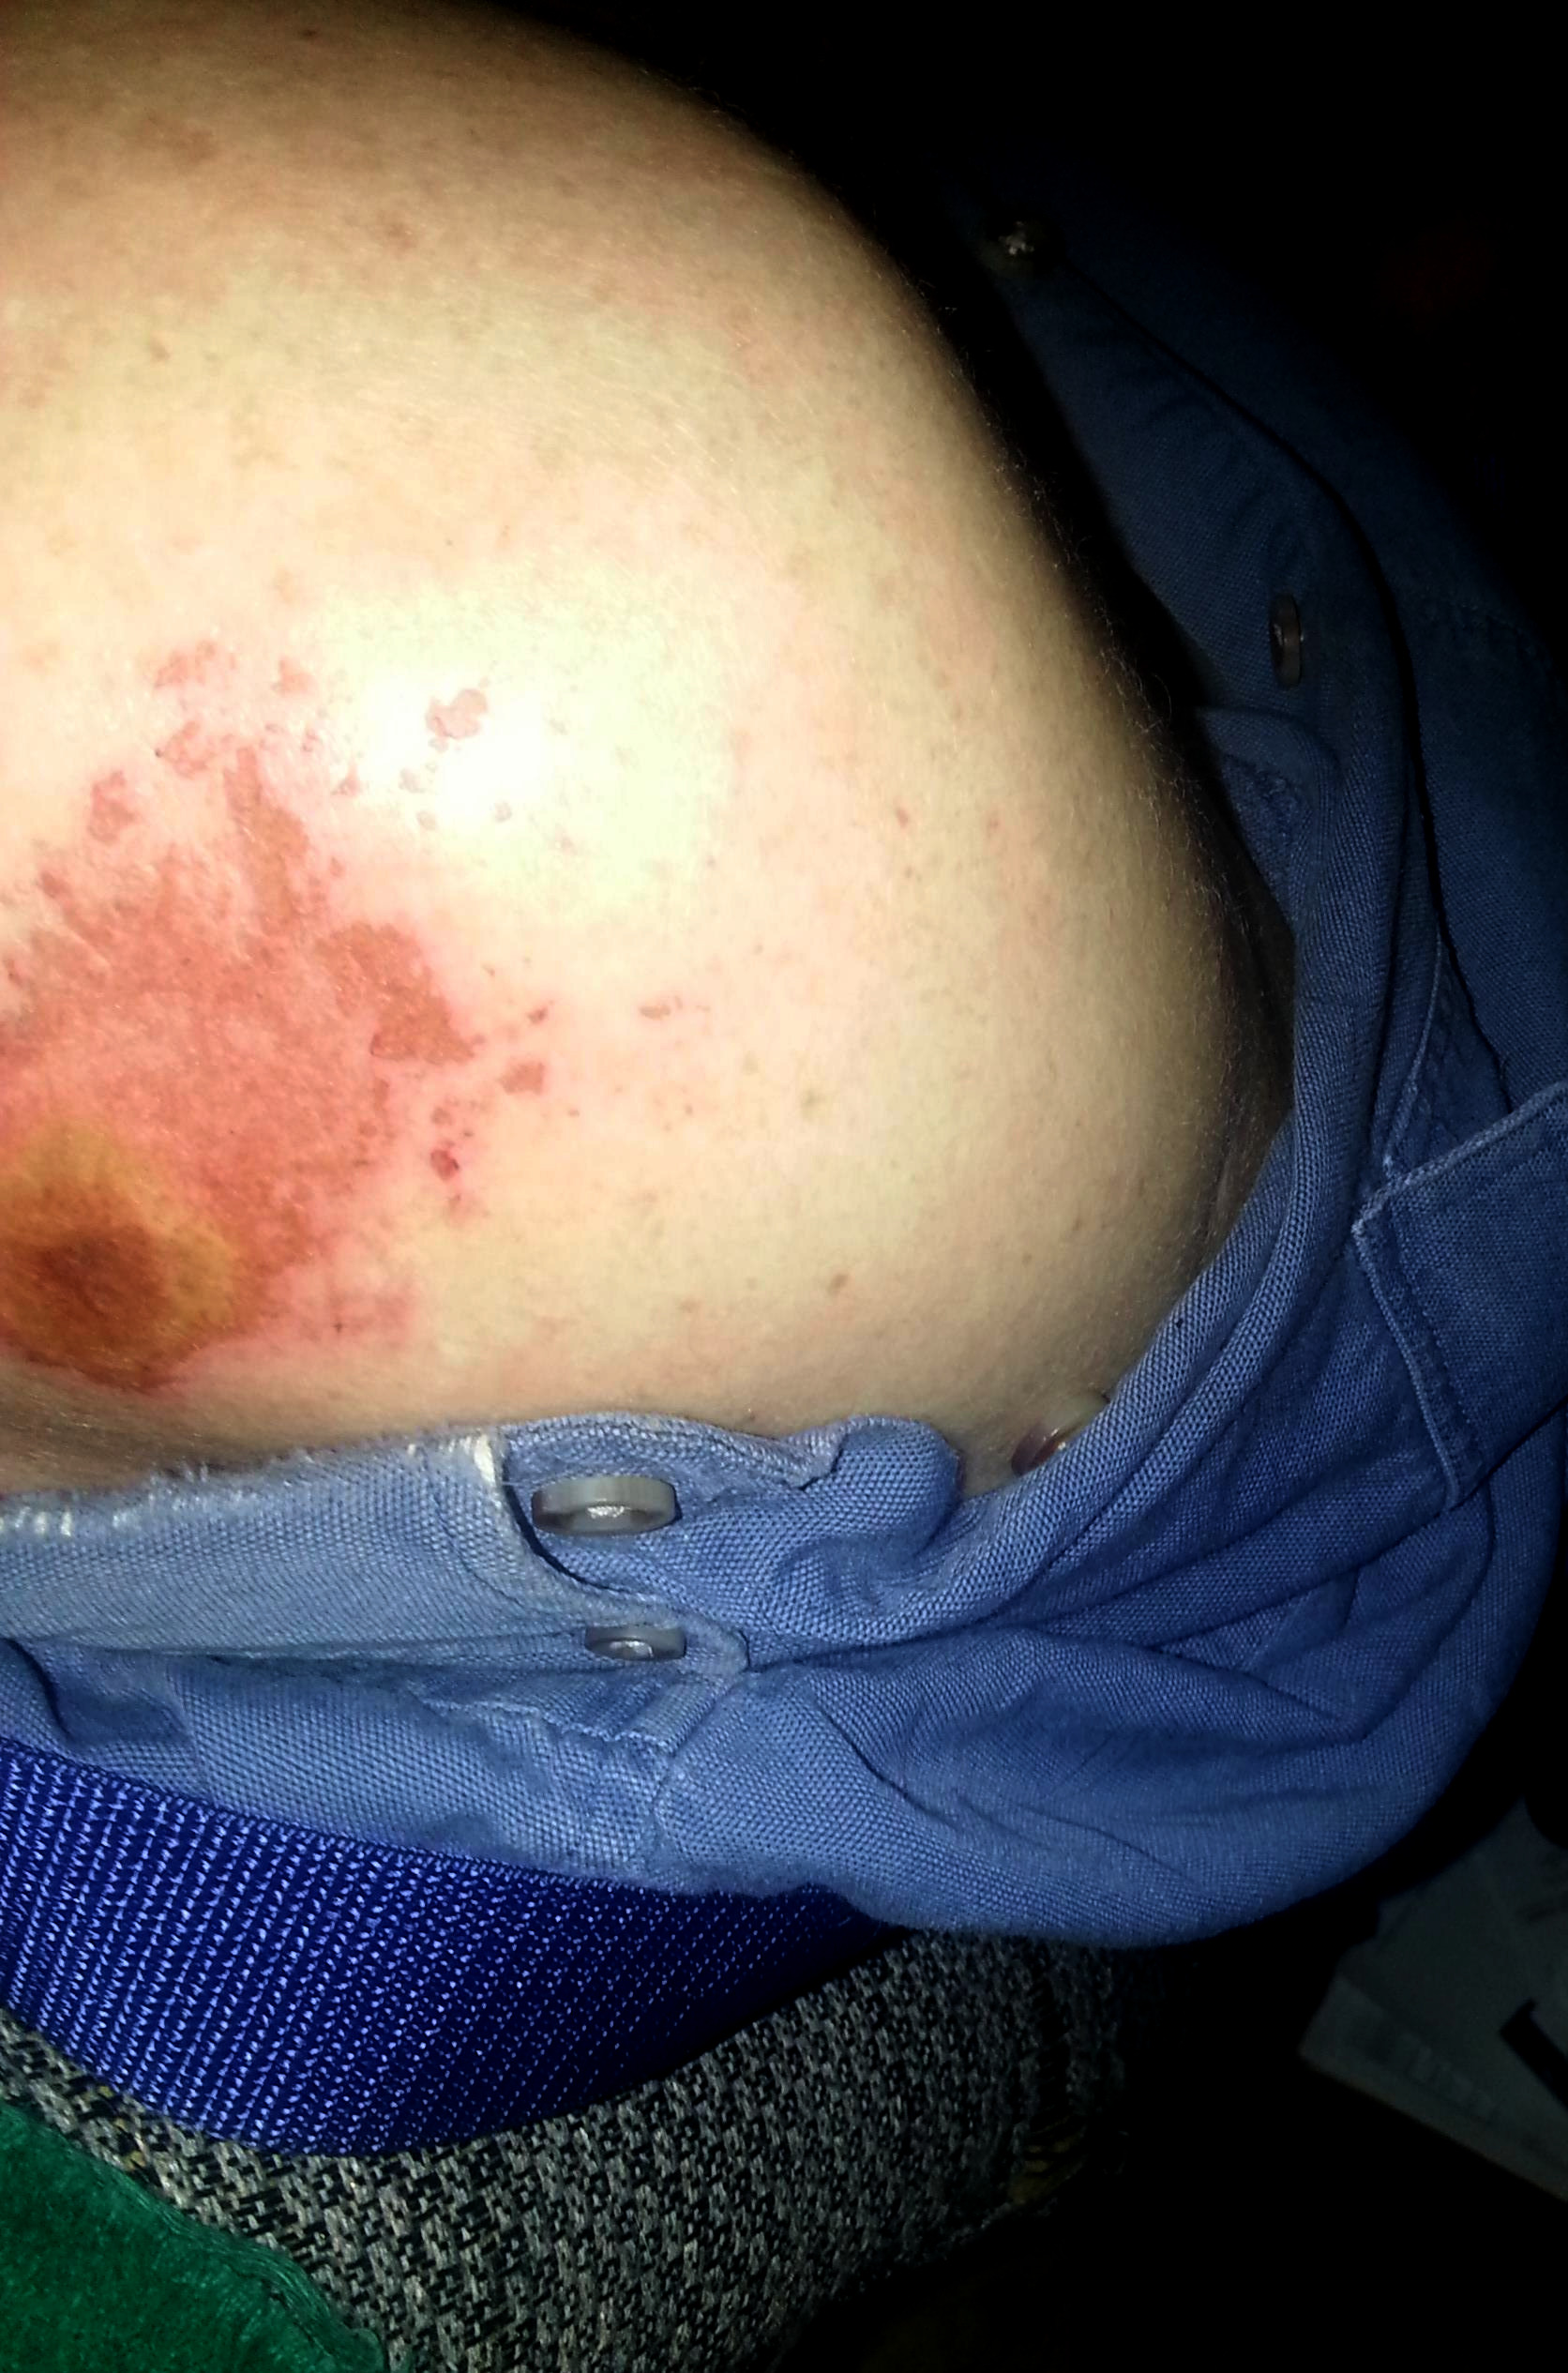
The clicking, grinding, and popping sounds continued in my neck and chest whenever I moved my head or arms, as well as the intense shoulder and neck pain, and regular headaches at the base of the skull. I also had several other symptoms such as problems typing correctly, tinnitus, and muscle spasms in the legs and face. The abrasion on the shoulder was particularly inflamed and painful. Combined with the neck and shoulder pain, sleep was impossible.

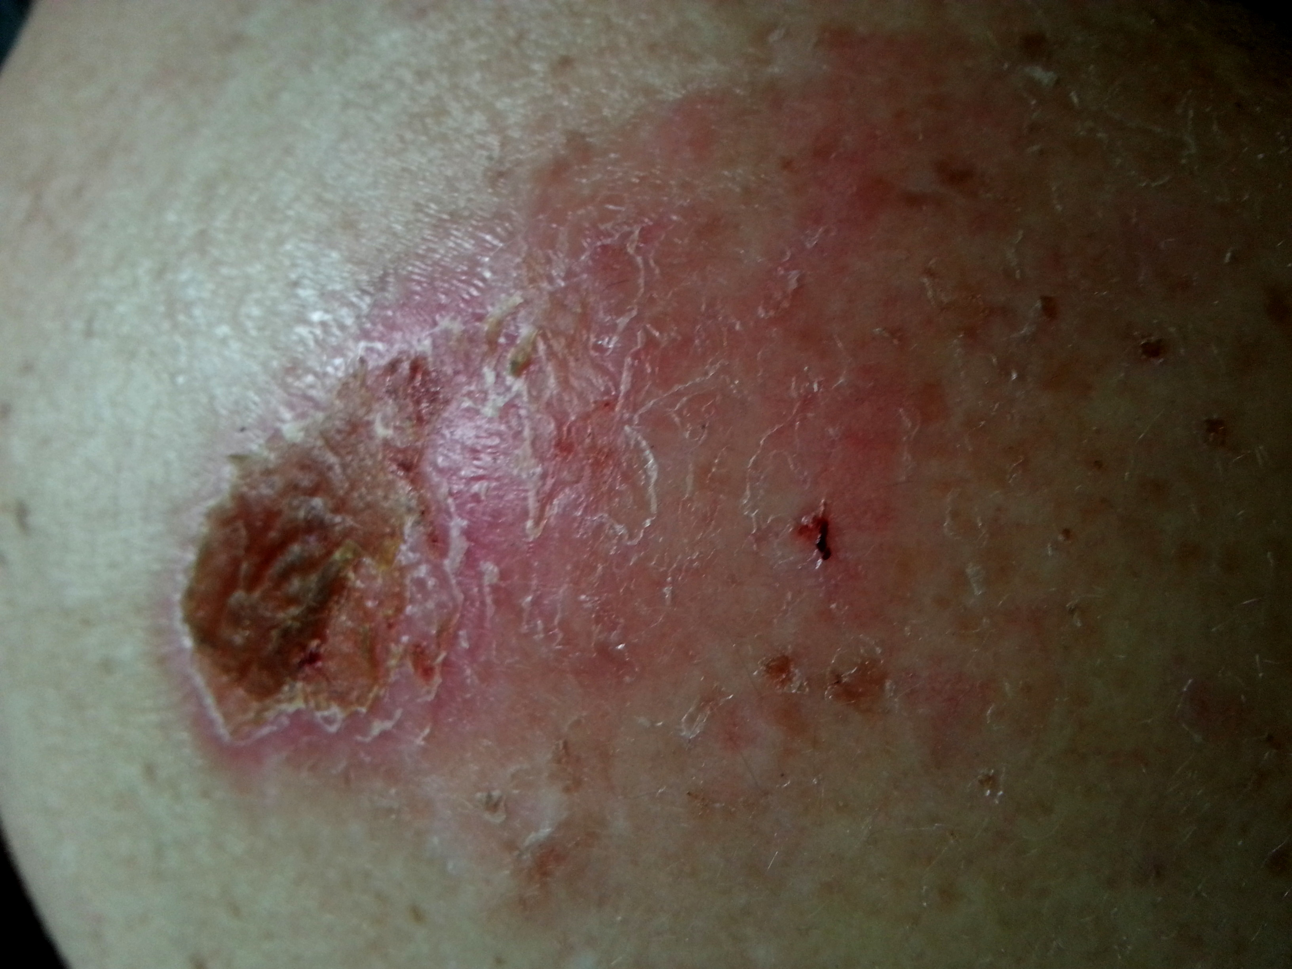
(Even weeks later, the abrasion on the shoulder was still incredibly tender, combined with the shoulder and neck pain continued to make sleep impossible.)

After spending most of Friday, June 8th, in the Glace Bay and Sydney hospitals in the neck brace and getting CT scans, and waiting to see my family Doctor on Monday, June 11th, I was finally able to contact Sgt. Paul MacDonald regarding the police report on the morning of Saturday, June 9th.
The call (on the attached USB memory key, or available at https://gass.ca/media ) did not go well.
He again indicated (despite obviously not having any idea of the accident circumstances) that “had everything here that I need,” that he wouldn't be taking a statement from me, that a witness said the driver did stop at the stop sign (contrary to what I clearly experienced, and what I heard witnesses at the scene say) and that the driver of the SUV would not be charged.
(Note: It’s possible that the Glace Bay fire department security cameras captured this incident.)

I became rather upset at these supposed the mistakes and omissions from the police report, and was very concerned about negative insurance impacts they might have should any of my injuries tend to be longer term ones.
I expressed this to Sgt. MacDonald, and the call deteriorated from there, to the point where I realized talking to him further would be of no use. I indicated before hanging up that I would be filing a complaint about the way he handled the situation.
In the call, when I asked who his superior was, he made it clear that answered to nobody. This also seems to be a highly unusual and inappropriate response for an officer to have. Is there no supervision and accountability in the CBRPS hierarchy? Should an officer flat out deny a request to speak to his supervisor? If he doesn’t answer to the Police force, and doesn’t answer to the public, I’d like to know to whom he does answer, if anyone. (He clearly has no interest in serving nor protecting the likes of me.)
I have been struggling with, and managing depression for years, but the combination of the pain I was in, and Sgt. MacDonald's unhelpful, incomplete, inaccurate work on the report, and his antagonistic attitude towards me upset me greatly, sending me into a major depressive episode which continues to date.
It was initially very difficult for me to judge how inaccurate or incomplete the police report was, since I was not given a copy. I had to file and pay for a FOIPOP request to even obtain a copy.
(Saturday morning I was also called by the Glace Bay Hospital for an appointment with an Orthopedic Surgeon, Dr. Collicut, for the morning of Thursday, June 14th.)
The first time I went into CBRPS headquarters in Sydney to request a copy of the colloision report, I was told (despite being on income assistance) that there was a fee that had to be paid by debit card. As I did not have my debit card with me, I had to return home without filing the application.
The following day I returned with my debit card, and was prepared to fill out the FOIPOP request for the police report. I was told by the lady behind the counter that I could not do so, as they only give out the reports to insurance companies as giving it to me would “violate the privacy of the other party.” I was stunned.
I explained that as a cyclist I had no car insurance, and I had been unable to get home insurance on my company home. After going away for a few minutes, she returned and grudgingly let me fill out the FOIPOP request. Despite filling out the fee waiver request on the form, indicating I was on income assistance, I was charged the fee regardless. Modest, but when you're living on income assistance, every dollar matters.
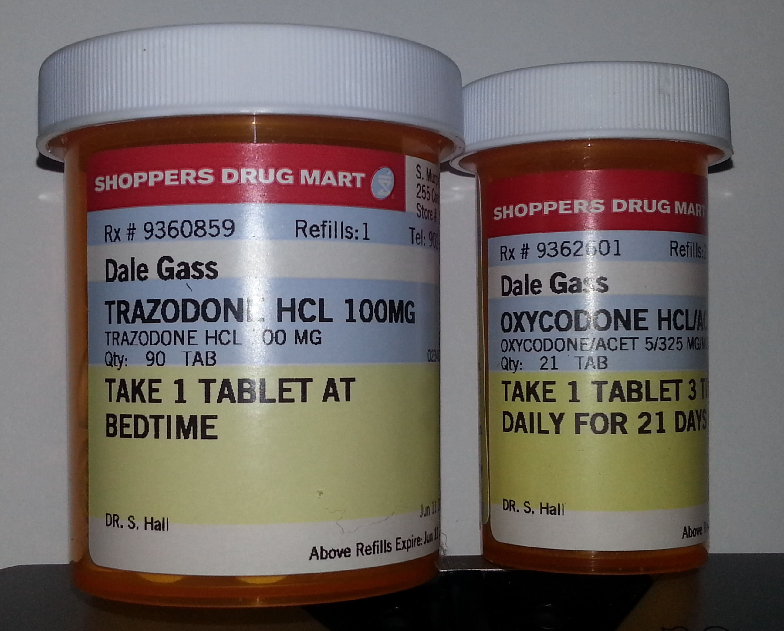
On Monday, June 11th, I saw my family Dr., who prescribed Endocet (Oxydone + Acetaminophen) for the intense pain, and Trazadone to assist with the depressive episode and anxiety attacks. Endocet is not prescribed lightly, a further indicator of the level of pain I was continuing to suffer. Even with the Endocet, for the first few months sleeping is still near impossible, except for brief periods while sitting up.
I attended the meeting with the Orthopedic Surgery, Dr. Collicut, on Thursday June 14th. He indicated that the CT scans showed no breaks, fractures, nor bleeding, and that a rotator cuff tear was unlikely, but schedule an MRI to be certain. He indicated this would take up to six months, and that if the pain continued in 6-8 weeks to make an appointment for cortisone injections in the shoulder.
I returned again to Glace Bay Emergency yet again, unable to deal with the ongoing pain. I was referred to physiotherapy and back to my Family Doctor. (Unfortunately my Family Dr. was on vacation, I had to go a week without pain medication, in severe agony nearly the entire time.)
I have attended physiotherapy twice a week since the collision, and continue to do so. The physiotherapist indicated that I had a Grade II sprain of the A.C. and S.C. joints of the right collarbone, first rib, a concussion, and whiplash. The clicking of the sprained joints is obvious and can be heard from a distance.
While the constant chronic pain has subsided, the chest and shoulder are still very sore with use, sleeping is difficult, and the headaches, mental fog, and tinnitus remain to this day. I have seen a neurologist, who has prescribed medication to assist with the sleeping and tinnitus, and has scheduled a follow-up MRI.
On June 26th, 2018, I received a copy of the FOIPOP request for the police report of the collision of which I was a victim. (See attached.) I was once again shocked and upset to the point of shaking and tears by the conduct of Sgt. MacDonald in writing this report.
There were only a few sparse lines regarding the collision itself, referring to only one unnamed “attached” witness who said the SUV stopped, contrary to what I experienced, and contrary to what I heard other witnesses at the scene describe. There was no attached statement nor any indication he actually took any witness names nor spoke to any of the witnesses.
(Note that my name is “Gass”, not “Glass” as Sgt. MacDonald occasionally refers to me, amongst other mistakes and inaccuracies [to put it mildly] in the report.)
Note that in the call that when I mentioned that I remember there being witnesses, he (after a noteworthy pause) responded “yes, there are.” Note the plural,“there are,” seemingly confirming my understanding that there was more than witness to the collision. Also, he later states “there were two witnesses.”
However, in the report, he only mentions one, does not name the individual, does not include the supposed “attached” witness statement, and mentioned details that were blatantly incorrect. This seems highly shoddy, inconsistent, and worrisome.
(And multiple times in the call, despite supposedly having talked to two witnesses, he seems to have no idea about the details of the accident; e.g. indicating I hit the passenger door—which was clearly not the case, and would have been impossible given her turning right into traffic and hitting me.)
I have doubts that he followed up on this collision at all. And I have concerns that it may stem from a complaint I filed about him a year prior, and a resulting complete lack of willingness to provide the level of care and attention to his duty that any citizen should be due. Or perhaps he is inappropriately attempting to protect the driver who struck me from charges, at my potential risk and expense.
He indicated the results of the collision as “minor injuries” and “some soreness,” and then spent four paragraphs which basically implied I was faking my injuries in an attempt at insurance fraud, and that I had “threatened him” during the call.
I was astounded and unbelievably upset. This obviously greatly worsened the depressive episode I was, and am, suffering.
I mentioned filing the complaint at the end of the call before hanging up, never trying to use it as leverage to get him to do anything. I was rightfully upset at the handling of my case, asked for his supervisors name, was not given that, and terminated the call indicating I would be filing a complaint without waiting for nor expecting any response nor action from him. That is *not* a threat.
I don't consider my behaviour threatening, just exasperated. I have never threatened an individual in my life, nor thrown a punch, nor taken part in any violent behaviour, which makes the report all the more unfair and upsetting.
A complaint against a police officer should never be considered threatening in the first place, it should be a right of the citizens to ensure officers are performing their jobs.
If the officer (and the Police Commission) are doing their jobs, then an officer has nothing to fear from a complaint.
I don't feel that Sgt. MacDonald has come anywhere close to an acceptable standard of doing his job, but to indicate in a police report that I “threatened” a law enforcement officer is incorrect and highly offensive to me, and I have serious concerns about that being present on the police record. (As well as the implication that I was faking injuries for insurance fraud purposes.)
It is certainly conceivable that officers might approach me differently should I require their assistance in the future, if previous police reports indicate that I have “threatened” an officer. I absolutely want this removed from the report, as well as the implications of insurance fraud or “minor” injuries and soreness. Sgt. MacDonald, to my knowledge, is not a physician.
Additionally, I think it is reasonable that any existing witness statement be provided as part of the FOIPOP request, as well as an explanation of why “witnesses” suddenly became one unnamed “witness.” As well as accepting a statement from me, the victim and closest witness to the collision.
It seems like this would be the bare minimum that any citizen should expect when the victim of a motor vehicle/bicycle collision involving injuries to the cyclist resulting in severe pain for months, prescription of strong painkillers, multiple hospital, Doctor, and physiotherapist visits, severe depression, and inability to sleep properly for months.
Hardly the “minor soreness” Sgt. MacDonald's report indicates.
I am an honest, quiet, cooperative, law-abiding citizen with no criminal record, who feels that he has been treated like a criminal because he was struck by a SUV while cycling and simply wanted an accurate and detailed police report on the incident. The treatment I have received is almost beyond comprehension, and as mentioned has made my depression massively worse, which continues unimproved to this date.
Thankfully my lawyer informs me that the police report is not relevant to the civil suit that is proceeding against her insurance company (or others), so I am able to obtain physiotherapy and other treatment.
However, that is no excuse for lack of effort nor blatant inaccuracies in a motor vehicle report involving injuries.
Similar to my complaint against Sgt. MacDonald in 2017, I have grave concerns about how a more serious matter might be handled in the future where the incorrect details and substandard performance of the officer *will* matter—in a matter of life and death, which the incident of June 7th, 2018 could easily have been with a foot or two difference in the collision.
I don't feel safe in my own town due to the behaviour of this officer, and once I heal I will be relocating to another town as soon as possible where I have greater trust in the police force to protect the rights and safety of individuals, rather than treat them with scorn, contempt, vindictiveness, and perform shoddy and incomplete police work related to incidents involving them.
I has hoping to have moved out of Glace Bay before filing this complaint, as I believe Sgt. MacDonald has shown vindictive behaviour already, and I fear further repercussions. Unfortunately, I have not had sufficient time to manage this relocation yet, and have serious concerns for my safety—I only leave the house when absolutely necessary, and do not feel comfortable doing so in the slightest.
I would also like to request confirmation that the Police Commission actually received my complaint last year (I submitted it to the Glace Bay station, and not directly to the Commission--I want to be sure it actually made it there.)
In this previous incident, Sgt. MacDonald appeared so quickly (and unwarranted to start with) that I had concerns he was responding to a friend’s call, rather than through proper police dispatch channels.
I was given a brief and vague verbal assurance by another officer that it went through dispatch, shown no actual documentation of the fact, and felt pressured into signing a retraction of the complaint.
I did not feel comfortable doing so, and have regretted withdrawing it since. Especially now, in hindsight of Sgt. MacDonald’s subsequent treatment of me in a somewhat more serious circumstance.
I would similarly like it verified that Sgt. MacDonald responded to my June 7th, 2018 cycling collision due to a call through dispatch, and not a personal call from Ms. MacDonald or others.
Frankly, I don’t have much hope for the integrity of the CBRPS and their ability and willingness to protect of all citizens equally, and am relieved to be moving away at the first possible opportunity.

Sincerely,

Dale Gass
December 3rd, 2018

