AEGIS
Stress-test fraud models against attacks they haven't learned yet.
Mastercard Innovation Challenge 2026
AI Defense Lab for Payment Security
AEGIS is a closed-loop AI red team for payment fraud. GenAI reasons about emerging attacks and about a detector's blind spots; deterministic simulators generate every transaction row; a frozen XGBoost defender scores them; and fraud that escapes becomes adversarial evidence for the next round. AEGIS then asks the question a static test split cannot answer — does hardening against the attacks a model has seen actually transfer to an attack family it has never seen?
Verified evidence | Value
Attack vectors identified | 14 (3 deeply simulated, 11 research-identified only)
Synthetic transactions generated | 55,000 across 3,000 scenarios, seed-reproducible
Families with live GenAI evidence | 3 / 3
Defender v3 PR-AUC | 0.904 (untouched PaySim test split)
Defender v3 recall @ 0.1% FPR | 85.2%
Defender v3 false positive rate | 0.0216% (alert rate 0.35%)
Generalization to an unseen family | 58.3% mean LOAFO recall — PARTIAL GENERALIZATION

58.3% is not a fraud-detection rate. It is the mean recall of three separate fold models, each trained with one attack family contributing zero rows, each scored on one fresh scenario of that held-out family (3–12 fraud events each — directional, not statistically powered). Two of three families transferred; mule-network structuring did not.

Live demo https://mastercard-aegis.vercel.app
Repository https://github.com/tensorforgee/mastercard-aegis
API https://mastercard-aegis.onrender.com
Every figure in this document is read from a persisted artifact tracked in the repository, so each one is checkable from a clean clone with no dataset download and no pipeline run.

How AEGIS works
One closed loop. A language model reasons at exactly two points and never writes a transaction row; deterministic, seeded code produces every number.

- 1 GenAI Attack Analyst — turns researched fraud taxonomy into a structured attack hypothesis.
- 2 Structured Blueprint — bounded, contract-validated simulator parameters.
- 3 Deterministic Simulator — writes every transaction row. Seeded, reproducible.
- 4 XGBoost Defender — scores each transaction, decision-time-safe features only.
- 5 Caught / Escaped — escaped fraud is the blind-spot signal the next round reads.
- 6 GenAI Blind-Spot Analyst — reads the real misses and the risk scores assigned.
- 7 Bounded Mutation Proposal — bounds-checked by deterministic code; out-of-range proposals are rejected, never clamped.
- 8 Deterministic Next Generation — the simulator, not the model, generates the next seeded scenario.

LOAFO sits outside this loop. Leave One Attack Family Out is a generalization test, not a generation stage: hold one attack family out of hardening entirely, then score a fresh scenario of that family. It creates no attacks and proposes no mutations.
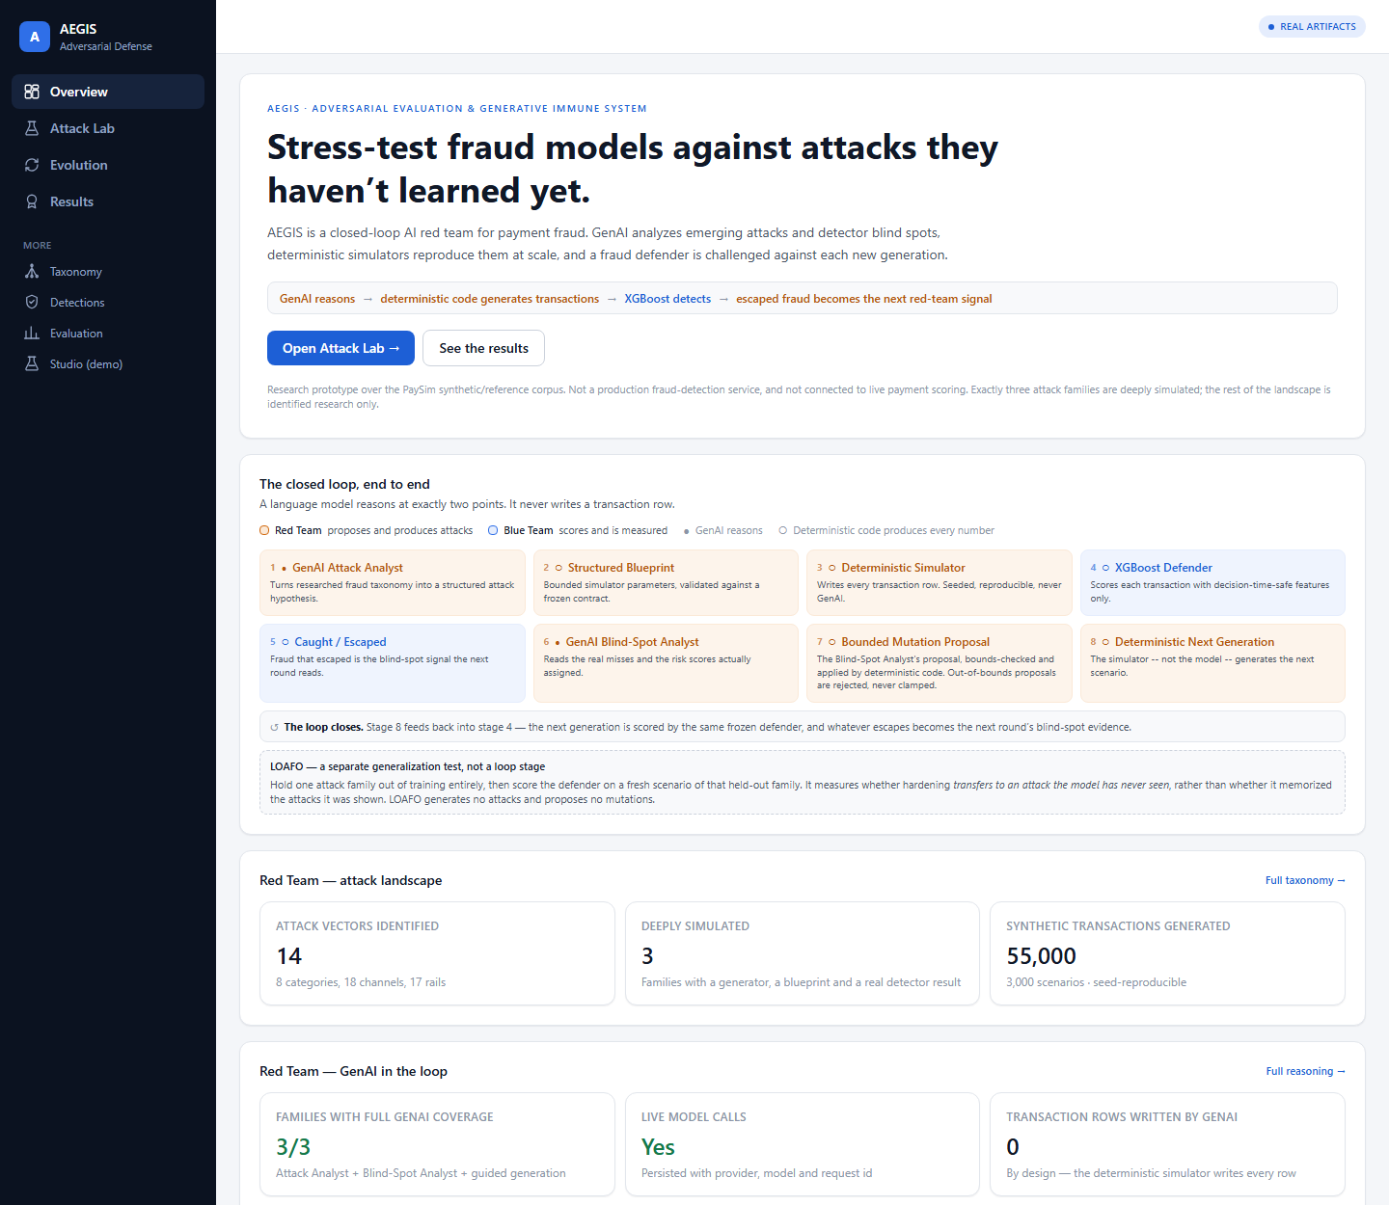
Overview — the judge-facing landing screen. Red Team stages are amber, Blue Team stages blue; a filled dot marks the two stages where a language model reasons.

Red Team — the Attack Lab
- Breadth is researched; depth is measured. 14 attack vectors are catalogued across 8 categories with cited sources. Exactly 3 are deeply simulated — only those have a generator, a blueprint and a real detector result.
- GenAI reasons; it writes 0 transaction rows. Every row in every corpus is written by a deterministic, seeded simulator, so any result can be regenerated and re-checked.
- Live GenAI provenance is persisted. Each reasoning artifact carries provider, model, prompt version, latency and a real request id. With no API key the layer fails loudly rather than inventing reasoning text.
- Bounded mutation is enforced, not described. GenAI supplies a direction and magnitude; deterministic validation recomputes the value and refuses anything outside the blueprint's declared bounds. Refusals are persisted and shown.
- Scenario identity is always explicit. Guided-generation, replay and LOAFO evidence may use different persisted scenarios — or, for some families, the same one. AEGIS labels each scenario id rather than assuming either relationship.
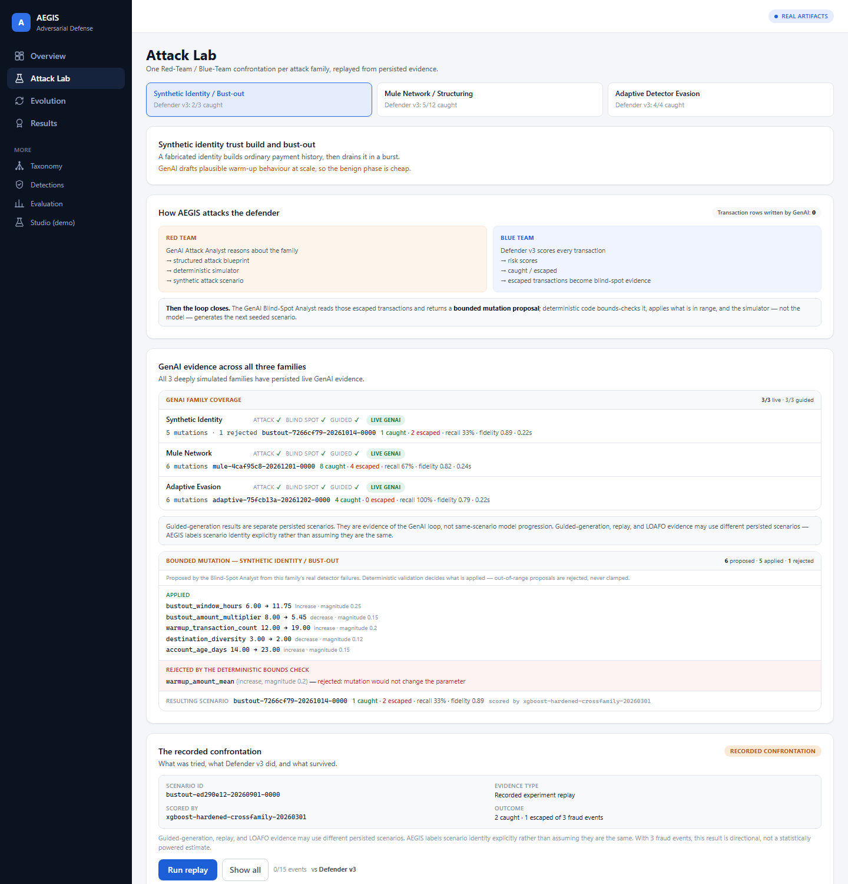
Attack Lab — synthetic identity bust-out. The Blind-Spot Analyst proposed 6 mutations: 5 applied, 1 rejected by the deterministic bounds check with its reason printed verbatim. Note the two distinct scenario ids: the guided generation and the recorded confrontation are different runs.

The closed loop in practice
- Recorded escapes reveal detector blind spots. Every escape shown is a fraudulent transaction that a real detector let through in a run that already happened.
- Only evidence explicitly promoted as hard positives informed later hardening. Promotion is recorded in the artifact; it is never inferred from whether a transaction escaped.
- LOAFO evaluation evidence does not imply retraining. Held-out fold results measure generalization. They never feed a training set, and the interface says so on every such row.
- Historical snapshots are not automatically same-scenario comparisons. One confrontation was recorded per defender generation against the same blueprint, each with its own persisted scenario. Those document the system's evolution — they are deliberately not drawn as a causal v1 → v2 → v3 chart.
The loop is also reported honestly where it cost something: hardening Defender v2 against specific hard positives reduced native-split F1 by 1.36 points versus baseline v1. That line is on the screen, not buried in an appendix.
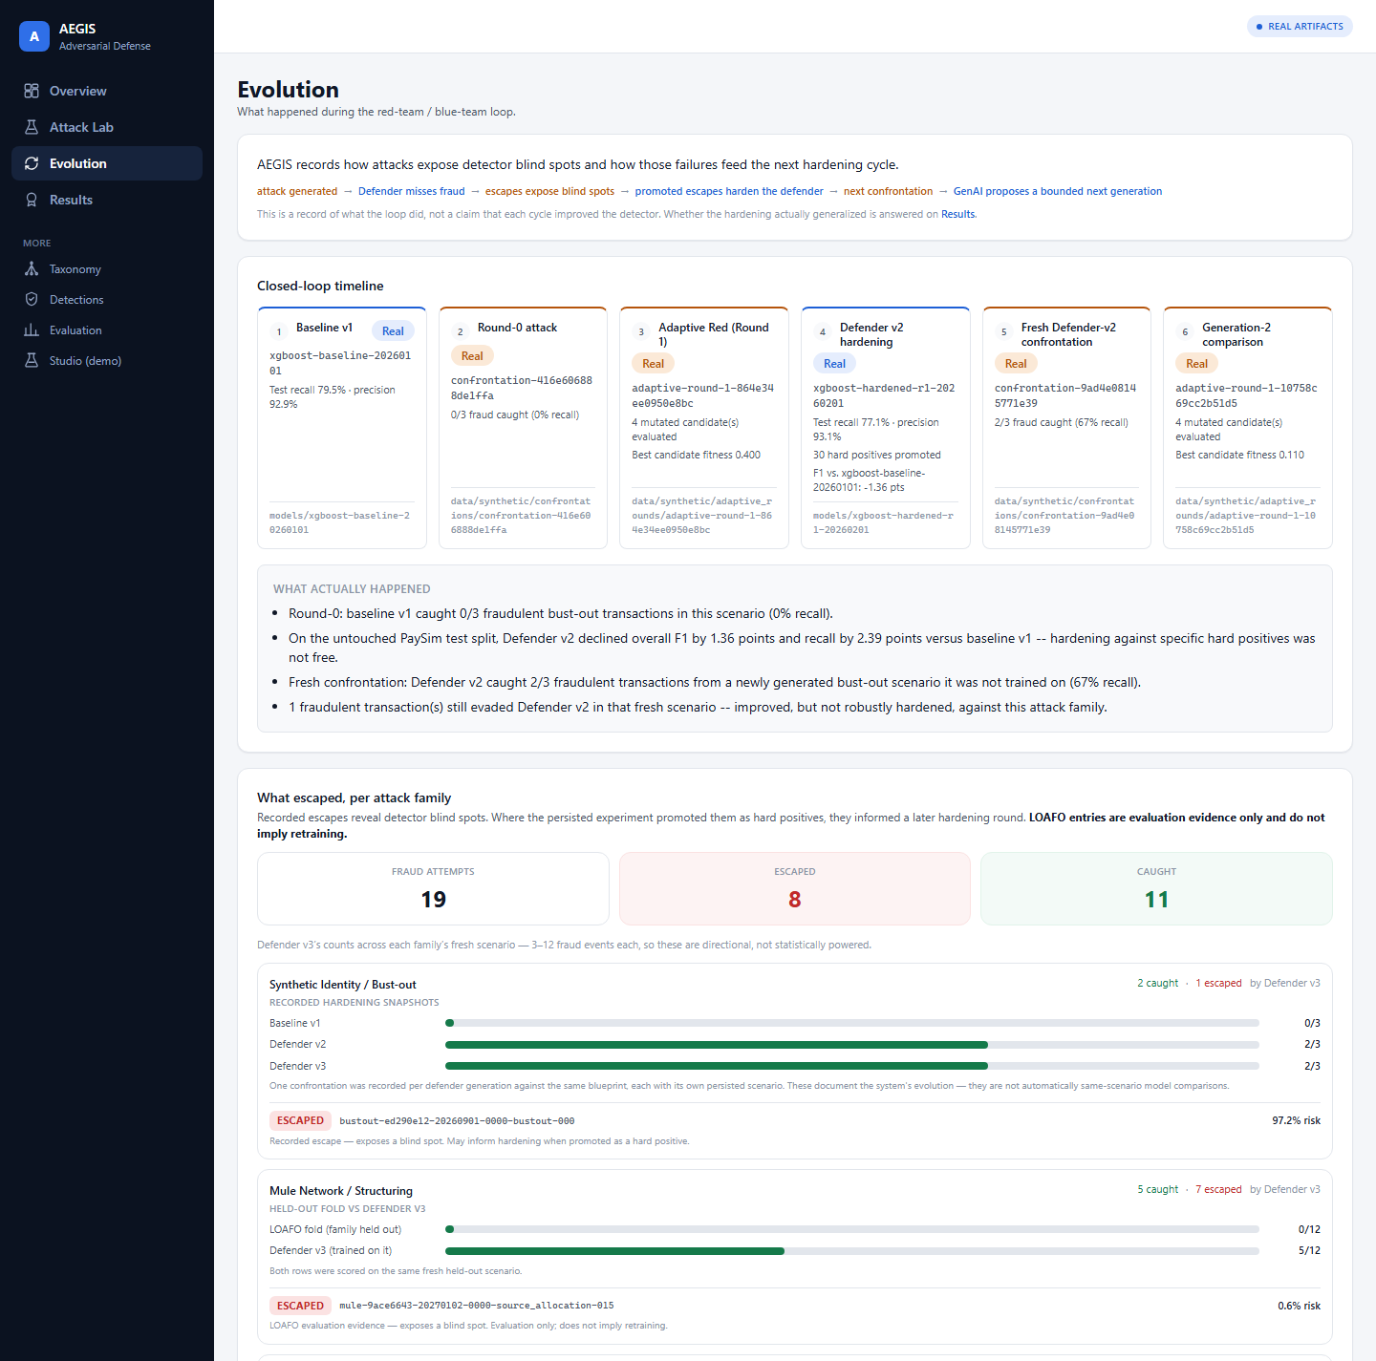
Evolution — the recorded closed-loop timeline, then what escaped per attack family. Note the two different evidence roles: "Recorded hardening snapshots" for bust-out, "Held-out fold vs Defender v3" for mule network.

Results — partial generalization
PARTIAL GENERALIZATION
2 of 3 families transferred. Mule-network structuring did not. Mean LOAFO recall across the three folds is 58.3%.

LOAFO in plain language: hold one attack family out of hardening, then evaluate on a fresh scenario from that unseen family. In each fold the held-out family contributes zero training rows, and the fold model and Defender v3 are scored on the same fresh scenario — so that comparison is like-for-like.
- Transfer occurred for 2 of 3 families in the recorded benchmark (bust-out 100%, adaptive evasion 75%).
- Mule-network structuring remained the weakest unseen family — 0 of 12 caught by the fold trained without it, against 42% for Defender v3, which was trained on it.
- Results are directional. Each fresh scenario holds 3–12 fraud events, so a single additional catch or miss moves a family's recall materially.
- 58.3% is not Defender v3's production recall and not a fraud-detection rate of any kind.

The native-test trade-off
On the identical untouched PaySim test split, baseline v1 still leads PR-AUC, recall and F1; Defender v3 leads precision, false positive rate and recall at a 0.1% FPR budget. Hardening changed the operating trade-off; it did not uniformly improve every native-test metric.
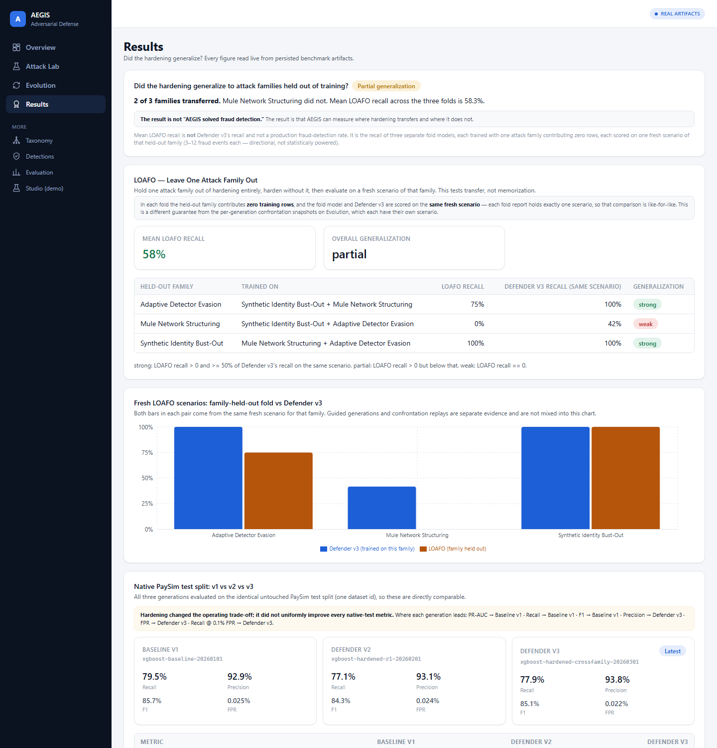
Results — the LOAFO verdict and table, and the fresh-scenario family chart. Mule network shows a Defender v3 bar and no held-out bar at all: that is the 0% result, left visible.

Real-world fit and limitations
AEGIS is offline adversarial validation and hardening infrastructure for fraud-model teams.
Historical transaction logs and fraud labels → offline AEGIS evaluation → reproducible attack scenarios, blind-spot evidence, hard-positive datasets and a generalization report → the next model validation or retraining cycle.

What it needs, who uses it
- Users: fraud model validation and model-risk functions, fraud data-science teams, security and financial-crime red teams, and issuer, acquirer or network fraud functions.
- Inputs: a batch export of historical transactions with fraud labels, plus institution-specific feature mapping and governance.
- Outputs: reproducible attack scenarios, hard-positive datasets, blind-spot evidence, and a generalization benchmark.

Boundaries
- AEGIS is not in the authorization path. It never scores a live payment and has no code path that could.
- The current prototype is not connected to live payment scoring. The deployed demo is a read-only surface over persisted benchmark artifacts.
- PaySim is synthetic / reference data — a public synthetic mobile-money simulator, not captured real transactions. No real fraud cases are involved anywhere.
- A real deployment would require institution-specific data mapping, privacy, governance and validation controls.

Limitations
- Synthetic / reference benchmark throughout; every attack is generated by AEGIS's own simulators.
- Exactly three deeply simulated attack families; the other eleven are research-identified only.
- Small scenario counts (3–12 fraud events per fresh scenario) — all per-family figures are directional.
- Generalization is partial, not universal, and mule-network structuring remains the weakest unseen family.
- No claim of universal fraud detection, production readiness, latency SLA, or any customer, partnership or regulatory approval.

Frontend https://mastercard-aegis.vercel.app
GitHub https://github.com/tensorforgee/mastercard-aegis
API https://mastercard-aegis.onrender.com

