**P31.**

In modern packet-switched networks, including the Internet, the source host segments long, application-layer messages (for example, an image or a music file) into smaller packets and sends the packets into the network. The receiver then reassembles the packets back into the original message. We refer to this process as *message segmentation*. Figure 1.27 illustrates the end-to-end transport of a message with and without message segmentation. Consider a message that is 8x106 bits long that is to be sent from source to destination in Figure 1.27. Suppose each link in the figure is 2Mbps. Ignore propagation, queuing, and processing delays.

**A.** Consider sending the message from source to destination without message segmentation. How long does it take to move the message from the source host to the first packet switch? Keeping in mind that each switch uses store-and-forward packet switching, what is the total time to move the message from source host to destination host?

**Time to first switch = (8x106 bits / 2x106bps) = 4 seconds**

**Total time = 12 seconds (four seconds to each switch, then from the second switch to destination)**

**B.** Now suppose that the message is segmented into 800 packets, with each packet being 10,000 bits long. How long does it take to move the first packet from source host to the first switch? When the first packet is being sent from the first switch to the second switch, the second packet is being sent from the source host to the first switch. At what time will the second packet be fully received by the first switch?

**Time from source host to first switch = (10,000 bits / 2x106bps) = .005 seconds**

**After .005 seconds have elapsed the first packet has been fully transported to the first switch, after that time the first packet will begin transferring from the first switch to the second switch. Thus the second packet will have been fully transferred to the first switch after the first packet has been transmitted twice. Essentially after 2(.005 seconds) = .01 seconds have elapsed the second packet will be fully received by the first switch.**

**C.** How long does it take to move the file from source host to destination host when message segmentation is used? Compare this result with your answer in part (a) and comment.

**To move the first packet from host to destination it will take .015 seconds. After that since we are using message segmentation the destination will receive another packet ever .005 seconds. Thus:**

**Total Time = .015 + (799*.005) = 4.01 seconds**

**P1.**

**a.** A user requests a Web page that consists of some text and three images. For this page, the client will send one request message and receive four response messages.

**False**

**b.** Two distinct Web pages (for example, [www.mit.edu/research.html](http://www.mit.edu/research.html) and [www.mit.edu/students.html](http://www.mit.edu/students.html)) can be sent over the same persistent connection.

**True**

**c.** With non-persistent connections between browser and origin server, it is possible for a single TCP segment to carry two distinct HTTP request messages.

**False**

**d.** The Date: header in the HTTP response message indicates when the object in the response was last modified.

**False**

**e.** Http response messages never have an empty message body.

**False**

**P3.** Consider an HTTP client that wants to retrieve a Web document at a given URL. The IP address of the HTTP server is initially unknown. What transport and application-layer protocols besides HTTP are needed in this scenario?

**DNS and TCP (detailed on page 127)**

**P4.** Consider the following string of ASCII characters that we captured by Wireshark when the browser sent an HTTP GET message (i.e., this is the actual content of an HTTP GET message). The characters <cr><lf> are carriage return and line-feed characters (that is, the italicized character string <cr> in the text below represents the single carriage-return character that was contained at that point in the HTTP header). Answer the following questions, indicating where in the HTTP GET message below you find the answer.

**a.** What is the URL of the document requested by the browser?

**/cs453/index.html – whole url is gaia.cs.umass.edu/cs453/index.html**

**b.** What version of HTTP is the browser running?

**HTTP/1.1**

**c.** Does the browser request a non-persistent or a persistent connection?

**Persistent since we see the Connection: keep-alive**

**d.** What is the IP address of the host on which the browser is running?

**Unknown – not contained in GET**

**e.** What type of browser initiates this message? Why is the browser type needed in an HTTP request message?

**Mozilla/5.0**

**P5.** The text below shows the reply sent from the server in response to the HTTP GET message in the question above. Answer the following questions, indicating where in the message below you find the answer.

**a.** Was the server able to successfully find the document or not? What time was the document reply provided?

**Yes the document was found since the code returned was 200. Tue, 07 Mar 2008 12:39:45GMT**

**b.** When was the document last modified?

**Sat, 10 Dec2005 18:27:46GMT**

**c.** How many bytes are there in the document being returned?

**3874 bytes – “Content-Length: 3874”**

**d.** What are the first 5 bytes of the document being returned? Did the server agree to a persistent connection?

**Yes, since the value for Connections: Keep-Alive. So the server did agree to a persistent connection.**

**P7.** Suppose within your Web browser you click on a link to obtain a Web page. The IP address for the associated URL is not cached in your local host, so a DNS lookup is necessary to obtain the IP address. Suppose that *n* DNS servers are visited before your host receives the IP address from DNS; the successive visits incur an RTT of RTT1, …, RTTn. Further suppose that Web page associated with the link contains exactly one object, consisting of a small amount of HTML text. Let RTT0 denote the RTT between the local host and the server containing the object. Assuming zero transmission time of the object, how much time elapses from when the client clicks on the link until the client receives the object?

**Since this is a three-way-handshake (from the book) then RTT0 will occur twice, once from client to server then from server to client acknowledging the request. After that it will incur as many DNS lookups as necessary, so the total time would be RTTn + 2RTT0 which is time to issue request and receive the object, plus all of the intermediate DNS lookups.**

**P8.** Referring to Problemt P7, suppose the HTML file references eight very small objects on the same server. Neglecting transmission times, how much time elapses with

**a.** Non-persistent HTTP with no parallel TCP connections?

**Time to request and retrieve an object from server = 2RTT0 so for 8 objects that is 16RTT0. This plus the DNS look up plus establishing connection = RTTn + 16RTT0+2RTT0**

**b.** Non-persistent HTTP with the browser configured for 5 parallel connections?

**c.** Persistent HTTP?

**Since persistent connection the time to send for and receive the object is RTT0. So the total time incurred is the DNS look up + the connection and request establishment + time to retrieve object.**

**RTTn + 3RTT0**

**P19.** In this problem, we use the useful dig tool available on Unix and Linux hosts to explore the hierarchy of DNS servers. Recall that in Figure 2.19, a DNS server in the DNS hierarchy delegates a DNS query to a DNS server lower in the hierarchy, by sending back to the DNS client the name of that lower-level DNS server. First read the man page for dig, and then answer the following questions.

1. Starting with a root DNS server (from one of the root servers [a-m]. root-servers.net), initiate a sequence of queries for the IP address for your department’s Web server by using dig. Show the list of the names of DNS servers in the delegation chain in answering your query.

**Query 1:**

**“dig @a.root-servers.net** [**www.cs.iastate.edu**](http://www.cs.iastate.edu)**”**

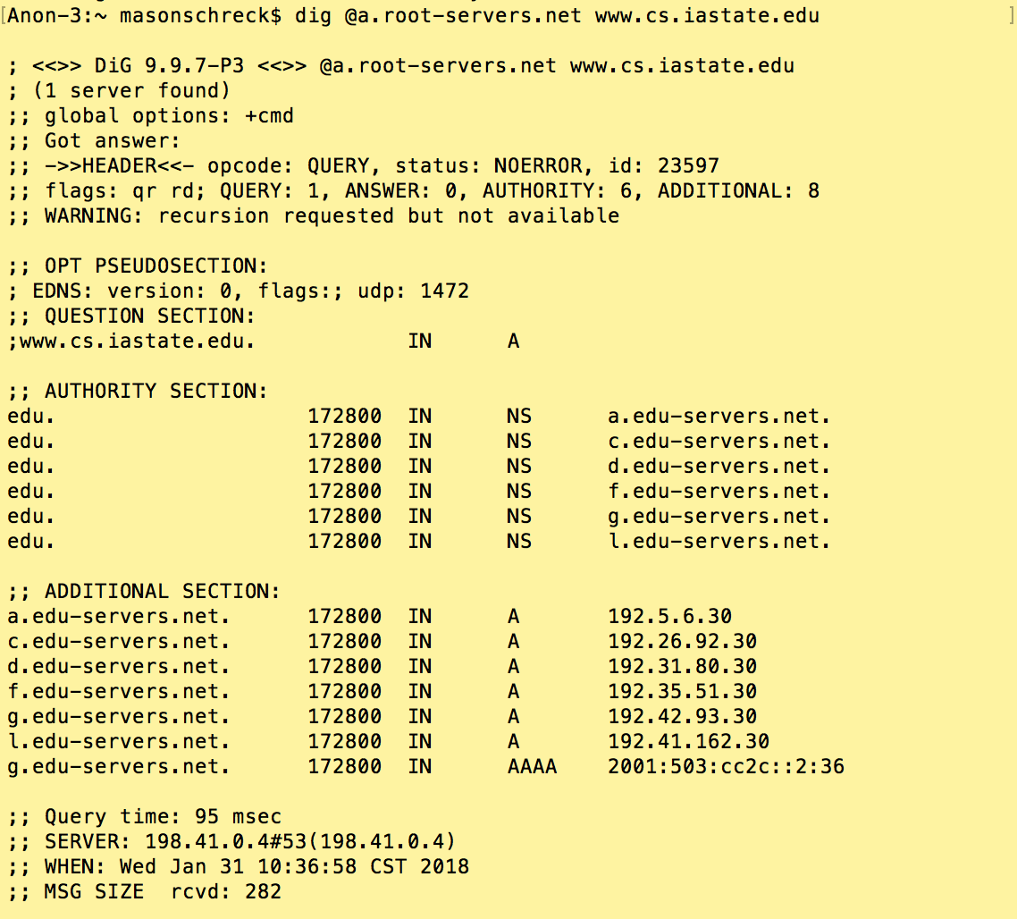

**Query 2:**

**“dig @a.edu-servers.net** [**www.cs.iastate.edu**](http://www.cs.iastate.edu)**”**

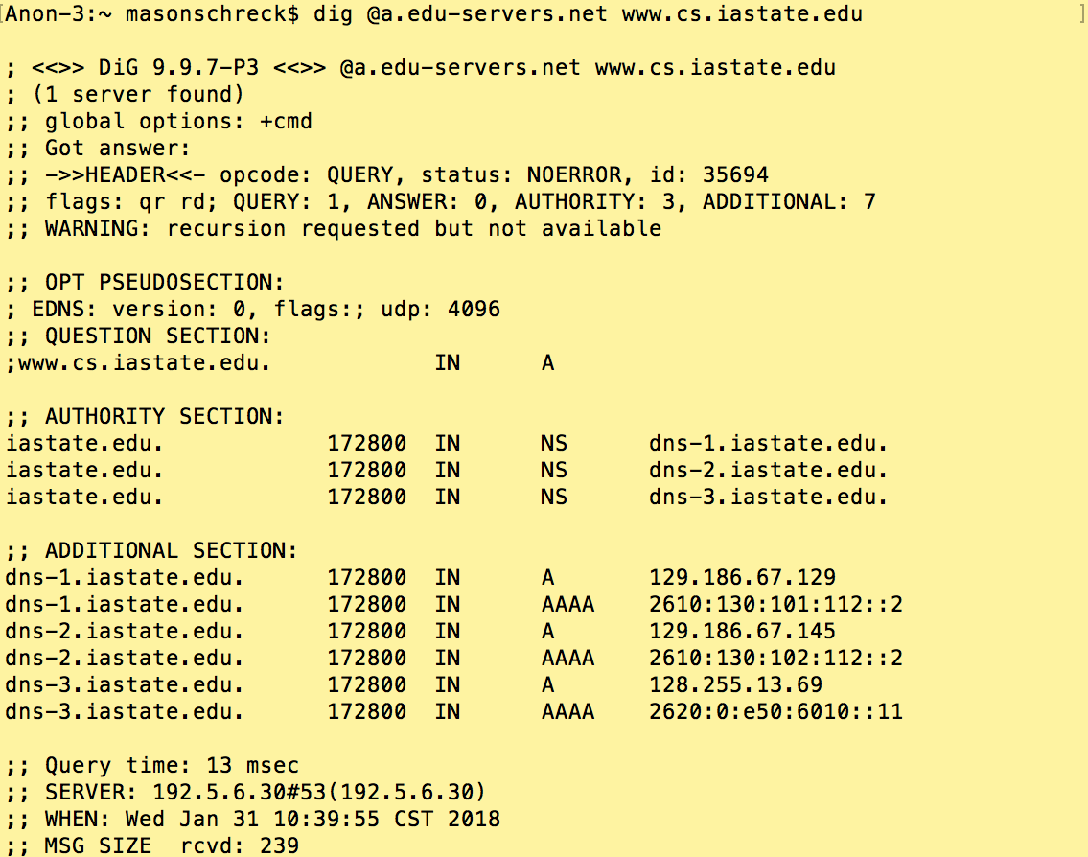

**Query 3:**

**“dig @dns-1.iastate.edu** [**www.cs.iastate.edu**](http://www.cs.iastate.edu)**”**

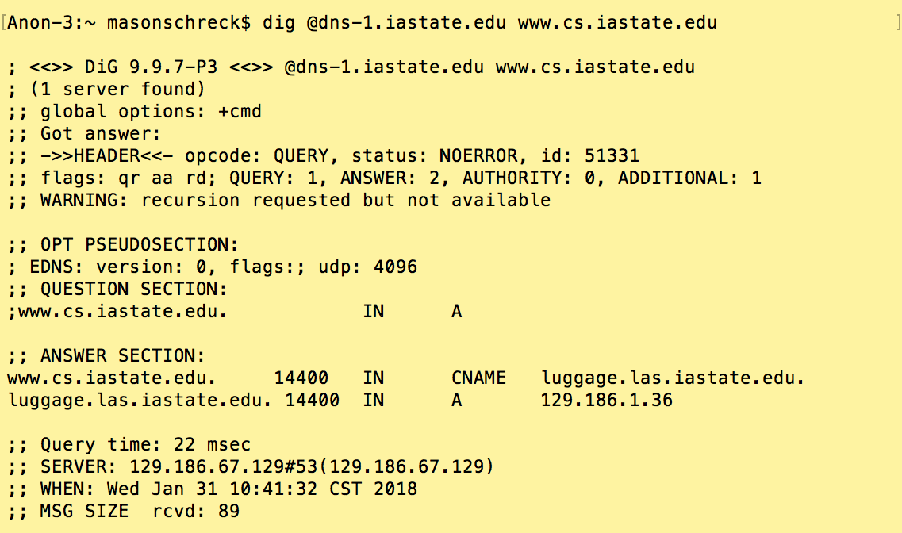

1. Repeat part (a) for yahoo.com.

**Query 1:**

**“dig @a.root-servers.net** [**www.yahoo.com**](http://www.yahoo.com)**”**

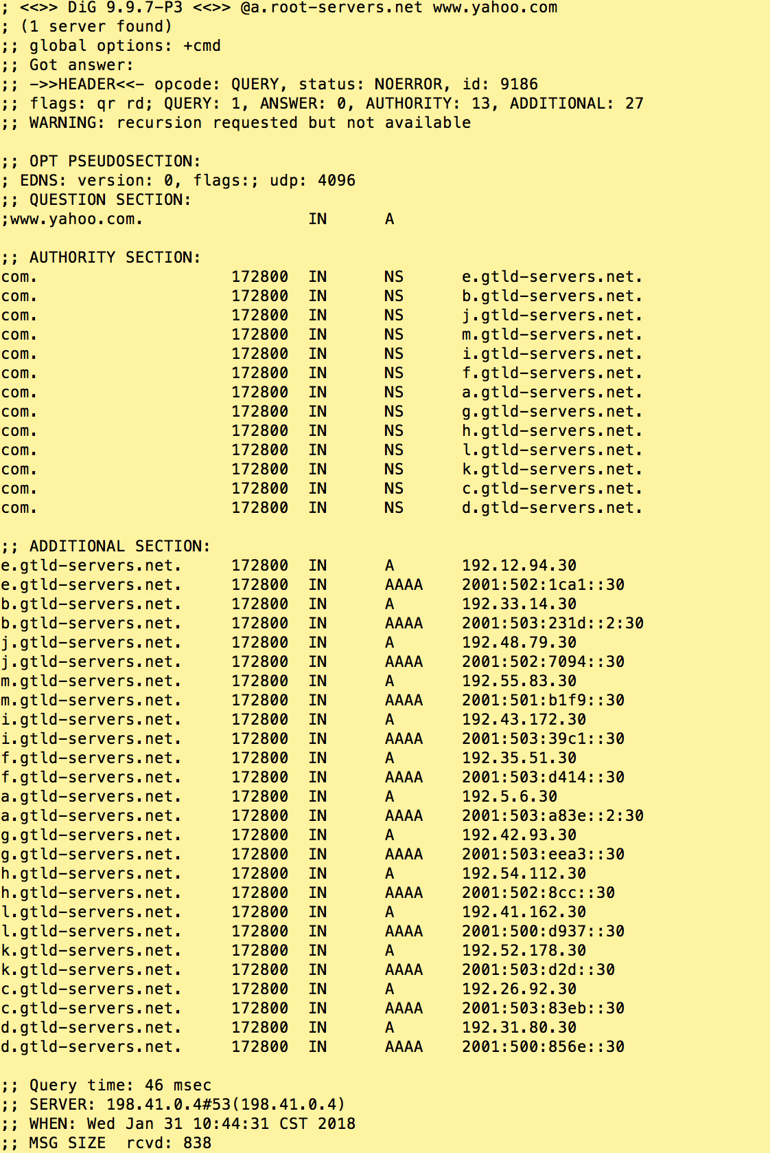

**Query 2:**

**“dig @a.gtld-servers.net** [**www.yahoo.com**](http://www.yahoo.com)**”**

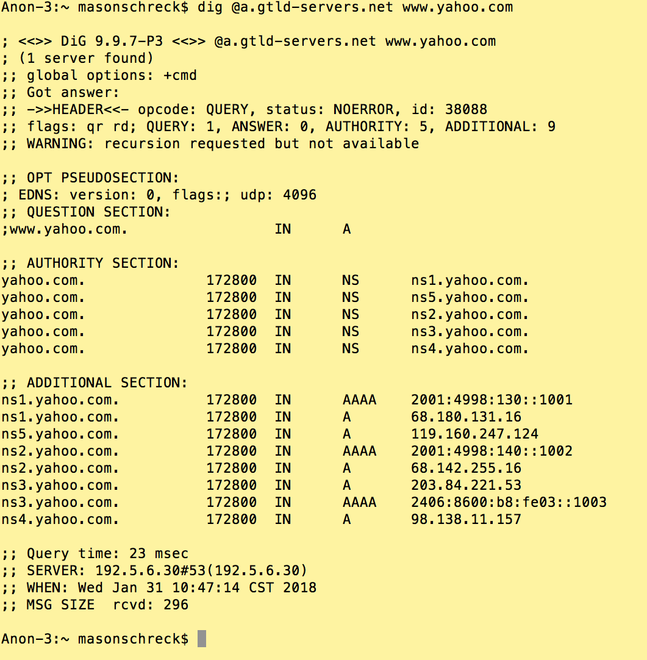

**Query 3:**

**“dig @ns1.yahoo.com** [**www.yahoo.com**](http://www.yahoo.com)**”**

