Testing of implemented functions

Function get_data and big_downloader:
-tested with various examples, redownloads
-no problems appeared, except sometimes when there is a new error message which is not ‘,’ delimited, but problem has been fixed

Function calc_amplitudes:
(tested with the code version of 11/02)
-calculates the amplitudes of given timeseries, which is the cut out data for different seismic phases, and subsequently the rms of given timeseries. Different algorithms can be implemented here, RMS as implemented works
-however, source of error can be the assignment of variables to columns
-after assignment of amplitude values, which are stored in the station variable, they can be plotted (in the following for event France_west2)
-no problems in the routine, amplitudes of phases (not ratios) are rather low, thats why they are
not really visible on the map

Function SNR and SNR_distance:
-calculates the SNR in dB, based on the Formula SNR = 10*log10(E(Signal)/E(Noise)), where E(series) = sum(abs(series)**2)
- different phases can be chosen, Pn,Sn,Lg,Pg and coda
- function runs smoothly,

Testing of SNR

Different Phases Different time windows for coda
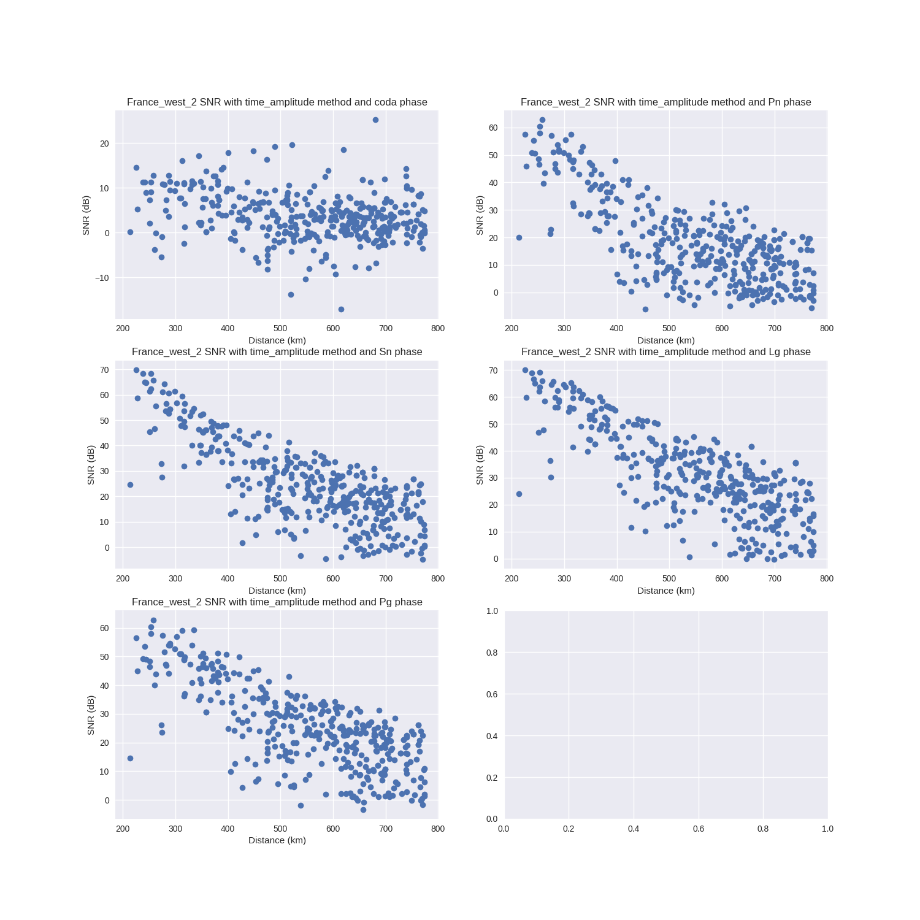

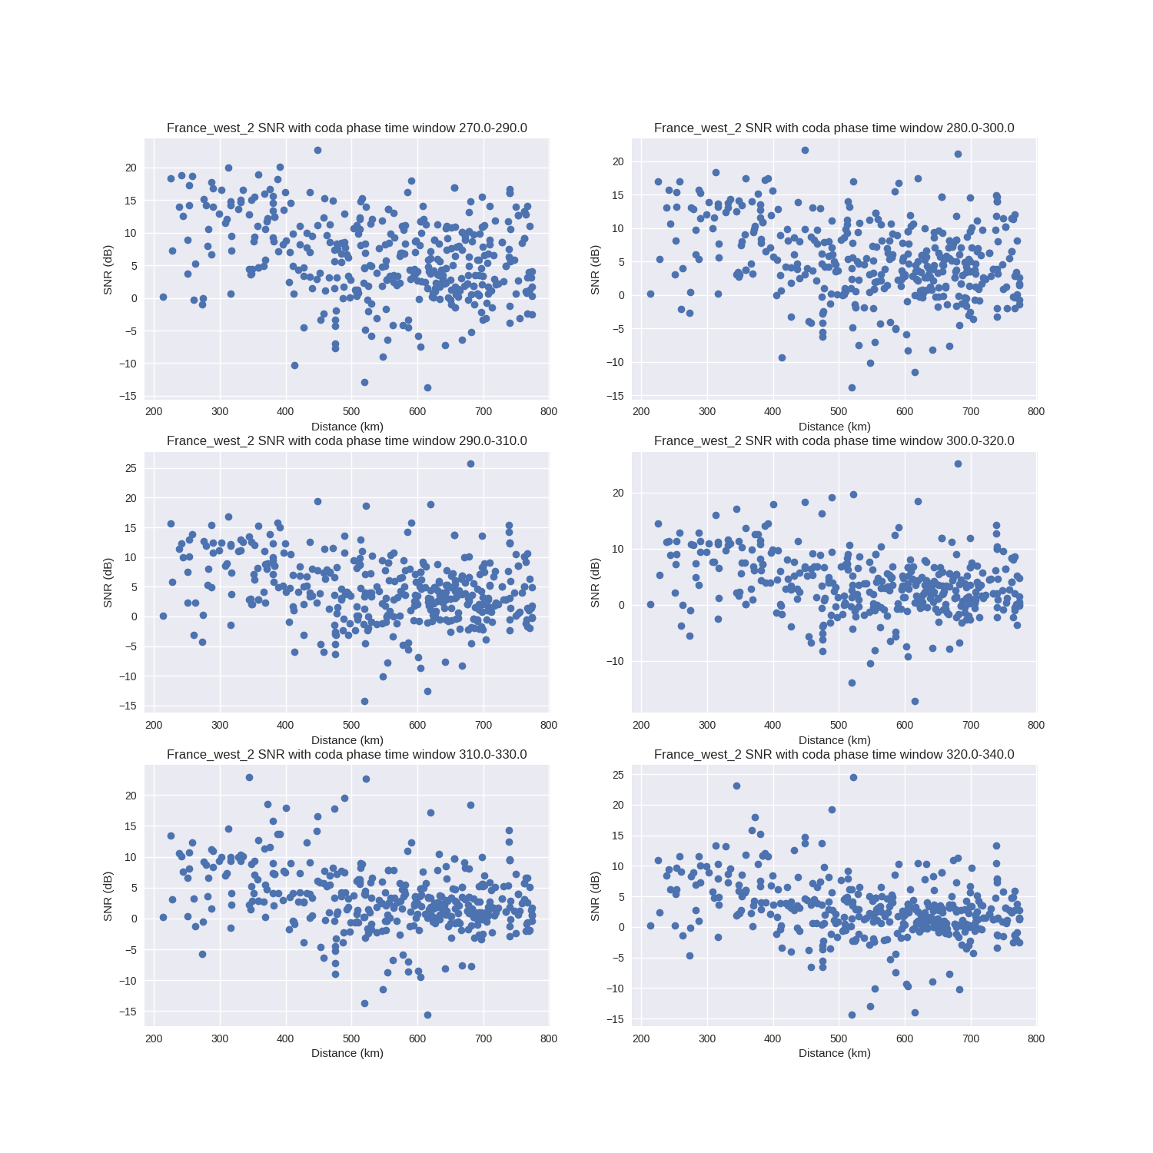

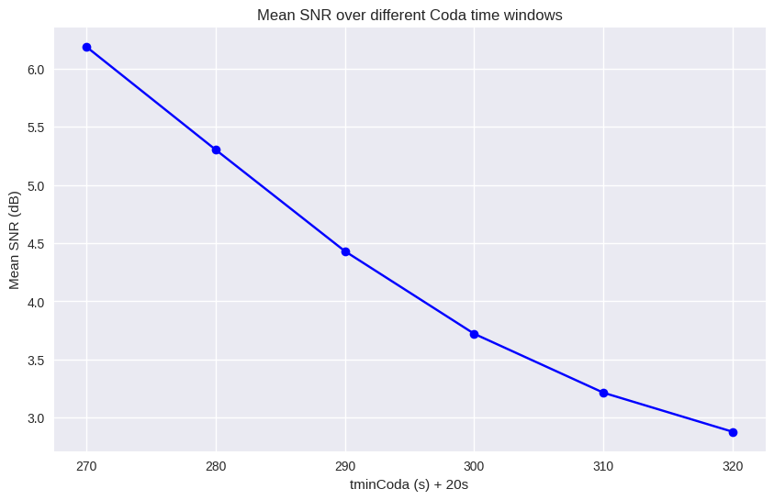

Mean SNR for different coda time windows

Testing of calc_amp, and plot_station_amps
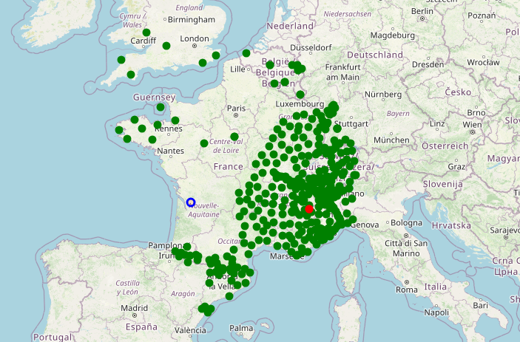
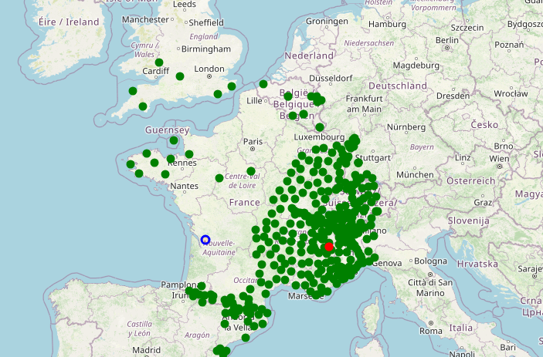
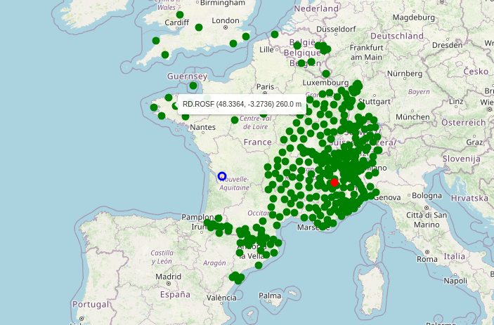
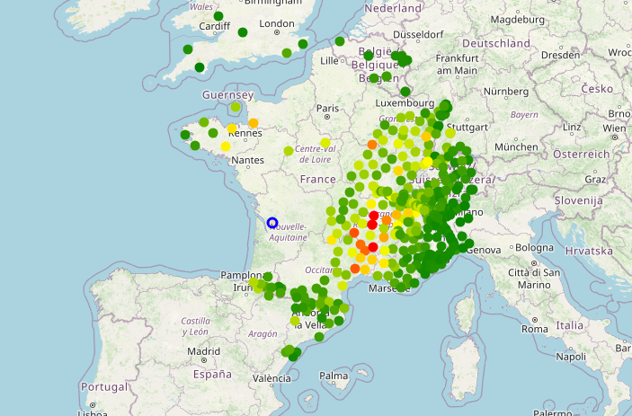
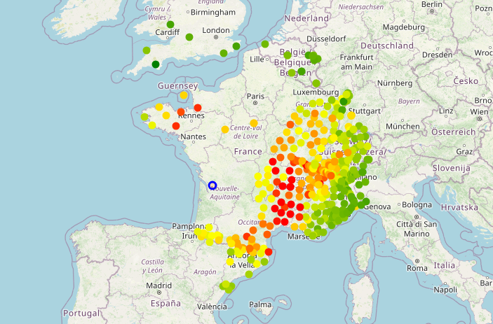
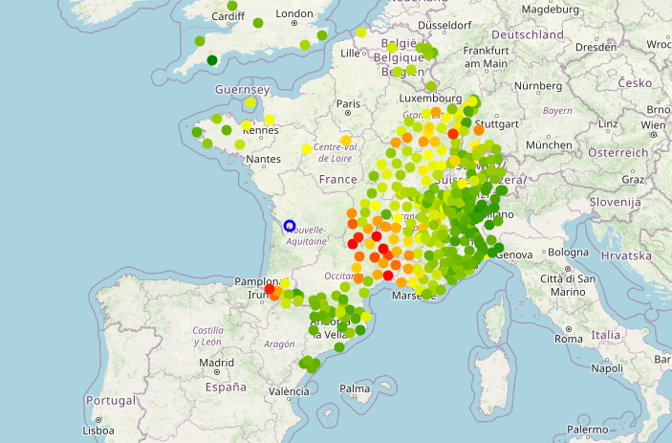
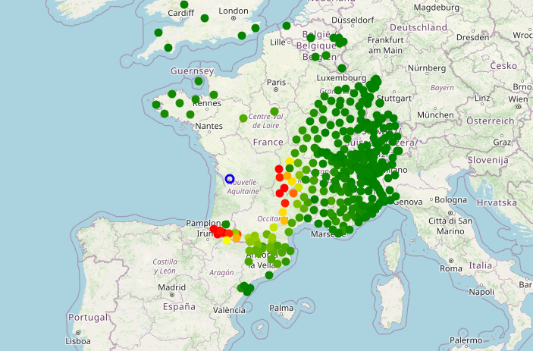
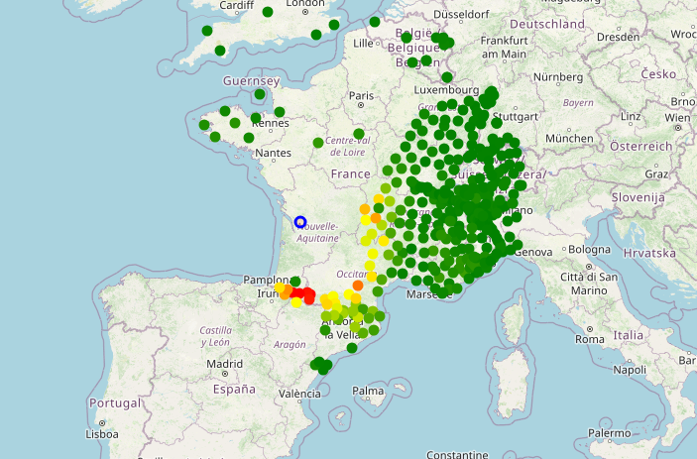
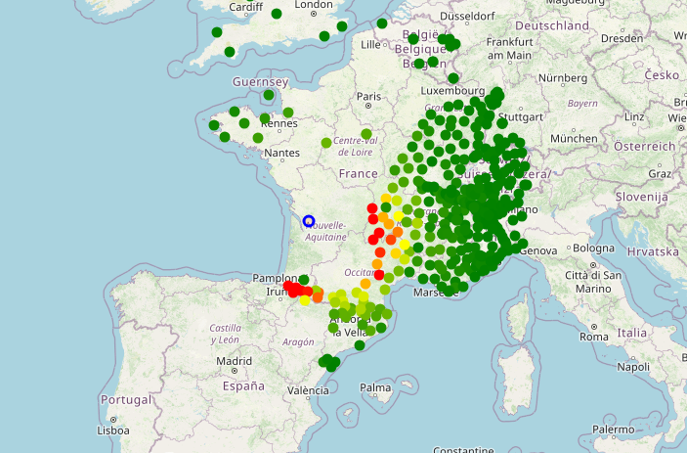
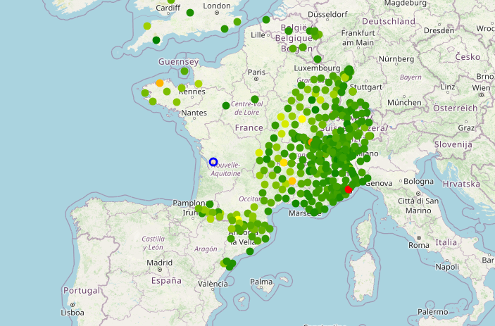
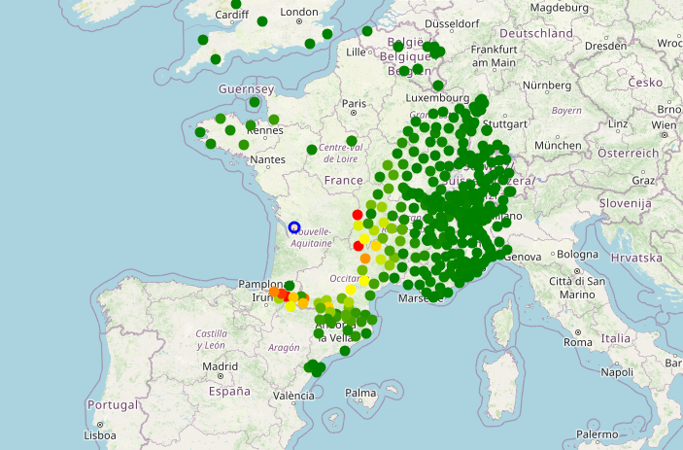
Pn
Sn
Lg
Lg/Pn
Lg/Sn
Lg/Pg
Sn/coda
Pn/coda
Lg/coda
Coda/noise
Lg/noise

