Website Specifications
  - Website Name: AutomationHub
AutomationHub is a digital platform designed with a main goal of bridging the gap between industrial hardware systems and modern web-based monitoring. This site serves as a tool and tech resource that demonstrates integration of Programmable Logic Controllers (PLCs) and industrial instrumentation using web interfaces that are responsive and accessible.
- Website Objective: To provide a one stop web-based platform or rather dashboard that gives way for virtual representation of the industrial process and improving accessibility for off-site engineers and students.

- Business Goals:

- To showcase the feasibility of IIoT (Industrial internet of things) integration and using standard web technologies and to give a way to showcase automation projects and instrumentation layouts.

- To serve as an educational bridge between industrial engineering concepts and web-accessible interfaces — providing students, junior engineers, and technical professionals in Botswana and the broader southern African region with a centralized reference platform for automation and instrumentation knowledge that does not require proprietary software or paid subscriptions to access.

- To establish AutomationHub as a credible digital presence for an emerging OT/IT consultancy, demonstrating to potential mining and industrial clients — such as those operating in Botswana's diamond, copper, and coal sectors — that modern web technologies can be used to visualize, monitor, and communicate industrial process data in a cost-effective and accessible manner.
- Target Audience: The site is mainly targeting Junior Automation Engineers and Computer Systems Engineering students, and the secondary target being Industrial plant managers who have and interest in making their data modern.

Demographics and Technical Aptitude:
- Demographics: Professionals between the ages of 19-45 holding a technical qualification or technical experience.
- Technical Aptitude: The audience is familiar with industrial logic (Ladder Logic, SCADA)
but needs a simplified way of viewing data without heavy software.

- Website Type: Technical Informational and data Visualization Board.

Information Design & Taxonomy
Site Map: The site map below shows the sequential structure of “AutomationHub”. It enforces a logical order that allows users to access technical content easily and quickly.
Page 1: Home
The main entry point which features the Hero section and an overview of the site’s purpose.
Page 2: PLC & Automation
Category for Programmable Logic Controllers, which features content on Ladder Logic and SCADA systems.
Page 3: Industrial Instrumentation
Category which lists and shows field devices, which may include sensors and actuators.
Page 4: Project Showcase
A gallery showcasing specific web-integrated automation projects.
Page 5: Feedback
A page with an HTML5 form for user inquiries.

Navigation Plan
3 clicks: The site will be structured such that any specific technical detail can be accessed from the home page in no more than 3 clicks.
Static Navigation Bar: remains at the top or side of a webpage, ensuring constant visibility as users scroll.

SITE MAP
AUTOMATION HUB-HOME
index.html

FEEDBACK
feedback.html
PLC & AUTOMATION
plc.html

PROJECT SHOWCASE
projects.html

projectE
INSTRUMENTATION
instrumentation.html

Global Navigation (Persistent Navbar) — all five pages are interlinked in both directions via a fixed top navigation bar. Any page is reachable from any other page in no more than 1 click (3-click rule satisfied). The same navigation is repeated in the footer for accessibility.

Technical Brief
Development Stack
Structural Layer: HTML5 will be used to create the semantic structure of the five mandatory pages, ensuring accessibility and search engine optimization.
Presentation Layer: * CSS3: Custom external stylesheets will be developed to handle unique branding and layout precision.
Bootstrap 5: This framework will be integrated to ensure the "AutomationHub" is fully responsive across mobile, tablet, and desktop devices.
Behavioral Layer: JavaScript (ES6+) will be implemented for form validation on the Feedback page and to handle any interactive elements like data visualization or navigation toggles.
Software & Production Tools
IDE: Visual Studio Code (VS Code) for efficient coding and debugging.
Version Control: GitHub Desktop and Git Bash will be used to manage the repository and track development milestones.
Graphics & Assets: GIMP (GNU Image Manipulation Program) will be used to design the site logo, process custom PLC icons, and optimize industrial imagery for fast loading.
Hosting: The project will be deployed and hosted live via GitHub Pages.

Low Fidelity Wireframes: Home Page
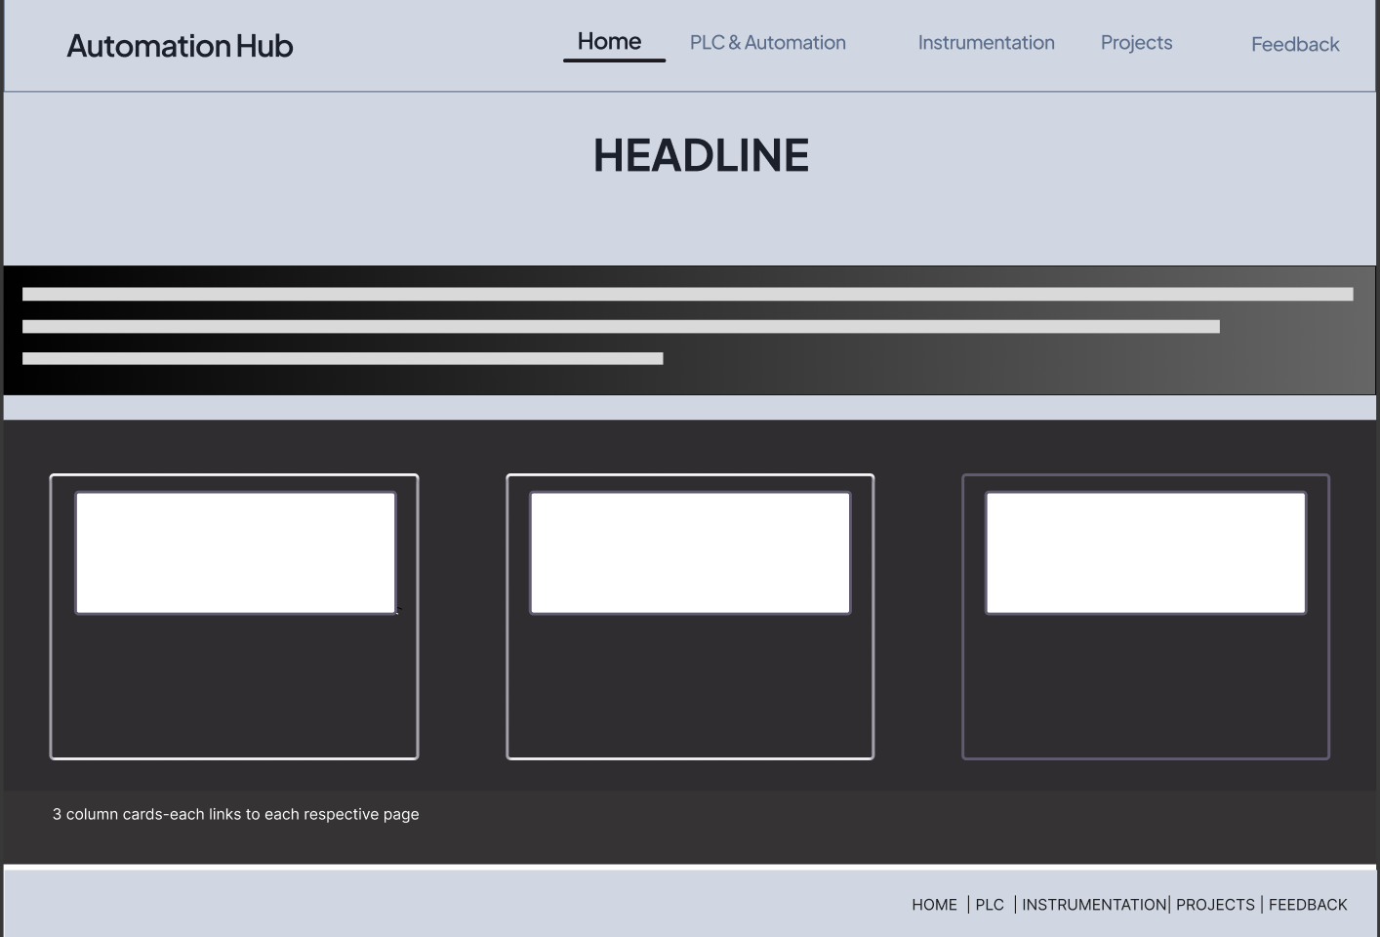
TEXT

TEXT

TEXT
TEXT
IMAGE
IMAGE
IMAGE

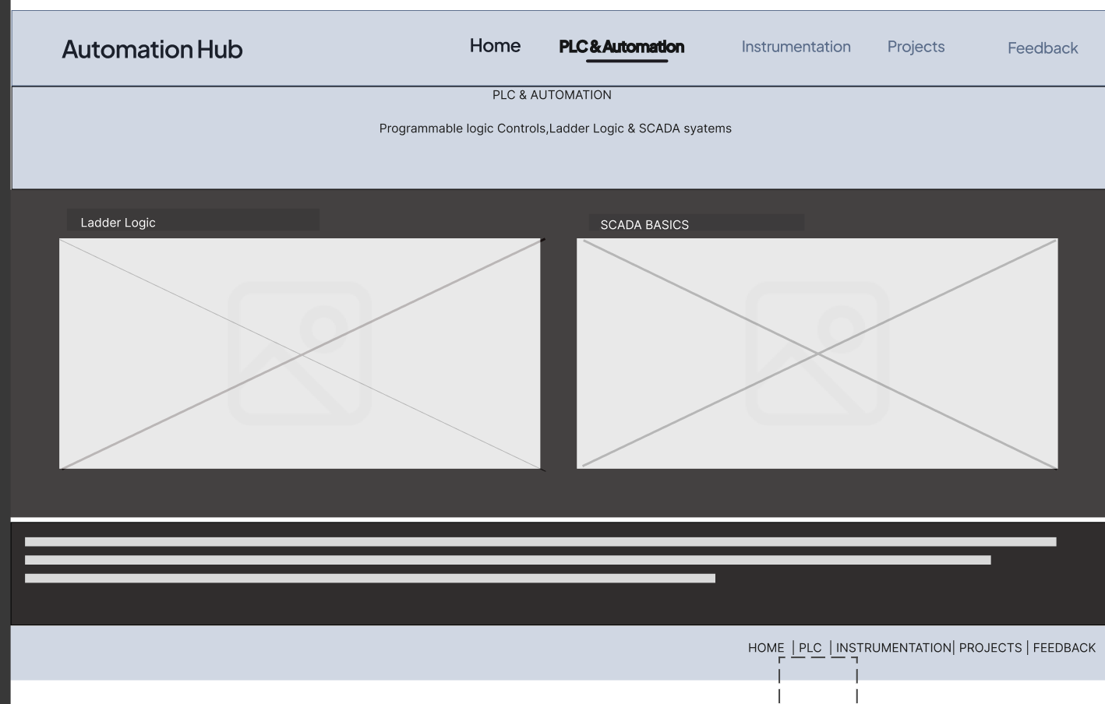

IMAGE

IMAGE

PLC & Automation Page
TEXT

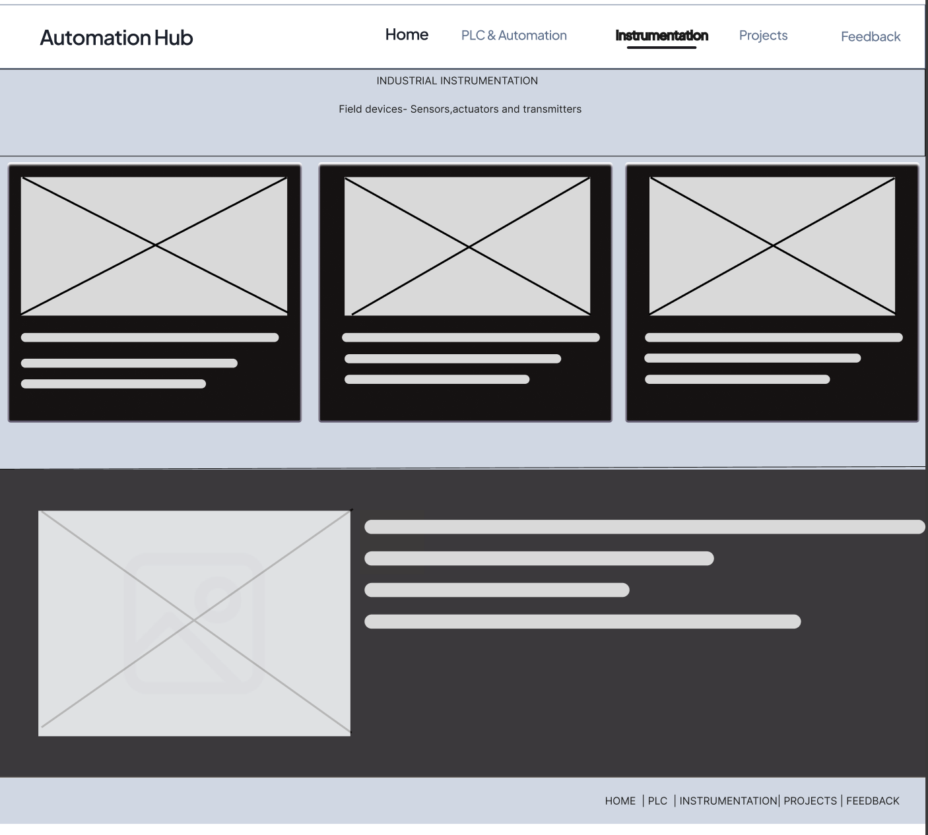

Instrumentation Page
TEXT

IMAGE
IMAGE
IMAGE
IMAGE

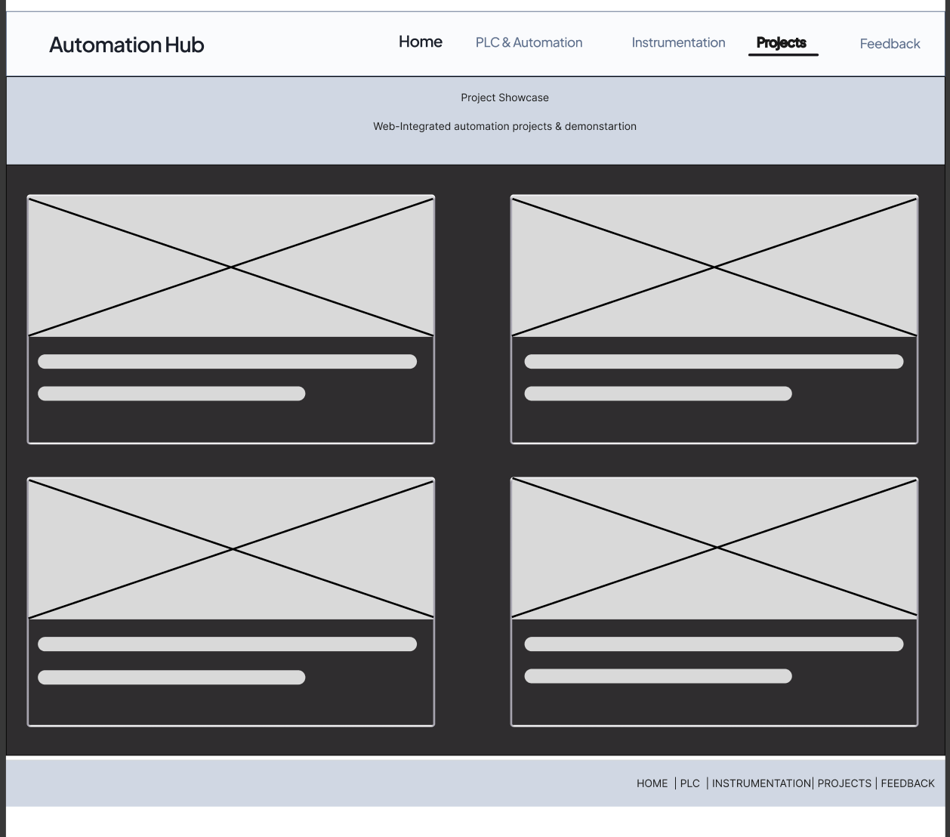

Projects Showcase Page
IMAGE
TEXT

TEXT

TEXT

TEXT

IMAGE
IMAGE
IMAGE

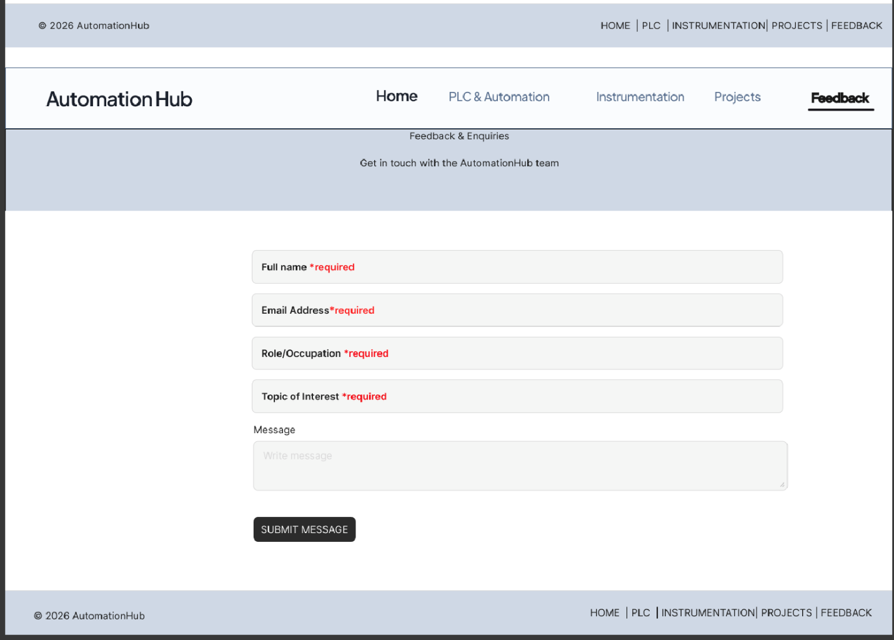

Feedback Page

Higher Fidelity Wireframe: Home Page
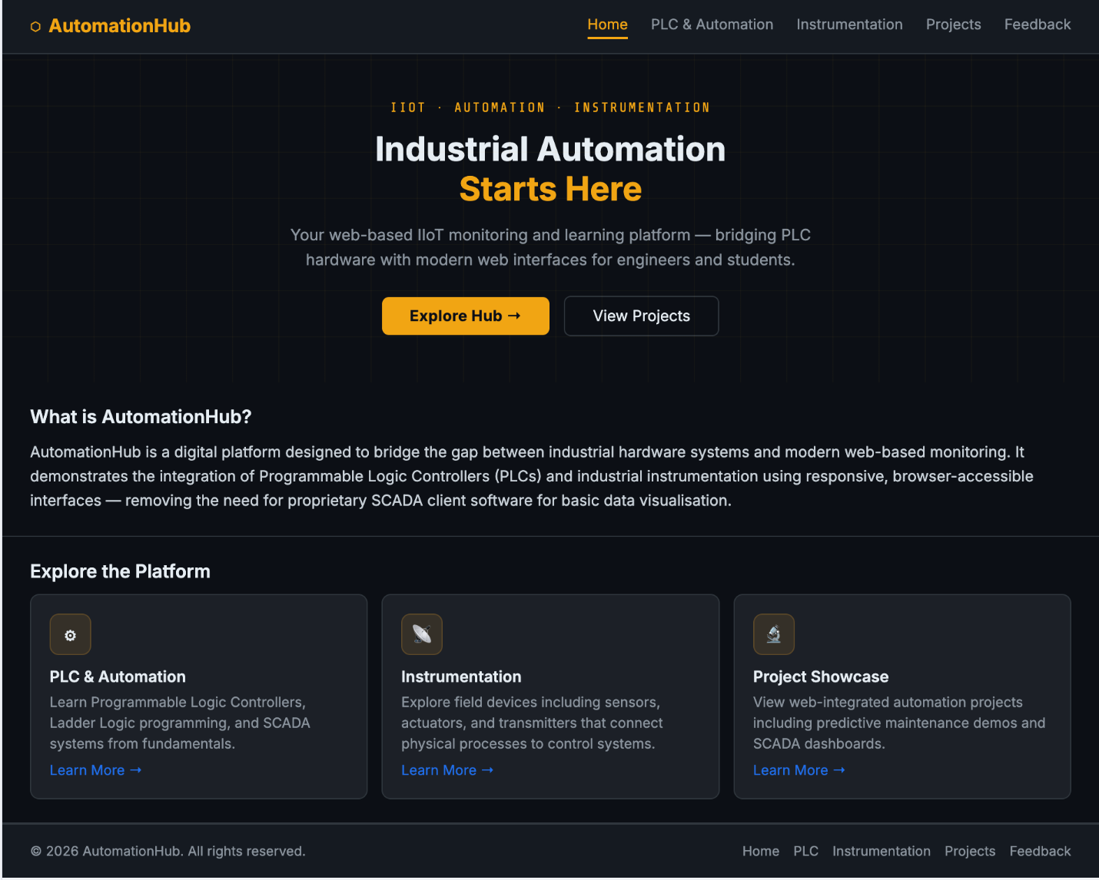

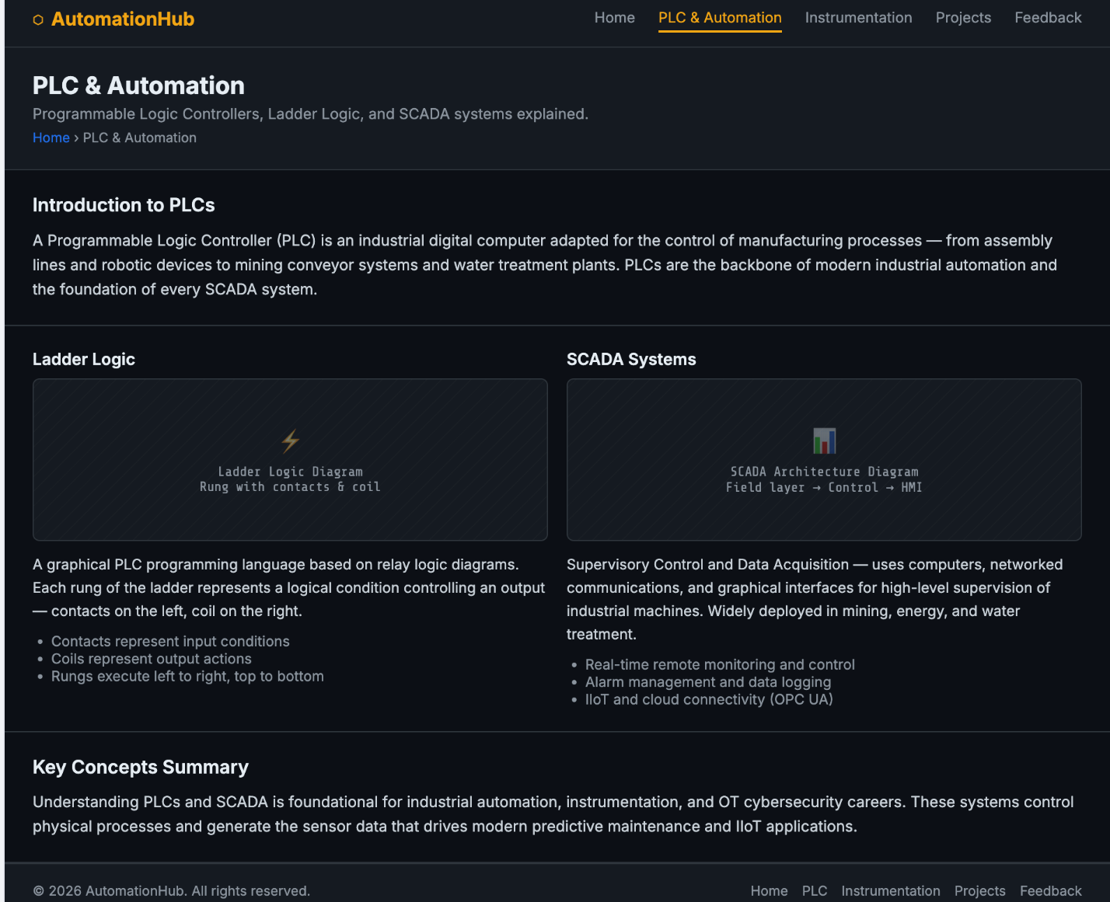

PLC & Automation Page

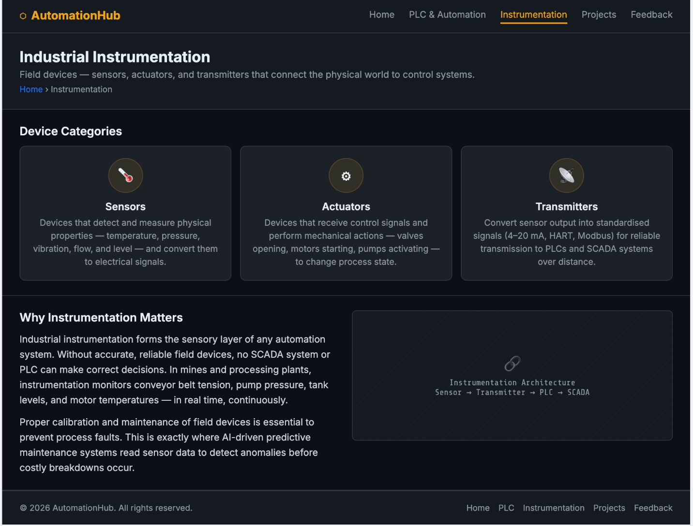

Instrumentation Page

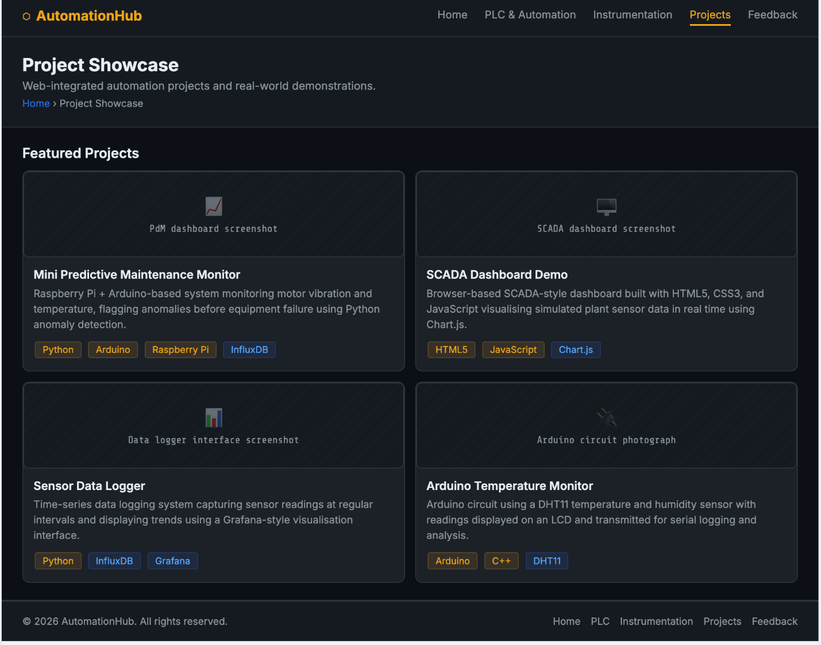

Projects Showcase Page

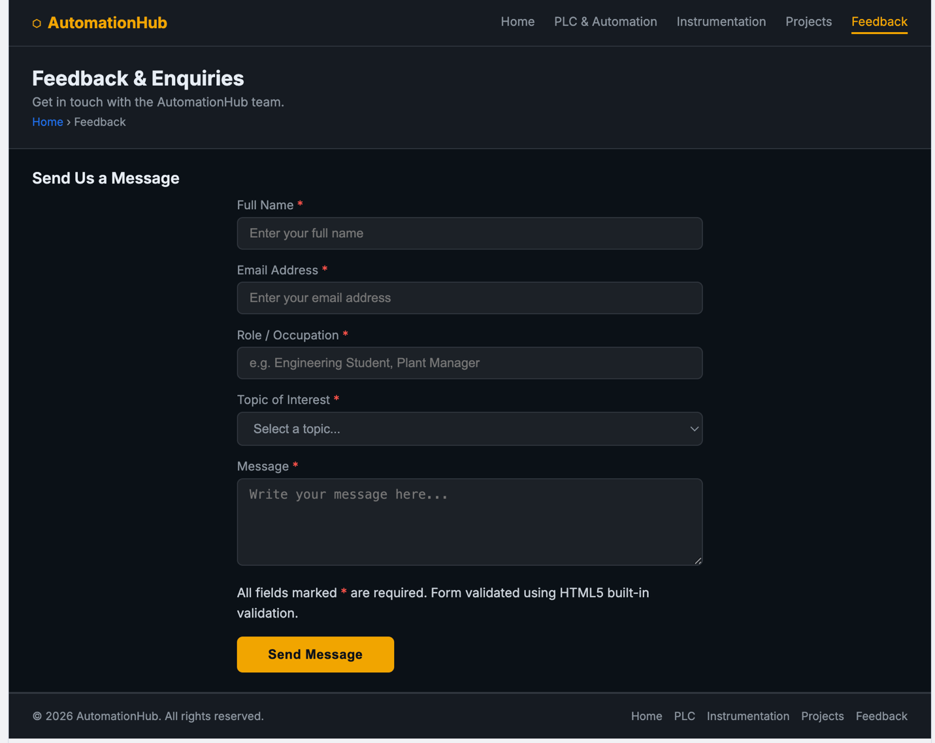

Feedback Page

