Individual Report
Lee Chun Kit Edwin

A. Introduction
In this project, I analyse interesting rules mined in browsing patterns from weblog data, which publicly available from “http://kdd.ics.uci.edu/databases/msweb/msweb.html”. In the project, I preprocess data and build models using Python language, with aid of popular machine learning and visualization libraries such as sklearn, pandas, plotnine and modified version of apyori program. Following I will present the works done sequentially and results.

B. Preprocessing
The raw data I got from website is plain text file “anonymous-msweb.data” would act as train data, another file “anonymous-msweb.test” is used for validating rules mined from training data. The useful data are extracted according to prefix character, ignoring header descriptive data, separate into two data frames, one is storing list of website each user visited, another is storing description (title, url) to each site id. Originally there are 32711 records and 294 vroots.

Since from microsoft’s data description there’s no mention of timing order in site visting for each user, I just assume data reflect collective action of user within 1 week, there’s no sequential pattern minging. In terms of association rule mining, I treat each user as a customer, each site visit as an item, all visiting from same user as a transaction.

Before modelling, we need to filter out all less frequent items and less valuable transactions, to limit the number of rules mined finally. According to histogram chart, there are 54 sites (vroot) that only visited by less than 5 visitors, so they are removed from training data and not counted in transactions. 10 users are also excluded because they only visit 1 site, that is included in those 54 sites.
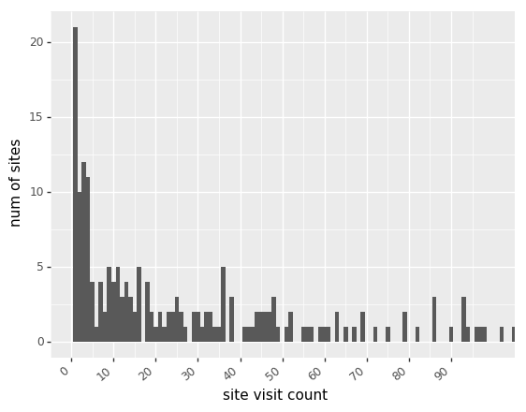

The visiting data then do one-hot encoding, set user id as index of data frame, set each feature as 1 if that user has visited that site.

Finally I further filter features according to variance of features after 1-hot encoding. The thresold is set to be [p=0.999, threshold = p*(1-p) = 0.001] since the data is mainly sparse matrix which has very low variance features. 69 more features and corresponding users with no features left are removed. There is 32608 rows and 162 features (sites) left for modelling.
C. Modelling
Since the remaining record is still very huge, it would be time consuming and memory intensive to mine rules all records directly, so instead I first do agglomerative clustering to cluster users according to their features, and then mine rules in each cluster individually. I use traditional associative rule mining with apyori principle, under constraint of certain minimum support and confidence level.

To start with, I test different number of cluster, starting from 5 clusters. Here I list the number of rules mined when support and confidence are 0.1.

clusters | 3 | 6 | 9 | 12 | 15 | 18 | 21 | 24 | 27 | 30 | 33
rules | 63 | 146 | 615 | 647 | 743 | 806 | 1043 | 1135 | 3035 | 3133 | 3217
clusters | 36 | 39 | 42 | 45 | 48 | 51 | 54 | 57
rules | 3480 | 3518 | 3867 | 4140 | 4259 | 4386 | 7758 | 7869

From the result, when the number of cluster is small, the total number of possible rules from all clusters is also small, becuase more users are within same cluster, then relatively fewer rules have enough support. Rule count > 3000 is too much for analysis, count < 200 is too few, a good compromise is 18-24.

Next we take a look at number of rules mined, when number of cluster fixed at 21. I tried grid search of support (Sup) and confidence (Con) from 0.1 to 0.9, with interval of 0.1. The rules from different clusters are combined and duplicates are removed.

Sup\Con | 0.1 | 0.2 | 0.3 | 0.4 | 0.5 | 0.6 | 0.7 | 0.8 | 0.9
0.1 | 846 | 813 | 735 | 656 | 594 | 480 | 419 | 355 | 216
0.2 | 232 | 232 | 212 | 179 | 173 | 159 | 140 | 119 | 64
0.3 | 79 | 79 | 79 | 76 | 71 | 61 | 52 | 44 | 25
0.4 | 55 | 55 | 55 | 55 | 54 | 48 | 39 | 35 | 18
0.5 | 38 | 38 | 38 | 38 | 38 | 37 | 31 | 28 | 14
0.6 | 19 | 19 | 19 | 19 | 19 | 19 | 17 | 16 | 8
0.7 | 15 | 15 | 15 | 15 | 15 | 15 | 15 | 14 | 6
0.8 | 6 | 6 | 6 | 6 | 6 | 6 | 6 | 6 | 4
0.9 | 2 | 2 | 2 | 2 | 2 | 2 | 2 | 2 | 2

Here we can see the dominant factor for associative mining is support. Support is defined as frequency of itemset among dataset. When the minimum support increase from 0.1 to 0.2, the number of rules drop by around 4 times, meaning most of the rules mined in low support and confidence are not that strong. We can compare this with the rule count when cluster size increase to 24.

Sup\Con | 0.1 | 0.2 | 0.3 | 0.4 | 0.5 | 0.6 | 0.7 | 0.8 | 0.9
0.1 | 896 | 848 | 767 | 687 | 627 | 512 | 448 | 373 | 231
0.2 | 240 | 240 | 220 | 189 | 180 | 164 | 146 | 123 | 68
0.3 | 88 | 88 | 88 | 85 | 78 | 68 | 59 | 47 | 28
0.4 | 59 | 59 | 59 | 59 | 57 | 51 | 44 | 37 | 20
0.5 | 40 | 40 | 40 | 40 | 40 | 39 | 33 | 28 | 14
0.6 | 19 | 19 | 19 | 19 | 19 | 19 | 17 | 16 | 8
0.7 | 15 | 15 | 15 | 15 | 15 | 15 | 15 | 14 | 6
0.8 | 6 | 6 | 6 | 6 | 6 | 6 | 6 | 6 | 4
0.9 | 2 | 2 | 2 | 2 | 2 | 2 | 2 | 2 | 2

We observe that the numbers are only slightly changes by within 100 when support is low, and the count distribution keeps the same. Interestingly wehn support gets higher, especially when support >= 0.6, the rule counts are identical, meaning that a few rules (around 20) are very strong no matter how we group the users.

We may further investigate on how records are distributed in different clusters size. The two graphs show what happens when cluster number is 17 and 45. Basically the distribution is quite steady, one cluster with exceptionally high record size, almost double or trible of second highest, and remaining clusters have linearly decreasing size. We could expect some specific rules will be mined in smaller cluster, while a few very strong rules will be found in multiple clusters and presented in results under high support and confidence rate.
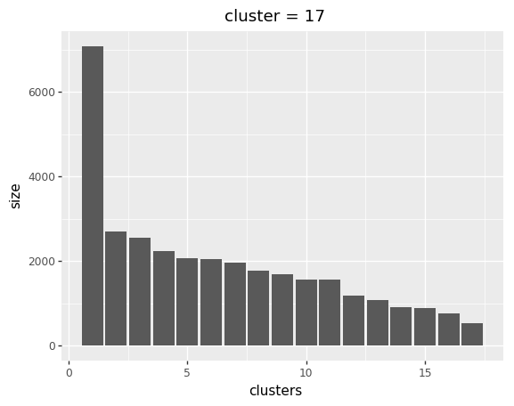
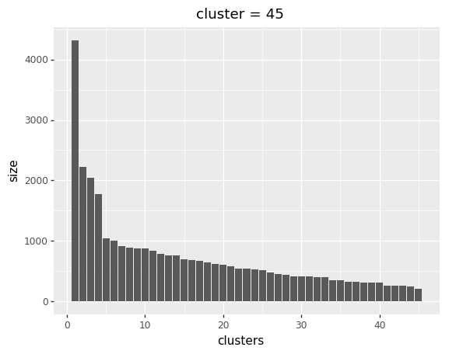

C. Testing and Results
I choose the rules mined in training dataset with number of cluster = 21, suppport = 0.2 and confidnece = 0.3, in total 212 rules are mined. These rules will be applied into all testing dataset to get corresponding support, confidence and lift.

First we sort rules according to this weighting: support > confidence > lift. The top 10 rules without itemset duplication are:

Rules | Explanation | Support | Conf | Lift
1034 => 1008 | Internet Explorer => Free Downloads | 0.1664 | 0.5773 | 0.0003
1009 => 1008 | Windows Family of Oss => Free Downloads | 0.0748 | 0.5607 | 0.0003
1018 => 1008 | Free Downloads => isapi | 0.0706 | 0.4694 | 0.0002
1004 => 1008 | Microsoft.com Search => Free Downloads | 0.0624 | 0.2356 | 0.0001
1017 => 1008 | Products =>Free Downloads | 0.0612 | 0.3898 | 0.0002
1003 => 1001 | Knowledge Base => Support Desktop | 0.0594 | 0.6305 | 0.0009
1001 => 1018 | Support Desktop => isapi | 0.056 | 0.40287 | 0.0005
1004 => 1034 | Microsoft.com Search => Internet Explorer | 0.0524 | 0.1978 | 0.0001
1017 => 1004 | Products => Microsoft.com Search | 0.051 | 0.32484 | 0.0002
1003 => 1018 | Knowledge Base => isapi | 0.048 | 0.50955 | 0.0006

Unsurprisingly,

