Ryan Schulman

Design and Analysis of Algorithms

HW 2

Problem 1)

1. Proof:

We know the sum of all numbers in a magic square is



where n is the side length of the magic squre.

We know each row, column, and diagonal of a magic square has n elements. We also know that the sum of all elements in the square must be distributed evenly through each row and column.. In other words, the sum of each row Sn must be equivalent to the sum of each row sum. So Sn = sum(row 1) + sum(row 2) + sum(row 3) …. + sum(row n). Since each of these sums is equivalent, we have that Sn = n * sum(row n). So, we see sum(row n) = Sn / n or



b)

This function accepts input n, cur_val, cur_arr, and good_arrs. And outputs an array of arrays M_n where the arrays of M_n have length n^2 and represent a “flattened” magic square.Cur_val can be any integer from 1 to n^2, cur_arr should be an empty array, and good_arrs should be an empty array of arrays.

getMagicSquare(n, cur_val, cur_arr, good_arrs)

If cur_val not in cur_arr DO

If cur_val != 0 DO

cur_arr.append(cur_val)

END

For x from cur_val + 1 to n*n

If length(cur_arr) == n*n

If check(cur_arr)

good_arrs.append(cur_arr)

Else

getMagicSquare(n, x, copy of cur_arr, good_arrs)

END

END

END

c) Analysis

Primary operator => n*n in the if statement



if n > 2

T(n) = d if n <= 2

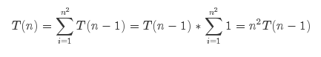

T(n-1) = (n-1)2T(n-2)

=> T(n) = n2(n-1)2T(n-2)

T(n-2) = (n-2)2(n-3)2T(n-4)

=> T(n) = n2(n-1)2(n-2)2(n-3)2T(n-4)

.

.

.

After k steps



Assume n-k = 1

=> T(n) = n2!T(1) = n2! * d

**=> Θ(n2!)**

d)

#!/usr/bin/python

import timeit

import numpy as np

import math

import matplotlib.pyplot as plt

import pdb

testArr = [2,7,6,9,5,1,4,3,8]

def check(arr, n):

magicNumber = n * (n * n + 1) / 2.0

# print "magicNumber", magicNumber

# print arr

# should_pass = False

# if testArr == arr:

# print "should have passed"

# should_pass = True

# pdb.set_trace()

for x in range(n):

# check rows

summ = np.sum(arr[x*n:x*n + n])

if summ != magicNumber:

return False

# check columns

tempArr = [arr[y] for y in range(x, n*n, n)]

summ = np.sum(tempArr)

if summ != magicNumber:

return False

# check diagonals

tempArr = [arr[x] for x in range(0, n*n, n+1)]

summ = np.sum(tempArr)

if summ != magicNumber:

return False

tempArr = [arr[x] for x in range(n-1, n*n - n + 1, n-1)]

summ = np.sum(tempArr)

if summ != magicNumber:

return False

return True

def getMagicSquares(n, good_arrs, cur_val=0, cur_arr=[]):

# print cur_arr

# print cur_val

if cur_val not in cur_arr:

if cur_val != 0:

cur_arr.append(cur_val)

# print "cur_arr", cur_arr

# print "depth: ", len(cur_arr)

# print "cur_val", cur_val

# print "range", range(cur_val + 1, n, 1)

rr = range(1, n*n + 1, 1)

# print rr

if len(cur_arr) == n*n:

# print "found right length"

if check(cur_arr, n):

print "passed check"

print cur_arr

good_arrs.append(cur_arr)

else:

for x in rr:

getMagicSquares(n, good_arrs, x, list(cur_arr))

if __name__ == "__main__":

good_arrs = []

n = 3

# pdb.set_trace()

getMagicSquares(n, good_arrs, cur_arr=[])

print good_arrs

e)

3x3 check:

[6, 1, 8,

7, 5, 3,

2, 9, 4]

Do rows = 15? Yes

Do columns = 15? Yes

Do diagonals = 15? Yes

4x4 check:

[16, 5, 4, 9,

3, 10, 15, 6,

13, 8, 1, 12,

2, 11, 14, 17]

Do rows =34? Yes

Do columns = 34? Yes

Do diagonals = 34? Yes

Problem 2)

a)

Pseudo-code:

Input: G = graph of nodes and edges, n = number of nodes, good_path = pointer to output

Output: good_path = data now pointed to by input pointed

minimum <- 99999999

getPath(G, n, good_path, curPath <- [], curNode<-None):

if curNode is None DO

for node in G.nodes:

getPath(G, n, good_path, curPath <- [], curNode<-node)

END

else:

if curNode not in curPath DO

curPath.append(curNode)

else:

return

END

for edge in G.edges(curNode) DO

node <- edge[1]

if lengeth(curPath) == n DO

tmp <- path_len(curPath, G)

if tmp < minimum DO

minimum <- tmp

good_path.append(curPath)

while len(good_path) > 1 DO

good_path.pop(0)

END

END

else:

getPath(G, n, good_path, curPath<-list(curPath), curNode<-node)

END

END

b)

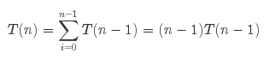… n > 2

T(2) = d … n = 2

T(n-1) = (n-2)T(n-2)

=> T(n) = (n-1)(n-2)T(n-2)

T(n-2) = (n-3)(n-4)T(n-4)

=> T(n) = (n-1)(n-2)(n-3)(n-4)T(n-4)

… After k steps

=> T(n) = (n-1)!T(n-k)

Assume n-k = 2

=> T(n) = (n-1)!T(2) = (n-1)! * d

=> T(n) = 𝛳((n-1)!)

c)

#!/usr/bin/python

import timeit

import numpy as np

import math

import matplotlib.pyplot as plt

import pdb

import networkx as nx

import random

import pprint

minimum=99999999

def path_len(path, G):

# pdb.set_trace()

result = 0

length = len(path)

for x in range(0, length - 1, 1):

cost = G[path[x]][path[x+1]]["weight"]

result += cost

cost = G[path[length-1]][path[0]]["weight"]

result += cost

return cost

def getPath(G, n, good_path, curPath = [], curNode=None):

global minimum

if curNode is None:

for node in G.nodes():

getPath(G, n, good_path, curPath = [], curNode=node)

else:

if curNode not in curPath:

# print "curNode", curNode

curPath.append(curNode)

else:

return

for edge in G.edges(curNode):

node = edge[1]

if len(curPath) == n:

tmp = path_len(curPath, G)

# print curPath, ":",tmp

if tmp < minimum:

minimum = tmp

good_path.append(curPath)

while len(good_path) > 1:

good_path.pop(0)

else:

getPath(G, n, good_path, curPath=list(curPath), curNode=node)

if __name__ == "__main__":

good_path = []

G = nx.Graph()

labels = {}

n = 10

numEdges = (n**2)/2.0 - 1

for x in range(n):

for y in range(n):

if y != x:

G.add_edge(x,y,weight=random.randint(1,10))

getPath(G, n, good_path)

print "good_path", good_path

form = pprint.pformat(dict(G.adj))

f = open('cities.txt', 'w')

print form

f.write(form)

pos = nx.shell_layout(G, scale=10)

nx.draw(G, pos, with_labels=True)

edge_labels = nx.get_edge_attributes(G, 'r')

# plt.plot(nx.draw_shell(G, with_labels=True))

nx.draw_networkx_edge_labels(G, pos, labels=edge_labels)

plt.title("Good path"+str(good_path))

plt.show()

# pdb.set_trace()

d)

Generated cities:

{0: AtlasView({1: {'weight': 8}, 2: {'weight': 7}, 3: {'weight': 1}, 4: {'weight': 2}, 5: {'weight': 2}, 6: {'weight': 6}, 7: {'weight': 5}, 8: {'weight': 8}, 9: {'weight': 10}}),

1: AtlasView({0: {'weight': 8}, 2: {'weight': 10}, 3: {'weight': 4}, 4: {'weight': 4}, 5: {'weight': 9}, 6: {'weight': 7}, 7: {'weight': 5}, 8: {'weight': 8}, 9: {'weight': 2}}),

2: AtlasView({0: {'weight': 7}, 1: {'weight': 10}, 3: {'weight': 9}, 4: {'weight': 4}, 5: {'weight': 3}, 6: {'weight': 5}, 7: {'weight': 2}, 8: {'weight': 4}, 9: {'weight': 8}}),

3: AtlasView({0: {'weight': 1}, 1: {'weight': 4}, 2: {'weight': 9}, 4: {'weight': 7}, 5: {'weight': 5}, 6: {'weight': 2}, 7: {'weight': 1}, 8: {'weight': 1}, 9: {'weight': 1}}),

4: AtlasView({0: {'weight': 2}, 1: {'weight': 4}, 2: {'weight': 4}, 3: {'weight': 7}, 5: {'weight': 1}, 6: {'weight': 2}, 7: {'weight': 3}, 8: {'weight': 4}, 9: {'weight': 9}}),

5: AtlasView({0: {'weight': 2}, 1: {'weight': 9}, 2: {'weight': 3}, 3: {'weight': 5}, 4: {'weight': 1}, 6: {'weight': 8}, 7: {'weight': 7}, 8: {'weight': 9}, 9: {'weight': 2}}),

6: AtlasView({0: {'weight': 6}, 1: {'weight': 7}, 2: {'weight': 5}, 3: {'weight': 2}, 4: {'weight': 2}, 5: {'weight': 8}, 7: {'weight': 8}, 8: {'weight': 5}, 9: {'weight': 8}}),

7: AtlasView({0: {'weight': 5}, 1: {'weight': 5}, 2: {'weight': 2}, 3: {'weight': 1}, 4: {'weight': 3}, 5: {'weight': 7}, 6: {'weight': 8}, 8: {'weight': 2}, 9: {'weight': 6}}),

8: AtlasView({0: {'weight': 8}, 1: {'weight': 8}, 2: {'weight': 4}, 3: {'weight': 1}, 4: {'weight': 4}, 5: {'weight': 9}, 6: {'weight': 5}, 7: {'weight': 2}, 9: {'weight': 6}}),

9: AtlasView({0: {'weight': 10}, 1: {'weight': 2}, 2: {'weight': 8}, 3: {'weight': 1}, 4: {'weight': 9}, 5: {'weight': 2}, 6: {'weight': 8}, 7: {'weight': 6}, 8: {'weight': 6}})}

Program output:

good_path [[0, 1, 2, 4, 5, 6, 7, 8, 9, 3]]

Time vs Number of cities

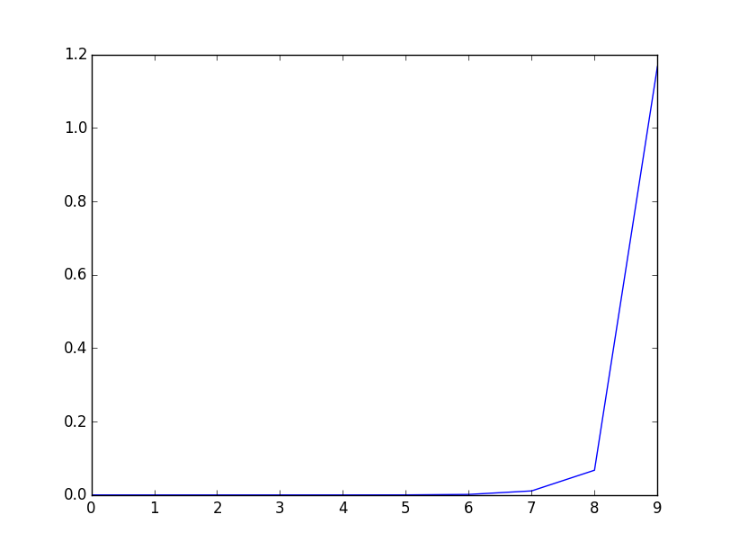

Number of cities

e)

Graph of cities:

