Outline for an Ecosphere “Methods” Paper: Presented to the CRCSTL Seminar by Jonathon Schramm and Jennifer Doherty
Audience and Message: ecologists, reading with an interest in teaching Bio 101 or ecology courses
Main goals: 1) make ecologists aware that researchers are developing models of student reasoning in specific content areas important to these courses, 2) present the rigorous methods behind this type of research (both to help faculty appreciate that rigor and to recognize well-validated efforts when they come across them in the literature) and 3) convince faculty that they can use these models (and related assessments) to better diagnose problems in their students’ reasoning and generally be more proactive in planning their instruction.
Models, not just for nature anymore: models of student reasoning in the ecology classroom
- The crucial role of models in ecology and ecology education
  - Models are attempts to simplify complex situations down to most salient features without losing the key explanatory descriptors
  - Ecologists use models to predict and explain processes occurring within systems. Ecological models allow for richer reasoning about known systems, thinking about connections among disparate systems, and predictions about novel systems.
  - Applied ecologists use models to more effectively monitor, diagnose and manage specific issues in ecosystems.
  - Ecosystems and classrooms share several key features: complexity (since antecedents to an outcome range across space and time), indirect interactions (one-to-one causality is rare), and unequal effects (not all interactions have the same strength).
  - Thesis: Instructors of ecology can use an analogous application of models in their interventions within classroom systems.

- Applying models to improve outcomes: examples from agriculture and teaching
  - Models can be applied with goals of improving specific functions in both ecosystems and classrooms.
  - Briefly describe general structure of models of student reasoning, since this is what teaching interventions are designed to effect
  - Effective application of models incorporates both diagnostic/monitoring methods (e.g. gathering evidence from subjects/system) and predictive management decisions (e.g. using models to “know” when and how to intervene).
  - One very successful example of applied models is Integrated Pest Management
    - Moving from blanket applications of insecticides on a set schedule (Fig. 1a and b – at end of outline), it is more appropriate to (a) monitor the state of insect and host plant populations and (b) choose treatments that are appropriate for the specific problem.
    - This isn’t effective without a fairly detailed model of the field as an ecosystem.
    - Models help sort out which data is more central (e.g. cost-benefit analyses of interventions)
  - Standard teaching practice is more like conventional than IPM agriculture
    - Spreads the learning out according to a set schedule and hope that it produces desired learning gains in all students.
    - So what would the equivalent of IPM be for pedagogy?
      - It’s not just an empirical “what works” approach. The model is essential, too.
  - The model is derived and refined through a series of implementation steps

- This paper will present the development of one model of student reasoning, in particular how students reason about carbon-transforming processes (oxidation and reduction of organic carbon). Further, we will demonstrate how this model can inform and improve classroom practice. Although this paper will focus on development of assessment tools, comparable rigor should also be applied to the development of instructional interventions (cf. active learning literature).

- “Methods-like” Section
- Quick introduction to the iterative nature of this process, using the three steps in the design cycle. Will follow with a more detailed exposition that also traces the development of our research on reasoning about carbon-transforming processes
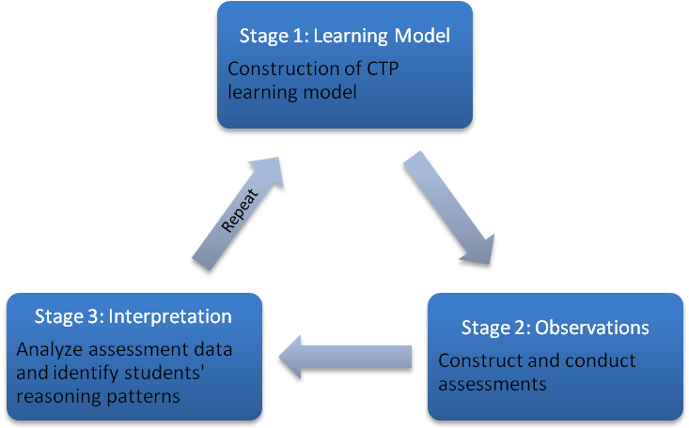
An outline of the iterative design framework used in this study to enhance the fit of assessment to the model of students’ reasoning.

- Iteration One of Design Cycle
  - Step one: develop hypothesis/model of student reasoning, from both prior work and existing education literature
    - literature provides wealth of misconceptions,
    - Examining these uncovered principles or key ideas that seem to underlie many seemingly disconnected misconceptions--problems with tracing and conserving matter and energy.
    - provide examples from realm of photosynthesis and respiration
  - Step two: develop and deploy instruments to test model; our primary measurement instruments are written assessments and interviews
    - Instruments often need to be developed, as in education these tools are not as available as standard measurement tools in ecology. This encompasses ideas of validity (similar to accuracy in ecology tools) and reliability (similar to precision): are the items actually uncovering the reasoning patterns you are interested in, and do they do so consistently?
    - We created assessments designed to uncover student reasoning about tracing and conserving matter and energy.
    - Items were either drawn from previously published sources or written directly for this study, with validation interviews conducted for key items.
  - Step three: analysis of data for two main purposes: checking assessment items are valid/reliable, and evaluating hypotheses/model about student reasoning (i.e. using assessments to revise model)
    - Describe the process of coding student answers reliably
    - Verifying the validity of the assessments using IRT: with examples from carbon project work
      - Wright maps that compare student proficiency with the difficulty of each step (from one level to the next) for each item.
      - Item fit statistics assessing the degree to which responses for each individual item are consistent with responses for other items (degree of randomness in student responses)
      - Information curves assessing the levels of student proficiency for which the DQC as a whole provides the most reliable assessments.
    - Combine IRT analyses with qualitative analyses of student answers to refine overall model
- Iteration Two of Design Cycle
  - Step one: Refinement of hypothesis/model of student reasoning
    - Iteration One uncovered an even deeper issue than students' problems tracing and conserving matter and energy: students using purely informal patterns of thinking instead of applying qualitative scientific models and principles.
    - Students’ reasoning is built informally and not developed from the small set of key principles underlying all scientific knowledge
  - Step two: revise assessments to more directly approach new model — provide example from the carbon project
    - include flexibility to accommodate range of student performances
  - Step three: to be completed as data is made available; as an iterative process we will revise our most recent model

- Discussion and Implications
- Summarize the rigorous process of developing and refining models and tools in educational research
- How using models of student reasoning can transform ecology teaching
  - They have potential for explaining student abilities over wide range, and allow anticipation of problems ahead of time
  - We have found this approach is most effective when faculty apply an abbreviated version of the design cycle to their instruction
    - faculty in the BioDQC project had to ground-truth for themselves the patterns in student thinking before they began to fully integrate that into their instruction
    - use data from Nancy Pelaez regarding faculty practices
  - How using these models might transform everyday teaching in a college setting (recall analogy to applied ecology and IPM):
    - Using assessments as diagnostics to inform instruction even when not developing your own model (e.g. formative assessment)
    - Using assessments as post-tests to recognize areas of instruction that need improvement
    - Using reasoning tools for scaffolding instruction
  - Examples of transforming instruction regarding the carbon cycle, including assessments and activities.
    - Implications of a hidden curriculum

Figure 1a. Conventional “Management”
Start
End
Scheduled interventions
Harvest
Conventional Industrial Agriculture
Sowing
Fertilizer, herbicide and pesticide scheduled before seeding
Start topic
Conventional Teaching
Exam
Lectures, activities, labs scheduled before starting

Figure 1b. Model-based “Management”
Model of students’ typical background knowledge and ways it is expressed, common problems with both those areas

Lectures, activities, labs planned with
anticipation of problem areas for students.

Formative assessment and informal observations

Lectures, activities,
labs adjusted in response to observations

Summative assessment,
Plan changes in how to teach this topic and related
topics in the course and in the future
Knowledge of the system
Prevention
Observations
Interventions

Evaluation
and Planning
Model of system including key pests, pest lifecycles, natural enemies, management options
Site selection, choice of variety, time of planting, water and nutrition management
Crop and insect population monitoring

Mechanical,
biological and
chemical controls in response to observations
Crop records, changes to management plan and techniques
Model-based teaching
Integrated pest management
Crop and insect population monitoring

