Analyzing open answer questions using

PASW Text Analysis for Surveys

Part II

PASW Text Analysis for Surveys PTAfS), former SPSS Text Analysis for Surveys, is a program that allows classifying open-ended responses in a set of categories based on words and phrases that are recognized by the software. The process of recognizing words is referred to as ‘extraction’ and the words and phrases are referred to as ‘terms’. The linguistic machinery of the software will put together terms that have similar meaning and will refer to them as ‘concepts’. This software has a great potential to be applied in the assessment of students learning in large-enrollment classes. The following steps will help a first-time user to start working with the software. Additional explanations for particular procedures can be found in either the User’s Guide or by clicking the Help button on the software.

- Dealing with fuzzy match, plurals and other word issues:
Fuzzy match is when the software extracts a word as a given term because of close spelling resemblance. For example, the word STARCH (which is a complex sugar) was extracted by the program as a spelling variation for the word STAR. To deal with situations like this the first thing to do is to go to the ‘Edit Advanced Resources’ which is in Resource Files under Tools (see screenshot below)**. A window will pop up with a list of exceptions for fuzzy grouping; add the words that should not be extracted as a same term and then go to File (in this same window) and click on ‘Save all and close’. See also pages 205-206 in the User’s Guide.
**Note that in v.3, there is not a Tools tab on the Resource Editor View. The Edit Advanced Resources is under the Resources tab

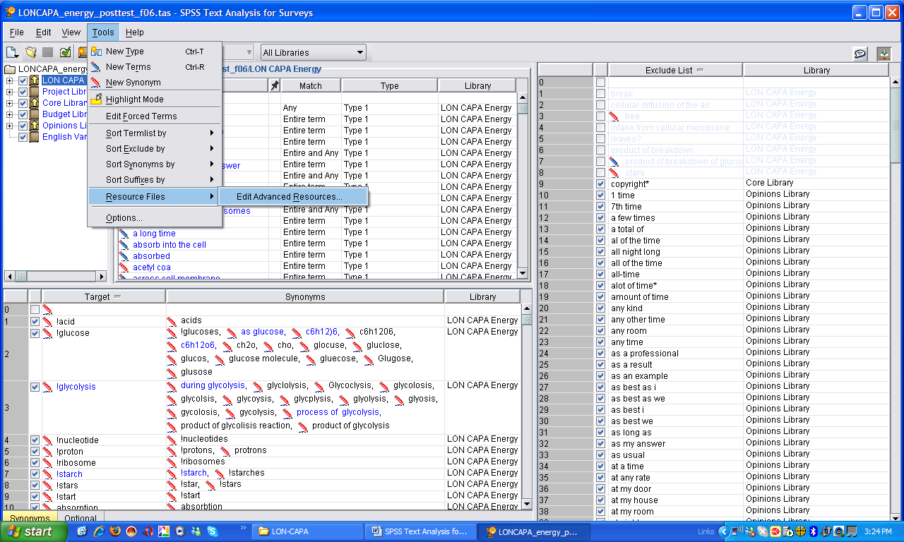

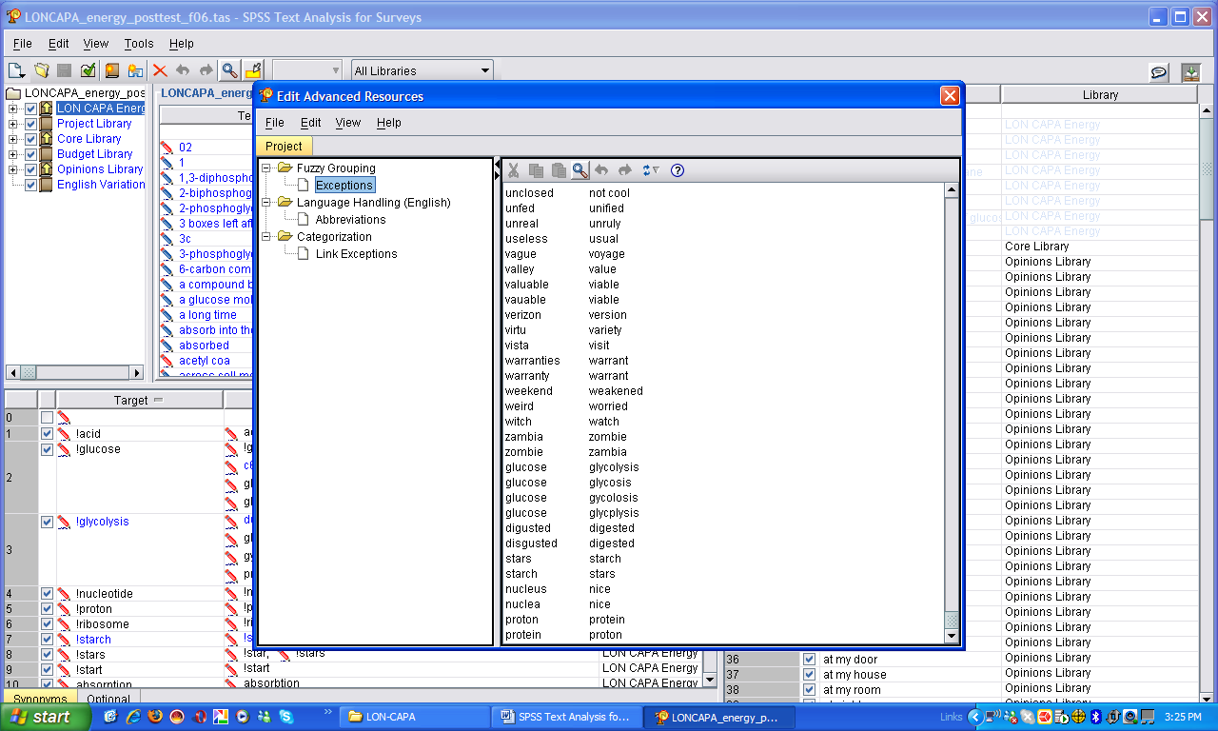

In those cases in which, in spite of having included the words in the list of exceptions for the fuzzy grouping they still are extracted as the same term, it is necessary to apply other editing tools, specifically an exclamation mark (!) preceding the target word. In the example given above, STAR vs. STARCH, by writing the words !starch and !star on different lines on the Substitution dictionary panel it is implied that we want those words extracted as they appear in the target column. Note that in this specific example, the exclamation mark precedes both the target word and the synonym word; usually it is only the target word that is preceded by the exclamation mark. The reason why the exclamation mark precedes both words is to avoid having them extracted as the same term, and by doing this the program differentiates between them. In general, any inflection added as synonyms (like plurals) will be extracted as the word after the exclamation mark. On the screenshot above can be seen some examples. More detail on how to deal with inflected forms of a word can be read on pages 192-193 on the User’s Guide.

- Forcing responses into a category:
Sometimes there is going to be an answer in which no words were extracted. If the answer uses words that we are not interested in adding to the project custom library, we can just force the response to the correspondent category (see also p. 132-133). For example, on the screenshot below it is shown that the response “honestly…” has not been extracted, and we were not interested in adding that word to our custom library. In this case, we just right-click on the response, select ’Force Response’ and then select the category to which we wanted to add it (in this case, ‘don’t know’). Only the selected response will be added to the selected category and this procedure will not alter that category. Force responses will be reflected on the categorized data but not on the category itself and therefore when we export a set of categories (see below), any forced response will not be exported.

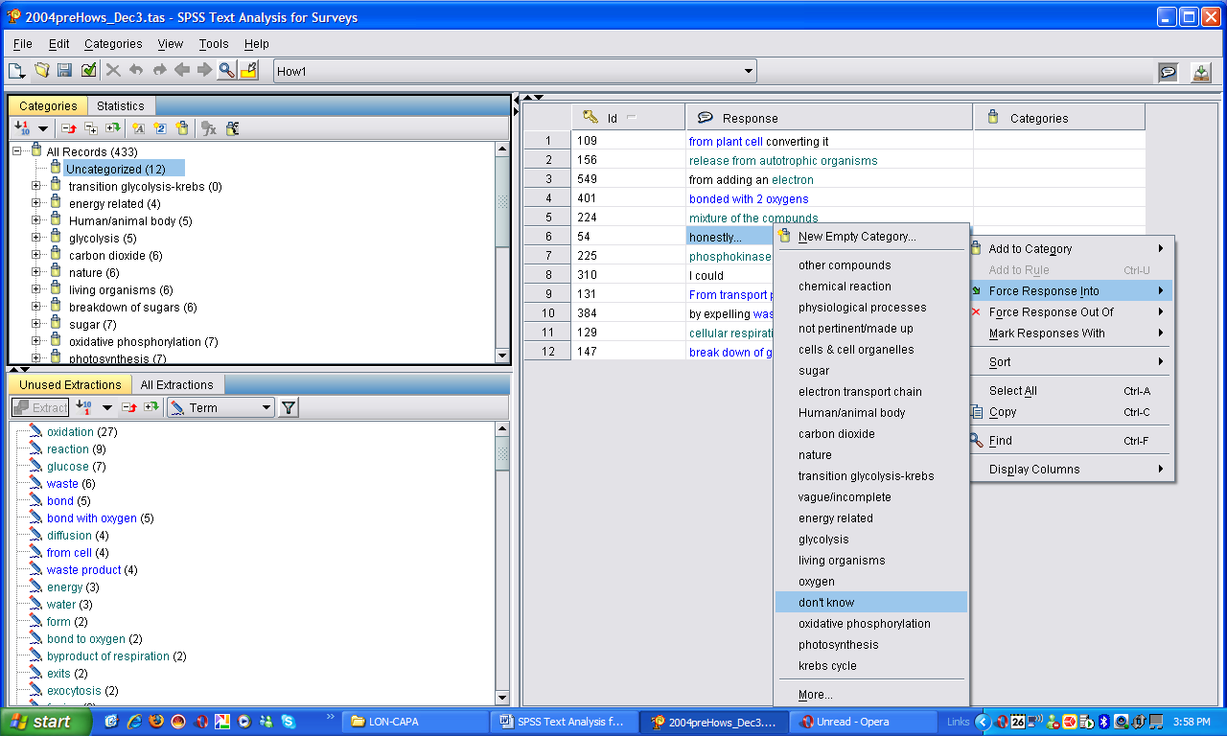

- Publishing, exporting and importing libraries:
Chapter 8 of the User’s Guide discusses working with libraries. In order to be able to work with a custom library in a new project, the library has to be published and then exported. To publish a library either right click on the library and click on ‘Publish’ while in the Dictionary Editor view, or click on the File window, then click on Library and then click on Publish…

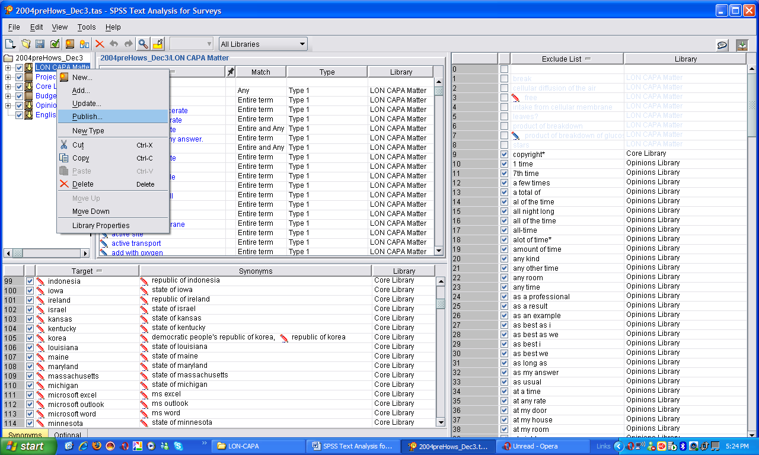

After publishing, to export the new custom library from a project, go to File, click on Library, then click on Manage Libraries… A window will pop-up showing the available libraries, select the target library and then click on the ‘Export…’ button (see screenshot below). This procedure will save the library in a file that can be shared with other users and used in other projects.

A library that has been exported and saved can be imported into a project following the same procedure as above to export libraries: go to File, click on Library, and then click on Manage Libraries… A window will pop-up showing the available libraries, select the target library and then click on the ‘Import…’ button.

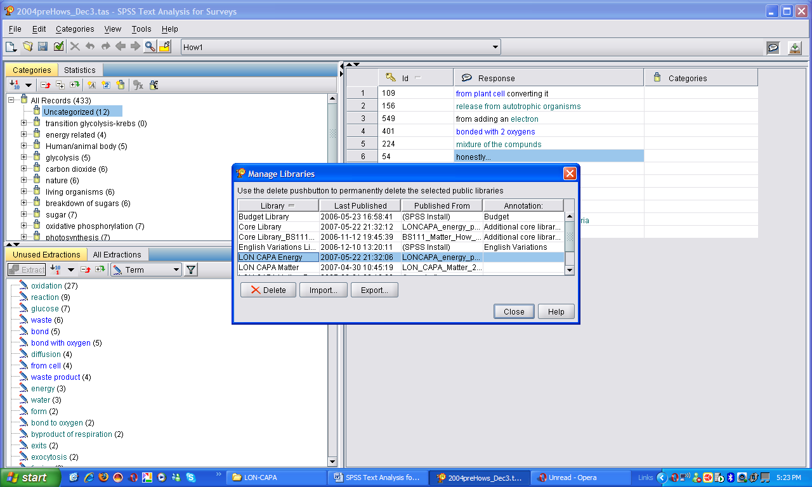

- Published vs. Local library versions
When an existing project is re-opened, a window will pop up asking the version of the library you want to open with the project, the local or the published version (see screenshot below). The direction of the yellow arrow will indicate which version is the most recent; i.e. on the screenshot below, the arrow is on the Published folder pointing to the Local folder, indicating that the local version is the most recent. Libraries can exist in these two versions. While you are working on a project, the libraries associated to your project are local libraries, until you publish them.

Local libraries cannot be shared with other users and only exist in your computer. If you make changes in your project library that you want to share with other users, the local version has to be synchronized with the published version. Synchronizing means publishing the modified local version of the library following the same steps indicated above (10. Publishing, exporting and importing libraries). Additional information can be found on pages 165, 167-168 of the User’s Guide.

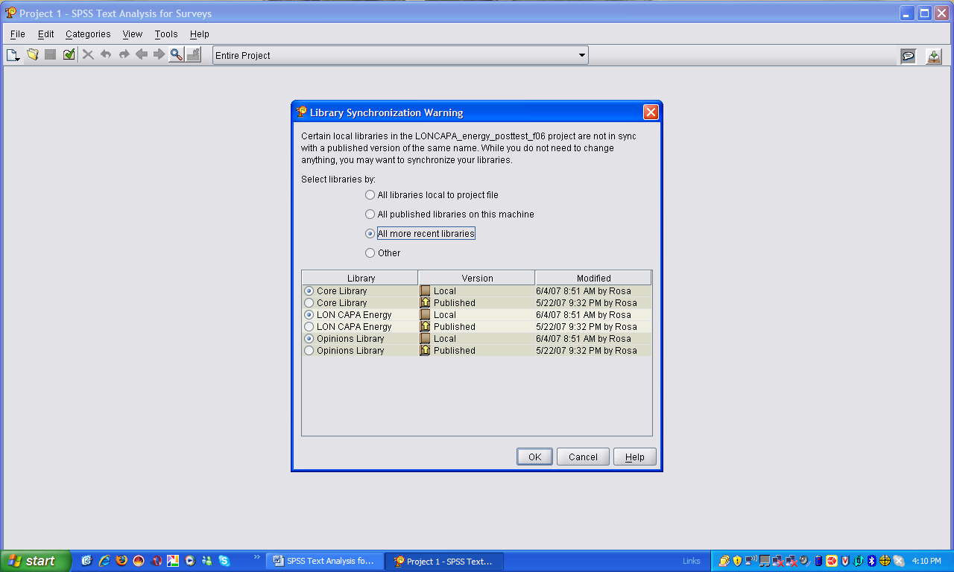

- Exporting and importing categories:
The process of creating appropriate categories for a project can be long and tedious, so it is one of our goals to create set of categories that can be re-used in new projects where similar questions are asked. To make a set of categories available to be re-used in a new project, it has to be exported; this is done by clicking on File, then Text Analysis Package, then Make Package. This will open a save dialog box where the Text analysis package (TAP) will be saved. In addition to give the file a name, you can add a label to the TAP, which can include further description to help the user remember the information included in the TAP. Make sure that the box next to the name of the project that has the relevant categories is checked before hitting the Save button. When a set of categories are exported, also conditional rules that were created for each category are exported, but forced responses are not.

In the steps above, it was explained how to start a project form zero. However, when there is already a set of categories that has been created and it fits your project, those categories can be re-used by importing them. To import a set of saved categories (in a TAP) into a new project, you can choose a custom TAP in the Categories and Resources window during the New Project Wizard (see Step 3 above). In the Categories and Resources window, click on the button that says “Choose package” and select the “Load custom package” option. Browse to the desired file location, select the TAP file and click the Finish button.

In v.3, categories, along with custom libraries, are saved as TAP.

- Update Data:
In general, the order of steps to create a new project are as follow: 1- import the data, 2- import project library, 3- extract terms, 4- import categories, and 5- update data. It is necessary to update the data to activate all rules in the categories and have real information of how many responses were categorized automatically. This is done by going to File and click on Update Data.

- Exporting PTAfS for statistical analysis:
Finally, the classification of responses done by PTAfS can be analyzed statistically. These data can be exported to other formats, including SPSS or Excel, for further analysis. This can be done by clicking on File, then click on Export and there click on the appropriate format. A window will pop up, make sure that on ‘Question:’ the Entire Project is selected. This will save a file that contents the list of categories followed by columns with zeros and ones.

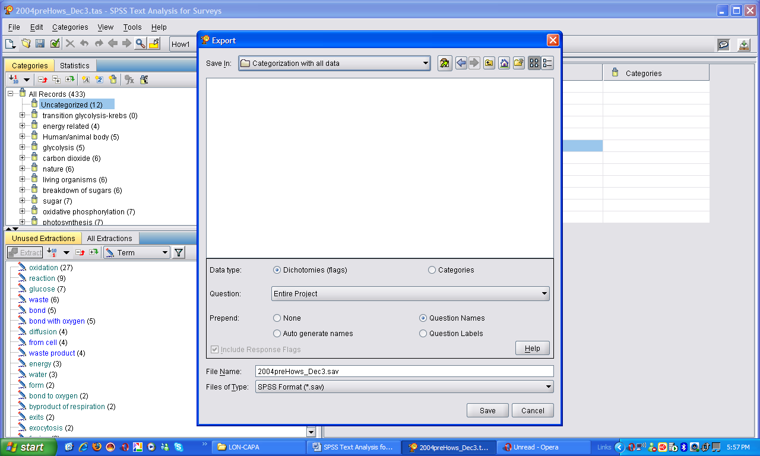

Some troubleshooting for PASW TAfS v.3x

- Creating TAPs from projects created using PTAfS v.2.x
The last version of PTAfS, now called PASW TAfS v.3.1, cannot import categories created from older versions projects. Instead, these categories, along with the associated custom libraries, can be re-used through TAPs. An older project can be opened using PASW TAfS v.3.1 and a TAP can be saved. However, there are some steps that need to be followed to successfully create a TAP:
  - Open the project created with PTAfS v.2.x using PASW TAfS v.3.1
  - After opening the project, publish all the libraries of the project (see #10, above)
  - Under the Resource Menu, click on Switch Resources…
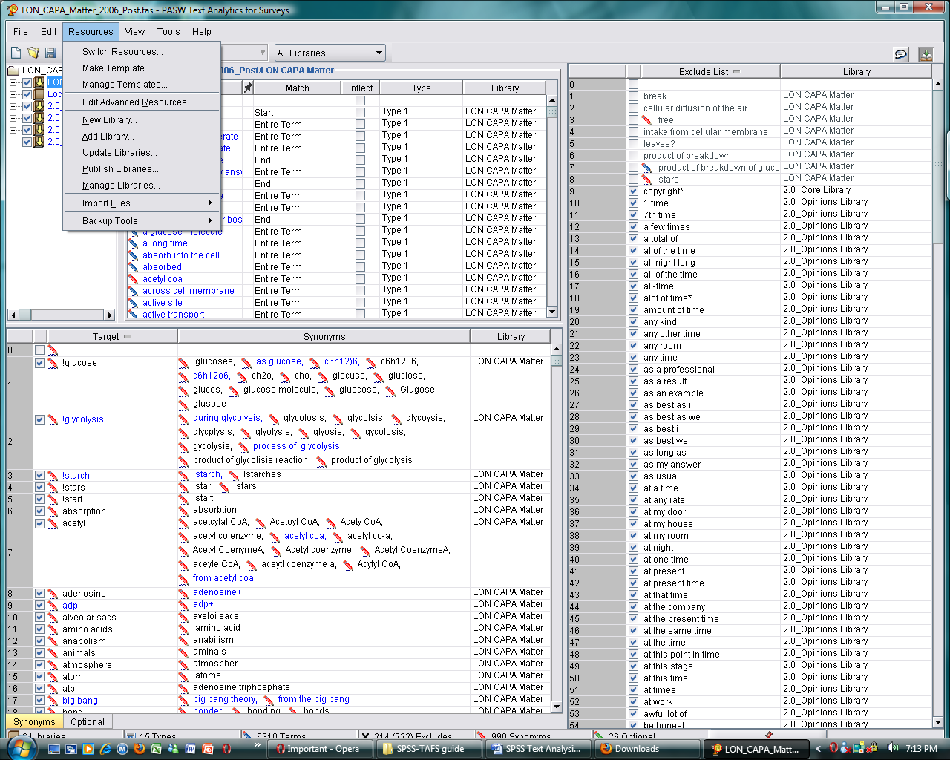

There will be ready-made 3.1 Library template (in our case, the only relevant one is Opinions), double click on it to pick that library up
  - Add the custom library associated to the project (see #10, above)
  - Next, SAVE the project. If you use the same file name, you will overwrite your 2.x project with a 3.x project version that cannot be read in version 2.x. You may want to give the project a new name and keep the original version.
  - If you wish to use your categories in other project, you must create a Text Analysis Package (TAP) from this project. To do so see step 12 above.

