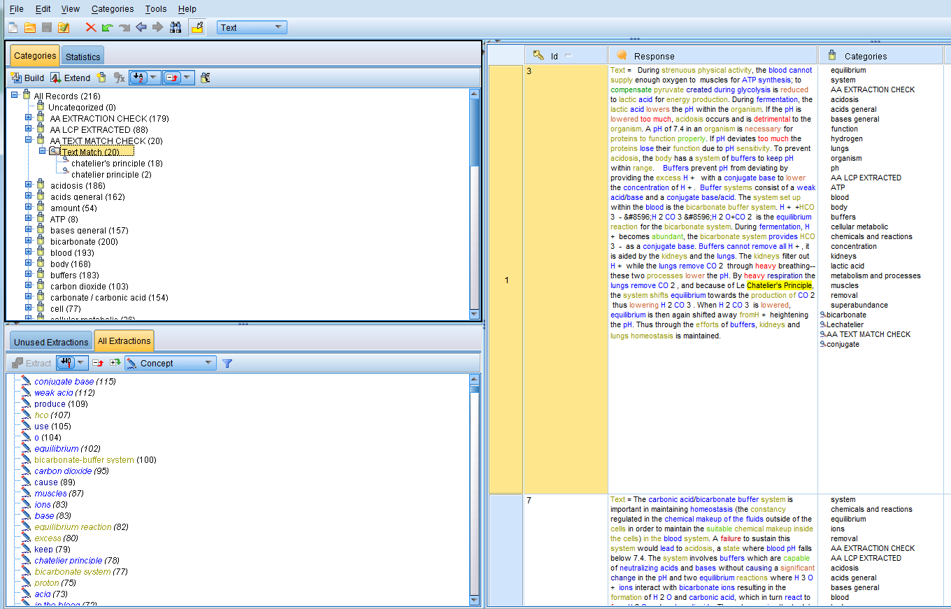
The text match I created, including both “chatelier’s principle” and “chatelier principle.” Selecting this brings up all responses in which these strings of characters have been identified, and highlights the instances of these within the responses.
Note how the sequence of responses goes from 3 to 7, indicating that no responses in between should have “chatelier’s principle or “chatelier principle” written in them
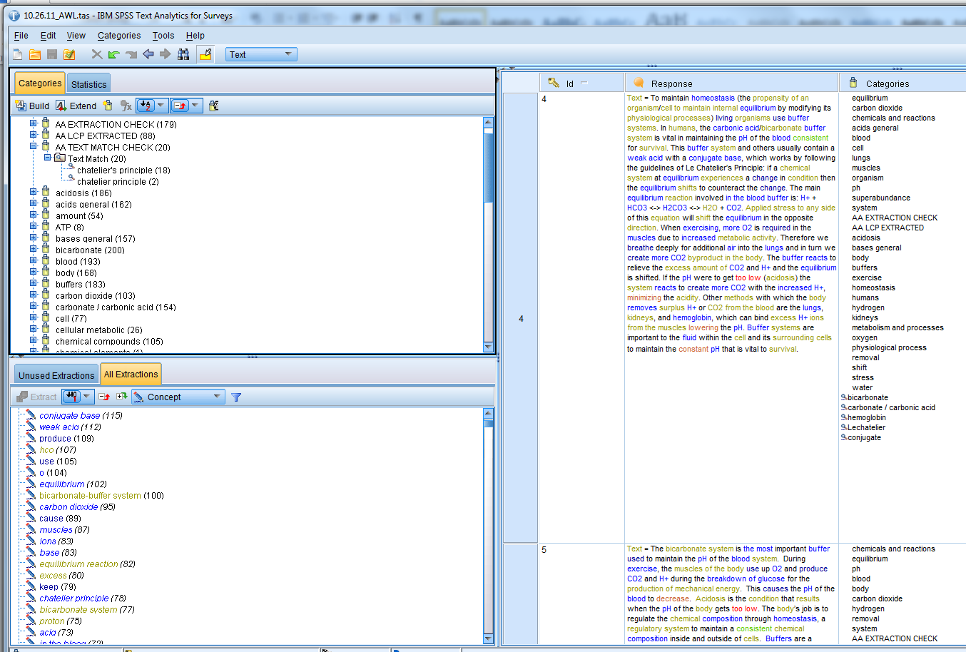
But when I go to response 4, you can see that it contains the string of characters “chatelier’s principle.” This string of characters was not identified by the text match, even though it should have been.

