1. Start STAfS, and open the existing old project by navigating to the correct file location.

2. After project is open, go to File menu and choose Change Data Source
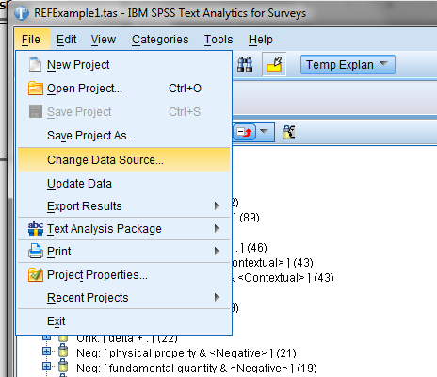

3. On first screen select type of data source (most likely an excel file), then navigate to the correct file location of the new data you wish to use. After selecting the file name, make sure that the worksheet is the correct one too (this is near the bottom of the pop-up window). Click Next
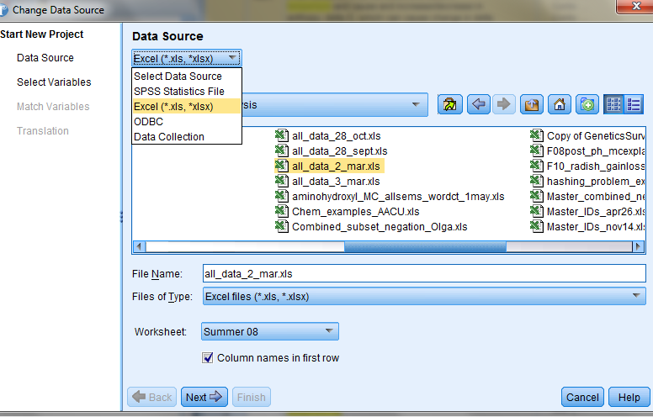

4. Choose the column with identifiers and those containing the text you wish to analyze (you can choose more than one text column if you wish). If you have multiple text columns and don't want the program to extract all the data immediately in order to save a bit of time, make sure to change the "Automatically extract" option to "None" on this menu. Click Next
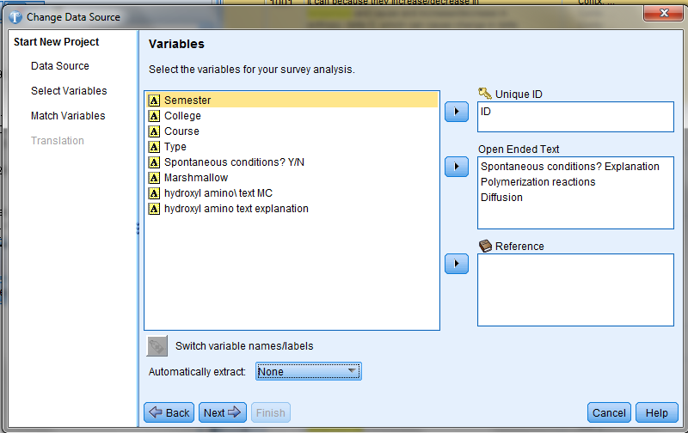

5. Matching variables. This screen should show all the existing data sheets in the old project and which columns from the new data sheet should be matched to the old project. You can change which text column by clicking on a name in the "Replace With" column. You can also choose to replace an old project with "None" (by clicking in the Replace With column) if you don't have new data to match all the old data. If you have more new data than existed in the old project, the unmatched new data will appear in the box called “New open ended question”.
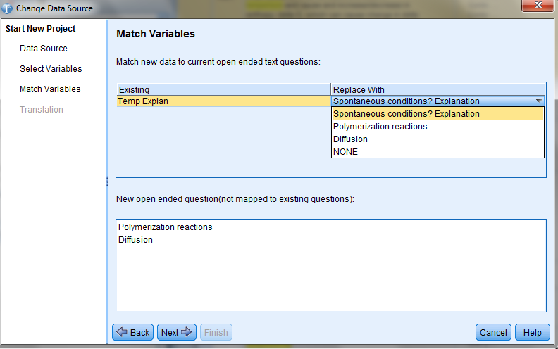

After you've set-up the appropriate matches, click Next.

6. The last screen is Translation, which doesn't concern us, simply click Finish.

7. If everything has been done properly, the new data should appear in the old project, i.e. existing old categories and old libraries being used to analyze the new data. Make sure to save this new STAfS project with a new file name! If you didn't select automatically extract in step 4, you'll need to hit extract before all the results are updated.

