Updated Categories and Cluster for “Spontaneous” Thermodynamics question

Stream saved as Spontaneous Report 3.str

Revised with spell-checked responses from
Source file: ThermoAllResponses Sept.sav

Using package: spontaneous rpt Sept5_C.tap

Categories included in K-means 3- cluster analysis are in the figure below.
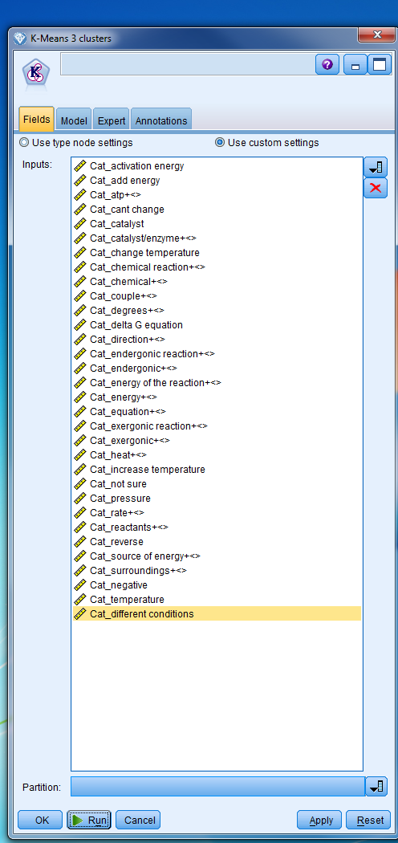

The following output was produced

Cluster Analysis Results

