Changes to Genetics Libraries

At GBM , Q1 and Q5

1. Dna and genome broken up as synonyms
2. Disconnect = shutdown, when disconnect synonym unchecked then close down= shut down; close down cannot be found.
3. Targets (synonyms) unchecked
   1. Disconnect (shutdown)
   2. Better(produce)
   3. Develop(produce)
   4. Creative (original)
   5. Meaningless (nonsense)
4. Ss
   1. Target – better : removed – ^develop$

|  |  |  |  |
| --- | --- | --- | --- |
|  | Target | Synonyms removed | Synomyns add |
| opinions | Better | ^develop$ |  |
| Genetics core | Develop | Make, create, created, produce, produces, produced |  |
| Opinions | Produce (added as new) | Produces, produced |  |
| Opinions | Creative | Original |  |
| Opinion | Meaningless | Nonsense, nonsence, non-sense |  |
| Opinion | Nonsense(added as new) | Nonsence, non-sence |  |

Changes for Q3

* GeneticsUnique Feb 2012 library : “Still be” should be entire no compounds
* “will not effect” changed to entire no compounds
* “not influence” change to entire no compounds
* GeneticsUnique Feb 2012 library: remove
  + “influence DNA replication”
  + “does not influence DNA replication”
  + Not influence DNA replication
  + Not affect DNA replication
* Synonyms
  + “Will not effect” removed as a synonym of “will not” genetics unique Feb 2012
  + Deleted “does not influence DNA replication” from synonyms
  + Deleted “will continue” as synonym of “no intention to change” opinions GBM
  + Deleted “C” as a synonym of “carbon” – genetics core
  + Deleted “!length” and “length” as synonyms of “too long”
  + Created new target “shorten” with synonym “shortens”
  + Deleted “compliment” as a synonym of “excellent” in opinions GBM
  + Turned off excellent in regular opinions library

Screenshot of Genetics Q3 categories May 9prior to changes to categories: DNA replication affected and DNA replication unaffected

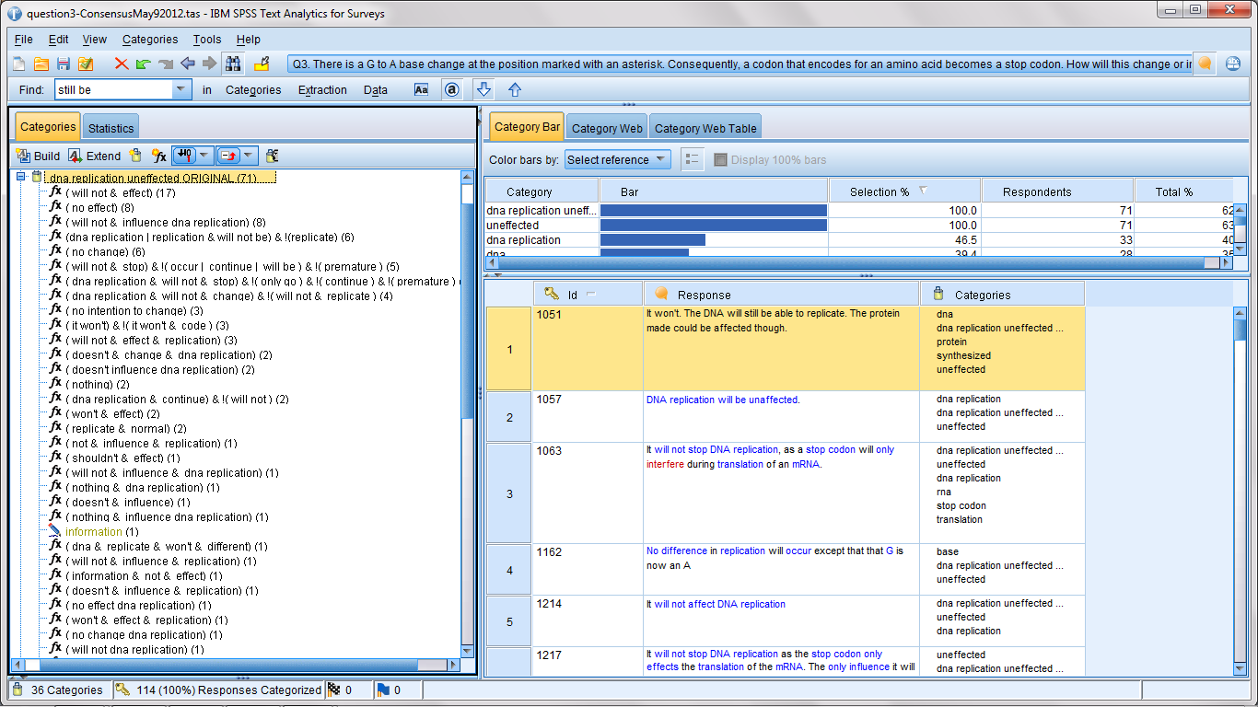

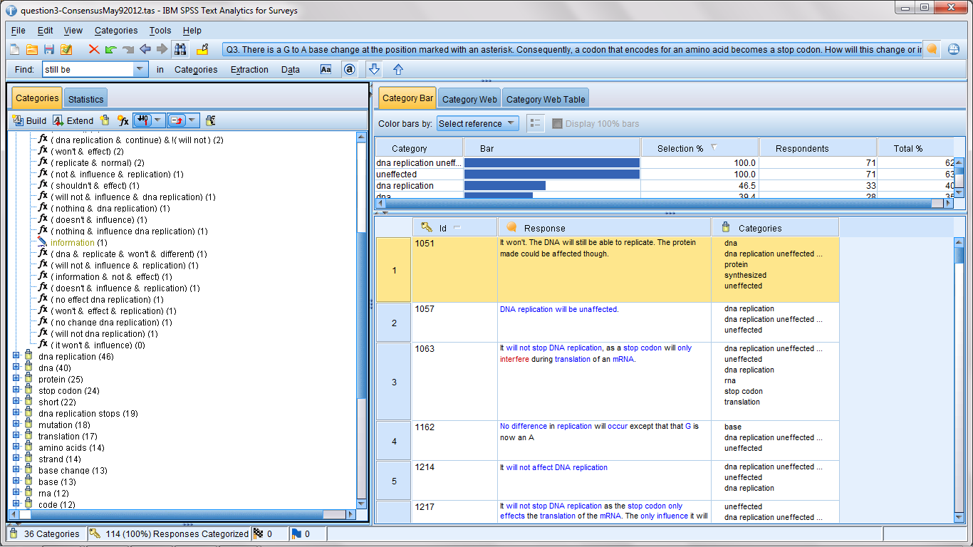

Copy of: rules beginning with copy of have not been rectified:

Working to see if these can be parsed into a few rules…common themes so far:

Does not/will not stop replication/DNA replication 3

Still be able to replicate

Will continue.