**Extraction Error Screen shot**

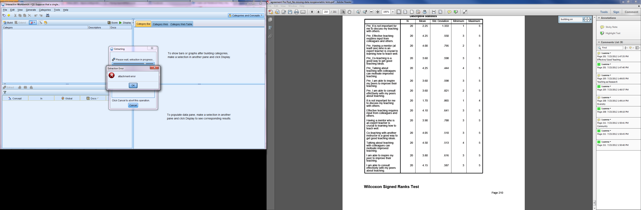

**In the Source (Excel) node: Rename variables (fields) for IBM SPSS Statistics**

