


DGE-METRIC: A Dynamic General Equilibrium Model for Vietnam’s Energy Transition
Technical Report
Christoph Schult
Halle (Saale), 30.07.2026

Prepared under the joint GIZ–IWH research project supporting Vietnam’s energy and climate policy dialogue.
How to use this document. This is the methodological companion to the PDP8 Macroeconomic Impact Assessment, which presents policy findings. This report documents the model, its data foundations, its solution method, and its limitations, so that results can be reproduced, audited, and extended. It is written to convert cleanly to Word/PDF (e.g. via pandoc) for circulation as a standalone technical annex.
Reporting conventions used in this technical report. The document follows standard technical-report practice used by international financial institutions: (i) clear separation of evidence, assumptions, and modeled outcomes; (ii) explicit statement of limitations and interpretation risks; (iii) figure-by-figure documentation using caption, note, and source; and (iv) reproducibility through direct file and script references.

Table of Contents
Table of Contents I
List of Figures III
List of Tables III
Abbreviations IV
Executive Summary V
1 Introduction and Motivation 1
1.1 The Policy Motivation 1
1.2 Scope of the Model 2
2 Model Structure 3
2.1 Sectors 3
2.2 Representative Household 4
2.3 Firms and production structure 5
2.4 Wholesale, Retail, and Export Sectors 5
2.5 Government and the Emissions Trading System 6
2.6 Key extensions beyond a textbook DGE model 7
2.7 External sector 7
3 Data and Calibration 8
3.1 Data sources 8
3.2 Calibration workflow 10
3.3 Calibration Consistency 10
3.4 Code defaults vs. active calibration 11
3.5 Baseline Validation and Diagnostic Assessment 11
4 Solution Method 16
4.1 Dynare perfect-foresight solving 17
4.2 Steady-state / calibration pipeline 17
4.3 Simulation 18
4.4 Verification approach 19
5 Scenario Design Framework 21
5.1 Nested-counterfactual logic 21
5.2 Net-Zero decomposition 22
5.3 Green finance as a reduced-form cost-of-capital shock 23
5.4 Operational status vs. scenario capability 24
5.5 EE scenario reporting figures 24
5.6 Green finance scenario reporting figures 29
6 Limitations, Implementation Risks, and Interpretation Guidance 33
7 Conclusion 34
References 35
A. Technical Appendix 36
A.1 Equation reference 36
A.2 Parameter reference 36
A.3 Repository map 36

List of Figures
Figure 1: Expenditure-side GDP components: actual 2019 vs simulated baseline start and end. 9
Figure 2: Baseline simulation vs PDP8 target for renewable installed capacity (end-year levels). 13
Figure 3: Baseline simulation vs PDP8 target for fossil installed capacity (end-year levels). 14
Figure 4:Baseline simulation vs PDP8 target for renewable investment share. 15
Figure 5:Baseline simulation vs PDP8 target for fossil investment share. 16
Figure 6: Hierarchical organisation of the DGE-METRIC scenario framework 21
Figure 7: Energy-intensity deviation of EE scenarios from the Baseline. 26
Figure 8: Government consumption share deviation versus Baseline (5-year average). 26
Figure 9: Housing investment share deviation versus Baseline (5-year average). 27
Figure 10: Net exports share deviation versus Baseline (5-year average). 27
Figure 11: GDP level deviation versus Baseline across EE scenarios (5-year average). 28
Figure 12: Consumption share deviation versus Baseline across EE scenarios (5-year average). 28
Figure 13: Investment share deviation versus Baseline across EE scenarios (5-year average). 29
Figure 14: GDP growth deviation versus Baseline across green-finance scenarios (5-year average). 29
Figure 15: GDP level deviation versus Baseline across green-finance scenarios (5-year average). 30
Figure 16: Consumption share deviation versus Baseline across green-finance scenarios (5-year average). 30
Figure 17: Investment share deviation versus Baseline across green-finance scenarios (5-year average). 31
Figure 18:Government consumption share deviation versus Baseline across green-finance scenarios (5-year average). 31
Figure 19: Housing investment share deviation versus Baseline across green-finance scenarios (5-year average). 32
Figure 20:Net exports share deviation versus Baseline across green-finance scenarios (5-year average). 32
Figure 21: Renewable-energy WACC deviation versus Baseline across green-finance scenarios (5-year average). 33

List of Tables
Table 1: Sectoral classification 4
Table 2: Model Extentions 7
Table 3: Sectoral classification 8
Table 4 23

Abbreviations
BESS Battery Energy Storage System
CMIP6 Coupled Model Intercomparison Project Phase 6
COP26 26th UN Climate Change Conference of the Parties
DGE Dynamic General Equilibrium
DGE-METRIC Dynamic General Equilibrium Model for Vietnam’s Energy Transition Incorporating Carbon Markets
EDGAR Emissions Database for Global Atmospheric Research
ETS Emissions Trading System
EVN Electricity of Vietnam
EXIOBASE Environmentally Extended Multi-Regional Input-Output Database
FDI Foreign Direct Investment
GIZ Deutsche Gesellschaft für Internationale Zusammenarbeit
GDP Gross Domestic Product
IEA International Energy Agency
IRENA International Renewable Energy Agency
IWH Halle Institute for Economic Research
IO Input-Output
KfW Kreditanstalt für Wiederaufbau
LCOE Levelized Cost of Energy
NDC Nationally Determined Contribution
NSO National Statistics Office
OECD Organisation for Economic Co-operation and Development
PDP8 Power Development Plan 8 PV
Photovoltaic SSP Shared Socioeconomic Pathway
USD United States Dollar
UIP Uncovered Interest Parity
WACC Weighted Average Cost of Capital
WACF Weighted Average Cost of Finance

Executive Summary
The DGE-METRIC (Dynamic General Equilibrium for Macroeconomic Energy Transition Incorporating Carbon markets) model was developed to analyse the macroeconomic implications of Vietnam’s energy transition and to evaluate alternative pathways for achieving the objectives of the Power Development Plan 8 (PDP8) and the country’s net-zero emissions commitment by 2050. The model provides a quantitative framework for assessing how alternative energy and climate policies affect economic growth, investment, sectoral production, household welfare, public finances, and carbon emissions over the transition period.
Unlike engineering-based energy system models, which focus on technology deployment and electricity-system optimisation, DGE-METRIC captures the economy-wide interactions between investment, production, consumption, labour markets, international trade, and climate policy. This integrated perspective enables the assessment of transition pathways within a consistent macroeconomic framework, allowing policy interventions in the energy sector to be evaluated alongside their broader economic consequences
The model is formulated as a deterministic, forward-looking dynamic general equilibrium (DGE) model implemented in Dynare and MATLAB. It represents Vietnam as a five-subsector, one-region economy, comprising a representative household, firms operating in five production sectors, wholesale and retail trade, an exporting sector, a government with an emissions trading system (ETS), and the rest of the world. The model is calibrated to Vietnam’s 2019 input-output structure and a 2026 baseline and is solved over the 2026–2050 transition horizon, drawing on data from the National Statistics Office (NSO), Electricity of Vietnam (EVN), the International Energy Agency (IEA), EDGAR, the World Bank, and project-specific (GIZ/IWH)calibration inputs.
The report documents the theoretical foundations, calibration strategy, and numerical implementation of the model, together with the construction of the policy scenarios used throughout the analysis. It explains how baseline and scenario pathways are translated into model inputs, how the perfect-foresight transition path is solved, and how key assumptions regarding technology, emissions, and financing are incorporated into the modelling framework. The report also discusses the principal limitations of the approach and provides guidance for the interpretation of simulation results.
Taken together, these elements provide a transparent and reproducible modelling framework for analysing the macroeconomic consequences of Vietnam’s energy transition and for supporting evidence-based policy analysis on climate, energy, and green finance.

Introduction and Motivation

The Policy Motivation
Vietnam’s energy transition represents one of the country’s most significant long-term development challenges. Achieving sustained economic growth while simultaneously transforming the electricity sector to meet national climate objectives requires unprecedented levels of investment, coordinated policy interventions, and substantial structural adjustment across the economy. Decisions regarding the timing, scale, and financing of these investments will shape not only the future energy system but also broader economic development over the coming decades.
To achieve the objectives of the Power Development Plan 8 (PDP8) and Vietnam’s commitment to reach net-zero greenhouse gas emissions by 2050 (COP26 NDC), the country is estimated to require approximately USD 136 billion of investment in the energy sector by 2050 (IWH Investment Needs Assessment, 2025). At the same time, Vietnam aims to sustain annual GDP growth of around 6–7%, increase the share of renewable electricity generation to 60%, phase out the expansion of coal-fired power generation after 2030 (PDP8, Decision 500/QD-TTg, 2023), and meet its Nationally Determined Contributions under the Paris Agreement.
Bottom-up energy-system models (capacity expansion, LCOE, dispatch) play a central role in energy planning by identifying cost-effective technology portfolios, evaluating generation capacity expansion, and analysing system operation. these models are not designed to quantify the broader macroeconomic consequences of alternative transition pathways. In particular, they cannot directly address economy-wide questions such as:
- What are the macroeconomic costs of meeting PDP8 investment requirements in terms of GDP, household consumption, investment, and employment?
- To what extent does achieving net-zero emissions impose additional economic costs beyond those already associated with implementing PDP8?
- How do improvements in energy efficiency affect investment requirements and long-term economic performance?
- How do alternative green-finance architectures influence the pace, affordability, and macroeconomic impacts of the energy transition?
- Which carbon-price trajectories are consistent with alternative transition pathways?
- Which sectors experience the largest structural adjustment during the transition?
Addressing these questions requires an economy-wide analytical framework that captures the interactions between the energy sector and the broader economy. Investment in low-carbon technologies competes for capital and labour with investment in other sectors, while changes in energy prices, production costs, household income, international trade, and public finances generate adjustment effects throughout the economic system. DGE-METRIC was developed to analyse these interactions within a consistent forward-looking general equilibrium framework and to quantify the macroeconomic implications of alternative energy-transition pathways.

Scope of the Model
DGE-METRIC is a reduced-form dynamic general equilibrium model designed to analyse the economy-wide consequences of Vietnam’s energy transition. It combines a detailed representation of the energy sector with a comprehensive macroeconomic framework that captures interactions between households, firms, government, international trade, capital accumulation, and carbon pricing. Rather than determining optimal technology choices, the model evaluates the economic implications of externally specified policy pathways and investment trajectories.
As with any macroeconomic model, DGE-METRIC deliberately abstracts from several aspects that are more appropriately analysed using specialised engineering or financial models. In particular, the model does not:
- optimise electricity dispatch or represent individual power plants;
- endogenously model technology learning and cost reductions;
- distinguish between sub-national regions or provincial governments.
Similarly, technology cost projections, renewable deployment pathways, and capacity expansion plans are taken as exogenous inputs based on official planning documents and international energy outlooks rather than being determined endogenously within the model.
Consequently, DGE-METRIC should be viewed as complementary to engineering-based energy system models rather than as a substitute for them. While engineering models identify technically feasible and cost-efficient energy-system configurations, DGE-METRIC evaluates the broader macroeconomic consequences of implementing these pathways. Together, the two modelling approaches provide a more comprehensive evidence base for assessing Vietnam’s transition towards a low-carbon economy.

Model Structure
DGE-METRIC is a deterministic, forward-looking dynamic general equilibrium model developed to analyse the macroeconomic implications of Vietnam's energy transition. The model represents Vietnam as a small open economy in which households, firms, government, and the rest of the world interact through interconnected markets for goods, labour, capital, international trade, and emissions permits. Within this framework, changes in energy policy affect not only the energy sector itself but also production costs, household welfare, investment decisions, public finances, and external trade, allowing the economy-wide consequences of alternative transition pathways to be analysed in a consistent manner.
The model is formulated as a five-sector, one-region economy and is solved as a deterministic perfect-foresight transition path over the period 2026–2050. The perfect-foresight framework reflects the nature of the policy questions considered in this report, where major policy interventions—including the implementation of PDP8, emissions reduction targets, and alternative green-finance strategies—are represented as anticipated long-term policy pathways rather than unexpected economic shocks.
The economy consists of a representative household, firms operating in five productive sectors, wholesale and retail trade, an exporting sector, a government that operates an emissions trading system (ETS), and the rest of the world. These agents are linked through markets for intermediate goods, labour, capital, emissions permits, and internationally traded goods, forming a coherent representation of the economic mechanisms through which the energy transition affects aggregate economic performance.

Sectors
The model distinguishes five production sectors that capture the principal channels through which the energy transition influences Vietnam's economy. The chosen level of aggregation represents a compromise between economic structure, data availability, and computational tractability. In particular, the explicit separation of fossil and renewable energy production enables the model to analyse structural changes within the electricity sector and to evaluate policies targeting fuel switching, renewable deployment, and carbon pricing.

Table 1: Sectoral classification
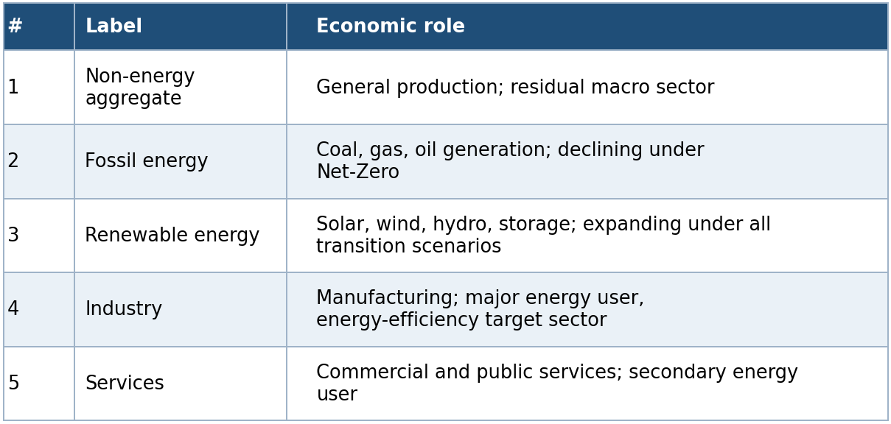
Source: own depiction.
Following the detailed sectoral representation used within the model, results are also reported for a more aggregated sector classification in which the fossil and renewable energy sectors are combined into a single energy sector. This produces the four-sector reporting structure—Primary, Energy, Secondary, and Tertiary—that is used throughout the presentation of simulation results. Capital and labour are mobile across sectors in response to changes in relative prices, while the energy sectors supply intermediate inputs to the non-energy production sectors.

Representative Household
A representative household maximizes discounted lifetime utility by choosing consumption, labour supply, housing, savings, and investment over the transition horizon. Household decisions determine the allocation of labour across production sectors and the accumulation of physical and housing capital, thereby linking current economic decisions with future production possibilities. The forward-looking nature of the household ensures that anticipated policy changes influence behaviour before they are fully implemented, an important feature for analysing long-term transition policies.
A representative household derives utility from consumption C_t, housing services H_(t+1), and disutility from supplying labor N_(s,t) across sectors s ∈ \1,…,S\:
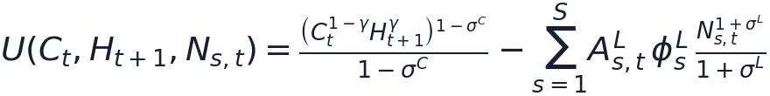
where γ is the preference weight on housing, σ^C the inverse intertemporal elasticity of substitution in consumption, and σ^L the inverse Frisch elasticity of labor supply. Labor disutility is scaled by sector-specific labor productivity A^L_(s,t) and calibrated weights φ^L_s that pin down realistic long-run sectoral labor shares.
The household chooses consumption, sectoral labor supply, sectoral investment I_(s,t), next-period sectoral capital K_(s,t+1), housing H_(t+1), and net foreign asset holdings B_(t+1) to maximize discounted lifetime utility Σ_t β^t U(·) subject to:
- a budget constraint (income = expenditure);
- sector-specific capital accumulation, $K_{\left(s,t+1\right)}=\left(1-δ\right)K_{\left(s,t\right)}+I_{\left(s,t\right)}Γ_{\left(,t\right)}-D_{\left(s,t\right)}^{K}$, where climate damages $D_{\left(s,t\right)}^{K}$ reduce the capital stock directly;
- housing accumulation, $H_{\left(t+1\right)}=\left(1-δ^{H}\right)H_{t}+I_{t}^{H}-D_{t}^{H}.$
Income sources are rental income from sector-specific capital, labor income across sectors, and returns on foreign bond holdings; foreign borrowing carries a debt-elastic risk premium (§3.7, §5.3).

Firms and production structure
Production is carried out by profit-maximizing firms operating in each of the five sectors. Firms combine intermediate inputs Q^I_(s,k,t), labour L_(s,t), and capital K_(s,t) to produce sectoral output while responding to changes in relative prices, wages, capital costs, and carbon prices. The nested production structure allows substitution between production factors and intermediate inputs while preserving the input-output relationships that characterize Vietnam's economy:

Sector-specific emission intensity κ^E_(s,t) is proportional to output and can vary over time (the channel through which fuel-switching and emission-intensity scenarios operate). Final output is a CES (or Cobb-Douglas, when the elasticity equals 1) aggregate of intermediate inputs and value added; value added is a CES/Cobb-Douglas aggregate of effective labor and capital; intermediate inputs are themselves a CES aggregate across sectors of origin. This production structure enables the model to capture both direct effects of climate and energy policies on individual sectors and indirect effects transmitted through intermediate input linkages across the economy. See model.md for the full equation set (production, value-added, and intermediate-aggregation identities, wholesaler/retailer/exporter blocks).

Wholesale, Retail, and Export Sectors
Domestic production and international trade are linked through wholesale, retail, and export sectors that combine domestic and imported goods using constant-elasticity-of-substitution (CES) aggregation functions. These sectors determine the composition of intermediate and final demand while allowing domestic and imported products to substitute imperfectly in response to relative price changes.
A representative wholesaler in each subsector combines domestic and imported intermediate goods to supply both intermediate demand and final retail demand. A representative retailer combines domestic goods and imports for final use (consumption, investment, and government spending) via a CES nest. An exporter aggregates subsectoral exports into a single export good sold to the rest of the world. Elasticities of substitution between domestic and imported goods (η^Q_s, η^F) and origin-sector home bias (ω^Q_s, ω^M_s) are sector-specific calibrated parameters.

Government and the Emissions Trading System
The government fulfils two principal functions within the model. First, it collects taxes on consumption τ^C_tC_t, labor and capital income , provides public expenditure, and maintains the public budget according to a reduced-form fiscal framework, i.e. tax rates on consumption, labor, and capital income are constant over time (no endogenous fiscal feedback rule), . Second, it operates an economy-wide emissions trading system (ETS), which establishes an endogenous carbon price consistent with an exogenously specified emissions cap. This representation enables the model to analyse how carbon pricing influences production decisions, investment, and the overall cost of achieving alternative emissions targets.

Under the ETS, firms hold allowances for covered emissions; the carbon price P^E_t clears the permit market against the cap. Government debt B^G_t is serviced at the world interest rate, and the government faces the same interest-rate schedule as households. Because tax rates are fixed, any change in government revenue from climate policy flows entirely through the tax base and the ETS revenue term, not through an endogenous rate response.

Key extensions beyond a textbook DGE model
While DGE-METRIC builds upon the standard dynamic general equilibrium framework, it incorporates several extensions that enable the analysis of long-term energy transition policies. These extensions adapt the core model to the specific characteristics of Vietnam's energy sector and climate policy objectives while preserving the internal consistency and behavioural foundations of a dynamic general equilibrium model. Table 2 summarises the principal extensions incorporated into DGE-METRIC.
Table 2: Model Extensions
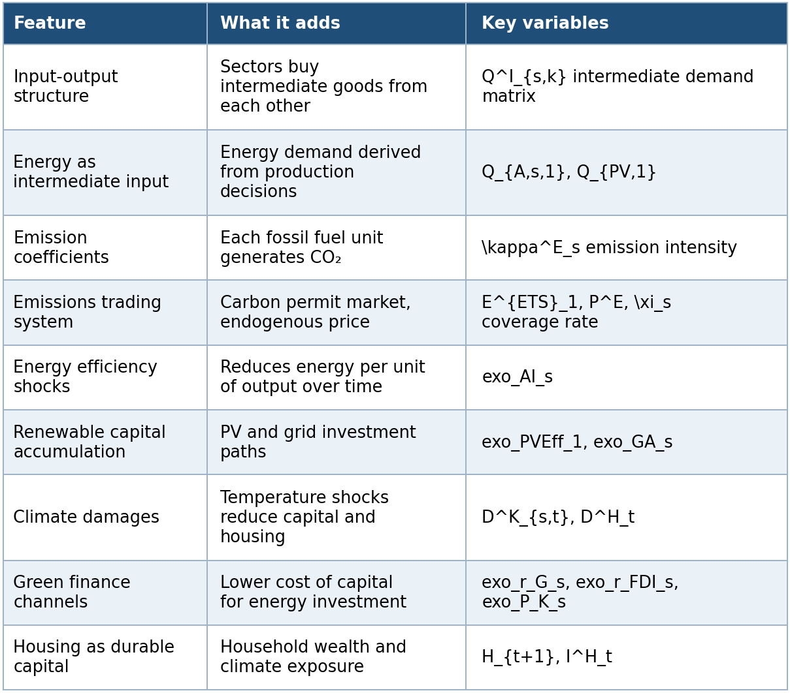
Source: own depiction.

External sector
Vietnam is represented as a small open economy that trades goods and financial assets with the rest of the world. The external sector determines exports, imports, foreign borrowing, and the evolution of net foreign assets, thereby linking domestic investment and consumption decisions with international capital markets. To ensure a stable long-run equilibrium, the model employs a debt-elastic external finance premium and a standard stationarity closure for foreign asset accumulation.
Net foreign assets follow a law of motion linked to the trade balance; the external finance premium is debt-elastic, exp(-φ_B · external_position_gap/Y), with an additional quadratic adjustment cost (φ_(adjB)) — a standard closure device for stationarity in small open-economy models. The exchange-rate variable s_(reg) is not a full UIP-style nominal exchange-rate block: it follows an AR(1) process when exo_lNXTarget = 0, or becomes the balancing variable that enforces a target net-exports/GDP ratio when exo_lNXTarget = 1 (the baseline mode). Treat s_(reg) as an external-balance closure/valuation factor, not a nominal exchange rate in the conventional sense (see dev/model_consistency_and_calibration_findings_2026-07-14.md).

Data and Calibration
The credibility of a computable general equilibrium model depends critically on the consistency between its theoretical structure and the empirical data used for calibration. DGE-METRIC combines national accounts, energy statistics, emissions inventories, international datasets and project-specific assumptions to construct a representation of Vietnam's economy that serves as the reference point for all policy simulations. Calibration therefore serves two complementary purposes: it ensures consistency with observed economic data and provides the benchmark from which all scenario analyses are conducted.
The model is calibrated to Vietnam's 2019 input-output structure, representing the latest comprehensive benchmark prior to the economic disruptions associated with the COVID-19 pandemic, and uses a 2026 baseline as the starting point for forward-looking simulations over the period 2026–2050.

Data sources
Detailed documentation of the underlying datasets and variable mappings is maintained in the accompanying technical documentation files and calibration workbooks.
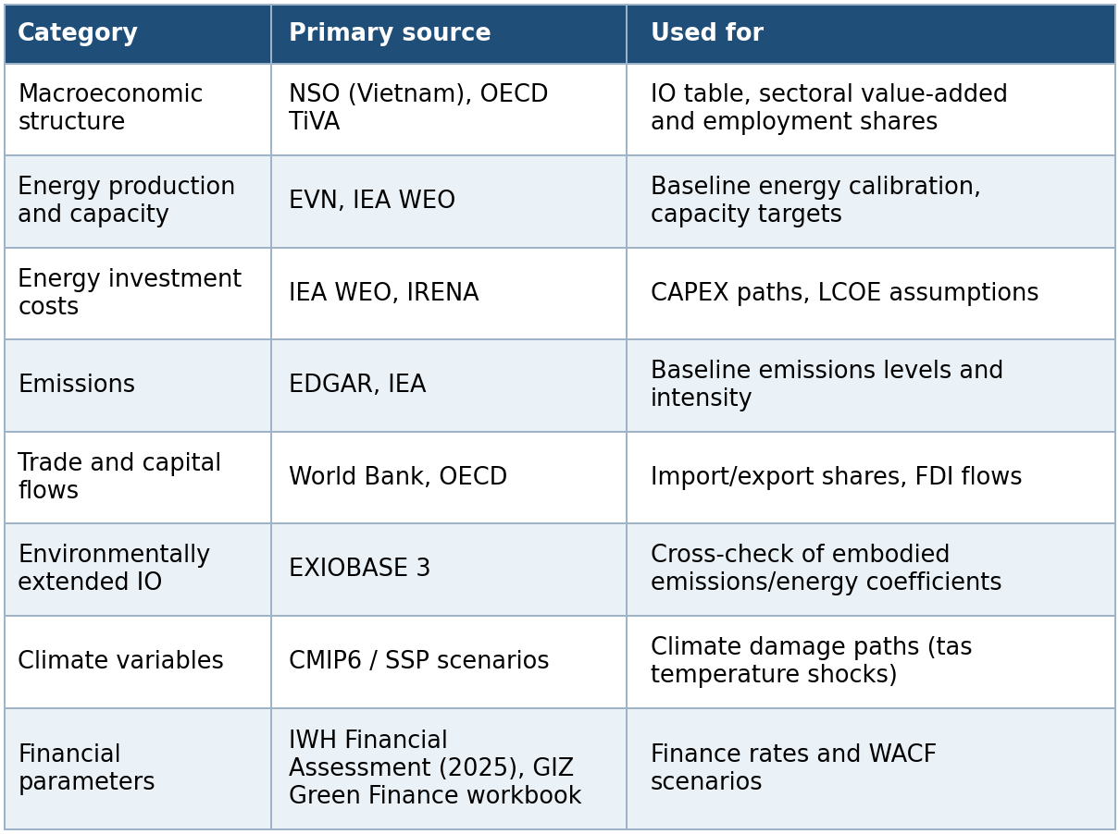
Table 3: Data Sources
Source: own depiction.

Full variable-to-source mapping is documented in data_sources.md; parameter-by-parameter citations for the structural-parameters sheet are in structural_parameters_source_audit.md. Raw source data is maintained outside the repository (size/licensing) and is pre-processed into the calibration workbook.

Expenditure-side GDP cross-check output
Provenance note (ETS fiscal revenue): the model does not use an official published long-run (2030/2050) government ETS revenue forecast for Vietnam. Instead, ETS revenue is scenario-based and follows:
where only auctioned allowances generate direct public revenue. Free allocation is treated as compliance value transfer, not fiscal revenue.

The repository includes a reproducible cross-check generated by scripts/reporting/GenerateGDPComponentsStartEndVsActual.m, which compares the model’s expenditure-side GDP component shares at the baseline start and end years against actual 2019 Vietnam national-accounts shares.
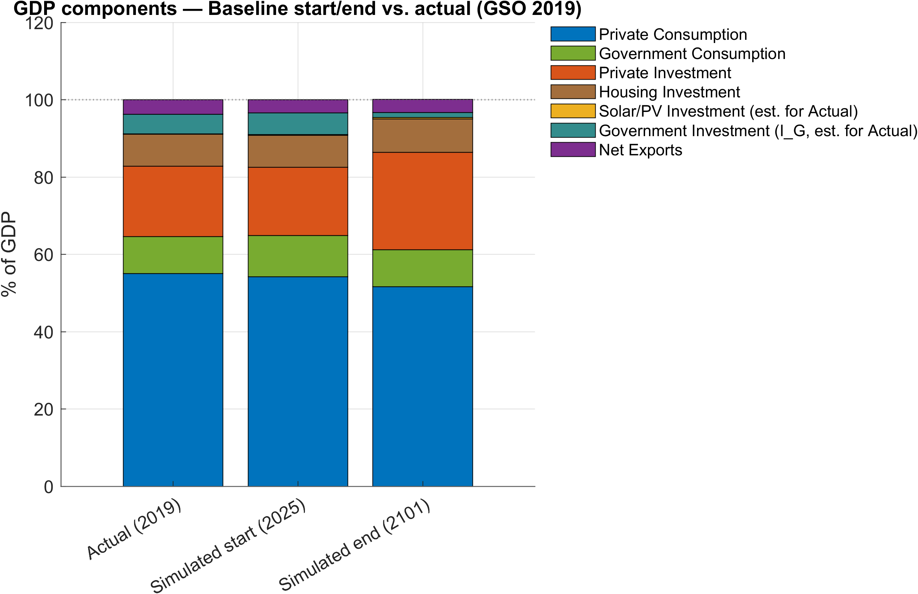
Figure 1: Expenditure-side GDP components: actual 2019 vs simulated baseline start and end.
Note: The chart stacks seven components as shares of GDP: private consumption, government consumption, private investment, housing investment, solar/PV investment, government investment, and net exports. In the Actual (2019) bar, government investment and solar/PV investment are proxy estimates documented in the script header; housing investment is taken directly from the NSO IO table.
Source: Output files GDPComponents_StartEndVsActual.png, GDPComponents_StartEndVsActual.svg, and GDPComponents_StartEndVsActual.csv in Figures/Baseline/GDPComponents/, generated from ExcelFiles/Output/Baseline.csv and external NSO workbook IO_GSO_2019.xlsx by scripts/reporting/GenerateGDPComponentsStartEndVsActual.m.

Calibration workflow
The calibration combines observed economic data with structural assumptions and model-consistent parameter estimation. Four categories of information enter the calibration process:
- Observed baseline data, including sectoral production, employment, trade flows, and expenditure shares obtained from official statistics (phiY0, phiN0, phiW, phiX, phiQI, …) — read directly from workbook sheets.
- Structural parameters, such as discount factors, depreciation rates, substitution elasticities, and tax rates, derived from the literature or project assumption (beta, delta, sigmaL, sigmaC, CES elasticities, tax rates) — read from the Structural Parameters sheet or left at code defaults.
- Initial macroeconomic conditions, defining the baseline economy at the beginning of the simulation period (Y0, N0, PoP0, LF0, H0, E0, PE0, …) — read from Start when available.
- Residual calibration parameters, including productivity levels, CES share parameters, labour-disutility parameters, and emission coefficients, which are determined endogenously to ensure that the model exactly reproduces the observed benchmark equilibrium (CES weights, emission intensities kappaE, labor disutility weights, TFP levels A_s, rf0).
This combination allows the model to remain closely aligned with observed economic data while preserving internal consistency between the theoretical structure and the empirical calibration.
The 5-sector, 1-region model is driven by three workbooks:
- ExcelFiles/ModelCalibration5Sectorsand1Regions.xlsx (calibration inputs and named ranges),
ExcelFiles/ModelBaseline5Sectorsand1Regions.xlsx (the split baseline path, built Baseline_Input → Baseline_calc → Baseline_Implied → Baseline), and
- ExcelFiles/ModelScenarios5Sectorsand1Regions.xlsx (scenario shock paths).

The model is calibrated in three stages:
- lCalibration_p = 1 builds the baseline steady state and solves residual parameters via fsolve;
- lCalibration_p = 0 re-solves the full steady state using the calibrated parameters as fixed;
- non-baseline scenarios run in a hybrid mode (lCalibration_p = 2) that takes the calibrated baseline as given and applies scenario shocks.
See calibration.md for the step-by-step MATLAB call sequence.

Calibration Consistency
An essential objective of the calibration is to ensure consistency between the model's accounting framework and Vietnam's national accounts. Particular attention is given to reproducing the benchmark structure of production, value added, intermediate demand, investment, trade, and emissions before introducing any policy shocks.
One important consistency condition links price-weighted value added to factor-cost gross value added:
load-bearing whenever the baseline emission price is positive (PE > 0), is:
i.e., the baseline price-weighted value-added target in the model numeraire must equal the factor-cost gross value added actually computed from national accounts (basic-price gross output, minus intermediate use, minus direct ETS permit cost). This identity guarantees that the benchmark economy remains internally consistent even when a positive baseline carbon price is introduced, thereby avoiding inconsistencies between the calibration routines and the model equations.
An earlier share-based normalization (φ Y_s · Q0_p) was only valid when PE = 0 and produced non-zero Dynare static residuals in the TFP equations at any positive carbon price. The current implementation enforces P0_s · Y0_s = FCgva_s consistently across the MATLAB calibration routines and the .mod productivity equations — see calibration_model_detailed.md for the full derivation, code locations, and baseline-check identities.

Code defaults vs. active calibration
While the model source code (ModFiles/DGE_Model_Parameters.mod) contains default values for all structural parameters, the parameterization used in any simulation in the active 5-sector/1-region workbook materially overrides several of them. This distinction is particularly important for parameters governing the external financing block. For example, the default values of the external finance premium parameter phiB_p (code default 10.0 vs. active workbook 0.1) and the associated adjustment-cost parameter phiadjB_p (1.0 vs. 0.1), which differ by two orders of magnitude. The workbook values, not the .mod file defaults, govern the currently compiled model. .
Accordingly, all simulation results presented in this report are based on the parameter values defined in the active calibration rather than the default values contained in the model source code. When reproducing or extending the model, users should therefore verify which calibration workbook was used for a particular simulation before interpreting or reporting individual parameter values. The full override table is in calibration_model_detailed.md §12

Baseline Validation and Diagnostic Assessment
To ensure that the calibrated model provides a reliable basis for scenario analysis, the baseline solution is evaluated using a comprehensive set of diagnostic indicators. These diagnostics assess whether the calibrated economy reproduces both the intended macroeconomic benchmark and the planned evolution of Vietnam's energy sector under the baseline assumptions. Rather than serving as policy results, the figures presented in this section constitute an integral part of the model validation process.
The validation focuses on three complementary aspects. First, long-term development paths for key energy-sector variables—including renewable capital, renewable electricity generation, energy efficiency, and the renewable share of electricity production—are examined to verify that the simulated baseline follows the intended transition trajectory over the period 2026–2050. Second, annual comparisons between simulated outcomes and PDP8 targets assess whether the model reproduces the planned development of renewable and fossil generation capacity as well as annual investment requirements. Third, end-of-period comparisons evaluate whether cumulative investment volumes and installed capacities remain consistent with the planning assumptions that underpin the baseline calibration.
The resulting figures therefore provide a transparent quality-assurance framework for the calibration. Consistent agreement between simulated trajectories and the underlying planning assumptions demonstrates that the model successfully reproduces both the empirical structure of the benchmark economy and the intended energy transition pathway before any policy scenarios are introduced.
The baseline reporting script scripts/reporting/DisplayBaselineEnergy.m writes its figures to the repository-level Figures/ directory (not docs/figures/). The script uses outDir = fullfile(repoRoot, 'Figures') and exports both raster and vector versions (.png at 300 dpi and .pdf vector).
These plots provide an operational bridge between the workbook targets and the calibrated baseline path:
- Level/index path checks (baseline_ren_capital, baseline_ren_production, baseline_energy_efficiency, baseline_res_share) show whether the solved baseline trajectory behaves plausibly over 2025-2050.
- Annual target alignment checks (ren_cap_annual, fos_cap_annual, ren_inv_annual, fos_inv_annual, plus dashboard baseline_pdp8_annual_comparison) compare simulation series to PDP8/Baseline target paths year by year.
- Period/end-year consistency checks (ren_inv_bar, fos_inv_bar, ren_cap_bar, fos_cap_bar, plus dashboard baseline_pdp8_period_comparison) verify that 5-year investment shares and end-year capacity levels match the planning aggregates used in calibration discussions.
In practice, Section 4’s data provenance and calibration claims should be read alongside these files in Figures/, because they are the fastest visual QA artifacts for checking whether the solved baseline reproduces the workbook’s energy transition intent.
Bar-plot previews used in this section (rendered from Figures/):
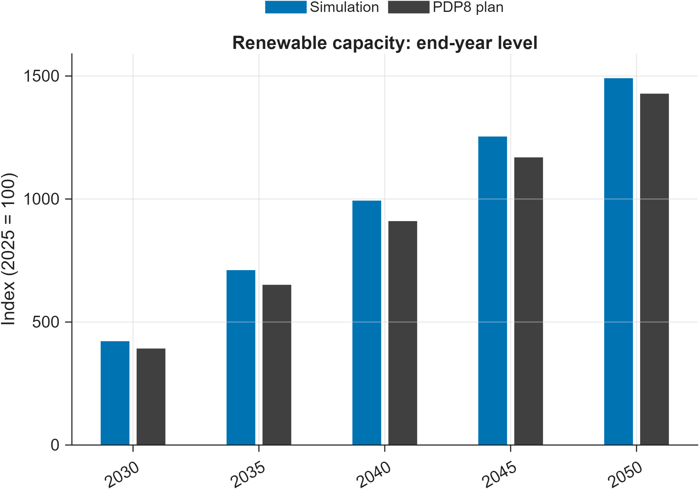
Figure 2: Baseline simulation vs PDP8 target for renewable installed capacity (end-year levels).
Note: Bars compare the model-implied renewables installed capacity index to PDP8 index values at the end of each reporting period (2025 = 100).
Source: Author calculations based on baseline simulation output ExcelFiles/Output/Baseline.csv and PDP8 capacity targets ExcelFiles/PDP8/IndexedTrajectories_FossilRenewable_Capacity.csv, plotted by scripts/reporting/DisplayBaselineEnergy.m.
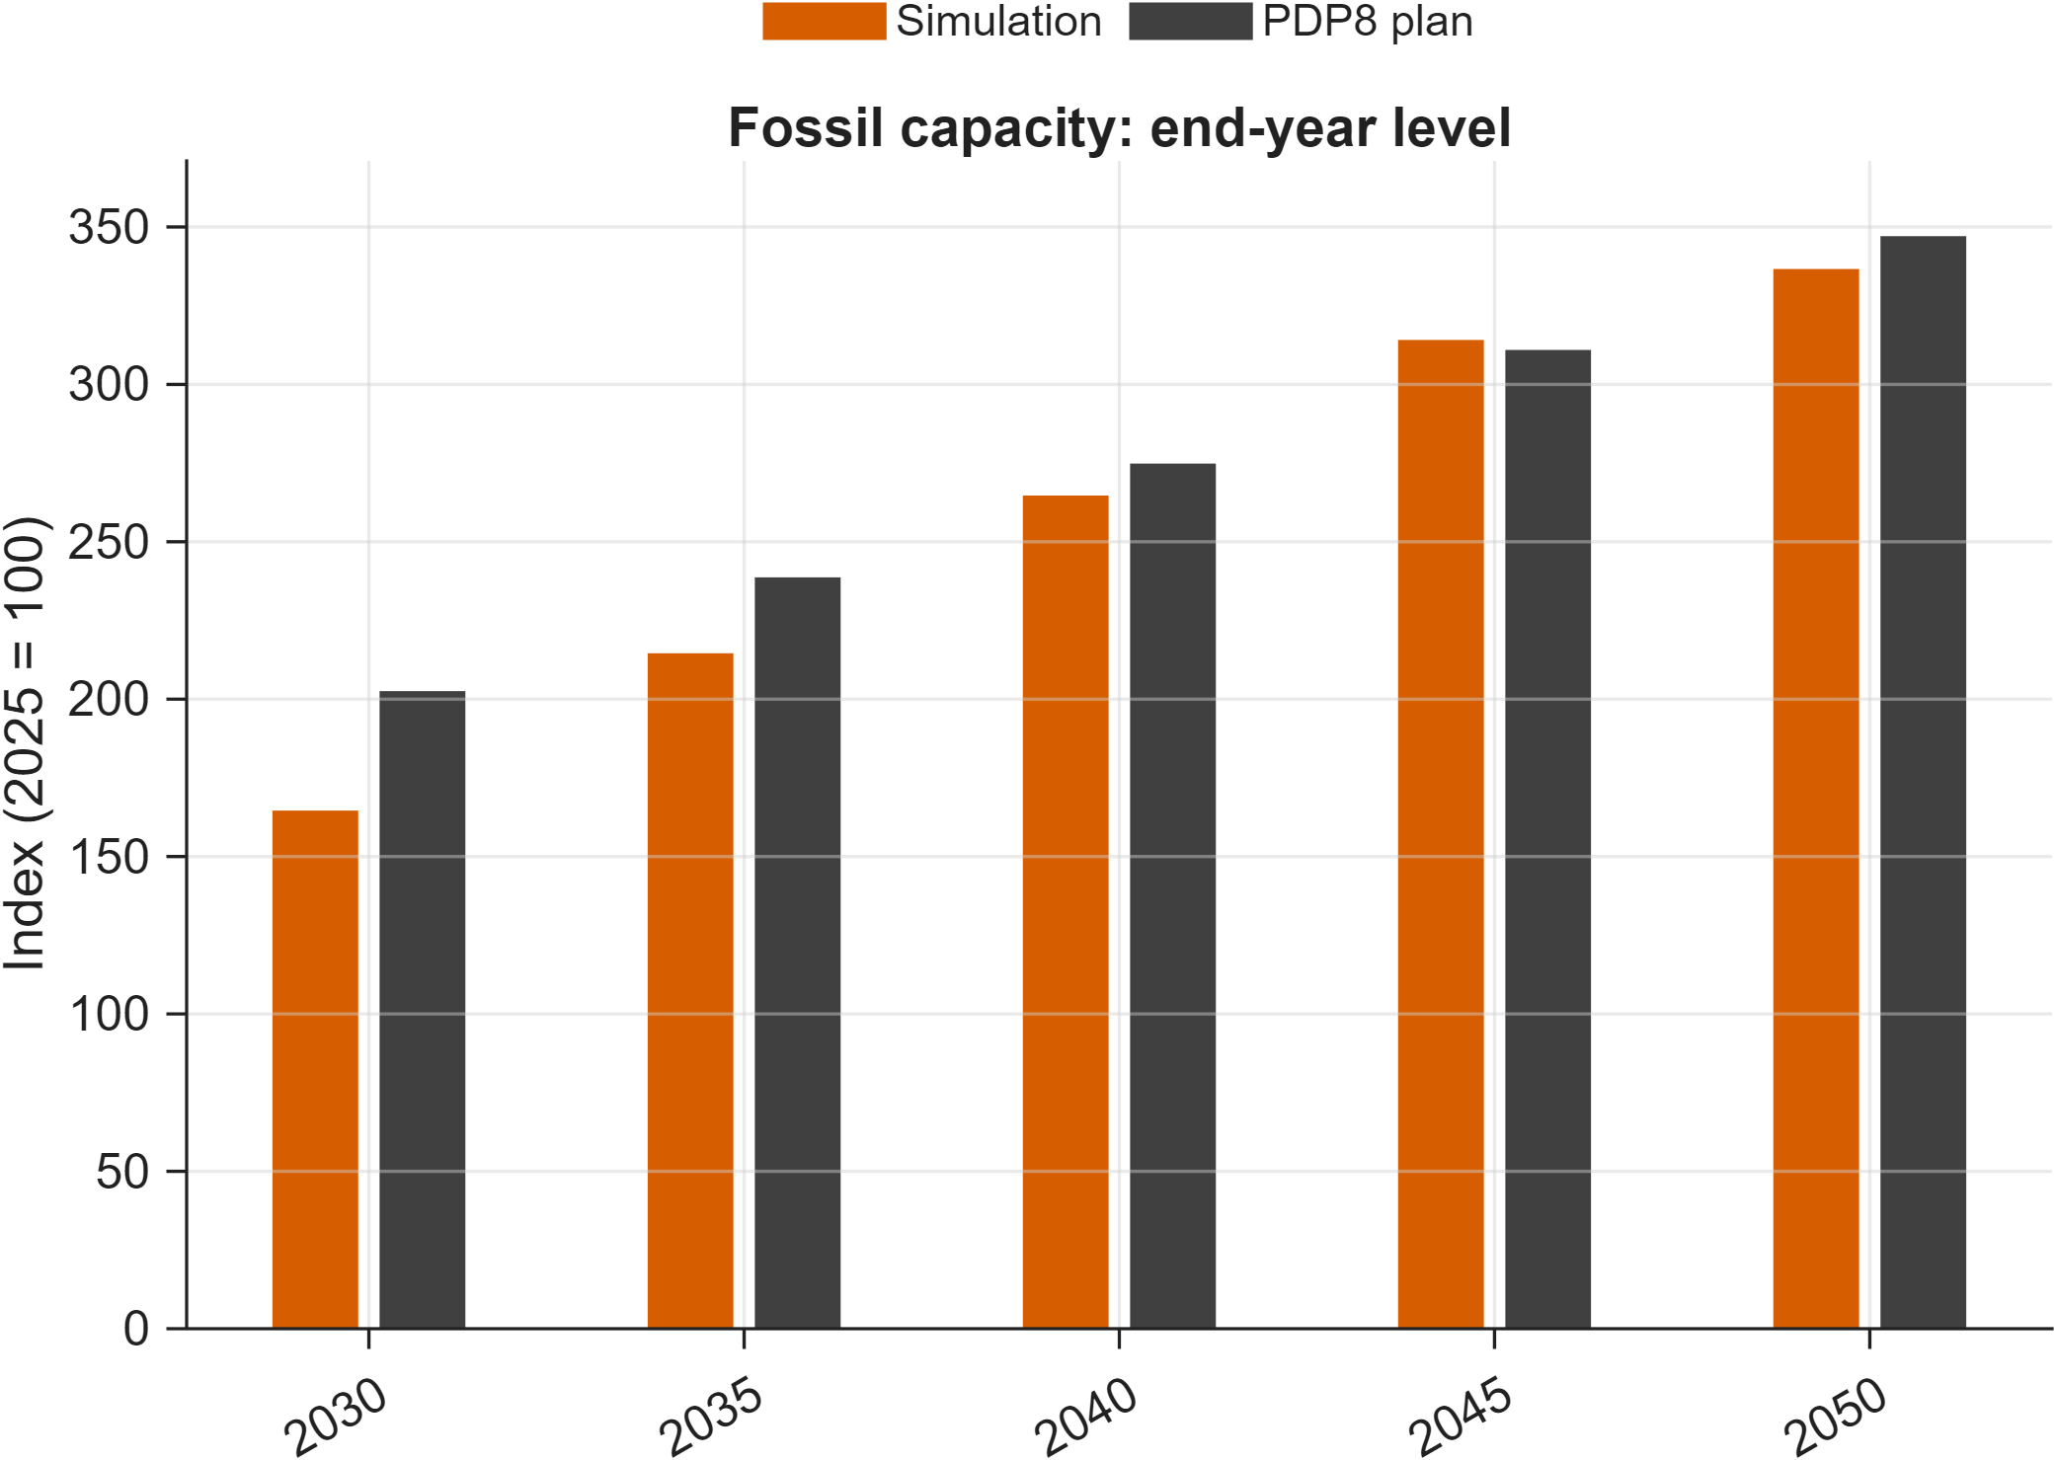
Figure 3: Baseline simulation vs PDP8 target for fossil installed capacity (end-year levels).
Note: Bars compare the model-implied capacity index to PDP8 index values at the end of each reporting period (2025 = 100).
Source: Author calculations based on baseline simulation output ExcelFiles/Output/Baseline.csv and PDP8 capacity targets ExcelFiles/PDP8/IndexedTrajectories_FossilRenewable_Capacity.csv, plotted by scripts/reporting/DisplayBaselineEnergy.m.
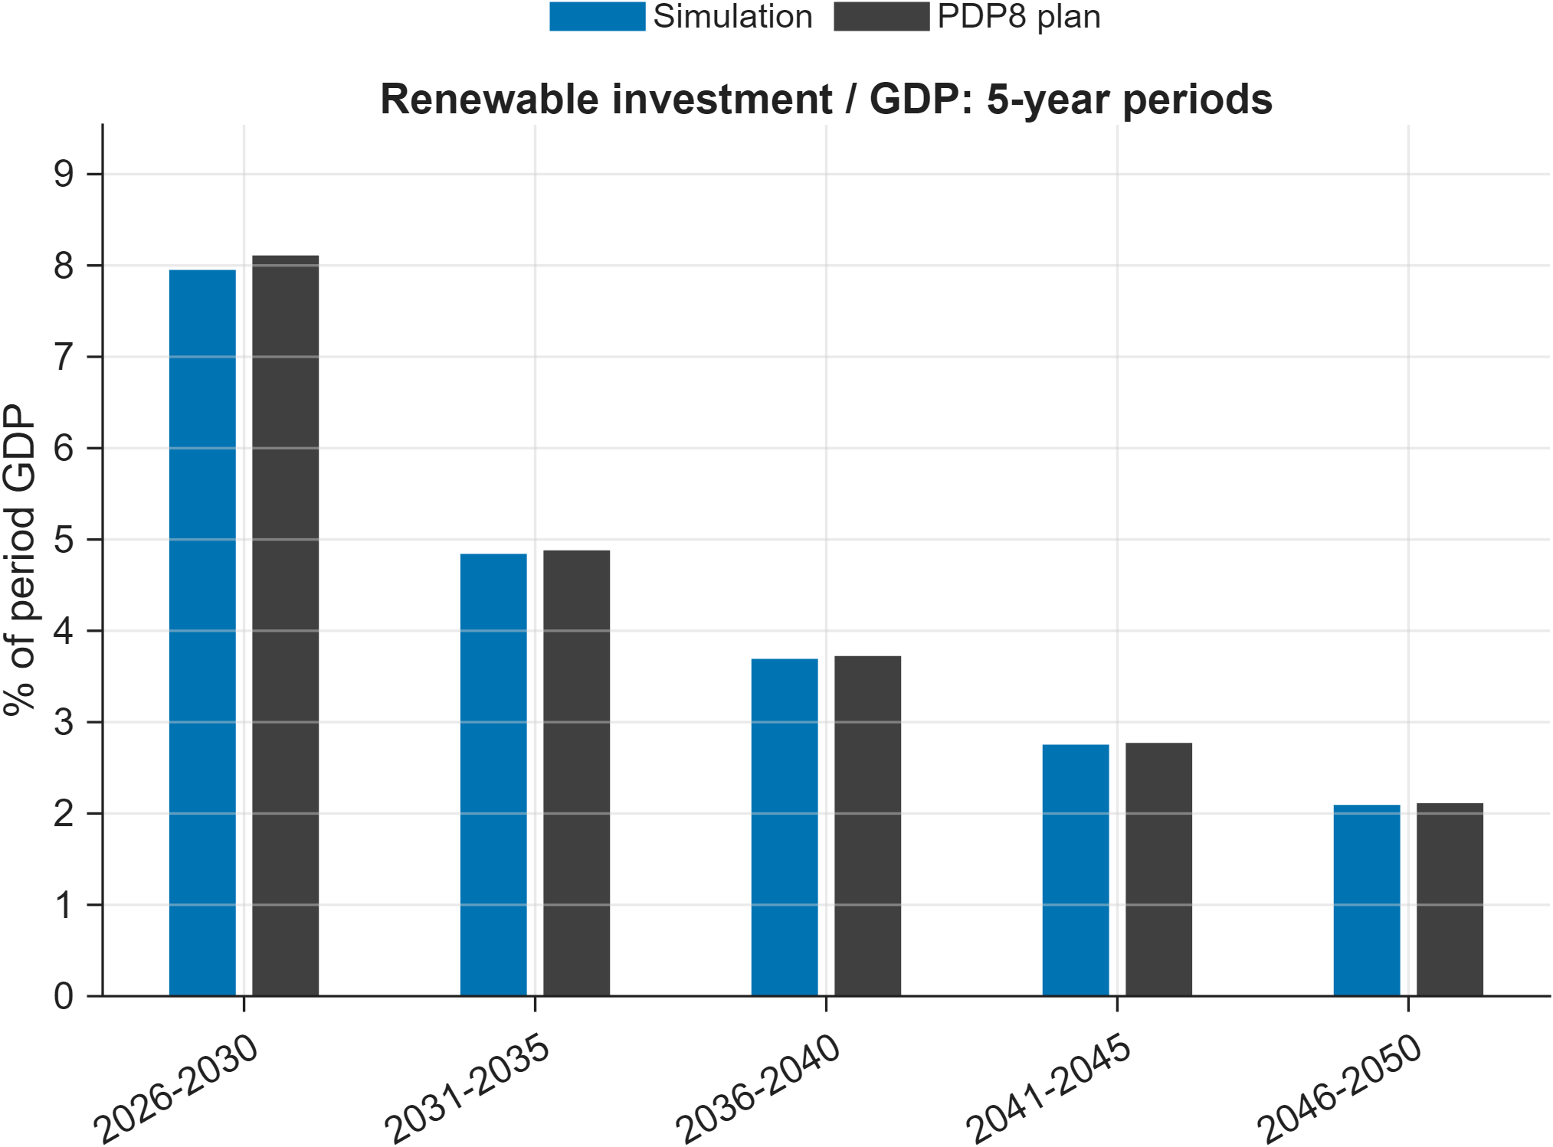
Figure 4: Baseline simulation vs PDP8 target for renewable investment share.
Note: Each bar reports renewable investment as a share of GDP aggregated over a 5-year period (% of period GDP), comparing simulation outcomes to the baseline workbook target path.
Source: Author calculations based on baseline simulation output ExcelFiles/Output/Baseline.csv and baseline target workbook ExcelFiles/ModelBaseline5Sectorsand1Regions.xlsx (sheet Baseline), plotted by scripts/reporting/DisplayBaselineEnergy.m.
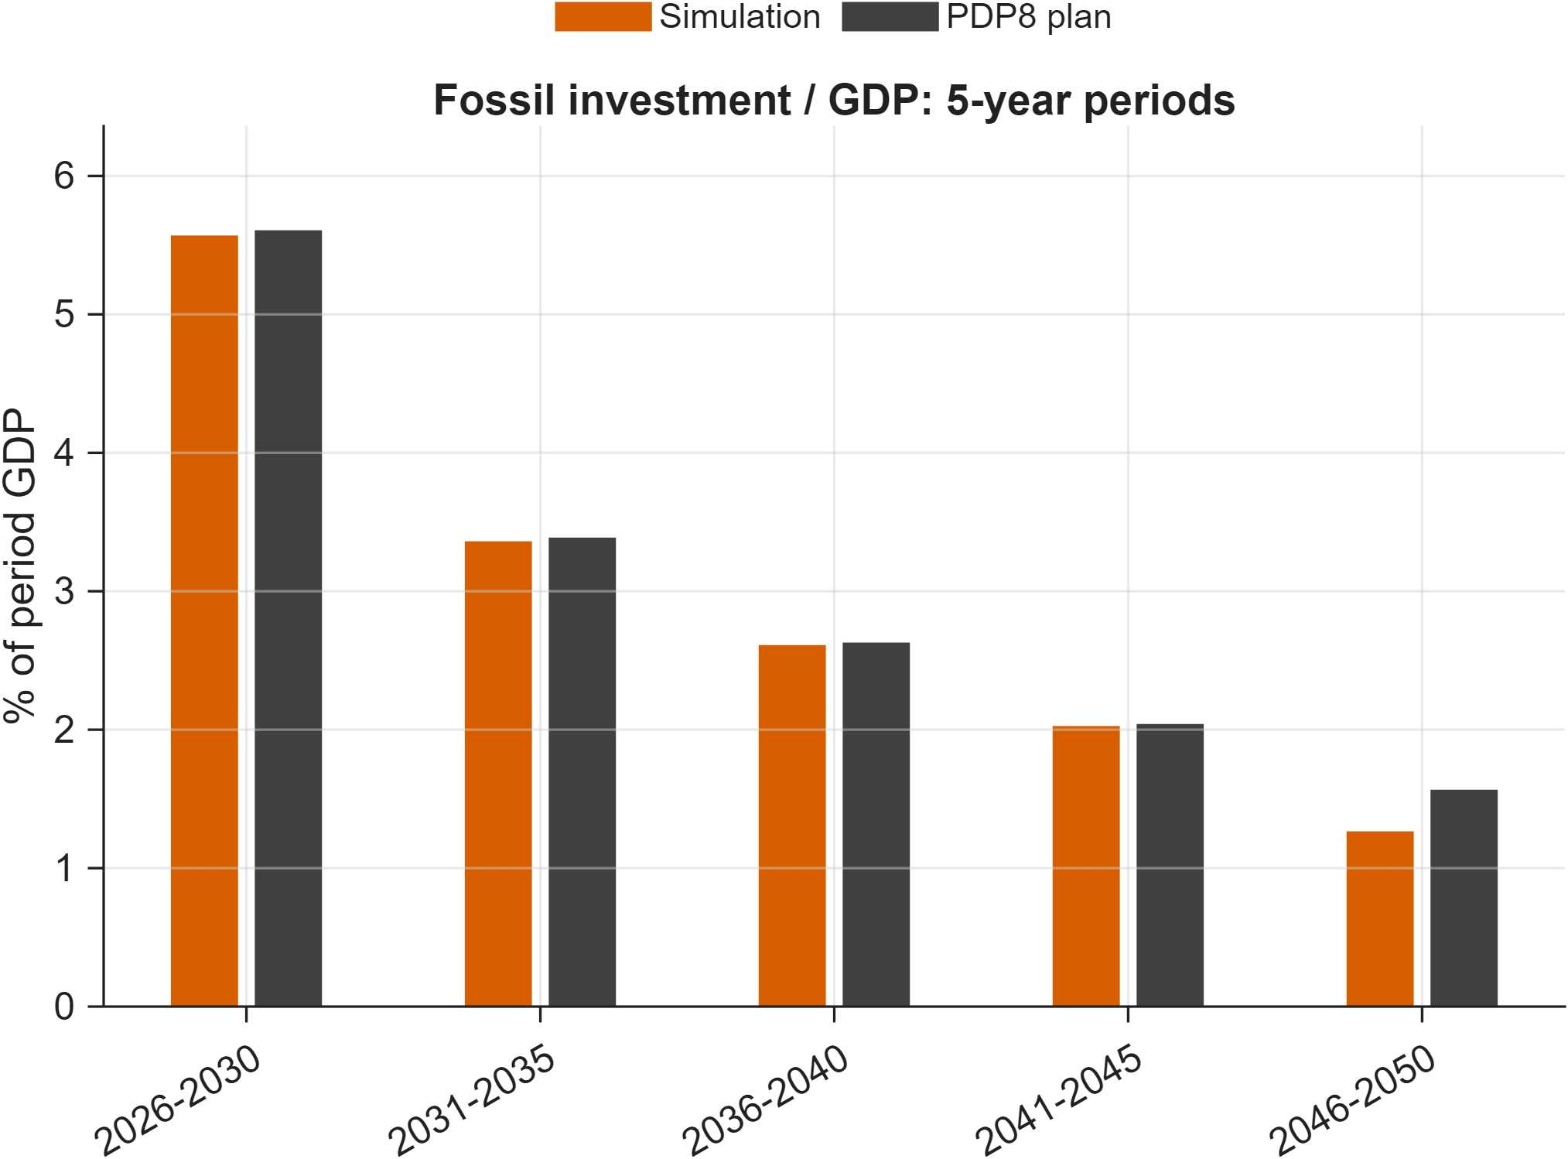
Figure 5: Baseline simulation vs PDP8 target for fossil investment share.
Note: Each bar reports fossil investment as a share of GDP aggregated over a 5-year period (% of period GDP), comparing simulation outcomes to the baseline workbook target path.
Source: Author calculations based on baseline simulation output ExcelFiles/Output/Baseline.csv and baseline target workbook ExcelFiles/ModelBaseline5Sectorsand1Regions.xlsx (sheet Baseline), plotted by scripts/reporting/DisplayBaselineEnergy.m.
Taken together, the diagnostic results indicate that the calibrated baseline reproduces the principal macroeconomic and energy-sector characteristics that define the reference scenario. This provides confidence that subsequent differences between policy scenarios can be attributed to the simulated policy interventions rather than inconsistencies in the underlying calibration

Solution Method
DGE-METRIC is implemented in Dynare and MATLAB and solved as a deterministic, forward-looking dynamic general equilibrium model under perfect foresight. The solution framework combines Dynare's nonlinear equilibrium solver with a custom calibration pipeline developed specifically for DGE-METRIC. This pipeline constructs an internally consistent benchmark economy, calibrates residual model parameters, initializes the transition path, and subsequently evaluates alternative policy scenarios within a common computational framework.
The economic model is defined in modular Dynare source files, empirical calibration is managed through structured Excel workbooks and MATLAB routines, and scenario simulations are executed through dedicated simulation scripts. This modular architecture improves transparency, facilitates model maintenance, and allows individual components of the framework to be modified or extended without affecting the overall solution procedure.

Dynare perfect-foresight solving
DGE-METRIC is implemented in Dynare and solved using its deterministic perfect-foresight simulation framework. Economic agents are assumed to full knowledge of the future path of exogenous shocks and policy variables, and the model solves for the transition path that satisfies all first-order conditions and market-clearing conditions simultaneously across the full 2026–2050 horizon.
The deterministic perfect-foresight framework is well suited to the policy questions addressed in this report. The principal policy interventions—including the implementation of the revised Power Development Plan VIII (PDP8), the introduction of an emissions trading system (ETS), improvements in energy efficiency, and alternative green-finance strategies—represent announced policy pathways rather than unforeseen shocks. Forward-looking households and firms therefore adjust investment, production, consumption, and financing decisions in anticipation of these policy changes, allowing the model to capture the dynamic adjustment process associated with Vietnam's long-term energy transition.
The implementation follows a modular architecture that separates model specification from calibration and simulation. DGE_Model.mod is the canonical entry point, which defines shared equation blocks live under ModFiles/Equations/ (and are mirrored in human-readable form under ModFiles/Equations/Equations_display/). Dynare’s macro-preprocessor (@#-directives) expands sector/region loops and branches on structural switches (lCapPrice, lAdjPos, YEndogenous, CapandTrade, …) declared at the top of DGE_Model.mod. All Dynare-generated code (+DGE_Model/, DGE_Model/, *_dynamic.m, *_static.m) is rebuilt on every invocation and is not source — fixes belong in the .mod files, followed by a re-run.

Steady-state / calibration pipeline
Before the transition dynamics can be simulated, DGE-METRIC requires an internally consistent benchmark economy that satisfies all behavioural equations, accounting identities, and market-clearing conditions. Constructing this benchmark is a multi-stage process that combines the empirical calibration described in Section 3 with a sequence of numerical procedures that initialise the model for perfect-foresight simulation. The resulting benchmark serves as the common starting point for all policy scenarios analysed in this report.
steadystate_model.m dispatches to DGE_Model_steadystate.m, which routes to Functions/SteadyState/ depending on lCalibration_p: build_initial_guess.m → compute_capital.m → setup_initial_state.m, with low-level blocks in SteadyState/computeCapital/ and SteadyState/setupInitialState/. Functions/steady_state/ holds thin ss_* wrapper functions preserving legacy call signatures over the snake_case refactored implementation.
Critical invariant: evaluate_capital_steady_state_residuals.m must retain the equation labeled fval_vec_11, which pins Q_(fossil) = Q_0 · exp(exo_(Q,fossil)) in hybrid calibration mode (lCalibration_p == 2). This is the closing equation that lets EE_1/EE_sec_reg float; removing it makes the hybrid steady-state solve underdetermined and fsolve fails to converge. This has been mistakenly “cleaned up” before.

Simulation
simulation_model_refactored.m loads exogenous series (Functions/Miscellaneous/Simulation/), applies baseline/scenario transitions, then applies optional AdditionalShocks (see Functions/README_AdditionalShocks.md for the shock-struct schema and the fineTuneSteps incremental-shock mechanism used to help the Newton solver converge for large shocks). Post-run audit CSVs compare Excel gY_* growth targets against simulated growth, written next to ExcelFiles/Output/Baseline.csv.
All policy scenarios are evaluated relative to a common calibrated baseline. This ensures that differences between simulation outcomes are attributable solely to the policy interventions under consideration rather than to differences in model calibration or initial conditions. The benchmark economy therefore serves as a consistent reference point against which the macroeconomic, sectoral, fiscal, and environmental implications of alternative transition pathways can be assessed.
Scenario configuration
Each simulation begins by loading the calibrated benchmark dataset together with the scenario-specific assumptions that define the policy experiment. These assumptions may include alternative emissions caps, renewable energy deployment pathways, technology cost trajectories, energy-efficiency improvements, green-financing mechanisms, or other exogenous policy parameters relevant to the analysis.
Scenario inputs are maintained separately from the core model specification. This separation preserves the integrity of the benchmark calibration while allowing multiple policy experiments to be evaluated using an identical underlying economic structure. Consequently, new scenarios can be introduced by modifying only the relevant exogenous assumptions without requiring changes to the structural equations of the model.
Model execution
Once the scenario inputs have been assembled, the simulation is executed through the integrated MATLAB–Dynare workflow. MATLAB routines prepare the calibrated parameter set, initialise the endogenous variables, and construct the complete set of inputs required by Dynare's deterministic solver. Dynare subsequently computes the nonlinear equilibrium transition path by solving the complete system of behavioural equations simultaneously over the entire simulation horizon.
Because all endogenous variables are determined jointly, changes introduced in one part of the economy propagate throughout the model via production linkages, household behaviour, government accounts, international trade, and capital accumulation. This general equilibrium framework captures both the direct effects of policy interventions and the indirect adjustments transmitted through interconnected markets.
The modular implementation allows the same computational pipeline to be applied consistently across all policy scenarios, thereby ensuring that simulation results remain directly comparable.
Output generation and post-processing
Following successful model solution, simulation results are exported for post-processing and analysis. The post-processing routines organise the raw model outputs into a consistent set of economic indicators, including macroeconomic aggregates, sectoral production, employment, investment, trade, public finances, energy-system variables, and greenhouse gas emissions.
Additional MATLAB routines generate the tables and figures presented throughout this report. These routines apply a common reporting structure across all scenarios, ensuring that outputs are directly comparable and that differences between scenarios reflect underlying policy assumptions rather than differences in data processing or presentation. Automated post-processing also improves reproducibility by standardising the generation of all reported indicators from the underlying simulation results.

Verification approach
The verification framework follows a layered approach in which each stage of the computational workflow is validated before proceeding to the next. This strategy facilitates the early identification of numerical or calibration inconsistencies and substantially improves the transparency and reproducibility of the modelling framework.
There is no automated test suite. “Does it work” is verified by: the steady-state solver converging (fsolve residuals near zero, no lCalibration_p branch errors); the accounting identities in ExcelFiles/README.md holding after any calibration edit (row sums, phiQI = phiX + phiY0, Trade_Flows rows summing to 1); and, after a baseline/scenario run, the growth-audit CSVs showing simulated growth tracking the Excel gY_* targets. scripts/analysis/CheckResults.m and Functions/steady_state/diagnostics/check_allocation_errors.m are the existing sanity-check entry points.
Numerical convergence
The first layer of verification concerns the successful numerical solution of the model. During calibration and scenario simulations, Dynare iteratively solves the nonlinear system of equilibrium equations until all convergence criteria are satisfied. Convergence is assessed using Dynare's standard residual and tolerance measures, ensuring that the complete transition path satisfies the model equations simultaneously in every simulation period.
Particular attention is paid to the quality of the initial solution path supplied to the perfect-foresight solver. Because the model spans a long simulation horizon and contains highly nonlinear relationships between production, investment, emissions, and international capital flows, a carefully constructed initial trajectory substantially improves convergence performance and numerical stability.
Accounting consistency
The second layer verifies that the calibrated benchmark satisfies the accounting identities embedded within the model specification. Production accounts, income balances, government accounts, trade balances, capital accumulation equations, and emissions accounting are systematically checked to ensure consistency between the empirical calibration and the theoretical model.
These consistency checks confirm that all markets clear, budget constraints are satisfied, and benchmark aggregates reproduce the underlying national accounts and energy balances used during calibration. Maintaining these identities is essential because even small inconsistencies can propagate through the dynamic simulation and distort long-run policy results.
Calibration verification
The third verification layer evaluates whether the calibrated benchmark accurately reproduces the intended baseline economy. This includes comparisons of macroeconomic aggregates, sectoral production, investment, energy use, emissions, and capacity expansion against the calibration datasets and baseline assumptions described in Section 3.
Diagnostic figures generated during the calibration process provide an additional visual assessment of model performance by comparing simulated trajectories with planned development pathways, including the targets specified under Vietnam's revised Power Development Plan VIII. These diagnostics verify that the benchmark economy provides an appropriate reference point for subsequent policy analysis before any scenario-specific interventions are introduced.
Implementation checks
In addition to the economic verification procedures, the computational workflow incorporates several implementation checks that ensure consistency between the calibration inputs, Dynare model specification, and MATLAB processing routines. These checks confirm that calibration workbooks have been read correctly, parameter values have been transferred consistently to the model environment, and all required data structures have been successfully initialised prior to simulation.
The modular organisation of the implementation further supports verification by allowing intermediate outputs to be inspected independently at each stage of the solution pipeline. This facilitates the identification of potential inconsistencies during model development and simplifies future extensions of the framework.
Reproducibility
An important objective of the verification framework is to ensure that the complete modelling process is reproducible. The separation of calibration, model specification, simulation, and post-processing allows each stage of the computational workflow to be repeated independently while producing identical benchmark and scenario results, provided that the same calibration inputs and model configuration are used.
This reproducible workflow strengthens the transparency of DGE-METRIC and enables researchers to verify calibration outcomes, replicate published simulations, and extend the model for alternative policy applications without modifying the underlying numerical solution methodology.

Scenario Design Framework
With the model specification, calibration, and computational framework established, this section introduces the policy scenarios used to evaluate Vietnam's energy transition. The scenarios translate alternative policy assumptions into a consistent set of model inputs, enabling the economy-wide implications of different transition strategies to be analysed within the DGE-METRIC framework. All simulations are conducted relative to the calibrated baseline described in Section 3.

Nested-counterfactual logic
The scenario analysis is organised as a nested counterfactual framework that allows the individual economic mechanisms underlying Vietnam's energy transition to be examined in a systematic and internally consistent manner. Rather than treating each policy scenario as an independent experiment, all simulations are constructed sequentially from a common benchmark economy. This hierarchical design ensures that the marginal contribution of individual policy measures can be isolated while maintaining a consistent calibration, model structure, and initial conditions across all simulations.
Note: All scenarios originate from the same calibrated benchmark economy. Each branch introduces a distinct set of exogenous policy assumptions while preserving the common model structure and calibration.
Figure 6: Hierarchical organisation of the DGE-METRIC scenario framework
Baseline (PDP8)
│
├── Net-Zero (NZ) ─────────────────────── adds: binding emissions cap + ETS
│ ├── NZ_constInt ─────────────────── removes: emission-intensity improvement
│ └── NZ_constEEInt ───────────────── removes: energy efficiency + intensity
│
├── Energy Efficiency ────────────────── adds: EE shocks on PDP8 baseline
│ ├── EE_PDP8
│ ├── EE_Directive10
│ └── EE_PDP8_PV_BESS (+ NoBESS variants)
│
└── Green Finance ────────────────────── modifies: cost-of-capital and investment paths
├── On PDP8: GF_A, GF_B, GF_C
└── On NZ: NZ_GF_A, NZ_GF_B, NZ_GF_C
The analysis begins with a policy-consistent baseline (PDP8), then either (a) impose a binding Net-Zero emissions cap and sequentially shut down individual adjustment channels to decompose their contribution, (b) add demand-side energy efficiency shocks, or (c) modify the cost of capital for transition investment. Every scenario shares the identical calibration and is solved as a deterministic transition path from the same initial steady state, so differences are attributable solely to the shock paths applied.
An important advantage of the nested design is that it supports mechanism decomposition. Because only a limited number of exogenous variables are modified between successive scenarios, differences in simulation outcomes can be attributed directly to specific economic adjustment channels. This approach improves the interpretability of the results and facilitates a transparent assessment of how individual policy instruments contribute to achieving Vietnam's long-term climate and energy objectives.

Net-Zero decomposition
The Net-Zero scenario imposes a binding long-run emissions cap via an economy-wide emissions trading system (ETS) with an endogenous carbon price.
The scenario hierarchy comprises three closely related simulations:
- NZ represents the full Net-Zero pathway. Firms and households may adjust through all available mechanisms, including changes in production structure, improvements in energy efficiency, reductions in fossil-fuel emission intensity, investment reallocation, and substitution towards renewable energy technologies.
- NZ_constInt constrains improvements in fossil-fuel emission intensity while leaving all remaining adjustment channels available. Comparing this scenario with the unconstrained Net-Zero case isolates the economic contribution of technological improvements that reduce emissions per unit of fossil-energy output.
- NZ_constEEInt constrains both emission-intensity improvements and energy-efficiency gains. Consequently, adjustment to the emissions cap must occur primarily through higher carbon prices, larger structural changes in production, accelerated renewable investment, and reductions in fossil-energy use. This scenario therefore represents an upper-bound estimate of adjustment costs under limited technological progress
Constrained variants (NZ_constInt: fossil emission intensity held fixed; NZ_constEEInt: energy efficiency and emission intensity both held fixed) isolate how much of the adjustment burden would fall on carbon pricing, sectoral reallocation, and accelerated renewable deployment if fuel-switching and efficiency channels were unavailable — an upper bound on adjustment cost under limited technological learning.
This decomposition framework provides considerably greater insight than a simple comparison between a baseline and a single Net-Zero scenario. Rather than reporting only the aggregate cost of decarbonisation, it identifies the principal economic adjustment channels through which the transition is achieved and quantifies their relative importance. The approach therefore strengthens the interpretation of subsequent simulation results and supports more targeted policy conclusions regarding technology deployment, efficiency improvements, and carbon pricing.
Finally, the constrained scenarios should not be interpreted as realistic policy pathways. Instead, they represent analytical counterfactuals designed to isolate individual adjustment mechanisms within an otherwise identical economic environment. Their primary purpose is methodological: to improve understanding of the transmission channels through which climate policy affects production, investment, household welfare, public finances, and long-run economic growth

Green finance as a reduced-form cost-of-capital shock
Financing conditions play a central role in determining the pace and cost of the energy transition. Renewable energy technologies are typically characterised by high upfront capital requirements and relatively low operating costs, making investment decisions particularly sensitive to the cost of capital. Consequently, policies that improve access to affordable finance can accelerate renewable deployment even in the absence of additional technology improvements or direct investment subsidies.
Green finance instruments (concessional loans, blended finance, green bonds, guarantees) are not modeled as named balance-sheet items. Hence, rather than modelling individual financial instruments explicitly, DGE-METRIC represents green finance through a reduced-form cost-of-capital shock.
Table 4: Green Finance Transmission Channels
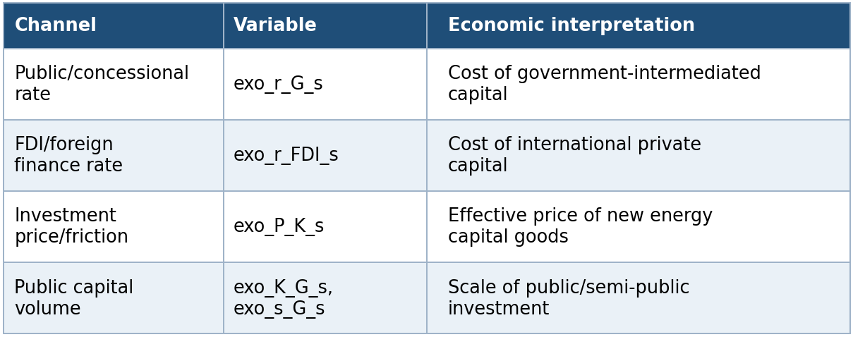
Source: Own depiction.
Three financing architectures (GF_A balanced, GF_B market-led, GF_C public-led) are distinguished by their Weighted Average Cost of Finance (WACF: 6.43%, 7.37%, 5.07% respectively), each run against both the PDP8 and Net-Zero baselines.
Modeling implication: results should be read as an upper bound on what a given financing architecture can achieve if fully deployed — the model cannot verify whether the assumed cost reductions are institutionally achievable at scale (see finance_instruments_comments_feasibility.md).
The green-finance scenarios are implemented both as standalone policy experiments and in combination with the Net-Zero pathway. Standalone scenarios quantify the economic benefits of improved financing conditions under the baseline transition trajectory, whereas the combined scenarios evaluate the extent to which lower financing costs reduce the macroeconomic adjustment required to achieve Vietnam's long-term emissions objectives. Comparing these two sets of simulations provides insight into the interaction between climate policy and financial-market conditions and illustrates how improved access to affordable capital can facilitate a more cost-effective transition.

Operational status vs. scenario capability
A scenario being defined in the model does not mean it runs by default. RunSimulations.m only executes activeScenarioGroups = {'Reference'} out of the box, and within that group only Baseline is uncommented. The Green Finance groups (GF_PDP8, GF_NZ) are fully wired (scenario-switch logic uncommented) but excluded from the default active set; several EE and NZ_Sensitivity scenario names are individually commented out. Reproducing a specific published result requires knowing exactly which activeScenarioGroups (or DGE_SCENARIO_GROUPS environment variable) configuration produced it — see running.md and scenario.md.

EE scenario reporting figures
Whereas the Net-Zero scenarios presented in the previous section isolate the economic mechanisms through which emissions reductions are achieved, the scenarios described here examine how alternative rates of energy efficiency improvement influence energy demand, investment requirements, emissions, and overall macroeconomic performance.
Improving energy efficiency reduces the amount of energy required to produce a given level of economic output. Within DGE-METRIC, these improvements lower intermediate energy demand across production sectors and households, thereby reducing emissions, alleviating pressure on electricity generation capacity, and moderating the investment required to satisfy future energy demand. Because these effects propagate throughout the economy via changes in production costs, household expenditure, international competitiveness, and capital accumulation, the model provides a comprehensive assessment of both the direct and indirect economic benefits of energy efficiency policies.
EE_PDP8
The EE_PDP8 scenario adopts the energy efficiency trajectory embedded in the revised Power Development Plan VIII (PDP8). This scenario represents the reference efficiency pathway used in the government's long-term electricity planning and provides the benchmark against which more ambitious efficiency policies are evaluated. Improvements in energy intensity reduce electricity demand growth while maintaining consistency with the broader assumptions underlying the baseline transition pathway.
EE_Directive10
The EE_Directive10 scenario represents an accelerated improvement in energy efficiency consistent with the objectives of Directive No. 10 and related national energy-efficiency policies. Relative to the PDP8 pathway, this scenario assumes stronger reductions in energy intensity, leading to lower final energy demand, reduced fossil-fuel consumption, and a corresponding decline in greenhouse gas emissions.
By lowering future electricity demand, enhanced efficiency also reduces the investment required for generation capacity expansion and network development. Consequently, this scenario illustrates how demand-side measures can complement supply-side decarbonisation policies by lowering the overall cost of the energy transition.
EE_PDP8_PV_BESS
The EE_PDP8_PV_BESS scenario extends the PDP8 efficiency pathway by incorporating distributed photovoltaic (PV) systems together with battery energy storage systems (BESS). In addition to reducing overall electricity demand through improved efficiency, this scenario increases decentralised renewable electricity generation and enables greater temporal flexibility in electricity consumption through local energy storage.
The inclusion of distributed PV and battery storage modifies both electricity demand and supply. Self-generation reduces demand for grid-supplied electricity, while battery storage allows renewable generation to be shifted across time, reducing curtailment and improving system utilisation. Within the model, these changes influence generation requirements, investment patterns, wholesale electricity demand, and the broader allocation of capital across the economy.
Where applicable, additional NoBESS variants isolate the contribution of battery storage by comparing otherwise identical distributed photovoltaic systems with and without storage capacity. These comparisons quantify the incremental economic value of storage technologies within the broader energy transition.
Comparisons across these scenarios therefore quantify the incremental macroeconomic benefits associated with stronger improvements in energy efficiency and distributed renewable technologies. The resulting differences in economic growth, investment requirements, electricity demand, emissions, and household welfare provide an integrated assessment of the extent to which demand-side measures can reduce the overall cost of Vietnam's energy transition.
The script scripts/reporting/GenerateEESimulationResultsFigures.m exports scenario-comparison figures to docs/figures/EE_Simulation_Results/. This subsection reports only deviation-versus-Baseline diagnostics (Figure 7 - Figure 13).
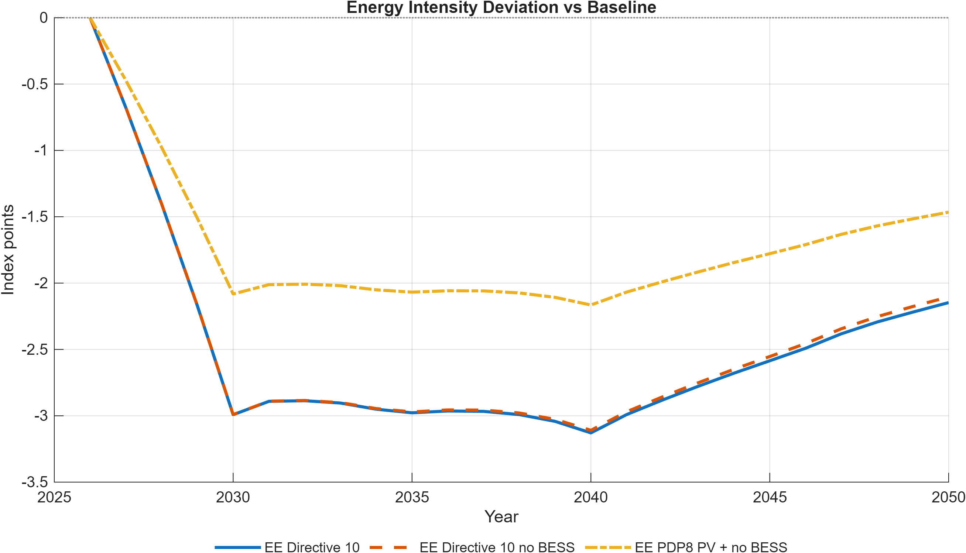
Figure 7: Energy-intensity deviation of EE scenarios from the Baseline.
Note: Values are index-point deviations from the Baseline energy-intensity index (base year 2026). Negative values indicate improved energy efficiency relative to Baseline.
Source: Generated by scripts/reporting/GenerateEESimulationResultsFigures.m from scenario output CSV files in ExcelFiles/Output/.
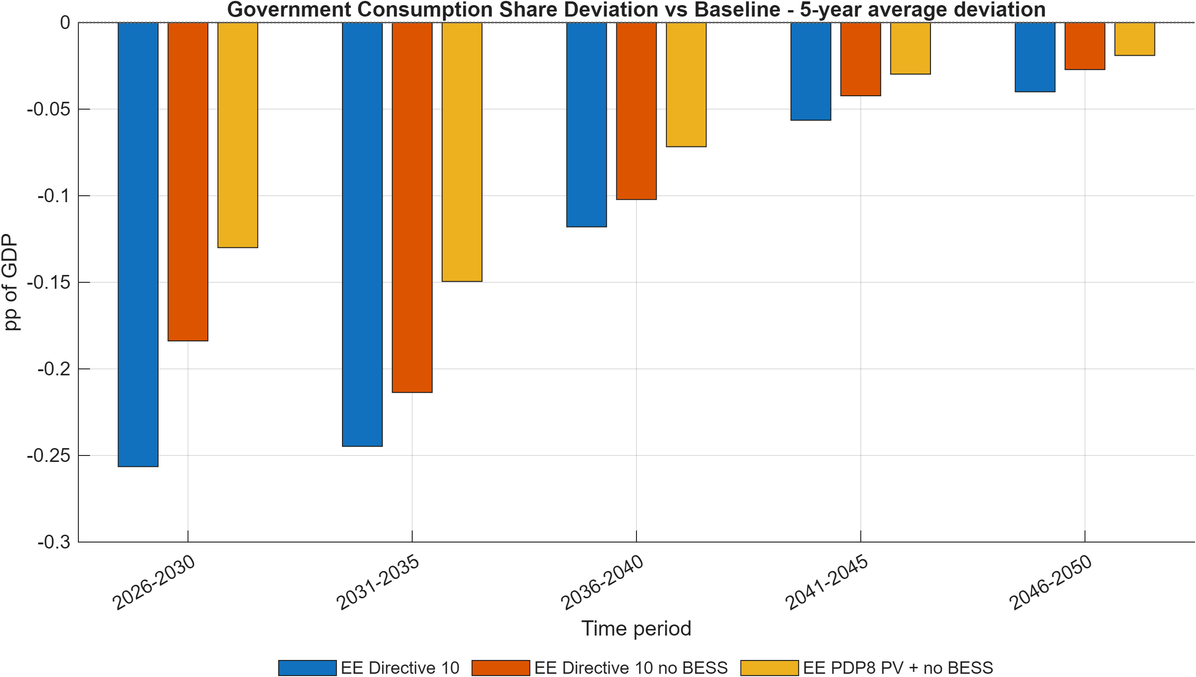
Figure 8: Government consumption share deviation versus Baseline (5-year average).
Note: Bars report average deviation in government consumption share of GDP (pp of GDP) by 5-year block, showing persistent fiscal-demand composition differences relative to Baseline.
Source: Generated by scripts/reporting/GenerateEESimulationResultsFigures.m from scenario output CSV files in ExcelFiles/Output/.
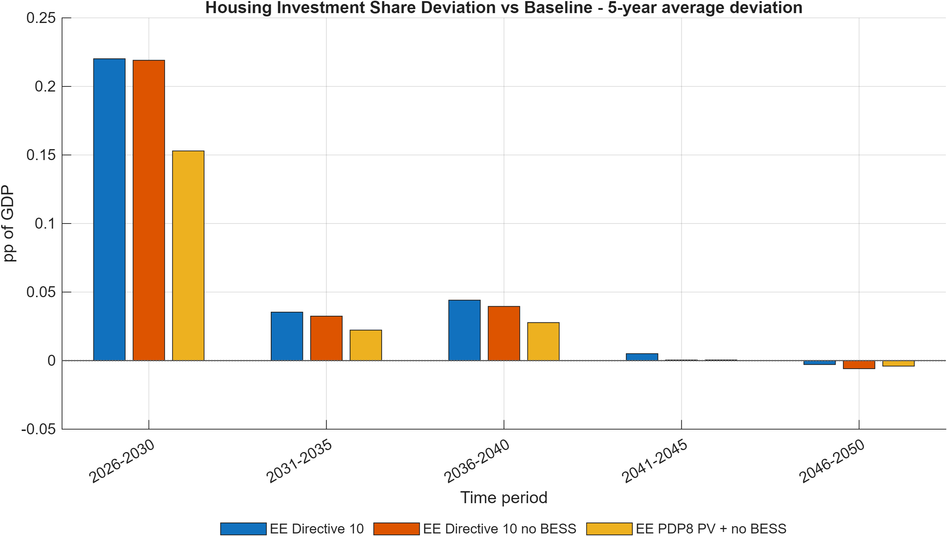
Figure 9: Housing investment share deviation versus Baseline (5-year average).
Note: Bars report average deviation in housing investment share of GDP (pp of GDP) by 5-year block, highlighting medium-term allocation differences versus Baseline.
Source: Generated by scripts/reporting/GenerateEESimulationResultsFigures.m from scenario output CSV files in ExcelFiles/Output/.
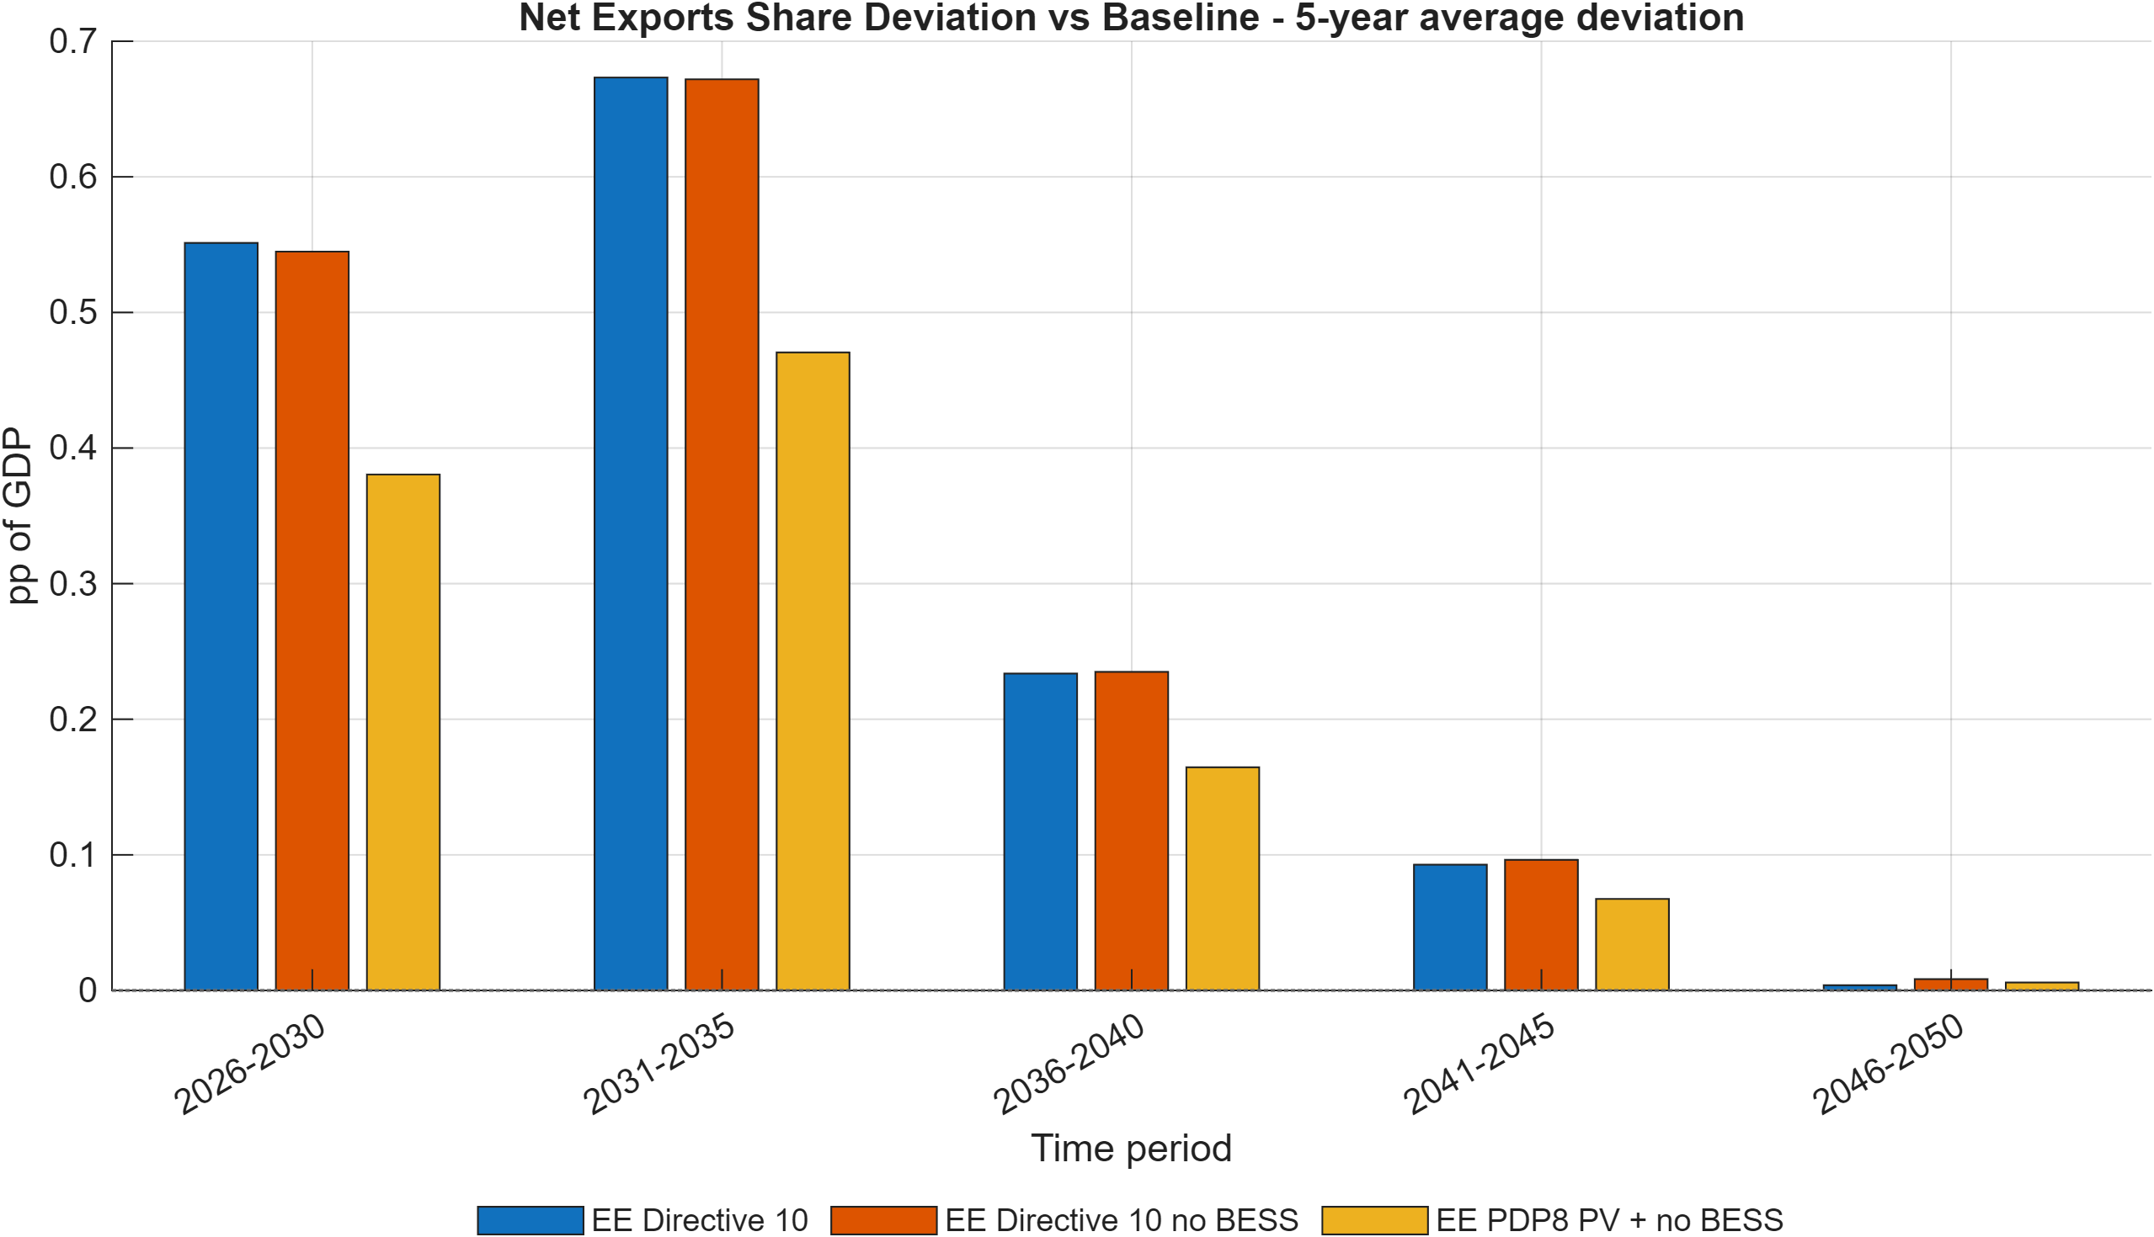
Figure 10: Net exports share deviation versus Baseline (5-year average).
Note: Bars report average net-exports-share deviation (pp of GDP) by 5-year block, summarizing sustained external-balance differences under each EE scenario.
Source: Generated by scripts/reporting/GenerateEESimulationResultsFigures.m from scenario output CSV files in ExcelFiles/Output/.
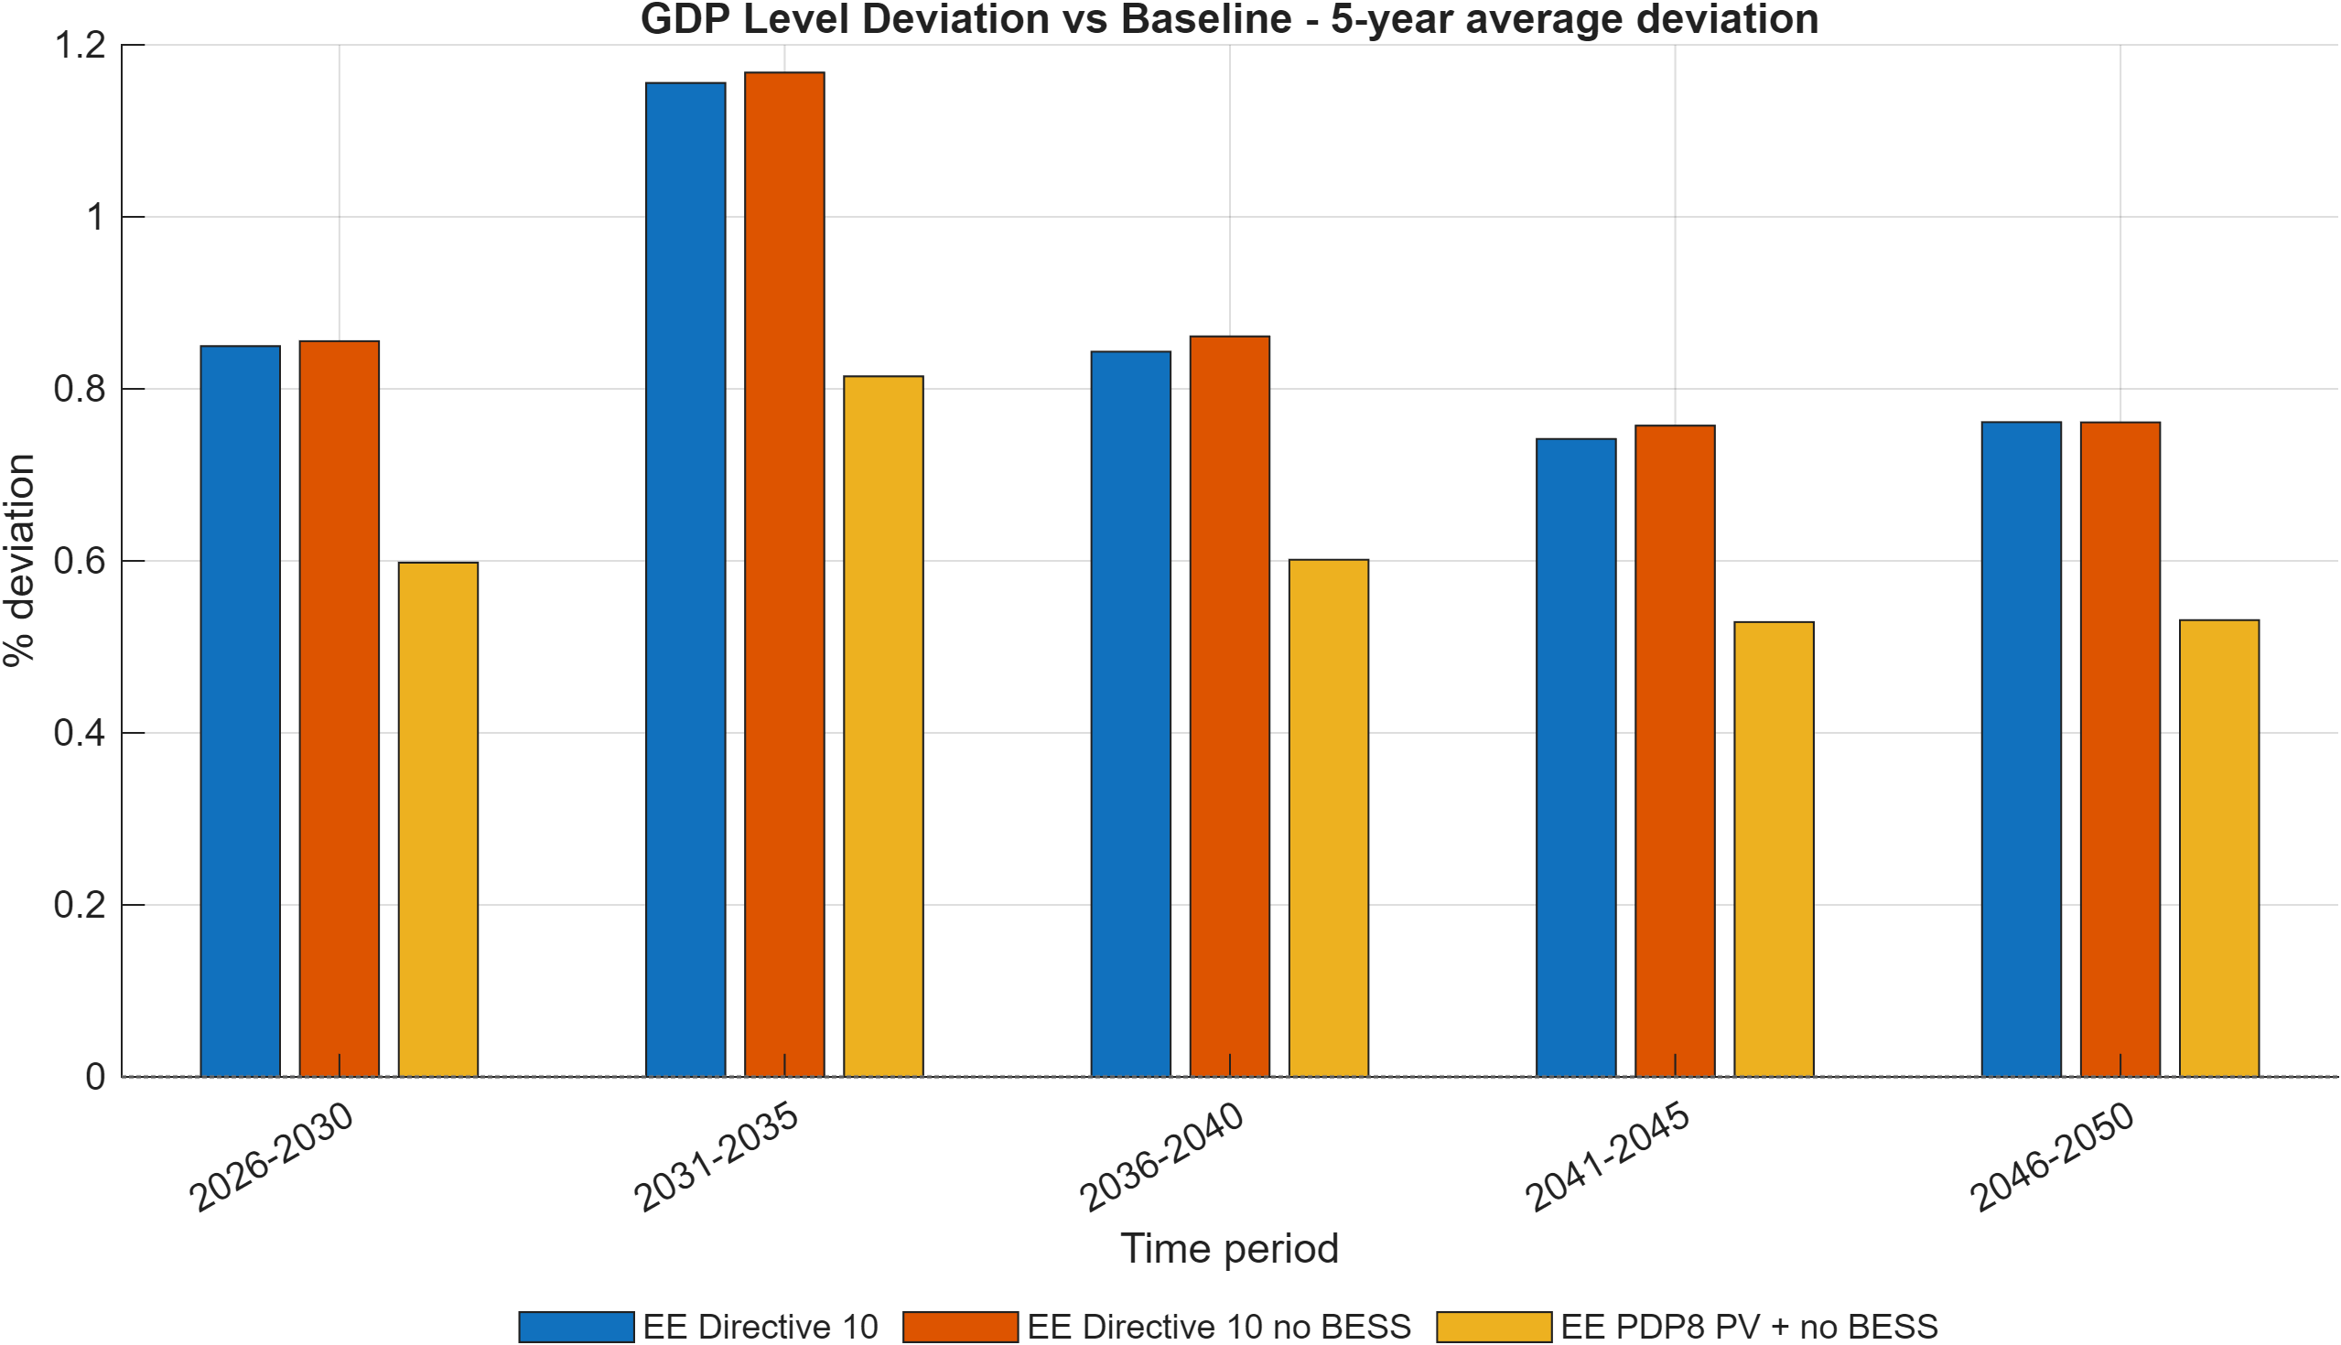
Figure 11: GDP level deviation versus Baseline across EE scenarios (5-year average).
Note: Bars show average GDP-level deviation (percent) from Baseline by 5-year block, highlighting medium-run macro effects of each EE pathway.
Source: Generated by scripts/reporting/GenerateEESimulationResultsFigures.m from scenario output CSV files in ExcelFiles/Output/.
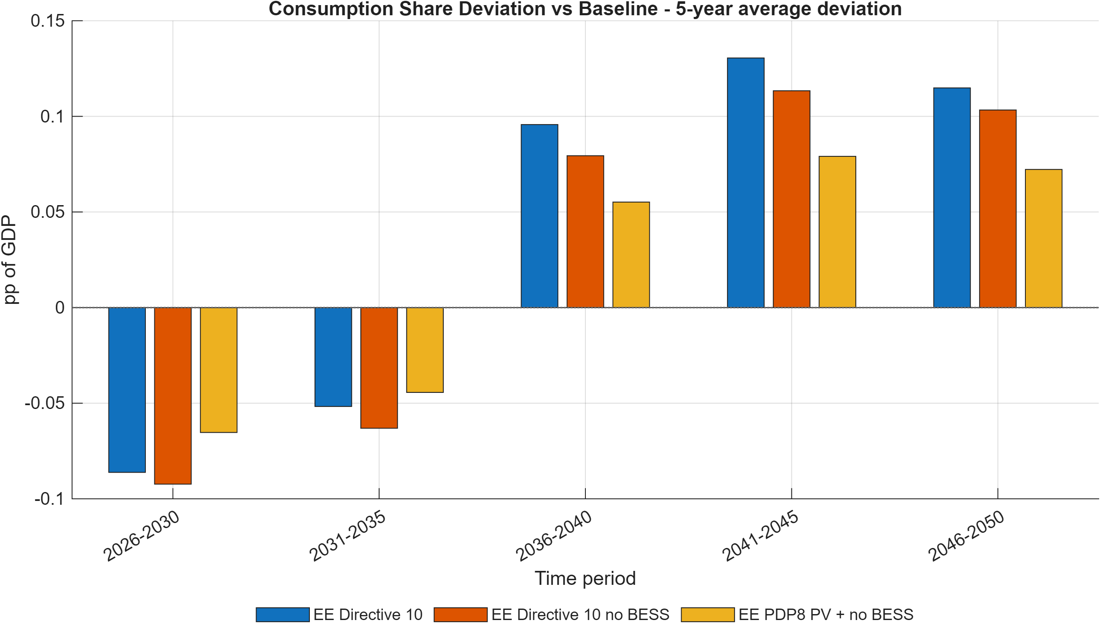
Figure 12: Consumption share deviation versus Baseline across EE scenarios (5-year average).
Note: Bars report average deviation in consumption share of GDP (pp of GDP) for each 5-year block, allowing direct comparison of household-demand reallocation under alternative EE scenarios.
Source: Generated by scripts/reporting/GenerateEESimulationResultsFigures.m from scenario output CSV files in ExcelFiles/Output/.
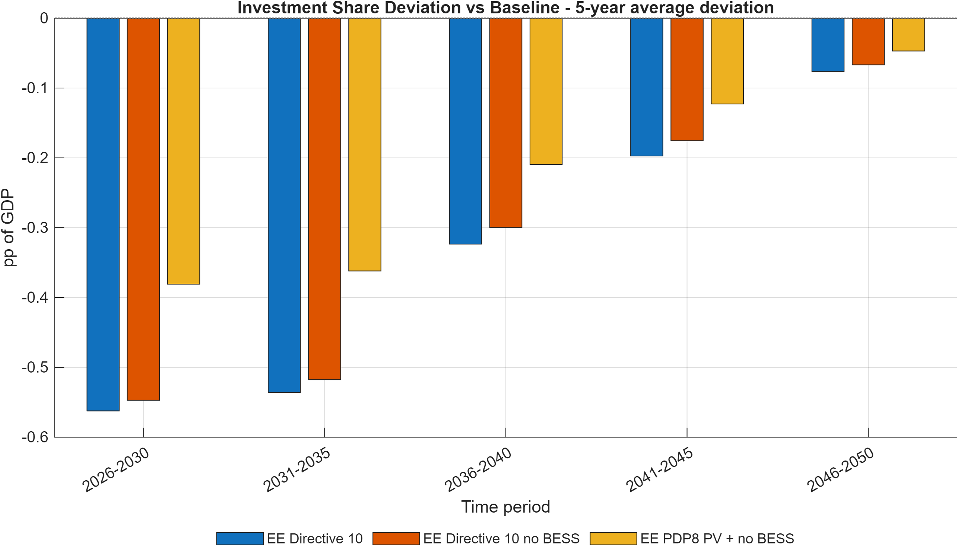
Figure 13: Investment share deviation versus Baseline across EE scenarios (5-year average).
Note: Bars report average deviation in investment share of GDP (pp of GDP) by 5-year block and summarize the medium-term capital-allocation response in each EE pathway.
Source: Generated by scripts/reporting/GenerateEESimulationResultsFigures.m from scenario output CSV files in ExcelFiles/Output/.

Green finance scenario reporting figures
The script scripts/reporting/GenerateFinanceSimulationResultsFigures.m exports scenario-comparison figures to docs/figures/Finance_Simulation_Results/. This subsection reports only deviation-versus-Baseline diagnostics, using 5-year average bar charts.
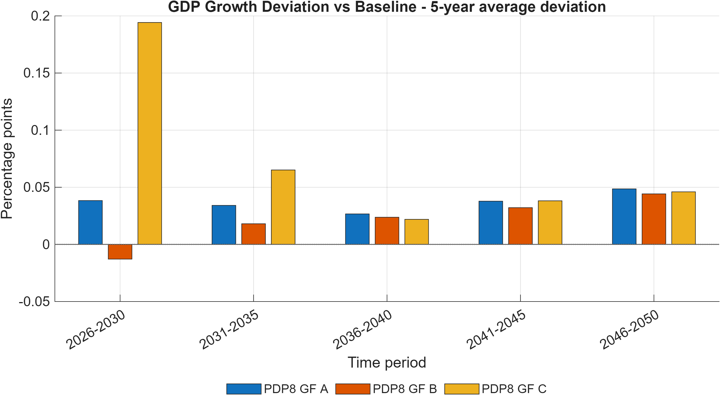
Figure 14: GDP growth deviation versus Baseline across green-finance scenarios (5-year average).
Note: Bars show the average deviation in annual GDP growth (percentage points) from Baseline by 5-year block, comparing how financing architectures alter the medium-run growth profile.
Source: Generated by scripts/reporting/GenerateFinanceSimulationResultsFigures.m from scenario output CSV files in ExcelFiles/Output/.
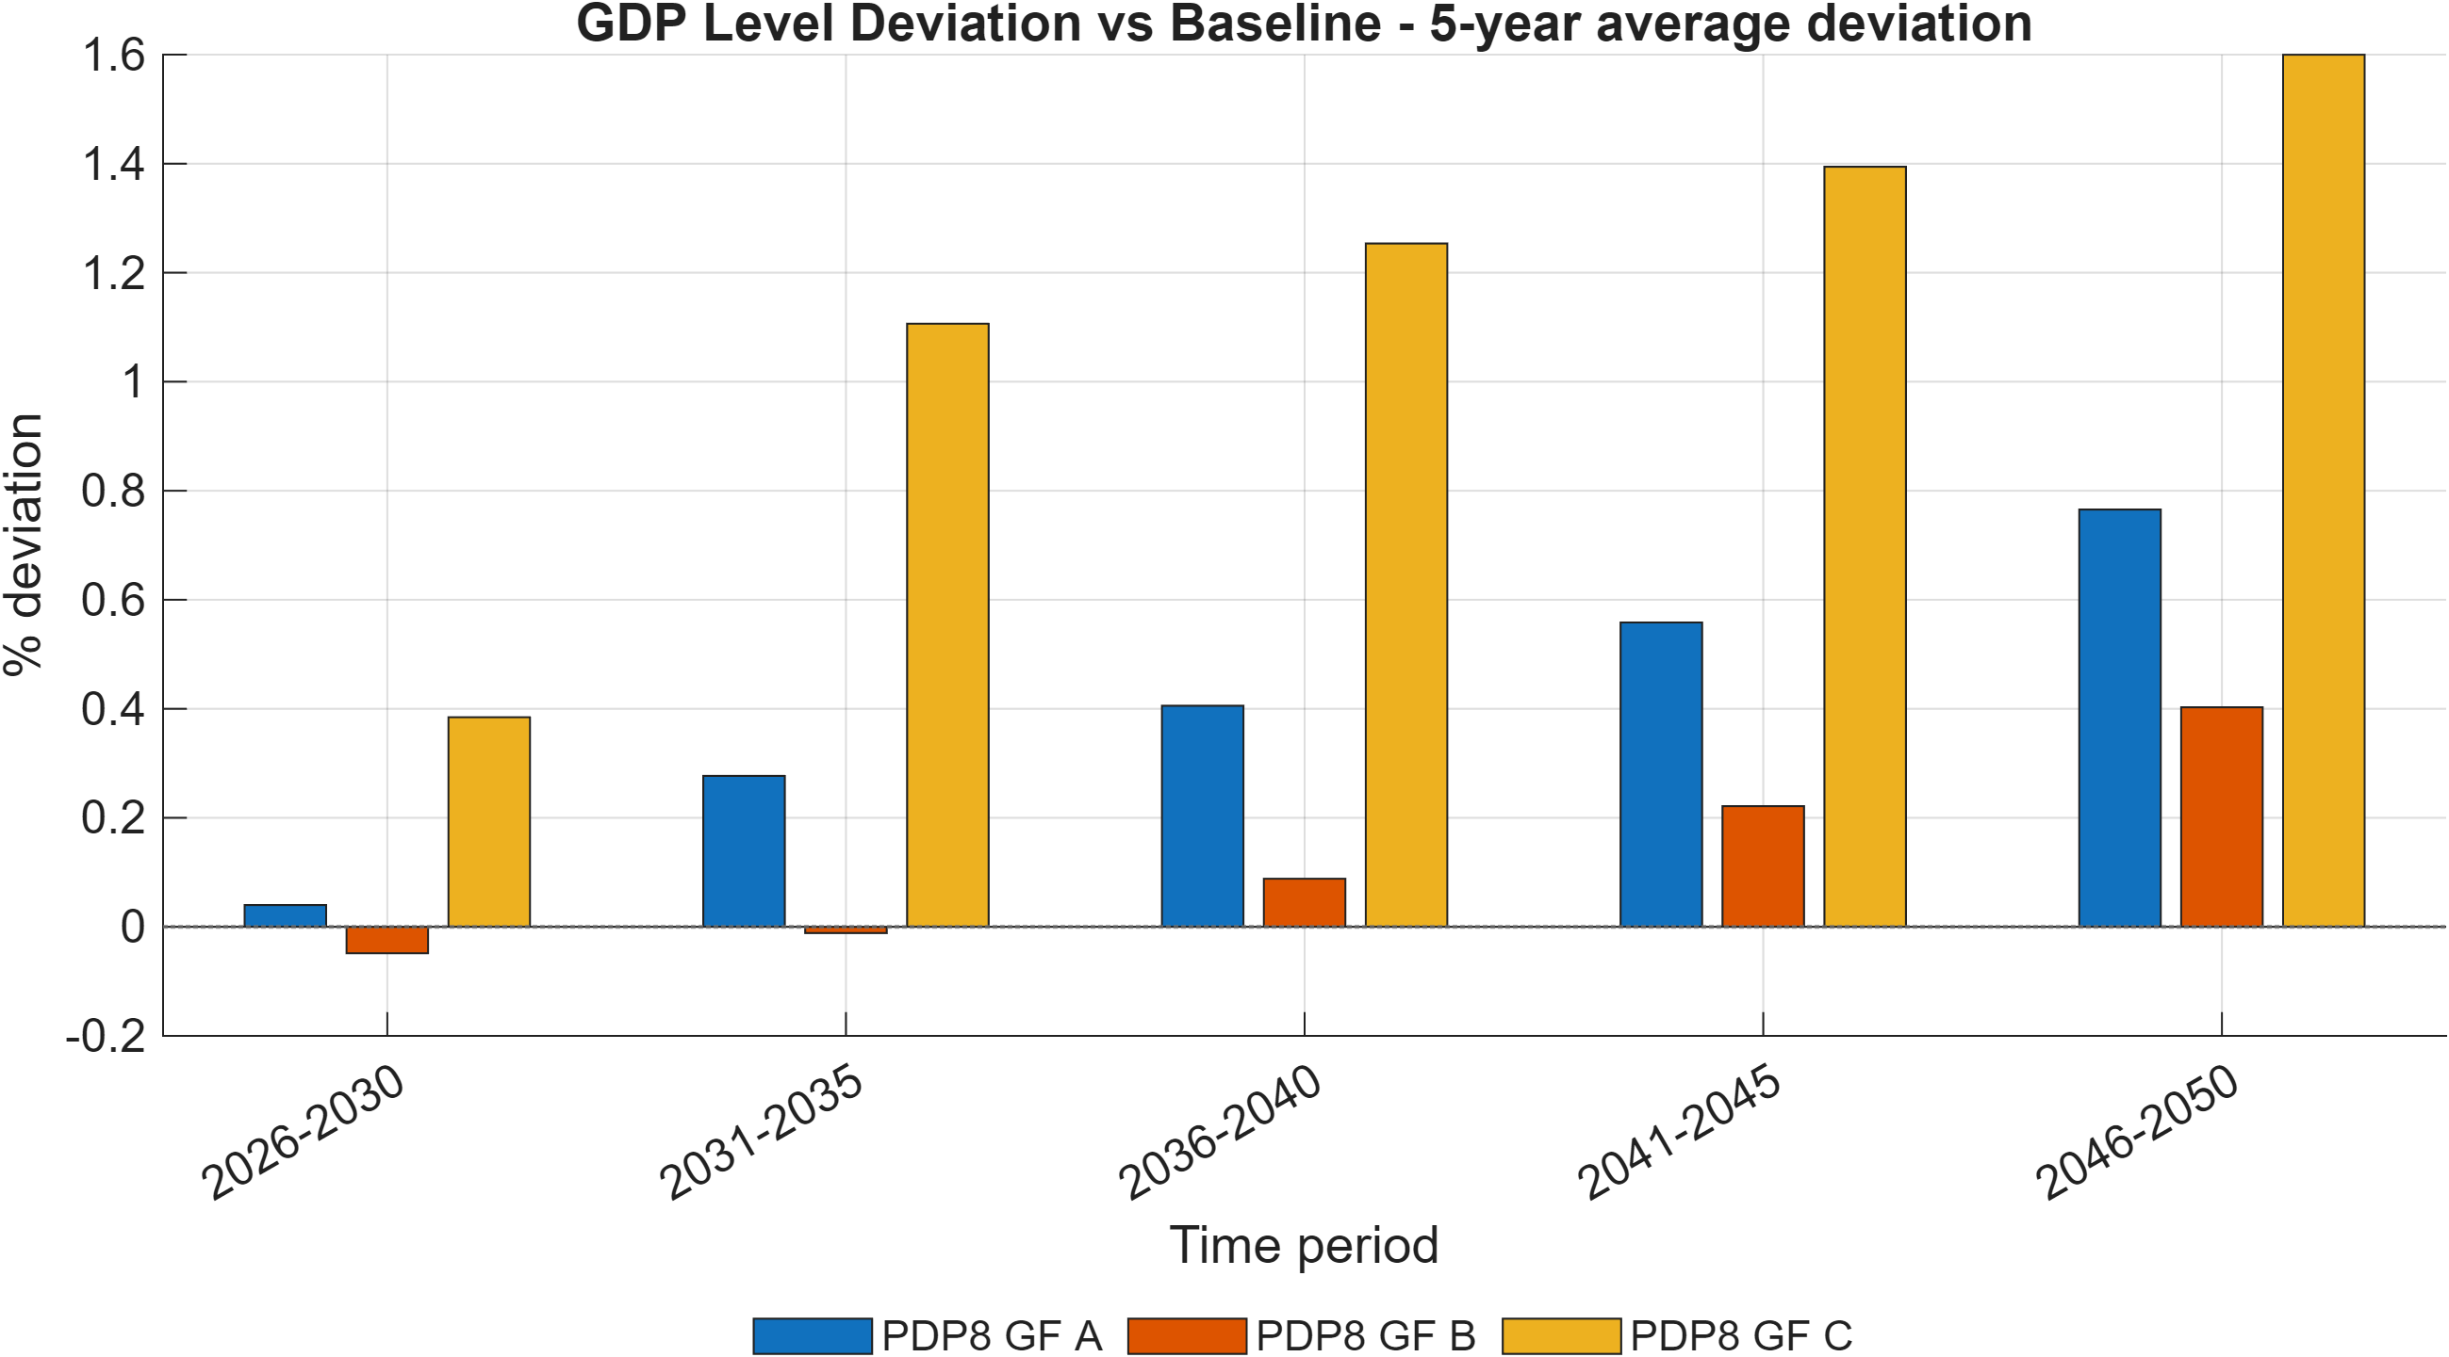
Figure 15: GDP level deviation versus Baseline across green-finance scenarios (5-year average).
Note: Bars show average percent deviations of GDP level from Baseline by 5-year block and capture cumulative macro effects of financing conditions.
Source: Generated by scripts/reporting/GenerateFinanceSimulationResultsFigures.m from scenario output CSV files in ExcelFiles/Output/.
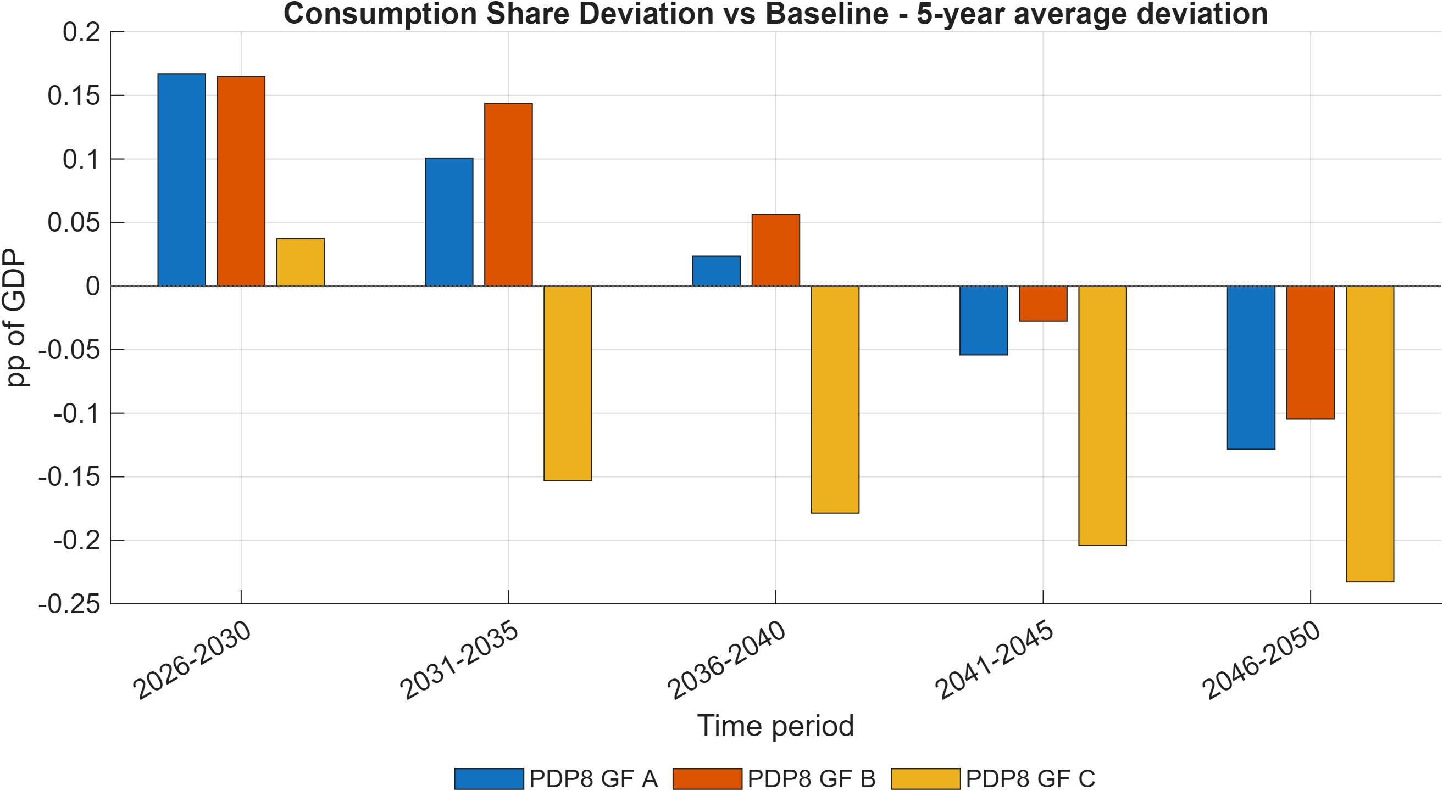
Figure 16: Consumption share deviation versus Baseline across green-finance scenarios (5-year average).
Note: Bars report average deviation in private-consumption share of GDP (pp of GDP) by 5-year block.
Source: Generated by scripts/reporting/GenerateFinanceSimulationResultsFigures.m from scenario output CSV files in ExcelFiles/Output/.
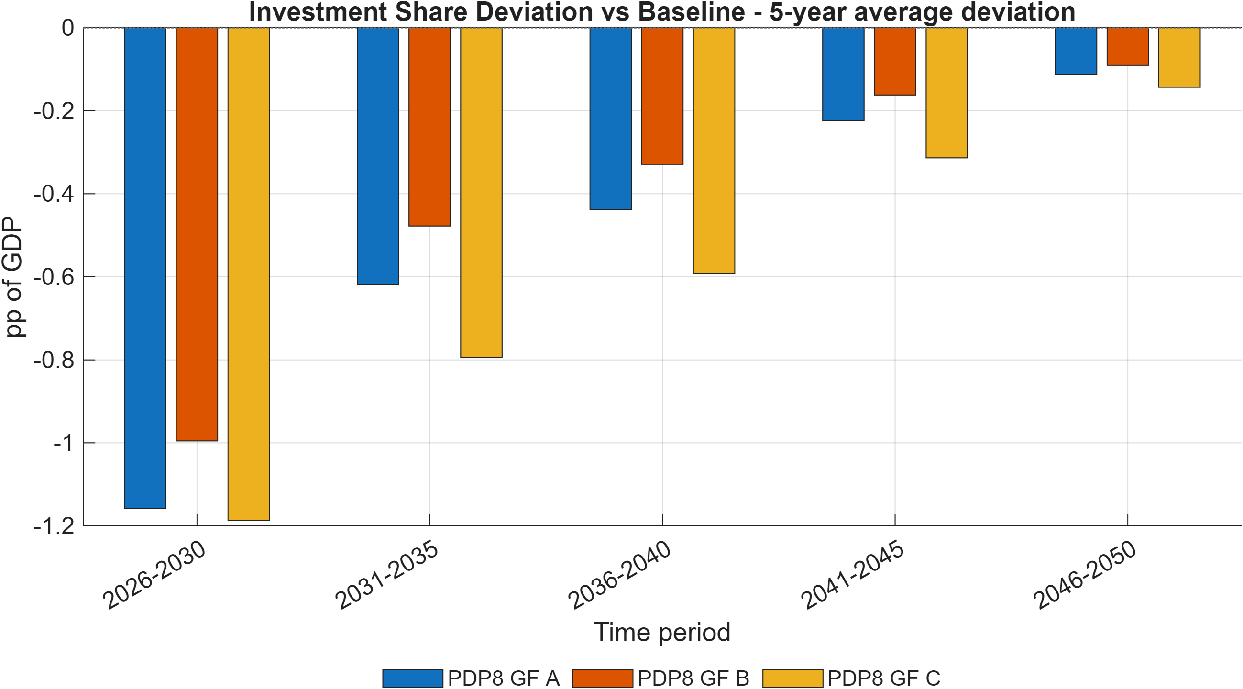
Figure 17: Investment share deviation versus Baseline across green-finance scenarios (5-year average).
Note: Bars report average deviation in investment share of GDP (pp of GDP) by 5-year block, indicating medium-run capital-allocation shifts.
Source: Generated by scripts/reporting/GenerateFinanceSimulationResultsFigures.m from scenario output CSV files in ExcelFiles/Output/.
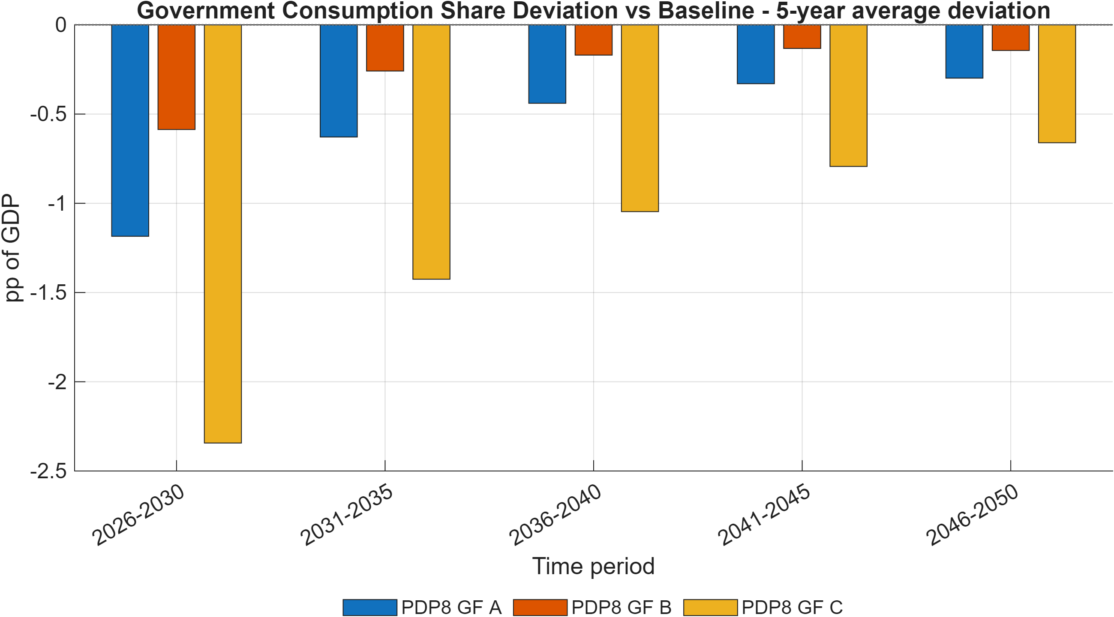
Figure 18:Government consumption share deviation versus Baseline across green-finance scenarios (5-year average).
Note: Bars report average deviation in government consumption share of GDP (pp of GDP) by 5-year block.
Source: Generated by scripts/reporting/GenerateFinanceSimulationResultsFigures.m from scenario output CSV files in ExcelFiles/Output/.
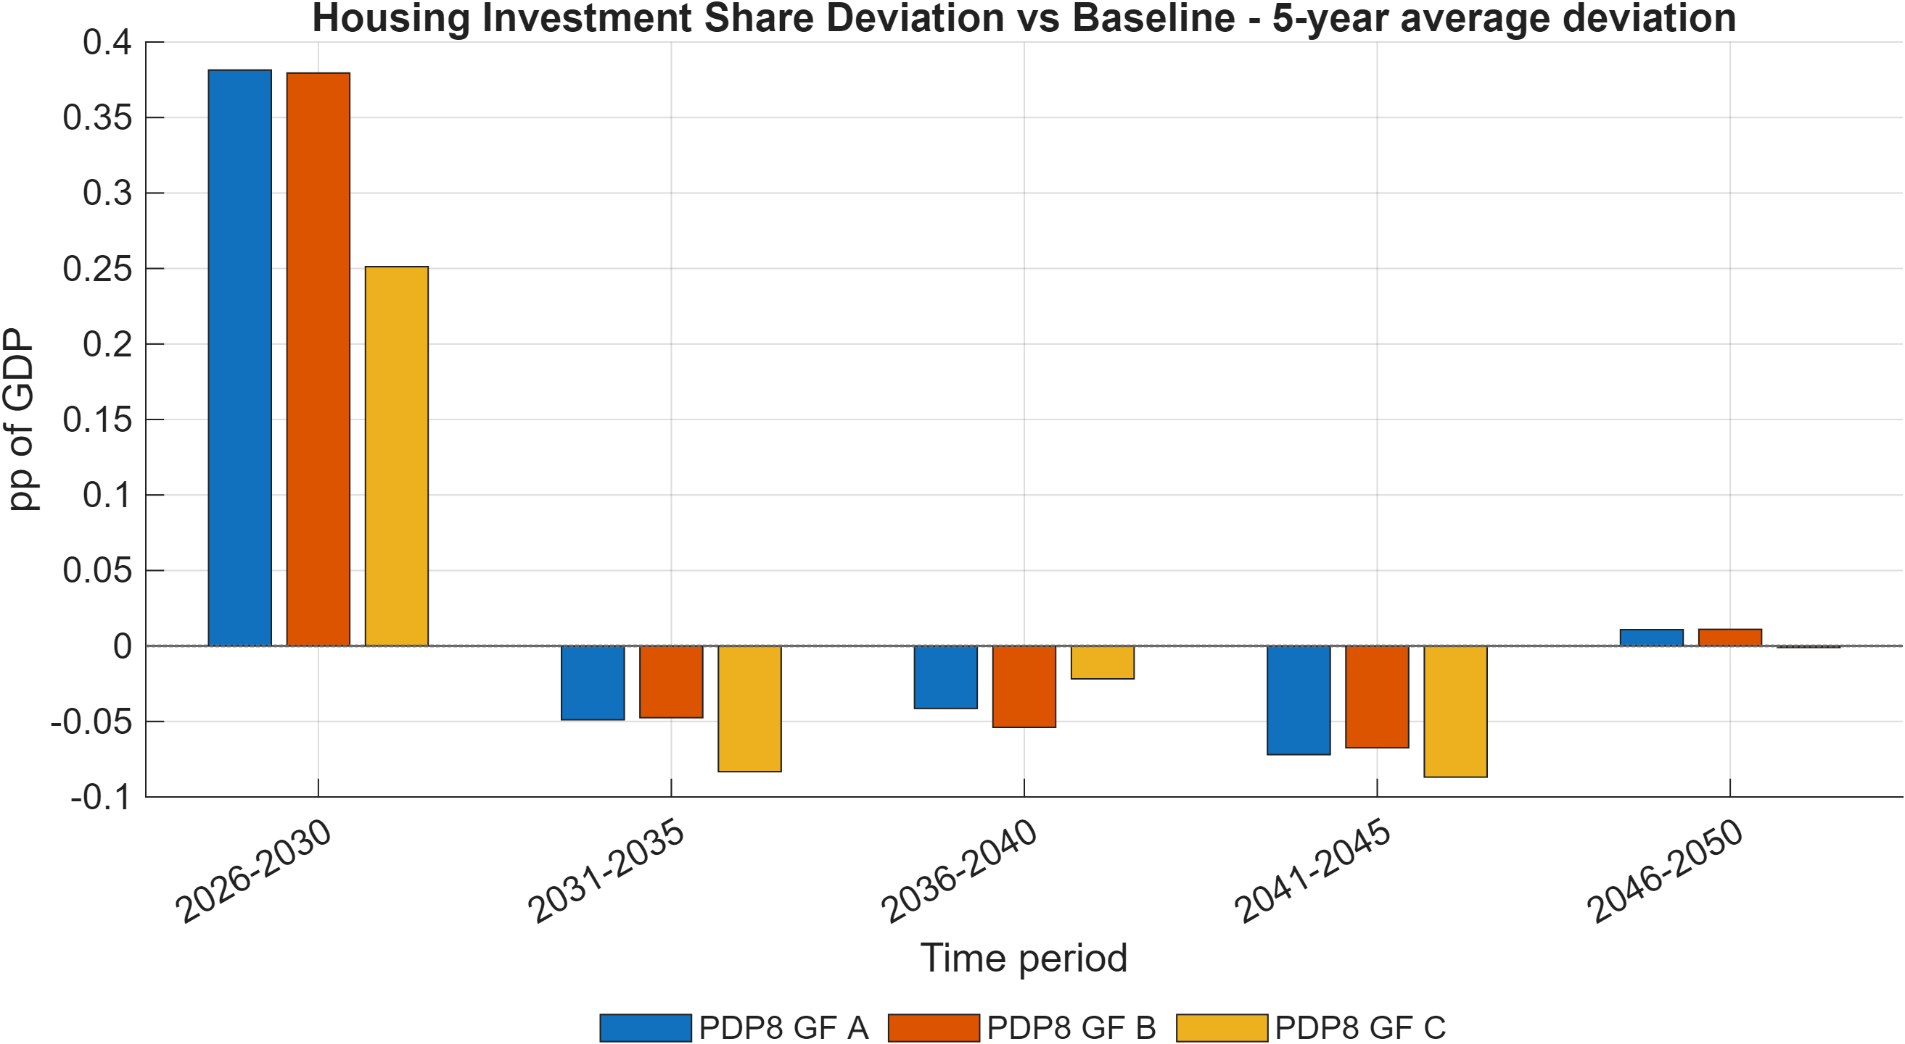
Figure 19: Housing investment share deviation versus Baseline across green-finance scenarios (5-year average).
Note: Bars report average deviation in housing investment share of GDP (pp of GDP) by 5-year block.
Source: Generated by scripts/reporting/GenerateFinanceSimulationResultsFigures.m from scenario output CSV files in ExcelFiles/Output/.
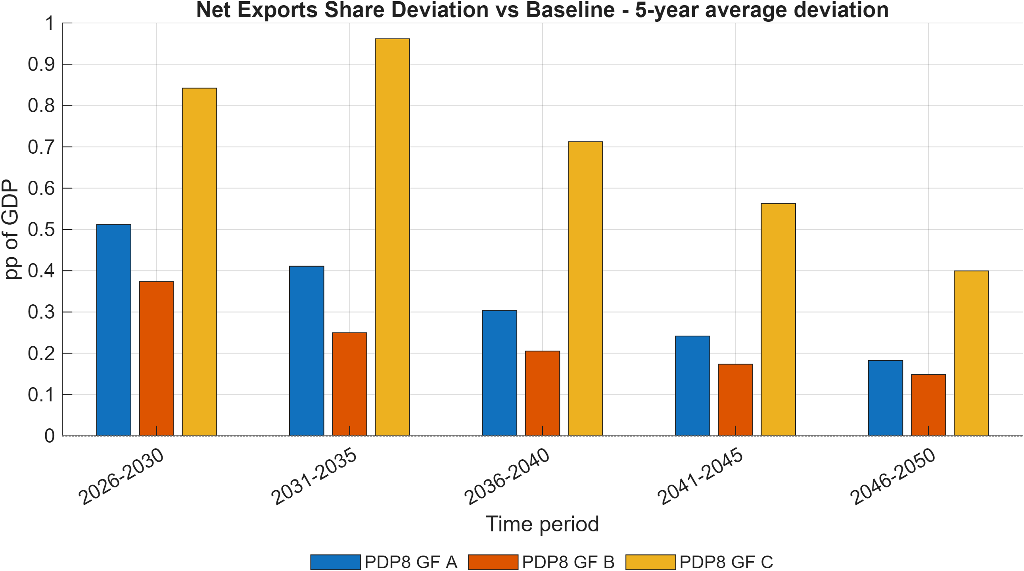
Figure 20:Net exports share deviation versus Baseline across green-finance scenarios (5-year average).
Note: Bars report average deviation in net exports share of GDP (pp of GDP) by 5-year block, summarizing external-balance effects.
Source: Generated by scripts/reporting/GenerateFinanceSimulationResultsFigures.m from scenario output CSV files in ExcelFiles/Output/.
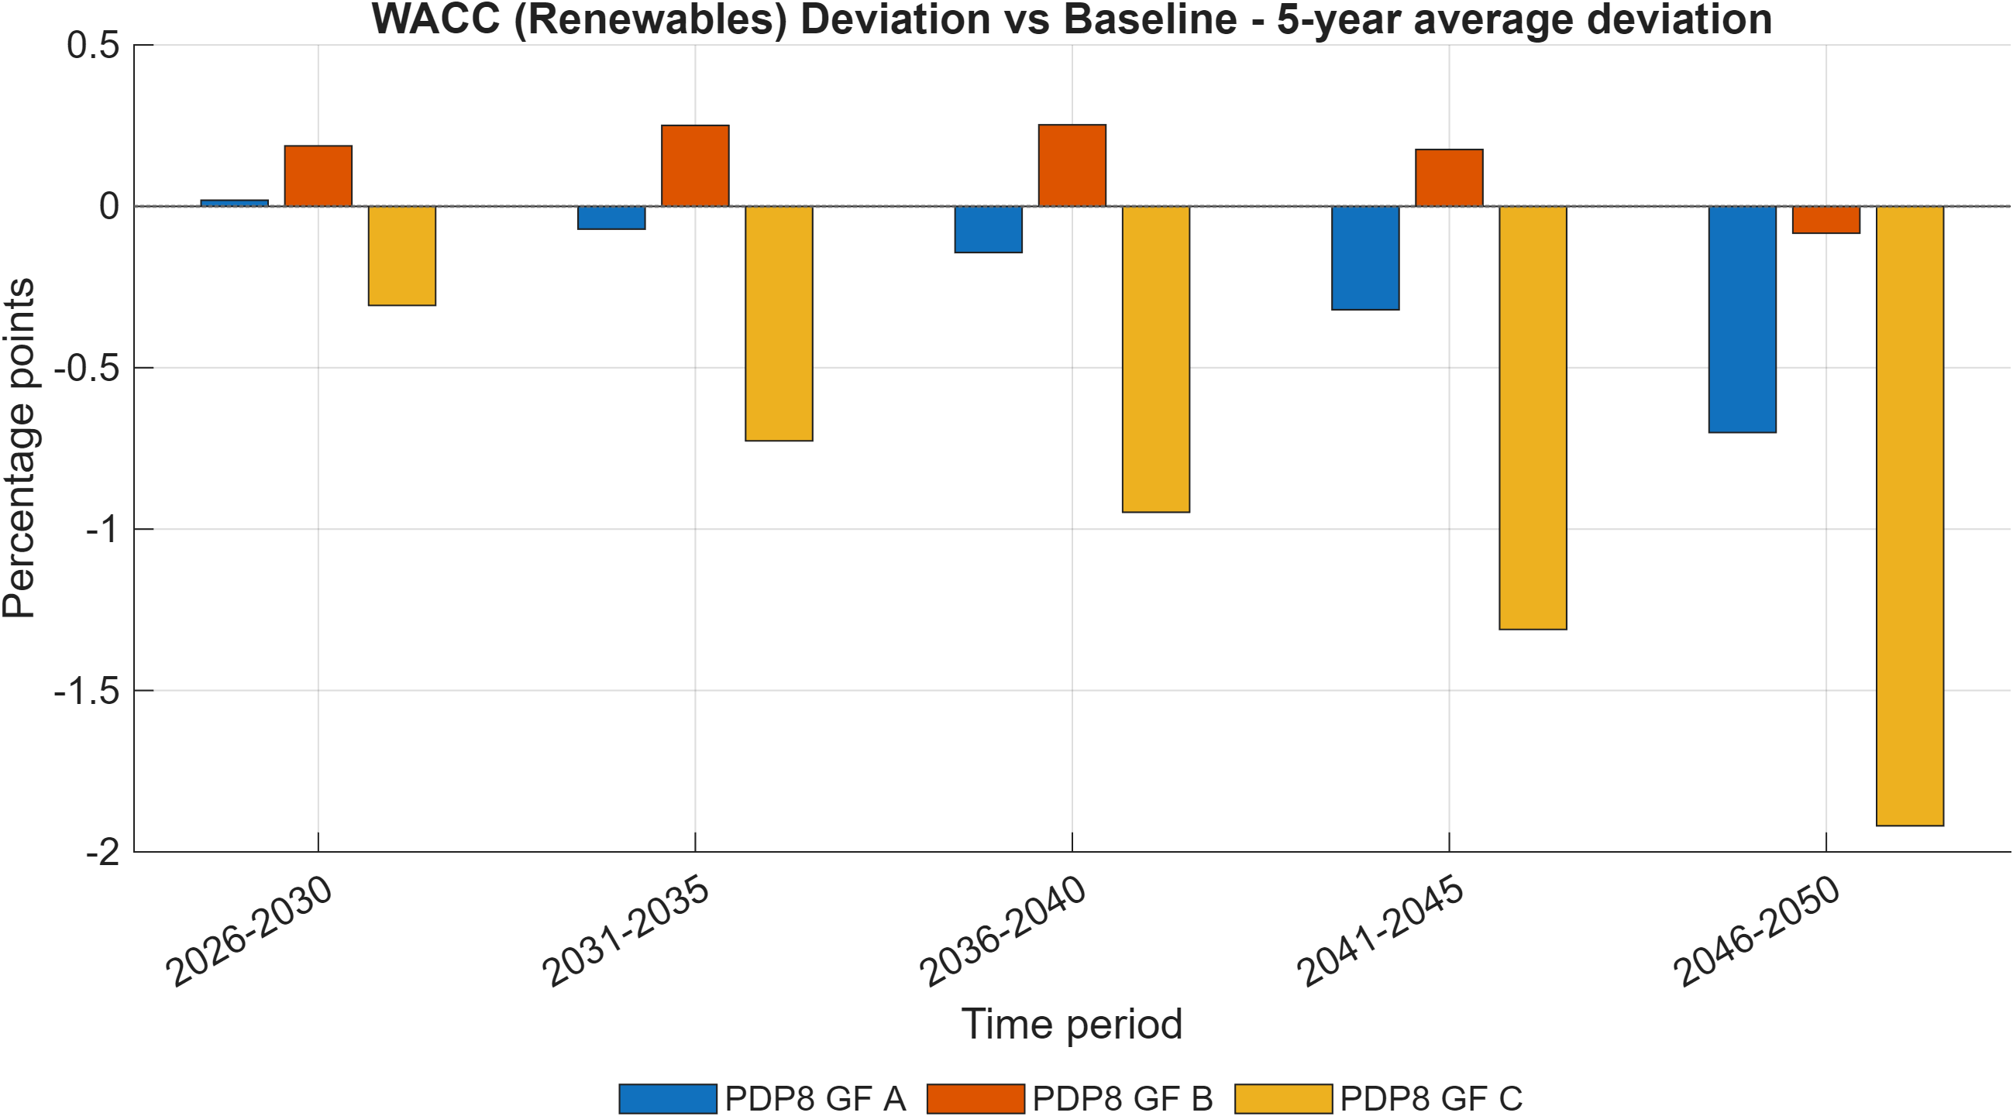
Figure 21: Renewable-energy WACC deviation versus Baseline across green-finance scenarios (5-year average).
Note: Bars report average deviations in renewable weighted average cost of capital (percentage points) from Baseline by 5-year block, summarizing the financial-channel intensity of each policy package.
Source: Generated by scripts/reporting/GenerateFinanceSimulationResultsFigures.m from scenario output CSV files in ExcelFiles/Output/.

Limitations, Implementation Risks, and Interpretation Guidance
Like all quantitative policy models, DGE-METRIC provides a simplified representation of a complex economic system. The framework is designed to evaluate the economy-wide implications of alternative energy-transition policies while maintaining internal consistency, computational tractability, and transparency. Consequently, several modelling assumptions should be considered when interpreting the simulation results. This section summarizes recurrent implementation risks and interpretation constraints that have caused incorrect results or wasted debugging time in practice. It should be treated as a pre-publication quality-control checklist.
- fval_vec_11 is load-bearing. Never remove it from evaluate_capital_steady_state_residuals.m (§5.2). Deleting it makes the hybrid steady state underdetermined.
- Energy-efficiency variable shape. Two shapes exist in this codebase’s history — legacy regional EE_1/exo_EE_1 and a sector-specific refactor EE_sec_reg/exo_EE_sec_reg. As of this writing, only the legacy regional shape is declared in ModFiles/. Confirm with git grep -n "EE_.*_1" in ModFiles/ before writing code that assumes either shape.
- Perfect-foresight singularity under direct capital targeting. Pinning total sector capital K_t directly via a Dynare equation while the household Euler equation for I_(H,t) remains active produces a rank-deficient Jacobian (the Euler equation loses its degree of freedom once K_t = K_(H,t)+K_(G,t)+K_(FDI,t) is fixed and K_(G,t) is predetermined). The working pattern is to pin the flow (insert a wedge into the Euler equation via exo_lTargetInv/wedgeKE) and let the stock follow from the law of motion, not to pin the stock directly. See implementation_plans/capital_targeting_trial_and_error.md.
- Code defaults vs. active calibration can diverge by orders of magnitude (§4.4) — always confirm the workbook actually loaded for a given run before citing a structural parameter value.
- Generated code is not source. +DGE_Model/, DGE_Model/, *_dynamic.m, *_static.m are rebuilt by Dynare on every invocation. Never hand-edit them; the fix belongs in the .mod source.
- Scenario “existing” ≠ scenario “running by default” (§6.4). Many scenario names in RunSimulations.m are commented out or excluded from activeScenarioGroups; check before assuming a cited figure is reproducible from a plain RunSimulations call.
- What the model does not do (§2.2): no plant-level dispatch, no endogenous technology learning curves, no sub-national regions, no explicit financial-instrument balance sheets.
- The exchange-rate variable s_reg is a closure device, not a full UIP nominal exchange rate (§3.7) — do not interpret its dynamics as a conventional exchange-rate block.

Conclusion
This report has presented DGE-METRIC, a dynamic general equilibrium framework developed to analyse the macroeconomic implications of Vietnam's long-term energy transition. The model integrates detailed representations of the energy sector within a forward-looking economic framework, enabling consistent evaluation of interactions among energy investment, production, household welfare, public finances, international trade, and greenhouse gas emissions. The modular architecture combines a transparent calibration methodology, deterministic perfect-foresight solution framework, and flexible scenario design to provide a reproducible platform for policy analysis.
The report has demonstrated the application of DGE-METRIC through a structured suite of policy scenarios, including the revised Power Development Plan VIII baseline, Net-Zero transition pathways, energy-efficiency policies, and green-finance interventions represented as reduced-form changes in the cost of capital. The nested scenario framework enables both comparison of alternative policy packages and decomposition of the principal economic adjustment mechanisms, allowing policymakers to distinguish the contributions of emissions constraints, technological improvements, and financing conditions to long-term economic outcomes.
Although the model abstracts from many engineering, financial, and institutional details, these simplifications are intentional. DGE-METRIC is designed to complement, rather than replace, engineering and sector-specific models by providing an economy-wide perspective on the consequences of energy-transition policies. Its principal strength lies in capturing the interactions between the energy sector and the broader economy within a consistent general equilibrium framework, thereby supporting evidence-based assessment of alternative policy pathways.
While developed for Vietnam, the methodological architecture of DGE-METRIC is not country specific. The framework has been designed to support continued development as new data and policy priorities emerge. Future enhancements may include greater sectoral and regional detail, stochastic analysis, endogenous technological learning, and closer integration with engineering-based energy-system models. As Vietnam advances towards its long-term climate and development objectives, DGE-METRIC provides a transparent, extensible, and reproducible analytical platform for evaluating the macroeconomic implications of energy-transition policies and informing evidence-based decision-making.

References
CITATION.cff (this repository) — canonical citation for the model: Schult, C. (2026). DGE-METRIC: Dynamic General Equilibrium for Macroeconomic Energy Transition Incorporating Carbon Markets. Halle Institute for Economic Research (IWH). https://github.com/schultkr/DGE-METRIC
Schult, C. et al. (2025). Investment Needs Assessment for Vietnam’s Energy Transition. IWH Policy Note. GIZ project “Support for Carbon Pricing and Green Finance in Vietnam.”
Schult, C. et al. (2025). Financial Assessment Report: Green Finance Instruments for Vietnam’s PDP8. IWH Policy Note. GIZ project “Support for Carbon Pricing and Green Finance in Vietnam.”
Vietnam Government, Decision 500/QD-TTg (2023). Power Development Plan 8 (PDP8).
General Statistics Office of Vietnam (NSO). Input-Output Table 2019.
IEA. World Energy Outlook 2025.
EDGAR (EU Joint Research Centre). Global GHG Emissions Database, 2024 release.
EXIOBASE 3. Environmentally extended multi-region input-output database.
Schultz, T.W. (1961). “Investment in Human Capital.” American Economic Review; related labor-productivity treatment cross-referenced via NBER working paper 21381.
Christiano, Motto, and Rostagno (2014); Leeper (2010); Kliem (2014);
Drygalla et al. (2020) — reduced-form fiscal-policy modeling conventions followed in the government block (§3.5).

A. Technical Appendix

A.1 Equation reference
Full equation listings, by block, are maintained in ModFiles/Equations/*.mod with a parallel human-readable mirror in ModFiles/Equations/Equations_display/. The primary equation-set narrative is in model.md; this report’s §3 summarizes the theoretical structure without reproducing every first-order condition.

A.2 Parameter reference
The full parameter-by-parameter calibration source audit — including flags for stale or uncertain values — is maintained in structural_parameters_source_audit.md. The code-default-vs-active-workbook override table is in calibration_model_detailed.md §12.

A.3 Repository map

