Macroeconomic Impact Assessment of Vietnam’s Power Development Plan 8 and Associated Policy Instruments
  - A DGE-METRIC model-based assessment.
Halle Institute for Economic Research (IWH), for GIZ Vietnam
2026-07-14

Macroeconomic Impact Assessment of Vietnam’s Power Development Plan 8 and Associated Policy Instruments
How to use this document. This report presents policy findings on the macroeconomic effects of PDP8 and three transition policy instruments — energy efficiency, green finance, and carbon pricing — using the DGE-METRIC model. For the underlying model, data, and solution method, see the companion Technical Report. This document is written to convert cleanly to Word/PDF (e.g. via pandoc) for circulation as a policy deliverable.

Table of Contents
- Executive Summary
- Vietnam's Energy Transition Challenge
- Policy Instruments Assessed
- Cross-Cutting Findings
- Policy Recommendations
- Data and Modeling Caveats
- Annex: Methodology Summary

1. Executive Summary
Vietnam’s Power Development Plan 8 (PDP8) and net-zero-by-2050 commitment require an estimated USD 136 billion in energy-sector investment through 2050. This report uses DGE-METRIC (Dynamic General Equilibrium for Macroeconomic Energy Transition Incorporating Carbon markets) — a five-sector dynamic general equilibrium model calibrated to Vietnam — to quantify the macroeconomic consequences of three policy levers available to shape that transition: energy efficiency ambition, the architecture of green finance, and carbon pricing under a net-zero emissions cap.
Headline findings:
- Energy efficiency is GDP-positive at low cost. Both PDP8-consistent and more ambitious (PM Directive 10/CT-TTg) efficiency targets raise GDP levels throughout the 2026–2050 horizon, with only a small near-term investment-consumption trade-off. Scaling ambition from PDP8 to Directive-10-equivalent targets roughly doubles the GDP gain for an incremental cost of USD 100–150 million per year.
- Cheaper capital delivers a measurable, compounding growth dividend. Shifting from market-led to public-led (concessional) green finance reduces annual financing costs by approximately USD 3 billion, compounding into a persistent GDP growth premium that builds through the 2030s as lower-cost capital accumulates.
- A binding net-zero emissions cap imposes a modest but persistent GDP cost relative to the PDP8 baseline — the price of accelerating fossil phase-out via a carbon market. Decomposition scenarios show that a meaningful share of this cost is avoided when fuel-switching and efficiency channels remain available; the cost rises substantially under a “worst case” of limited technological learning.
- The value of concessional finance is higher, not lower, under more ambitious climate policy — financing-cost reductions and carbon pricing are complements, not substitutes, meaning development partners and MDBs have larger impact precisely where climate ambition is highest.
- Energy efficiency alone does not reduce emissions under the PDP8 baseline; efficiency gains only translate into emissions reduction when combined with a binding carbon constraint (the net-zero pathway).
These findings are based on specific, non-default model configurations (see §6); reproducing any individual figure requires the exact activeScenarioGroups configuration used to generate it.

2. Vietnam’s Energy Transition Challenge
Vietnam is one of Southeast Asia’s fastest-growing economies, with electricity consumption that has roughly doubled every decade, historically powered largely by coal. Vietnam has committed to:
- net-zero emissions by 2050 (COP26 pledge, restated in its Nationally Determined Contribution);
- 60% renewable electricity share by 2030 (PDP8, Decision 500/QD-TTg, 2023);
- no new coal capacity after 2030 (a core PDP8 commitment).
These targets compress a multi-decade technology transition into roughly a decade. In the model, PDP8 serves as the reference (baseline) scenario: the trajectory the economy follows if current energy and climate policy plans are maintained, including rapid solar/wind/storage build-out, coal phase-down, large grid investment, and continued 6–7% annual GDP growth through the 2030s. PDP8 is treated as a planning baseline, not a certainty — it is ambitious relative to current implementation capacity.
Investment scale. The IWH Investment Needs Assessment (2025) estimates cumulative energy-sector investment needs of approximately USD 1 trillion (2026–2050), spanning renewable capacity, grid reinforcement/transmission, energy efficiency, and climate-adaptation measures. The central economic question is not whether Vietnam can eventually afford this, but whether the timing, financing cost, and institutional capacity are adequate at the pace PDP8 requires.
The financing gap. The IWH Financial Assessment (2025) identifies a financing bottleneck in the pre-2035 window, driven by large upfront grid/storage costs, high market borrowing costs (8–10% for private energy projects), a limited domestic institutional investor base, and uncertainty over carbon-market revenue. Green finance instruments — concessional loans, blended finance, green bonds, and development-bank facilities — are designed to narrow this gap by lowering the effective cost of capital (§3.2).
Carbon market development. Vietnam is building a domestic emissions trading system (ETS), piloted first in the power sector. Design questions — coverage rate, cap trajectory, and revenue recycling — determine both the carbon-price path and its distributional consequences (§3.3).

3. Policy Instruments Assessed

3.1 Energy efficiency
Policy question: if Vietnam accelerates energy efficiency in industry and services beyond what PDP8 already assumes, what are the macroeconomic consequences — and what role does battery storage (BESS) play?
Two ambition levels are modeled: EE_PDP8 (PDP8-consistent targets: ~7.4% industry and ~5.1% services energy savings by 2030, ~USD 361 million/year combined investment, ≈0.076% of GDP) and EE_Directive10 (higher ambition calibrated to Vietnam’s Prime Minister Directive 10/CT-TTg). Both run on the PDP8 baseline with no binding carbon constraint.
Results:
- GDP levels rise throughout the horizon under both variants; Directive-10 ambition delivers roughly 0.44–0.58 percentage points higher GDP level than EE_PDP8 across 2030–2050, for an incremental investment cost of USD 100–150 million/year.
- The near-term effect on the consumption/investment mix is small (consumption share down at most 0.09 pp in 2030, recovering by 2040) as upfront EE capital outlay is later offset by lower energy costs.
- Emissions are identical across all EE variants — efficiency reduces energy intensity but does not, by itself, reduce the emissions path, since the PDP8 baseline has no binding cap. The emissions benefit of efficiency only materializes when combined with the net-zero carbon constraint.
- Removing the BESS-specific contribution (NoBESS counterfactuals) changes aggregate GDP outcomes negligibly (≤0.013 pp by 2050) — BESS’s value case rests on grid reliability, not aggregate macro impact.
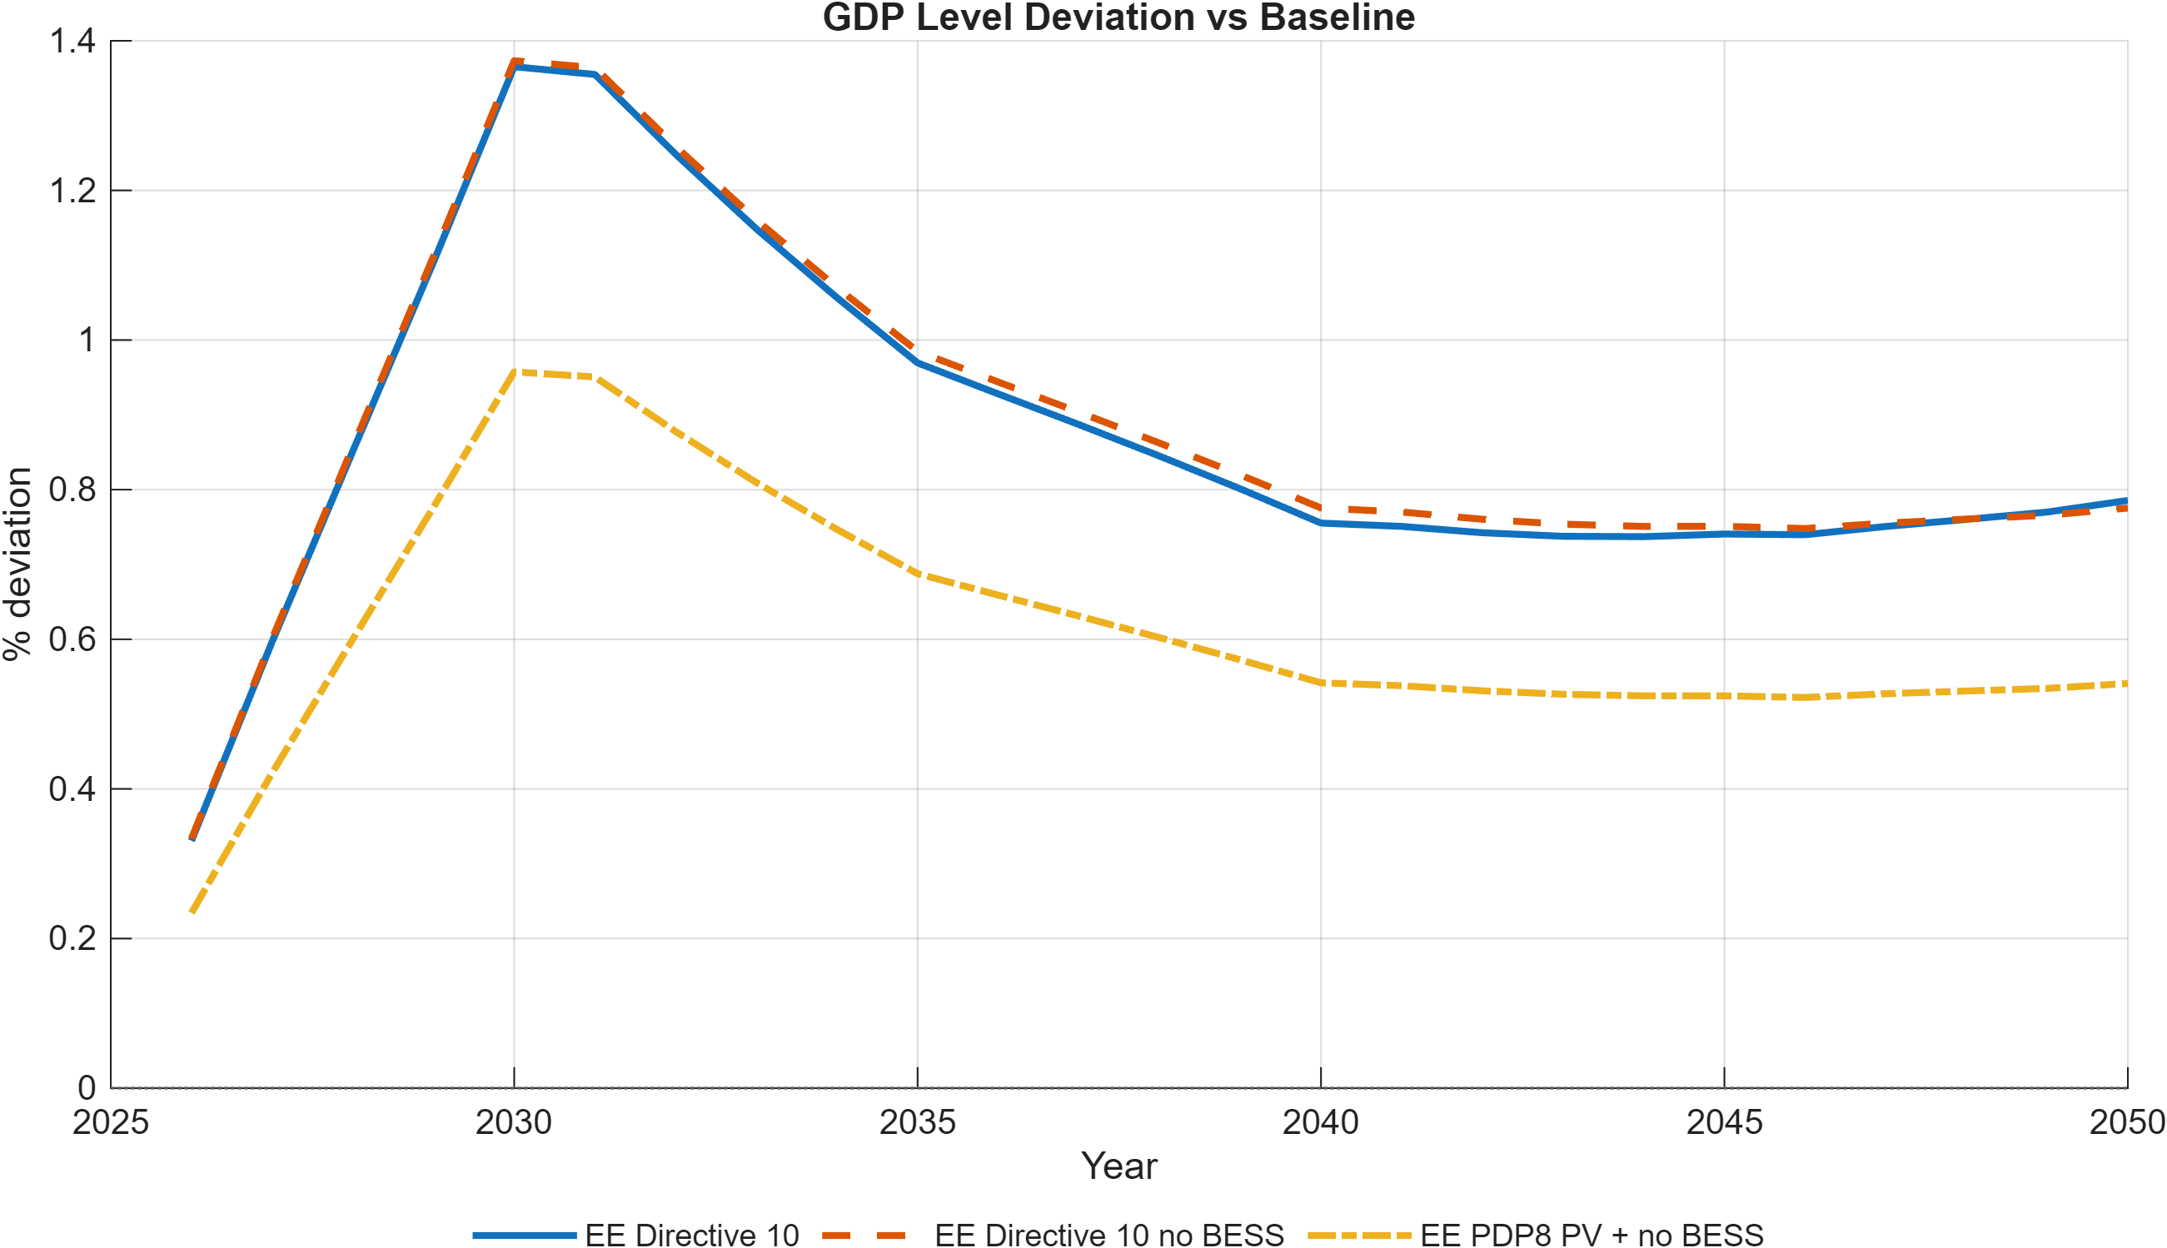
GDP level deviation from baseline — EE scenarios
Figure 3.1. GDP level deviation from the PDP8 Baseline, EE_PDP8 vs. EE_Directive10.
Note: Values are percent deviations of GDP level from the PDP8 Baseline path, 2026–2050. EE_Directive10 reaches roughly 0.5 percentage points higher GDP than EE_PDP8 by 2040, for an incremental investment cost of USD 100–150 million/year.
Source: Generated by scripts/reporting/GenerateEESimulationResultsFigures.m from scenario output CSV files in ExcelFiles/Output/.
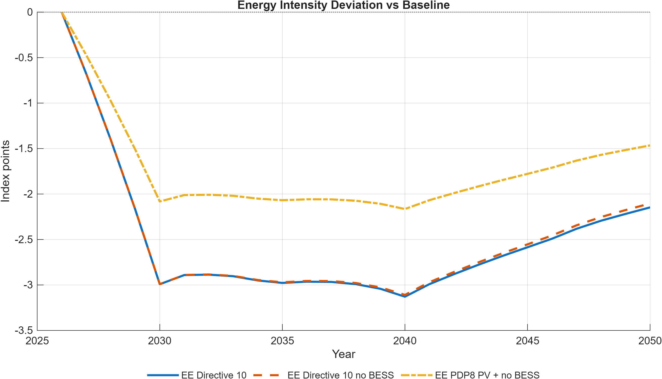
Energy intensity deviation vs baseline — EE scenarios
Figure 3.2. Energy-intensity deviation of EE scenarios from the PDP8 Baseline.
Note: Values are index-point deviations from the Baseline energy-intensity index (base year 2026). Directive 10 delivers a roughly 1.9 pp lower energy intensity index than EE_PDP8 by 2030, widening to about 1.6 pp by 2040.
Source: Generated by scripts/reporting/GenerateEESimulationResultsFigures.m from scenario output CSV files in ExcelFiles/Output/.
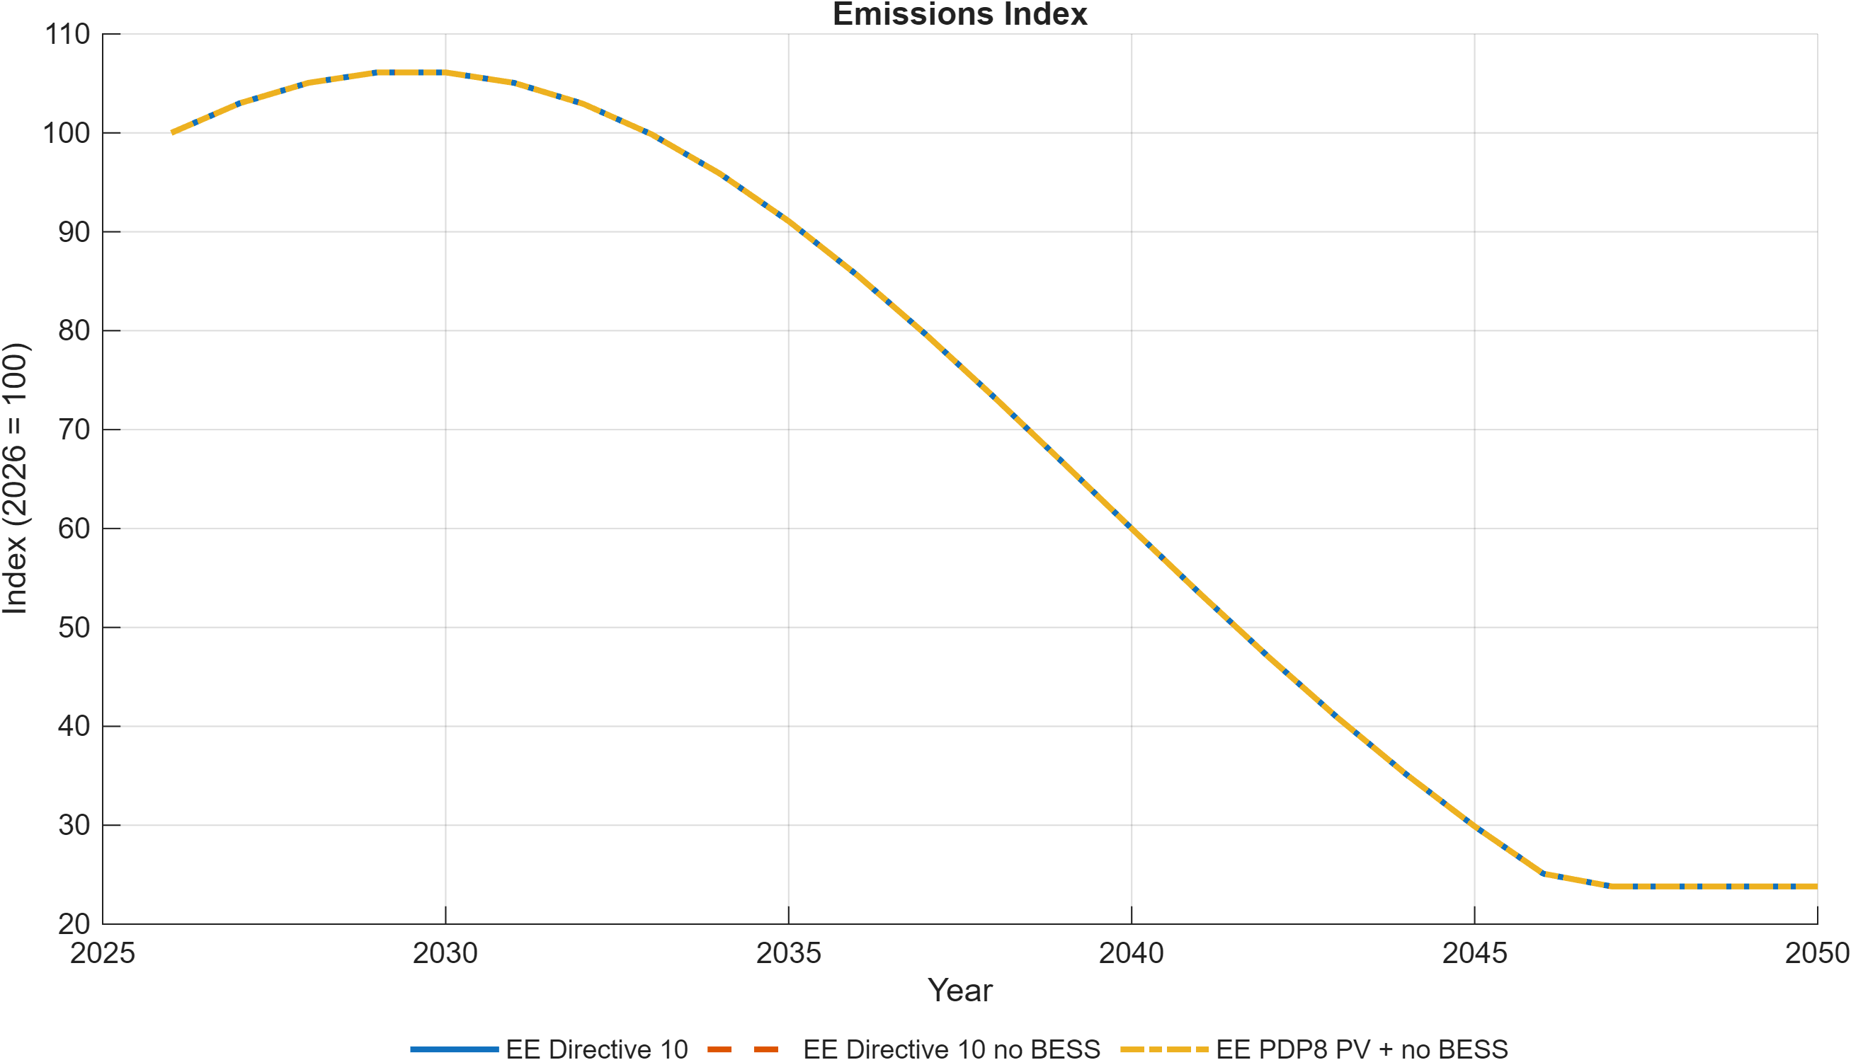
Emissions index — EE scenarios
Figure 3.3. Emissions index across EE scenario variants, PDP8 Baseline vs. EE_PDP8/EE_Directive10 (with and without BESS).
Note: Index, base year 2026 = 100. All four EE variants track the same emissions path — efficiency reduces energy intensity but does not, by itself, bend the emissions path absent a binding carbon constraint.
Source: Generated by scripts/reporting/GenerateEESimulationResultsFigures.m from scenario output CSV files in ExcelFiles/Output/.
(Full discussion, including the consumption/investment mix and BESS sensitivity: use_cases_ee.md.)

3.2 Green finance architecture
Policy question: does who provides transition capital, and at what cost, materially change Vietnam’s macroeconomic trajectory?
Three financing architectures are compared by their Weighted Average Cost of Finance (WACF): GF_A balanced (ODA/MDB + blended + green bonds, WACF 6.43%), GF_B market-led (predominantly commercial capital, WACF 7.37%), and GF_C public-led (concessional/ODA-dominant, WACF 5.07%). Each runs on both the PDP8 baseline and the Net-Zero path (six finance configurations in total). Finance instruments enter as reduced-form cost-of-capital and investment-price shocks (public/FDI finance rates, effective investment price) rather than as named balance-sheet instruments — see §6 for what this does and does not capture.
Results:
- The public-led (GF_C, 5.07% WACF) vs. market-led (GF_B, 7.37% WACF) comparison — a roughly 2 percentage-point WACF spread — translates into approximately USD 3 billion per year in avoided financing costs at the USD 136 billion investment scale, and a consistent GDP growth premium through the horizon.
- The GDP effect can be slightly negative in the very near term (higher investment temporarily displaces consumption) before the payoff from a larger, cheaper-financed capital stock materializes.
- Financing effects are amplified under Net-Zero. When the same finance scenarios are run against the NZ baseline, investment requirements are larger and the cost of capital more binding, so a given WACF reduction has a larger absolute GDP effect than under PDP8 alone. This means concessional finance and carbon pricing are complements, not substitutes — the case for cheaper capital strengthens as climate ambition rises.
- The model results represent an upper bound: they show what a given financing architecture achieves if fully deployed at the assumed cost, not whether that cost reduction is institutionally achievable at scale.
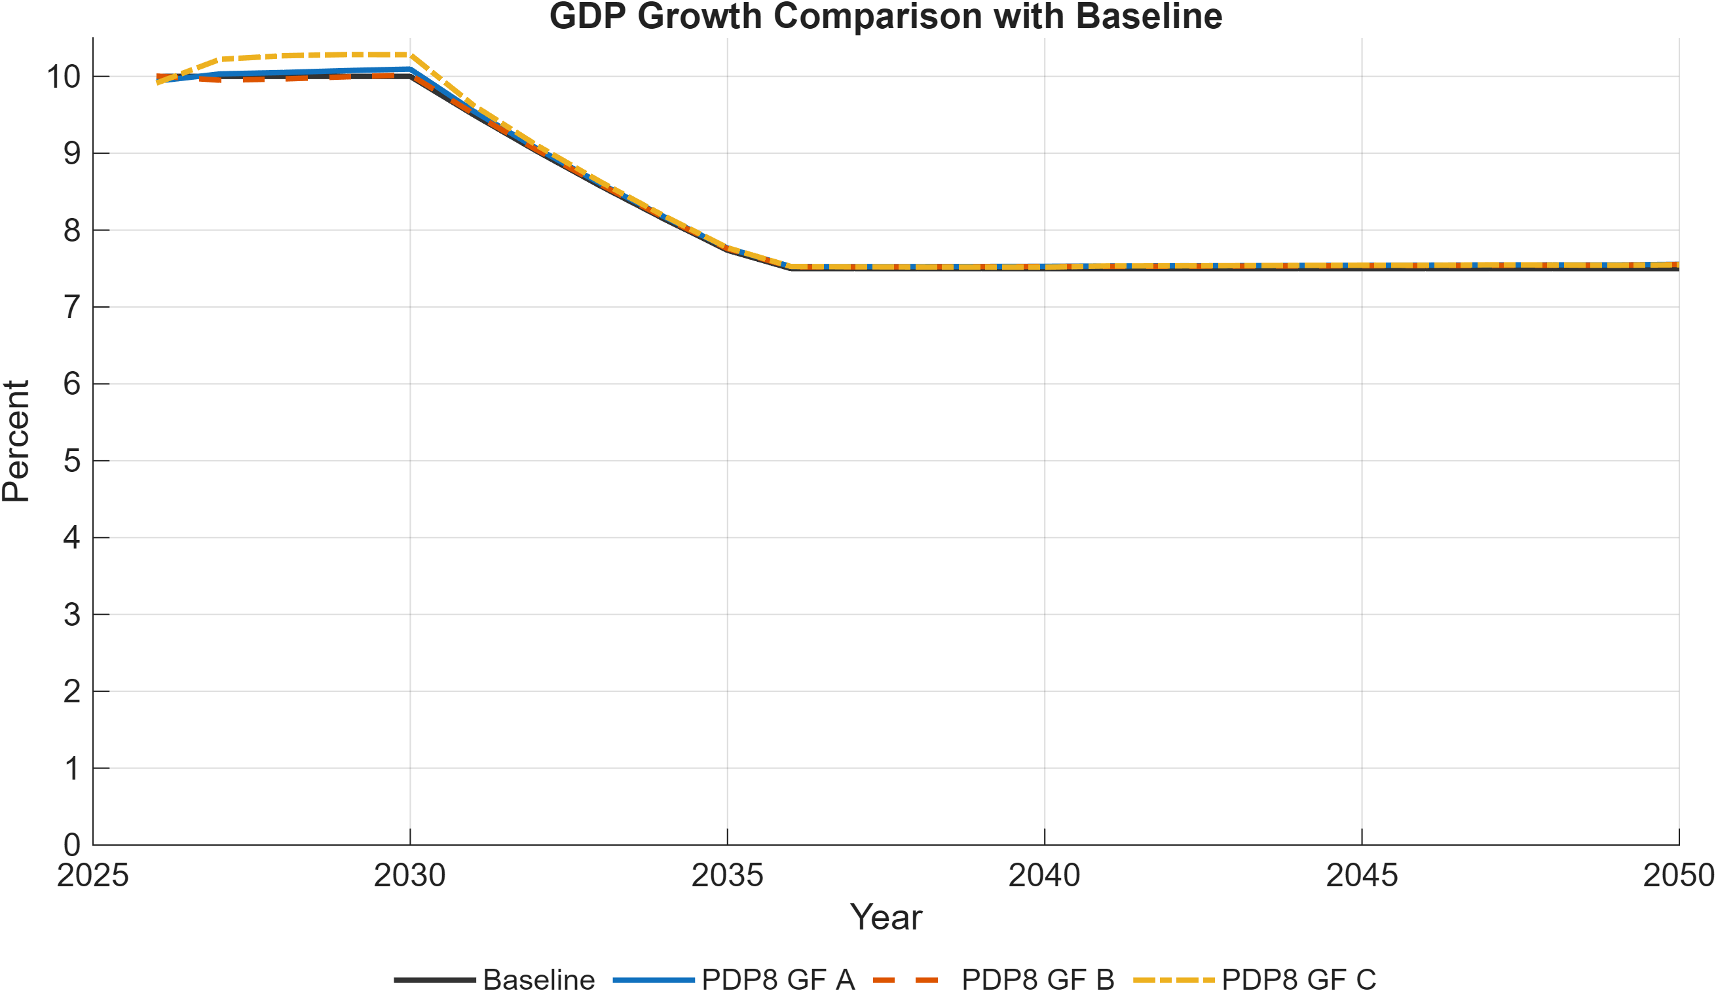
GDP growth comparison — finance scenarios
Figure 3.4. GDP growth under GF_A, GF_B, and GF_C financing architectures vs. the PDP8 Baseline.
Note: Annual GDP growth rates, 2026–2050. Cheaper capital (GF_C, public-led) delivers a measurable growth premium over market-led finance (GF_B), largest in the pre-2035 investment-intensive window.
Source: Generated by scripts/reporting/GenerateFinanceSimulationResultsFigures.m from scenario output CSV files in ExcelFiles/Output/.
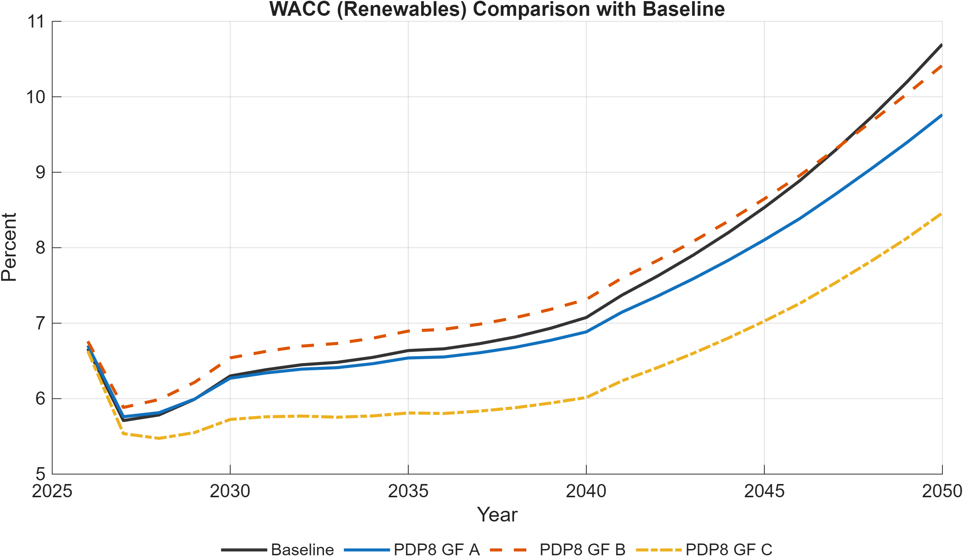
WACC for renewables comparison — finance scenarios
Figure 3.5. Weighted average cost of capital (WACC) for renewable investment under GF_A, GF_B, and GF_C.
Note: Effective financing cost for renewable energy investment, in percent. The roughly 2 percentage-point WACF spread between GF_C (5.07%) and GF_B (7.37%) translates directly into a lower effective WACC for renewable investment.
Source: Generated by scripts/reporting/GenerateFinanceSimulationResultsFigures.m from scenario output CSV files in ExcelFiles/Output/.
(Full discussion, including the Net-Zero amplification effect: use_cases_finance.md.)

3.3 Carbon pricing and the Net-Zero pathway
Policy question: what is the macroeconomic cost of a binding net-zero emissions cap on top of the PDP8 baseline, and how much of that cost is attributable to the absence of fuel-switching or efficiency improvements?
The Net-Zero (NZ) scenario imposes an economy-wide ETS with a cap declining to net-zero by 2050 and an endogenous carbon price. Two constrained decomposition variants isolate specific adjustment channels: NZ_constInt (fossil emission intensity held fixed — no fuel-switching within fossil categories) and NZ_constEEInt (energy efficiency and emission intensity both held fixed).
Results:
- The binding net-zero cap imposes a modest but persistent GDP cost relative to the PDP8 baseline, reflecting faster-than-planned fossil phase-out and accelerated renewable capital formation.
- Comparing NZ to its constrained variants decomposes this cost: forgoing fuel-switching and efficiency channels raises the carbon price needed to hit the same emissions path and increases the GDP cost, illustrating that fuel-switching and efficiency are not “nice-to-haves” but material cost-reduction channels for the transition.
- The most constrained variant (NZ_constEEInt) represents a worst case under limited technological learning and provides an upper bound on carbon prices and adjustment costs.
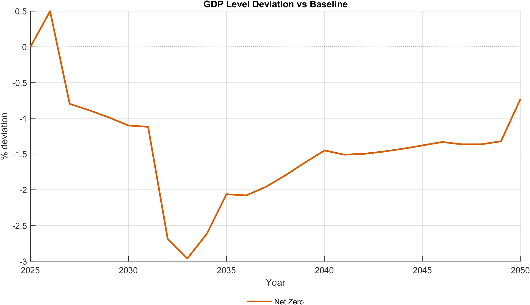
GDP level deviation — NZ scenarios
Figure 3.6. GDP level deviation from the PDP8 Baseline, NZ and constrained decomposition variants (NZ_constInt, NZ_constEEInt).
Note: Values are percent deviations of GDP level from the PDP8 Baseline path, 2026–2050. The decomposition variants show how much of the net-zero transition’s GDP cost is attributable to forgoing fuel-switching and efficiency channels.
Source: Generated by scripts/reporting/GenerateNZBaselineComparisonFigures.m from scenario output CSV files in ExcelFiles/Output/.
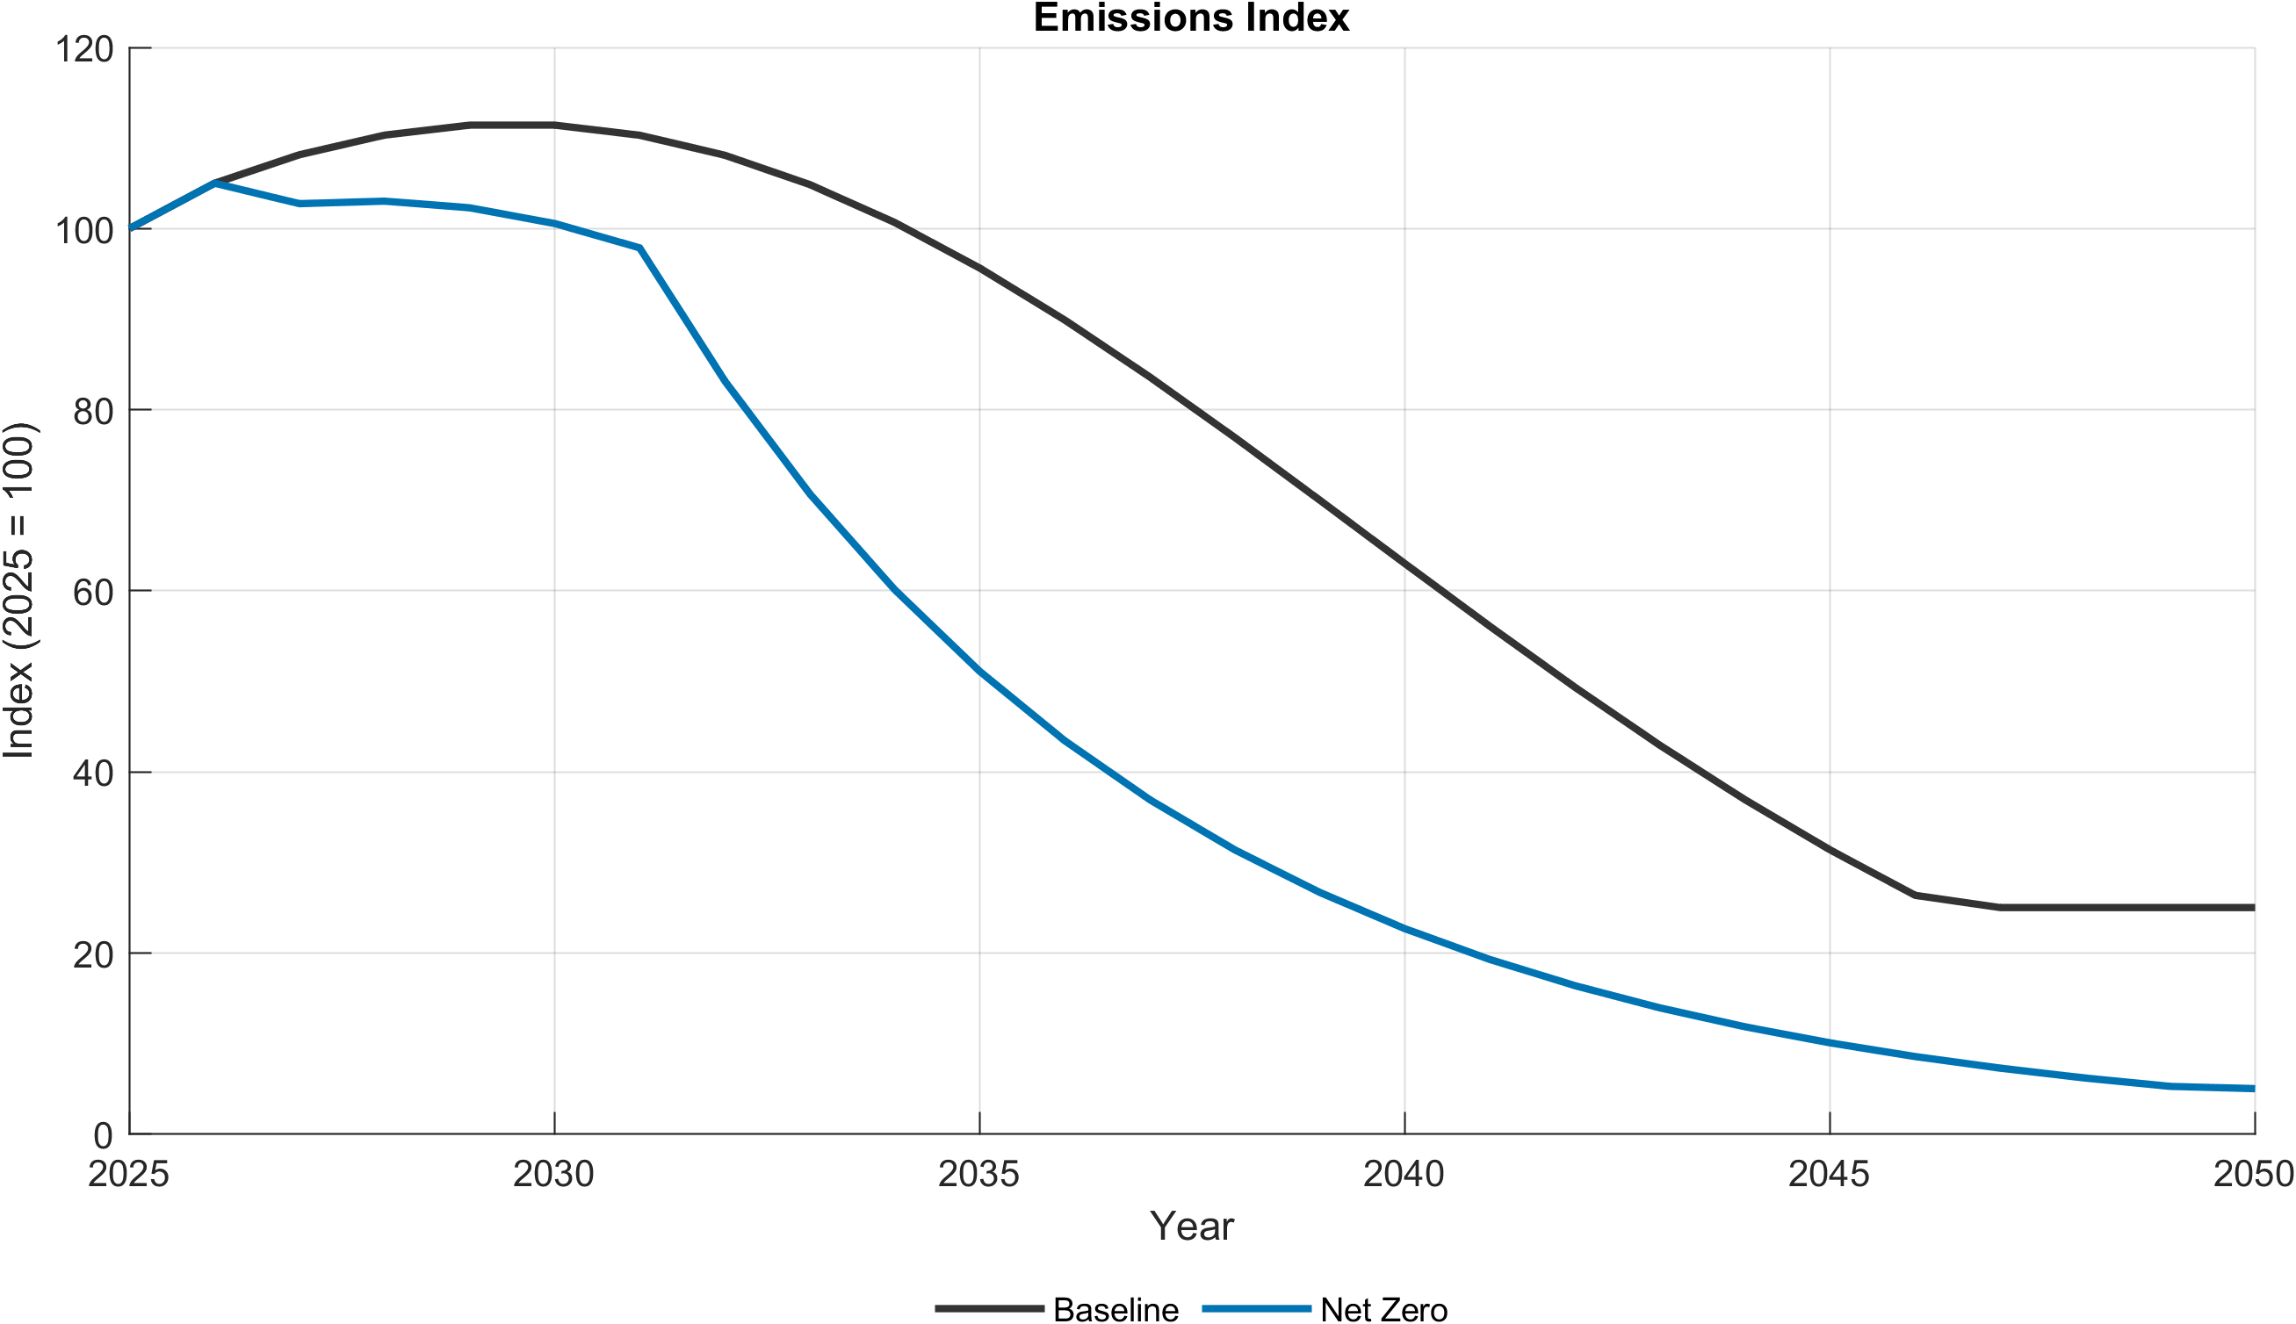
Emissions index — NZ scenarios
Figure 3.7. Emissions index under NZ and constrained decomposition variants vs. the PDP8 Baseline.
Note: Index, base year 2026 = 100. The binding cap forces accelerated emissions decline; the more adjustment channels are held fixed (NZ_constInt, then NZ_constEEInt), the higher the carbon price needed to hit the same emissions path.
Source: Generated by scripts/reporting/GenerateNZBaselineComparisonFigures.m from scenario output CSV files in ExcelFiles/Output/.
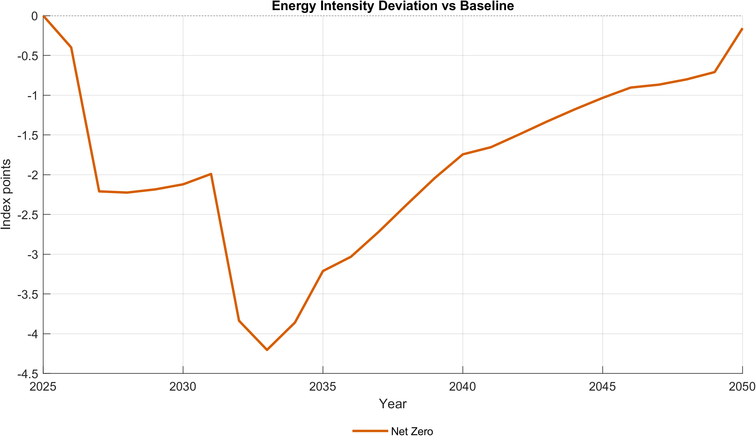
Energy intensity deviation — NZ scenarios
Figure 3.8. Energy-intensity deviation of NZ and constrained decomposition variants from the PDP8 Baseline.
Note: Values are index-point deviations from the Baseline energy-intensity index (base year 2026). The ETS carbon price accelerates efficiency investment beyond what PDP8 alone induces, amplifying the energy intensity decline relative to the EE-only scenarios in §3.1.
Source: Generated by scripts/reporting/GenerateNZBaselineComparisonFigures.m from scenario output CSV files in ExcelFiles/Output/.
(Full discussion: scenario.md, scenarios_overview.md.)

4. Cross-Cutting Findings
- Sectoral adjustment burden. The fossil energy sector faces the largest structural adjustment across all Net-Zero variants, as capital and labor reallocate toward renewables and non-energy sectors under a rising carbon price. Industry and services face demand-side pressure from changing energy prices and are the natural target sectors for efficiency policy.
- Fiscal/ETS revenue implications. Because tax rates on consumption, labor, and capital are held constant in the model (no endogenous fiscal rule), any change in government revenue from climate policy flows through the tax base and ETS auction revenue alone. ETS revenue recycling design — to the budget, to firms, or to households — is therefore a first-order distributional policy choice not resolved by the model itself.
- Instrument complementarity, not substitution. Across all three instruments assessed, the strongest results come from combinations rather than any single lever in isolation: efficiency needs a carbon constraint to reduce emissions; concessional finance is worth more under an ambitious carbon price; and BESS’s case rests on system reliability rather than competing with efficiency or finance on GDP grounds.

5. Policy Recommendations
- Prioritize energy efficiency as a low-cost, GDP-positive early action, and consider raising ambition toward Directive-10-equivalent targets given the modest incremental cost and roughly doubled GDP return.
- Pair energy efficiency with an active carbon-pricing mechanism. Efficiency gains alone will not deliver emissions reductions under a PDP8-only baseline; the emissions dividend requires a binding cap.
- Prioritize mobilizing concessional and blended (public-led) finance over market-rate capital, particularly in the pre-2035 window where the financing gap is largest — the modeled USD ~3 billion/year saving is a lower bound on the value of closing this gap, since it excludes volume effects (§6).
- Sequence concessional finance mobilization alongside — not instead of — carbon-price ambition. The model shows the two are complements: the macroeconomic payoff to cheaper capital rises with climate ambition, so development-partner engagement has more leverage in an ambitious net-zero pathway than in a PDP8-only one.
- Treat BESS investment as a reliability and system-stability requirement, not a mechanism to justify on aggregate GDP grounds alone — the model shows negligible macro sensitivity to BESS removal, consistent with its role being primarily technical (grid balancing) rather than macroeconomic.
- Design fuel-switching and efficiency support explicitly into the net-zero pathway, since the decomposition scenarios show these channels materially reduce the carbon price and GDP cost required to reach the same emissions target — removing them raises both.

6. Data and Modeling Caveats
Readers relying on this assessment for decision-making should be aware of the following:
- Reduced-form financial instruments. DGE-METRIC does not model named financial instruments (green bonds, guarantees, KfW loans) as explicit balance-sheet items. All green-finance results are the aggregate macro consequence of an assumed cost-of-capital or investment-price change — not a tool-by-tool breakdown of which specific instrument delivers it. Institutional feasibility of achieving the assumed WACF at scale is outside the model’s scope (see finance_instruments_comments_feasibility.md).
- Volume vs. price. Current finance scenarios primarily represent cost-of-capital/rate changes; concessional-finance volume effects (e.g., mobilization ratios, blended-finance leverage) are only captured to the extent they are separately mapped into public-capital or FDI-volume shock paths.
- Reproducibility of cited figures. RunSimulations.m runs only the Baseline scenario by default. The EE, Green Finance, and Net-Zero results in this report were generated with a specific non-default activeScenarioGroups configuration (including EE, GF_PDP8, GF_NZ, and/or NZ_Sensitivity, as documented in running.md). Anyone reproducing these figures should confirm the exact configuration and re-verify against current calibration before re-citing them in a new context.
- EE result completeness. At the time some of the underlying EE result CSVs were generated, two scenario runs (EE_Directive10_PV_BESS, EE_PDP8_PV_BESS) were reported missing — see implementation_plans/ee_simulation_scenarios_results.md. Confirm all four EE scenario CSVs are present and current before treating the EE comparison table in §3.1 as final.
- PDP8 optimism. The PDP8 baseline itself may embed optimistic implementation timelines relative to current institutional capacity; this report does not independently stress-test PDP8 delay scenarios.
- Single-region model. Sub-national/provincial dynamics (where GIZ has done prior related work) are not represented; sub-sovereign finance questions can only be addressed narratively, not quantitatively.
- Calibration sensitivity. Key external-sector parameters (phiB_p, phiadjB_p) in the active calibration are far weaker than the model’s built-in code defaults (two orders of magnitude apart) — see calibration_model_detailed.md §12. Results involving external borrowing/foreign-asset dynamics should be read alongside this sensitivity.

7. Annex: Methodology Summary
DGE-METRIC is a five-sector, one-region dynamic general equilibrium model, solved with Dynare as a deterministic (perfect-foresight) transition path from 2026–2050, calibrated to Vietnam’s 2019 input-output structure and a 2026 baseline. Households, firms (five subsectors: non-energy aggregate, fossil energy, renewable energy, industry, services), a wholesale/retail/export trade chain, a government with an emissions trading system, and the rest of the world interact through goods, labor, capital, emissions-permit, and trade markets. Scenarios are constructed as shock paths to exogenous variables (efficiency productivity, emission intensity, cost of capital, ETS cap) applied to a common calibrated baseline, so that differences across scenarios isolate the mechanism being tested.
For the full model structure, calibration methodology, data sources, solution method, and known limitations, see the companion Technical Report.

