DGE-METRIC: A Dynamic General Equilibrium Model for Vietnam’s Energy Transition — Technical Report
Christoph Schult, Halle Institute for Economic Research (IWH)
2026-07-14
Prepared under the joint GIZ–IWH research project supporting Vietnam’s energy and climate policy dialogue.
How to use this document. This is the methodological companion to the PDP8 Macroeconomic Impact Assessment, which presents policy findings. This report documents the model, its data foundations, its solution method, and its limitations, so that results can be reproduced, audited, and extended. It is written to convert cleanly to Word/PDF (e.g. via pandoc) for circulation as a standalone technical annex.
Reporting conventions used in this technical report. The document follows standard technical-report practice used by international financial institutions: (i) clear separation of evidence, assumptions, and modeled outcomes; (ii) explicit statement of limitations and interpretation risks; (iii) figure-by-figure documentation using caption, note, and source; and (iv) reproducibility through direct file and script references.

Table of Contents
Table of Contents
1 Table of Contents 1
2 List of Figures 2
3 Abbreviations 2
4 Executive Summary 2
5 Introduction and Motivation 3
5.1 The Policy Motivation 3
5.2 Scope of the Model 4
5.3 Scope of the Model 4
5.4 Model Structure and Theory 5
5.4.1 2.1 Sectors 5
5.5 Household 5
5.6 Firms and the production structure 6
5.7 Wholesaler, retailer, exporter 6
5.8 Government and the Emissions Trading System 6
5.8.1 2.6 Key extensions beyond a textbook DGE model 7
5.9 External sector 7
5.10 Data and Calibration 8
5.10.1 3.1 Data sources 8
5.11 Expenditure-side GDP cross-check output 8
5.12 Expenditure-side GDP cross-check output 8
5.13 Calibration workflow 9
5.14 The factor-cost GVA identity 10
5.15 Code defaults vs. active calibration 10
5.16 Baseline diagnostics plots used for calibration checks 11
6 Solution Method 15
6.1 Dynare perfect-foresight solving 15
6.2 Steady-state / calibration pipeline 16
6.3 Simulation 16
6.4 Verification approach 16
7 Scenario Design Framework 17
7.1 Nested-counterfactual logic 17
7.2 Net-Zero decomposition 17
7.3 Green finance as a reduced-form cost-of-capital shock 17
7.4 Operational status vs. scenario capability 18
7.5 EE scenario reporting figures 18
7.6 Green finance scenario reporting figures 23
8 Limitations, Implementation Risks, and Interpretation Guidance 29
9 Conclusion 30
9.1 References 30
A Technical Appendix 30
A.1 Equation reference 30
A.2 Parameter reference 30
A.3 Repository map 31

List of Figures

Abbreviations
BESS — Battery Energy Storage System CMIP6 — Coupled Model Intercomparison Project Phase 6 COP26 — 26th UN Climate Change Conference of the Parties DGE — Dynamic General Equilibrium DGE-METRIC — Dynamic General Equilibrium Model for Vietnam’s Energy Transition Incorporating Carbon Markets EDGAR — Emissions Database for Global Atmospheric Research ETS — Emissions Trading System EVN — Electricity of Vietnam EXIOBASE — Environmentally Extended Multi-Regional Input-Output Database FDI — Foreign Direct Investment GIZ — Deutsche Gesellschaft für Internationale Zusammenarbeit GDP — Gross Domestic Product IEA — International Energy Agency IRENA — International Renewable Energy Agency IWH — Halle Institute for Economic Research IO — Input-Output KfW — Kreditanstalt für Wiederaufbau LCOE — Levelized Cost of Energy NDC — Nationally Determined Contribution NSO — National Statistics Office OECD — Organisation for Economic Co-operation and Development PDP8 — Power Development Plan 8 PV — Photovoltaic SSP — Shared Socioeconomic Pathway USD — United States Dollar UIP — Uncovered Interest Parity WACC — Weighted Average Cost of Capital WACF — Weighted Average Cost of Finance —

Executive Summary
The DGE-METRIC (Dynamic General Equilibrium for Macroeconomic Energy Transition Incorporating Carbon markets) model was developed to analyse the macroeconomic implications of Vietnam’s energy transition and to evaluate alternative pathways for achieving the objectives of the Power Development Plan 8 (PDP8) and the country’s net-zero emissions commitment by 2050. The model provides a quantitative framework for assessing how alternative energy and climate policies affect economic growth, investment, sectoral production, household welfare, public finances, and carbon emissions over the transition period.
Unlike engineering-based energy system models, which focus on technology deployment and electricity-system optimisation, DGE-METRIC captures the economy-wide interactions between investment, production, consumption, labour markets, international trade, and climate policy. This integrated perspective enables the assessment of transition pathways within a consistent macroeconomic framework, allowing policy interventions in the energy sector to be evaluated alongside their broader economic consequences
The model is formulated as a deterministic, forward-looking dynamic general equilibrium (DGE) model implemented in Dynare and MATLAB. It represents Vietnam as a five-subsector, one-region economy, comprising a representative household, firms operating in five production sectors, wholesale and retail trade, an exporting sector, a government with an emissions trading system (ETS), and the rest of the world. The model is calibrated to Vietnam’s 2019 input-output structure and a 2026 baseline and is solved over the 2026–2050 transition horizon, drawing on data from the National Statistics Office (NSO), Electricity of Vietnam (EVN), the International Energy Agency (IEA), EDGAR, the World Bank, and project-specific (GIZ/IWH)calibration inputs.
The report documents the theoretical foundations, calibration strategy, and numerical implementation of the model, together with the construction of the policy scenarios used throughout the analysis. It explains how baseline and scenario pathways are translated into model inputs, how the perfect-foresight transition path is solved, and how key assumptions regarding technology, emissions, and financing are incorporated into the modelling framework. The report also discusses the principal limitations of the approach and provides guidance for the interpretation of simulation results.
Taken together, these elements provide a transparent and reproducible modelling framework for analysing the macroeconomic consequences of Vietnam’s energy transition and for supporting evidence-based policy analysis on climate, energy, and green finance.

Introduction and Motivation

The Policy Motivation
Vietnam’s energy transition represents one of the country’s most significant long-term development challenges. Achieving sustained economic growth while simultaneously transforming the electricity sector to meet national climate objectives requires unprecedented levels of investment, coordinated policy interventions, and substantial structural adjustment across the economy. Decisions regarding the timing, scale, and financing of these investments will shape not only the future energy system but also broader economic development over the coming decades.
To achieve the objectives of the Power Development Plan 8 (PDP8) and Vietnam’s commitment to reach net-zero greenhouse gas emissions by 2050 (COP26 NDC), the country is estimated to require approximately USD 136 billion of investment in the energy sector by 2050 (IWH Investment Needs Assessment, 2025). At the same time, Vietnam aims to sustain annual GDP growth of around 6–7%, increase the share of renewable electricity generation to 60%, phase out the expansion of coal-fired power generation after 2030 (PDP8, Decision 500/QD-TTg, 2023), and meet its Nationally Determined Contributions under the Paris Agreement.
Bottom-up energy-system models (capacity expansion, LCOE, dispatch) play a central role in energy planning by identifying cost-effective technology portfolios, evaluating generation capacity expansion, and analysing system operation. these models are not designed to quantify the broader macroeconomic consequences of alternative transition pathways. In particular, they cannot directly address economy-wide questions such as:
- What are the macroeconomic costs of meeting PDP8 investment requirements in terms of GDP, household consumption, investment, and employment?
- To what extent does achieving net-zero emissions impose additional economic costs beyond those already associated with implementing PDP8?
- How do improvements in energy efficiency affect investment requirements and long-term economic performance?
- How do alternative green-finance architectures influence the pace, affordability, and macroeconomic impacts of the energy transition?
- Which carbon-price trajectories are consistent with alternative transition pathways?
- Which sectors experience the largest structural adjustment during the transition?
Addressing these questions requires an economy-wide analytical framework that captures the interactions between the energy sector and the broader economy. Investment in low-carbon technologies competes for capital and labour with investment in other sectors, while changes in energy prices, production costs, household income, international trade, and public finances generate adjustment effects throughout the economic system. DGE-METRIC was developed to analyse these interactions within a consistent forward-looking general equilibrium framework and to quantify the macroeconomic implications of alternative energy-transition pathways.

Scope of the Model
DGE-METRIC is a reduced-form macroeconomic model, not an energy-system planning model. It does not:
loans) as explicit balance-sheet items — these are translated into equivalent cost-of-capital or investment-price shocks (§6.3).
Technology cost projections and supply-stack detail are taken as exogenous inputs from IEA World Energy Outlook and Vietnam PDP8 planning documents.

Scope of the Model
DGE-METRIC is a reduced-form dynamic general equilibrium model designed to analyse the economy-wide consequences of Vietnam’s energy transition. It combines a detailed representation of the energy sector with a comprehensive macroeconomic framework that captures interactions between households, firms, government, international trade, capital accumulation, and carbon pricing. Rather than determining optimal technology choices, the model evaluates the economic implications of externally specified policy pathways and investment trajectories.
As with any macroeconomic model, DGE-METRIC deliberately abstracts from several aspects that are more appropriately analysed using specialised engineering or financial models. In particular, the model does not:
- optimise electricity dispatch or represent individual power plants;
- endogenously model technology learning and cost reductions;
- distinguish between sub-national regions or provincial governments.
Similarly, technology cost projections, renewable deployment pathways, and capacity expansion plans are taken as exogenous inputs based on official planning documents and international energy outlooks rather than being determined endogenously within the model.
Consequently, DGE-METRIC should be viewed as complementary to engineering-based energy system models rather than as a substitute for them. While engineering models identify technically feasible and cost-efficient energy-system configurations, DGE-METRIC evaluates the broader macroeconomic consequences of implementing these pathways. Together, the two modelling approaches provide a more comprehensive evidence base for assessing Vietnam’s transition towards a low-carbon economy.

Model Structure and Theory

2.1 Sectors
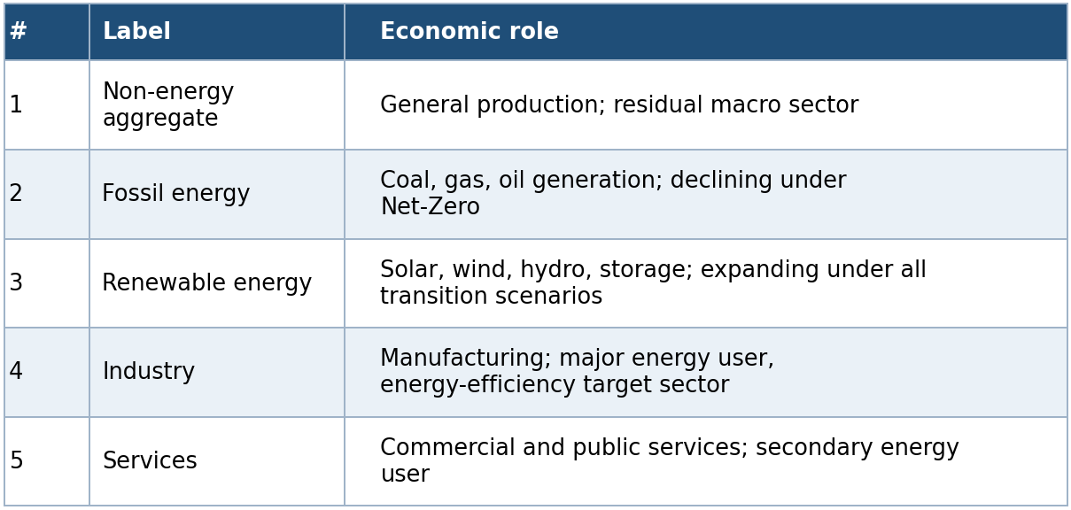
Aggregate reporting sectors collapse Fossil and Renewable into a single “Energy” sector (giving the four-sector aggregate view: Primary, Energy, Secondary, Tertiary used in results reporting). Capital and labor move across sectors in response to relative prices; energy sectors supply intermediate inputs to sectors 1, 4, and 5.

Household
A representative household derives utility from consumption C_t, housing services H_(t+1), and disutility from supplying labor N_(s,t) across sectors s ∈ \1,…,S\:
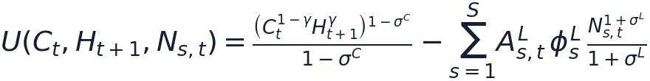
where γ is the preference weight on housing, σ^C the inverse intertemporal elasticity of substitution in consumption, and σ^L the inverse Frisch elasticity of labor supply. Labor disutility is scaled by sector-specific labor productivity A^L_(s,t) and calibrated weights φ^L_s that pin down realistic long-run sectoral labor shares.
The household chooses consumption, sectoral labor supply, sectoral investment I_(s,t), next-period sectoral capital K_(s,t+1), housing H_(t+1), and net foreign asset holdings B_(t+1) to maximize discounted lifetime utility Σ_t β^t U(·) subject to:
- a budget constraint (income = expenditure);
- sector-specific capital accumulation, $K_{\left(s,t+1\right)}=\left(1-δ\right)K_{\left(s,t\right)}+I_{\left(s,t\right)}Γ_{\left(,t\right)}-D_{\left(s,t\right)}^{K}$, where climate damages $D_{\left(s,t\right)}^{K}$ reduce the capital stock directly;
- housing accumulation, $H_{\left(t+1\right)}=\left(1-δ^{H}\right)H_{t}+I_{t}^{H}-D_{t}^{H}.$
Income sources are rental income from sector-specific capital, labor income across sectors, and returns on foreign bond holdings; foreign borrowing carries a debt-elastic risk premium (§3.7, §5.3).

Firms and the production structure
In each sector s, firms choose intermediate inputs Q^I_(s,k,t), labor L_(s,t), and capital K_(s,t) to maximize static profit:

Sector-specific emission intensity κ^E_(s,t) is proportional to output and can vary over time (the channel through which fuel-switching and emission-intensity scenarios operate). Final output is a CES (or Cobb-Douglas, when the elasticity equals 1) aggregate of intermediate inputs and value added; value added is a CES/Cobb-Douglas aggregate of effective labor and capital; intermediate inputs are themselves a CES aggregate across sectors of origin. See model.md for the full equation set (production, value-added, and intermediate-aggregation identities, wholesaler/retailer/exporter blocks).

Wholesaler, retailer, exporter
A representative wholesaler in each subsector combines domestic and imported intermediate goods to supply both intermediate demand and final retail demand. A representative retailer combines domestic goods and imports for final use (consumption, investment, and government spending) via a CES nest. An exporter aggregates subsectoral exports into a single export good sold to the rest of the world. Elasticities of substitution between domestic and imported goods (η^Q_s, η^F) and origin-sector home bias (ω^Q_s, ω^M_s) are sector-specific calibrated parameters.

Government and the Emissions Trading System
Fiscal policy follows standard reduced-form rules: tax rates on consumption, labor, and capital income are constant over time (no endogenous fiscal feedback rule), and government expenditure is pinned down by the budget constraint. Revenue sources are consumption tax τ^C_tC_t, labor and capital income taxes, and ETS auction revenue:

Under the ETS, firms hold allowances for covered emissions; the carbon price P^E_t clears the permit market against the cap. Government debt B^G_t is serviced at the world interest rate, and the government faces the same interest-rate schedule as households. Because tax rates are fixed, any change in government revenue from climate policy flows entirely through the tax base and the ETS revenue term, not through an endogenous rate response.

2.6 Key extensions beyond a textbook DGE model
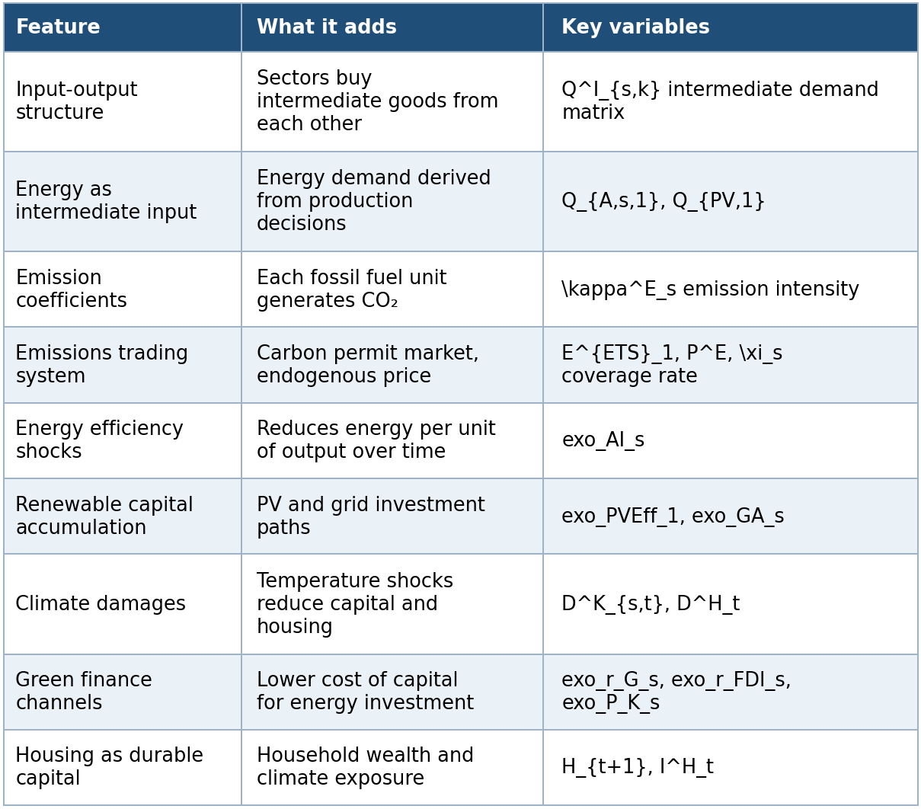

External sector
Net foreign assets follow a law of motion linked to the trade balance; the external finance premium is debt-elastic, exp(-φ_B · external_position_gap/Y), with an additional quadratic adjustment cost (φ_(adjB)) — a standard closure device for stationarity in small open-economy models. The exchange-rate variable s_(reg) is not a full UIP-style nominal exchange-rate block: it follows an AR(1) process when exo_lNXTarget = 0, or becomes the balancing variable that enforces a target net-exports/GDP ratio when exo_lNXTarget = 1 (the baseline mode). Treat s_(reg) as an external-balance closure/valuation factor, not a nominal exchange rate in the conventional sense (see dev/model_consistency_and_calibration_findings_2026-07-14.md).

Data and Calibration

3.1 Data sources
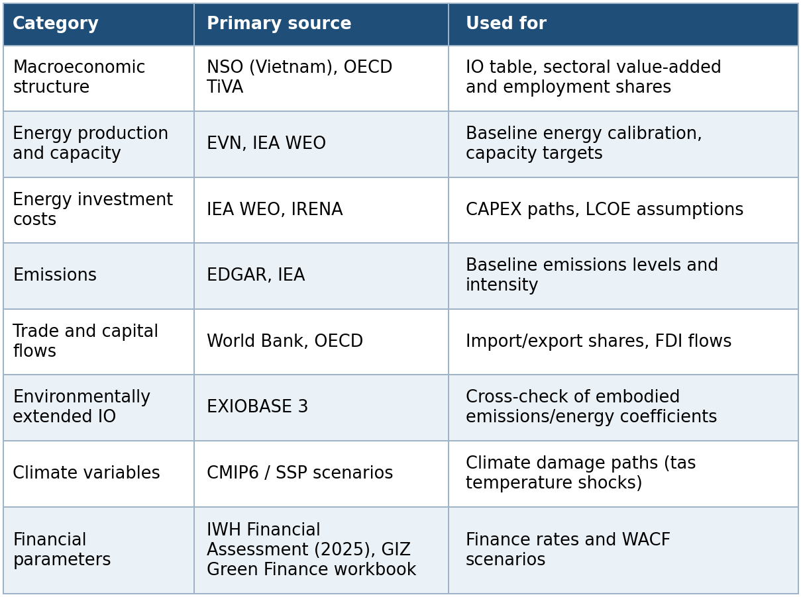
Full variable-to-source mapping is documented in data_sources.md; parameter-by-parameter citations for the structural-parameters sheet are in structural_parameters_source_audit.md. Raw source data is maintained outside the repository (size/licensing) and is pre-processed into the calibration workbook.

Expenditure-side GDP cross-check output
Provenance note (ETS fiscal revenue): the model does not use an official published long-run (2030/2050) government ETS revenue forecast for Vietnam. Instead, ETS revenue is scenario-based and follows:
where only auctioned allowances generate direct public revenue. Free allocation is treated as compliance value transfer, not fiscal revenue.

Expenditure-side GDP cross-check output
The repository includes a reproducible cross-check generated by scripts/reporting/GenerateGDPComponentsStartEndVsActual.m, which compares the model’s expenditure-side GDP component shares at the baseline start and end years against actual 2019 Vietnam national-accounts shares.
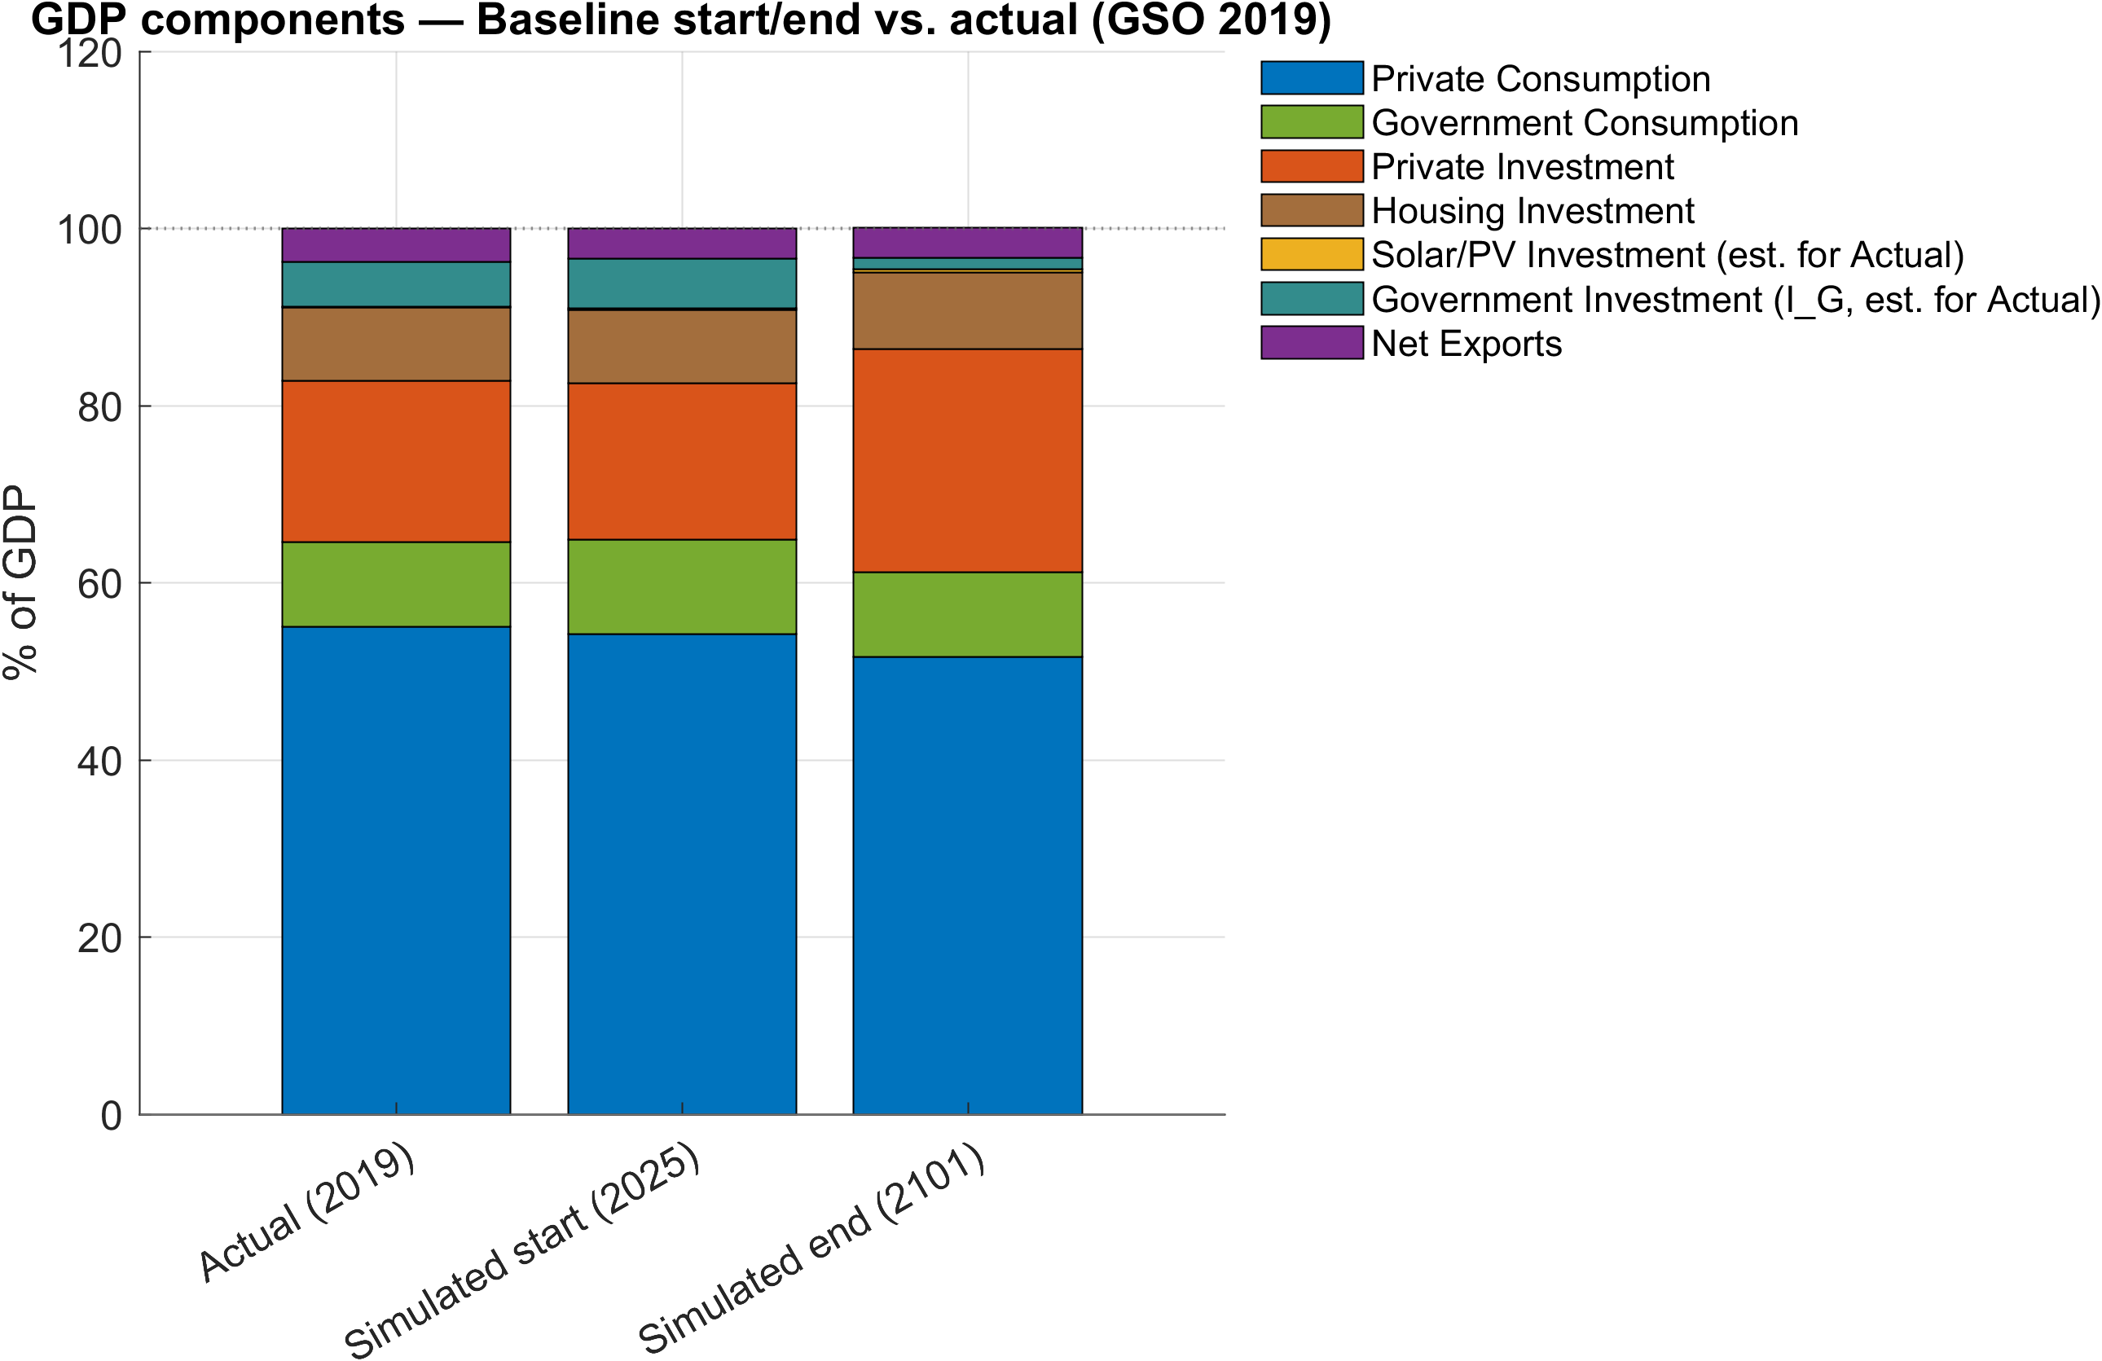
GDP components start/end vs actual
Figure 4.1. Expenditure-side GDP components: actual 2019 vs simulated baseline start and end.
Note: The chart stacks seven components as shares of GDP: private consumption, government consumption, private investment, housing investment, solar/PV investment, government investment, and net exports. In the Actual (2019) bar, government investment and solar/PV investment are proxy estimates documented in the script header; housing investment is taken directly from the NSO IO table.
Source: Output files GDPComponents_StartEndVsActual.png, GDPComponents_StartEndVsActual.svg, and GDPComponents_StartEndVsActual.csv in Figures/Baseline/GDPComponents/, generated from ExcelFiles/Output/Baseline.csv and external NSO workbook IO_GSO_2019.xlsx by scripts/reporting/GenerateGDPComponentsStartEndVsActual.m.

Calibration workflow
The 5-sector, 1-region model is driven by three workbooks: ExcelFiles/ModelCalibration5Sectorsand1Regions.xlsx (calibration inputs and named ranges), ExcelFiles/ModelBaseline5Sectorsand1Regions.xlsx (the split baseline path, built Baseline_Input → Baseline_calc → Baseline_Implied → Baseline), and ExcelFiles/ModelScenarios5Sectorsand1Regions.xlsx (scenario shock paths).
Calibration mixes four distinct types of input, and keeping them separate is essential to interpreting results correctly:
- Observed or targeted baseline shares (phiY0, phiN0, phiW, phiX, phiQI, …) — read directly from workbook sheets.
- Structural assumptions (beta, delta, sigmaL, sigmaC, CES elasticities, tax rates) — read from the Structural Parameters sheet or left at code defaults.
- Initial levels / macro closures (Y0, N0, PoP0, LF0, H0, E0, PE0, …) — read from Start when available.
- Solved residual parameters (CES weights, emission intensities kappaE, labor disutility weights, TFP levels A_s, rf0) — backed out inside the steady-state routines so the baseline is internally consistent.
The model is calibrated in three stages: (i) lCalibration_p = 1 builds the baseline steady state and solves residual parameters via fsolve; (ii) lCalibration_p = 0 re-solves the full steady state using the calibrated parameters as fixed; (iii) non-baseline scenarios run in a hybrid mode (lCalibration_p = 2) that takes the calibrated baseline as given and applies scenario shocks. See calibration.md for the step-by-step MATLAB call sequence.

The factor-cost GVA identity
A central calibration invariant, load-bearing whenever the baseline emission price is positive (PE > 0), is:
i.e., the baseline price-weighted value-added target in the model numeraire must equal the factor-cost gross value added actually computed from national accounts (basic-price gross output, minus intermediate use, minus direct ETS permit cost). An earlier share-based normalization (φ Y_s · Q0_p) was only valid when PE = 0 and produced non-zero Dynare static residuals in the TFP equations at any positive carbon price. The current implementation enforces P0_s · Y0_s = FCgva_s consistently across the MATLAB calibration routines and the .mod productivity equations — see calibration_model_detailed.md for the full derivation, code locations, and baseline-check identities.

Code defaults vs. active calibration
ModFiles/DGE_Model_Parameters.mod ships default parameter values, but the active 5-sector/1-region workbook materially overrides several of them — most importantly the external-finance-premium parameters phiB_p (code default 10.0 vs. active workbook 0.1) and phiadjB_p (1.0 vs. 0.1), which differ by two orders of magnitude. The workbook values, not the .mod file defaults, govern the currently compiled model. Analysts citing a structural parameter should always confirm which workbook is loaded for the run in question; the full override table is in calibration_model_detailed.md §12.

Baseline diagnostics plots used for calibration checks
The baseline reporting script scripts/reporting/DisplayBaselineEnergy.m writes its figures to the repository-level Figures/ directory (not docs/figures/). The script uses outDir = fullfile(repoRoot, 'Figures') and exports both raster and vector versions (.png at 300 dpi and .pdf vector).
These plots provide an operational bridge between the workbook targets and the calibrated baseline path:
- Level/index path checks (baseline_ren_capital, baseline_ren_production, baseline_energy_efficiency, baseline_res_share) show whether the solved baseline trajectory behaves plausibly over 2025-2050.
- Annual target alignment checks (ren_cap_annual, fos_cap_annual, ren_inv_annual, fos_inv_annual, plus dashboard baseline_pdp8_annual_comparison) compare simulation series to PDP8/Baseline target paths year by year.
- Period/end-year consistency checks (ren_inv_bar, fos_inv_bar, ren_cap_bar, fos_cap_bar, plus dashboard baseline_pdp8_period_comparison) verify that 5-year investment shares and end-year capacity levels match the planning aggregates used in calibration discussions.
In practice, Section 4’s data provenance and calibration claims should be read alongside these files in Figures/, because they are the fastest visual QA artifacts for checking whether the solved baseline reproduces the workbook’s energy transition intent.
Bar-plot previews used in this section (rendered from Figures/):
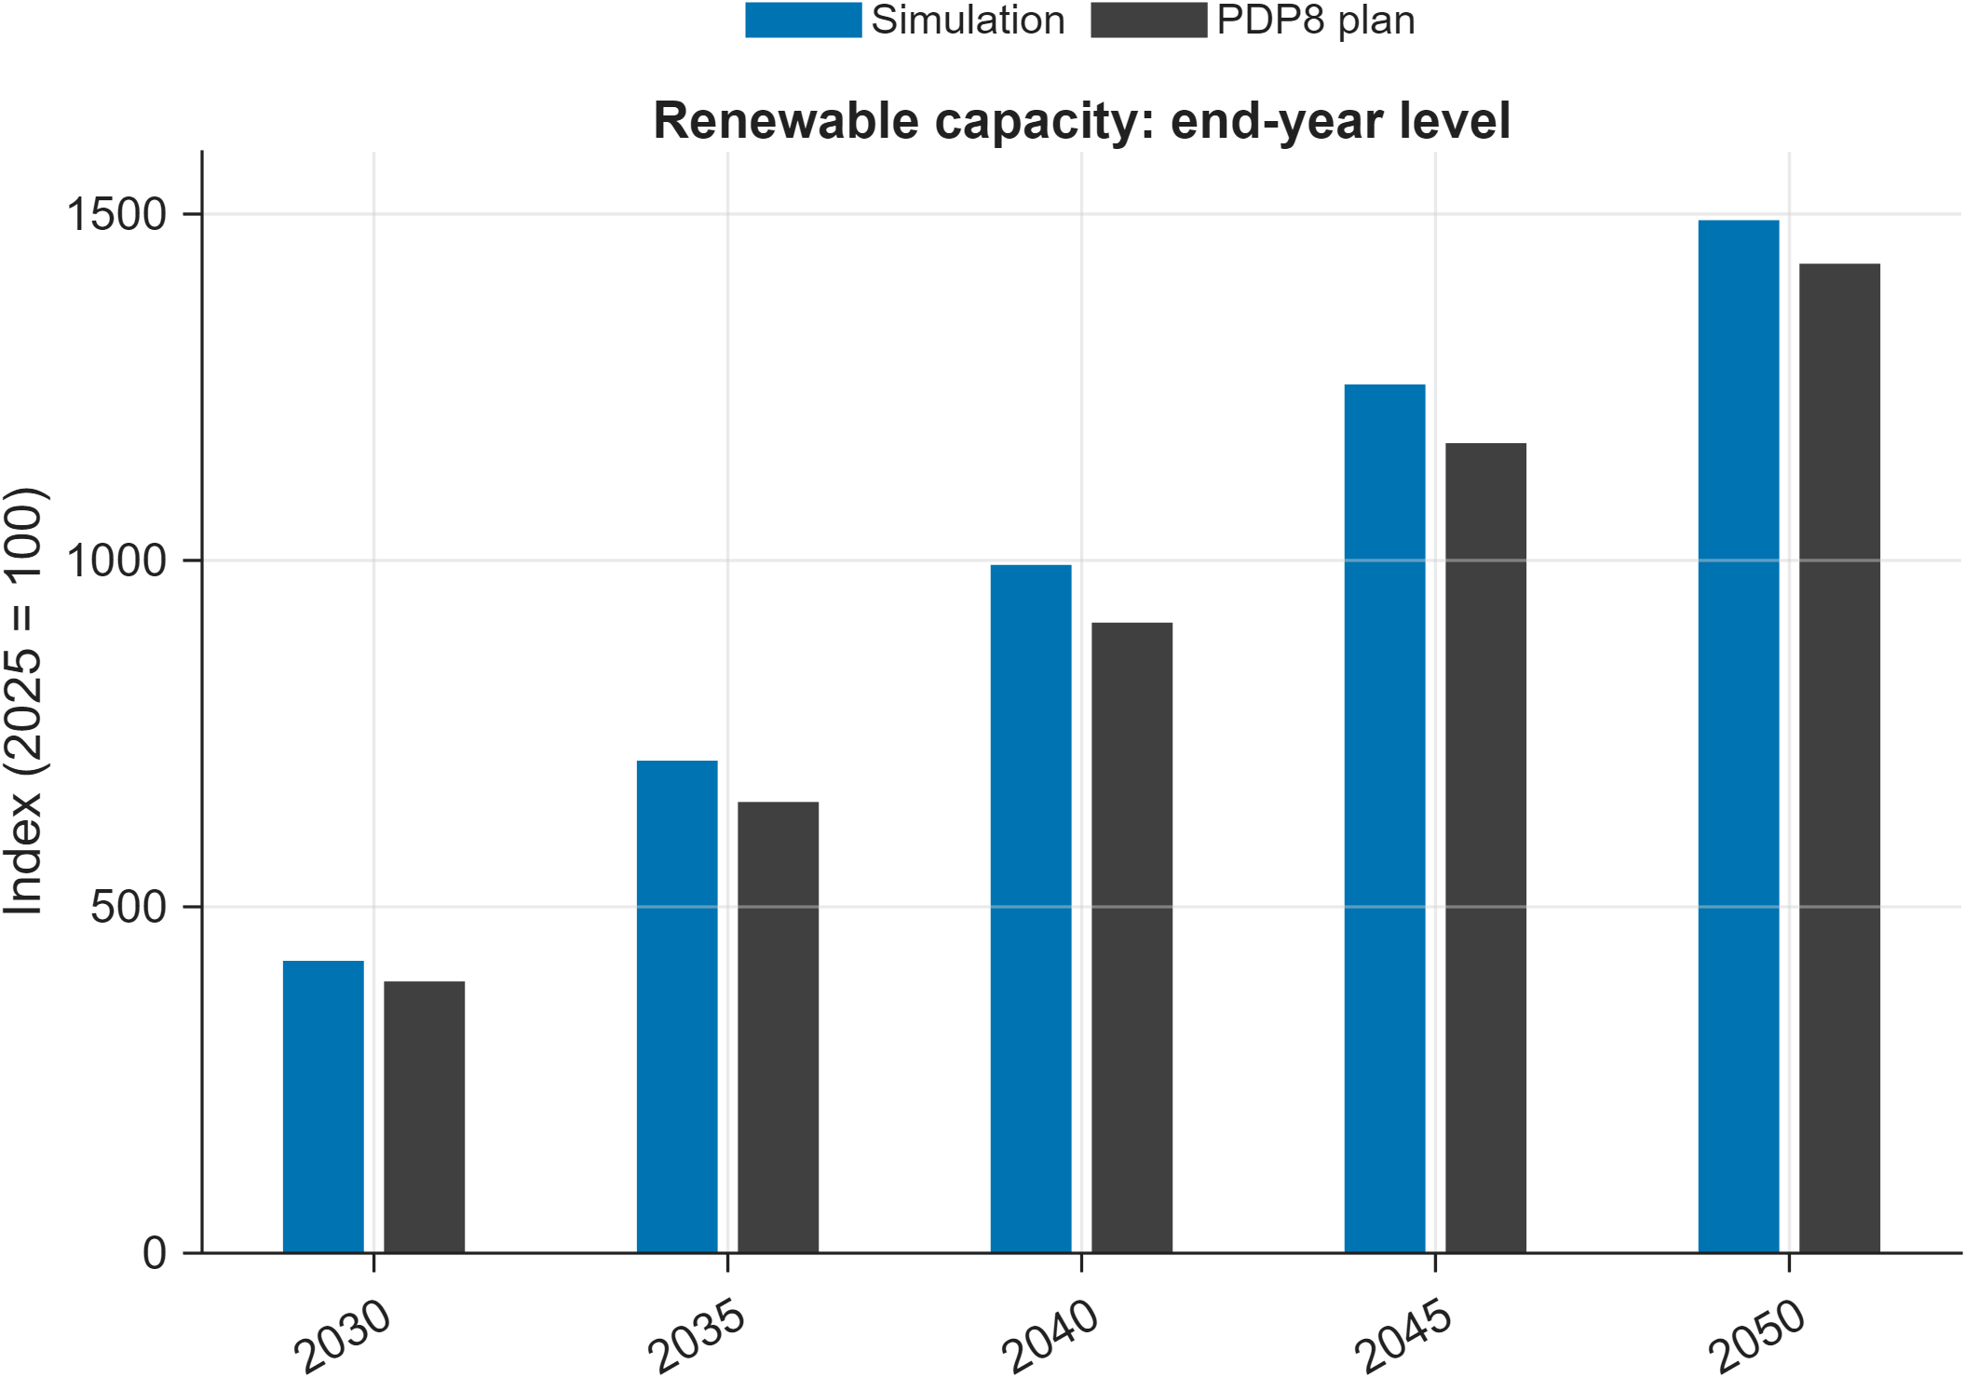
Renewable capacity end-year comparison
Figure 4.2. Baseline simulation vs PDP8 target for renewable installed capacity (end-year levels).
Note: Bars compare the model-implied capacity index to PDP8 index values at the end of each reporting period (index base: 2025 = 100).
Source: Author calculations from baseline simulation output ExcelFiles/Output/Baseline.csv and PDP8 capacity targets ExcelFiles/PDP8/IndexedTrajectories_FossilRenewable_Capacity.csv, plotted by scripts/reporting/DisplayBaselineEnergy.m.
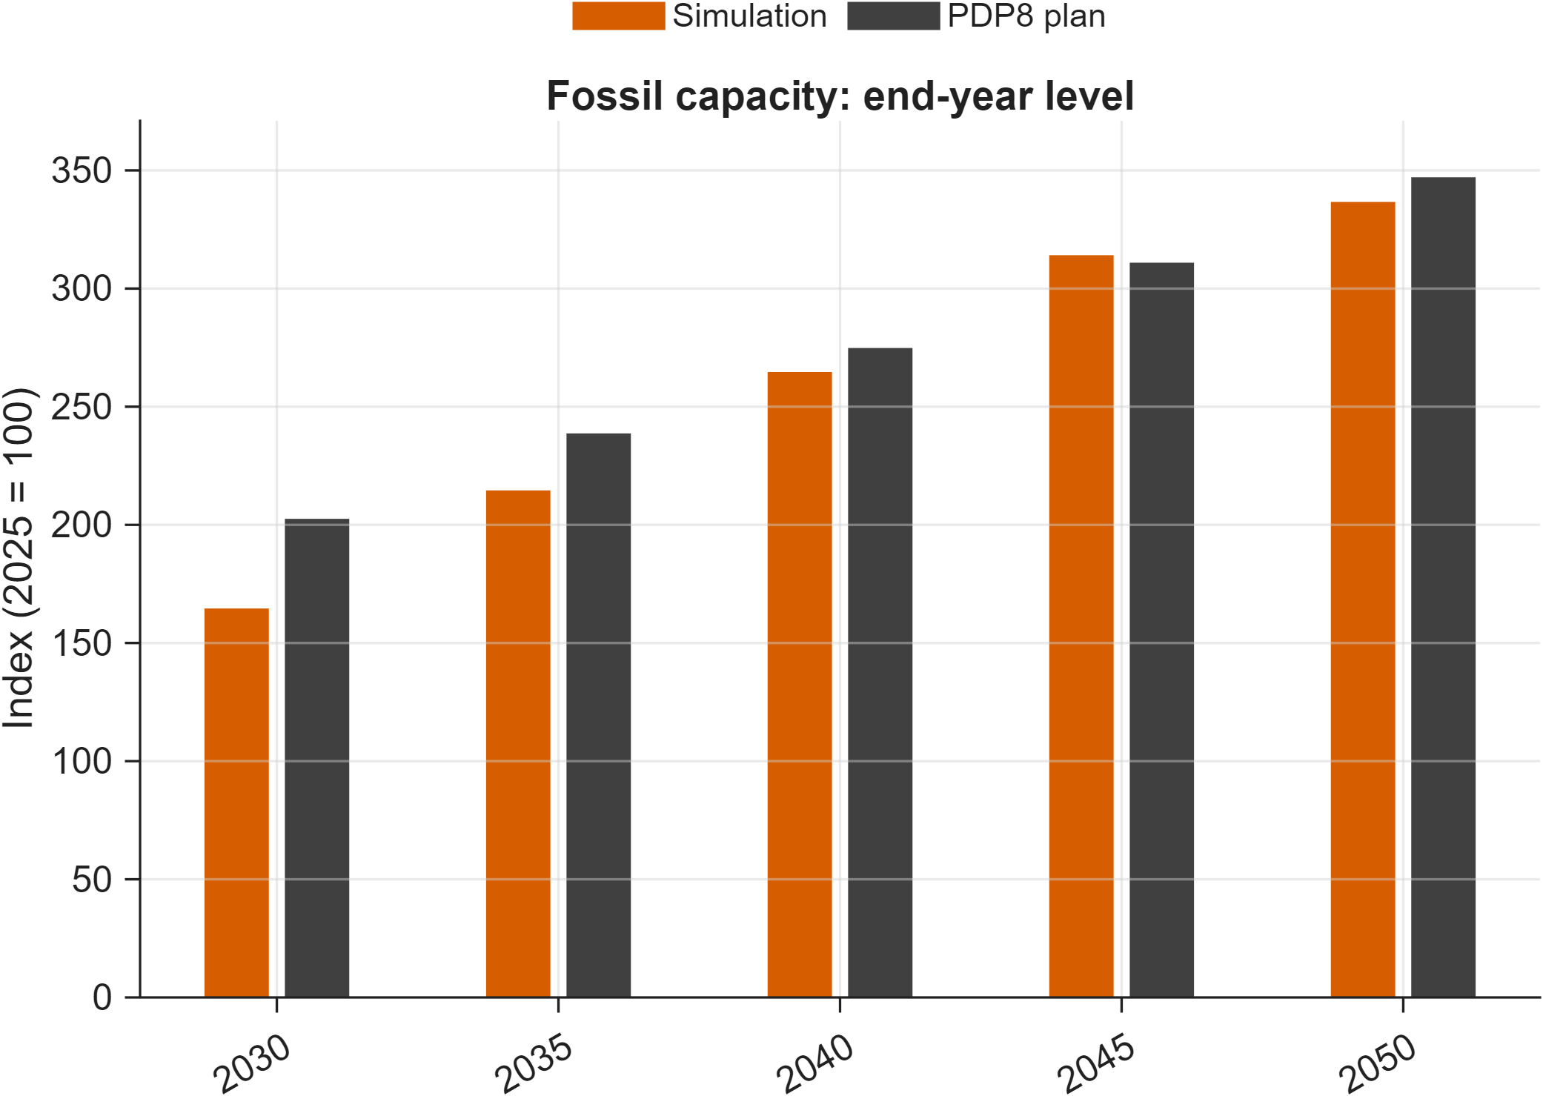
Fossil capacity end-year comparison
Figure 4.3. Baseline simulation vs PDP8 target for fossil installed capacity (end-year levels).
Note: Bars compare the model-implied capacity index to PDP8 index values at the end of each reporting period (index base: 2025 = 100).
Source: Author calculations from baseline simulation output ExcelFiles/Output/Baseline.csv and PDP8 capacity targets ExcelFiles/PDP8/IndexedTrajectories_FossilRenewable_Capacity.csv, plotted by scripts/reporting/DisplayBaselineEnergy.m.
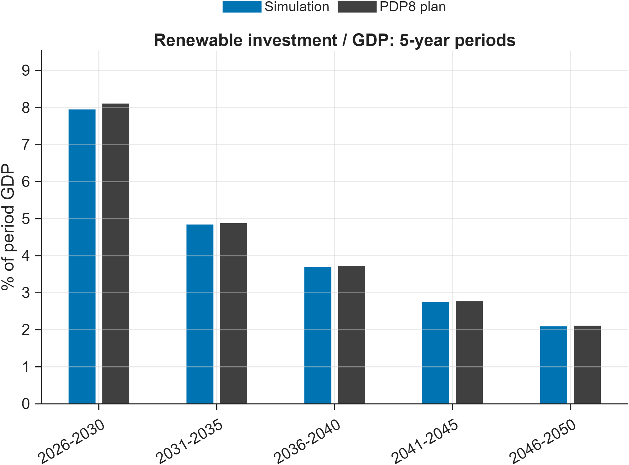
Renewable investment share by period
Figure 4.4. Baseline simulation vs PDP8 target for renewable investment share.
Note: Each bar reports renewable investment as a share of GDP aggregated over a 5-year period (% of period GDP), comparing simulation outcomes to the baseline workbook target path.
Source: Author calculations from baseline simulation output ExcelFiles/Output/Baseline.csv and baseline target workbook ExcelFiles/ModelBaseline5Sectorsand1Regions.xlsx (sheet Baseline), plotted by scripts/reporting/DisplayBaselineEnergy.m.
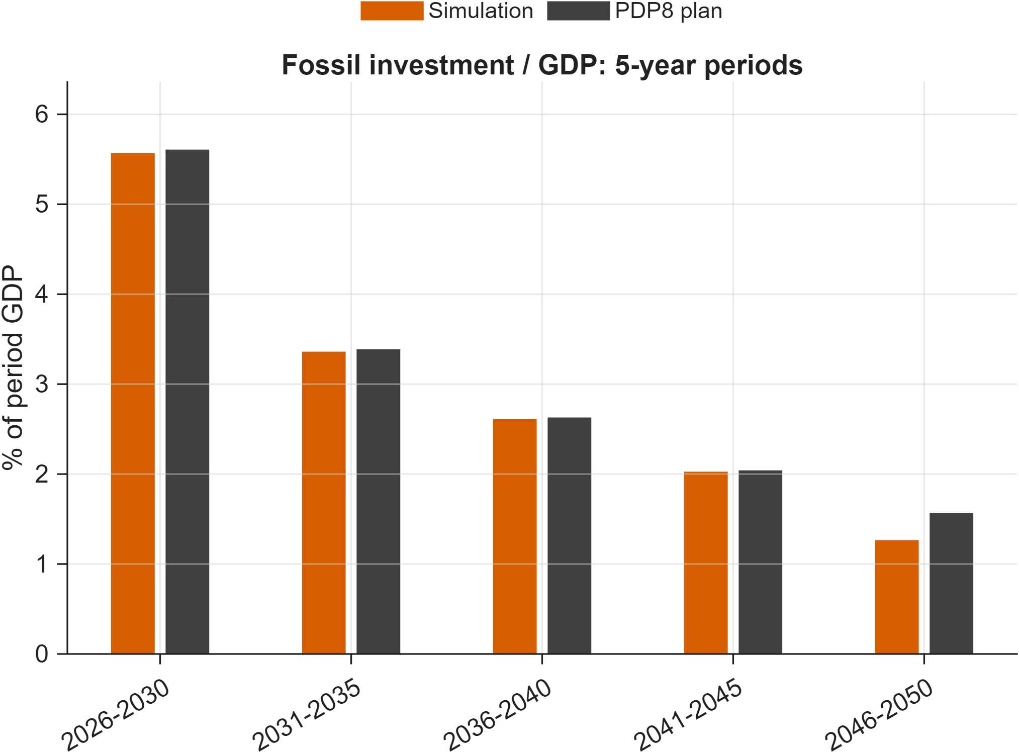
Fossil investment share by period
Figure 4.5. Baseline simulation vs PDP8 target for fossil investment share.
Note: Each bar reports fossil investment as a share of GDP aggregated over a 5-year period (% of period GDP), comparing simulation outcomes to the baseline workbook target path.
Source: Author calculations from baseline simulation output ExcelFiles/Output/Baseline.csv and baseline target workbook ExcelFiles/ModelBaseline5Sectorsand1Regions.xlsx (sheet Baseline), plotted by scripts/reporting/DisplayBaselineEnergy.m.

Solution Method

Dynare perfect-foresight solving
DGE-METRIC is solved with Dynare’s deterministic (perfect-foresight) simulation routines: agents have full knowledge of the future path of exogenous shocks and policy variables, and the model solves for the transition path that satisfies all first-order conditions and market-clearing conditions simultaneously across the full 2026–2050 horizon. This is the right solution concept for anticipated, pre-announced policy paths (e.g. a legislated ETS cap schedule or a pre-announced PDP8 investment plan), as opposed to a stochastic/linearized solution concept built for analyzing responses to unanticipated shocks.
DGE_Model.mod is the canonical entry point; shared equation blocks live under ModFiles/Equations/ (and are mirrored in human-readable form under ModFiles/Equations/Equations_display/). Dynare’s macro-preprocessor (@#-directives) expands sector/region loops and branches on structural switches (lCapPrice, lAdjPos, YEndogenous, CapandTrade, …) declared at the top of DGE_Model.mod. All Dynare-generated code (+DGE_Model/, DGE_Model/, *_dynamic.m, *_static.m) is rebuilt on every invocation and is not source — fixes belong in the .mod files, followed by a re-run.

Steady-state / calibration pipeline
steadystate_model.m dispatches to DGE_Model_steadystate.m, which routes to Functions/SteadyState/ depending on lCalibration_p: build_initial_guess.m → compute_capital.m → setup_initial_state.m, with low-level blocks in SteadyState/computeCapital/ and SteadyState/setupInitialState/. Functions/steady_state/ holds thin ss_* wrapper functions preserving legacy call signatures over the snake_case refactored implementation.
Critical invariant: evaluate_capital_steady_state_residuals.m must retain the equation labeled fval_vec_11, which pins Q_(fossil) = Q_0 · exp(exo_(Q,fossil)) in hybrid calibration mode (lCalibration_p == 2). This is the closing equation that lets EE_1/EE_sec_reg float; removing it makes the hybrid steady-state solve underdetermined and fsolve fails to converge. This has been mistakenly “cleaned up” before.

Simulation
simulation_model_refactored.m loads exogenous series (Functions/Miscellaneous/Simulation/), applies baseline/scenario transitions, then applies optional AdditionalShocks (see Functions/README_AdditionalShocks.md for the shock-struct schema and the fineTuneSteps incremental-shock mechanism used to help the Newton solver converge for large shocks). Post-run audit CSVs compare Excel gY_* growth targets against simulated growth, written next to ExcelFiles/Output/Baseline.csv.

Verification approach
There is no automated test suite. “Does it work” is verified by: the steady-state solver converging (fsolve residuals near zero, no lCalibration_p branch errors); the accounting identities in ExcelFiles/README.md holding after any calibration edit (row sums, phiQI = phiX + phiY0, Trade_Flows rows summing to 1); and, after a baseline/scenario run, the growth-audit CSVs showing simulated growth tracking the Excel gY_* targets. scripts/analysis/CheckResults.m and Functions/steady_state/diagnostics/check_allocation_errors.m are the existing sanity-check entry points.

Scenario Design Framework

Nested-counterfactual logic
Scenarios are organized as a layered counterfactual: start from a policy-consistent baseline (PDP8), then either (a) impose a binding Net-Zero emissions cap and sequentially shut down individual adjustment channels to decompose their contribution, (b) add demand-side energy efficiency shocks, or (c) modify the cost of capital for transition investment. Every scenario shares the identical calibration and is solved as a deterministic transition path from the same initial steady state, so differences are attributable solely to the shock paths applied.
Baseline (PDP8)
│
├── Net-Zero (NZ) ─────────────────────── adds: binding emissions cap + ETS
│ ├── NZ_constInt ─────────────────── removes: emission-intensity improvement
│ └── NZ_constEEInt ───────────────── removes: energy efficiency + intensity
│
├── Energy Efficiency ────────────────── adds: EE shocks on PDP8 baseline
│ ├── EE_PDP8
│ ├── EE_Directive10
│ └── EE_PDP8_PV_BESS (+ NoBESS variants)
│
└── Green Finance ────────────────────── modifies: cost-of-capital and investment paths
├── On PDP8: GF_A, GF_B, GF_C
└── On NZ: NZ_GF_A, NZ_GF_B, NZ_GF_C

Net-Zero decomposition
The Net-Zero scenario imposes a binding long-run emissions cap via an economy-wide ETS with an endogenous carbon price. Constrained variants (NZ_constInt: fossil emission intensity held fixed; NZ_constEEInt: energy efficiency and emission intensity both held fixed) isolate how much of the adjustment burden would fall on carbon pricing, sectoral reallocation, and accelerated renewable deployment if fuel-switching and efficiency channels were unavailable — an upper bound on adjustment cost under limited technological learning.

Green finance as a reduced-form cost-of-capital shock
Green finance instruments (concessional loans, blended finance, green bonds, guarantees) are not modeled as named balance-sheet items. They enter through reduced-form channels:
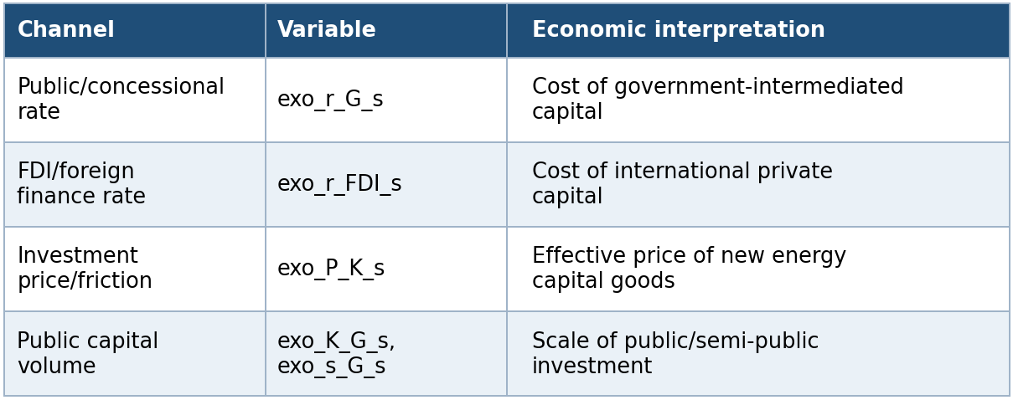
Three financing architectures (GF_A balanced, GF_B market-led, GF_C public-led) are distinguished by their Weighted Average Cost of Finance (WACF: 6.43%, 7.37%, 5.07% respectively), each run against both the PDP8 and Net-Zero baselines. Modeling implication: results should be read as an upper bound on what a given financing architecture can achieve if fully deployed — the model cannot verify whether the assumed cost reductions are institutionally achievable at scale (see finance_instruments_comments_feasibility.md).

Operational status vs. scenario capability
A scenario being defined in the model does not mean it runs by default. RunSimulations.m only executes activeScenarioGroups = {'Reference'} out of the box, and within that group only Baseline is uncommented. The Green Finance groups (GF_PDP8, GF_NZ) are fully wired (scenario-switch logic uncommented) but excluded from the default active set; several EE and NZ_Sensitivity scenario names are individually commented out. Reproducing a specific published result requires knowing exactly which activeScenarioGroups (or DGE_SCENARIO_GROUPS environment variable) configuration produced it — see running.md and scenario.md.

EE scenario reporting figures
The script scripts/reporting/GenerateEESimulationResultsFigures.m exports scenario-comparison figures to docs/figures/EE_Simulation_Results/. This subsection reports only deviation-versus-Baseline diagnostics.
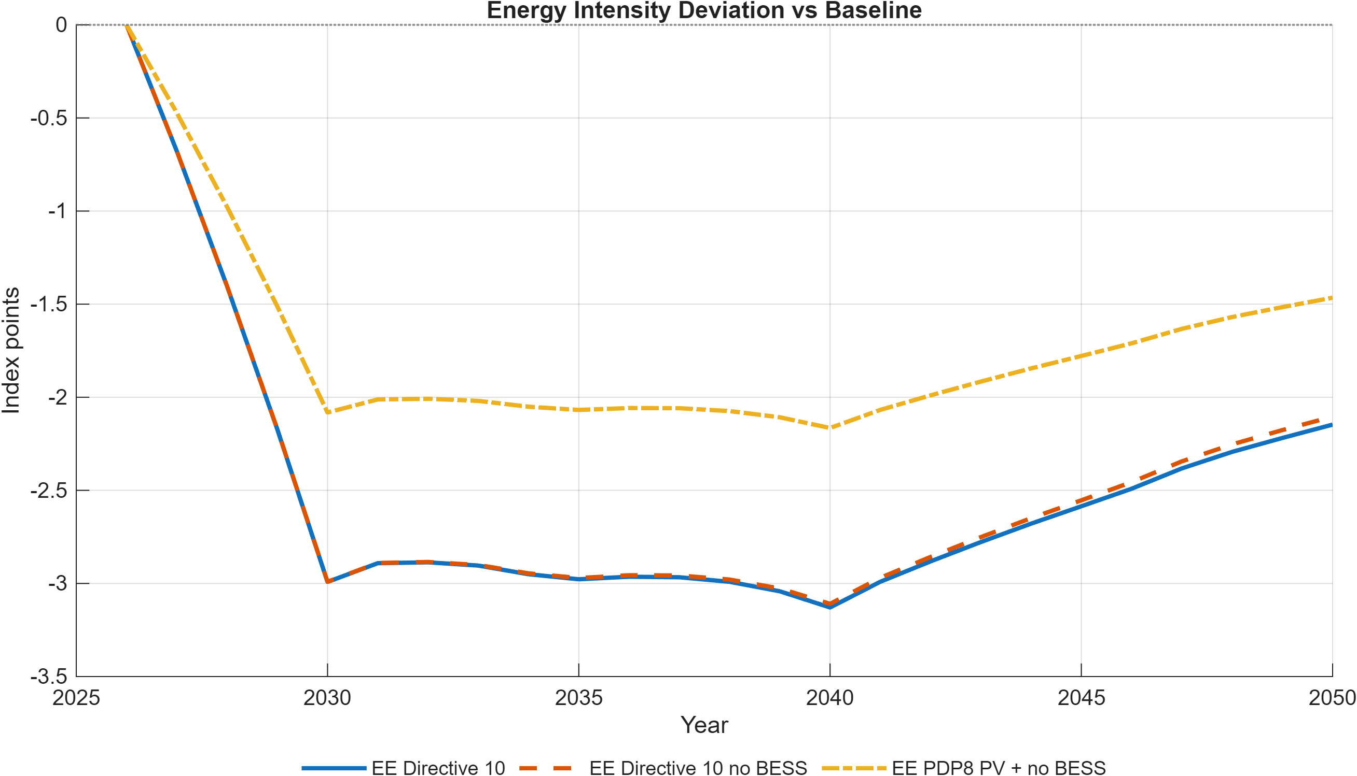
Energy intensity deviation vs baseline
Figure 6.1. Energy-intensity deviation of EE scenarios from the Baseline.
Note: Values are index-point deviations from the Baseline energy-intensity index (base year 2026). Negative values indicate improved energy efficiency relative to Baseline.
Source: Generated by scripts/reporting/GenerateEESimulationResultsFigures.m from scenario output CSV files in ExcelFiles/Output/.
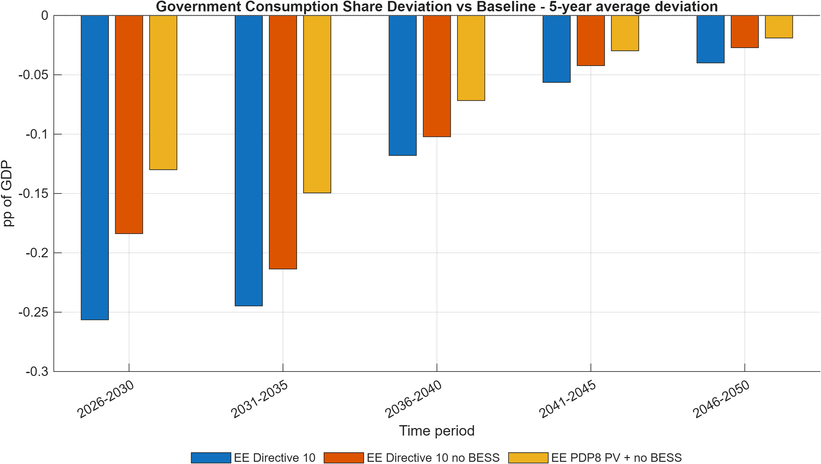
Government consumption share deviation vs baseline (5-year average)
Figure 6.2. Government consumption share deviation versus Baseline (5-year average bar chart).
Note: Bars report average deviation in government consumption share of GDP (pp of GDP) by 5-year block, showing persistent fiscal-demand composition differences relative to Baseline.
Source: Generated by scripts/reporting/GenerateEESimulationResultsFigures.m from scenario output CSV files in ExcelFiles/Output/.
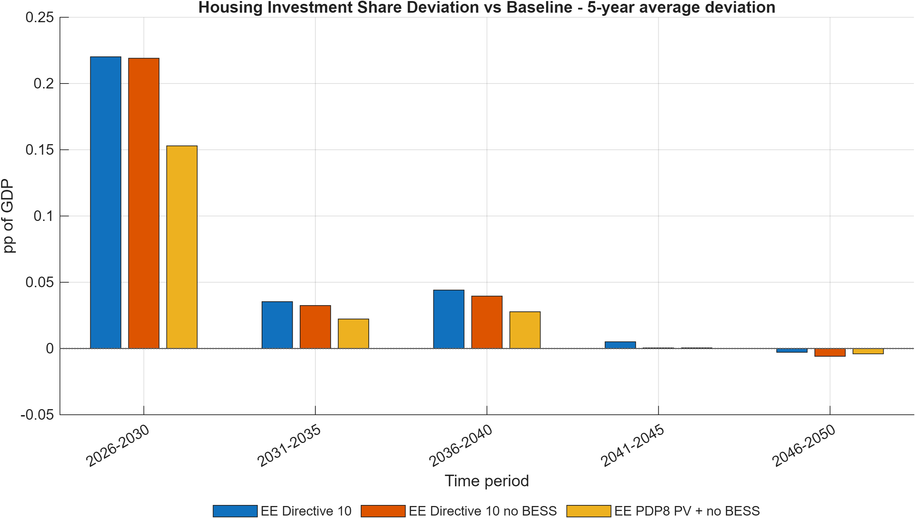
Housing investment share deviation vs baseline (5-year average)
Figure 6.3. Housing investment share deviation versus Baseline (5-year average bar chart).
Note: Bars report average deviation in housing investment share of GDP (pp of GDP) by 5-year block, highlighting medium-term allocation differences versus Baseline.
Source: Generated by scripts/reporting/GenerateEESimulationResultsFigures.m from scenario output CSV files in ExcelFiles/Output/.
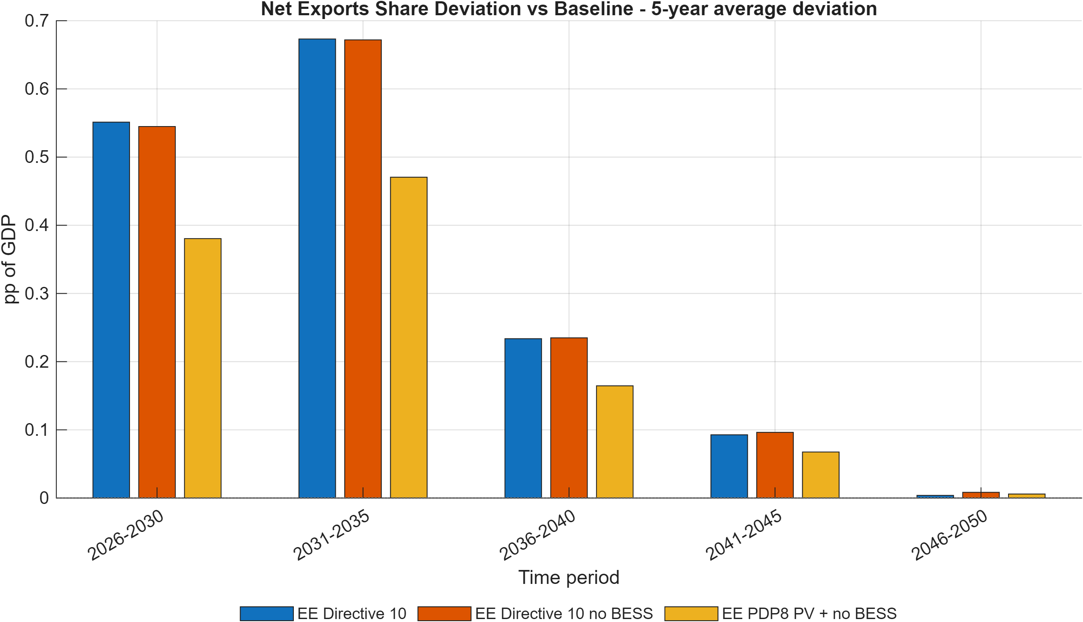
Net exports share deviation vs baseline (5-year average)
Figure 6.4. Net exports share deviation versus Baseline (5-year average bar chart).
Note: Bars report average net-exports-share deviation (pp of GDP) by 5-year block, summarizing sustained external-balance differences under each EE scenario.
Source: Generated by scripts/reporting/GenerateEESimulationResultsFigures.m from scenario output CSV files in ExcelFiles/Output/.
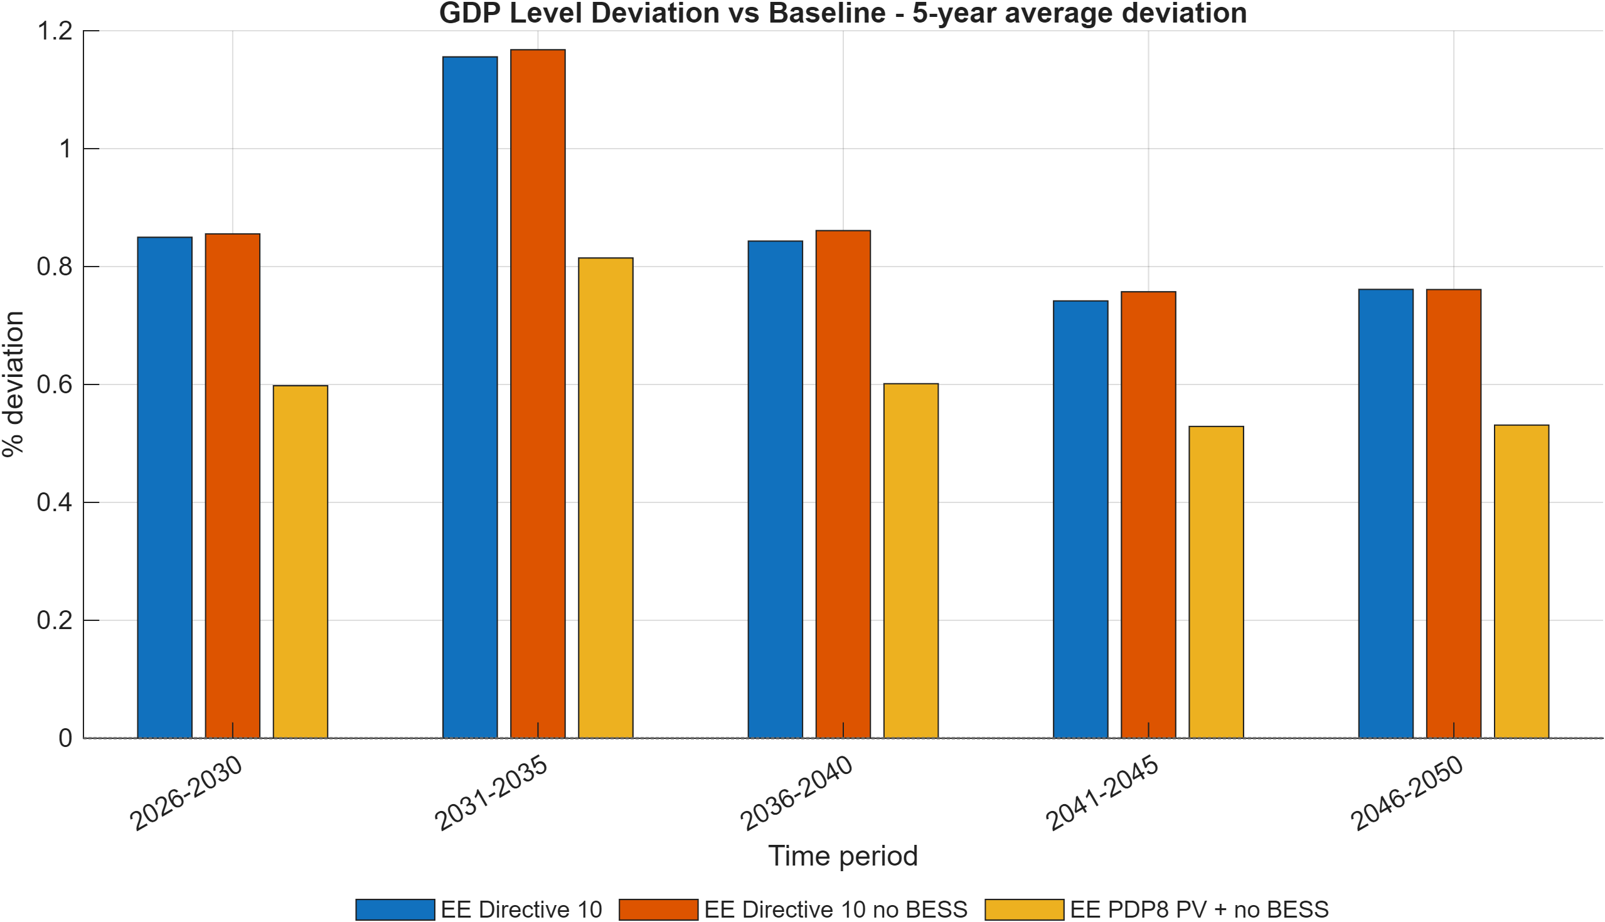
GDP level deviation vs baseline (5-year average)
Figure 6.5. GDP level deviation versus Baseline across EE scenarios (5-year average bar chart).
Note: Bars show average GDP-level deviation (percent) from Baseline by 5-year block, highlighting medium-run macro effects of each EE pathway.
Source: Generated by scripts/reporting/GenerateEESimulationResultsFigures.m from scenario output CSV files in ExcelFiles/Output/.
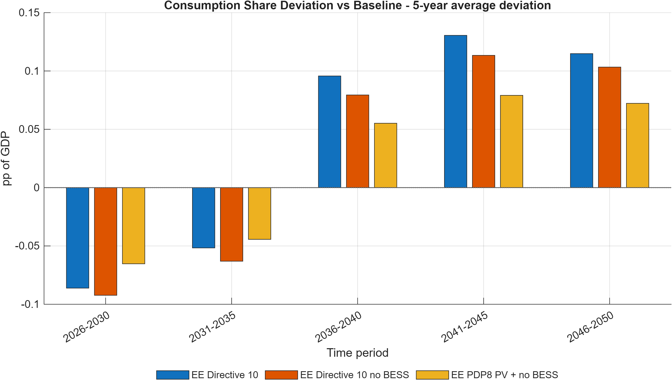
Consumption share deviation vs baseline (5-year average)
Figure 6.6. Consumption share deviation versus Baseline across EE scenarios (5-year average bar chart).
Note: Bars report average deviation in consumption share of GDP (pp of GDP) for each 5-year block, allowing direct comparison of household-demand reallocation under alternative EE scenarios.
Source: Generated by scripts/reporting/GenerateEESimulationResultsFigures.m from scenario output CSV files in ExcelFiles/Output/.
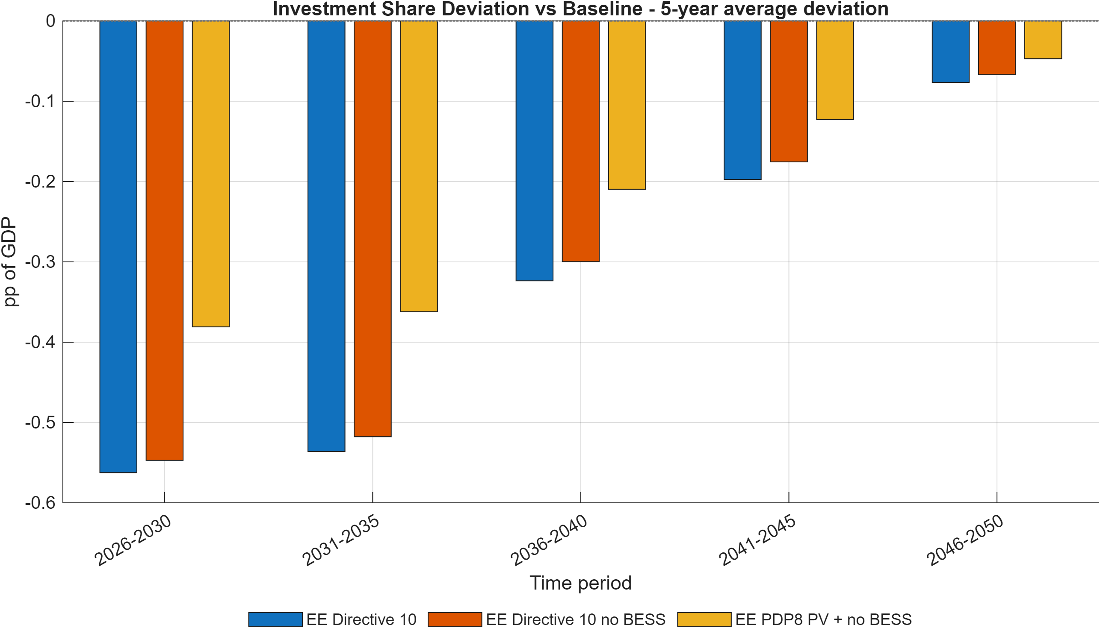
Investment share deviation vs baseline (5-year average)
Figure 6.7. Investment share deviation versus Baseline across EE scenarios (5-year average bar chart).
Note: Bars report average deviation in investment share of GDP (pp of GDP) by 5-year block and summarize the medium-term capital-allocation response in each EE pathway.
Source: Generated by scripts/reporting/GenerateEESimulationResultsFigures.m from scenario output CSV files in ExcelFiles/Output/.

Green finance scenario reporting figures
The script scripts/reporting/GenerateFinanceSimulationResultsFigures.m exports scenario-comparison figures to docs/figures/Finance_Simulation_Results/. This subsection reports only deviation-versus-Baseline diagnostics, using 5-year average bar charts.
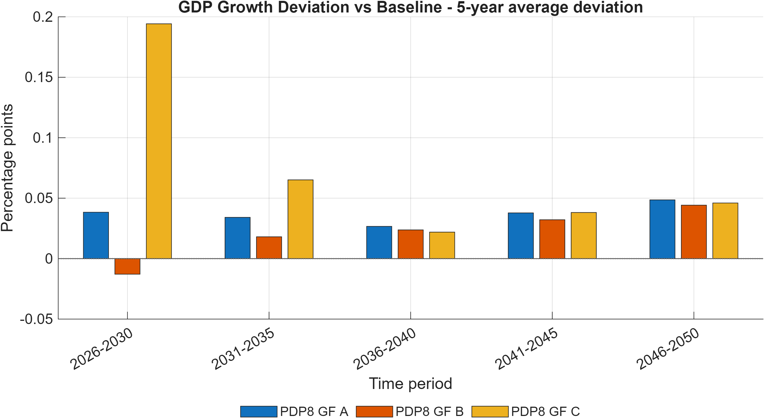
GDP growth deviation vs baseline (5-year average)
Figure 6.8. GDP growth deviation versus Baseline across green-finance scenarios (5-year average bar chart).
Note: Bars show the average deviation in annual GDP growth (percentage points) from Baseline by 5-year block, comparing how financing architectures alter the medium-run growth profile.
Source: Generated by scripts/reporting/GenerateFinanceSimulationResultsFigures.m from scenario output CSV files in ExcelFiles/Output/.
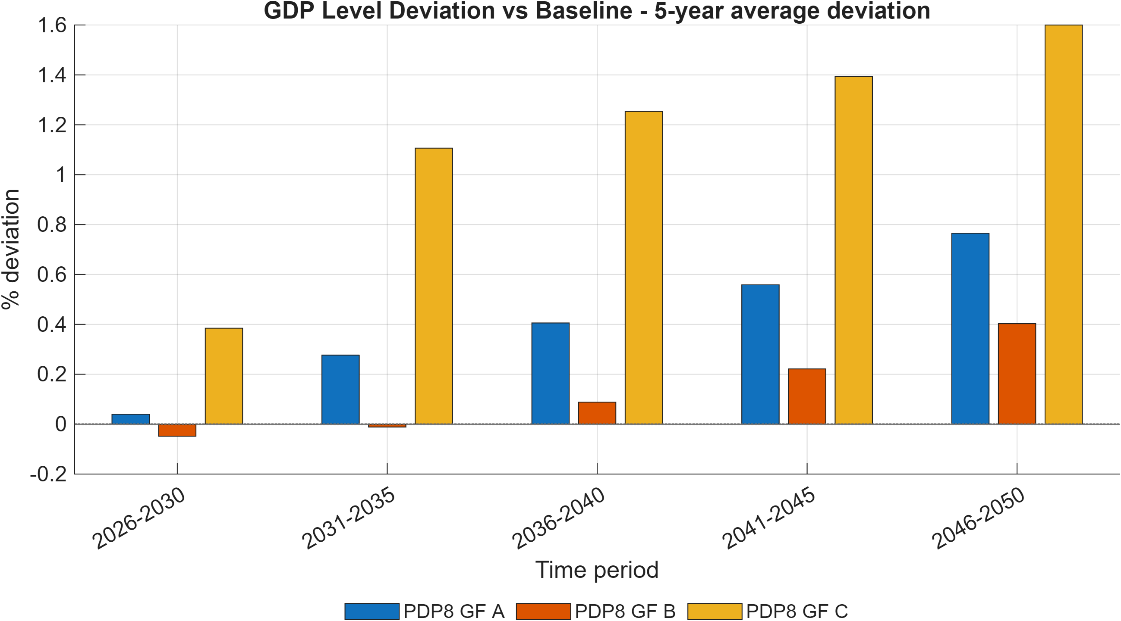
GDP level deviation vs baseline (5-year average)
Figure 6.9. GDP level deviation versus Baseline across green-finance scenarios (5-year average bar chart).
Note: Bars show average percent deviations of GDP level from Baseline by 5-year block and capture cumulative macro effects of financing conditions.
Source: Generated by scripts/reporting/GenerateFinanceSimulationResultsFigures.m from scenario output CSV files in ExcelFiles/Output/.
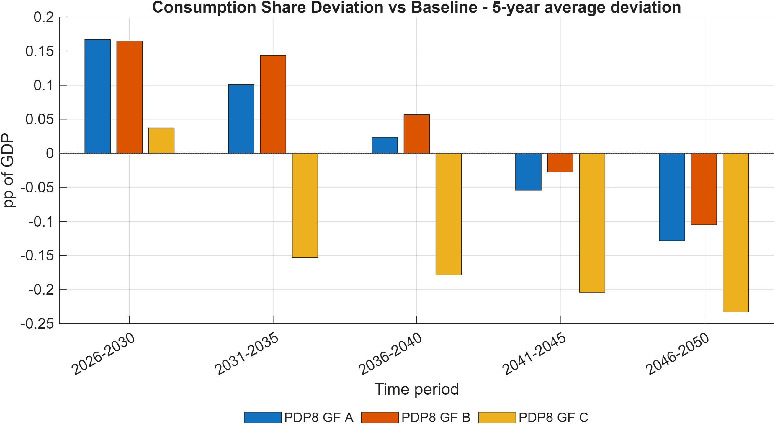
Consumption share deviation vs baseline (5-year average)
Figure 6.10. Consumption share deviation versus Baseline across green-finance scenarios (5-year average bar chart).
Note: Bars report average deviation in private-consumption share of GDP (pp of GDP) by 5-year block.
Source: Generated by scripts/reporting/GenerateFinanceSimulationResultsFigures.m from scenario output CSV files in ExcelFiles/Output/.
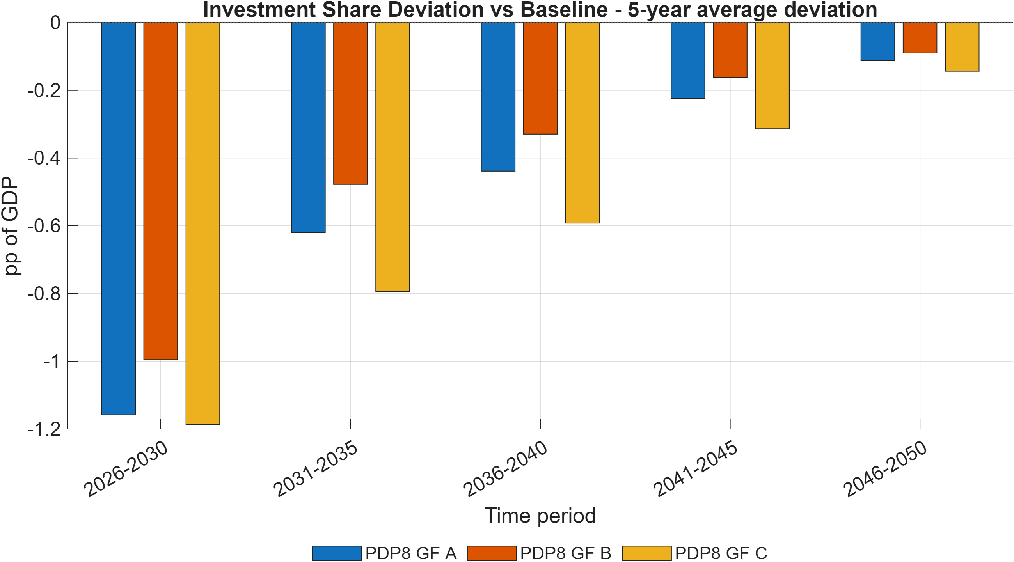
Investment share deviation vs baseline (5-year average)
Figure 6.11. Investment share deviation versus Baseline across green-finance scenarios (5-year average bar chart).
Note: Bars report average deviation in investment share of GDP (pp of GDP) by 5-year block, indicating medium-run capital-allocation shifts.
Source: Generated by scripts/reporting/GenerateFinanceSimulationResultsFigures.m from scenario output CSV files in ExcelFiles/Output/.
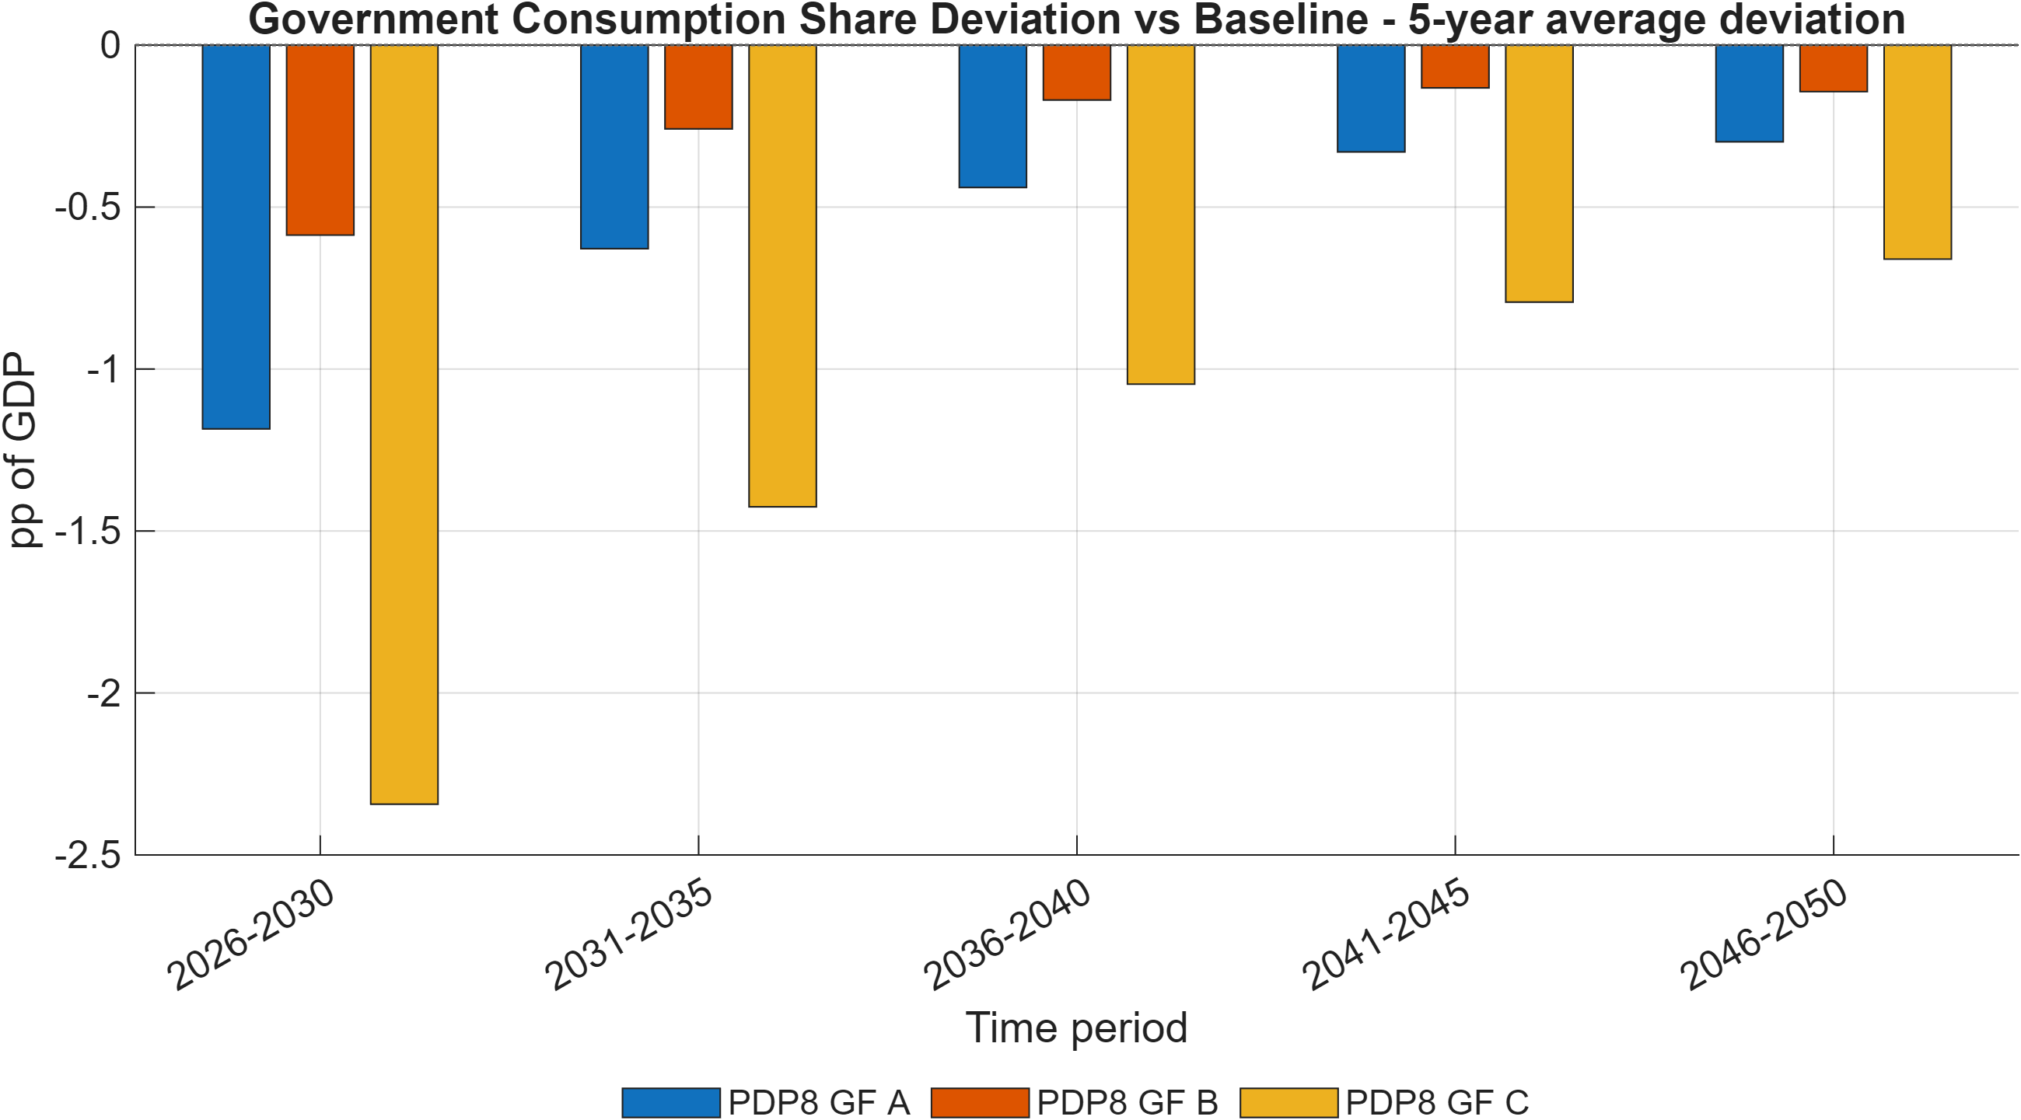
Government consumption share deviation vs baseline (5-year average)
Figure 6.12. Government consumption share deviation versus Baseline across green-finance scenarios (5-year average bar chart).
Note: Bars report average deviation in government consumption share of GDP (pp of GDP) by 5-year block.
Source: Generated by scripts/reporting/GenerateFinanceSimulationResultsFigures.m from scenario output CSV files in ExcelFiles/Output/.
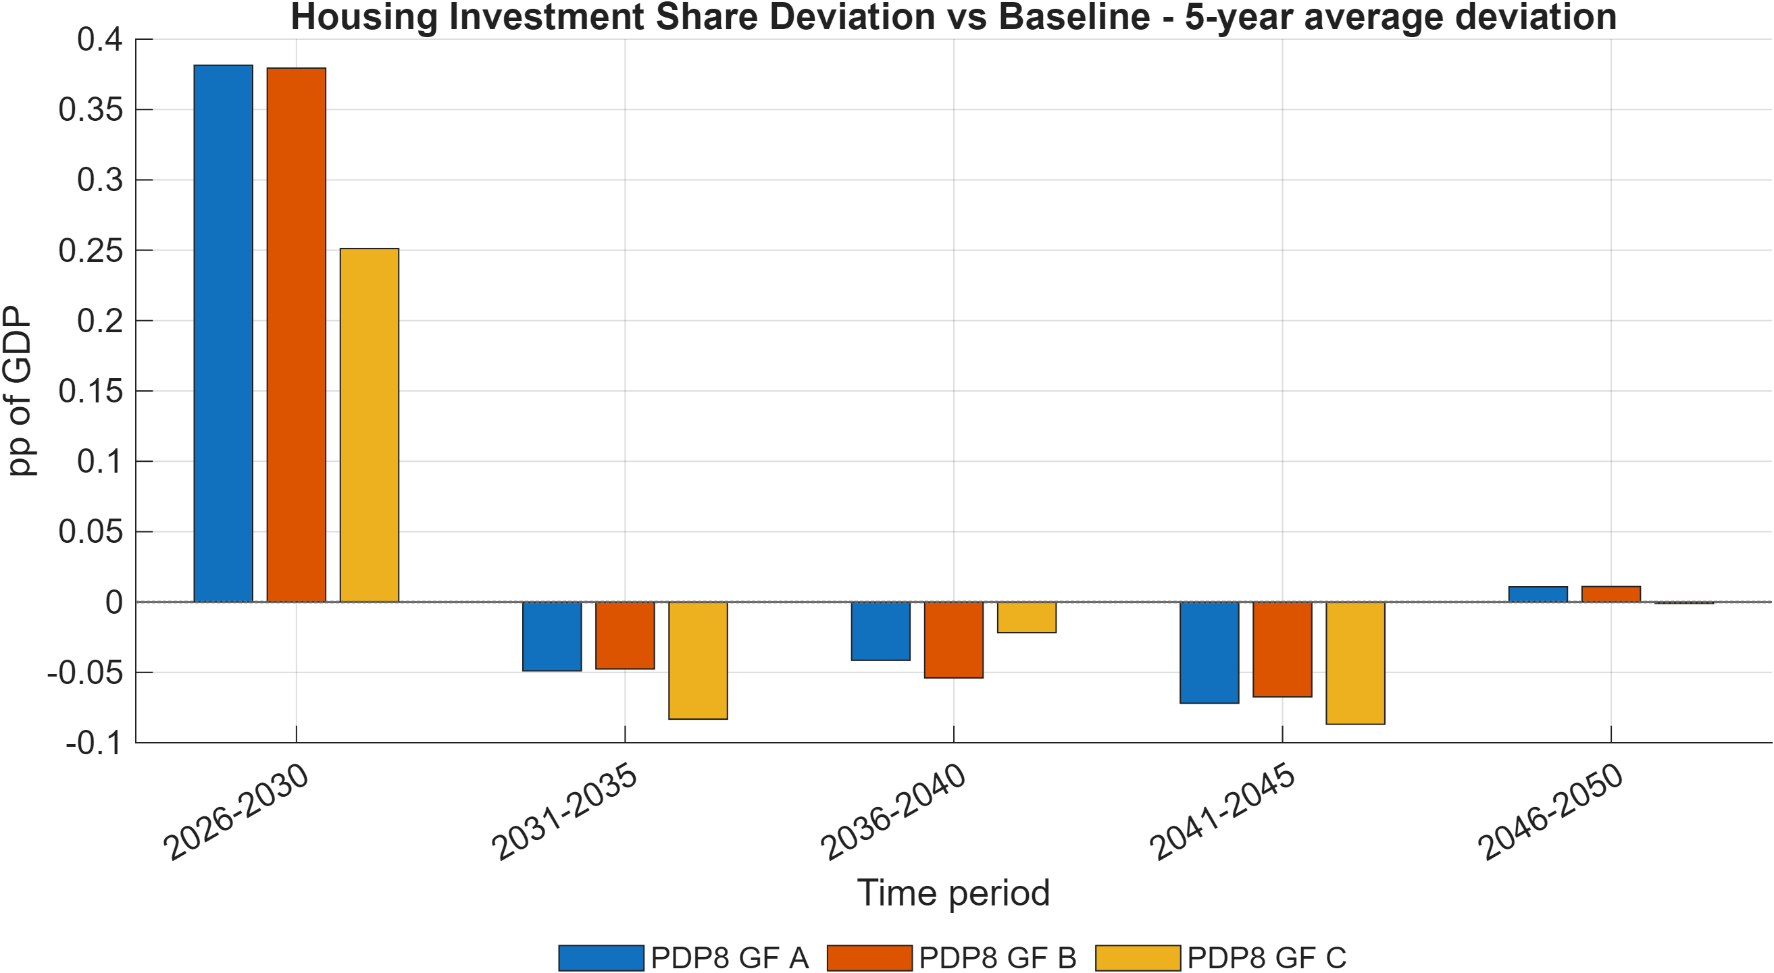
Housing investment share deviation vs baseline (5-year average)
Figure 6.13. Housing investment share deviation versus Baseline across green-finance scenarios (5-year average bar chart).
Note: Bars report average deviation in housing investment share of GDP (pp of GDP) by 5-year block.
Source: Generated by scripts/reporting/GenerateFinanceSimulationResultsFigures.m from scenario output CSV files in ExcelFiles/Output/.
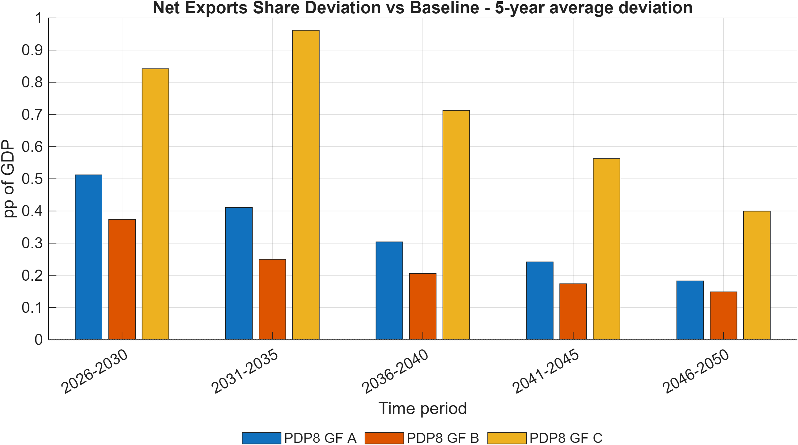
Net exports share deviation vs baseline (5-year average)
Figure 6.14. Net exports share deviation versus Baseline across green-finance scenarios (5-year average bar chart).
Note: Bars report average deviation in net exports share of GDP (pp of GDP) by 5-year block, summarizing external-balance effects.
Source: Generated by scripts/reporting/GenerateFinanceSimulationResultsFigures.m from scenario output CSV files in ExcelFiles/Output/.
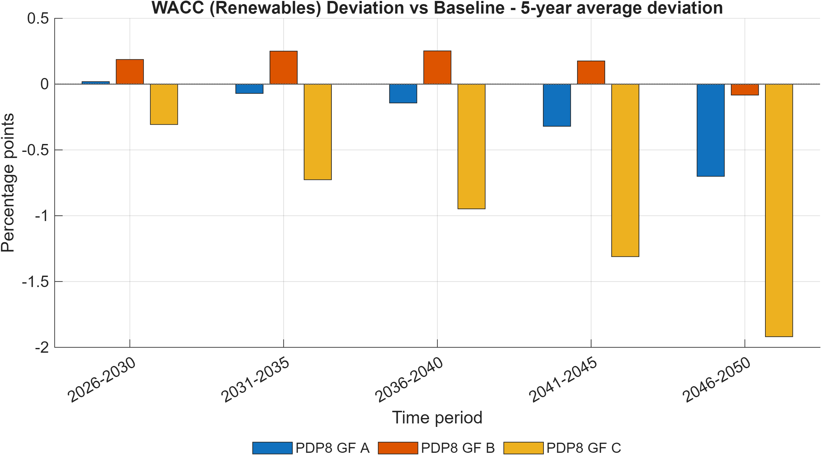
WACC renewables deviation vs baseline (5-year average)
Figure 6.15. Renewable-energy WACC deviation versus Baseline across green-finance scenarios (5-year average bar chart).
Note: Bars report average deviations in renewable weighted average cost of capital (percentage points) from Baseline by 5-year block, summarizing the financial-channel intensity of each policy package.
Source: Generated by scripts/reporting/GenerateFinanceSimulationResultsFigures.m from scenario output CSV files in ExcelFiles/Output/.

Limitations, Implementation Risks, and Interpretation Guidance
This section summarizes recurrent implementation risks and interpretation constraints that have caused incorrect results or wasted debugging time in practice. It should be treated as a pre-publication quality-control checklist.
- fval_vec_11 is load-bearing. Never remove it from evaluate_capital_steady_state_residuals.m (§5.2). Deleting it makes the hybrid steady state underdetermined.
- Energy-efficiency variable shape. Two shapes exist in this codebase’s history — legacy regional EE_1/exo_EE_1 and a sector-specific refactor EE_sec_reg/exo_EE_sec_reg. As of this writing, only the legacy regional shape is declared in ModFiles/. Confirm with git grep -n "EE_.*_1" in ModFiles/ before writing code that assumes either shape.
- Perfect-foresight singularity under direct capital targeting. Pinning total sector capital K_t directly via a Dynare equation while the household Euler equation for I_(H,t) remains active produces a rank-deficient Jacobian (the Euler equation loses its degree of freedom once K_t = K_(H,t)+K_(G,t)+K_(FDI,t) is fixed and K_(G,t) is predetermined). The working pattern is to pin the flow (insert a wedge into the Euler equation via exo_lTargetInv/wedgeKE) and let the stock follow from the law of motion, not to pin the stock directly. See implementation_plans/capital_targeting_trial_and_error.md.
- Code defaults vs. active calibration can diverge by orders of magnitude (§4.4) — always confirm the workbook actually loaded for a given run before citing a structural parameter value.
- Generated code is not source. +DGE_Model/, DGE_Model/, *_dynamic.m, *_static.m are rebuilt by Dynare on every invocation. Never hand-edit them; the fix belongs in the .mod source.
- What the model does not do (§2.2): no plant-level dispatch, no endogenous technology learning curves, no sub-national regions, no explicit financial-instrument balance sheets.
- The exchange-rate variable s_reg is a closure device, not a full UIP nominal exchange rate (§3.7) — do not interpret its dynamics as a conventional exchange-rate block.

Conclusion

References
- CITATION.cff (this repository) — canonical citation for the model: Schult, C. (2026). DGE-METRIC: Dynamic General Equilibrium for Macroeconomic Energy Transition Incorporating Carbon Markets. Halle Institute for Economic Research (IWH). https://github.com/schultkr/DGE-METRIC
- Schult, C. et al. (2025). Investment Needs Assessment for Vietnam’s Energy Transition. IWH Policy Note. GIZ project “Support for Carbon Pricing and Green Finance in Vietnam.”
- Schult, C. et al. (2025). Financial Assessment Report: Green Finance Instruments for Vietnam’s PDP8. IWH Policy Note. GIZ project “Support for Carbon Pricing and Green Finance in Vietnam.”
- Vietnam Government, Decision 500/QD-TTg (2023). Power Development Plan 8 (PDP8).
- General Statistics Office of Vietnam (NSO). Input-Output Table 2019.
- IEA. World Energy Outlook 2025.
- EDGAR (EU Joint Research Centre). Global GHG Emissions Database, 2024 release.
- EXIOBASE 3. Environmentally extended multi-region input-output database.
- Schultz, T.W. (1961). “Investment in Human Capital.” American Economic Review; related labor-productivity treatment cross-referenced via NBER working paper 21381.
- Christiano, Motto, and Rostagno (2014); Leeper (2010); Kliem (2014); Drygalla et al. (2020) — reduced-form fiscal-policy modeling conventions followed in the government block (§3.5).

A Technical Appendix

A.1 Equation reference
Full equation listings, by block, are maintained in ModFiles/Equations/*.mod with a parallel human-readable mirror in ModFiles/Equations/Equations_display/. The primary equation-set narrative is in model.md; this report’s §3 summarizes the theoretical structure without reproducing every first-order condition.

A.2 Parameter reference
The full parameter-by-parameter calibration source audit — including flags for stale or uncertain values — is maintained in structural_parameters_source_audit.md. The code-default-vs-active-workbook override table is in calibration_model_detailed.md §12.

A.3 Repository map
