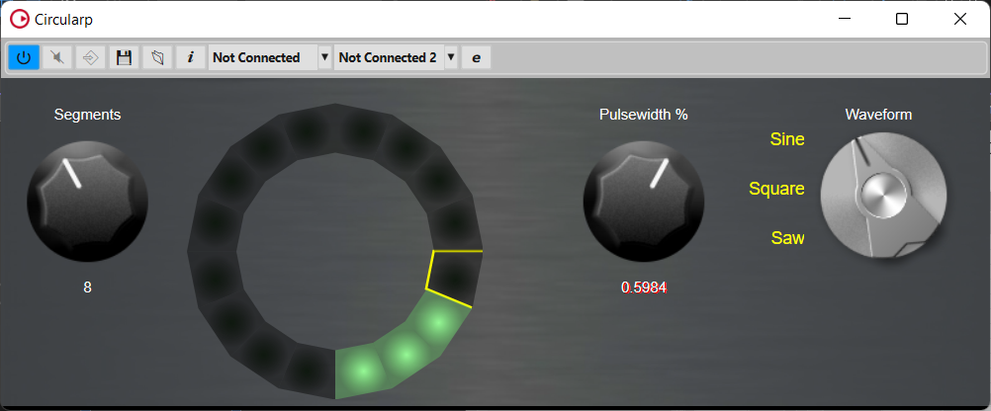
c1(100, 200, 100, 00);
c2(150, 250, 150, 255);

c1(100, 200, 100, 255);
c2(150, 250, 150, 255);

r
r
r
R
double r = R / (1 + 1 / sin(PI2 / 2 / segs));

