

**Detail Design Document**

**For Mapping Factory API**



Version: 1.0

Date: 31/12/2019

Author: Suraj Desai

**Version: 2.0**

**Author: Ajay Gupta**

**Date: 6-January-2021**

Table of Contents

Revision Log

Purpose of this Document

System Overview

Brief overview of the System

Open API specification

Sequence Diagram (at method level)

Client-Side Requirements

Michelin APIM Clients

Connectivity

Security Requirements – Client Side

Transport Security

Client IP Control

Target Requirements

Michelin APIM Targets

Connectivity

Security Requirements – Target Side

Transport Security

IP Control

Performance

Target Response Times

Target Throughput

Michelin APIM Solution

API Proxy details

Threat Protection

Transport

Identify & Access

Request Processing

Routing

Traffic Monitoring

Response Processing

Error Handling

Developer Portal Requirements

Branding

API Package & Monetization

# 

# Revision Log

|  |  |  |  |
| --- | --- | --- | --- |
| **Date** | **Author** | **Version** | **Changes** |
| 14-January-2020 | Ajay Gupta | 1.0 | Initial Draft |
| 6-January-2021 | Ajay Gupta | 2.0 | Revised |

# Purpose of this Document

This document is to capture the comprehensive set of technical requirements. The requirements are specific to the Michelin APIM API proxy implementation and cover all aspects: design, architecture, and interactions of Michelin APIM with other components.

# System Overview

Provide business geo-services (map, route calculations, search, geocoding …) MTP would to deliver all needs around geo-services viz. Dealer locator ( example : https://www.michelin.fr/auto/dealer-locator ),Map display, Route planner solution, etc.

As part of API solutions, MTP serves with below API services :

1. **Geocoding:**

Convert a postal address into GPS coordinates. This feature enables the conversion of one or multiple addresses into latitude and longitude coordinates.This feature is used for departure, stop-off and arrival points as well as the positioning of your points of interest on a map and many other digital mapping requirements.

Converts addresses into geographic coordinates (WGS84) and obtain an ordered list of places matching these geographical coordinates with the parameters provided. Address is entered on 4 separate fields (country, city, postcode, street).

1. **Reverse Geocoding:**

Convert GPS coordinates into a postal address. This feature enables you to convert GPS coordinates into postal addresses. It enables you to know the geographical location of points of interest in real-time and track their movements. These tracks can then be outlined on a map and, by means of a logo, you can follow the progression of the journey.

1. **Autocomplete:**

This API offers functionality of 'typeahead search’. The request specifies a textual search string and optional boosts and/or filters. The MTP auto-complete API returns potentials countries, potentials administrative areas, potentials cities and potentials addresses matching a partial user input. The output format is a JavaScript: a callback function with json object (search result) as parameter (e.g. fct({...})).The MTP auto-complete API is exposed via a GET HTTPs method.

1. **MapboxCatalog:**

Mapbox catalog service enables Mapbox client to obtain JSON object of Mapbox Style document. Here, Mapcatalog: is a config file (XML) which describe the set of map available via our map server (« modMap »). Mapbox style templates are generic Mapbox style documents which contains variables to replace. Mapbox style is a document (JSON object) that defines where to find data (raster tiles, vector tiles, geosjon…) and the visual appearance of a map: what data to draw, the order to draw it in, and how to style the data when drawing it. It is used by mapbox engine (javascript or native)

1. **Omniroute:**

Itinerary service computes the best route on the road network between locations. Returns summary, data sheet and map.

Service provides an easier way to calculate a basic route and allows larger requests (e.g. more itinerary steps) to be able to handle more complex additional parameters if needed.

1. **Distance Matix:**

Distance Matrix is the second service of the collection of APIs that will provide route-related services which can be added to customers applications. The first one is route calculation.This service (Distance Matrix) allows to calculate all possible routes combinations between a set of origins and destinations. It provides travel time and distances for each one.Our Distance Matrix service will support up to 10 000 origins and/or destinations at a time. Given these limits the service can take time to process a request. Therefore our Distance Matrix is a “batch” service. The process is asynchronous, and can be broken down into steps:

* initiate the job (initiate batch processing)
* monitor job state
* get job result

**Business Value:**

Distance matrices can be used in several different types of applications.The main advantage over our competitors (Google, Yandex, Here, Bing, ...) is to be able to compute larger matrix (with 20 000 elements).

## API documentation:

**Mapping Factory API documentation:**



## Sequence Diagram:

**Geocoding/Reverse Geocoding**

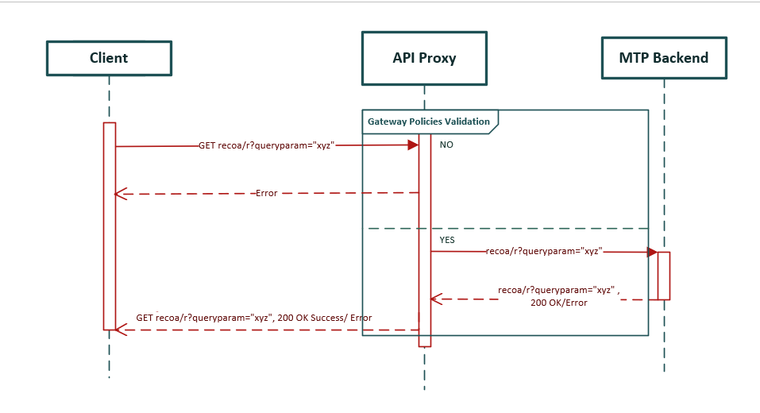**Autocomplete**



**MapboxCatalogue API**



**Omniroute API**



**Distance Matix API**

# Client-Side Requirements

## 3.1 Michelin APIM Clients

Internal and External developer / consumers

## Connectivity

HTTPs (one-way)

# Security Requirements – Client Side

## Transport Security

SSL (or TLS), certificates can be obtained from MICHELIN or via MTP.

## Client IP Control

No client IP control is needed

# Target Requirements

## Michelin APIM Targets

Public API (MTP API)

## 5.2 Connectivity

HTTPs (one-way).

An explanation schema:

## C:\Users\pgawlik\AppData\Local\Microsoft\Windows\INetCache\Content.MSO\89AEC7A.tmp

# Security Requirements – Target Side

## Transport Security

SSL based security where MTP will generate and manage the certificates.

## 6.2 IP Control

As a first step, we need not to whitelist Michelin APIM. If necessary and when an environment will be dedicated to the Michelin APIM, we will be able to whitelist Michelin APIM to improve security level.

# Performance

## 7.1 Target Response Times

< 100ms

## 7.2 Target Throughput

Not required as on date.

# Michelin APIM Solution

## API Proxy / Target details

API Name: **geocode**

API Name: **reverse-geocode**

|  |  |
| --- | --- |
| SAG Env. | Software AG endpoints URL’s |
| DEV | https://dev.api.michelingroup.com/gateway/geocode/v1 |
| QUALIF | https://qualif.api.michelingroup.com/gateway/geocode/v1 |
| INDUS | https://indus.api.michelingroup.com/gateway/geocode/v1 |
| PROD | https://api.michelingroup.com/gateway/geocode/v1 |

|  |  |  |
| --- | --- | --- |
| Native Env. | Native Endpoint URL’s | Alias |
| DEV | https://rc.search-api.oms.viamichelin.com/api/1.0 | mappingfactory-http-endpoint |
| TEST | https://rc.search-api.oms.viamichelin.com/api/1.0 | mappingfactory-http-endpoint |
| PROD | https://rc.search-api.oms.viamichelin.com/api/1.0 | mappingfactory-http-endpoint |

API Name: **autocomplete**

|  |  |
| --- | --- |
| SAG Env. | Software AG endpoints URL’s |
| DEV | https://dev.api.michelingroup.com/maps/address-search/v1/autocomplete |
| QUALIF | https://qualif.api.michelingroup.com/maps/address-search/v1/autocomplete |
| INDUS | https://indus.api.michelingroup.com/maps/address-search/v1/autocomplete |
| PROD | https://api.michelingroup.com/maps/address-search/v1/autocomplete |

|  |  |  |
| --- | --- | --- |
| Native Env. | Native Endpoint URL’s | Alias |
| DEV | https://rc.search-api.oms.viamichelin.com/api/1.0 | mappingfactory-http-endpoint |
| TEST | https://rc.search-api.oms.viamichelin.com/api/1.0 | mappingfactory-http-endpoint |
| PROD | https://rc.search-api.oms.viamichelin.com/api/1.0 | mappingfactory-http-endpoint |

API Name: **mapboxcatalog**

|  |  |
| --- | --- |
| SAG Env. | Software AG endpoints URL’s |
| DEV | https://eu-west.dev1.apigateway.michelingroup.com/gateway/mapboxcatalog/1.0/MapBoxCatalog.json2 |
| QUALIF | https://eu-west.dev2.apigateway.michelingroup.com/gateway/mapboxcatalog/1.0/MapBoxCatalog.json2 |
| INDUS | https://eu-west.test.apigateway.michelingroup.com/gateway/mapboxcatalog/1.0/MapBoxCatalog.json2 |
| PROD | https://eu-west.apigateway.michelingroup.com/gateway/mapboxcatalog/1.0/MapBoxCatalog.json2 |

|  |  |  |
| --- | --- | --- |
| Native Env. | Native Endpoint URL’s | Alias |
| DEV | https://secure-apir.viamichelin.com/apir/1 | mtp-http-endpoint |
| TEST | https://secure-apir.viamichelin.com/apir/1 | mtp-http-endpoint |
| PROD | https://secure-apir.viamichelin.com/apir/1 | mtp-http-endpoint |

API Name: **omniroute**

|  |  |
| --- | --- |
| SAG Env. | Software AG endpoints URL’s |
| DEV | https://dev.api.michelingroup.com/gateway/omniroute/v1 |
| QUALIF | https://qualif.api.michelingroup.com/gateway/omniroute/v1 |
| INDUS | https://indus.api.michelingroup.com/gateway/omniroute/v1 |
| PROD | https://api.michelingroup.com/gateway/omniroute/v1 |

|  |  |  |
| --- | --- | --- |
| Native Env. | Native Endpoint URL’s | Alias |
| DEV | https://rc.route-api.omr.viamichelin.com/api/1.0 | mapping-factory-omniroute-http-endpoint |
| TEST | https://rc.route-api.omr.viamichelin.com/api/1.0 | mapping-factory-omniroute-http-endpoint |
| PROD | https://rc.route-api.omr.viamichelin.com/api/1.0 | mapping-factory-omniroute-http-endpoint |

API Name: **distance-matrix**

|  |  |
| --- | --- |
| SAG Env. | Software AG endpoints URL’s |
| DEV | https://eu-west.dev1.apigateway.michelingroup.com/gateway/distance-matrix/v1/distancematrix |
| QUALIF | https://eu-west.dev2.apigateway.michelingroup.com/gateway/distance-matrix/v1/distancematrix |
| INDUS | https://eu-west.test.apigateway.michelingroup.com/gateway/distance-matrix/v1/distancematrix |
| PROD | https://eu-west.apigateway.michelingroup.com/gateway/distance-matrix/v1/distancematrix |

|  |  |  |
| --- | --- | --- |
| Native Env. | Native Endpoint URL’s | Alias |
| DEV | https://rc.route-api.dm.viamichelin.com | mapping-distance-matrix-http-endpoint |
| TEST | https://rc.route-api.dm.viamichelin.com | mapping-distance-matrix-http-endpoint |
| PROD | https://rc.route-api.dm.viamichelin.com | mapping-distance-matrix-http-endpoint |

## 8.2 Threat Protection

|  |  |
| --- | --- |
| Requirement | Implemented(Y) |
| JSON Threat Protection | N |

## 8.3 Transport

|  |  |
| --- | --- |
| Requirement | Implemented(Y) |
| Enable HTTP / HTTPS | Y |

## 8.4 Identify & Access

|  |  |
| --- | --- |
| Requirement | Implemented(Y) |
| Identify & Authorize Application | Y |

## 8.5 Request Processing

|  |  |
| --- | --- |
| Requirement | Implemented(Y) |
| Request Transformation | Y |

## 8.6 Routing

|  |  |
| --- | --- |
| Requirement | Implemented(Y) |
| Straight Through Routing | Y |
| Outbound Authentication | Y |

## 8.7 Response Processing

|  |  |
| --- | --- |
| Requirement | Implemented(Y) |
| CORS | Y |

## 8.8 Traffic Monitoring

|  |  |
| --- | --- |
| Requirement | Implemented(Y) |
| Log Invocation | Y |
| Throttling Traffic Optimization | Y |

## 8.9 Error Handling

|  |  |
| --- | --- |
| Requirement | Implemented(Y) |
| Conditional Error Processing | Y |

# Developer Portal Requirements

## 9.1 Branding

N.A.

## 9.2 API Package & Monetization

N.A.