Unifying Classic Machine Learning and Generative AI Under One Governance Plane:
A Reference Architecture and Operational Practices for Industrial and Manufacturing AI
Sudhakar Chundu
IEEE · chundubabu@gmail.com
Abstract. Manufacturing and other industrial organizations are now running two kinds of AI side by side: the familiar predictive stack - yield models, vision-based defect detectors, failure forecasts - trained on equipment and process data, and a generative layer of copilots and agents that work over engineering documents. The two are usually built by separate teams on separate tooling, and that split is where governance, security, and delivery begin to fray. This paper presents a vendor-neutral reference architecture that places both lifecycles under a single governance plane, adapted for the strict networking, edge-deployment, and asynchronous document-ingestion realities of industrial environments, together with operational practices for taking models and language-based systems from prototype to monitored production. We define a drift taxonomy specific to manufacturing execution data and distinguish detection that is possible without labels from detection that requires delayed ground truth. We contrast retrieval-augmented generation, direct generation, and agentic patterns, and give selection guidance. Finally, we define an evaluation methodology that corrects for model-graded evaluator bias and a continuous-delivery pipeline that gates generative systems with the same rigor applied to predictive models. The throughline is straightforward: once a generative system is baselined, evaluated, gated, and monitored the way a predictive model already is, a single delivery discipline can serve both - from the cloud down to constrained hardware on the line.
Keywords: MLOps; LLMOps; retrieval-augmented generation; agentic AI; concept drift; model evaluation; continuous delivery; manufacturing AI; edge computing.

1. Introduction
Two kinds of AI now coexist in industrial settings. The first is classic supervised machine learning applied to operational data: predicting yield, detecting defects from inspection imagery, and forecasting equipment failure for predictive maintenance. The second is generative AI applied to unstructured engineering knowledge: grounded question answering over specifications and procedures, natural-language querying of operational databases, and document understanding over supplier and quality records. These lifecycles differ in their data, their failure modes, and the way they are evaluated, yet they share the same demands for security, reproducibility, and reliable delivery.
When the two are operated by separate teams on separate stacks, governance fragments: identity and network controls diverge, model and prompt lineage are tracked inconsistently, and each team reinvents continuous delivery. Mature MLOps practice already codifies this discipline for predictive models [13]; the open question we take up is how to extend it to generative systems. This paper argues that both lifecycles belong under one governance plane and that, because a generative system can be evaluated and released with the same discipline as a predictive model, a single set of practices can serve both.
The contributions are: (i) a vendor-neutral reference architecture spanning a cloud control plane and the industrial edge (Section 2), including an asynchronous document-ingestion and vectorization pipeline (Section 2.2); (ii) a baselining methodology for predictive models and foundation-model selection (Section 3); (iii) a drift taxonomy for manufacturing execution data that separates label-free from label-dependent detection (Section 4); (iv) selection guidance across retrieval, generation, and agentic patterns (Section 5); (v) an evaluation methodology that corrects for model-graded evaluator bias (Section 6); and (vi) continuous-delivery and edge-aware monitoring patterns that gate generative systems like models (Sections 7 and 8).

2. Reference Architecture
Figure 1 shows the reference architecture. A governance hub provides one control plane for both lifecycles, enforcing private networking, role-based access control, content safety, and cost governance. Within it, two project workspaces hold, respectively, the predictive models and the generative systems, while a shared registry built on MLflow [11] records experiments, parameters, metrics, model versions, and prompt configurations with full lineage, and managed endpoints serve online and batch workloads. A multi-source data estate, spanning operational systems, inspection imagery, engineering documents, and enterprise resource data, feeds the hub; an integration plane connects outputs to enterprise systems; and an observability layer captures metrics, traces, and quality signals.
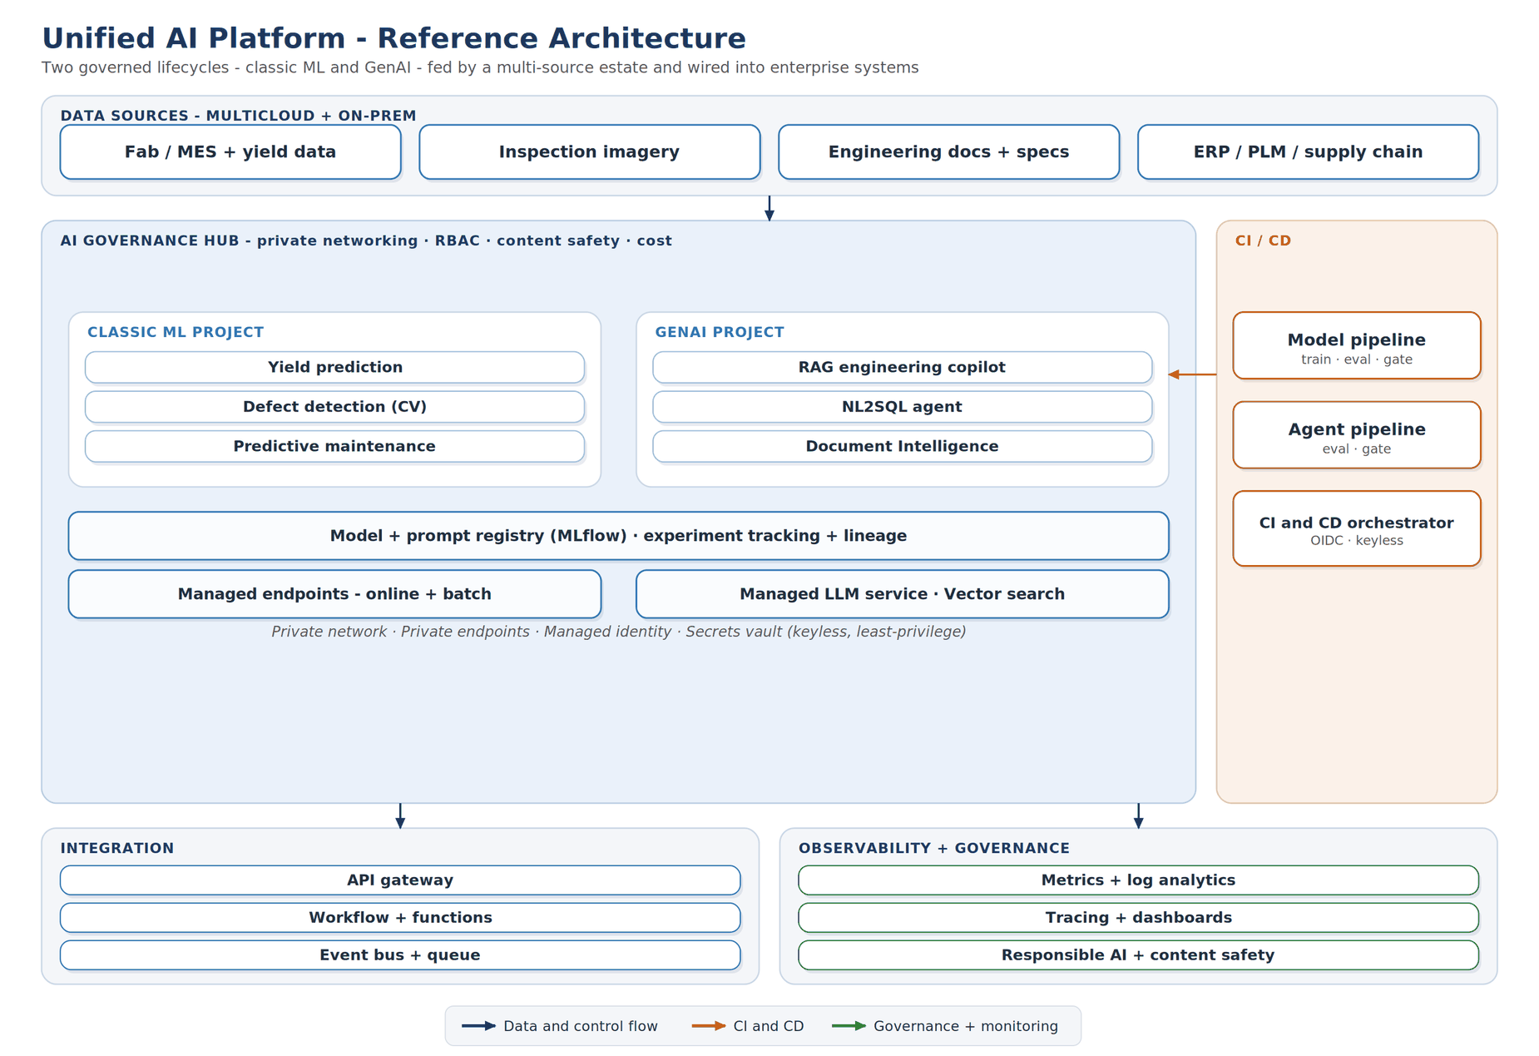
Figure 1. Reference architecture. Two governed lifecycles - classic ML on operational data and generative AI on engineering knowledge - sit under one governance hub, fed by a multi-source data estate and integrated with enterprise systems.
Security is uniform across both lifecycles: a private network with private endpoints, workload identity in place of stored credentials, a secrets vault accessed by role rather than key, and least-privilege roles scoped to each resource. Automation authenticates with federated identity, so no long-lived secrets are stored in the delivery system. These patterns are realized today by managed AI development platforms from major cloud providers; the architecture and the practices that follow are independent of any single provider.

2.1 Edge and Cloud Deployment Topology
Industrial deployments cannot assume cloud connectivity for time-critical work, so the architecture separates execution into two planes under the one hub (Figure 2). The cloud inference plane serves heavy workloads where latency bounds are relaxed: large-model serving, deep vector search, and batch scoring and training. The industrial edge plane runs latency- and safety-critical work, such as in-line optical defect inspection and high-frequency telemetry forecasting, on edge gateways and industrial PCs at the line.
The unified hub is what makes this safe at scale. Models and prompts are versioned and signed centrally, then pushed to the edge as immutable, signed containers; computer-vision models are cross-compiled (for example, to ONNX or TensorRT profiles) and language models are quantized in the cloud workspace before deployment. In the reverse direction, edge telemetry, model-health metrics, and drift signals stream back to the hub and the observability layer, so a model running disconnected on the floor remains governed, monitored, and re-trainable from the center.
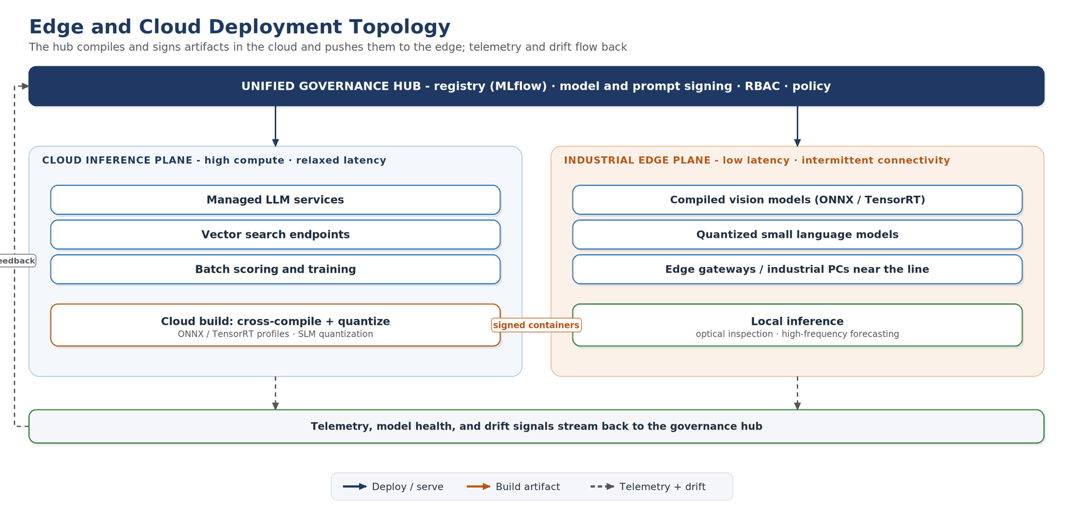
Figure 2. Edge and cloud deployment topology. The governance hub signs and compiles artifacts centrally and pushes them to the edge as immutable containers, while telemetry and drift signals stream back.

2.2 Unstructured Document Ingestion and Embedding
Generative quality depends on an asynchronous ingestion pipeline that keeps the retrieval index current as engineering documents change (Figure 3). Manufacturing knowledge - standard operating procedures, CAD sheets, and quality records - is revised frequently, so a document update must trigger re-processing rather than a manual rebuild.
The pipeline runs five stages: extraction of layout, tables, and text from source files; hierarchical chunking that preserves parent-child structure with overlap; metadata harvesting of facility, equipment, author, and version stamps; bi-encoder embedding of each chunk into a dense vector; and indexing of vectors and metadata into a vector store, with each index version cataloged in the shared registry. Versioning the index alongside models and prompts means a retrieval regression can be traced and rolled back exactly like a model regression.
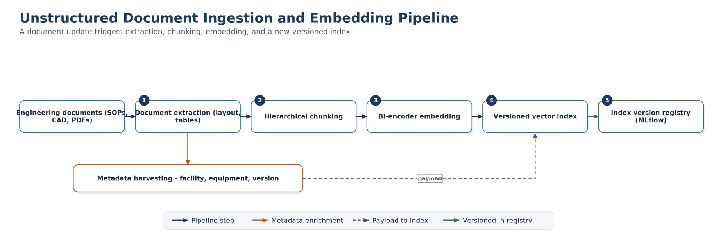
Figure 3. Asynchronous document ingestion and embedding. A document update triggers extraction, hierarchical chunking, metadata harvesting, embedding, and a new index version cataloged in the registry.

3. The Predictive Lifecycle and Baselining
Before tuning, a candidate model must clear a baseline floor, the score of a naive predictor such as a majority-class classifier, a last-value forecaster, or a simple regressor. A model that cannot beat the naive baseline by a defined margin should not advance. Beyond the floor, the metric must match the task and, critically, the class balance.
Defect and anomaly detection are typically severely imbalanced, so accuracy is misleading; precision, recall, the F1 score, and especially the area under the precision-recall curve are more informative, often expressed as recall at a fixed precision. Regression targets such as yield or remaining useful life use root-mean-square error, mean absolute error, and the coefficient of determination. Where a probability feeds a downstream decision, calibration matters as much as discrimination, measured by the Brier score and expected calibration error. Promotion to production is a champion-versus-challenger gate: a candidate is registered only if it beats the deployed model on a frozen holdout, with strict split discipline (time-ordered splits for time series, stratified splits for imbalance) to prevent leakage. The experiment-tracking and registry layer (MLflow [11]) autologs each run's parameters, metrics, and artifacts and records the staged promotion of the chosen version, so every baseline and challenger stays reproducible. Table 1 summarizes the baselining metrics; selecting a foundation model for the generative lifecycle is the analogous exercise, comparing candidates on public benchmarks such as MMLU [9] and HumanEval [10] and then on a private, representative dataset.
Lifecycle stage | What is baselined | Metric or benchmark | Illustrative target
Baseline floor | Beat a naive model first | Majority-class, last-value, or simple regressor | Beat the naive baseline by a set margin
Classification (defect/anomaly) | Detection quality | Precision, Recall, F1, ROC-AUC | F1 ≥ champion
Imbalanced (rare defects) | Rare-event detection | PR-AUC, Recall at fixed Precision, MCC | Recall ≥ target at Precision ≥ x
Regression (yield, RUL) | Continuous prediction | RMSE, MAE, MAPE, R² | RMSE ≤ champion
Calibration | Trustworthy probabilities | Brier score, expected calibration error | Within tolerance
Promotion | Champion vs challenger | Δ on a frozen holdout | Beat the deployed model on the primary metric
Model selection (GenAI) | Pick a foundation model | Public benchmarks (MMLU, HumanEval, BBH, GPQA) + quality, cost, latency | Win on a private dataset, not only public
Table 1. Baselining metrics for the predictive lifecycle, with the analogous model-selection step for the generative lifecycle.

4. A Drift Taxonomy for Manufacturing AI
Deployed predictive models degrade as the world moves away from their training distribution. In a manufacturing context the causes are concrete, and the most useful distinction is operational: which drift can be detected without labels, and which requires ground truth that arrives late. Data (covariate) drift is a shift in the input distribution, caused by a new recipe, tool, lot, product mix, or sensor recalibration; it is detectable label-free with the population stability index, Jensen-Shannon or Kullback-Leibler divergence, or a Kolmogorov-Smirnov test per feature. Prediction drift is a shift in the output distribution, equally label-free, and is often the earliest visible signal.
Concept drift [5], where the relationship between inputs and target changes because a tool ages or a new failure mode appears, is the dangerous case: the inputs can look normal while accuracy silently decays. It can only be confirmed against labels, and in a fabrication line those labels (final test, field returns) arrive after a long delay; detectors such as adaptive windowing [4] and the drift detection method [3] operate on the label stream once available. A frequent confound is data-quality or pipeline drift, a schema change, unit flip, or broken join that masquerades as data drift; the operational rule is to confirm the pipeline is intact before retraining. Label drift, seasonality, and upstream-model cascades round out the taxonomy (Table 2). A common convention treats a population stability index below 0.10 as stable, 0.10 to 0.25 as moderate, and above 0.25 as significant.
Drift type | What shifts | Signal | Labels? | Action
Data / covariate | New recipe, tool, lot, mix, recalibration | PSI, JS/KL divergence, KS test | No | Investigate; retrain if real
Prediction | Output distribution moves | PSI on scores; mean/variance shift | No | Early warning; check upstream
Concept | Input-to-target relationship changes | Accuracy/F1 drop vs labels; ADWIN, DDM | Yes (late) | Retrain on fresh ground truth
Data-quality / pipeline | Schema, nulls, units, broken join | Range/schema checks, row counts | No | Fix the pipeline, not the model
Label / annotation | Relabeling, class redefinition | Class-prior shift; audit | Yes | Re-label, re-train, govern
Seasonality / recurring | Shift cycles, ambient conditions | Recurring residual pattern | Partly | Time-aware features/models
Upstream cascade | A feeding model drifts | Correlated drift across models | Mixed | Version and monitor lineage
Table 2. Drift taxonomy for manufacturing AI, organized by whether detection requires labels.

5. Generative Patterns: Retrieval, Generation, and Agents
Three patterns cover most generative use. Retrieval-augmented generation grounds a model in retrieved enterprise content so answers cite sources rather than rely on parametric memory [1], [12]; it suits question answering over specifications, procedures, and knowledge bases where freshness and citations matter. Direct generation uses the model alone for drafting, summarizing, classifying, and translating, where no corpus is required. Agents [2] plan and act: they call tools, maintain state, and loop until a goal is met, suiting multi-step workflows such as triage-then-remediate or natural-language querying followed by an action.
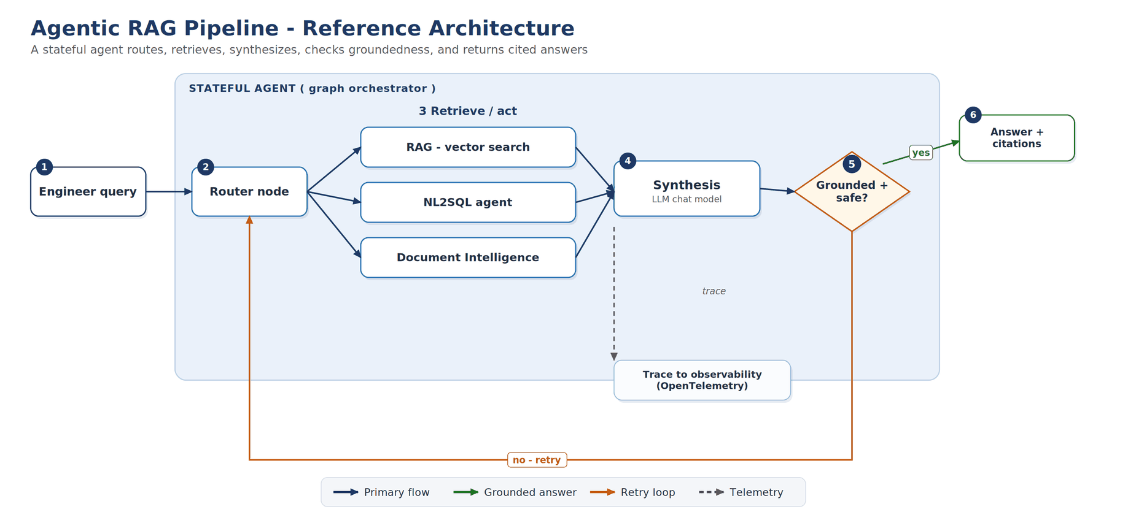
Figure 4. An agentic retrieval pipeline. A stateful agent routes a query across retrieval, structured query, and document-understanding tools, synthesizes with a language model, checks groundedness, and returns cited answers, with traces sent to an observability backend.
Figure 4 shows an agentic pipeline that subsumes retrieval as one branch. The selection rule is to escalate only as needed: start with retrieval-augmented generation, and adopt an agent only when a task genuinely requires more than one step or a tool call, because agents add latency, cost, and failure surface. Table 3 contrasts the three patterns across the dimensions that drive this choice.
Dimension | Retrieval-augmented | Direct generation | Agents
Core idea | Ground answers in retrieved data | Generate from parametric knowledge | Plan and act; call tools, hold state
Best for | Cited Q&A over specs, procedures, KB | Drafting, summarizing, classifying | Multi-step workflows; query-then-act
Data freshness | Live via index | Frozen at training cutoff | Live via tools
Hallucination risk | Lower (grounded, cited) | Higher (ungrounded) | Depends on tool grounding
State / memory | Stateless per query | Stateless | Stateful, cyclic, human-in-the-loop
Cost / latency | Medium | Low | Higher (multiple model and tool calls)
Key evaluators | Retrieval, Groundedness, Relevance | Coherence, Fluency, Similarity | Tool-call accuracy, intent, task adherence
Avoid when | No corpus, or pure creativity | Facts and citations required | A single call suffices
Table 3. Selection guidance across retrieval-augmented generation, direct generation, and agentic patterns.

6. Evaluation Methodology
Generative systems require evaluation that goes beyond a single accuracy number [14]. Three families of evaluators apply. Model-graded evaluators use a strong language model as a judge to score qualities such as coherence, fluency, relevance, and, for retrieval, groundedness against the retrieved context. Reference-based evaluators compare output to a gold answer using overlap measures such as the F1 score, BLEU [6], ROUGE [7], and METEOR [8]. Safety evaluators assess harmful content and resistance to prompt injection. For agents, process evaluators score whether the right tools were called with the right parameters, and outcome evaluators score intent resolution and task adherence (Table 4).

6.1 Mitigating Model-Graded Evaluator Bias
Model-graded scoring is only trustworthy if its known biases are controlled. The pipeline applies three safeguards: position-bias control, randomizing or swapping option order in pairwise comparisons so the judge does not favor a fixed slot; verbosity control, length-normalizing outputs so a longer answer is not rewarded over a shorter, equally correct one; and few-shot calibration, anchoring the scale with human-verified boundary examples in the judge prompt. Reference-based and rule-based checks are retained alongside model-graded ones so that no single judge is authoritative.
Category | Evaluators | Measures | Type | Illustrative gate
General quality | Coherence, Fluency | Readability, logical flow | Model-graded (1–5) | ≥ 4 of 5
Retrieval quality | Groundedness, Retrieval, Relevance | Answer supported by context | Model-graded (1–5) | Groundedness ≥ 4 of 5
Reference-based | F1, BLEU, ROUGE, METEOR, Similarity | Overlap with a gold answer | Reference-based | Task-dependent
Agent process | Tool-call accuracy, tool selection, input accuracy, output use | Right tools, right parameters | Model-graded / rule | High pass rate
Agent outcome | Intent resolution, task adherence | Understood intent, completed task | Model-graded (1–5) | ≥ 4 of 5
Safety / security | Harmful-content classes; indirect (cross-prompt) injection | Unsafe content; injection resistance | Model-graded | Zero criticals
Operational | Latency, token cost, error rate, throughput | Runtime service levels | Telemetry | P95 latency within edge and cloud budget
Table 4. Evaluator families for generative and agentic systems. Pass thresholds are team-defined, not fixed by any platform.
Evaluation is run both offline, against a curated dataset as a pre-deployment gate, and online, as controlled A/B comparison in production. Where curated data is scarce, simulators can generate representative and adversarial inputs. The unifying idea is evaluation as a release gate: a regression below threshold blocks promotion, exactly as a metric regression blocks a predictive model.

7. Continuous Delivery for Models and Agents
The delivery pipeline applies one discipline to both lifecycles. Triggers are path-filtered, so a change runs only the affected use case; automation authenticates with federated identity rather than stored secrets; and a single tested pipeline is reused by many thin per-use-case callers rather than copied. The main branch is protected, with promotion flowing from a development branch, and security scanning (static analysis, dependency, infrastructure-as-code, and secret scanning) runs on every change.
# Thin per-use-case trigger that calls one shared, tested pipeline
on:
pull_request:
paths: ["use_case/**", "lib/**"] # only run what changed
jobs:
evaluate-and-deploy:
uses: ./pipelines/shared_pr_pipeline.yml # one implementation
secrets: inherit # federated identity
Listing 1. Illustrative reusable CI workflow with path filtering and keyless, federated authentication.
Two gates govern promotion. The model gate registers a predictive model in the MLflow registry only when it beats the champion on the evaluation metric (the deploy decision of Section 3). The evaluation gate runs the generative system against its evaluation dataset and blocks the change on a quality or safety regression (Section 6). Deployment uses a safe rollout, blue-green or canary, with traffic shifted gradually behind the endpoint. Figure 5 shows event-driven operation and retraining; Figure 6 shows the release gate for an agent, which mirrors the model gate.
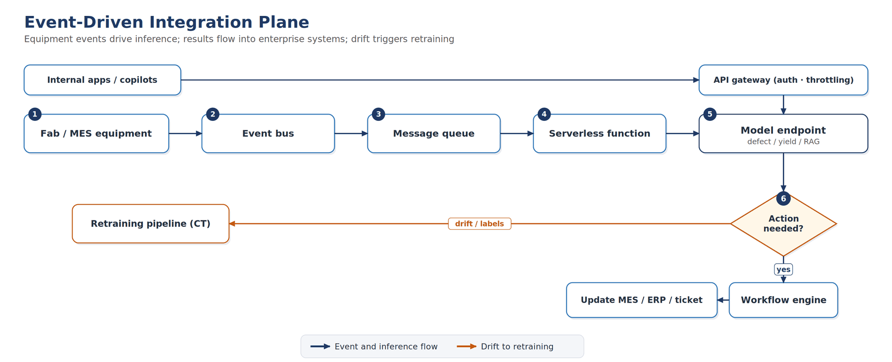
Figure 5. Event-driven integration. Equipment events flow through an event bus and message queue to a serverless function that calls a model endpoint; results drive a workflow engine into enterprise systems, and detected drift triggers retraining. An API gateway fronts the endpoint.
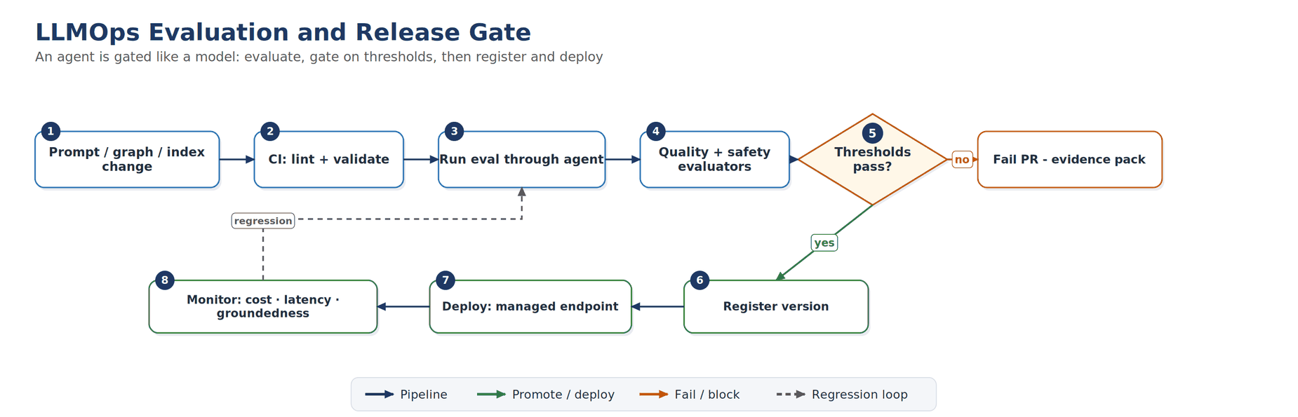
Figure 6. Evaluation and release gate. An agent is gated like a model: an evaluation dataset runs through the system, evaluators score it, and a threshold gate controls registration and deployment, with a regression loop from monitoring.
Aspect | Practice | Mechanism
Triggers | Path-filtered, scheduled, manual | Run only the affected use case
Authentication | Keyless | Federated workload identity, no stored secrets
Reusability | One tested implementation, many callers | Reusable pipeline invoked by thin callers
Branching | Protected main, promote from develop | Block direct changes to main
Security scanning | Static, dependency, IaC, secret | Runs on every change
Model gate | Promote only if it beats champion | Metric threshold on a holdout
Evaluation gate | Block on quality/safety regression | Evaluation suite in CI; evidence retained
Deployment | Safe rollout | Blue-green or canary; endpoint traffic split
Reproducibility | Pinned and traceable | Pinned components, immutable data, MLflow registry and lineage
Monitoring | Close the loop | Observability metrics; drift alerts to retrain or re-index
Table 5. Continuous-delivery practices common to the predictive and generative lifecycles.

8. Monitoring and Feedback
Production monitoring closes the loop. Operational telemetry tracks latency, token cost, error rate, and throughput against service-level objectives, with tighter latency budgets for edge inference, while quality and groundedness scores are sampled continuously and compared to their evaluation baselines. On the predictive side, the label-free drift signals of Section 4, gathered from both cloud and edge deployments, raise early alarms and can trigger retraining once labels confirm a genuine concept shift; on the generative side, retrieval and groundedness drift trigger re-indexing or re-tuning. Online A/B comparison extends evaluation into production, measuring the real effect of a model, prompt, or workflow change before it is fully rolled out.

9. Conclusion
Industrial organizations no longer choose between predictive machine learning and generative AI; they run both, often against the same equipment and the same engineering record. The argument here is that the two need not live in separate worlds. A generative system can be baselined against a naive floor, evaluated on a held-out set, gated before release, and watched in production for drift - the lifecycle a predictive model already follows - so one governance plane and one delivery discipline can reasonably cover both. Two habits do most of the work: catching distribution shifts early, without waiting for labels, and refusing to ship a model or an agent that regresses against its evaluation set. Neither idea is new on its own; what we have tried to show is that they compose into a single operating model that holds up as workloads move from the cloud down to constrained hardware on the line. The architecture and tables are a starting point rather than a prescription, and we expect teams to adapt them to their own platforms and failure modes.

References
Reference list in IEEE style; verify formatting against the target venue.
[1] P. Lewis et al., “Retrieval-Augmented Generation for Knowledge-Intensive NLP Tasks,” in Advances in Neural Information Processing Systems, 2020.
[2] S. Yao et al., “ReAct: Synergizing Reasoning and Acting in Language Models,” in Proc. International Conference on Learning Representations (ICLR), 2023.
[3] J. Gama, P. Medas, G. Castillo, and P. Rodrigues, “Learning with Drift Detection,” in Advances in Artificial Intelligence (SBIA), 2004.
[4] A. Bifet and R. Gavaldà, “Learning from Time-Changing Data with Adaptive Windowing,” in Proc. SIAM International Conference on Data Mining, 2007.
[5] J. Gama, I. Žliobaitė, A. Bifet, M. Pechenizkiy, and A. Bouchachia, “A Survey on Concept Drift Adaptation,” ACM Computing Surveys, vol. 46, no. 4, 2014.
[6] K. Papineni, S. Roukos, T. Ward, and W. Zhu, “BLEU: a Method for Automatic Evaluation of Machine Translation,” in Proc. ACL, 2002.
[7] C.-Y. Lin, “ROUGE: A Package for Automatic Evaluation of Summaries,” in Text Summarization Branches Out, 2004.
[8] S. Banerjee and A. Lavie, “METEOR: An Automatic Metric for MT Evaluation with Improved Correlation with Human Judgments,” in Proc. ACL Workshop, 2005.
[9] D. Hendrycks et al., “Measuring Massive Multitask Language Understanding,” in Proc. ICLR, 2021.
[10] M. Chen et al., “Evaluating Large Language Models Trained on Code,” arXiv:2107.03374, 2021.
[11] M. Zaharia et al., “Accelerating the Machine Learning Lifecycle with MLflow,” IEEE Data Engineering Bulletin, vol. 41, no. 4, pp. 39–45, 2018.
[12] Y. Gao et al., “Retrieval-Augmented Generation for Large Language Models: A Survey,” arXiv:2312.10997, 2023.
[13] D. Kreuzberger, N. Kühl, and S. Hirschl, “Machine Learning Operations (MLOps): Overview, Definition, and Architecture,” IEEE Access, vol. 11, pp. 31866–31879, 2023.
[14] Y. Chang et al., “A Survey on Evaluation of Large Language Models,” ACM Transactions on Intelligent Systems and Technology, vol. 15, no. 3, pp. 1–45, 2024.

Appendix A. Abbreviations
Abbr. | Meaning | Abbr. | Meaning
AI | Artificial Intelligence | ML | Machine Learning
GenAI | Generative AI | MLOps | Machine Learning Operations
LLMOps | Large Language Model Operations | AIOps | AI for IT Operations
CI | Continuous Integration | CD | Continuous Delivery or Deployment
CT | Continuous Training | IaC | Infrastructure as Code
LLM | Large Language Model | SLM | Small Language Model
RAG | Retrieval-Augmented Generation | NL2SQL | Natural Language to SQL
RBAC | Role-Based Access Control | IAM | Identity and Access Management
PSI | Population Stability Index | KL | Kullback-Leibler divergence
KS | Kolmogorov-Smirnov test | ADWIN | Adaptive Windowing
DDM | Drift Detection Method | AUC | Area Under the Curve
ROC-AUC | Receiver Operating Characteristic AUC | PR-AUC | Precision-Recall AUC
MCC | Matthews Correlation Coefficient | RMSE | Root Mean Square Error
MAE | Mean Absolute Error | MAPE | Mean Absolute Percentage Error
ECE | Expected Calibration Error | F1 | Harmonic mean of precision and recall
NLP | Natural Language Processing | SLO | Service Level Objective
BLEU | Bilingual Evaluation Understudy | ROUGE | Recall-Oriented Understudy for Gisting Evaluation
METEOR | Metric for Evaluation of Translation with Explicit Ordering | MMLU | Massive Multitask Language Understanding
BBH | BIG-Bench Hard | GPQA | Graduate-level Google-proof Q&A benchmark
MES | Manufacturing Execution System | ERP | Enterprise Resource Planning
PLM | Product Lifecycle Management | CV | Computer Vision
RUL | Remaining Useful Life | CAPA | Corrective and Preventive Action
SOP | Standard Operating Procedure | IoT | Internet of Things
MLflow | Open-source ML lifecycle platform (tracking + registry) | OIDC | OpenID Connect (federated identity)
API | Application Programming Interface | ONNX | Open Neural Network Exchange
TensorRT | Optimized inference runtime for edge / GPU | IPC | Industrial PC
CAD | Computer-Aided Design | P95 | 95th-percentile (latency)

