ALFALFA and BROME–TIMOTHY CROP MODELS

Table of Contents

ALFALFA CROP MODEL
Acknowledgements 3
1. Introduction 3
2. Activities 4
2.1 Legumes – Alfalfa Crop Model 4
2.1.1 Introduction 4
2.1.2. Climate Requirements/Ratings 4
2.1.3 Soil Requirements/Ratings 10
2.1.4 Landscape Requirements/Ratings 12
2.1.5 Organic Soil Requirements Ratings 14
3. Validation Process 14
4. References 18

BROME -TIMOTHY CROP MODEL
Acknowledgements 19
1. Introduction 19
2. Actvities 19
2.1 Grasses – Brome-Timothy Crop Model 19
2.1.1 Climate Requirements/Ratings 19
2.1.2 Soil Requirements/Ratings 24
2.1.3 Landscape Requirements/Ratings 24
2.1.4 Organic Soil Requirements Ratings 25
3. Validation Process 25
4. References 26
5. Appendices 28
Appendix 1. Timothy Yield Reduction vs P-PE 28
Appendix 2. Conversion of NSDB Stoniness Rating to Annual Removal Values 29

list of tables

Table 1. Point deductions assigned to GDDs for alfalfa 5
Table 2. Estimated days for alfalfa cuts. 5
Table 3. Point deductions assigned to growing season length for alfalfa. 6
Table 4. Potential and actual alfalfa yields and climatic and soil for selected research sites. 9
Table 5. Comparison of LSRS ratings for small grains, brome-timothy and alfalfa for selected SLC polygons across Canada. 15
Table 6. Comparison of climatic and selected soil ratings for small grains, brome-timothy and alfalfa for selected SLC polygons across Canada. 17
Table 7. Point deductions assigned to GDDs for brome-timothy 20
Table 8. Estimated days for brome-timothy cuts 21
Table 9. Point deductions assigned to growing season length for brome-timothy. 21
Table 10. Potential and actual brome-timothy yields and selected climatic parameters for several research sites. 23

List of Figures

Figure 1. Growing season length vs accumulated GDDs (based on 61-90 station data) 4
Figure 2. Accumulated Growing Degree Days >5ºC vs point deductions for alfalfa. 5
Figure 3. Deduction for growing season length for alfalfa 7
Figure 4. Comparison of P-PE (May to Aug) to P-PE (May to Sep). 8
Figure 5. The relationship of alfalfa yield reduction to P-PE and LSRS-M values. 10
Figure 6. First cutting alfalfa yield relative to soil pH (from Undersander et al. 1991). 11
Figure 7. Point deductions for surface soil pH. 11
Figure 8. Percent deductions for subsurface pH. 12
Figure 9. Point deductions for slope steepness. 13
Figure 10. Percent deductions for stoniness. 13
Figure 11. Deductions for GDD>5ºC limitations for brome-timothy. 20
Figure 12. Deductions for growing season length for brome-timothy. 22
Figure 13. The relationship of brome-timothy yield reduction to P-PE and LSRS-M values. 23
Figure 14. Point deductions for slope steepness. 24
Figure 15. Percent deductions for stoniness. 25
Figure 16. Percentage yield reduction of grass vs P-PE (May-Aug). 28

ALFALFA CROP MODEL

Acknowledgements
The author would like to acknowledge and thank the many people who offered frank comments and advice at various stages of the forage initiative: particularly Jane Thornton, Manitoba Forage Specialist, and Dr. Bruce Coulman, University of Saskatchewan.

1. Introduction
Both grasses and legumes are used as forages (McCartney and Horton 1997). The various species are adapted to such a large range of climatic and soil conditions that a single rating would be rather meaningless. On the other hand, to attempt to accommodate all the represented niches would result in an irresponsible number of specific ratings that would not support general land use planning. It is recognized that a general rating would not address the concerns of a forage specialist who deals with site-specific conditions (J. Thornton pers. comm..), however it was felt that the main objective of a suitability rating that was initially to use the 1:1M soil Landscapes of Canada database (or 1:100,000 regional data) should be to support regional land use planning rather than site-specific decision making.
With the above arguments in mind, it was decided that two general categories of forages with somewhat different climatic and soil requirements should be recognized; namely legumes and grasses. Alfalfa (Medicago sativa L.) which is the most widely grown legume in Canada was chosen as a surrogate for that group. For the grass group, timothy (Phleum pretense L.) was chosen as the surrogate for eastern and central Canada and brome (Bromus inermis Leyss.) for western Canada.
It should be noted that the LSRS system could be modified to address any number of site-specific situations. It is the presumed objective of a general lands use objective that predicates the present decision of two categories.
Many annual crops (grains and pulses) are also used for forage, but the emphasis here is on the perennial crops. The main difference is that the perennial crops, with no concerns for annual seeding or for frost damage to grain, have a longer growing season. This extended season is assumed to be the period with mean daily temperatures above 5ºC (Bootsma and Boisvert 1991)
Another critical difference is that forages are not restricted to a single “harvest”. Depending on the season length, there can be one, two or even three or four cuts. This makes the forage rating fundamentally different from those for single-crop grains and oil seeds and they should not be directly compared - especially at a regional or local level. For example, at the west coast, long seasons and adequate moisture commonly allow for three cuts of forages but may not have the heat requirements for corn and soybeans.
Season length is correlated fairly well with accumulated Growing Degree Days (GDDs) for the range of 800 to 1600 GDD (Figure 1) with an R² of 0.63 (not shown). However in the coastal regions with extended growing seasons, the relationship breaks down. This situation required the introduction of season length as an independent climatic variable.
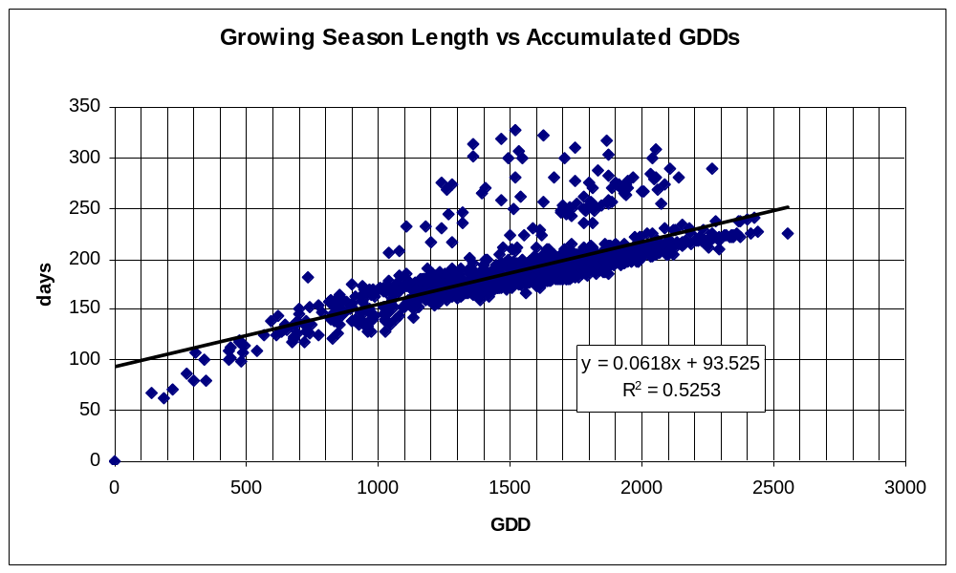

Figure 1. Growing season length vs accumulated GDDs (based on 61-90 station data)

Note: all stations with growing season >230 days are located on the west coast.

2. Activities

2.1 Legumes – Alfalfa Crop Model

2.1.1 Introduction
Alfalfa, like other crops is limited by climatic and soil constraints. In general, it responds positively to increases in temperature and increases in moisture availability up to the point of decreasing oxygen supply in the rooting zone (impeded drainage) (Undersander et al. 1991).
The main soil constraint is a sensitivity to low pH (Goplin et al. 1987). The LSRS landscape rating is a recognition of erosion potential and workability or management constraints (slope steepness, stoniness) both of which are of a lesser concern for the management of forages than for annual crops.

2.1.2. Climate Requirements/Ratings

2.1.2.1 Heat Requirement / Rating (Section 3.2, Figure 3.2, LSRS Manual, 1995)
According to Bootsma and Boisvert (1991) it requires about 480 GDDs (Growing Degree Days > 5ºC) to produce a first cut of alfalfa and one should allow for about 450 GDDs for crop carryover requirements. Therefore the minimum heat requirement for alfalfa is about 930 GDDs. This was considered the “marginal” requirement or the Class 4-5 boundary. The minimum requirement for Class 1 was taken as the ability to support 3 cuts per year. This translates into (3 x 480) + 450 = 1890 GDDs. The ability to support two cuts per year, ((2x480) + 450 = 1410 GDDs) should be in Class 3. The ability to produce one cut with no carry over (480 GDDs) should represent the Class 5-6 boundary. The maximum deduction was set at 90 points.
Based on the above considerations, deductions were assigned as follows:

Table 1. Point deductions assigned to GDDs for alfalfa
GDD | Class description | Point deduction
480 | Class 5-6 boundary | 80
930 | Class 4-5 boundary | 70
1410 | Lower part of Class 3 | 50
1890 | Bottom of Class 1 | 20

The Alfalfa climatic temperature (heat) factor then becomes (Figure 2):
Deduction = 89.02 + 0.0067(GDD) – 0.000016(GDD)(GDD)

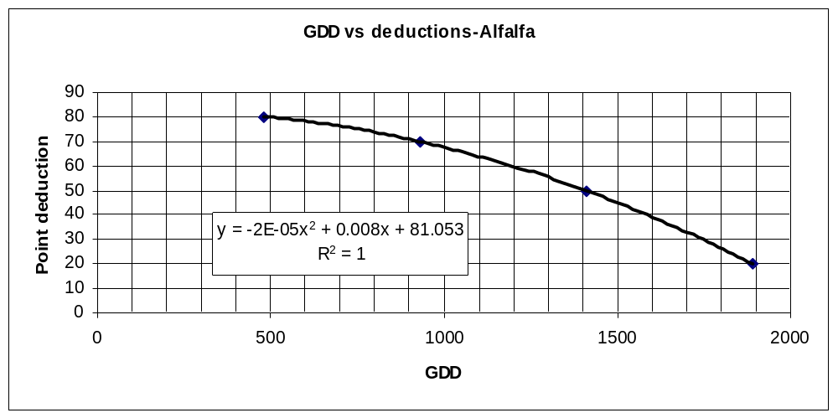
Figure 2. Accumulated Growing Degree Days >5ºC vs point deductions for alfalfa.

2.1.2.2 Length of Growing Season Requirement / Rating
Length of season requirements were established using monthly climatic data and the GDD requirements from the previous section for one, two and three cuts of alfalfa. Bootsma and Boisvert (1991) suggest a minimum of 45 days between cuts.

Table 2. Estimated days for alfalfa cuts.
Cut | GDD | Est. days
1 | 480 | 65
2 | 480 | 45
3 | 480 | 45
carryover | 450 | 55

Note that the beginning and end of season, spring and fall, take longer to accumulate heat units due to lower temperatures. Coastal British Columbia, with lower temperatures, particularly in the winter season, takes up to 20 days longer for both spring and fall but more than compensates with the longer growing season so is not limited in this respect.
Based on the above, the number of days per cut are estimated as follows:
- One cut = 65 + 55 = 120 days
- Two cuts = 65 + 45 + 55 = 165 days
- Three cuts = 65 + 45 + 45 + 55 = 210 days
Using the same considerations as for temperature requirements, the season length is assessed as:

Table 3. Point deductions assigned to growing season length for alfalfa.
Cut | days | Class description | Point deduction
1 – no carryover | 65 days | Class 5-6 boundary | 80
1 - carryover | 120 | Class 4-5 boundary | 70
2 | 165 | Lower part of Class 3 | 50
3 | 210 | Bottom of Class 1 | 20

The growing season factor for alfalfa becomes (Figure 3):
Point deduction = 72.052+ 0.2889(GSL) -0.0026(GSL)(GSL)
(where GSL = growing season length in days)
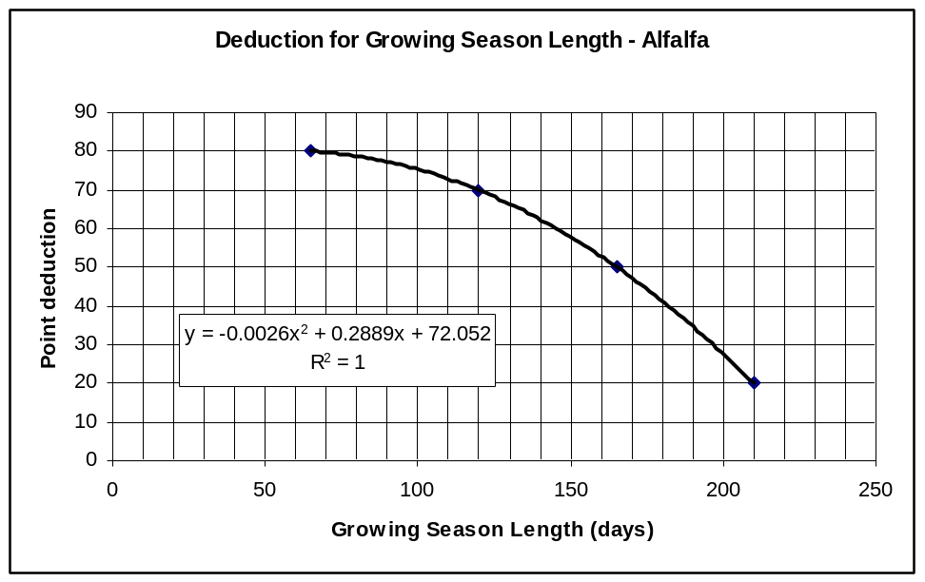
Figure 3. Deduction for growing season length for alfalfa

The heat rating or temperature factor (H) will be the most limiting of the GDD and GSL. For alfalfa, these two values are quite close with the controlling factor generally being GDD in the shorter season and cooler areas (<1600 GDD) and GSL in the longer season and or warmer areas (>2000 GDD).
The above is the recommended approach for temperature requirements for alfalfa. However, this requires new climatic parameters that are not in the present database: namely GDD for the period >5ºC and the growing season length represented by that period. It is felt that evaluations of climate change will consider a Biometeorological Time Scale (BMTS) which will use the >5ºC growing season. When the BMTS approach is ready for implementation, the above characteristics can be included in the LSRS program. In the meantime, it was felt that a proxy using present climatic parameters should be attempted.

2.1.2.3 Moisture Requirement/Rating (Section 3.1, Figure 3.1, LSRS Manual, 1995)
Bootsma and Boisvert (1991) in evaluating the FORYLD forage model described the Moisture Stress Factor (MSF) in terms of average moisture deficit (D) such that:
D = P + θi – PE
Deficit (surplus) = precipitation + soil moisture – potential evapotranspiration
Or D = (P – PE) + soil moisture.
The P-PE is the same factor as that used for small grains except that it is calculated for the longer season forage season. Adding the soil moisture component makes it equivalent to the M factor used in the LSRS soil component.
As with the heat component, a comparison was made of the standard (May – Aug) P-PE used in the small grains assessment and the longer season (May – Sept) P-PE suggested for forages (Figure 4). The comparison involved over 2000 stations across Canada and again, there was a very good correlation (R² = 0.9838). With the good correlation it seemed reasonable that, with conversion, the present P-PE index could be used for forages.

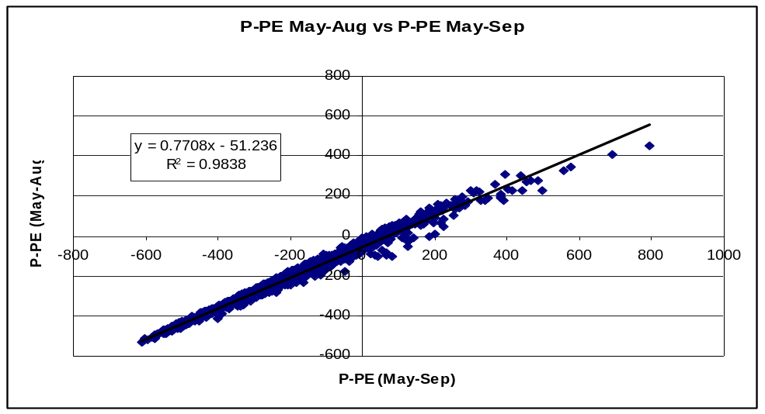
Figure 4. Comparison of P-PE (May to Aug) to P-PE (May to Sep).
The next step, that of assigning limits and deductions, followed the same process as for other crops.
It was felt that a yield of about 2.5 t/ha would represent the lower practical limit (Class 4-5 boundary, 70 point deduction) of forage production. This is the average yield for a loam soil in the Brown Soil Zone in western Canada (Bootsma et al. 1995) and approximates the limit of present forage production. This is essentially the same as for small grains and it is suggested that the same value of P-PE, that is -500, should represent a 70 point climate deduction.
For the soil component (M) that translates into a 70 point deduction (Class 5) for a sandy loam soil at a P-PE = -400 (The Brown Soil Zone).
As an approximation of the upper limit (Class 1) a comparison was made of potential to actual yields as noted by Bootsma and Boisvert (1991) and Bootsma et al (1994) (Table 4).
Table 4. Potential and actual alfalfa yields and climatic and soil for selected research sites.
 | Alfalfa yield (t/ha) |  | % yield  reduction | P-PE¹  May-Sep | Soil  AWC | LSRS²  M factor | P-PE¹  May-Aug | LSRS²  M factor
location | potential | rain fed
Charlottetown | 12.7 | 9.2 | 27 | -39 | 150 | 0 | -72 | 0
Ottawa | 14.1 | 10.0 | 30 | -171 | 130 | 10 | -182 | 12
Ridgetown | 17.5 | 12.7 | 26 | -220 | 200 | 15 | -208 | 12
Swift Current | 15.0 | 3.8 | 75 | -362 | 150 | 60 | -325 | 45
¹ from 51-80 climate data provided by A. Bootsma
² calculated from LSRS Manual, 1995

Using the premise Yield (actual) = Yield (potential) x MSF (moisture stress factor), it was assumed that those areas with little difference between potential and actual yields should have low moisture deficit constraints. Conversely, those with large differences (keeping the soil component similar) should be the result of high moisture stress.
The number of controls is small but the trends support the argument (see Appendix 1 for correlation support). The correlation for yield reduction in alfalfa vs P-PE(may-Sep) (Figure 5 a) has an R² = 0.6693. This is not high but it does not take into account soil water holding capacity (WHC). The M factor of the LSRS soil component combines P-PE with WHC and when this is compared to yield reduction (Figure 5 b) the R² is 0.9384 which is quite good.
The comparative values for P-PE (May-Aug) and associated LSRS-M values (Figures 5 c, d) are 0.681 and 0.9209 which are very close to the first set and support the close correlation between P-PE (May –Sep) and P-PE (May-Aug).
The above relationships appear to be reasonable and suggest that the present P-PE deductions as used for small grains are also appropriate for alfalfa.
a b
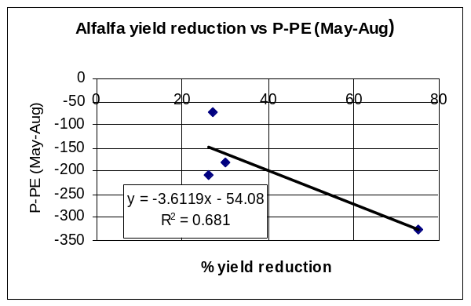
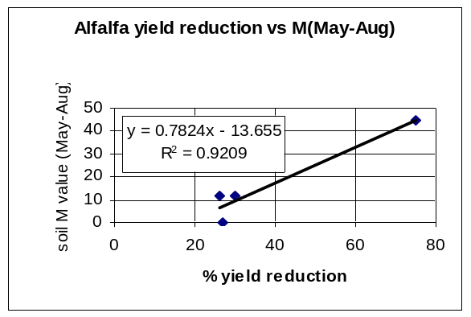

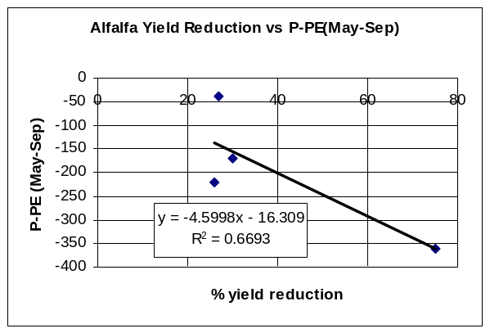
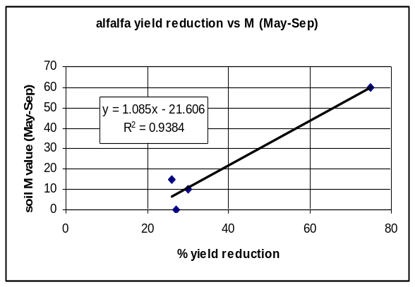
c d
a)
c)

Figure 5. The relationship of alfalfa yield reduction to P-PE and LSRS-M values.

2.1.3 Soil Requirements/Ratings

2.1.3.1 Soil Moisture Factor (M) Requirement/Rating
As there was no change suggested for the climatic moisture index, there is no change required for the soil moisture factor.

2.1.3.2. Surface Soil Reaction (pH) Requirement/ Rating (Section 4.2.4, Table 4.6, LSRS Manual, 1995)
As indicated in the introduction, alfalfa is sensitive to acidic conditions (low pH). There are two aspects. First, pH values below 6.0-6.5 increasingly inhibit the functioning of rhizobium bacteria (McKenzie 2005). Secondly, at pHs below about 5.5, aluminum ions, which affect root elongation, are released into the soil solution (Rechcigl et al. 1988, Kochian 1995). Both of these features have a marked effect on alfalfa productivity.
Undersander et al. (1991) suggest that yields at a pH of 5 would be less than one third of those expected at a pH of 6.5 (Figure 6).
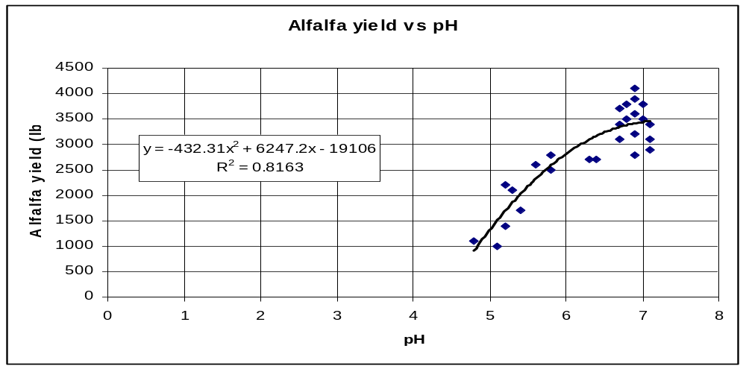
Figure 6. First cutting alfalfa yield relative to soil pH (from Undersander et al. 1991).

It is generally reported that ideal pH for alfalfa is between 6.5 and 7.5 (Goplin et al. 1987, Undersander et al. 1991). Therefore a pH of 6.5 was taken as no limitation and assigned a 0 point deduction. It appears that a pH of about 5 is becoming marginal for alfalfa and this value was assigned a deduction of 70 points deduction. If we assume a pH of 6.0 is Class 2 (and a 20 point deduction) and that a pH of 5.5 is Class 3 (a 40 point deduction) then the alfalfa – pH relationship for surface soils (Figure 7) becomes:
Point deduction = 624.5 – 161(pH) + 10(pH)(pH)

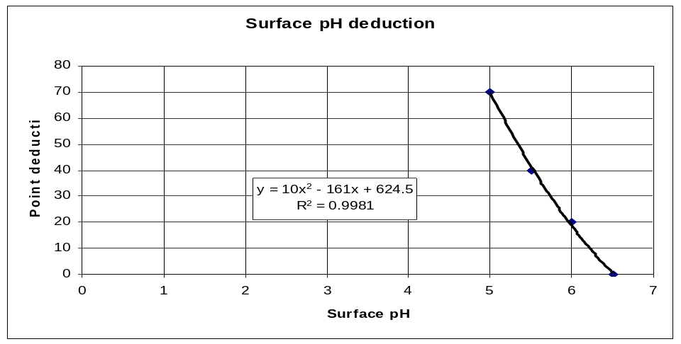
Figure 7. Point deductions for surface soil pH.
This formula is only applied where pH <= 6.5

2.1.3.3 Subsurface Soil Reaction (pH) Requirement/ Rating (Section 4.3.3, Table 4.15, LSRS Manual, 1995)
Subsurface acidity can still be a problem as it can restrict root growth and therefore moisture availability. The following relationship (Figure 8) is suggested.
Percent deduction = 687 – 207.86 (pH) + 15.714 (pH)(pH)

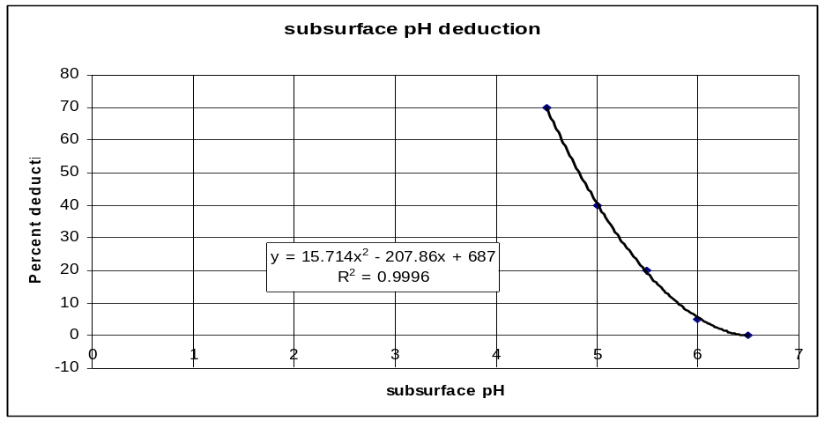
Figure 8. Percent deductions for subsurface pH.
This formula is only applied where pH <= 6.5
Note that deductions are made for the subsurface only if they are greater than the deduction for surface acidity.
No other modifications are suggested for mineral soils.

2.1.4 Landscape Requirements/Ratings
Landscape parameters are not as critical for forages as for annual crops. Erosion is much reduced with the continuous cover of perennial crops so slope steepness is important only as a limitation for haying (and silage) machinery. Stoniness is still a concern from a machinery perspective though perhaps not as critical at the lower stoniness classes. Gravel is not an issue from a landscape (management) perspective.
With the above in mind, the following relationships are suggested (Figures 9 and 10).

2.1.4.1 Basic Landscape Rating (slope steepness) (Section 6.1, Figures 6.2, 6.3, LSRS Manual, 1995)
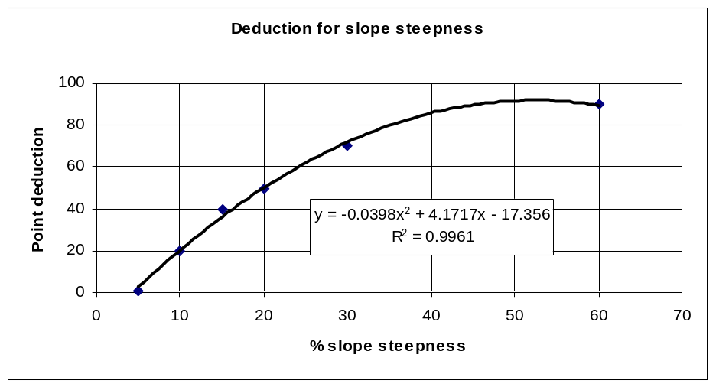
Figure 9. Point deductions for slope steepness.
Point deduction = – 17.356 + 4.1717 (% slope) -0.0398(% slope)(% slope)
This should apply to all regions and landform types.

2.1.4.2 Stoniness (Section 6.2.1, Figure 6.4, LSRS Manual, 1995.)
Deduction for stoniness
y = -14.463x
2
+ 85.413x - 15.612
R
2
= 0.9993
0
10
20
30
40
50
60
70
80
90
0
0.2
0.4
0.6
0.8
1
1.2
1.4
1.6
Annual removal (cubic m/ha)
Percent deduction
Figure 10. Percent deductions for stoniness.
Percent deduction = – 15.612 + 85.413 (annual removal) -14.463(annual removal)^2

See Appendix 2 for stoniness rating conversion to annual removal rate.

2.1.5 Organic Soil Requirements Ratings
Organic soils are often used for forage production. There are some slight differences in specific suitability criteria but overall these do not appear to be major enough to change the rating from that of small grains.
The water supplying ability and drainage relationships should remain the same. The surface structure-seedbed issue may not be as critical for perennial crops but the workability component remains. The pH effect is not as severe because the Al toxicity component is reduced but the nutrient supply and rhizobium issues remain.

3. Validation Process
In the introduction, it was stressed that forages are not directly comparable to single-harvest crops. However, comparisons are inevitable and can be useful for pointing out differences as well as concurrences. With this in mind, the small grains ratings were used to evaluate initial forage ratings.
Two sets of data were used to test the general application of the Alfalfa crop model: the standard SLC set used for testing the previous crop models (Table 5) and an abbreviated set to test for extreme conditions (Table 6).
Initial review of ratings (Table 5) indicated that the program was responding as planned. The alfalfa ratings were very similar to the brome-timothy ratings (and the small grain ratings) with one major exception: the sensitivity to pH (Figures 7&8). Anytime the pH drops below 6.5, Alfalfa is affected. At a pH of 5.9 the deduction is 22 points (Figure 7) or at least 1 class. At a pH of 4.95 it is 73 points as compared to 17 points for the grasses. The fact that the SLC database is often represented by virgin rather than managed (limed) soils makes the results look worse than may actually be the case.
As expected, with the relaxed landscape constraints, the T limitation is often not noted for the forages ratings. In those instances where T is the dominant limitation for small grains, this could result in a higher rating for the forages
All of the areas in Canada with greater than 1800 EGDDs have a growing season of at least 200 days (61-90 summaries). In British Columbia all have greater than the 210 minimum identified for a third cut of alfalfa. In central Canada, all those with greater than 2000 EGDDs have between 200 and 210 days. Even though a small portion of the country might be slightly below the length of season threshold, it is concluded that the use of the EGDDs is a reasonable proxy for the alfalfa temperature factor (H).

Table 5. Comparison of LSRS ratings for small grains, brome-timothy and alfalfa for selected SLC polygons across Canada.
Prov. | area | SL# | LSRS - Small Grains | LSRS – Brome-timothy | LSRS – Alfalfa
 | Fort St John | 581008 | 7WV(10) | 7WV(10) | 7WV(10)
 | Fort St John | 585015 | 4DT(6) - 6W(4) | 4DT(6) - 6W(4) | 7VD(6) – 7WV(4)
 | Prince George | 982044 | 3HT(7) - 6M(3) | 3H(7) - 6M(3) | 4H(6) – 6MV(4)
 | Prince George | 982041 | 3HT(8) - 6MT(2) | Missing climate data | Missing climate data
BC | Penticton | 1007020 | 6MT(5) - 7MTN(4) - 4W(1) | 6M(6) - 7MTN(3) - 4W(1) | 6M(6)-7MNT(3) - 4W(1)
 | Penticton | 1007019 | 6MTD(8) - 6MT(2) | 6MTD(6) - 6MT(4) | 7MTD(6) – 7MT(4)
 | Lower Fraser | 959004 | 6W(10) | 6W(10) | 7WV(10)
 | Lower Fraser | 959011 | 7WV(10) | 7WV(10) | 7WV(10)
 | Lower Fraser | 959019 | 2T(4) - 3M(4) - 7V(2) | 2(4) - 3M(4) - 7V(2) | 3V(4) – 5V(4) – 7VW(2)
 | Foremost | 828012 | 4MT(9) - 6M(1) | 4M(9) - 6M(1) | 4M(9) - 6M(1)
 | Vulcan | 793001 | 2M(10) | 2M(10) | 3HA(10)
 | Neutral | 771005 | 3MT(9) - 5W(1) | 3MT(9) - 5W(1) | 3MT(9) – 5W(1)
 | Wetaskiwin | 727011 | 3H(5) - 3HM(4) - 5W(1) | 3H(5) - 3HM(4) - 5W(1) | 4HM(5) – 4H(4) – 5W(1)
AB | Lloydminster | 729003 | 2HM(8) - 5W(2) - 5M(1) | 3HM(8) - 5W(2) - 4M(1) | 4HM(8) – 5W(2) – 4M(1)
 | Camrose | 731002 | 3D(9) - 5W(1) | 3HD(9) - 5W(1) | 4VD(9) – 5W (1)
 | La Corey | 680002 | 3H(9) - 5W(1) | 3H(9) - 5W(1) | 4H(6) – 4V(3) - 5W(1)
 | Grande Prairie | 599001 | 3H(8) - 4N(1) - 5W(1) | 3H(8) - 4N(1) - 5W(1) | 4H(8) – 4V(3) – 5W(1)
 | Clairview | 591027 | 3H(9) - 5W(1) | 3H(9) - 5W(1) | 3H(9) - 5W(1)
 | High Level | 586001 | 3(8) - 6W(2) | 3(8) - 6W(2) | 7V(6( - 3H(2) – 6W(2)
 | Regina | 792004 | 3M(9) - 5W(1) | 3M(9) - 5W(1) | 3M(9) – 5W(1)
 | Saskatoon | 736008 | 2M(9) - 5W(1) | 2M(9) - 5W(1) | 3HM(9) – 5W(1)
SK | Melfort | 705005 | 2(9) - 5W(1) | 3H(9) - 5W(1) | 3H(9) – 5W(1)
 | Meadow Lake | 680012 | 3H(9) - 4MV(1) | 3H(9) - 4MV(1) | 4H(9) – 7V(1)
 | B topo | 820002 | 4MT(10) | 4M(10) | 4M(10)
 | C topo | 810003 | 4MT(9) - 5W(1) | 4MT(9) - 5W(1) | 4MT(9) – 5W(1)
 | Sandy (Black) | 742002 | 5M(8) - 3M(2) | 5M(8) - 3M(2) | 5M(8) – 3HM(2)
 |  | 709007 | 3(5) - 2H(4) - 5W(2) | 3H(9) - 5W(2) | 3H(9) - 5W(2)
 |  | 717004 | 7WB(6) - 4DMP(4) | 7WB(6) - 4DP(4) | 7WB(6) – 4DP(4)
MB |  | 724008 | 4DW(6) - 5W(3) - 6MD(1) | 4DW(6) - 5W(3) - 6MD(1) | 4D(6) – 5(3) – 6MD(1)
 |  | 763001 | 5MD(7) - 5W(2) - 3W(1) | 5MD(6) - 4M(2) - 5W(2) | 5MD(6) - 4M(2) - 5W(2)
 |  | 849009 | 2W(6) - 5W(4) | 2W(6) - 5W(4) | 3W(6) – 5WV(4)
 |  | 854002 | 1(6) - 2(3) - 5W(1) | 3H(9) – 5W(1) | 3H(9) – 5W(1)
Table 5 (continued)
Prov. | area | SL# | LSRS – Small Grains | LSRS – Brome-timothy | LSRS – Alfalfa
 | Chatham | 565022 | 3(5) – 5W(5) | 3(5) - 6W(5) | 3(5) – 6WV(5)
 | Guelph | 564005 | 4TP(5) - 7WVB(3) - 4VT(2)
ON | Ottawa | 545001 | 6VWT(7) – 2T(3)
 | Ottawa | 543005 | 3M(4) - 4M(3) – 7WV(3)
 | Ottawa | 543009 | 6WV(7) – 2TM(2) – 4MT(1)
 | Ottawa | 545004 | 3DW(9) – 3TM(1)
 | Montreal | 541011 | 3W(10) | 3W(10) | 3W(10)
 | Quebec City | 540102 | 4PT(7) - 3(3) | 4P(7) - 3(3) | 5VP(7) – 7V(3)
 | Chicoutimi | 441007 | 3HDT(10) | 3HDT(10) | 4HD(10)
QU | poorly drained | 540098 | 5W(7) - 4DW(3) | 5W(7) - 4DW(3) | 6WV(7) – 6VDW(3)
 | Imp. drained | 540074 | 3DW(6) - 5W(4) | 3DW(6) - 5W(4) | 4VDW(6) – 6W(4)
 | Organic | 541053 | 7WVB(10) | 7WVB(10) | 7WVB(10)
 | Caribou | 494001 | 2T(6) - 5DW(2) - 6WT(2) | 2H(6) – 5DW(2) - 6W(2) | 3HV(6) – 6VDW(2) – 7W(2)
 | Siegas | 493002 | 2(6) - 3W(3) - 7W(1) | 2H(6) - 3W(3) - 7W(1) | 6V(7) – 3V(2) – 7WV(1)
NB | Thibault | 486011 | 3HT(8) - 3TW(1) - 7WTJ(1) | 3H(8) – 3HWT(1) - 7W(1) | 5V(9) –7W(1)
 | Belldune | 485001 | 3WT(6) - 6W(3) - 3M(1) | 3W(7) - 6W(3) | 6V(7) – 7WV(3)
 | Tormentine | 504033 | 3W(9) - 6W(1) | 3W(9) - 6W(1) | 6V(9) – 7WV(1)
 | King | 503024 | 5DTW(6)-3TD(3)-6WTD(1) | Missing climate data | Missing climate data
 | Kentville | 518004 | 4MT(8) - 6MDT(2) | 3M(8) - 6MD(2) | 6MDV(8) – 4V(2)
 | Kentville | 518005 | 3T(9) - 7W(1) | NO SOIL DATA | NO SOIL DATA
NS | Truro | 517006 | 6W(7) - 3WTD(3) | Missing climate data | Missing climate data
 | Truro | 507003 | 3DT(8) - 6WD(2) | Missing climate data | Missing climate data
 | Sydney | 523003 | 4DTW(10) | 4DW(10) | 6VD(10)
 | Sydney | 523004 | 6W(9) - 3DT(1) | 6W(9) - 3D(1) | 7WV(9) – 6V(1)
 |  | 535001 | 3DT(8) - 5DV(1) - 7WD(1) | 3D(8) - 5DV(1) - 7WD(1) | 7VD(8) – 5V(1) - 7WVD(1)
PE |  | 536003 | 3DT(7) - 6W(2) - 5DV(1) | 3D(7) - 6W(2) - 5DV(1) | 7VD(6) – 5V(2) – 7WV(2)
 |  | 537003 | 3T(6) - 3DT(4) | 2(6) - 3D(4) | 6V(10)
 | Codroy Valley | 463013 | 4TVP(10) | 4HVP(10) | 7VPT(10)
 | Codroy Valley | 463011 | 5TVP(7) - 7WT(3) | NO SOIL DATA | NO SOIL DATA
NL | Central | 471012 | 4HTV(6) - 7WT(4) | NO SOIL DATA | NO SOIL DATA
 | Central | 466043 | 4TVP(6) - 7WV(4) | 4VPT(6) - 7WV(4) | 7VPT(6) – 7WV(4)
 | St Johns | 475007 | 4DTV(10) | 4DVT(10) | 7VD(10)
 | St Johns | 471017 | 5HPV(10) | Missing climate data | Missing climate data

Table 6. Comparison of climatic and selected soil ratings for small grains, brome-timothy and alfalfa for selected SLC polygons across Canada.
SL# | Crop | EGDD |  | Climate |  | Surface pH |  | Soil
SL# | Crop | value | deduct | rating | Class | value | deduct | rating | Class
Kentville, NS  518004  (soil 1) | Small grains | 1609 | 0 | 100 | 1 | 5.9 | 0 | 34 | 4
Kentville, NS  518004  (soil 1) | Brome-timothy | 1609 | 28 | 72 | 2H | 5.9 | 0 | 34 | 4
Kentville, NS  518004  (soil 1) | Alfalfa | 1609 | 33 | 67 | 2H | 5.9 | 22 | 14 | 6V
Ridgetown, ON  565022  (soil 2) | Small grains | 2242 | 0 | 100 | 1 | 6.5 | 0 | 55 | 3
Ridgetown, ON  565022  (soil 2) | Brome-timothy | 2242 | 0 | 100 | 1 | 6.5 | 0 | 55 | 3
Ridgetown, ON  565022  (soil 2) | Alfalfa | 2242 | 0 | 100 | 1 | 6.5 | 0 | 55 | 3
Saskatoon, SK  736008  (soil 1) | Small grains | 1375 | 21 | 71 | 2H | 7.3 | 0 | 61 | 2
Saskatoon, SK  736008  (soil 1) | Brome-timothy | 1375 | 47 | 53 | 3H | 7.3 | 0 | 61 | 2
Saskatoon, SK  736008  (soil 1) | Alfalfa | 1375 | 47 | 53 | 3H | 7.3 | 0 | 61 | 2
Prince George, BC  982044  (soil 3) | Small grains | 1100 | 50 | 50 | 3H | 6.1 | 0 | 56 | 3
Prince George, BC  982044  (soil 3) | Brome-timothy | 1100 | 59 | 41 | 4H | 6.1 | 0 | 56 | 3
Prince George, BC  982044  (soil 3) | Alfalfa | 1100 | 61 | 39 | 4H | 6.1 | 15 | 43 | 4V
Demmit, AB  610002  (soil 2) | Small grains | 817 | 76 | 24 | 5H | 4.95 | 17 | 62 | 2
Demmit, AB  610002  (soil 2) | Brome-timothy | 817 | 69 | 31 | 4H | 4.95 | 17 | 62 | 2
Demmit, AB  610002  (soil 2) | Alfalfa | 817 | 71 | 29 | 5H | 4.95 | 73 | 10 | 6V
EGDD = effective growing degree days (GDD for general crop season modified for daylength)

4. References
Bootsma, A. and J.B. Boisvert. 1991. Modeling methodology for estimating forage yield potential in Canada. Tech, Bull. 1991-6-E. Research Branch, Agriculture Canada, Ottawa.
Bootsma, A., J. Boisvert and J. Dumanski. 1994. Climate-based estimates of potential forage yields in Canada using a crop growth model. Agriculture and forest Meteorology 67: 151-172.
Bootsma, A., J.B. Boisvert and J. Dumanski. 1995. Climate-based estimates of forage yields in the prairie region of western Canada. Soil Use and Management 11:55-62.
Goplen, B.P., H. Baenziger, L.D. Bailey, A.T.H. Gross, M.R. Hanna, R. Michaud, K.W. Richards and J. Waddington. 1987. Growing and managing alfalfa in Canada. Agriculture Canada Publication 1705/E. Agriculture Canada, Ottawa.
Kochian, L.V. 1995. Cellular mechanisms of aluminum toxicity and resistance in plants. Annu. Rev. Plant Physiol. Plant Mol. Biol. 46: 237-260.
McCartney, H and P.R. Horton. 1997. Canada’s forage resources. Available from Western Forage / Beef Group, Agriculture and Agri-Food Canada, Lacombe, Alberta. 24p.
McKenzie, R.H. 2005. Soil and nutrient management of alfalfa. Agdex 121/531-5. Alberta Agriculture food and Rural Development, Edmonton, Alberta.
Moser, L.E., D.R. Buxton, and M.D. Casler, editors. 1996. Cool-season forage grasses. Agronomy series No. 34. Amer. Soc. of Agron. Madison, Wisconsin.
Rechcigl, 1988. Soil solution Al as a measure of Al toxicity to alfalfa in acid soils. Commun. Soil Sci. Plant Anal. 19:989-1001.
Undersander, D., N. Martin, D. Cosgrove, K. Kelling, M. Schmitt, J. Wedberg, R. Becker, C. Grau and J. Doll. 1991. Alfalfa Management Guide. Amer. Soc of Agron., Crop Sci. Soc. of Amer., Soil Sci. Soc. of Amer.. Madison, Wisconsin.

BROME - TIMOTHY CROP MODEL

Acknowledgements
The author would like to acknowledge and thank the many people who offered frank comments and advice at various stages of the forage initiative: particularly Jane Thornton, Manitoba Forage Specialist, and Dr. Bruce Coulman, University of Saskatchewan.

1. Introduction
Nearly all the cool season C3 grasses have similar growth requirements (Moser et al. 1996). Timothy is the usual forage grass where moisture is not limiting. However, brome is more tolerant of moisture stress and salinity and is the grass of choice on the prairies. It seemed appropriate to recognize the principal regional forage crops hence the title. As with alfalfa, the growing season is taken as the period with mean daily temperatures over 5ºC but in the case of the grasses, the length of growing season becomes even more critical as a control of the number of cuts. The constraint free (potential) yield suggested by Bootsma et al. (1994) shows a maximum in the southern boreal climates of the northern prairies and northern Ontario with a decrease to the cooler more northerly climates and also a decrease into the hotter summer climates of the southern prairies and southern Ontario. However, in practice it is not so simple. A review of yield data in Ontario (www.omafra.gov.on.ca/english/stats/crops/ctyhay01.html) for the years 2001 through 2005 suggests that maximum yields are in the south as long as moisture is not limiting.
With respect to soil characteristics, these forages have the same requirements as the C3 small grains.

2. Actvities

2.1 Grasses – Brome-Timothy Crop Model

2.1.1 Climate Requirements/Ratings

2.1.1.1 Heat Requirement / Rating
According to Bootsma and Boisvert (1991) it requires about 480 GDDs (Growing Degree Days > 5ºC) to produce a first cut of timothy and one should allow for about 400 GDDs for crop carryover requirements (slightly lower than that for alfalfa). The carry-over requirements are perhaps not too critical for the grasses (Coulman pers. com.) but, as the LSRS is a comparative rather than absolute rating, the concept was maintained to be consistent with alflafa. Therefore the minimum heat requirement for grasses is about 880 GDDs. This was considered the “marginal” requirement or the Class 4-5 boundary. Using the same approach, the ability to support two cuts per year should be (2 x 480) + 400 = 1360 GDDs and that for three cuts should be (3 x 480) + 400 = 1840 GDDs.
Deductions are assigned using the same argument as for alfalfa (Table 7).
From solely a GDD perspective (Figure 11) the climatic temperature factor then becomes:
Deduction = 89.28 + 0.0085(GDD) – 0.000016(GDD)(GDD)
Table 7. Point deductions assigned to GDDs for brome-timothy
GDD | Class description | Point deduction
480 | Class 5-6 boundary | 80
880 | Class 4-5 boundary | 70
1360 | Lower part of Class 3 | 50
1840 | Bottom of Class 1 | 20

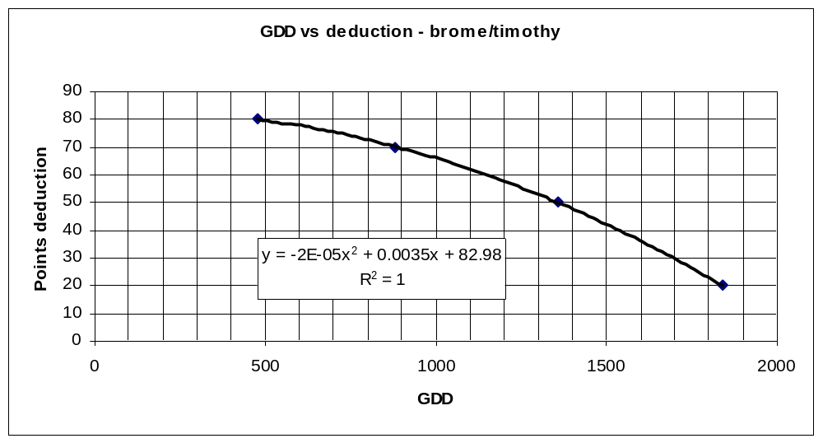
Figure 11. Deductions for GDD>5ºC limitations for brome-timothy.

However, in the case of grasses, it is the kind and length of growing season that determines the maximum dry matter production.

2.1.1.2 Length of Growing Season Requirement / Rating
The C3 grass crops are known to perform best at temperatures around 20ºC (Moser et al. 1996). At higher temperatures, particularly over about 25ºC, there is reduced growth. Therefore, while higher temperatures accumulate GDDs, they do not contribute as much to dry matter production. It is also possible that higher temperatures initiate flowering more quickly and thus reduce the amount of dry matter production relative to a slightly cooler temperature - as long as the season length is not limiting. However, this is apparently not a clear cut issue. Bootsma and Boisvert (1991) assumed that an ideal length of time between cuts, recognizing optimum heat requirements and regrowth potential, is about 55 days. Others (Coulman per. com.) suggest lower values. The decision was taken to use a value of 50 days between cuts.
Using 61-90 monthly climate data and the above considerations, length of season requirement for one, two and three cuts of brome-timothy were established (Table 8).

Table 8. Estimated days for brome-timothy cuts
Cut | GDD | Est. days
1 | 480 | 65
2 | 480 | 50
3 | 480 | 50
carryover | 400 | 55

Note again that the beginning and end of season, spring and fall, take longer to accumulate heat units due to lower temperatures. Coastal British Columbia, with lower temperatures, particularly in the winter season, takes up to 20 days longer for both spring and fall but more than compensates with the longer growing season so is not limited in this respect.
From a suitability perspective, and based on the above, the number of days per cut are estimated as follows:
- One cut = 65 + 55 = 120 days
- Two cuts = 65 + 55 + 55 = 170 days
- Three cuts = 65 + 55 + 55 + 55 = 220 days
Using the same considerations as for temperature requirements, the season length was assessed (Table 9).

Table 9. Point deductions assigned to growing season length for brome-timothy.
Cut | days | Class description | Point deduction
1 – no carryover | 65 days | Class 5-6 boundary | 80
1 - carryover | 120 | Class 4-5 boundary | 70
2 | 175 | Lower part of Class 3 | 50
3 | 230 | Bottom of Class 1 | 20

It should be noted that, with Class 1 defined as a minimum growing season of 220 days, Class 1 is mainly restricted to the coastal (and some interior) areas of B.C.

The growing season factor for brome-timothy becomes (Figure 12):
Deduction = 76.01 + 0.194(GSL) - 0.002(GSL)(GSL)
(where GSL = growing season length in days)
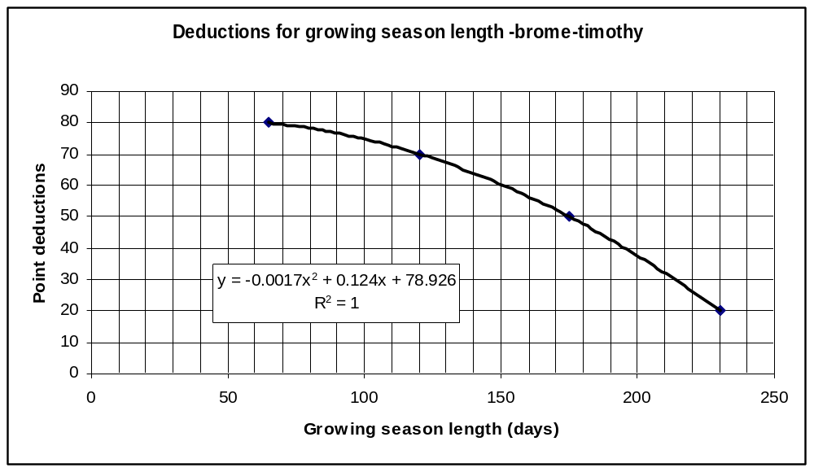
Figure 12. Deductions for growing season length for brome-timothy.

The heat rating or temperature factor (H) will be the most limiting of the GDD and GSL. For brome-timothy, these two values are fairly close in the shorter season and cooler areas (<1600 GDD) with the controlling factor generally being GDD. However, in the longer season and or warmer areas (>2000 GDD), the values diverge and GSL becomes the controlling factor.
The above is the recommended approach for temperature requirements for brome-timothy. However, this requires new climatic parameters that are not in the present database: namely GDD for the period >5ºC and the growing season length represented by that period. It is felt that evaluations of climate change will consider a Biometeorological Time Scale (BMTS) which will use the >5ºC growing season. When the BMTS approach is ready for implementation, the above characteristics can be included in the LSRS program. In the meantime, it was felt that a proxy using present climatic parameters should be attempted.

2.1.1.3 Moisture Requirement/Rating
This assessment followed the same procedure that was used for alfalfa. An assessment of yield reduction related to moisture stress (Table 11) resulted in very similar correlation relationships (Figure 13) to those for alfalfa (Figure 5). In fact, the May-Aug correlation (R² = 0.6817 and 0.9272) was slightly better than the May-Sep correlation (R² = 0.5992 and 0.8912).

Table 10. Potential and actual brome-timothy yields and selected climatic parameters for several research sites.
 | Brome-timothy yields¹ (t/ha) |  | % yield  reduction | P-PE  May-Sep  ² | Soil  AWC  ³ | LSRS  M factor  ⁴ | P-PE  May-Aug  ² | LSRS  M factor  ⁴
location | potential | rain fed
Charlottetown | 12.4 | 10.0 | 20 | -39 | 150 | 0 | -72 | 0
Ottawa | 12.8 | 7.5 | 41 | -171 | 130 | 10 | -182 | 12
Ridgetown | 12.5 | 9.5 | 24 | -220 | 200 | 15 | -208 | 12
Swift Current | 14.0 | 2.9 | 80 | -362 | 150 | 60 | -325 | 45
Truro | 12.1 | 8.8 | 28 | -128 | 100 | 5 | -131 | 6
Kapuskasing | 11.7 | 6.9 | 41 | -71 | 50 | 25 | -120 | 20
¹ ³ from Bootsma and Boisvert (1991)
² from 51-80 climate data provided by A. Bootsma
⁴ determined from the LSRS manual

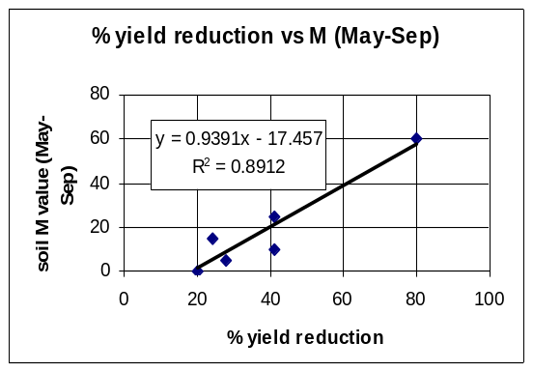
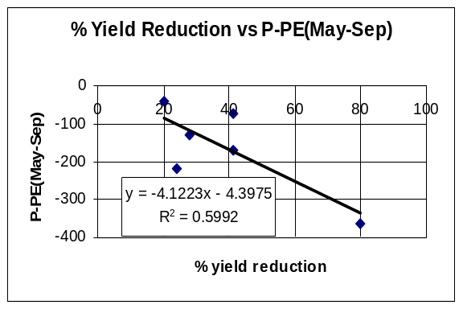

b)
a)
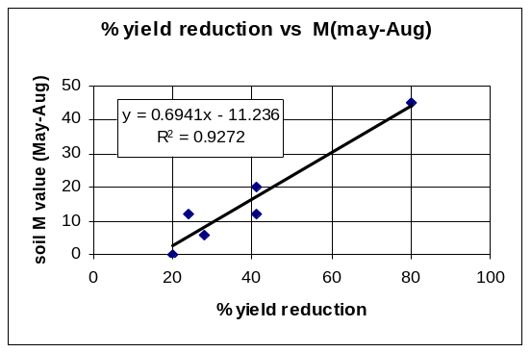
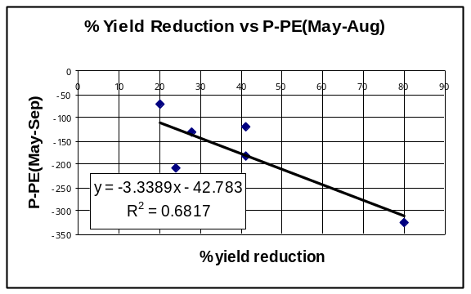

d)
c)
Figure 13. The relationship of brome-timothy yield reduction to P-PE and LSRS-M values.
a)
It was therefore felt that, as with alfalfa, that the present P-PE relationship used for small grains would be appropriate for the brome-timothy climatic moisture requirement.

2.1.2 Soil Requirements/Ratings
There are no recommended changes for soil requirements for the brome-timothy forage model. This is reasonable considering that these forages, like the small grains, are C3 grasses.

2.1.3 Landscape Requirements/Ratings
Landscape parameters are not as critical for forages as for annual crops. Erosion is much reduced with the continuous cover of perennial crops so slope steepness is important only as a limitation for haying (and silage) machinery. Stoniness is still a concern from a machinery perspective though perhaps not as critical at the lower stoniness classes. Gravel is not an issue from a landscape (management) perspective.
With the above in mind, the following relationships are suggested (Figures 14 and 15).

2.1.3.1 Basic Landscape Rating (slope steepness) (Section 6.1, Figures 6.2, 6.3, LSRS Manual, 1995)
Figure 14. Point deductions for slope steepness.

Point deduction = – 17.356 + 4.1717 (% slope) -0.0398(% slope)(% slope)
This should apply to all regions and landform types.

2.1.3.2 Stoniness (Section 6.2.1, Figure 6.4, LSRS Manual, 1995)
Deduction for stoniness
y = -14.463x
2
+ 85.413x - 15.612
R
2
= 0.9993
0
10
20
30
40
50
60
70
80
90
0
0.2
0.4
0.6
0.8
1
1.2
1.4
1.6
Annual removal (cubic m/ha)
Percent deduction
Figure 15. Percent deductions for stoniness.
Percent deduction = – 15.612 + 85.413 (annual removal) -14.463(annual removal)^2

See Appendix 2 for stoniness rating conversion to annual removal rate.

2.1.4 Organic Soil Requirements Ratings
Like the mineral soil requirements, the organic soil requirements should also remain the same those used for the small grains.

3. Validation Process
In the introduction, it was stressed that forages are not directly comparable to single-harvest crops. However, comparisons are inevitable and can be useful for pointing out differences as well as concurrences. With this in mind, the small grains ratings were used to evaluate initial forage ratings.
The standard SLC set used for testing previous crop models was also used for evaluation of the brome-timothy model (Table 5). The LSRS ratings from brome-timothy were very similar to those for small grains mainly in response to a dominant moisture deficiency limitation. However, there were some notable differences.
As expected, with the relaxed landscape constraints, the T limitation is often not noted for the forages ratings. In those instances where T is the dominant limitation for small grains, this could result in a higher rating for the forages. An example is PEI – SLC# 537003 where the brome-timothy rating is Class 2 compared to 3T for small grains.
With the different season/heat requirements it might be expected that there would be major climatic differences in the LSRS ratings for small grains and forages. This was not always apparent. Firstly, the shorter small grain season is situated in the middle of the longer forage season (900-1600 EGDD vs 800-1800 EGDD) and the extremes are not strongly represented in the test data set. Secondly, the heat parameter is often not the most limiting climatic factor. However, there are several examples where heat limitations alone have resulted in class changes. In most instances it was a rating decrease. Table 6, with selected examples from stations across Canada, clearly illustrate this point. In Table 5, other examples show the same result for the more usual cases: MB – SLC# 854002 went from a 20 point deduction for small grains to a 43 point deduction for brome-timothy (very bottom of Class 1 to the top of Class 3). Two other examples are AB – SLC# 729003 and SK – SLC# 705005 (both Class 2 to Class 3).
This does not mean that SLC# 854002 is “better” for small grains than for brome-timothy. Rather, it should be interpreted that, compared to the rest of Canada, there is no limitation for small grains but in the case of brome-timothy there are even better areas. That is, the relationship must be made on a national rather than local comparison.
It was also noted that there were several instances where the H limitation was missing from the LSRS roll-up.
The concordance between GDD and GSL requirements is not as good for brome-timothy as it was for alfalfa. It works well up to about 1600 GDD where growing season length is generally < 190 days (see Figure 1). That is, up to about the bottom of Class 2 which is defined as about 1550 GDD (see Figure 11) and 195 days (see Figure 12). The Class 1 distinction based on GDD alone is really not appropriate as it includes parts of southern Ontario (Table 7) with more than 1840 GDD but which does not have a long enough growing season for three cuts and may exclude a small portion of the west coast which has less than 1840 GDD but which has a very long growing season.
From a practical perspective this may not be overly serious. Firstly, southern Ontario will generally have a moisture limitation that will exclude Class 1 ratings. Secondly, both Class 1 and Class 2 are considered to be “very suitable” for the respective crops which is adequate for general planning. Therefore, as a first approximation, it is suggested that this rating will be adequate. However, it is strongly recommended that the new climatic parameters related to the longer forage growing season, be added to the database and incorporated into the LSRS forage models as soon as feasible.

4. References
Bootsma, A., and J.B. Boisvert. 1991. Modeling methodology for estimating forage yield potential in Canada. Tech, Bull. 1991-6-E. Research Branch, Agriculture Canada, Ottawa.
Bootsma, A., J. Boisvert and J. Dumanski. 1994. Climate-based estimates of potential forage yields in Canada using a crop growth model. Agriculture and forest Meteorology 67: 151-172.
Bootsma, A., J.B. Boisvert and J. Dumanski. 1995. Climate-based estimates of forage yields in the prairie region of western Canada. Soil Use and Management 11:55-62.
McCartney, H and P.R. Horton. 1997. Canada’s forage resources. Available from Western Forage / Beef Group, Agriculture and Agri-Food Canada, Lacombe, Alberta. 24p.
Moser, L.E., D.R. Buxton, and M.D. Casler, editors. 1996. Cool-season forage grasses. Agronomy series No. 34. Amer. Soc. of Agron. Madison, Wisconsin.

5. Appendices

Appendix 1. Timothy Yield Reduction vs P-PE
Using the FORYLD database (Bootsma and Boisvert 1991) supplied by A. Bootsma, a comparison was made of % yield reduction of vs P-PE (May-Aug) for 1 and 2 cuts of timothy. The result (Figure 16) indicates a fairly good positive correlation with R² = 0.663.
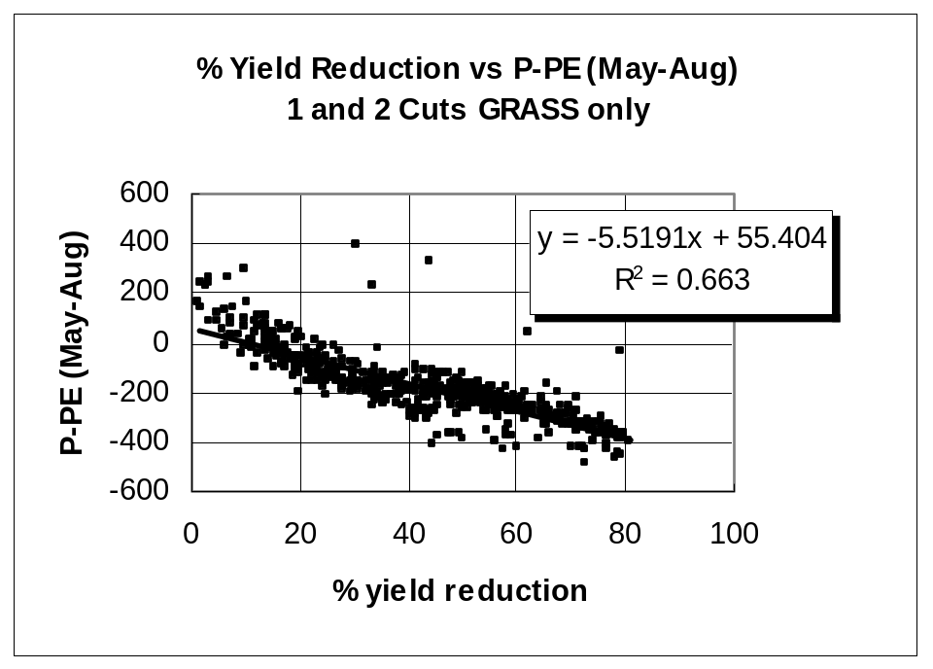
Figure 16. Percentage yield reduction of grass vs P-PE (May-Aug).

This relationship, using nearly 600 map units from across Canada provides some confidence for using a limited dataset to compare a set of expanded comparisons that include:
a) an expanded May to September growing season,
b) P-PE vs the LSRS M factor.

Appendix 2. Conversion of NSDB Stoniness Rating to Annual Removal Values

1.The Proxy Table.
The Stoniness Class types presently noted are those found in the NSDB-SLC map unit file.
Also included in this table are the Classes that are present in the regular soils map unit files in CanSIS as they will be needed at some time.

SLC Stoniness Classes
If "nothing" then stoniness “Annual Removal” value = 0.00
If StoneClass == "-" then stoniness “Annual Removal” value = 0.00
If StoneClass == "N" then stoniness “Annual Removal” value = 0.00
If StoneClass == "S" then stoniness “Annual Removal” value = 0.20
If StoneClass == "U" then stoniness “Annual Removal” value = 0.00
If StoneClass == "V" then stoniness “Annual Removal” value = 1.00
CanSIS Stoniness Classes
If StoneClass == "1" then stoniness “Annual Removal” value = 0.01
If StoneClass == "2" then stoniness “Annual Removal” value = 0.20
If StoneClass == "3" then stoniness “Annual Removal” value = 0.40
If StoneClass == "4" then stoniness “Annual Removal” value = 1.00
If StoneClass == "5" then stoniness “Annual Removal” value = 1.60
It is the “stoniness Annual Removal values” from this proxy that are used in the formula for Figure 6.4 in the LSRS manual.

2. The Percent Deduction Table (for small grains) (Figure 6.4 in LSRS manual, 1995)
It was felt that the Class 2-3 boundary should be nearly a 1 Class deduction (suggest 20 point/percent). This is set at an annual removal value of 0.3. Also, the 3-4 boundary, an annual removal of 0.6 should be a 2 Class (40 point/percent) deduction. The stoniness Class 4-5 boundary, at an annual removal rate of 1.2 should marginal or the LSRS 4-5 boundary (a 70 point/percent deduction).

J. Thornton, Government of Manitoba Forage Specialist. Brandon, MB.

