CORN and SOYBEAN CROP MODELS

Table of Contents
CORN CROP MODEL 3
Acknowledgements 3
1. Introduction 3
2. Activities 3
2.1 Climate, Soil and Landscape Requirements. 3
2.1.1 LSRS Climatic Requirements / Ratings 3
2.1.2 Soil Requirements / Ratings 5
2.1.3 Landscape Requirements / Ratings 5
2.2 Testing and evaluation. 6
2.2.1 Program function 6
2.2.2 Implementation of the corn model 6
3. Validation Process 6
3.1 Evaluation of ratings 6
4. References 10

SOYBEAN CROP MODEL 11
Acknowledgements 11
1. Introduction 11
2. Activities 11
2.1 Climate, Soil and Landscape Requirements 11
2.1.1 Introduction 11
2.1.2 LSRS Climate Requirements / Ratings 14
2.1.3 LSRS Soil Requirements / Ratings 15
2.1.4 LSRS Landscape Requirements / Ratings 16
2.2 Programming, Testing and Evaluation 16
3. Validation Process 16
3.1 Evaluation of Ratings 16
3.2 Programming, Testing and Evaluation 16
4. References 18
5. Appendices 20
Appendix 1. Documentation for gridded CHU data 20
1. 1961-1990 baseline climate 20
2. Calculation of CHU from monthly gridded data 20
3. Output from program 21
Appendix 2: Development of the Crop Heat Unit (CHU) climate indice 22
1. Introduction 22
2. Activities 22
2.1 Developing and enabling a Crop Heat Unit (CHU) database. 22
2.2 Testing and evaluation 22
3. Results and Discussion 22
3.1 The CHU database 22
4. Conclusions 25
5. References 26
Appendix 3. Attaching the CHU data to SLC polygons 27

list of tables

Table 1. Comparison of County yields to CHUs and LSRS climate ratings. 6
Table 2. Comparison of LSRS corn and small grain ratings for selected SLC polygons across Canada 8
Table 3. Yield vs days to maturity for soybean cultivars (1976-1992) 12
Table 4. Comparison of climatic and selected soil ratings for small grains, canola, corn and soybeans for selected SLC polygons across Canada. 16
Table 5. Comparison of LSRS ratings for small grains, corn and soybeans for selected SLC polygons across Canada. 17
Table 6. Comparison of Ontario Counties and SLC Crop Heat Units 24

List of Figures

Figure 1. Point deductions for CHU limitations for corn. 4
Figure 2. Point deductions for P-PE limitations for corn. 5
Figure 3. Yield vs CHUs for Ontario Counties 7
Figure 4. Yield vs LSRS climate ratings for Ontario Counties 8
Figure 5. Yield vs days to maturity for soybean cultivars (1976-1992) 13
Figure 6. Relationship between present day average soybean yields from variety trials and average Crop Heat Units (CHU) based on data from the period 1996-2000. 13
Figure 7. Point deductions for P-PE limitations for soybeans. 15
Figure 8. Average CHUs by Soil Landscape Polygon 23

CORN CROP MODEL

Acknowledgements
Appreciation is expressed to the specialists who freely responded to questions and provided suggestions about corn: K. Reid, OMAF, who commented on corn requirements and passed on the request to A. Nadler in Manitoba who also provided comments and references. Dr. L. Reid, AAFC, Ottawa provided insight on hybrids and heat units and Dr. L. Ma was contacted regarding corn agronomy.

1. Introduction
There were two aspects to this phase:
1. Modifying the LSRS program to reflect corn requirements.
2. Testing to ensure the modified program operates properly in response to the above modifications.
The program initially limited to operations using the national Soil Landscapes of Canada (SLC) - National Soils Database (NSDB).

2. Activities

2.1 Climate, Soil and Landscape Requirements.

2.1.1 LSRS Climatic Requirements / Ratings

2.1.1.1 Heat requirements
The consensus from all researchers and extension people was that CHUs (Corn Heat Units or Crop Heat Units) was the most appropriate index for ranking corn heat requirements. It correlates very well with standard Growing Degree Day (GDD) values and indexes such as that used in the U.S., but has been specifically developed to recognize the threshold and physiological requirements of corn. In addition, all cultivars are rated on their CHU requirements and both extension and crop insurance agencies in all provinces use this index.
Note: the CHU index has been shown to work equally well for other warm season crops such as soybeans hence the name change to Crop Heat Units.
Literature reviews (Brown and Bootsma 1993) and consultations (L. Reid per. com.) have suggested the following critical values:
- 1900 - 2000 CHUs is the economic limit (present) for corn production
(Class 4-5 boundary: assign a 70 point deduction)
- about 2300 CHUs is the limit for grain corn
(Class 3-4 boundary: assign a 55 point deduction)
- about 2700 CHUs (Guelph, Ottawa) is considered a moderate limitation
(just into Class 3: assign a 40 point deduction)
- about 3500 CHUs presents no limitation
( assign a 0 point deduction) (Figure 1)

The EGDD equivalents would be about:
- 1250 or near the Class 2-3 boundary for small grains
- 1500 or Class 1 for small grains
- 1800 and 2350 which are not achieved on the prairies
Putting it another way around, a marginal situation for corn is only a slight limitation for spring cereals.
Conversion of the statements to LSRS rating would suggest the following relationship:

Point Deductions for CHU limitations
corn
y = -9E-06x
+ 0.0014x + 101.74
R
2
= 0.9989
0
10
20
30
40
50
60
70
80
90
100
1000
1500
2000
2500
3000
3500
4000
Crop Heat Units
Point Deduction
2
Figure 1. Point deductions for CHU limitations for corn.
Note: corn, a C4-type plant, is not significantly affected by daylength.

2.1.1.2 Moisture Requirements
General concensus was that P-PE was a reasonable, well established and accepted index. The question then is the rating. It seems reasonable that a crop that can produce up to a maximum of 14 t/ha dry matter must require more water than cereals with a maximum of 5-6 t/ha. (Bootsma et al. pers. comm., Agricultural Climate of Manitoba (web site)) and consultations suggest the following general relationship:
- a P-PE of –100 mm is a slight limitation
(assign middle of Class 1 = 10 point deduction)
- a P-PE of –200 to -250 mm (Winnipeg, Ottawa) is a moderate limitation
(assign -250 to the 3-4 boundary = 40 point deduction)
- a P-PE of –350 to - 400 (Brown Soil Zone) is a severe limitation
( assign -400 to 4-5 boundary = 70 point deduction)

That is, the curve for corn, using the same P-PE index that was used for small grains, is shifted up by about 100 units: what was Class 2 (slight limitation) for small grains is a Class 3-4 (moderate to severe) limitation for corn.
Conversion of the above statements to LSRS ratings would suggest the following relationship (Figure 2).
Point Deductions for P-PE Limitations
corn
y = -0.2x - 10
0

20
40
60

80
-450
-350
-250
-150
-50
50
P-PE (mm)
Point Deductions
Figure 2. Point deductions for P-PE limitations for corn.

2.1.2 Soil Requirements / Ratings

2.1.2.1 Water supplying ability
The water supplying ability of a soil includes a link to the P-PE rating and will automatically incorporate the increased climate limitation in its droughtiness assessment.

2.1.2.2 Other soil factors
There is no indication that other soil factors will be any different for corn than for the small grains (seed bed may not be so critical??)

2.1.3 Landscape Requirements / Ratings
There is no indication that the landscape factors need any adjustment: the erosion potentials and mechanical limitations are assumed to be the same as for small grains.

2.2 Testing and evaluation.

2.2.1 Program function
Using the new corn model as the test, the program was run on NSDB databases to ensure functionality.

2.2.2 Implementation of the corn model
Ontario county production statistics for grain corn was accessed (http://www.omafra.gov.on.ca/english/stats/crops/ctygrcorn.html) for the years 2001 through 2005. Yields were compared to CHU values and SLRS climate and soil ratings. Only relative rankings were evaluated.
As a general test, the same national set of SLC polygons that were used for the biomass project (Pettapiece and Tychon 2006) were rated using the corn model and the results compared to the small grains ratings.

3. Validation Process

3.1 Evaluation of ratings
The corn suitability model was implemented and the program, using NSDB databases, was used to generate SLC ratings. In an attempt to assess some measure of reliability, LSRS climate and soil ratings were compared to Ontario counties yield statistics and county CHU values (Table 1). It was felt that this could at least address relative rankings.

Table 1. Comparison of County yields to CHUs and LSRS climate ratings.
 |  |  | Yield |  |  | LSRS
County | rep SLC | SLC-CHU | Ave 02-05 | High 01-05  Bu/ac | t/ha | climate | soil | class
Brant | 564009 | 3000 | 130.25 | 156 | 9.81 | 68 | 55 | 3
Elgin | 565014 | 3230 | 135.5 | 160 | 10.06 | 88 | 62 | 2
Essex | 570007 | 3554 | 124.75 | 151 | 9.49 | 100 | 55 | 3
Hald-Norf | 569006 | 3154 | 131.75 | 145 | 9.12 | 83 | 37 | 4
Hamilton | 564002 | 3052 | 125.5 | 139 | 8.74 | 69 | 50 | 3
Chatham | 565022 | 3398 | 124 | 144 | 9.05 | 68 | 48 | 3
Lambton | 570001 | 3244 | 128.75 | 154 | 9.68 | 68 | 48 | 3
Middlesex | 565006 | 3063 | 128.5 | 151 | 9.49 | 68 | 50 | 3
Niagara | 569001 | 3211 | 114 | 130 | 8.17 | 87 | 48 | 3
Oxford | 564009 | 3000 | 139.75 | 164 | 10.31 | 68 | 55 | 3
Bruce | 558004 | 2693 | 114 | 126 | 7.92 | 60 | 46 | 3
Dufferin | 551029 | 2659 | 115 | 130 | 8.17 | 58 | 47 | 3
Grey | 558002 | 2607 | 112.75 | 123 | 7.73 | 56 | 49 | 3
Halton | 564002 | 3052 | 106.5 | 115 | 7.23 | 69 | 52 | 3
Huron | 558008 | 2682 | 137.5 | 151 | 9.49 | 59 | 49 | 3
Peel | 562001 | 2917 | 113 | 135 | 8.49 | 62 | 43 | 4
Perth | 557006 | 2838 | 137.75 | 158 | 9.93 | 67 | 56 | 3
Simcoe | 551021 | 2719 | 118.25 | 122 | 7.67 | 60 | 44 | 4
Waterloo | 564005 | 2819 | 122.5 | 139 | 8.74 | 66 | 60 | 2
Wellington | 560002 | 2643 | 123.25 | 138 | 8.68 | 57 | 57 | 3
Durham | 554002 | 2755 | 121 | 124 | 7.80 | 63 | 52 | 3
Hastings | 553001 | 2810 | 110.25 | 116 | 7.29 | 63 | 51 | 3
Northumberland | 553007 | 2796 | 117.25 | 125 | 7.86 | 65 | 55 | 3
Peterborough | 552007 | 2660 | 104.5 | 115 | 7.23 | 58 | 35 | 4
Pr. Edward | 555006 | 2960 | 104.75 | 113 | 7.10 | 71 | 63 | 2
York | 562001 | 2917 | 113 | 125 | 7.86 | 62 | 43 | 4
Frontenac | 555011 | 2905 | 115.75 | 123 | 7.73 | 67 | 58 | 3
Lanark | 547004 | 2750 | 113.25 | 126 | 7.92 | 59 | 40 | 4
Leeds& Gren | 547010 | 2810 | 116 | 126 | 7.92 | 65 | 55 | 3
Lennox&Add | 555011 | 2905 | 105.25 | 122 | 7.67 | 67 | 58 | 3
Ottawa | 545006 | 2748 | 133.25 | 144 | 9.05 | 62 | 42 | 4
Prescott&Russ | 543003 | 2741 | 135 | 152 | 9.56 | 62 | 43 | 4
Renfrew | 542002 | 2537 | 106 | 121 | 7.61 | 53 | 42 | 4
Storm,Dundas | 546005 | 2804 | 138.25 | 153 | 9.62 | 65 | 60 | 2
Manitoulin | 550003 | 2352 | 92.3 | 103 | 6.48 | 40
Sudbury |  | 2000 | 107.25 | 123 | 7.73 | 30
Thunder Bay | 388007 | 1558 | 93.3 | 105 | 6.60 | 23
Timiskaming | 407003 | 1754 | 101.75 | 114 | 7.17 | 27

The results of some basic comparisons (Figures 3, 4) indicated similar degrees of correlation between county CHU vs county yield and LSRS climate rating vs county yield. The R² values of 0.31 and 0.30 are essentially the same and show a positive correlation. This also illustrates the faithful linking of LSRS climate rating to CHU values.
The LSRS soil rating vs county yield had an R² of 0.06 which suggests no correlation. Given the amount of variation in each county, the probable selective use of better lands in each polygon and the uncertainty of having picked representative polygons, this result is not entirely surprising. The local testing at a more detailed scale should clarify this concern.

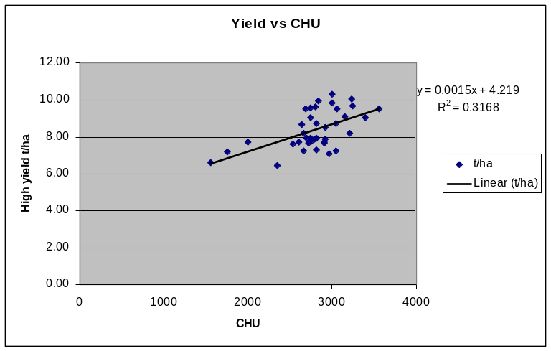
Figure 3. Yield vs CHUs for Ontario Counties

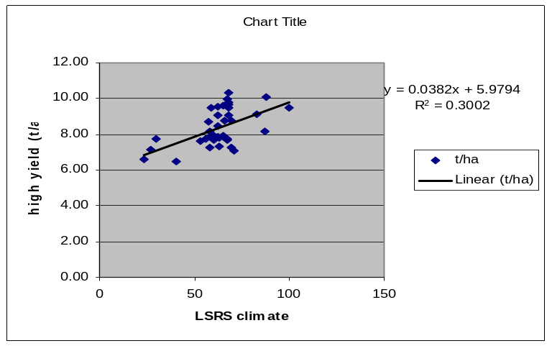
Figure 4. Yield vs LSRS climate ratings for Ontario Counties

A very general second comparison was that of corn suitability vs small grains suitability for a selected set of SLC polygons from each province (Table 2).

Table 2. Comparison of LSRS corn and small grain ratings for selected SLC polygons across Canada
Province | area | SL# | LSRS - Corn |  | LSRS - Small Grains
 | Fort St John | 581008 | 7WV(10) |  | 7WV(10)
 | Fort St John | 585015 | 6HDT(6) – 6HW(4) |  | 4DT(6) - 6W(4)
 | Prince George | 982044 | 6HA(7) – 7M(3) |  | 3HT(7) - 6M(3)
 | Prince George | 982041 | 6HT(8) – 7MT(2) |  | 3HT(8) - 6MT(2)
BC | Penticton | 1007020 | 6MT(5) – 7MTN(4) - 4AHW(1) |  | 6MT(5) - 7MTN(4) - 4W(1)
 | Penticton | 1007019 | 6MTD(8) – 6MT(2) |  | 6MTD(8) - 6MT(2)
 | Lower Fraser | 959004 | 6W(10) |  | 6W(10)
 | Lower Fraser | 959011 | 7WV(10) |  | 7WV(10)
 | Lower Fraser | 959019 | 4HA(6) – 5MT(2) – 7V(2) |  | 2T(4) - 3M(4) - 7V(2)
 | Foremost | 828012 | 5MT(10) |  | 4MT(9) - 6M(1)
 | Vulcan | 793001 | 5HA(10) |  | 2M(10)
 | Neutral | 771005 | 5MT(9) – 5W(1) |  | 3MT(9) - 5W(1)
 | Wetaskiwin | 727011 | 5H(5) – 5HM(4) – 5HW(1) |  | 3H(5) - 3HM(4) - 5W(1)
AB | Lloydminster | 729003 | 5HM(8) – 5W(2) – 6M(1) |  | 2HM(8) - 5W(2) - 5M(1)
 | Camrose | 731002 | 5HAD(9) – 5W (1) |  | 3D(9) - 5W(1)
 | La Corey | 680002 | 6H(9) – 6HW(1) |  | 3H(9) - 5W(1)
 | Grande Prairie | 599001 | 6H(8) – 6HN(1) – 6HW(1) |  | 3H(8) - 4N(1) - 5W(1)
 | Clairview | 591027 | 6H(9) – 6HW(1) |  | 3H(9) - 5W(1)
 | High Level | 586001 | 6H(8) – 6HW(2) |  | 3(8) - 6W(2)
 | Regina | 792004 | 4M(9) – 5W(1) |  | 3M(9) - 5W(1)
 | Saskatoon | 736008 | 4HM(9) – 5W(1) |  | 2M(9) - 5W(1)
SK | Melfort | 705005 | 5HA(9) – 5W(1) |  | 2(9) - 5W(1)
 | Meadow Lake | 680012 | 6H(9) – 6MV(1) |  | 3H(9) - 4MV(1)
 | B topography | 820002 | 5MT(10) |  | 4MT(10)
 | C topography | 810003 | 6MT(9) – 5W(1) |  | 4MT(9) - 5W(1)
 | Sandy (Black) | 742002 | 6M(8) – 4HM(2) |  | 5M(8) - 3M(2)
 |  | 709007 | 5HA(5) – 5HMD(4) – 5W(2) |  | 3(5) - 2H(4) - 5W(2)
 |  | 717004 | 7WB(6) – 5DMP(4) |  | 7WB(6) - 4DMP(4)
MB |  | 724008 | 4DMV(6) – 5M(3) – 7M(1) |  | 4DW(6) - 5W(3) - 6MD(1)
 |  | 763001 | 4HAW(10) |  | 5MD(7) - 5W(2) - 3W(1)
 |  | 849009 | 3HAW(6) – 5W(4) |  | 2W(6) - 5W(4)
 |  | 854002 | 4HA(9) – 5W(1) |  | 1(6) - 2(3) - 5W(1)
 | Chatham | 565022 | 3M(5) – 5W(5) |  | 3(5) - 6WV(5)
 | Guelph | 564005 | 4TMP(5) – 7WBV(3) – 3MT(2) |  | 7VTP(5) - 7VW(3) - 7V(2)
ON | Ottawa | 545001 | 6WVT(7) – 3MT(3) |  | 7V(7) - 7VT(3)
 | Ottawa | 543005 | 4M(4) – 5M(3) – 5WV(3) |  | 5VM(4) - 3M(3) - 7V(3)
 | Ottawa | 543009 | 6WV(7) – 3MT(2) – 5MT(1) |  | 7V(7) - 2MT(2) - 6VT(1)
 | Ottawa | 545004 | 4MDW(9) – 4MT(1) |  | 7V(9) - 7VT(1)
 | Montreal | 541011 | 3W(10) |  | 3W(10)
 | Quebec City | 540102 | 4PMT(7) – 4M(3) |  | 4PT(7) - 3(3)
 | Chicoutimi | 441007 | 5HD(10) |  | 3HDT(10)
QU | poorly drained | 540098 | 6W(7) – 4DW(3) |  | 5W(7) - 4DW(3)
 | Imperfect. drained | 540074 | 4MDW(6) – 6W(4) |  | 3DW(6) - 5W(4)
 | Organic | 541053 | 7WVB(10) |  | 7WVB(10)
 | Caribou | 494001 |  | 3HT(6) – 5DW(2) – 6WT(2) | 2T(6) - 5DW(2) - 6WT(2)
 | Siegas | 493002 |  | 4H(8) – 6MPV(1) – 7W(1) | 2(6) - 3W(3) - 7W(1)
NB | Thibault | 486011 |  | 5HT(8) – 5HTW(1) - 7WTJ(1) | 3HT(8) - 3TW(1) - 7WTJ(1)
 | Belldune | 485001 |  | 4HTW(6) – 6W(3) – 5M(1) | 3WT(6) - 6W(3) - 3M(1)
 | Tormentine | 504033 |  | 4W(9) – 6W(1) | 3W(9) - 6W(1)
 | King | 503024 |  | 5DTW(6) – 3TDM(3) -6WTD(1) | 5DTW(6) - 3TD(3) - 6WTD(1)
 | Kentville | 518004 |  | 6MT(6) – 4MT(4) | 4MT(8) - 6MDT(2)
 | Kentville | 518005 |  | DATA | 3T(9) - 7W(1)
NS | Truro | 517006 |  | 6W(7) – 3WTD(3) | 6W(7) - 3WTD(3)
 | Truro | 507003 |  | 4DTM(8) – 6WD(2) | 3DT(8) - 6WD(2)
 | Sydney | 523003 |  | 4HTD(10) | 4DTW(10)
 | Sydney | 523004 |  | 6W(9) - 4HTD(1) | 6W(9) - 3DT(1)
 |  | 535001 |  | 4DTM(8) – 6DVM(1) - 7WD(1) | 3DT(8) - 5DV(1) - 7WD(1)
PE |  | 536003 |  | 4MTD(7) – 7W(2) - 6DVM(1) | 3DT(7) - 6W(2) - 5DV(1)
 |  | 537003 |  | 3MT(6) – 4DTM(4) | 3T(6) - 3DT(4)
 | Codroy Valley | 463013 |  | 6HTV(10) | 4TVP(10)
 | Codroy Valley | 463011 |  | NO DATA | 5TVP(7) - 7WT(3)
NL | Central | 471012 |  | NO DATA | 4HTV(6) - 7WT(4)
 | Central | 466043 |  | 5HTV(6) – 7WV(4) | 4TVP(6) - 7WV(4)
 | St Johns | 475007 |  | 5HTD(10) | 4DTV(10)
 | St Johns | 471017 |  | 5HPV(10) | 5HPV(10)

The results appear reasonable with similar ratings where climate is not limiting (such as in southern Ontario) and lower corn suitability for comparable heat and moisture limitations (such as on the prairies).
One major source of error is in the assessment of drainage. The Ontario NSDB database does not recognize artificial (tile) drainage which is common for much of cultivated southern Ontario. Quebec data (e.g.SLC540074) does recognize drainage modification and this is reflected in a suitability rating of 4M vs 6M for poor drainage.

4. References
Bootsma, A. 1991. Risk Analyses of heat units available for corn production in the Maritime provinces. Agriculture Canada, Research Branch Tech. Bull. 1991-8E, 49pp.
Bootsma, A., Tremblay, G. and Filion, P. 1999. Risk analyses of heat units available for corn and soybean production in Quebec. Agriculture and Agri-Food Canada, Research Branch, Eastern Cereal and Oilseed Research Centre, Ottawa, Technical Bulletin, ECORC Contrib. No. 991396. 127 pp. Available on line: http://res2.agr.gc.ca/ecorc/clim2/index_e.htm
Brown, D.M. and Bootsma, A. 1993. Crop heat units for corn and other warm-season crops in Ontario. Ontario Ministry of Agriculture and Food Factsheet No. 93-119, Agdex 111/31, 4pp.
Chapman, L.J. and Brown, D.M. 1966. The Climates of Canada for Agriculture. Canada Land Inventory Report No. 3. Revised 1978. Environment Canada, Lands Directorate, 24 pp.
Pettapiece, W.W. (Pettapiece Pedology). 2005. Modifications to the Land Suitability Rating System to accommodate corn and canola. A discussion paper submitted to PFRA, Agriculture and Agri-Food Canada (M. Black, Scientific Advisor). Halifax, NS.
Pettapiece, W.W. (Pettapiece Pedology) and G. Tychon (Spatial Data Systems Consulting) 2006. Land Suitability Rating System enhancements: modifications of the Alberta platform to accommodate NSDB-SLC data. A report describing the process and including a computer program (LSRS 2.7) with documentation for SLC rating analysis across Canada submitted to PFRA, Agriculture and Agri-Food Canada (J. Fitzmaurice, Scientific Advisor). Winnipeg, MB.

SOYBEAN CROP MODEL

Acknowledgements
The author would like to acknowledge and thank E. Cober and M. Morrison who responded to questions, provided suggestions and reviewed background documents for soybeans.

1. Introduction
There were three aspects to this phase:
1. Reviewing the climate, soil and landscape requirements for commercial soybean production.
2. Modifying the LSRS program to reflect soybean requirements.
3. Testing to ensure the modified program operates properly in response to the above modifications.
The program initially limited to operations using the national Soil Landscapes of Canada (SLC) - National Soils Database (NSDB).

2. Activities

2.1 Climate, Soil and Landscape Requirements

2.1.1 Introduction
Soybean [Glycine max (L.) mer.] is a crop that has a relatively high heat requirement (Major et al, 1975). Indeed, the American soybean industry recognizes 13 Maturity Groups based on temperature and photoperiod (Boersma and Specht 2004). Maturity Groups are also recognized in Canada where the general approach is to rate cultivars on Crop Heat Unit (CHU) requirements (Brown and Bootsma 1993, OMAFRA 2002, OOPSCC 2006). Photoperiod sensitivity is a concern when selecting varieties but as there is a strong correlation between days to maturity and yield (Voldeng et al. 1997) (Table 3, Figure 5) it seems reasonable to assume that producers will grow the latest maturing variety possible (which is related to CHU ratings).

Table 3. Yield vs days to maturity for soybean cultivars (1976-1992)
Cultivar | Maturity  (days) | Yield  (Kg/ha)
Maple Arrow | 117 | 3145
McCall | 111 | 3122
Maple Presto | 101 | 2250
Maple Amber | 110 | 2839
Bicentennial | 119 | 3350
KG20 | 110 | 3048
Apache | 119 | 3286
Baron | 105 | 2915
Maple Ridge | 106 | 2945
Maple Isle | 109 | 2796
KG30 | 116 | 3222
OAC Libra | 122 | 3489
OAC Scorpio | 118 | 3324
Maple Donovan | 123 | 3588
Maple Glen | 116 | 3401
9061 | 122 | 3796
SOO-88 | 119 | 3414
OAC Frontier | 113 | 3236
Maple Belle | 111 | 2938
KG41 | 118 | 3450
PS42 | 118 | 3652
AC Bravor | 125 | 3483
Nordet | 107 | 2946
OAC Eramosa | 105 | 2797
AC Harmony | 112 | 3249
9071 | 125 | 3846

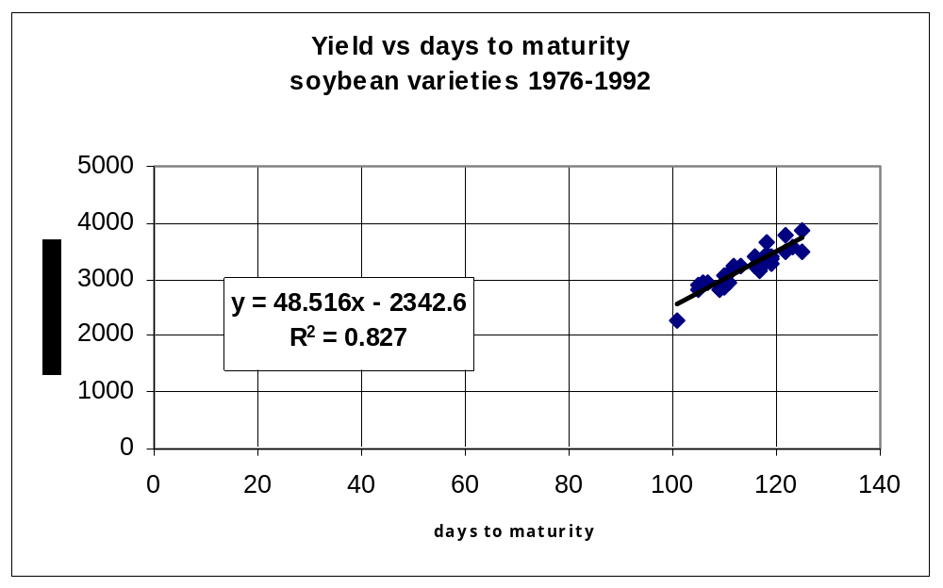
Figure 5. Yield vs days to maturity for soybean cultivars (1976-1992)

A similar relationship was found by Bootsma et al. (2005) for eastern Canada (Figure 6)

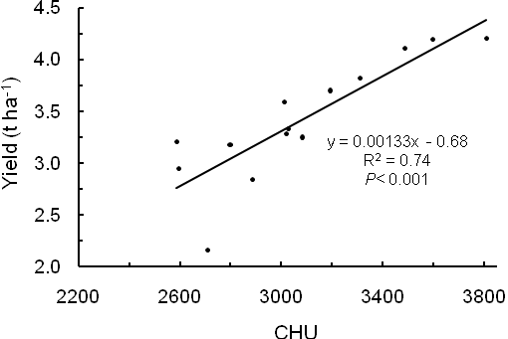
Figure 6. Relationship between present day average soybean yields from variety trials
and average Crop Heat Units (CHU) based on data from the period 1996-2000.

The CHU requirement for soybeans is very similar to that for corn (E. Cober pers. Comm⁵, OMAFRA 2002). The limit for commercial production of soybeans is about 2000 CHU (E. Cober pers. comm.)
The water requirement for soybeans is also a major consideration ranging from 450 to 600 mm per season depending cultivars and soil conditions (Boersma and Specht 2004). This is about 50 mm available water per week during the peak water use periods. Drought stress reduces both the total biomass production and also the proportion of harvestable seeds. It is suggested that soybean water requirement is not quite as high as that for corn but higher than for small grains (E. Cober pers. comm.)
Soybean soil requirements appear to be similar to that of the grains although they may be, like canola, slightly more sensitive to problems of crusting affecting emergence (OMAFRA 2002).
Landscape requirement should also be similar to that for other field crops.
Soybeans are similar to corn in that they are a warm season crop that is managed within a CHU framework. Soybeans can also be considered in a context similar to that of corn in that many cultivars have been developed that can tolerate climatic limitations of temperature relatively short, cool seasons. Also like corn, it is a reality that those cultivars that can tolerate stress invariably have lower yield and that the loss of yield is proportional to the amount of stress. Therefore, while the range of climatic limitations can be expanded, it comes with a yield reduction, and the ultimate control becomes an economic decision: the comparison of a mediocre or poor yield of a high value crop vs a good yield of a less valuable crop.

2.1.2 LSRS Climate Requirements / Ratings
Given the above discussion, the major considerations would appear to be with the climatic controls.

2. 1.2.1. Heat Requirements
It is suggested that the CHU scale be used with the same rankings as used for corn.

2.1.2.2 Moisture Requirements
It is suggested that P-PE should be used but with the point deduction set between that for corn and that for the small grains (Figure 7).

Point Deduction
Point Deductions for P-PE Limitations

soybeans
y = -0.2x - 20
R
2
= 1
0
20
40
60
-450
-350
-250
-150
-50
50
P-PE (mm)
Figure 7. Point deductions for P-PE limitations for soybeans.

2.1.3 LSRS Soil Requirements / Ratings

2.1.3.1 Water supplying ability
The water supplying ability of a soil includes a link to the P-PE rating and needs to be adjusted as follows to incorporate the increased climate limitation in its droughtiness assessment:
Deduction = ((100 + (P-PE))/-50)*10

2.1.3.2 Other soil factors
Most other soil factors for soybean production appear to be similar to those for corn or the small grains. The only exception might be the susceptibility to emergence problems relating to crusting where they appear to be more like canola. It is suggested that the following modification be made to the surface structure limitation.
Deduction = 2.5 / %OC + ((% S – 60) / (%OC*3)) + ((% Si – 50) / (%OC*0.8)) +
((% C – 50) / (%OC*0.5))
It is also suggested that the maximum deduction for surface structure be raised to 15 points from the present 10 point deduction.

2.1.4 LSRS Landscape Requirements / Ratings
There is no indication that the landscape factors need any adjustment: The erosion potentials and mechanical limitations are assumed to be the same as for small grains.

2.2 Programming, Testing and Evaluation
The proposed changes were programmed into the soybean crop model. The model was enabled in the LSRS program and the models run using NSDB databases to ensure functionality.
Soybean ratings were generated from the same SL list and compared to corn ratings.

3. validation process

3.1 Evaluation of Ratings
Initial review of ratings (Table 4) indicated that the program was responding as planned. The differences from the corn show up in moderated moisture requirements (P-PE in climate and M in soil) and in greater sensitivity to tilth concerns (surf D).
The comparison to corn for a range of conditions across Canada (Table 5) indicates similar ratings in all cases. There are some differences in number ratings (Table 4) but the polygon Classes are generally the same with a few instances (MB-717004, ON-545004) where soybean ratings are slightly higher. This seems reasonable.

3.2 Programming, Testing and Evaluation
General testing was accomplished using both batch mode and individual SLC runs for soybeans as well as small grains and corn. All worked as expected.

Table 4. Comparison of climatic and selected soil ratings for small grains, canola, corn and soybeans for selected SLC polygons across Canada.
SL# | Crop | deduction |  |  |  | Climate rating | deduction |  | Soil  rating
SL# | Crop | P-PE | EGDD | CHU | H I | Climate rating | M | Surf D | Soil  rating
Kentville, NS  518004  (soil 1) | Small grains | 0 | 0 | - | - | 100 | 44 | 10 | 34
Kentville, NS  518004  (soil 1) | Canola | 0 | 0 | - | 6 | 94 | 44 | 13 | 31
Kentville, NS  518004  (soil 1) | Corn | 19 | - | 47 | - | 53 | 64 | 10 | 15
Kentville, NS  518004  (soil 1) | Soybeans | 9 | - | 47 | - | 53 | 54 | 13 | 21
Ottawa, ON  565022  (soil 2) | Small grains | 12 | 0 | - | - | 88 | 41 | 0 | 55
Ottawa, ON  565022  (soil 2) | Canola | 12 | 0 | - | 13 | 75 | 41 | 0 | 55
Ottawa, ON  565022  (soil 2) | Corn | 32 | - | 3 | - | 68 | 56 | 0 | 40
Ottawa, ON  565022  (soil 2) | Soybeans | 22 | - | 3 | - | 78 | 49 | 0 | 47
Saskatoon, SK  736008  (soil 1) | Small grains | 29 | 21 | - | - | 71 | 36 | 0 | 61
Saskatoon, SK  736008  (soil 1) | Canola | 29 | 21 | - | 6 | 65 | 36 | 0 | 61
Saskatoon, SK  736008  (soil 1) | Corn | 49 | - | 66 | - | 34 | 56 | 0 | 41
Saskatoon, SK  736008  (soil 1) | Soybeans | 39 | - | 66 | - | 34 | 46 | 0 | 51
Prince George, BC  982044  (soil 3) | Small grains | 20 | 50 | - | - | 50 | 16 | 10 | 64
Prince George, BC  982044  (soil 3) | Canola | 20 | 50 | - | 0 | 50 | 16 | 12 | 54
Prince George, BC  982044  (soil 3) | Corn | 40 | - | 90 | - | 10 | 32 | 10 | 42
Prince George, BC  982044  (soil 3) | Soybeans | 30 | - | 90 | - | 10 | 24 | 12 | 47
P-PE = precipitation – potential evapotranspiration (aridity index),
EGDD = effective growing degree days (GDD>5ºC modified for daylength)
CHU = crop heat units, HI = heat index (canola deduction)
M = moisture deduction recognizing climate and soil water supplying capacity
Surf D = adverse surface structure (poor tilth, crusting)

Table 5. Comparison of LSRS ratings for small grains, corn and soybeans for selected SLC polygons across Canada.
Prov. | area | SL# |  | LSRS - Small Grains | LSRS - Corn | LSRS - Soybeans
 | Fort St John | 581008 |  | 7WV(10) | 7WV(10) | 7WV(10)
 | Fort St John | 585015 |  | 4DT(6) - 6W(4) | 6HDT(6) – 6HW(4) | 6HDT(6) – 6HW(4)
 | Prince George | 982044 |  | 3HT(7) - 6M(3) | 6HA(7) – 7M(3) | 6H (7) – 7M(3)
 | Prince George | 982041 |  | 3HT(8) - 6MT(2) | 6HT(8) – 7MT(2) | Missing climate data
BC | Penticton | 1007020 |  | 6MT(5) - 7MTN(4) - 4W(1) | 6MT(5)-7MTN(4) - 4AHW(1) | 6MT(5)-7MTN(4) - 4AHW(1)
 | Penticton | 1007019 |  | 6MTD(8) - 6MT(2) | 6MTD(8) – 7MT(2) | 6MTD(8) – 7MT(2)
 | Lower Fraser | 959004 |  | 6W(10) | 6W(10) | 6W(10)
 | Lower Fraser | 959011 |  | 7WV(10) | 7WV(10) | 7WV(10)
 | Lower Fraser | 959019 |  | 2T(4) - 3M(4) - 7V(2) | 4HA(6) – 5MT(2) – 7V(2) | 4HA(6) – 4MT(2) – 7V(2)
 | Foremost | 828012 |  | 4MT(9) - 6M(1) | 5MT(10) | 5MT(10)
 | Vulcan | 793001 |  | 2M(10) | 5HA(10) | 5HA(10)
 | Neutral | 771005 |  | 3MT(9) - 5W(1) | 5MT(9) – 5W(1) | 5HMT(9) - 5W(1)
 | Wetaskiwin | 727011 |  | 3H(5) - 3HM(4) - 5W(1) | 5H(5) – 5HM(4) – 5HW(1) | 5H(5) - 5HM(4) - 5HW(1)
AB | Lloydminster | 729003 |  | 2HM(8) - 5W(2) - 5M(1) | 5HM(8) – 5W(2) – 5M(1) | 5HM(8) - 5W(2) - 5M(1)
 | Camrose | 731002 |  | 3D(9) - 5W(1) | 5HAD(9) – 5W (1) | 5HD(9) - 5HW(1)
 | La Corey | 680002 |  | 3H(9) - 5W(1) | 6H(9) – 6HW(1) | 6H(9) - 6HW(1)
 | Grande Prairie | 599001 |  | 3H(8) - 4N(1) - 5W(1) | 6H(8) – 6HN(1) – 6HW(1) | 6H(8) - 6HN(1) - 6HW(1)
 | Clairview | 591027 |  | 3H(9) - 5W(1) | 6H(9) – 6HW(1) | 6H(9) - 6HW(1)
 | High Level | 586001 |  | 3(8) - 6W(2) | 6H(8) – 6HW(2) | 6H(8) - 6W(2)
 | Regina | 792004 |  | 3M(9) - 5W(1) | 4M(9) – 5W(1) | 4M(9) – 5W(1)
 | Saskatoon | 736008 |  | 2M(9) - 5W(1) | 4HM(9) – 5W(1) | 4HM(9) – 5W(1)
SK | Melfort | 705005 |  | 2(9) - 5W(1) | 5HA(9) – 5W(1) | 5H(9) – 5W(1)
 | Meadow Lake | 680012 |  | 3H(9) - 4MV(1) | 6H(9) – 6MV(1) | 6H(9) – 6HMV(1)
 | B topo | 820002 |  | 4MT(10) | 5MT(10) | 5MT(10)
 | C topo | 810003 |  | 4MT(9) - 5W(1) | 6MT(9) – 5W(1) | 5MT(9) – 5W(1)
 | Sandy (Black) | 742002 |  | 5M(8) - 3M(2) | 6M(8) – 4HM(2) | 6M(8) – 4HM(2)
 |  | 709007 |  | 3(5) - 2H(4) - 5W(2) | 5HA(5) – 5HMD(4) – 5W(2) | 5HM(5) - 5H(4) - 5W(2)
 |  | 717004 |  | 7WB(6) - 4DMP(4) | 7WB(6) – 5DMP(4) | 7WB(6) – 4DMP(4)
MB |  | 724008 |  | 4DW(6) - 5W(3) - 6MD(1) | 4DMV(6) – 5M(3) – 7M(1) | 4DW(6) - 5W(3) - 7MD(1)
 |  | 763001 |  | 5MD(7) - 5W(2) - 3W(1) | 6MD(6) - 4M(2) - 5W(2) | 6MD(6) - 4M(2) - 5W(2)
 |  | 849009 |  | 2W(6) - 5W(4) | 3HAW(6) – 5W(4) | 3HAW(6) – 5W(4)
 |  | 854002 |  | 1(6) - 2(3) - 5W(1) | 4HA(9) – 5W(1) | 4H (9) – 5W(1)
Prov. | area | SL# | LSRS – Small Grains |  | LSRS - Corn | LSRS - Soybeans
 | Chatham | 565022 | 3(5) – 5W(5) |  | 3M(5) – 5W(5) | 3M(5) – 5W(5)
 | Guelph | 564005 | 4TP(5) - 7WVB(3) - 4VT(2) |  | 4TMP(5) – 7WBV(3) – 4VMT(2) | 4TMP(5) – 7WBV(3) – 4VMT(2)
ON | Ottawa | 545001 | 6VWT(7) – 2T(3) |  | 6VWT(7) – 2MT(3) | 6VWT(7) – 2HMT(3)
 | Ottawa | 543005 | 3M(4) - 4M(3) – 7WV(3) |  | 4M(4) – 5M(3) – 5WV(3) | 3M(4) – 5M(3) – 5WV(3)
 | Ottawa | 543009 | 6WV(7) – 2TM(2) – 4MT(1) |  | 6WV(7) – 3MT(2) – 5MT(1) | 6WV(7) – 3MT(2) – 5MT(1)
 | Ottawa | 545004 | 3DW(9) – 3TM(1) |  | 4MDW(9) – 4MT(1) | 4MDW(9) – 3MT(1)
 | Montreal | 541011 | 3W(10) |  | 3W(10) | 3W(10)
 | Quebec City | 540102 | 4PT(7) - 3(3) |  | 4PMT(7) – 4M(3) | 4PTM (7) – 4M(3)
 | Chicoutimi | 441007 | 3HDT(10) |  | 5HD(10) | 5HD(10)
QU | poorly drained | 540098 | 5W(7) - 4DW(3) |  | 6W(7) – 4DW(3) | 5W(7) – 4DW(3)
 | Imp. drained | 540074 | 3DW(6) - 5W(4) |  | 4MDW(6) – 6W(4) | 3DW(6) - 5W(4)
 | Organic | 541053 | 7WVB(10) |  | 7WVB(10) | 7WVB(10)
 | Caribou | 494001 | 2T(6) - 5DW(2) - 6WT(2) |  | 3HT(6) – 5DW(2) – 6WT(2) | 3HT(6) – 5DW(2) – 6WT(2)
 | Siegas | 493002 | 2(6) - 3W(3) - 7W(1) |  | 4H(8) – 6MPV(1) – 7W(1) | 4H(6) - 4HW(3) - 7W(1)
NB | Thibault | 486011 | 3HT(8) - 3TW(1) - 7WTJ(1) |  | 5HT(8) – 5HTW(1) - 7WTJ(1) | 5HT(8) – 5HTW(1) - 7WTJ(1)
 | Belldune | 485001 | 3WT(6) - 6W(3) - 3M(1) |  | 4HTW(6) – 6W(3) – 5M(1) | 4HTW(6) – 6W(3) – 4M(1)
 | Tormentine | 504033 | 3W(9) - 6W(1) |  | 4W(9) – 6W(1) | 3W(9) – 6W(1)
 | King | 503024 | 5DTW(6)-3TD(3)-6WTD(1) |  | 5DTW(6) – 3TDM(3) -6WTD(1) | Missing climate data
 | Kentville | 518004 | 4MT(8) - 6MDT(2) |  | 6MT(6) – 4MT(4) | 6MT(6) – 3MT(4)
 | Kentville | 518005 | 3T(9) - 7W(1) |  | NO SOIL DATA | NO SOIL DATA
NS | Truro | 517006 | 6W(7) - 3WTD(3) |  | 6W(7) – 3WTD(3) | Missing climate data
 | Truro | 507003 | 3DT(8) - 6WD(2) |  | 4DTM(8) – 6WD(2) | Missing climate data
 | Sydney | 523003 | 4DTW(10) |  | 4HTD(10) | 4HTD(10)
 | Sydney | 523004 | 6W(9) - 3DT(1) |  | 6W(9) - 4HTD(1) | 7WD(9) - 4HTD(1)
 |  | 535001 | 3DT(8) - 5DV(1) - 7WD(1) |  | 4DTM(8) – 6DVM(1) - WD(1) | 3DT(8) - 6DV(1) - 7WD(1)
PE |  | 536003 | 3DT(7) - 6W(2) - 5DV(1) |  | 4MTD(7) – 7W(2) - 6DVM(1) | 3DT(7) - 7W(2) - 6DV(1)
 |  | 537003 | 3T(6) - 3DT(4) |  | 3MT(6) – 4DTM(4) | 3HT(6) - 4DT(4)
 | Codroy Valley | 463013 | 4TVP(10) |  | 6HTV(10) | 6HTV(10)
 | Codroy Valley | 463011 | 5TVP(7) - 7WT(3) |  | NO SOIL DATA | NO SOIL DATA
NL | Central | 471012 | 4HTV(6) - 7WT(4) |  | NO SOIL DATA | NO SOIL DATA
 | Central | 466043 | 4TVP(6) - 7WV(4) |  | 5HTV(6) – 7WV(4) | 5HTV(6) – 7WV(4)
 | St Johns | 475007 | 4DTV(10) |  | 5HTD(10) | 5HTD(10)
 | St Johns | 471017 | 5HPV(10) |  | 5HPV(10) | Missing climate data

4. References
Bootsma, A., Gameda, S. and McKenney, D.W. 2005. Potential impacts of climate change on corn, soybeans and barley yields in Atlantic Canada. Can. J. Soil Sci. 85: 345-357
Boersma, H.R. and J.E. Specht (eds). 2004. Soybeans: improvement production and uses. 3rd edition. Amer. Soc. of Agron. Madison, Wis. 1144p
Brown, D.M. and A. Bootsma. 1993. Crop heat units for corn and other warm season crops in Ontario. OMAFRA publication Agdex # 111/31. Guelph, Ontario. [Online] Available: http://www.omafra.gov.on.ca/english/crops/facts/93-119.html [30 Nov. 2005].
Environment Canada 2002. Canadian Climate Normals or Averages 1971-2000. Meteorological Service of Canada, National Archive and Data Management Branch, Downsview, Ontario, Canada. Available on-line: http://www.climate.weatheroffice.ec.gc.ca/climate_normals/index_e.html [18 Apr. 2006].
Major, D.M., D.R. Johnson, J.W. Tanner, and I.C. Anderson. 1975. Effects of daylength and temperature on soybean development. Crop Sci. 15:174-179.
OMAFRA. 2002. Agronomy guide for field crops. OMAFRA publication 811. Guelph, Ontario.
Pettapiece, W.W. (Pettapiece Pedology) and G. Tychon (Spatial Data Systems Consulting) 2006. Land Suitability Rating System enhancements: modifications of the Alberta platform to accommodate NSDB-SLC data. A report describing the process and including a computer program (LSRS 2.7) with documentation for SLC rating analysis across Canada submitted to PFRA, Agriculture and Agri-Food Canada (J. Fitzmaurice, Scientific Advisor). Winnipeg, MB.
Pettapiece, W.W., G. Tychon and A. Bootsma. 2006. Land Suitability Rating System Development: modifications to accommodate additional crops. Phase I Interim Report submitted to Agriculture and Agri-Food Canada (J.A. Brierley, Scientific Advisor). Edmonton, AB.
Voldeng, H.D., E.R. Cober, D.J. Hume, C. Gillard and M.J. Morrison. 1997. Fifty-eight years of genetic improvement of short season soybean cultivars in Canada. Crop Sci. 37:428-431.

5. Appendices

Appendix 1. Documentation for gridded CHU data
(by A. Bootsma)

1. 1961-1990 baseline climate
Gridded monthly mean values for daily maximum and minimum air temperature were constructed by interpolating average monthly climate station data from within the 1961-1990 period (Environment Canada, 1994) as a function of latitude, longitude and elevation using ANUSPLIN (Hutchinson, 2000). ANUSPLIN uses thin plate smoothing splines as the interpolation technique (Hutchinson, 1995). The grid is 500 arc seconds and was developed by Dr. D. McKenney, Canadian Forest Services, Sault Ste Marie, using a Digital Elevation Model (DEM) data, based on the National Topographic Series 1:250,000 topographic data. For details of these particular Canadian applications see McKenney et al. (2001) (see also Price et al. 2000). The gridded climate data are available on line at: http://www.cics.uvic.ca/scenarios/index.cgi . Gridded data are only available for latitudes up to 65.72N, as routines used for calculating daylength do not work for more northern latitudes.

2. Calculation of CHU from monthly gridded data
Crop Heat Units (Brown and Bootsma, 1993) were computed using the gridded monthly average temperatures as input data. Initially, 365 daily values of average maximum temperature and of average minimum temperature were generated from monthly average values for each grid point using the Brooks sine wave interpolation procedure (Brooks, 1943).
Average daily values of CHU were computed using the following formula:
Ymax = 3.33 (Tmax - 10.0) - 0.084 (Tmax - 10.0)² ; if Tmax < 10.0, Ymax = 0.0;
Ymin = 1.8 (Tmin - 4.44); if Tmin < 4.44, Ymin = 0.0
Where Ymax and Ymin are the contributions to CHU from average daily maximum (Tmax) and minimum (Tmin) air temperatures respectively.
Then, Daily CHU = (Ymax + Ymin) / 2.0
Daily CHU are accumulated from starting and stopping dates determined by the dates when certain temperature threshold values are reached. Starting dates are based on a threshold for the mean daily temperature (Tmean) and stopping dates are based on mean daily minimum temperature (Tmin). The threshold temperatures were “calibrated” to correspond closely to the average date of planting in spring and the date of 10% probability of occurrence of killing frost (-2C) in the fall. These values were documented in previous studies for eastern Canada as follows (Bootsma, 1991; Bootsma et al., 1999; 2004;2005).
Spring (Tmean) Fall (Tmin)
Atlantic (all longitudes ≥ -68W) 11.0C 5.8C
Quebec and Ontario (longitudes between –68 and -95W) 12.8C 6.5C
Temperature criteria have not been developed for western Canada, and therefore the criteria for Ontario and Quebec were also used for this region. The criteria for western Canada need to be further refined in future through research to establish more appropriate starting and ending dates for accumulating CHU in this region of Canada.
The seasonally accumulated CHU determined in this manner are called “CHUnorm”. Calculating CHU from mean daily maximum and minimum air temperatures may involve some error near the start and end of the accumulation period, since the temperature averages include days when the temperature was below base values. However, this procedure has been commonly accepted as being of sufficient accuracy (Chapman and Brown 1966), and in this case, biases are eliminated by using regression-based algorithms to estimate average CHU computed using daily data (CHUave).
The algorithms used to adjust the CHUnorm values were determined by comparing CHU computed from climate normals data to those calculated using 30 years of daily temperature data using linear regression. These have been determined and documented in previous studies (Bootsma et al., 1999; 2004; 2005) and were as follows:
For Atlantic region: CHUave = 185.2 + 0.93771*CHUnorm
For Quebec: CHUave = 157.45 + 0.9194*CHUnorm
For Ontario: CHUave = 177.82 + 0.91502*CHUnorm
Algorithms have not been developed for the Prairie provinces and British Columbia, and therefore the Ontario algorithm were assumed to apply to these provinces. Further work is needed to refine the algorithms for western provinces.

3. Output from program
The following variables are contained in the output file (Excel) in the order listed:
- CHUave
- Start date for accumulating CHU (Julian day)
- Stop date for accumulating CHU (Julian day)
- Latitude (decimal degrees)
- Longitude (decimal degrees)

Questions about the data or feedback should be directed to:
Andy Bootsma,
Agro-climatology Consultant
27 Trimble Crescent

Ottawa ON CANADA K2H 7M9
Tel: 613 828-3939
e-mail: bootsmaa@yahoo.ca

Appendix 2: Development of the Crop Heat Unit (CHU) climate indice

1. Introduction
There were two aspects to this activity:
1. Developing a Crop Heat Unit (CHU) database, attaching the database to SLC polygons and adding SLC-CHU values to the climate data file.
2. Testing to ensure the modified program operates properly in response to the above modifications.

2. Activities

2.1 Developing and enabling a Crop Heat Unit (CHU) database.
It was identified in a previous contract (Pettapiece 2005) that warm season crops such as corn and soybeans are evaluated in Canada using CHU’s rather than Growing Degree Days (EGDD). It was therefore necessary to develop a CHU database and attach it to SLC polygons so that it could be accessed in the same manner as EGDD and P-PE indices used for the small grains.
In order to be consistent with the EGDD and P-PE indices, the McKenney-gridded 61-90 monthly normals were used as the basic input. The specific procedure (Appendix 1) involved the conversion of monthly data to daily data and then CHU calculations.
The second step was the attachment of the 10K grid CHU data to SLC polygons. This was done by the Manitoba Land Resource Unit (Appendix 2).
The SLC-CHU data was then added to the climate file in the LSRS program.

2.2 Testing and evaluation
A printout of the national CHU distribution (MB- LRU) was visually inspected to identify any anomalies. Then a “representative” SLC was selected for each county in Ontario. The CHU value assigned to each SLC was compared to the county CHU value estimated from the Ontario CHU map (OMAF Factsheet No. 93-119, Agdex 111/31).

3. Results and Discussion

3.1 The CHU database
The CHU calculations were completed using 61-90 normals and successfully linked to SLC polygons. A visual check of the national printout (Figure 8, & Table 6) found the results to be as expected with values of >3000 in southern Ontario and <2000 in the Boreal areas

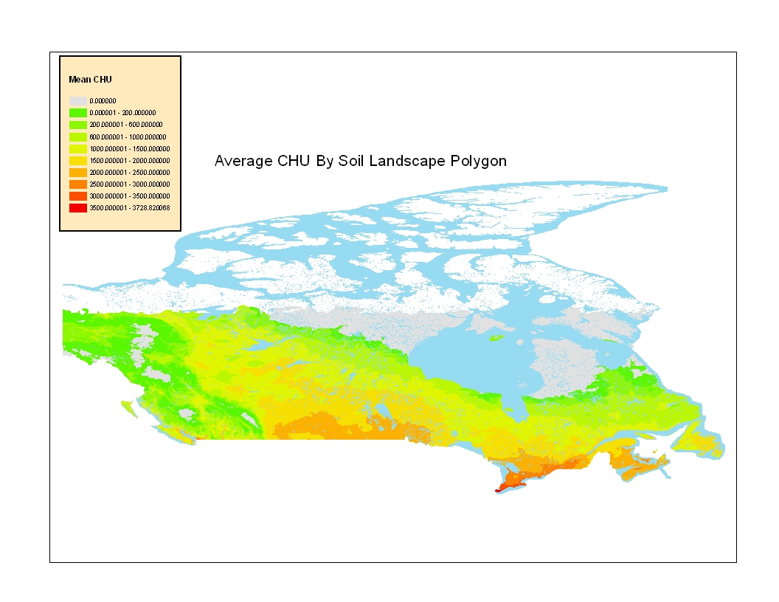Figure 8. Average CHUs by Soil Landscape Polygon
A comparison of estimated county CHUs and the CHU values for SLC polygons representing the counties (Table 6) also showed very good compliance.

Table 6. Comparison of Ontario Counties and SLC Crop Heat Units
County | representative SLC | SLC-CHU | representative station | CHU | estimated CHU
Brant | 564009 | 3000 |  |  | 3000
Elgin | 565014 | 3230 |  |  | 3100
Essex | 570007 | 3554 | Harrow | 3560 | 3500
Haldiman-Norfolk | 569006 | 3154 | Delhi | 3040 | 3100
Hamilton | 564002 | 3052 | Hamilton | 3210 | 3000
Chatham | 565022 | 3398 | Ridgetown | 3340 | 3300
Lambton | 570001 | 3244 |  |  | 3100
Middlesex | 565006 | 3063 | London | 2900 | 3000
Niagara | 569001 | 3211 | Vineland | 3190 | 3200
Oxford | 564009 | 3000 | Woodstock | 2890 | 2900
S. Ontario |  | 3190.6 |  |  | 3120
Bruce | 558004 | 2693 |  |  | 2600
Dufferin | 551029 | 2659 | Redickvill | 2390 | 2400
Grey | 558002 | 2607 |  |  | 2500
Halton | 564002 | 3052 |  |  | 2800
Huron | 558008 | 2682 | Brucefield | 2820 | 2700
Peel | 562001 | 2917 |  |  | 2900
Perth | 557006 | 2838 |  |  | 2800
Simcoe | 551021 | 2719 |  |  | 2700
Waterloo | 564005 | 2819 |  |  | 2700
Wellington | 560002 | 2643 | Guelph | 2680 | 2600
W. Ontario |  | 2762.9 |  |  | 2670
Durham | 554002 | 2755 |  |  | 2700
Haliburton | 413010 | 2290 |  |  | 2200
Hastings | 553001 | 2810 |  |  | 2600
Kawartha | 554001 | 2681 |  |  | 2600
Muskoka | 551009 | 2665 |  |  | 2300
Northumberland | 553007 | 2796 |  |  | 2800
Parry Sound | 413010 | 2290 |  |  | 2400
Peterborough | 552007 | 2660 | Peterborough | 2600 | 2600
Pr. Edward | 555006 | 2960 | Smithfield | 2940 | 3000
York | 562001 | 2917 |  |  | 2900
C. Ontario |  | 2682.4 |  |  | 2610
Frontenac | 555011 | 2905 |  |  | 2600
Lanark | 547004 | 2750 |  |  | 2600
Leeds& Grenville | 547010 | 2810 | Kemptville | 2730 | 2800
Lennox&Addington | 555011 | 2905 |  |  | 2700
Ottawa | 545006 | 2748 | Ottawa | 2890 | 2800
Prescott&Russell | 543003 | 2741 |  |  | 2800
Renfrew | 542002 | 2537 | Petawawa | 2380 | 2400
Stormont, Dundas | 546005 | 2804 |  |  | 2800
E. Ontario |  | 2779.94 |  |  | 2701
Algoma |  |  |  |  | 1700
Cochrane |  |  | Kapuskasing | 1720 | 1700
Kenora | 372040 | 1904 |  |  | 2100
Manitoulin | 550003 | 2352 |  |  | 2300
Nipissing |  |  |  |  | 2000
Rainy River | 377004 | 2199 | Fort Francis | 2330 | 2300
Sudbury | 409009 | 1955 |  |  | 2000
Thunder Bay | 388007 | 1558 | Thunder Bay | 1790 | 1800
Timiskaming | 407003 | 1754 | Earlton | 1930 | 1900
N.Ontario |  | 2071.706 |  |  | 2050.1

It seems reasonable to conclude that a standard national CHU database attached to the national SLC map has been established. The fact that it was developed on the standard 61-90 climate normals should make it a suitable base for any future climate change studies.
In the initial application, there were some polygons without CHU data. This was addressed by A. Waddell and a new procedure was implemented to eliminate the problem (Appendix 4)
Another concern is the poor representation of CHU values in the narrow mountain valleys in BC. The Pentiction area SLC, for example, shows CHU values of 2100 compared to expected values of > 3000. It is suggested that it is a result of the inclusion of higher elevation, side-slope grid points in the broad SLC polygons. The applicability of gridded climate data to characterize temperature and precipitation within the BC interior is an identified limitation.

4. Conclusions
- The CHU climatic index has been calculated from 61-90 normals and attached to SLC polygons along with the EGDD and P-PE indices.
- LSRS ratings derived for the mountainous areas within British Columbia, utilizing climate indices (EGDD, P-PE, CHU etc.) based upon the national 10km gridded climate data, are not valid. The extremes in elevation within a 10km area skew the temperature and precipitation estimates therefore the valley areas are not correctly represented.

5. References
Bootsma, A. 1991. Risk Analyses of heat units available for corn production in the Maritime provinces. Agriculture Canada, Research Branch Tech. Bull. 1991-8E, 49pp.
Bootsma, A., Anderson, D. and Gameda, S. 2004. Potential impacts of climate change on agroclimatic indices in southern regions of Ontario and Quebec. Eastern Cereal and Oilseed Research Centre, Research Branch, Agriculture and Agri-Food Canada, Ottawa, ECORC Tech. Bull. Contrib. No. 03-284. 20 pp. + maps. [Online] Available on line: http://res2.agr.gc.ca/ecorc/tb03284/index_e.htm
Bootsma, A., Gameda, S. and McKenney, D.W. 2005. Impacts of potential climate change on selected agroclimatic indices in Atlantic Canada. Can. J. Soil Sci. 85: 329-343.
Brooks, C.E.P. 1943. Interpolation tables for daily values of meteorological elements. Quart. J. Royal Meteorol. Soc. 69: 160-162.
Brown, D.M. and Bootsma, A. 1993. Crop heat units for corn and other warm-season crops in Ontario. Ontario Ministry of Agriculture and Food Factsheet No. 93-119, Agdex 111/31, 4pp.
Chapman, L.J. and Brown, D.M. 1966. The Climates of Canada for Agriculture. Canada Land Inventory Report No. 3. Revised 1978. Environment Canada, Lands Directorate, 24 pp.
Environment Canada 1994. Canadian Monthly Climate Data and 1961-1990 Normals on CD-ROM, Version 3.0E. Environment Canada, Atmospheric Environment Service, Downsview, Ontario.
Hutchinson, M.F. 1995. Interpolating mean rainfall using thin plate smoothing splines. Int. J. Geographical Information Systems 9: 385-403
Hutchinson, M.F. 2000. ANUSPLIN Version 4.1 User Guide. Centre for Resource and Environmental Studies, Australian National University, Canberra ACT 0200, Australia.
McKenney, D.W., Hutchinson, M.F., Kesteven, J. and Venier, L. 2001. Canada's plant hardiness zones revisited using modern climate interpolation techniques. Can J. Plant Science 81:129-143
Pettapiece, W.W. (Pettapiece Pedology). 2005. Modifications to the Land Suitability Rating System to accommodate corn and canola. A discussion paper submitted to PFRA, Agriculture and Agri-Food Canada (M. Black, Scientific Advisor). Halifax, NS.
Pettapiece, W.W. (Pettapiece Pedology) and G. Tychon (Spatial Data Systems Consulting) 2006. Land Suitability Rating System enhancements: modifications of the Alberta platform to accommodate NSDB-SLC data. A report describing the process and including a computer program (LSRS 2.7) with documentation for SLC rating analysis across Canada submitted to PFRA, Agriculture and Agri-Food Canada (J. Fitzmaurice, Scientific Advisor). Winnipeg, MB.
Price, D., McKenney, D.W., Nalder, I., Hutchinson, M.F. and Kestevan, J. 2000. A comparison of two statistical methods for interpolating monthly mean climate. Ag. And Forest. Met. 101:81-94.

Appendix 3. Attaching the CHU data to SLC polygons
A Waddell, Manitoba Land Resource Unit, AAFC, Winnipeg.

Out of a total of 12,353 SLC polygons, 10,474 have been populated with CHU values. No CHU values were calculated for north of 66 degrees (which would have zero values anyway), however there are other areas in the south that have pockets of zeros, possibly a function of the elevation. The areas in the north could be given some other value to express that the data was not analysed or, given the unlikely interest in that area, they could just be left out of the database.
The attached database represents various statistics for CHU by SLC polygon. It was generated by converting the original excel data into ARCGIS point Shapefile. The points were then converted into raster format by an inverse distance interpolation in order to account for areas in the south that were not represented with enough points to do a straight point to raster conversion. The inverse distance interpolation was compared to the direct feature to raster conversion, and the results were very similar. Next, the grid was overlaid onto the SLC polygons, and a zonal statistics function was used to produce the stats for each SLC polygon.

Dr. M. Morrison, Soybean breeder, Eastern Cereal and Oilseed Research Centre, Agriculture and Agri-Food Canada, Ottawa
OOPSCC = Ontario Oil and Protein Seed Crop Committee. See: http://www.oopscc.org/vartrial.php

