M A R K S C H U T E R A

[Dr.-Ing.]
Head of Industrial AI Global Operations

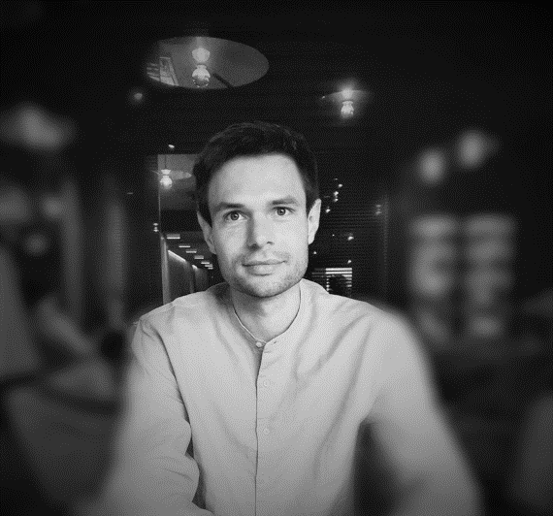

C O N T A C T


Am Bläsiberg 18, 88250 Weingarten, Germany
* 28.04.1991 in Künzelsau, Germany

Mark.schutera@mailbox.org
+49 1520 713 7061

You are looking to enable the next generation of developers to apply artificial intelligence in the real-world. I love intelligent systems at scale. And even more I would love to use my experience as a researcher, educator, and AI lead developer to contribute value to the success of your students, projects, and university.

My Research Publications on Google Scholar

My Patents on Google Patents

My Profile on LinkedIn, stack overflow, GitHub

C A P A B I L I T I E S

P R O F E S S I O N A L | P E R S O N A L
Machine Learning | Team Player
Scrum Project Management | Organized
Team Leadership | Creative
Communication | Fast Learner
Facilitation | Sprint Management
Innovation and Research | Curiosity Driven
Adding Layers | Ambitious

E X P E R I E N C E

today  -  02.2024 | H E A D O F I N D U S T R I A L A I  G L O B A L O P E R A T I O N S  ZF LIFETEC, Remote, Germany  I lead and build a team and global community of AI Architects and MLOps Engineers who work on enhancing the modern industrial workforce with cutting-edge AI solutions distributed and scaled on a central platform. My responsibilities are from product vision, to the full stack AI architecture.
02.2024 -  02.2020 | T E A M L E A D A I & P R O D U C T O W N E R  A U T O N O M O U S D R I V I N G S O F T W A R E  ZF Friedrichshafen AG, Friedrichshafen, Germany  Disciplinary responsibility for a software engineering team. Leading, supervising and guiding to achieve project goals, develop the employees and contribute to the success of the product and the growth of the organization. Product Owner of the perception machine learning stack and the validation and tooling team. Driving the development and value of the ZF high performance cluster for machine learning.

E D U C A T I O N

09.2023  -  09.2017 | P h D M A C H I N E L E A R N I N G  Karlsruhe Institute of Technology (KIT), Germany  Institute for Automation and Applied Informatics (IAI)  Research and competitive publications on unsupervised domain adaptation within deep learning for perception systems. Member of the program committee (for Workshops at CVPR, NeurIPS). Planning, Organizing and Leading R&D projects with interdisciplinary teams in both academia and the industry. Received the ZF Excellence Award 2019 with work on Autonomous Driving at Night. Nominated 2019 KI-Newcomer (Top 50) by the German Federal Ministry of Education and Research. Obtained the 2020 KHYS Networking Grant for a virtual research stay at ETH Zurich.  Summa cum laude
05.2017  -  08.2015  -  09.2011 | B A C H E L O R & M A S T E R O F S C I E N C E  M E C H A N I C A L E N G I N E E R I N G  Karlsruhe Institute of Technology (KIT), Germany  Major in cognitive technical systems and robotics. Instructor for mechanical design (KIT / IPEK). Research assistant for automated image and data analysis (KIT / IAI), resulting in my first scientific publication. Received the Hans Voith Award. Obtained the KIT Award for Student Research with the work on automated pattern recognition in high-throughput systems.  Grade B.Sc. (2.3) / Grade M.Sc. (1.4)
05.2014  -  09.2013 | S T U D I E S A B R O A D  M E C H A N I C A L E N G I N E E R I N G  Royal Institute of Technology (KTH), Sweden  Two term exchange with a focus on leadership development and automatic control. Voluntary work as Head of the German language café at the KTH language center.

S K I L L S
 | T O O L S
 | Python Tensorflow Keras  MS Office LaTeX Jira  Confluence Linux Azure
 | Pandas Pytorch Terminal  Git R Azure  Docker Inkscape Django
 | MATLAB C++ / C# PTC Creo  ROS Java  React OpenShift
 | L A N G U A G E S
 | German native  English professional  Swedish B1 advanced  French advanced
 | Q U A L I F I C A T I O N S
 | Certified Software Architecture ISAQB  Certified Agile Requirements Specialist CARS  Certified Tester Foundation Level ISTQB  Professional Scrum Product Owner II Scrum.org  B1 Test Driver License BMW  Certification International Competence KIT  Introduction to Academic Teaching KIT  Fundamentals of Accelerated Data Science and Computing NVIDIA

R E F E R E N C E S
S T E F A N E L S E R
Professor for Autonomous Driving, Ravensburg-Weingarten University
“.. ability to organize teams and projects, and to motivate and
lead research and development endeavors at all stages.”

A R W E D N I E S T R O J
Formerly Vice President Global Innovation Hubs and Digital Transformation, ZF Group
“.. the perfect model for a technical project lead and senior algorithm developer in a disruptive field of interdisciplinary challenges.”

C H R I S T I A N P Y L A T I U K
Professor Automated Image and Data Analysis Group, Karlsruhe Institute of Technology
“.. the type of person who will inevitably generate success in any undertaking that he engages with.”

E X P E R I E N C E – C O N T I N U E D -

01.2020  -  09.2017 | M A C H I N E L E A R N I N G E N G I N E E R  ZF Friedrichshafen AG, Friedrichshafen, Germany  Research and development of automotive vision algorithms based on deep learning in a cooperation with Karlsruhe Institute of Technology (affiliated with PhD studies). Focus on the continuous integration and unsupervised development of deep learning models. Demonstrating developments as on-vehicle prototypes for the application of night vision systems for autonomous driving. Responsible organizer of the ZF machine learning colloquium. Supervision and lead for student research teams within the ZF / KIT cooperation.
05.2019  -  08.2018 | M A C H I N E L E A R N I N G  R E S E A R C H E N G I N E E R  ZF Innovation Hub Silicon Valley, Sunnyvale, USA  10-month research stay as the ZF lead within the UC Berkeley Deep Driving Consortium. Representative of the ZF Innovation Hub during consortium meetings, and the alignment of research objectives within the cooperation. Communication and knowledge sharing, tech scouting to feed back to the ZF machine learning departments.
06.2017  -  07.2017 | J U N I O R R E S E A R C H F E L L O W  SAP Israel Ltd. Innovation Center, Tel Aviv, Israel  3-month R&D within the deep learning team. Development and training of neural networks for video and time-series analysis. Prototyping and preparing models for edge devices.
10.2016  -  11.2016  -  05.2017 | S T U D E N T R E S E A R C H E R R O B O T I C S  KUKA Robotics Corporate Research, Augsburg, Germany  8-month internship and thesis work within the machine learning group. Research and development of unsupervised object recognition and active vision on the KUKA Cobot.
08.2010  -  07.2011 | P A R A M E D I C  German Red Cross, Hohenlohe, Germany  Voluntary social year in emergency medical services and technical rescue. Preceding vocational training as paramedic.

H O B B I E S A N D I N T E R E S T S





Weingarten, 2025

