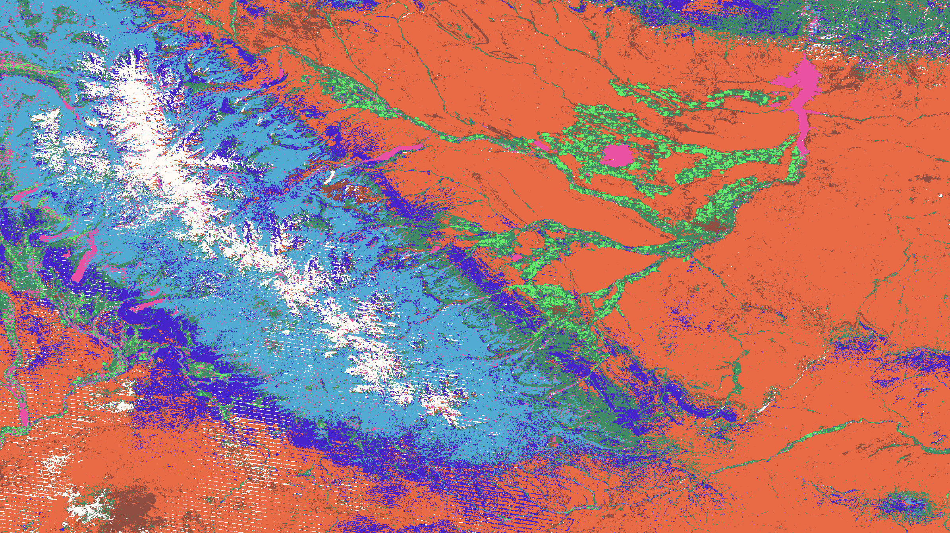

I used supervised classification with maximum likelihood to classify an area of Wyoming. I downloaded the data from Landsat off of Google Earth Engine. The area in Wyoming shown are the Wind Mountains. The landcover classes shown include barren land (orange), water (magenta), forest (light blue), healthy cropland (bright green), dark green (barren cropland), dark blue (grassland), and snow (white). I think it’s interesting how you can see the drainage channels in the map by seeing the green areas around the drainage systems.