Schuyler Williams

Geography 371 - Introduction to Remote Sensing

10/29/2015

Lab 6

**Introduction:** My goal for lab 6 was to use unsupervised classification to classify and map certain landcover within an image. I was given several images to choose from, and I decided upon the image depicting Romania. I chose Romania because at the time I was also working on another project that required the mapping of this country. Like I said previously, I used unsupervised classification to classify the landcover on this image; unsupervised classification is a method where the user specifies how many classes to break each cluster into, and the computer program separates the clusters into the user defined amount of classes. The user then analyzes the classes and the photo and determines to which general class each cluster belongs.

**Methods:** To start, I first outlined what I would want my classes to be so I had an idea going in. I broke the classes down into Evergreen forest, Deciduous forest, Mixed Forest, Grassland, Cropland, and Urban. I then ran a K-Means unsupervised classification on the image, using 35 classes with 5 iterations, giving me a moderately accurate cluster result. Once the K-Means finished I then went on to classify each spectral cluster generated. I classified each cluster based on several factors. 1) True-color imagery. 2) False-color image. 3) NDVI vegetation index. 4) Grey-scale band four. Using these various imagery, I was able to classify each spectral cluster quickly and efficiently. I also used the SPEAR feature to pinpoint precise locations in Google Earth to do further investigation for areas that I was not sure about, or areas whose spectral cluster was across the map in various locations. Using the combination of various forms of imagery and Google Earth, I was able to classify the landcover of the image. I chose to use the classification scheme of Evergreen forest, Deciduous forest, Mixed forest, Grassland, Cropland, and Urban based on preliminary Google Earth investigations of the imagery.

**Results:** The results of my unsupervised classification map can be seen below. You can almost make out the mountain ranges by reviewing the pattern of evergreen, deciduous and mixed forest. The cropland areas were largely located in the middle and northwest regions, while the forested areas made a curve through the map, following the mountain range. The forest and grassland landcover clusters seemed to work quite well, however, the cropland and urban classification was very difficult, as it was not separated into many clusters. This error can be seen as red squares indicating urban areas are present in areas of cropland and fields.

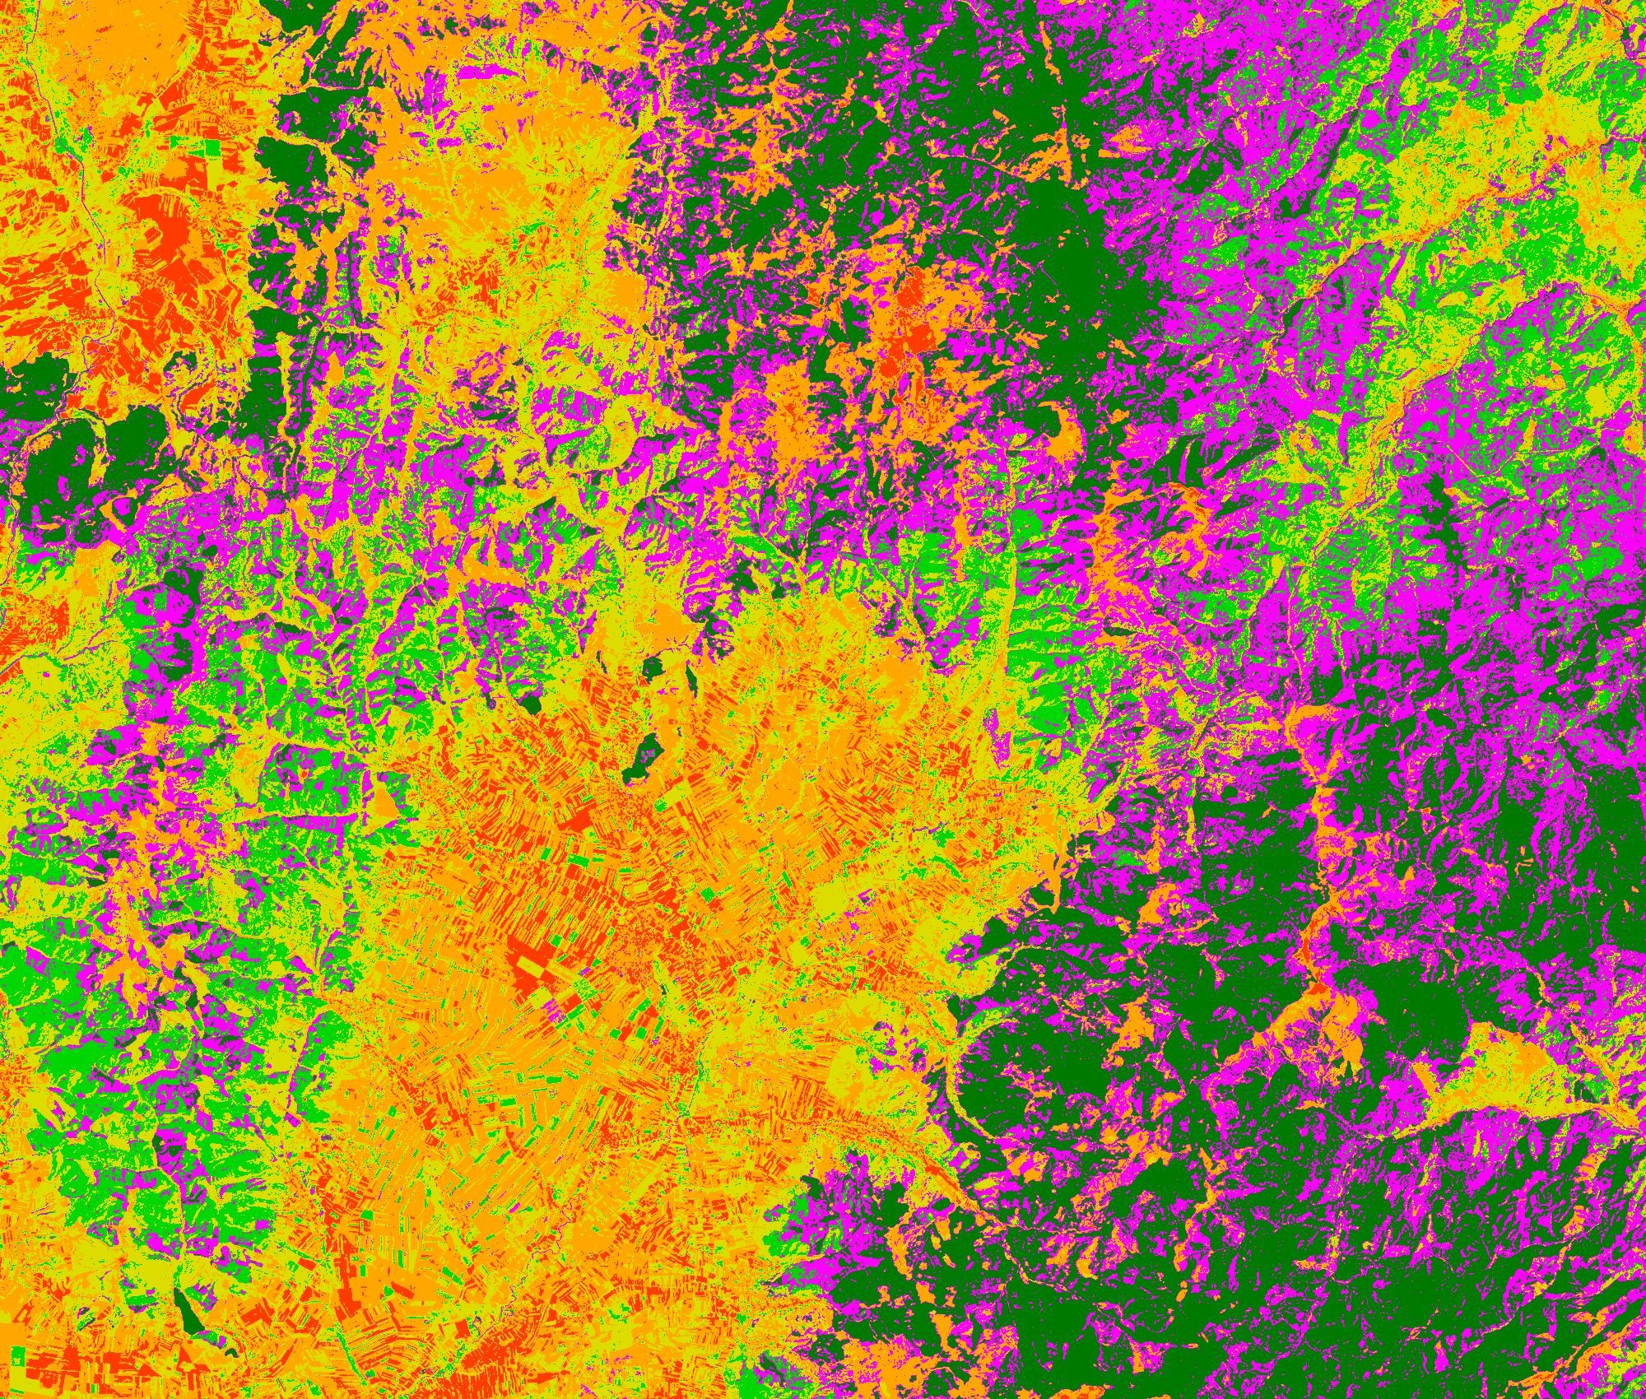

Figure 1: The map of central Romania produced using an unsupervised classification procedure. In the map, Cropland is shown in orange, Evergreen forest in dark green, Deciduous forest in bright green, Urban areas in red, Grassland in yellow, and Mixed Forest in purple.

Mixed Forest

Grassland

Urban

Deciduous Forest

Evergreen Forest

Cropland

Figure 2: Classification statistics showing the number and percentage of points belonging to each classification and spectral cluster. Evergreen forest, Mixed forest, Grassland, and Cropland are all relatively similar, while Deciduous forest and Urban are far less abundant.

| Class Name | Number of Points | Percentage of Points |
| --- | --- | --- |
| Evergreen Forest | 710406 | 20.894% |
| Mixed Forest | 767678 | 22.579% |
| Grassland | 693312 | 20.392% |
| Deciduous Forest | 390065 | 11.473% |
| Cropland | 679591 | 19.988% |
| Urban | 158948 | 4.675% |

**Discussion:** While classifying the landcover classes, the most difficult aspect was deciding between grassland and cropland, and distinguishing urban from all other classes. The grassland and cropland classes were hard to determine against because their spectral band clusters were very similar. Some areas of grassland that were located in the mountain regions had similar spectral characteristics as some types of field crops. This issue was resolved by using Google Earth and careful analysis of the imagery to determine the best fit for the spectral band in question. The urban class was very similar to barren and bright fields. This issue could have been resolved by adding more spectral clusters, which could have given me more classes to distinguish between urban and barren or soil covered fields. I could not perform this K-Means unsupervised classification again once I had started, because I lost my data file and had to start over on 10/29/2015. I do not offer this statement as an excuse, merely an explanation as the use of the word “could have been resolved” versus “was resolved.”