TAFKARR!

The App Formally Known As Rose Rooms  
Chris Andrews and David Gartzke

# Summary

The GradeTracker app would allow Rose-Hulman students to keep track of assignment grades for courses as well as provide an easy way to add classes to Google Calendar. This will give students a better idea of their course standings for professors that do not use Moodle and without all the bloat and confusion from Moodle. In addition, students will be able to quickly look up schedules of other students.

Current market solutions are complex with cluttered, poor designs. Ours will be optimized for Rose students to further eliminate clutter and bloat. GradeTracker will have a modern, simple interface with exactly what the user needs. Also, current solutions don’t have a “what’s the minimum I can get on this final to get an A” calculator. May students at Rose-Hulman want to know this during finals.

# Requirements

* Store assignment grades
* Categorize assignments by class
* Calculate class grade based on class assignments
* Categorize classes by terms
* Add courses to google calendar manually
* Pull students’ course schedule from Schedule Lookup and add to google calendar
* Search for students’ course schedules

# Mockups

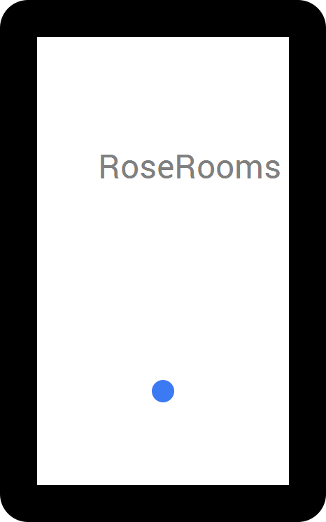

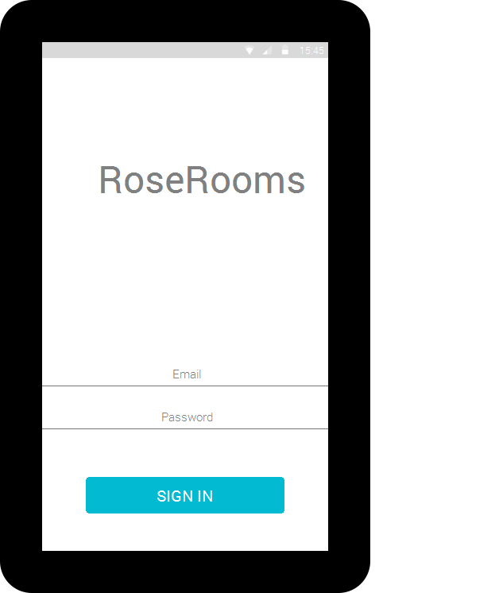

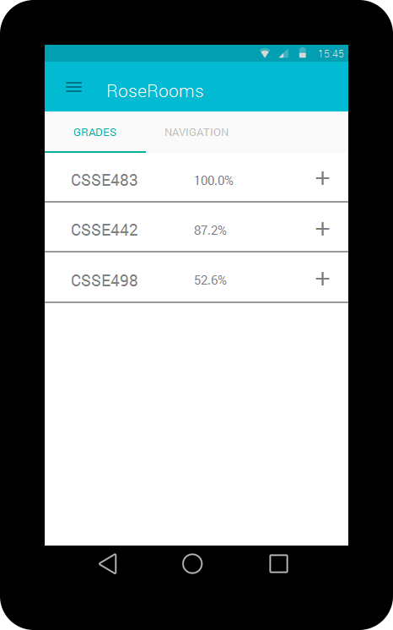

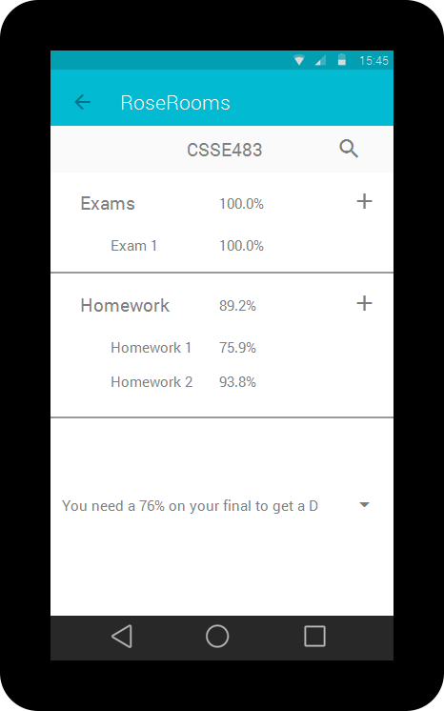

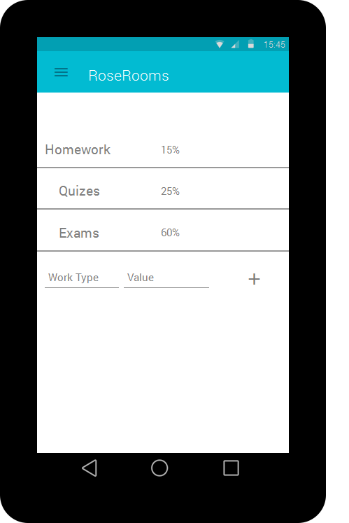

# User Stories

1. User enters correct Kerberos username and password into login screen; the program will open the course listing screen.
2. User enters incorrect KERBROS username and password into login screen; the program will open an authentication error dialog.
3. User clicks course; program shows the course specific screen.
4. User swipes left on course row; course is removed and course row is replaced with undo button temporarily.
5. User clicks on edit button on course row; program displays course edit screen.
6. User clicks on done button on course add screen; program displays course listing screen with added course.
7. User clicks grade category on course screen; list expands to show all saved assignments and scores in selected category.
8. User swipes left on category row; category is removed and category row is replaced with undo button temporarily.
9. User swipes left on assignment row; assignment is removed and assignment row is replaced with undo button temporarily.
10. User clicks on plus button on category row; program shows add assignment screen for selected course.
11. User clicks done button on assignment add screen with no or invalid information; program displays error message;
12. User clicks on done button on assignment add screen; program displays course screen with added assignment.
13. User clicks on target grade down arrow at bottom of course screen; program displays dropdown box of potential target grade.
14. User clicks on target grade from target grade down arrow dropdown box; program displays updated percentage required on final.
15. User clicks on search button on course screen; program opens keyboard and search box and displays matching categories or assignments.
16. User clicks on schedule lookup tab on course listing page; program displays blank screen with search bar and enables keyboard.
17. User enters text into schedule lookup search and clicks search; program displays matches separated by category (username, room number, course ID).
18. User clicks on result from schedule lookup search; program displays associated schedule.
19. User swipes right from left edge; program opens sidebar.
20. User clicks on sign out button on sidebar; program displays sign in screen.

# CRC cards

|  |  |
| --- | --- |
| **User** | |
| Store username and password | Course |

|  |  |
| --- | --- |
| **Course** | |
| Store and get course name Store and get resizable list of CourseCategory Get course grade  Store and get target grade | CourseCategory User |

|  |  |
| --- | --- |
| **CourseCategory** | |
| Store and get name  Store and get weight  Get category grade  Store and get resizable list of Assignment | Course Assignment |

|  |  |
| --- | --- |
| **Assignment** | |
| Store and get name  Store and get grade | CourseCategory |

# Sprint 1 Goals

* Finish layouts for all screens
* Connect layouts in appropriate order
* Login with valid Rose-Hulman Kerberos credentials

# Sprint 1 Goals Met

* Finish layouts for all screens
* Connect layouts in appropriate order
* Login with valid Rose-Hulman Kerberos credentials

# Sprint 2 Goals

* Persist grades, class, and login data
* Implement schedule lookup
* Add/edit courses and assignments manually

# Sprint 2 Goals Met

* Persist grades, class, and login data
* Implement schedule lookup

# Sprint 3 Goals

* Add/edit courses and assignments manually
* Finish implementing the rest of the user stories