# Documentation

“I Peter Schwartz (n9500375) would prefer for my partner and I to receive separate individual

marks for the assignment rather than the same average mark.”

## Group Members:

Brodie Birkett n9492143

Peter Schwartz n9500375

## Evidence of GUI functionality

### GUI: On start-up

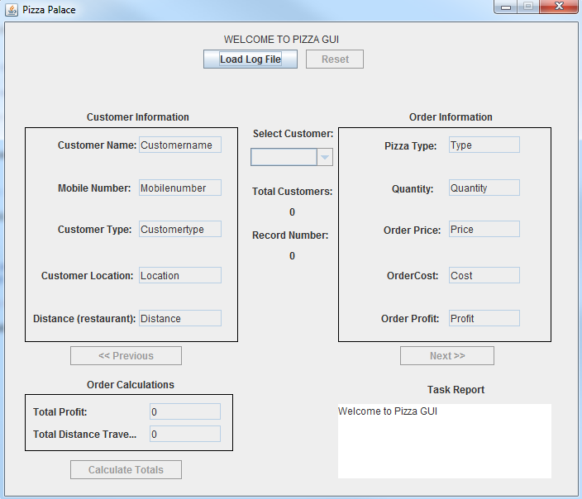

### GUI: Load Log File Button Press

**PAG** **to load Log file** - The user must be able to load a log file that is saved on disk. The functionality to request opening a file can be done via JButton or similar and actual files can be chosen via a JFileChooser. Once the log file is chosen it should be processed and analysed by the rest of the system. 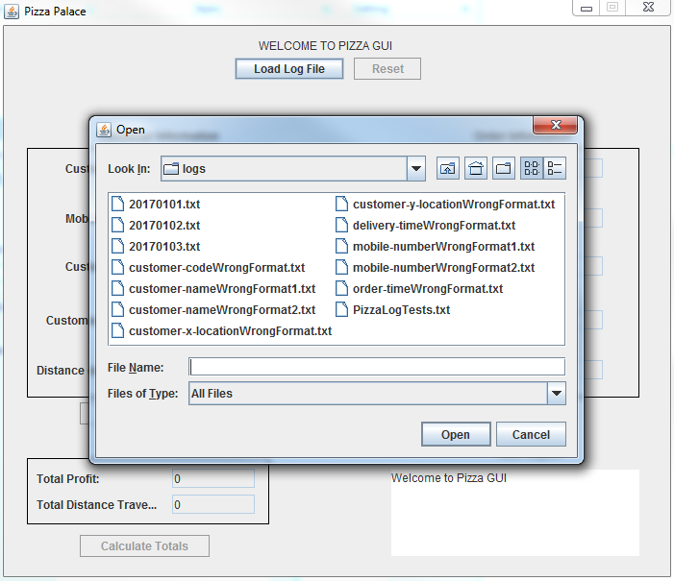

### GUI: Log File Selected (open)

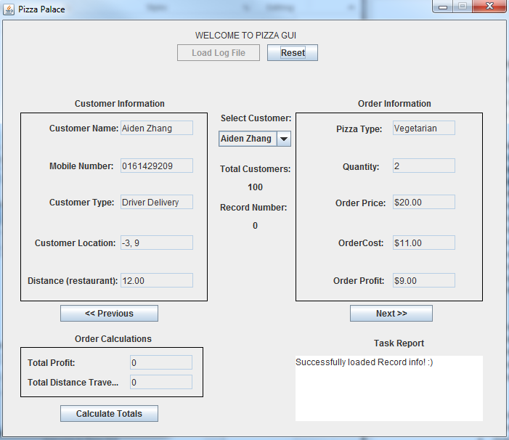

### GUI: Next button Press

**PAG to display information -** Once the information is processed the user can PAG to display the information contained in the log files. Separate components should be used to display information about the customers and the pizzas. A component such as a JTextField or JTable is suitable to display this information. The information needs to be user friendly, so the codes used to describe pizzas and customers should be translated to into pizza and customer ‘types’ using descriptive language (Margherita, Meat Lovers, Vegetarian/Pick Up, Driver Delivery, Drone Delivery). The user must not be allowed to perform this gesture unless the log file has successfully been loaded.

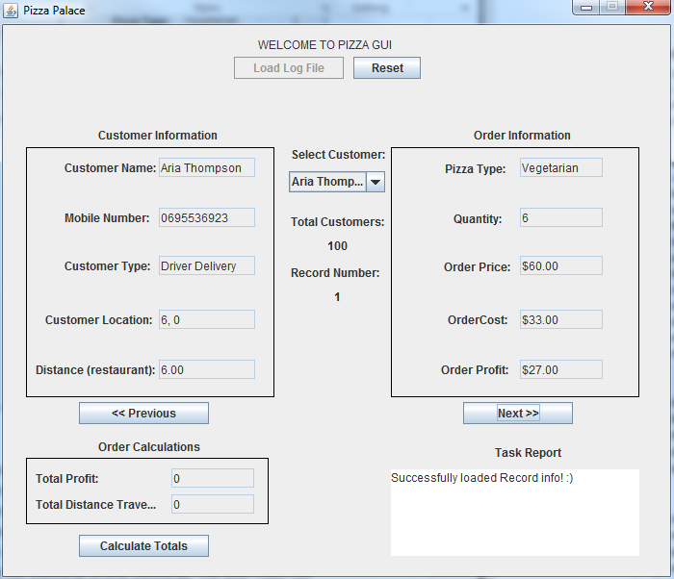

### GUI: Previous button Press

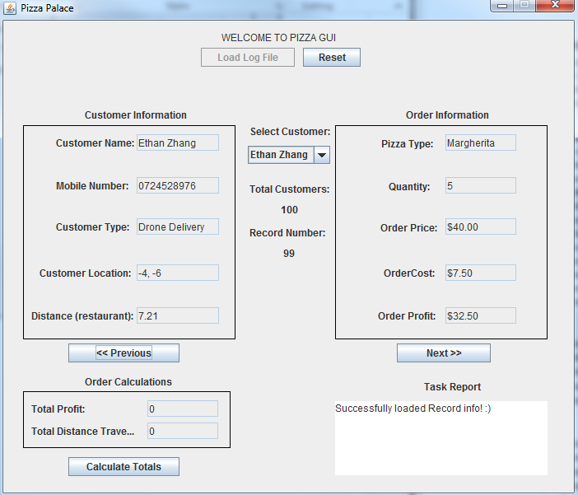

### GUI: Calculate Totals button press

**PAG to perform and display calculations** **-** Once the information is processed the user can PAG to calculate the total profit made and total distance travelled for all orders made that day. Again, separate components should be used to display each total. A component such as a JTextField is suitable to display each total. The user must not be allowed to perform this gesture unless the log file has successfully been loaded.

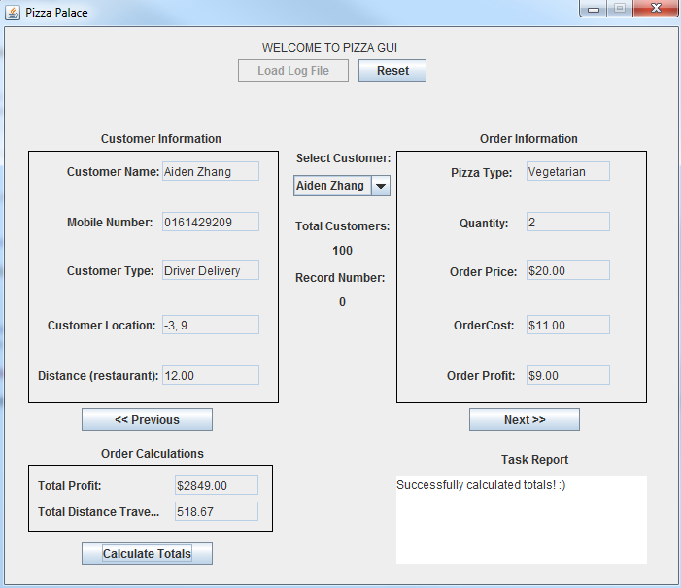

### GUI: Reset button press

**PAG to reset -** Finally, the user should be able to reset and clear all the information from the screen. All components should be also reset to their initial states. The user must not be allowed to perform this gesture unless the log file has successfully been loaded.

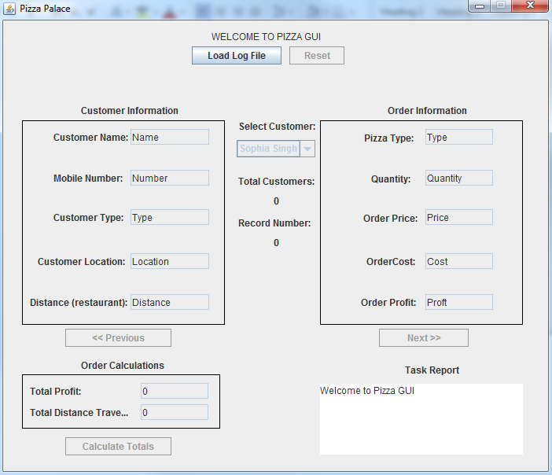

### GUI: Error Reporting

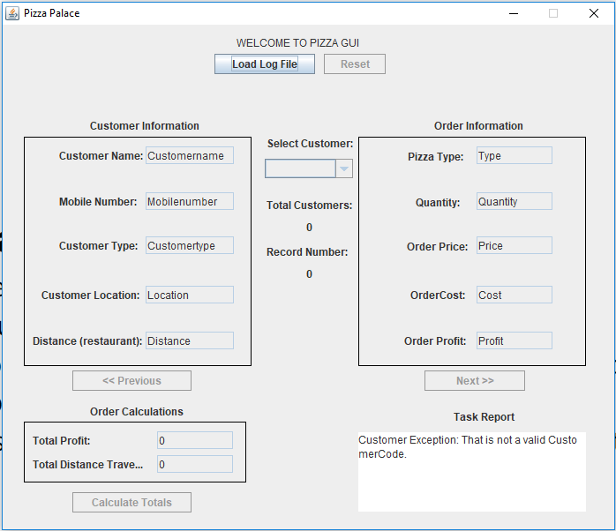All error reporting is printed to the Task Report Text Box in the lower Right-hand corner of the GUI. It prints the type of exception that was thrown and the message that was given by the program.