**DOCUMENT**

**TO DO LIST WEB SERVICE**

**Revision Sheet**

|  |  |  |
| --- | --- | --- |
| **Version** | **Date** | **Description** |
| 1.0 | 02/12/2017 | Initial version |
|  |  |  |
|  |  |  |
|  |  |  |
|  |  |  |
|  |  |  |
|  |  |  |

**TO DO LIST WEB SERVICE**

**TABLE OF CONTENTS**

Page #

A. GENERAL INFORMATION A-1

1.1 System Overview A-1

1.2 Constrain A-1

1.2.1 Environment A-1

B. API INFORMATION B-1

2.1 List All Tasks B-1

2.2 List A Single Task B-2

2.3 Add Task B-3

2.4 Edit Task B-4

2.5 Set Task Status B-5

2.6 Delete Task B-6

C. GETTING STARTED C-1

3.1 Installation C-1

D. Appendix D-1

**1.0 GENERAL INFORMATION**

# GENERAL INFORMATION

## 1.1 System Overview

This is API Service for to do list webservice including 6 functions

* View all items in the list
* View a single task in the list
* Add a task to the list
* Edit existing task
* Set the task status
* Delete a task from the list

## 1.2 Constrain

### 1.2.1 Environment

|  |  |
| --- | --- |
| Tool |  |
| Mongo DB | Collection named “tasks” |
| JDK | Version 1.7 or later |

# API INFORMATION

## 2.1 List All Tasks

|  |  |
| --- | --- |
| Title | View all items in the list |
| URL | */todo/tasks* |
| Method | **GET** |
| Header | **Content-type:** application/json |
| URL Params | - |
| Data Params | - |
| Response Data | [  {  "id": "5a1ffe9c1586a204b4073ff3",  "subject": "do homework",  "detail": "english homework",  "status": "waiting"  },  {  "id": "5a1ffee51586a22450a99287",  "subject": "play game",  "detail": "dota time",  "status": "playing"  },  {  "id": "5a1ffeee1586a22450a99288",  "subject": "play game2",  "detail": "dota time",  "status": "process"  },  {  "id": "5a1fff7b1586a224a8fe5f98",  "subject": "listen music",  "detail": "rock music",  "status": "process"  }  ] |
| Success Response | **Code:** 200  **Content:** Success |
| Error Response | **Code:** 500 INTERNAL SERVER ERROR **Description:** Server Error |

## 2.2 List A Single Task

|  |  |
| --- | --- |
| Title | View a single task in the list |
| URL | */todo/tasks/{id}* |
| Method | **GET** |
| Header | **Content-type:** application/json |
| URL  Params | **Required:**  id=[String]  example: id=5a1ffe9c1586a204b4073ff3 |
| Data  Params | - |
| Response Data | {  "id": "5a1ffe9c1586a204b4073ff3",  "subject": "do homework",  "detail": "english homework",  "status": "waiting"  } |
| Success Response | **Code:** 200  **Content:** Success |
| Error Response | **Code:** 404 NOT FOUND  **Description:** Task not found  **Code:** 500 INTERNAL SERVER ERROR **Description:** Server Error |

## 2.3 Add Task

|  |  |
| --- | --- |
| Title | Add a task to the list |
| URL | */todo/tasks* |
| Method | **POST** |
| Header | **Content-type:** application/json |
| URL  Params | **-** |
| Data  Params | {  "subject": "do homework",  "detail": "english homework",  "status": "waiting"  } |
| Response Data | - |
| Success Response | **Code:** 200  **Content:** Success |
| Error Response | **Code:** 400 BAD REQUESTS  **Description:** Invalid Parameters  **Code:** 500 INTERNAL SERVER ERROR **Description:** Server Error |

## 2.4 Edit Task

|  |  |
| --- | --- |
| Title | Edit existing task |
| URL | */todo/tasks/{id}* |
| Method | **PUT** |
| Header | **Content-type:** application/json |
| URL  Params | **Required:**  id=[String]  example: id=5a1ffe9c1586a204b4073ff3 |
| Data  Params | {  "subject": "do homework",  "detail": "english homework",  "status": "waiting"  } |
| Response Data | - |
| Success Response | **Code:** 200  **Content:** Success |
| Error Response | **Code:** 400 BAD REQUESTS  **Description:** Invalid Parameters  **Code:** 404 NOT FOUND  **Description:** Task not found  **Code:** 500 INTERNAL SERVER ERROR **Description:** Server Error |

## 2.5 Set Task Status

|  |  |
| --- | --- |
| Title | Set status of task |
| URL | */todo/tasks/status/{id}* |
| Method | **PUT** |
| Header | **Content-type:** application/json |
| URL  Params | **Required:**  id=[String]  example: id=5a1ffe9c1586a204b4073ff3 |
| Data  Params | “waiting” |
| Response Data | - |
| Success Response | **Code:** 200  **Content:** Success |
| Error Response | **Code:** 400 BAD REQUESTS  **Description:** Invalid Parameters  **Code:** 404 NOT FOUND  **Description:** Task not found  **Code:** 500 INTERNAL SERVER ERROR **Description:** Server Error |

## 2.6 Delete Task

|  |  |
| --- | --- |
| Title | Delete a task from the list |
| URL | */todo/tasks /{id}* |
| Method | **DELETE** |
| Header | **Content-type:** application/json |
| URL  Params | **Required:**  id=[String]  example: id=5a1ffe9c1586a204b4073ff3 |
| Data  Params | - |
| Response Data | - |
| Success Response | **Code:** 200  **Content:** Success |
| Error Response | **Code:** 404 NOT FOUND  **Description:** Task not found  **Code:** 500 INTERNAL SERVER ERROR **Description:** Server Error |

**3.0 GETTING STARTED**

# GETTING STARTED

## 3.1 Installation

1. Setting config in file application.properties

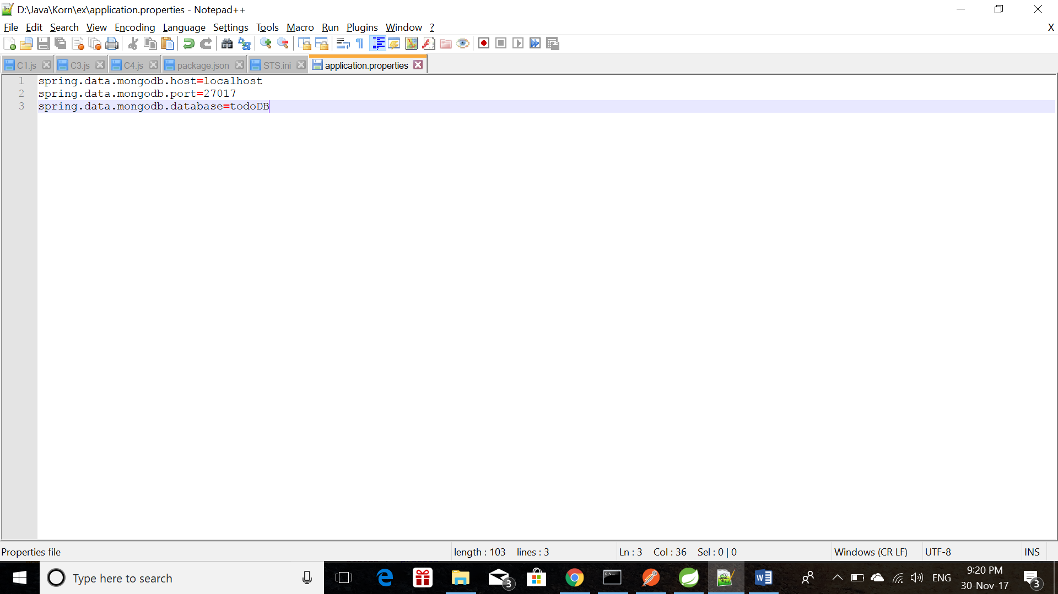

|  |  |
| --- | --- |
| Config Name | Config Value |
| spring.data.mongodb.host | IP address of your database server |
| spring.data.mongodb.port | Port of your database server |
| spring.data.mongodb.database | Database name |

1. Open command line
   1. Go to folder placed the todo-api-service.jar file
   2. Type command “java -jar todo-api-service.jar –spring.config.name=application”

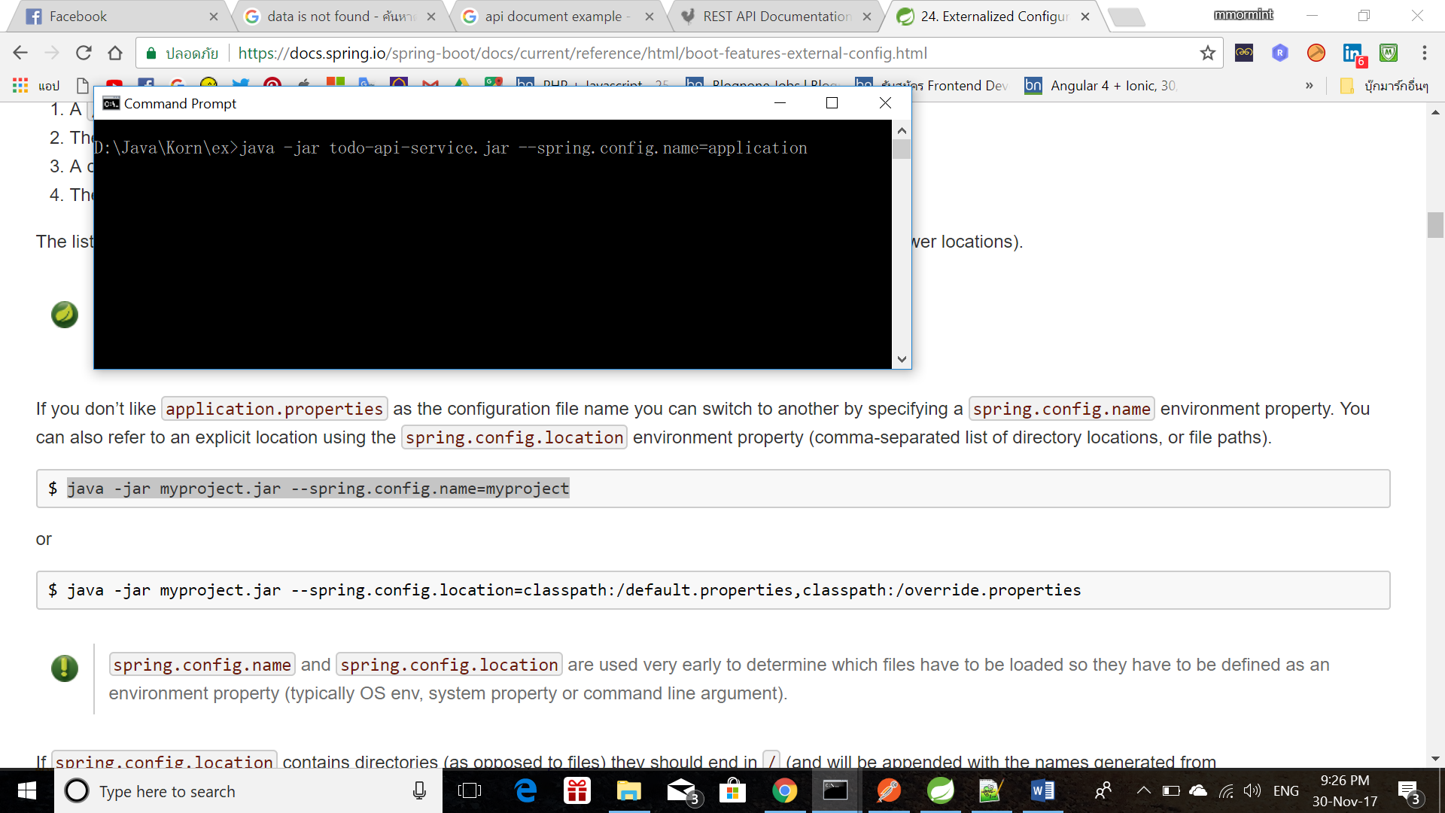

* 1. 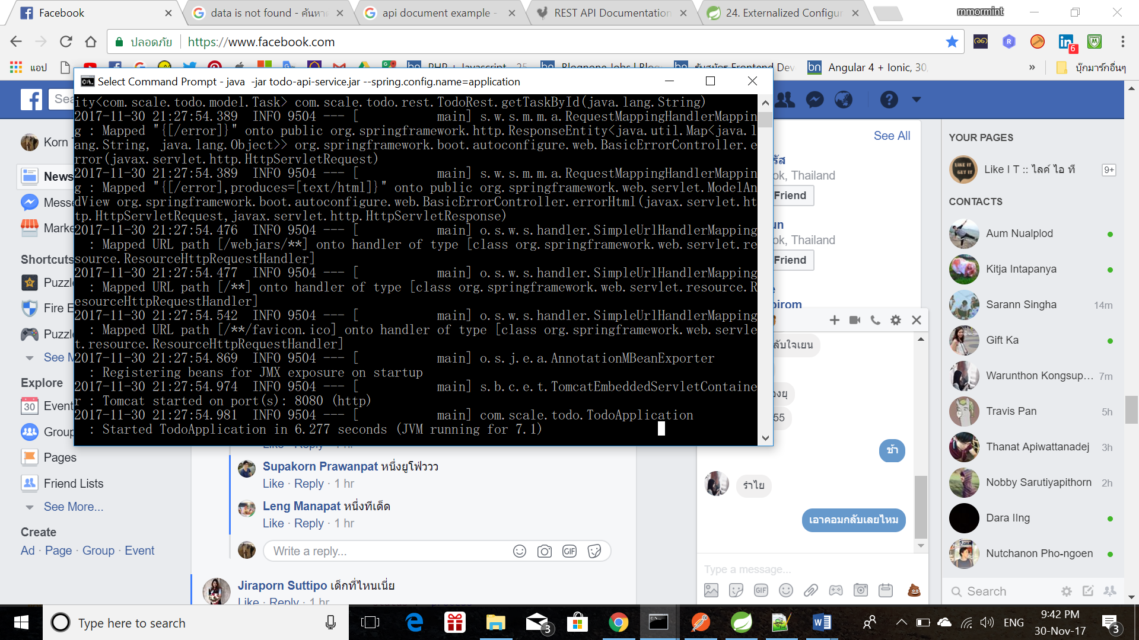Wait until service is running

# Appendix

*Functions:*

* *List All Tasks*

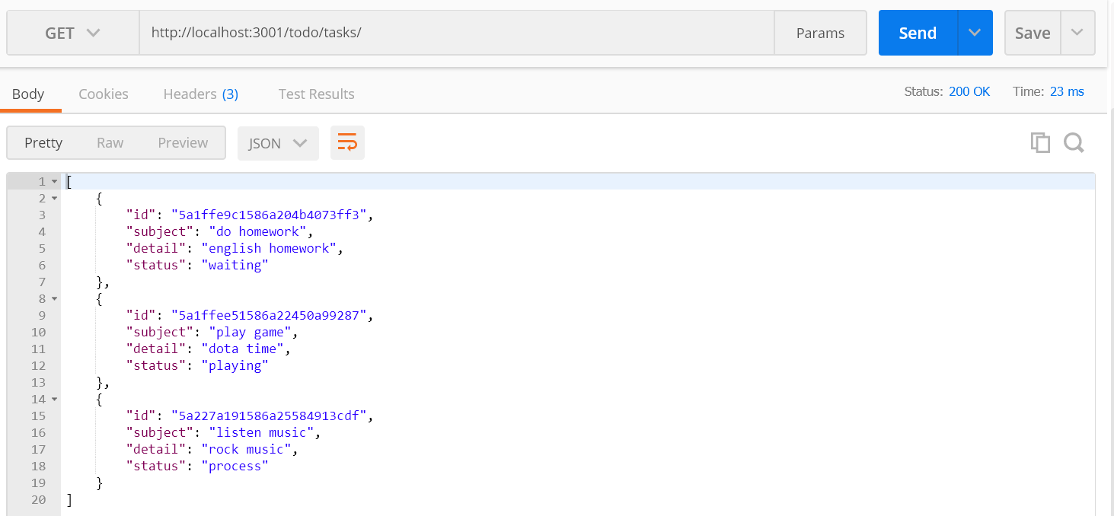

* *List A Single Tasks*

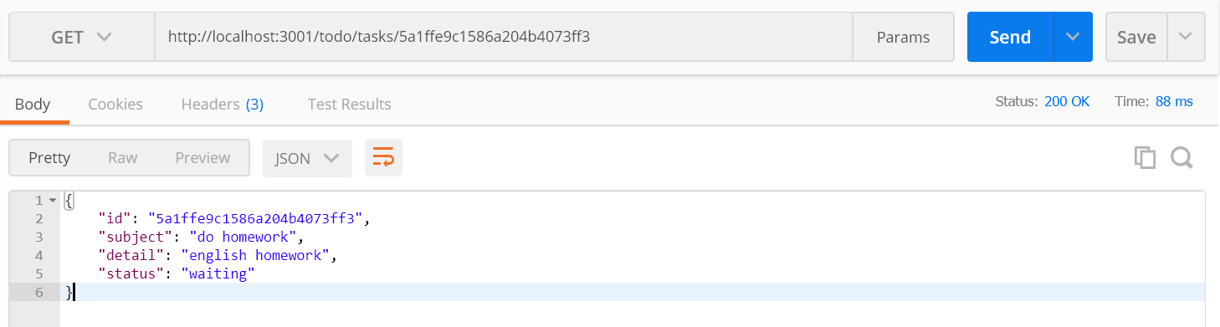

* *Add Task*

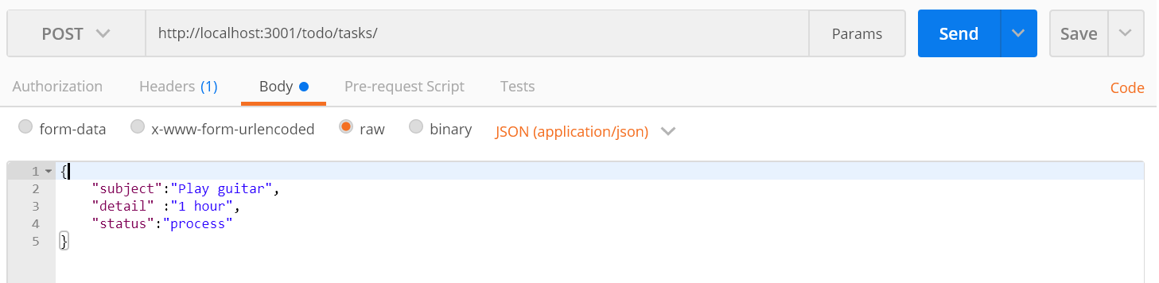

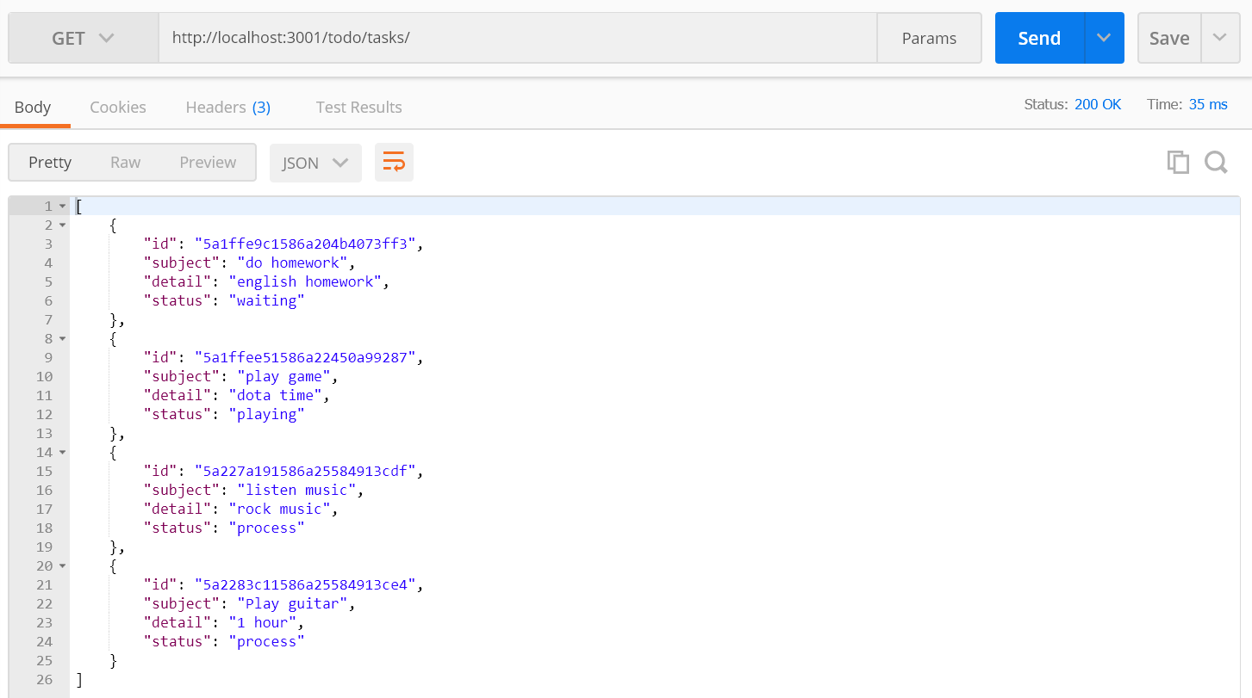

* *Edit Task*

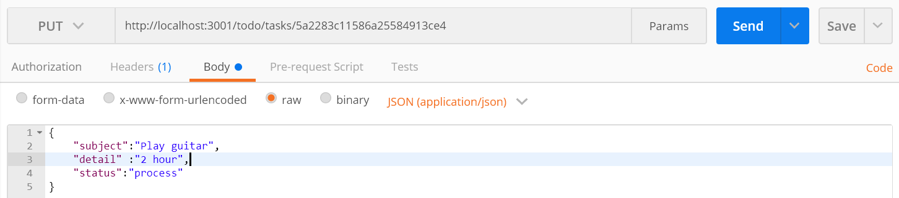

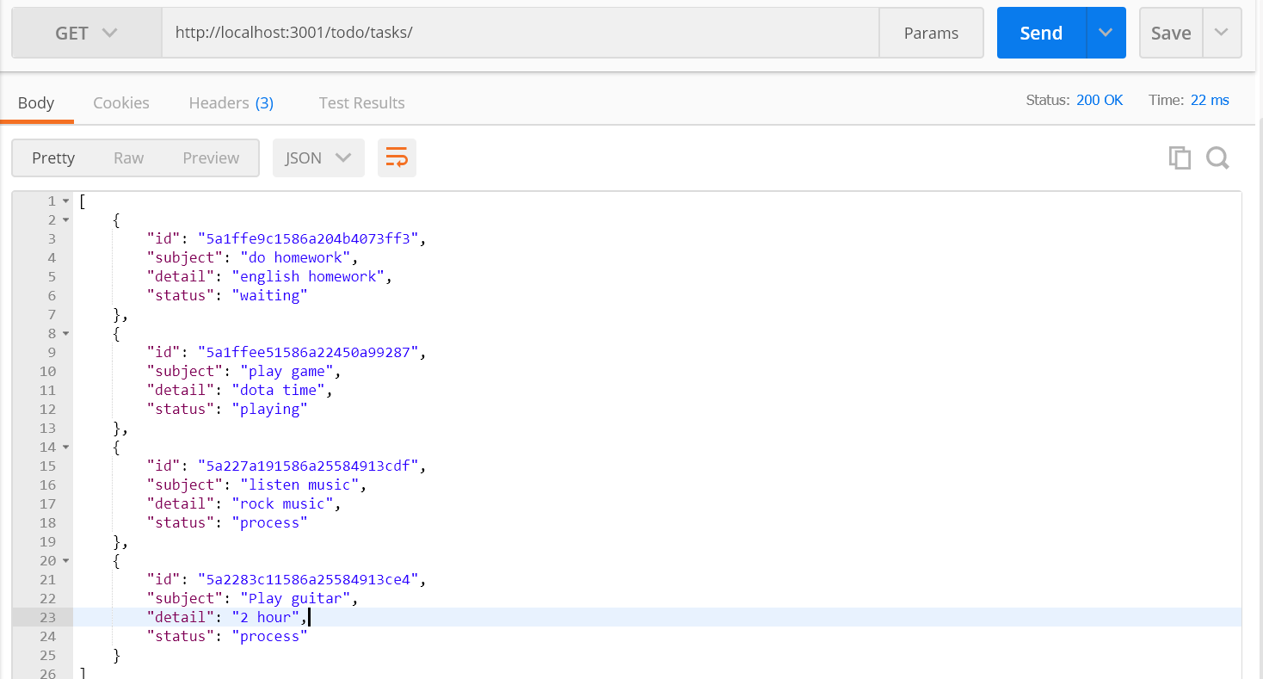

* *Set Task Status*

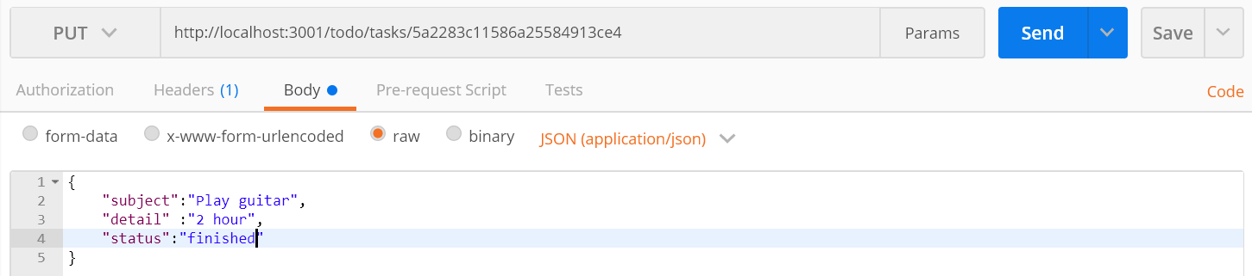

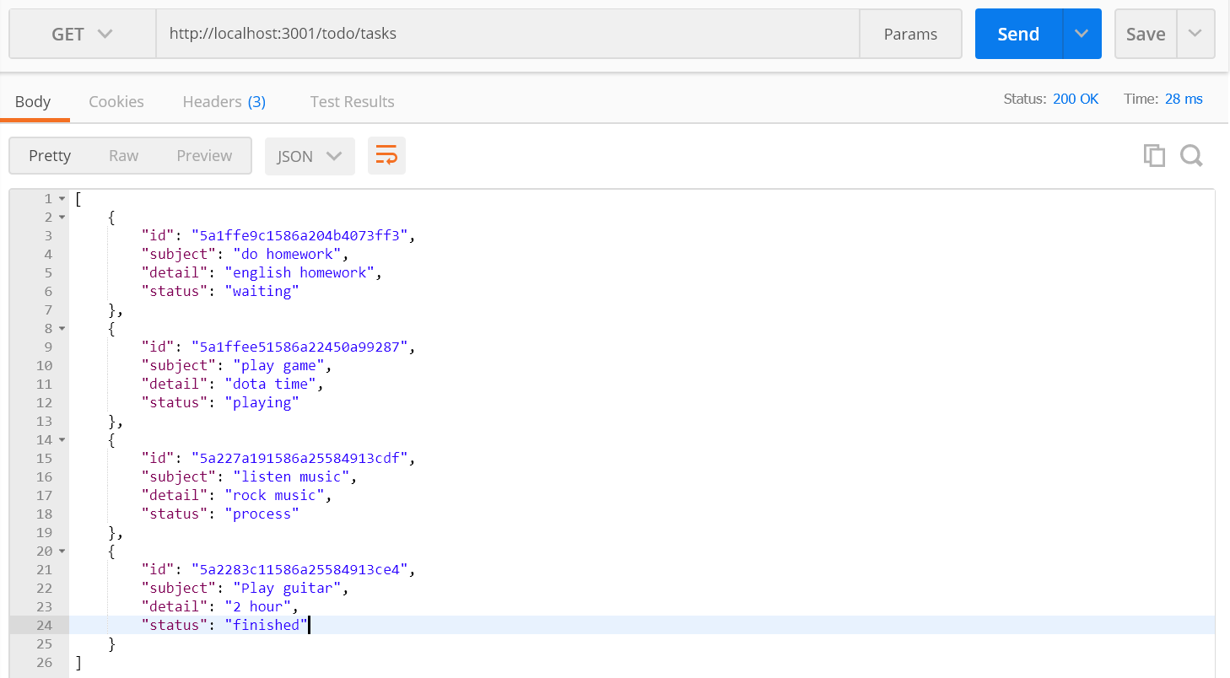

* *Delete Task*

