Figure Captions

Figure 1: Geographic distribution of data sources. Each triangle represents a study site.

Figure 2: Thinning treatments caused an increase in exotic species richness compared with control treatments (p=0.0005).

Figure 3: Burning treatments caused a decrease in shrub cover when compared with control treatments (p=0.0344).

...

Tables

Table 1. Papers with data included in this study.

|  |  |  |  |  |  |  |  |  |  |  |  |
| --- | --- | --- | --- | --- | --- | --- | --- | --- | --- | --- | --- |
| Paper | Year | Journal | Location | Measurements | Fire Intensity | State | Forest Type | Fuel Type | Years Since Treatment | Latitude | Longitude |
| Collins et al 2007 | 2007 | Forest Ecology & Management | Blodgett Forest Research Station, California | Percent Cover, Species Richness | Medium | California | Mixed Conifer | litter | 2 | 38.88629 | -120.648 |
| Dodson et al 2007 | 2007 | Restoration Ecology | Lubrecht Experimental Forest, Montana | Percent Cover, Species Richness | Low | Montana | Ponderosa Pine/Douglas Fir | grass | 3.5 | 46.8916 | -113.434 |
| Dodson 2004 | 2004 | Dissertation at University of Montana | Lubrecht Experimental Forest, Montana | Percent Cover | Low | Montana | Ponderosa Pine | grass | 2.5 | 46.8916 | -113.434 |
| Fornwalt et al 2010 (RL) | 2010 | Biological Invasions | Pike National Forest, Colorado | Percent Cover, Species Richness | Low | Colorado | Ponderosa Pine/Douglas Fir | grass | 2 | 39.1833 | -105.317 |
| Fornwalt et al 2010 (UH) | 2010 | Biological Invasions | Pike National Forest, Colorado | Percent Cover, Species Richness | High | Colorado | Ponderosa Pine/Douglas Fir | grass | 2 | 39.1833 | -105.317 |
| Fornwalt et al 2010 (UL) | 2010 | Biological Invasions | Pike National Forest, Colorado | Percent Cover, Species Richness | Low | Colorado | Ponderosa Pine/Douglas Fir | grass | 2 | 39.1833 | -105.317 |
| Fornwalt et al 2010 (UM) | 2010 | Biological Invasions | Pike National Forest, Colorado | Percent Cover, Species Richness | Medium | Colorado | Ponderosa Pine/Douglas Fir | grass | 2 | 39.1833 | -105.317 |
| Fornwalt et al 2014 (R) | 2014 | Journal of Vegetation Science | Pike National Forest, Colorado | Percent Cover, Species Richness | Low | Colorado | Ponderosa Pine/Douglas Fir | grass | 2 | 39.1833 | -105.317 |
| Fornwalt et al 2014 (U) | 2014 | Journal of Vegetation Science | Pike National Forest, Colorado | Percent Cover, Species Richness | Medium | Colorado | Ponderosa Pine/Douglas Fir | grass | 2 | 39.1833 | -105.317 |
| FulÃ© et al 2005 | 2005 | Forest Ecology and Management | Kaibab National Forest, Arizona | Percent Cover, Species Richness | Low | Arizona | Pine-Oak Forest | grass | 4 | 35.2432 | -112.19 |
| Huffman et al 2013 | 2013 | Forest Ecology and Management | Kaibab NF, Arizona | Percent Cover, Species Richness | Low | Arizona | Pinyon Juniper Woodlands | grass | 5 | 35.2432 | -112.19 |
| Kane et al 2010 | 2010 | Applied Vegetation Science | Challenge Experimental Forest, California | Percent Cover, Species Richness | Medium | California | Ponderosa Pine | grass | 4 | 39.29 | -121.13 |
| Kerns et al 2006 | 2006 | Ecoscience | Malheur NF, Oregon | Percent Cover, Species Richness | Low | Oregon | Ponderosa Pine | grass | 5 | 44.10444 | -118.656 |
| Knapp et al 2006 | 2006 | Canadian Journal of Forest Research | Sequoia National Park | Percent Cover, Species Richness | Medium | California | Mixed Conifer | litter | 3 | 36.43345 | -118.685 |
| Laughlin et al 2008 | 2008 | Plant Ecology | Coconino National Forest, Arizona | Species Richness | NA | Arizona | Ponderosa Pine | grass | 3 | 34.9249 | -111.736 |
| Mason et al 2009 (BA) | 2009 | Forest Ecology & Management | Lincoln National Forest, New Mexico | Percent Cover | NA | New Mexico | Mixed Conifer | litter | 1 | 32.88638 | -105.688 |
| Mason et al 2009 (CO) | 2009 | Forest Ecology & Management | Lincoln National Forest, New Mexico | Percent Cover | NA | New Mexico | Mixed Conifer | litter | 2 | 32.88638 | -105.688 |
| Mason et al 2009 (SL) | 2009 | Forest Ecology & Management | Lincoln National Forest, New Mexico | Percent Cover | NA | New Mexico | Mixed Conifer | litter | 2 | 32.88638 | -105.688 |
| Metlen and Fiedler 2006 | 2006 | Forest Ecology & Management | Lubrecht Experimental Forest, Montana | Percent Cover, Species Richness | Low | Montana | Ponderosa Pine/Douglas Fir | grass | 2 | 46.8916 | -113.434 |
| Nelson et al 2008 | 2008 | Ecological Applications | Colville, Okanogan, Wenatchee National Forests, Washington | Percent Cover | Low | Washington | Ponderosa Pine | grass | 8 | 48.67507 | -119.855 |
| O'Connor et al 2013 | 2013 | Environmental Management | High Desert Ecological Province, Oregon | Percent Cover | NA | Oregon | Pinyon Juniper Woodlands | grass | 2 | 43.75361 | -118.918 |
| Phillips and Hutchinson 2007 (OH) | 2007 | USDA Forest Service Proceedings | Central Appalachian Plateau in Ohio and Southern Appalachian Mountains in North Carolina | Percent Cover, Species Richness | Medium | Ohio | Mixed Oak Forests | litter | 2 | 38.94118 | -82.2546 |
| Phillips and Hutchinson 2007 (SA) | 2007 | USDA Forest Service Proceedings | Central Appalachian Plateau in Ohio and Southern Appalachian Mountains in North Carolina | Percent Cover, Species Richness | Medium | Ohio | Mixed Oak Forests | litter | 2 | 39.1773 | -82.9795 |
| Phillips and Waldrop 2007 | 2008 | Forest Ecology & Management | Clemson Experimental Forest, South Carolina | Percent Cover | Medium | South Carolina | Pinus taeda/Pinus echinata forests | litter | 2 | 35.0276 | -82.4194 |
| Provencher and Thompson 2014 | 2014 | Rangeland Ecology and Management | Smith Valley, Utah | Percent Cover | NA | Nevada | Pinyon Juniper Woodlands | grass | 4 | 39.26 | -114.575 |
| Scudieri and Sieg 2010 (CH) | 2010 | Forest Ecology & Management | Fort Valley EF and Long Valley EF in Coconino NF, Arizona | Percent Cover, Species Richness | Low | Arizona | Ponderosa Pine | grass | 2 | 34.9249 | -111.736 |
| Scudieri and Sieg 2010 (LI) | 2010 | Forest Ecology & Management | Fort Valley EF and Long Valley EF in Coconino NF, Arizona | Percent Cover, Species Richness | Low | Arizona | Ponderosa Pine | grass | 2 | 34.9249 | -111.736 |
| Waldrop et al 2010 | 2010 | Forest science | Southern Appalachian Mountain, North Carolina | Percent Cover | Medium | North Carolina | Mixed Oak Forests | litter | 3 | 35.29536 | -83.9795 |
| Waldrop et al 2008 (GR) | 2008 | Forest Ecology & Management | Green River Site, North Carolina and Ohio Hills, Ohio | Percent Cover | Medium | North Carolina | Mixed Oak Forests | litter | 2 | 35.28333 | -82.2833 |
| Waldrop et al 2008 (OH) | 2008 | Forest Ecology & Management | Green River Site, North Carolina and Ohio Hills, Ohio | Percent Cover | Medium | Ohio | Mixed Oak Forests | litter | 2 | 39.2 | -82.3833 |
| Weekley et al 2013 | 2013 | Southern Appalachian Botanical Society | Lake Wales Ridge State Forest, Florida | Percent Cover | Medium | Florida | Longleaf Pine | grass | 2 | 27.67972 | -81.4361 |
| Wienk et al 2004 | 2004 | Forest Ecology & Management | Badger Game Production Area, South Dakota | Species Richness | Low | South Dakota | Ponderosa Pine | grass | 2 | 44.44485 | -103.903 |
| Wolk and Rocca 2009 | 2009 | Forest Ecology & Management | Heil Valley Ranch, Colorado | Percent Cover, Species Richness | NA | Colorado | Ponderosa Pine | grass | 3 | 40.14941 | -105.3 |
| Youngblood et al 2006 | 2006 | Forest Ecology & Management | Blue Mountains, Oregon | Percent Cover | Low | Oregon | Ponderosa Pine/Douglas Fir | grass | 5 | 45.72738 | -117.273 |
| Zald et al 2008 | 2008 | Forest Ecology & Management | Teakettle Experimental Forest, California | Percent Cover | Medium | California | Mixed Conifer | litter | 1.5 | 36.96667 | -119.017 |
| Zhang et al 2008 | 2008 | Canadian Journal of Forestry | Blacks Mountain Experimental Forest, California | Percent Cover | NA | California | Ponderosa Pine | grass | 5 | 40.73027 | -121.15 |

Table 2. Contrast coefficient estimates (b), z-values (z) and adjusted p-values (p) for treatment contrasts.

|  |  |  |  |  |  |  |  |  |  |
| --- | --- | --- | --- | --- | --- | --- | --- | --- | --- |
| Response | Burn-Control coefficient | Burn-Control zval | Burn-Control adj. p | Burn-Thin coefficient | Burn-Thin zval | Burn-Thin adj. p | Thin-Control coefficient | Thin-Control zval | Thin-Control adj. p |
| exotic-richness | 0.646 | 2.61 | 0.0626 | -0.449 | -1.71 | 0.434 | 0.912 | 3.97 | 0.000543 |
| herb-cover | 0.237 | 0.784 | 0.845 | -0.374 | -0.972 | 0.845 | 0.39 | 1.32 | 0.787 |
| s-cover | -0.914 | -1.98 | 0.31 | -1.3 | -1.36 | 0.787 | 0.473 | 1.08 | 0.845 |
| total-cover | -0.223 | -1.19 | 0.817 | -1.87 | -1.94 | 0.31 | 0.551 | 1.97 | 0.31 |
| total-richness | 0.0521 | 0.207 | 0.845 | -0.154 | -0.237 | 0.845 | 0.284 | 0.961 | 0.845 |

Figure 1. Geographic distribution of data sources. Each triangle represents a study site.

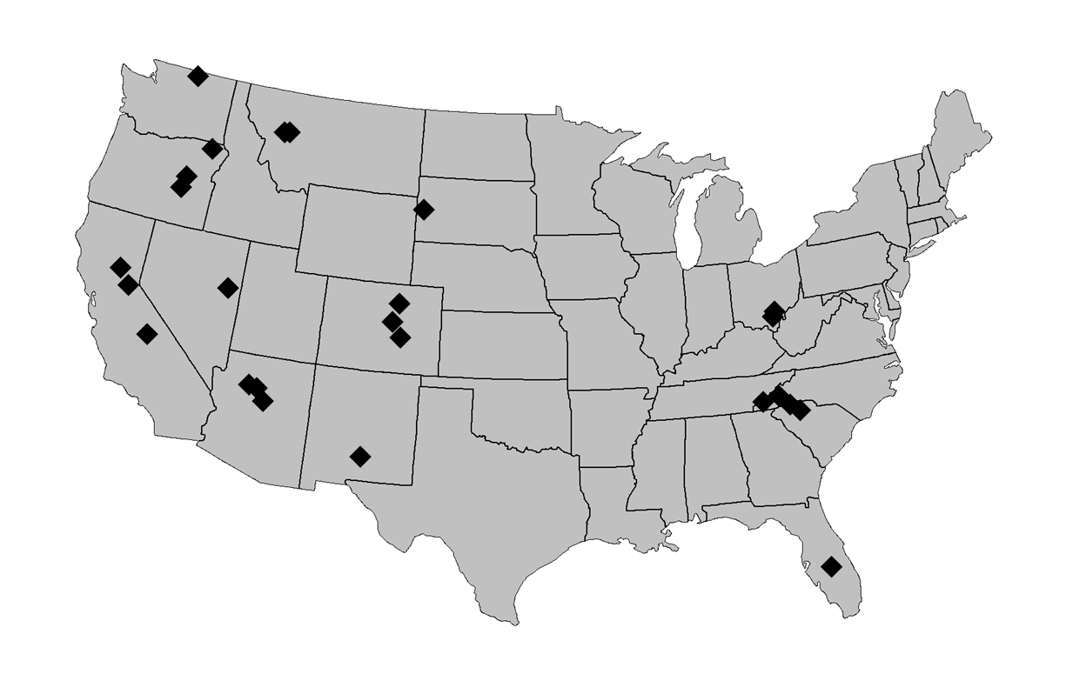

Figure 2. Thinning treatments caused an increase in exotic species richness compared with control treatments (p=0.0005).

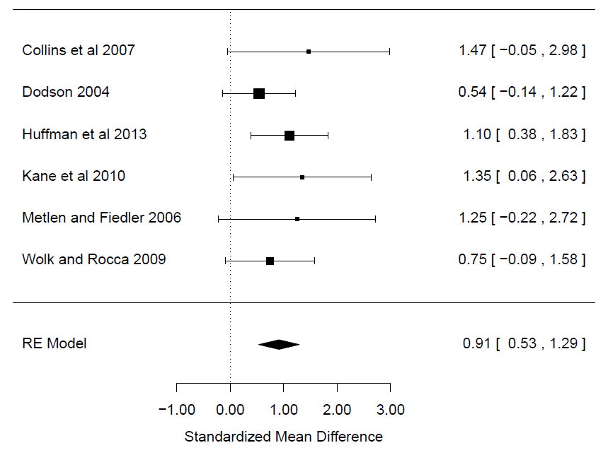

Figure 3. Burning treatments caused a decrease in shrub cover when compared with control treatments (p=0.0344).

