# First year report: Ion transport and selectivity in salt-rejecting membranes operating at elevated salinities and pressures

**Research Objectives**

***The overall goal of the proposed research*** is to elucidate the impact of high salinity and pressure on ion transport in salt-rejecting polymeric membranes using membrane transport experiments and molecular simulations. The PIs from both the U.S. (PI Straub and co-PI Shirts, CU Boulder) and Israel (PI Epsztein, Technion) will collaborate to (i) establish a systematic data set of salt permeabilities for different polyamide membranes under varying salinities and pressures; (ii) develop a fundamental understanding of ion (e.g., hydrated radius and hydration strength) and membrane (e.g., pore size and charge) properties under high concentrations and pressures; (iii) identify molecular mechanisms underlying ion transport and selectivity in salt-rejecting membranes; and (iv) utilize knowledge gained to develop membranes with improved selective properties. These four objectives are based around one central hypothesis and integrated with the education and outreach activities detailed in the Broader Impacts section.

# Main Progress and Accomplishments

Considering our goal mentioned above to understand the effect of solution ions on polyamide membranes, we first explored the effect of ion type and concentration on the charge and performance of a polyamide membrane that is commonly used in the industry. Specifically, we systematically evaluated the zeta potential (ZP, *ζ*) of the membrane under different conditions of pH, salinity, and ionic composition, and correlated the obtained data with membrane performance tested under similar conditions (**Fig. 1**). Our results show that for salinity higher than 1 mM (regardless of the tested cation or the pH), higher salt concentration resulted in better charge screening and thus reduced absolute value of ZP (|*ζ*|, **Fig. 1A-C**). However, deeper examination of the effect of solution ions on ZP at low salinity conditions (< 1 mM) demonstrates a different trend where increasing salinity leads to a decreased *ζ*, suggesting that adsorption of Cl- ions to uncharged segments of the membrane is a prominent factor for highly diluted solutions. More specifically, under the conditions of negatively charged fixed groups (i.e., pH ≥ 4.5, **Fig. 1B-C**) and very low salt concentrations (i.e., salinity < 1 mM), chlorides stick to the membrane surface to higher extent than the cations38, presumably due to the higher polarizability (and therefore “stickiness”) of chlorides compared to the cations. As a result, elevated membrane negative charge (i.e., lower *ζ*) is attained by elevating the concentration of Cl- in the solution. At higher salinities (> 1 mM), however, it is likely that chloride adsorption reaches its maximum and charge screening by the solution cations becomes prominent, leading to a decrease in the absolute value of *ζ*. To support the effect of Cl- adsorption on membrane charge at low salinities, we examined the effect of salinity on *ζ* at pH 2.6 (**Fig. 1A**), where membrane fixed groups are slightly positive and therefore both phenomena (i.e., charge screening and chloride adsorption) are expected to impact *ζ* in the same manner. **Fig. 1A** shows a consistent trend of decrease in *ζ* with the increase of salinity, corroborating the hypothesis of Cl- adsorption being the prominent factor effecting ZP at low salinities.

**Fig. 2. Effects of specific conditions on the zeta potential of the NF270 membrane.** The membrane was in contact with single-salt solutions of CsCl (blue squares) or LiCl (green triangles) at various concentrations and pH values. (A-C) Average (n=4) *ζ* obtained for solutions of different concentrations of CsCl and LiCl at 21 ± 2 °C and pH 2.62 ± 0.15, pH 4.51 ± 0.02, and pH 8.9 ± 0.37, respectively. (D) The stickiness tendency of Cs+ (compared to Li+) is noticeable only for 1 mM solutions (glowing symbols) at pH > 5.5. At high ionic strength, the |*ζ*| is lower as the electric double layer is compressed.

It was recently shown that even ions possessing similar hydrated size and charge show different permeabilities through NF membranes. Such differences in the transmembrane permeation of similar ions stem from delicate and more complex molecular-level interactions beyond simple size and charge exclusion. Similarly, the differences in “stickiness” of Li+ and Cs+ can explain the different *ζ* values attained with CsCl and LiCl solutions (**Fig. 1D**). Noticeably, at high pH (> 6) the CsCl solution has a less negative *ζ* than LiCl, which can be attributed to Cs+ ‘s softer hydration shell or lower hydration enthalpy, which facilitates its increased adsorption to the surface compared to Li+. In particular, our results demonstrate that the differences in the ZP values achieved with similar ions are most noticeable for moderate concentrations (between 0.5 and 1 mM), presumably due to the screening effect at higher concentrations that outcompetes ion-specific effects.

We discussed above the notion that chloride anions adsorb to the membrane surface, rendering the membrane charge more negative. It was shown before that polarizable ions experience free energy minimum at the water-organic phase interface. Therefore, a likely explanation for the seemingly low membrane *ζ* values is Cl- adsorption to neutral segments of the membrane surfacedue to its enhanced “stickiness” properties (i.e., weakly hydrated and highly polarizable); this explanation was further investigated experimentally, as discussed below. Ion concentrations in the membrane were probed using X-ray photoelectron spectroscopy (XPS) measurements for membranes that were soaked in NaCl solution (and then thoroughly rinsed with DI water), which demonstrated the adsorption of the salt ions to the membranes (**Fig. 2A**). More specifically, we observed an increase in the atomic fraction of both sodium and chlorine on the membrane surface after soaking the polyamide membrane in only 1 mM solution of NaCl as compared to soaking in DI water. We note that it is highly reasonable that despite being less “sticky”, the sodium fraction is higher than that of chlorine due to electroneutrality requirements (i.e., adsorption of each chloride anion is accompanied by adsorption of one sodium cation) and the exchange of protons from surface carboxyl groups with sodium cations.

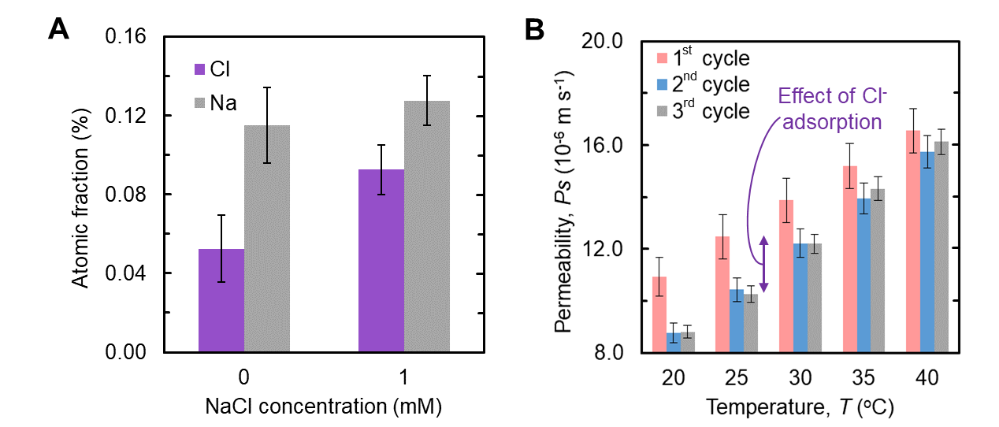

**Fig. 3. Irreversible and influential adsorption of chlorides.** (A) Atomic fractions of chlorine (purple) and sodium (grey) in the polyamide membrane obtained with X-ray photoelectron spectroscopy of membranes soaked in DI water (left) and 1mM NaCl (right). (B) Three consecutive experiments examining NaCl permeability as a function of temperature (i.e., in each cycle, the temperature was elevated from 20 °C to 40 °C) to explore chloride irreversible adsorption.

To further examine the hypothesis of chloride adsorption and its potential effect on Donnan exclusion, an additional set of experiments was conducted using the assumption that Cl- adsorption onto the membrane surface is promoted at elevated temperatures. More specifically, we kept the salt concentration constant and sequentially elevated the temperature from 20 °C to 40 °C three times to test the effect of chloride adsorption on water and salt permeabilities (**Fig. 2B**). Our results show the irreversible effect of membrane exposure to high temperature (40 oC) at the presence of merely 1 mM NaCl. That is, increasing the temperature in the first cycle results in a lower salt permeability in the following cycles for a given temperature. We attribute this decrease in salt permeability to irreversible chloride adsorption occurring at higher temperatures, contributing to the negative charge of the membrane and therefore to enhanced Donnan exclusion in the following cycles.

To better understand ion and polymer properties under high concentrations and pressures and the molecular mechanisms governing membrane performance, we will use transition-state theory to identify free energy barriers to membrane permeability. We have expanded the traditional formulation of transition-state theory applied to membrane permeability to include distributions of membrane energy barriers that arise from the structural and chemical heterogeneity within polymeric membranes. We numerically test this framework by drawing free energy barriers from distributions with varying spread (**Fig. 4**). The effective free energy barrier that is observable through experiment is primarily determined by the maximum individual barriers. However, the observable permeability comes from many molecular pathways each contributing its own permeability. When we consider many parallel pathways through the membrane, the effective free energy barrier is most dependent on the most permeable paths. Therefore, the highest energy barriers along the most permeable paths provide the largest contributions to the observable free energy barrier. For example, pathways through large voids without much tortuosity will contribute most to the overall permeability of the membrane. Additionally, we show that increasing the number of pathways while maintaining the same overall area introduces an additional entropic barrier. This entropic barrier increases the effective free energy barrier to permeability by applying geometric constraints to where molecular jumps occur. The top panel of **Fig. 4** shows this increase in free energy when there is not a distribution of free energy barriers. The other two panels demonstrate the effects of distributions of free energy barriers on the observable energy barrier.

**Fig. 4. Distributions of energy barriers across parallel pathways.** The overall effective free energy barrier is near the maximum of the distribution of energy barriers. Parallel pathways introduces an entropic shift in the effective barrier, indicated by the gap between the dashed lines in the top panel. Increasing heterogeneity within the membrane increases the effective barrier.